## **Tiếng Anh 8 i-Learn Smart World_Unit 4.3 Time allotted: 45**

**PART 1**  **PRONUNCIATION (4 questions)**

**Choose the word whose underlined part differs from the other three in pronunciation in the following question.**

1. A. typhoon B. flood C. moon D. bathroom

2. A. escape B. heatwave C. amazed D. blizzard

**Choose the word that differs from the other three in the position of the main stress in the following question.**

3. A. supply B. damage C. landslide D. earthquake

4. A. tsunami B. battery C. disaster D. announcement

**PART 2**  **USE OF ENGLISH (13 questions)**

**Choose the option that best completes the following sentence.**

5. Sometimes we have ______________ here and our house shakes; it's really scary.

A. floods B. avalanches C. earthquakes D. heatwaves

6. At least 96 people have died because of the ______________ in India, where the temperature reached 45 degrees Celsius.

A. heatwave B. blizzard C. typhoon D. landslide

7. You should stock ______________ on first aid supplies, batteries, flashlights, and other essential items.

A. with B. up C. to D. from

8. Everyone should always keep a ______________ in their house in case of a fire.

A. fire engine B. fire service C. fire brigade D. fire extinguisher

9. A lot of people were skiing on the mountain when the ______________ happened.

A. tsunami B. avalanche C. drought D. flood

10. When preparing for a hurricane, it is important to ______________ windows and doors to protect your house from strong winds.

A. board up B. switch on C. stay away D. turn off

11. Make sure to have extra ______________ for your flashlights and other devices in case of a natural disaster.

A. kits B. radios C. batteries D. power

12. You must stay ______________ your house during thunderstorms and blizzards.

A. indoor B. inside C. under D. into

13. You mustn't stand ______________ a tree during a storm; it's extremely dangerous.

A. in B. into C. under D. to

14. Don't walk ______________ flooded areas because the moving water can knock you over and sweep you away.

A. into B. inside C. outside D. under

15. Alex: " ______________ was the Sumatra tsunami in 2004?"   
Sophie: "The waves reached a height of 51 meters."

A. How far B. How tall C. How long D. How much

16. Mike: "______________ did Hurricane Katrina in late August 2005 cause?"   
Andy: "Approximately $108 billion in damage."

A. How much damage B. How many damage C. How high damage D. How damage

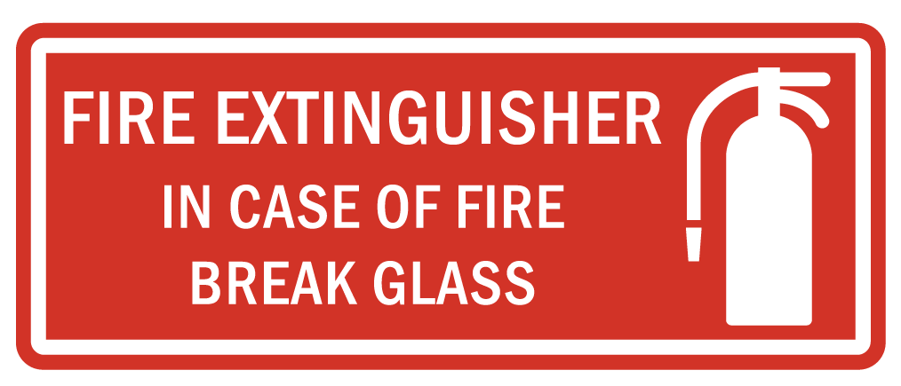

17. What does the notice tell us to do?

A. Use the fire extinguisher to break the glass in case of fire.

B. When a fire happens, only use fire extinguishers to break glass.

C. If there is a fire, break the glass to use the fire extinguisher.

D. The glass is used to break the fire extinguisher.

**PART 3**  **WORD FORMATION (6 questions)**

**Write the correct form of the given word.**

18. Talim is the strongest storm that has ______________ northern Vietnam in the past three years. ***(EFFECT)***

19. You should have a plan for what to do in the event of a ______________ disaster. ***(NATURE)***

20. There are a number of ______________ tips that can help you stay safe during wildfires. ***(SAFE)***

21. If you see a wildfire coming, go to a safe place ______________. ***(IMMEDIATE)***

22. It's important to follow ______________ that are given to you by emergency services. ***(INSTRUCT)***

23. If a flood occurs, you should stay informed, gather essential supplies and be ______________ to leave your house. ***(PREPARE)***

**Find the underlined part that needs correction in the following question.**

24. After hearing the warning of a coming hurricane, we moved all outside furniture inside the house.

A. After B. warning of C. outside D. inside the house

**PART 4**  **READING (5 questions)**

**Read the website article. Write ONE suitable word in each space. (5 questions)**

**What is a disaster?**   
We can use the word ‘disaster’ in normal conversation. If we say, ‘My project was a disaster’, we (25)___________ that many things went wrong. But when we use the word to talk about natural disasters, (26)___________ earthquakes, tsunamis, and typhoons, it has a very different meaning.   
Scientists say that there are over 50 earthquakes every day somewhere in the world, but not all of these earthquakes are disasters. In the same way, most of the 30 typhoons each year are not disasters, (27)___________ they happen far out to sea.   
So when does a natural event become a disaster? The most important thing is (28)___________ the height of the waves in a tsunami or the area of land in an earthquake. It is not even the cost of the event in dollars from buildings falling down or roads being damaged.   
A disaster is an event in which, unfortunately, a (29)___________ of people die. It is as simple, and sad, as that.

**PART 5**  **LISTENING (5 questions)**

**Listen to a conversation between two friends. Choose the best answer for each question. (5 questions)**

30. The boy is preparing his house for______________.

A. a high wind B. a storm C. a flood D. damage from falling trees

31. The girl ______________.

A. heard about the emergency on the radio

B. missed the emergency warning on the radio

C. did not know anything about an emergency

D. does not think there will be an emergency

32. Why are the boy’s parents not stocking up on food?

A. The emergency will not last very long.

B. There isn’t time to get to the store.

C. There is no food left in the store.

D. They already have a lot of food in case of an emergency.

33. How fast do typhoons move across land, according to the boy?

A. 20 kph B. 30 kph C. 200 kph D. 300 kph

34. What does the boy tell the girl to do?

A. Inform her parents about the emergency immediately

B. Stay at his house

C. Go and board up the windows of her house

D. Wait to see if a warning comes on the radio

**PART 7**  **WRITING (6 questions)**

**Write question for the underlined information in the following sentence.**

35. Typhoon Linda was the worst typhoon in Vietnam’s history.

→ ___________

36. Tōhoku Earthquake and Tsunami happened on 11th March 2011.

→ ___________

37. In 2020, severe floods and landslides killed at least 105 people in Central Vietnam.

→ ___________

38. The Dust Bowl Drought lasted for almost ten years.

→ ___________

**Put the words in the correct order to make correct sentence.**

39. Keywords: or a table/When/to the ground/drop down/an earthquake/a desk/./happens,you should/and get under

→ .......................................

40. Keywords: ./your flashlights/in a safe place/where you can/easily get them/in an emergency/You should keep

→ .......................................

**---THE END---**

## **Tiếng Anh 8 i-Learn Smart World_Unit 4.3 Time allotted: 45**

## **ANSWER KEY**

**PART 1**  **PRONUNCIATION (4 questions)**

**Choose the word whose underlined part differs from the other three in pronunciation in the following question.**

1. A. typhoon B. flood C. moon D. bathroom

2. A. escape B. heatwave C. amazed D. blizzard

**Choose the word that differs from the other three in the position of the main stress in the following question.**

3. A. supply B. damage C. landslide D. earthquake

4. A. tsunami B. battery C. disaster D. announcement

**PART 2**  **USE OF ENGLISH (13 questions)**

**Choose the option that best completes the following sentence.**

5. Sometimes we have ______________ here and our house shakes; it's really scary.

A. floods B. avalanches C. earthquakes D. heatwaves

6. At least 96 people have died because of the ______________ in India, where the temperature reached 45 degrees Celsius.

A. heatwave B. blizzard C. typhoon D. landslide

7. You should stock ______________ on first aid supplies, batteries, flashlights, and other essential items.

A. with B. up C. to D. from

8. Everyone should always keep a ______________ in their house in case of a fire.

A. fire engine B. fire service C. fire brigade D. fire extinguisher

9. A lot of people were skiing on the mountain when the ______________ happened.

A. tsunami B. avalanche C. drought D. flood

10. When preparing for a hurricane, it is important to ______________ windows and doors to protect your house from strong winds.

A. board up B. switch on C. stay away D. turn off

11. Make sure to have extra ______________ for your flashlights and other devices in case of a natural disaster.

A. kits B. radios C. batteries D. power

12. You must stay ______________ your house during thunderstorms and blizzards.

A. indoor B. inside C. under D. into

13. You mustn't stand ______________ a tree during a storm; it's extremely dangerous.

A. in B. into C. under D. to

14. Don't walk ______________ flooded areas because the moving water can knock you over and sweep you away.

A. into B. inside C. outside D. under

15. Alex: " ______________ was the Sumatra tsunami in 2004?"   
Sophie: "The waves reached a height of 51 meters."

A. How far B. How tall C. How long D. How much

16. Mike: "______________ did Hurricane Katrina in late August 2005 cause?"   
Andy: "Approximately $108 billion in damage."

A. How much damage

B. How many damage

C. How high damage

D. How damage



17. What does the notice tell us to do?

A. Use the fire extinguisher to break the glass in case of fire.

B. When a fire happens, only use fire extinguishers to break glass.

C. If there is a fire, break the glass to use the fire extinguisher.

D. The glass is used to break the fire extinguisher.

**PART 3**  **WORD FORMATION (6 questions)**

**Write the correct form of the given word.**

18. Talim is the strongest storm that has ______________ northern Vietnam in the past three years. ***(EFFECT) => affected***

19. You should have a plan for what to do in the event of a ______________ disaster. ***(NATURE) => natural***

20. There are a number of ______________ tips that can help you stay safe during wildfires. ***(SAFE) => safety***

21. If you see a wildfire coming, go to a safe place ______________. ***(IMMEDIATE) => immediately***

22. It's important to follow ______________ that are given to you by emergency services. ***(INSTRUCT) => instructions***

23. If a flood occurs, you should stay informed, gather essential supplies and be ______________ to leave your house. ***(PREPARE) => prepared***

**Find the underlined part that needs correction in the following question.**

24. After hearing the warning of a coming hurricane, we moved all outside furniture inside the house.

A. After B. warning of C. outside D. inside the house

**PART 4**  **READING (5 questions)**

**Read the website article. Write ONE suitable word in each space. (5 questions)**

**What is a disaster?**   
We can use the word ‘disaster’ in normal conversation. If we say, ‘My project was a disaster’, we (25) mean that many things went wrong. But when we use the word to talk about natural disasters, (26) like earthquakes, tsunamis, and typhoons, it has a very different meaning.   
Scientists say that there are over 50 earthquakes every day somewhere in the world, but not all of these earthquakes are disasters. In the same way, most of the 30 typhoons each year are not disasters, (27) because/ since/ as they happen far out to sea.   
So when does a natural event become a disaster? The most important thing is (28) not the height of the waves in a tsunami or the area of land in an earthquake. It is not even the cost of the event in dollars from buildings falling down or roads being damaged.   
A disaster is an event in which, unfortunately, a (29) lot of people die. It is as simple, and sad, as that.

**PART 5**  **LISTENING (5 questions)**

**Listen to a conversation between two friends. Choose the best answer for each question. (5 questions)**

30. The boy is preparing his house for______________.

A. a high wind B. a storm C. a flood D. damage from falling trees

31. The girl ______________.

A. heard about the emergency on the radio

B. missed the emergency warning on the radio

C. did not know anything about an emergency

D. does not think there will be an emergency

32. Why are the boy’s parents not stocking up on food?

A. The emergency will not last very long.

B. There isn’t time to get to the store.

C. There is no food left in the store.

D. They already have a lot of food in case of an emergency.

33. How fast do typhoons move across land, according to the boy?

A. 20 kph B. 30 kph C. 200 kph D. 300 kph

34. What does the boy tell the girl to do?

A. Inform her parents about the emergency immediately

B. Stay at his house

C. Go and board up the windows of her house

D. Wait to see if a warning comes on the radio

**PART 7**  **WRITING (6 questions)**

**Write question for the underlined information in the following sentence.**

35. Typhoon Linda was the worst typhoon in Vietnam’s history.

→ What was the worst typhoon in Vietnam's history?/Which was the worst typhoon in Vietnam's history?

36. Tōhoku Earthquake and Tsunami happened on 11th March 2011.

→ When did Tōhoku Earthquake and Tsunami happen?

37. In 2020, severe floods and landslides killed at least 105 people in Central Vietnam.

→ How many people in Central Vietnam were killed by severe floods and landslides in 2020?/How many people in Central Vietnam did severe floods and landslides kill in 2020?

38. The Dust Bowl Drought lasted for almost ten years.

→ How long did the Dust Bowl Drought last?/How many years did the Dust Bowl Drought last?

**Put the words in the correct order to make correct sentence.**

39. Keywords: or a table/When/to the ground/drop down/an earthquake/a desk/./happens,you should/and get under

→ When an earthquake happens,you should drop down to the ground and get under a desk or a table .

40. Keywords: ./your flashlights/in a safe place/where you can/easily get them/in an emergency/You should keep

→ You should keep your flashlights in a safe place where you can easily get them in an emergency.

**---THE END---**