Week 13
Period 37
Teaching date: 29/11/2021

UNIT 5 : NATURAL WONDERS OF VIET NAM
(DHLH) LESSON 3: COMMUNICATION
I.OBJECTIVES:By the end of the lesson, students will be able to:
1. Knowledge:
- Vocabulary: Review some words related to travel items .
- Grammar: + Making and accepting appointments.
+ Review “must / mustn’t”
2. Competence: Ss can make a short conversation about their trip .
3. Educational aims: To teach SS to work hard and love travelling.
II. TEACHING AIDS: Text books, laptop , smart TV , video clips
IV. PROCEDURES:
Contents | Teacher’s and Ss’activities
I.ACTIVITY 1: Warm – up (7’)
To review must/ mustn’t and lead in the new lesson
* GAME: Pass the ball  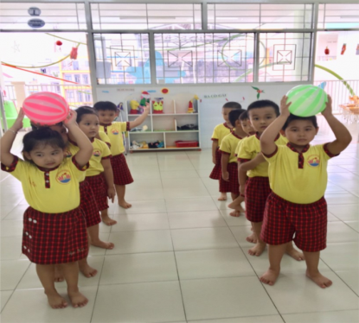 | - T: plays the music. When music’s on, students pass the ball as fast as they can.  - When music’s off, the student taking the ball has to make a sentence with must/ mustn’t.  - Lead in:  Teacher sets the scene.  They are Duong and Steven. Steven wants Duong to go picnic with him this Sunday. Now,We are going to come to the new lesson to know the conversation
II. ACTIVITY 2: ( 8’)
To introduce how to make and accept appointment
1.Listen and read the short conversa..,, paying attention to the highlighted parts.  - Making appointments:  Let’s + V.  How about …?  - Accepting appointments:  That’s fine / Sure | -T: has Ss listen and read the short conversation, paying attention to the highlighted parts.  -T: writes down highlighted parts on the board and asks students what they are used to, which is used to make appointments and which is used to accepting appointments.  -T: calls some students to share their opinions.  -T :gives more explanations and elicit the form.
III. ACTIVITY 3: (8’)
Ss can make a short conversation, following the example in Task 1.
2.Work in pairs. Make a short conversation, following the EX in 1.  - Example:  Huy: Nam, let's go to the supermarket this Sunday morning.  Nam: That's great. What time can we meet?  Huy: How about 8 o'clock?  Nam: Sure, I'll meet you at that time. | -T: asks students to work in pairs and make a short conversation, following the example.  -T: models with a volunteer.  -Ss do the task in pairs.  -T:calls some pairs to make a conversation in front of the class.  -T:gives feedback and corrections
III. ACTIVITY 3:(19’)
Ss can read the travel guide entry, Make a list of the things you must bring to the Himalayas.
3. Read the travel guide entry.  * Vocabulary :  - mountain range (n): rặng núi  - follow (v): tuân theo  - area (n): khu vực  -litter (v): vứt rác  - special (adj): đặc biệt  4.Make a list of the things you must bring to the Himalayas. Then add things you mustn’t bring. |  | -T: explains some new words  -S: read them chorally and individually  -T: asks 2 Ss to read the travel guide entry loudly  -T:tells Ss to read the travel guide entry silently  -Ss work in groups to write the things you must bring  - A student from each group says the whole sentence  - T: gives remarks and corrections
  MUST | MUSTN’T
  - compass  - sleeping bag  - plaster  - packback  - waterproof coat | - bicycle  - shorts  - T-shirt
IV. Home work: (3’)
- Learn new words by heart .
- Make a new conversation in task 5.
- Prepare Unit 5: SKILLS 1 (new words/page 55)

