ĐỀ VIP 8+ SỐ 4
Read the following advertisement and mark the letter A, B, C or D on your answer sheet to indicate the option that best fits each of the numbered blanks from 1 to 6.

BreatheFree Nicotine Patches – Your Path to a Smoke-Free Life!
Ready to (1) the habit of smoking and embrace a healthier lifestyle? ‘BreatheFree Nicotine Patches’ offer a safe, effective way to quit smoking for good.
Each patch releases a steady dose of nicotine, helping to reduce cravings and ease (2) . These discreet patches, (3) to fit seamlessly into your day, provide timely support whenever you need it, helping you stay on track and make quitting easier. ‘BreatheFree’ encourages you (4) to a healthier lifestyle, and is here to guide you every step of the way, with clear (5) to help you gradually reduce nicotine intake.
Take control (6) your health today and start your journey to a smoke-free life. Make the change with ‘BreatheFree’!
Get started at BreathFree.com – freedom is one patch away!
Question 1. | A. set | B. make | C. keep | D. break
Question 2. | A. symptoms common withdrawal  C. common withdrawal symptoms |  | B. withdrawal common symptoms  D. common symptoms withdrawal
Question 3. | A. designed | B. designing | C. which designed | D. are design
Question 4. | A. committing | B. to commit | C. commit | D. to committing
Question 5. | A. instruct | B. instructive | C. instructively | D. instructions
Question 6. | A. with | B. of | C. by | D. in
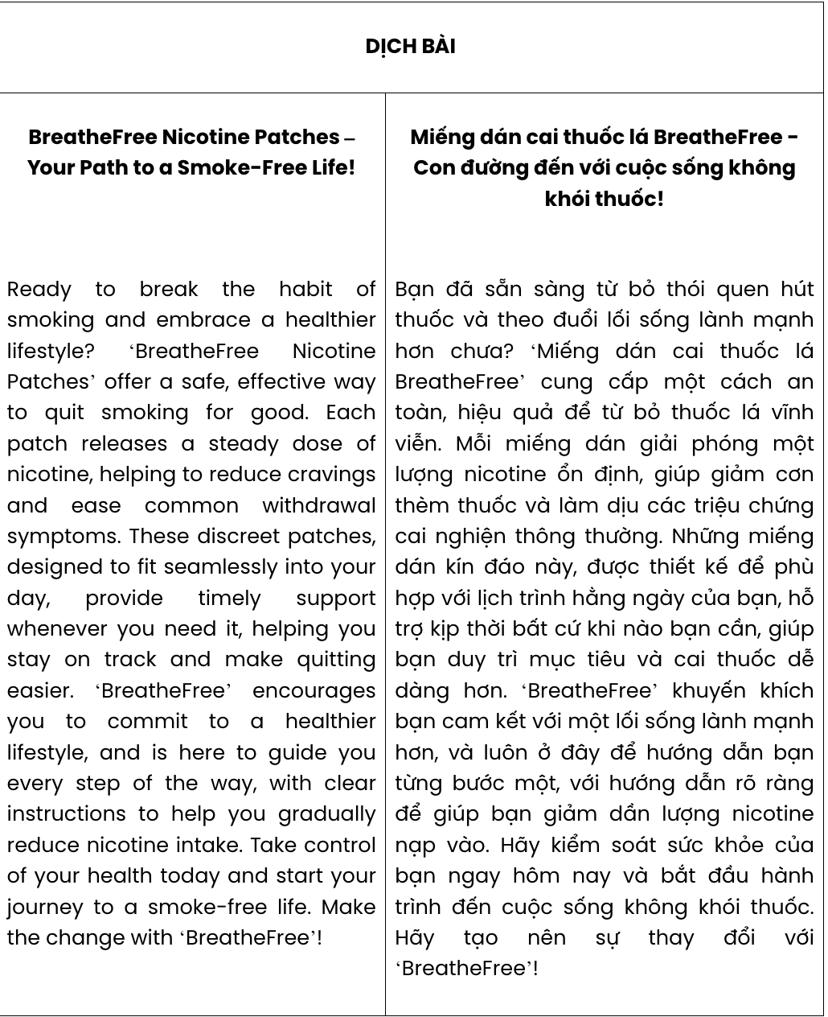
GIẢI CÂU 1:

GIẢI CÂU 2:
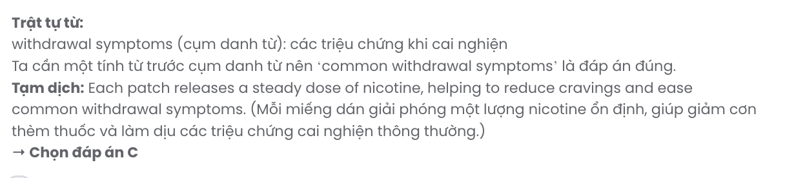
GIẢI CÂU 3:

GIẢI CÂU 4:
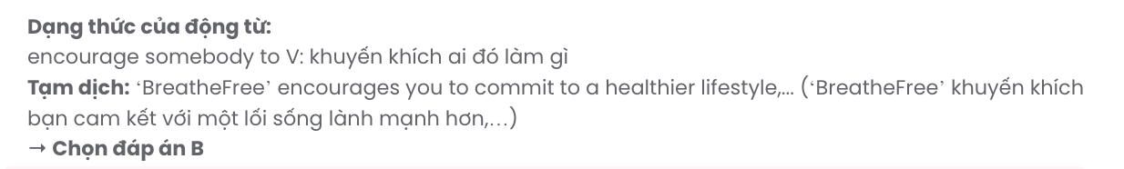
GIẢI CÂU 5:
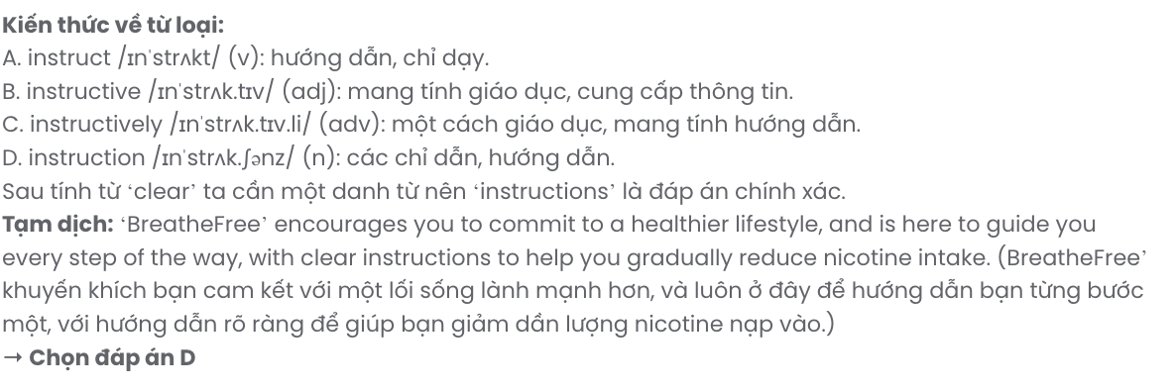
GIẢI CÂU 6:

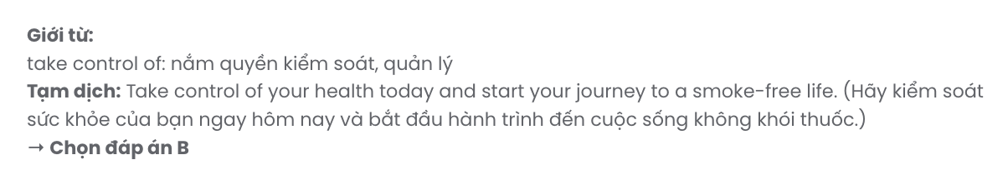
Read the following leaflet and mark the letter A, B, C or D on your answer sheet to indicate the option that best fits each of the numbered blanks from 7 to 12.

Save Electricity, Save the Future
Conserving energy for a sustainable tomorrow

◆+L* Some facts about electricity:
Humans primarily (7) natural resources for electricity generation. These finite resources are being (8) faster than ever on our planet. Moreover, the problem of electricity shortages, when consumption exceeds the (9) of electricity produced, remains acute in many countries.

L*+◆ Why Should We Save Electricity?
- Reduce Energy Bills: Cutting down on electricity use directly lowers your monthly expenses.
- Conserve Natural Resources: (10) natural conservation, the less energy we consume, the better it is.
- Protect the Environment: Less energy used means less greenhouse gas released, which reduces pollution and (11) environmental issues.
- Ensure Future Supply: (12) use today ensures that future generations will have access to essential energy.

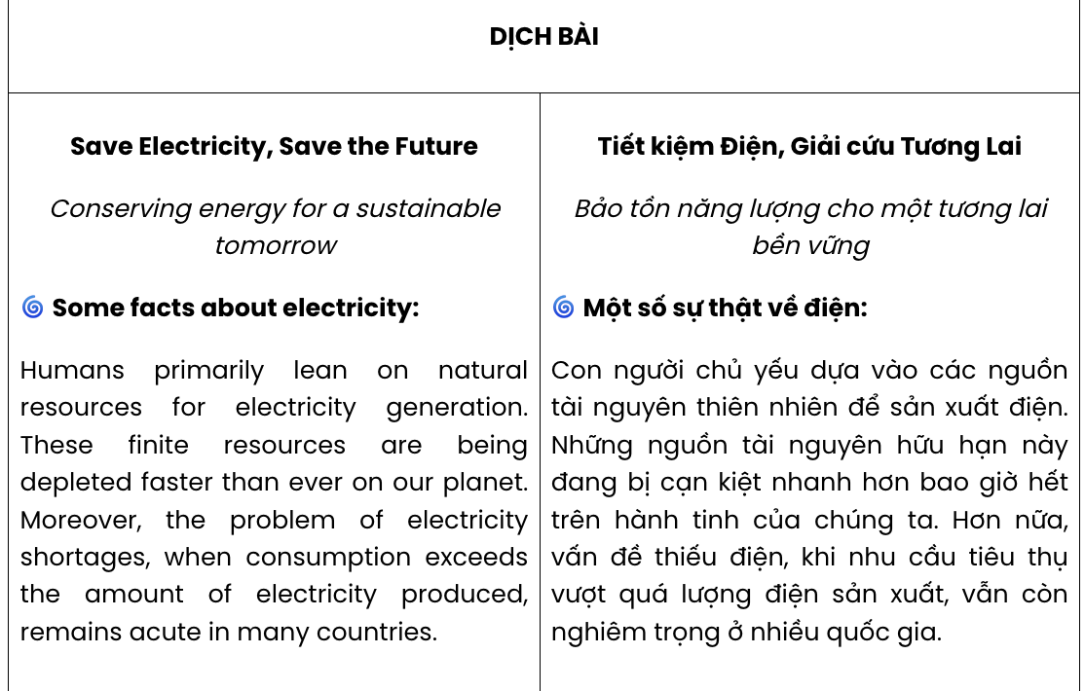
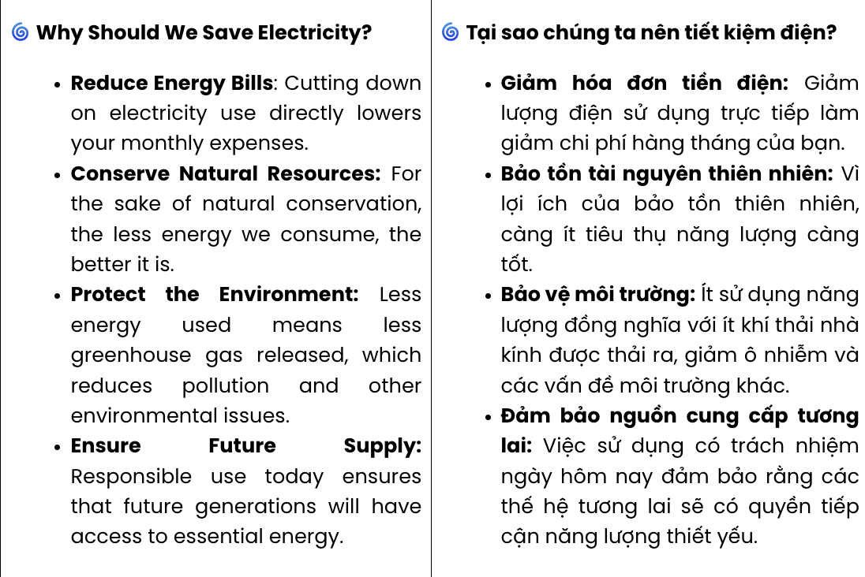

Question 7. | A. use up | B. lean on | C. work out | D. look after
Question 8. | A. developed | B. released | C. depleted | D. preserved
Question 9. | A. amount | B. range | C. variety | D. percentage
Question 10. | A. Thanks to | B. For the sake of | C. Irrespective of | D. In place of
Question 11. | A. the other | B. another | C. others | D. other
Question 12. | A. Eco-friendly | B. Responsible | C. Adaptable | D. Visionary

GIẢI CÂU 7
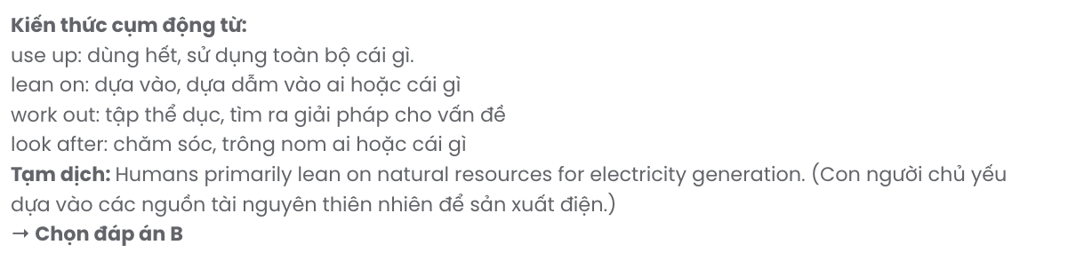
GIẢI CÂU 8
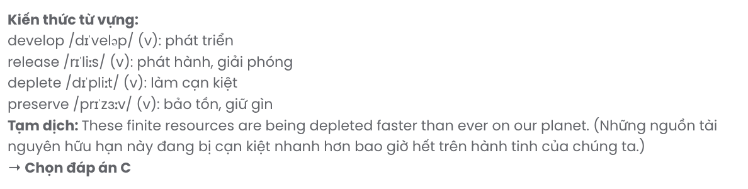
GIẢI CÂU 9
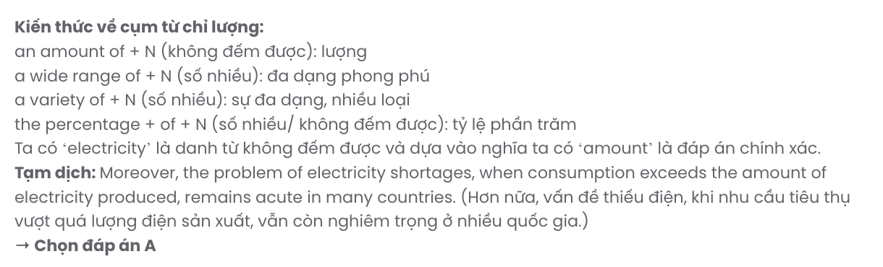
GIẢI CÂU 10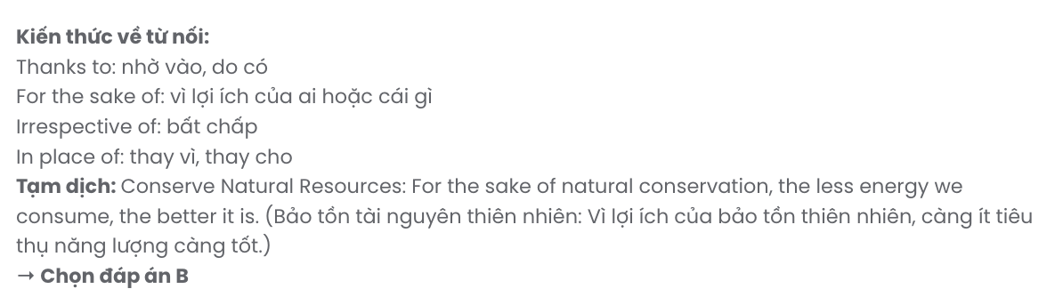
GIẢI CÂU 11

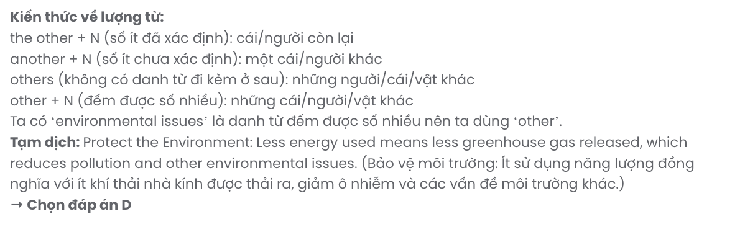
GIẢI CÂU 12
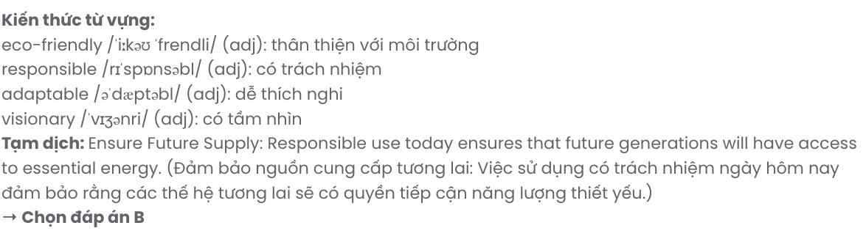
Mark the letter A, B, C or D on your answer sheet to indicate the best arrangement of utterances or sentences to make a meaningful exchange of text in each of the following questions from 13 to 17.

Question 13.
- Anna: I can imagine! It must feel amazing to finally be done with it.
- Anna: Hello, Ben! You look like you’re in a good mood today.
- Ben: Hi, Anna! Yeah, I just finished a big project at work, so I feel really relieved.
A. c – a – b B. b – a – c C. a – c – b D. b – c – a
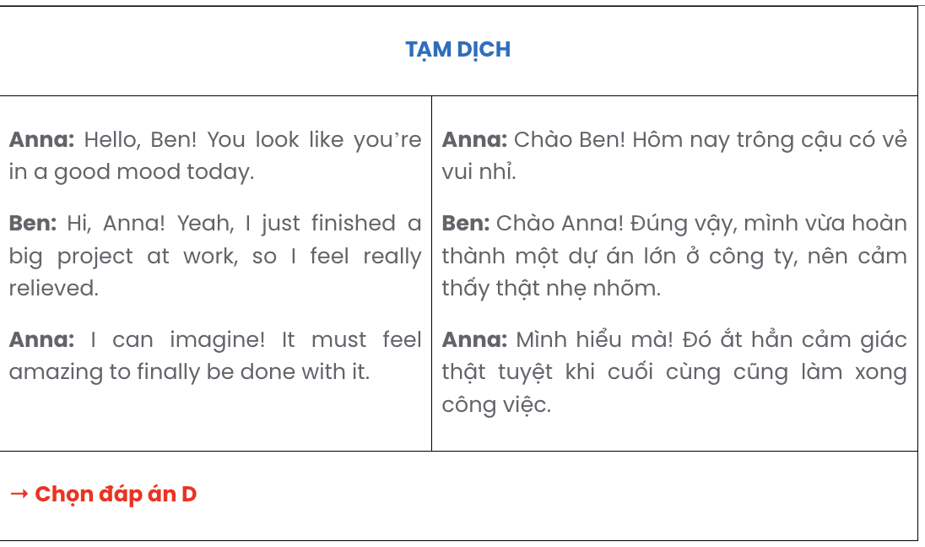

Question 14.
- Mia: That sounds exciting! Where do you plan on going?
- Mia: Sounds amazing! I hope you all have an unforgettable trip.
- Sam: We’re going to explore some national parks. We all love nature and hiking.
- Mia: How are you planning to spend your summer break?
- Sam: I’m planning to take a road trip with some friends.
A. d – e – a – c – b B. b – c – d – e – a C. a – e – b – c – d D. b – c – a – e – d
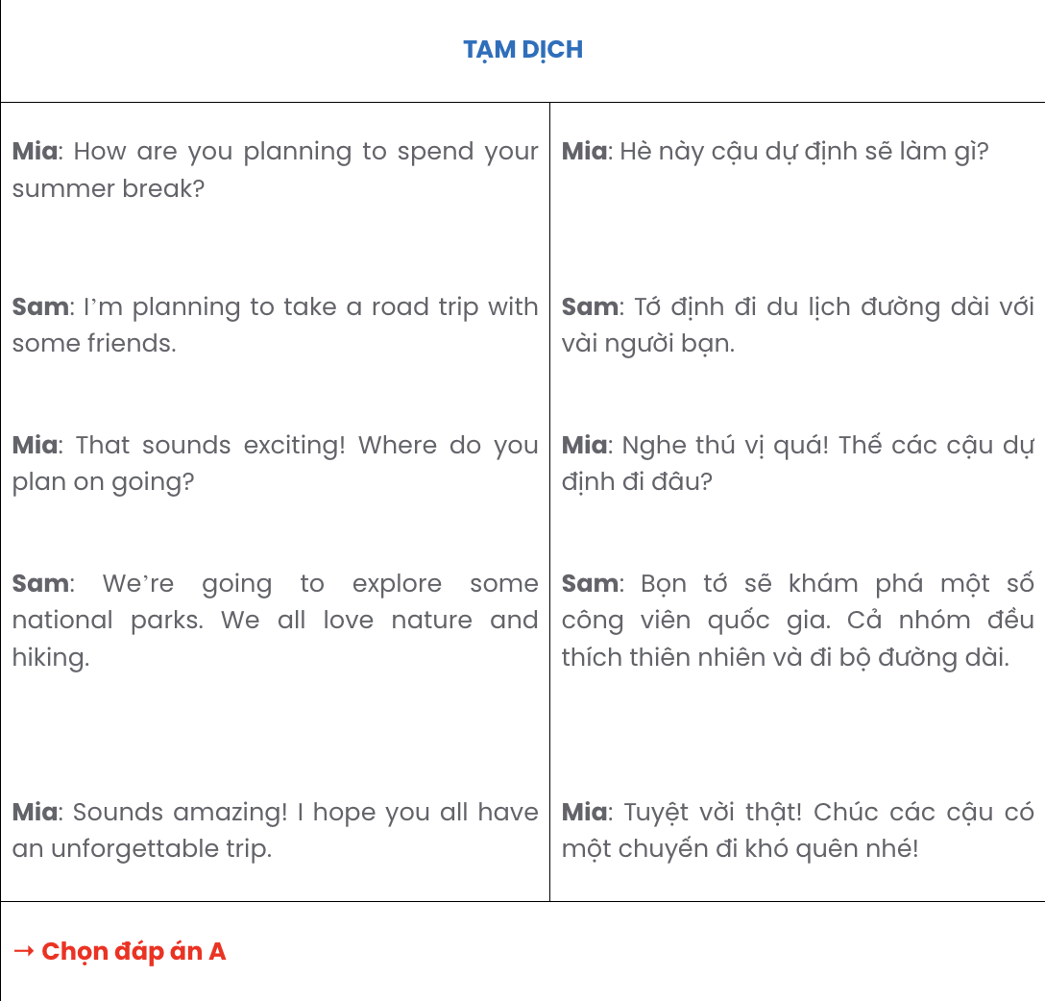

Question 15.
Hi Mark,
- Thanks for your suggestions about travel destinations for my holiday!
- Your advice to visit it during off-peak times is really useful; I’ll plan accordingly.
- I hadn’t considered exploring the countryside, but now it’s at the top of my list.
- I’ll let you know if I need any more tips as I finalise my itinerary.
- I’m also intrigued by that beach town you mentioned – it looks perfect for a relaxing getaway. Best wishes,
Oliver
A. a – b – e – c – d B. c – a – b – d – e C. c – e – a – b – d D. a – c – e – b – d
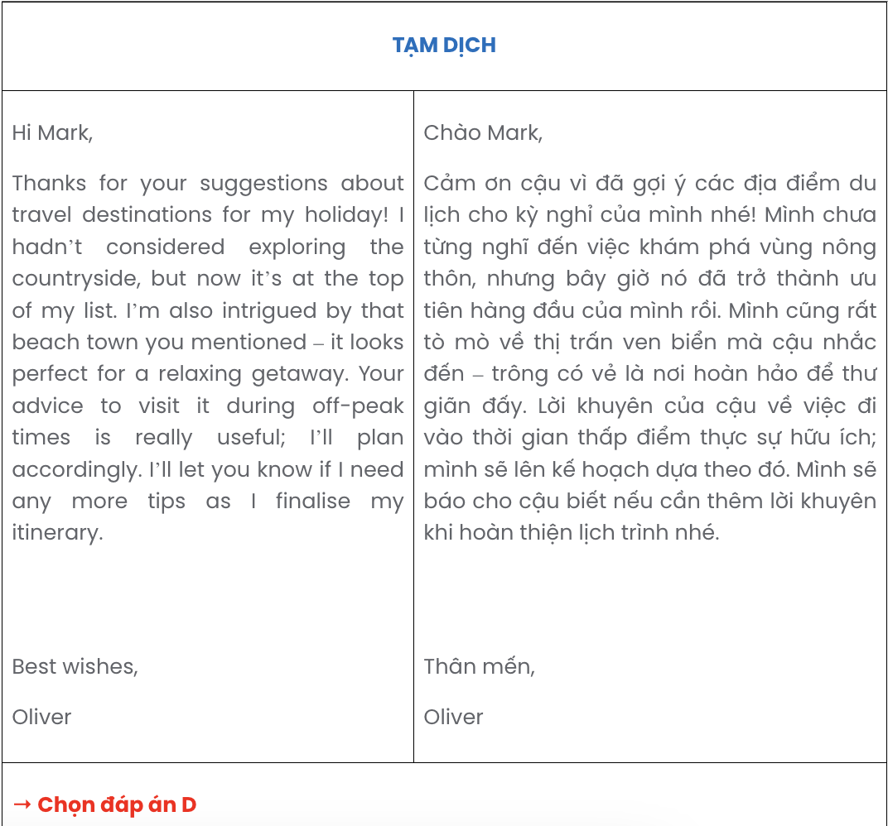

Question 16.
- However, a few challenges exist with cycling, such as rainy weather or some unexpected problems with the bike.
- Riding a bike to work has been both an enjoyable and practical change for me.
- I have been trying to avoid these incidents by bringing a raincoat and leaving for work a little earlier.
- The fresh air I enjoy on the route and some slight physical effort help me wake up fully, setting a positive tone for the day.
- Since switching my commuting habits, I have no longer worried about traffic or parking, and I also get some exercise in before my day begins.
A. b – d – a – e – c B. b – e – d – a – c C. b – e – a – c – d D. b – a – c – d – e

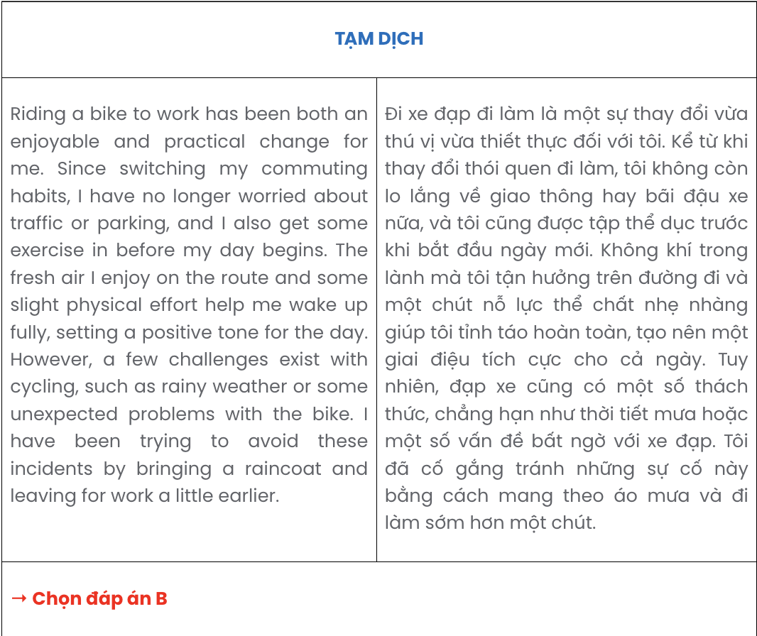

Question 17.
- Once focused primarily on local trade, these workshops now sell handcrafted items online, reaching a much broader global market.
- The steady influx of new orders has not only boosted the local economy but has also inspired many young artisans to carry on these valued traditions.
- As technology continues to advance, traditional craft workshops in Willowton have found a unique and innovative way to thrive.
- With every single sale, they highlight the deep culture and ancient skills passed down through many generations.
- Over time, Willowton’s intricate crafts have gradually gained recognition, preserving the town’s rich heritage even in the changing world.
A. c – e – a – b – d B. c – b – d – a – e C. c – a – b – e – d D. c – a – d – b – e

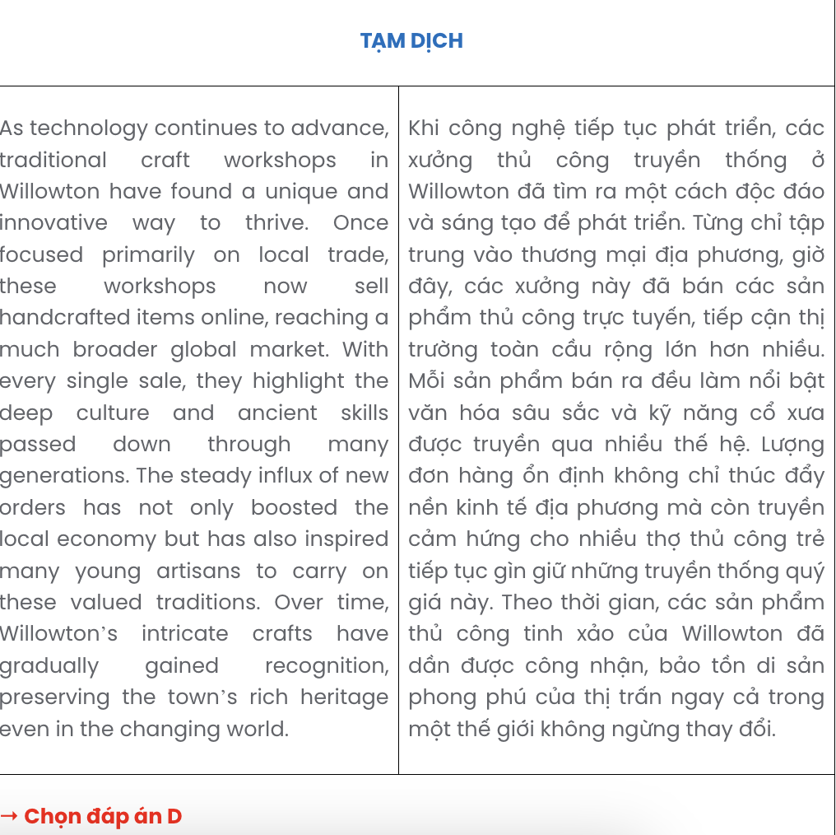
Read the following passage and mark the letter A, B, C, or D on your answer sheet to indicate the correct option that best fits each of the numbered blanks from 18 to 22.
In South Korea, the university entrance exam, known as the “Suneung”, is a defining moment for students. This intense exam, which occurs every November, (18) .
The exam is so intense that South Korea, where academic achievement holds significant weight, prioritises it nationally. (19) . Planes are grounded to minimize noise, businesses open late, and traffic is diverted to ensure students arrive on time.
Including subjects like Korean, English, and mathematics, with an emphasis on critical thinking and problem-solving, (20) . Students often begin studying in middle school, and many spend countless hours in “hagwons,” or private tutoring centres, to improve their scores. (21) , which helps them maximise their study efforts. Family members, (22) , gather at temples to pray for success, and friends write encouraging letters for good luck. This experience, which is a mixture of pressure and hope, shapes the lives of countless young Koreans as they strive for higher education and career success.
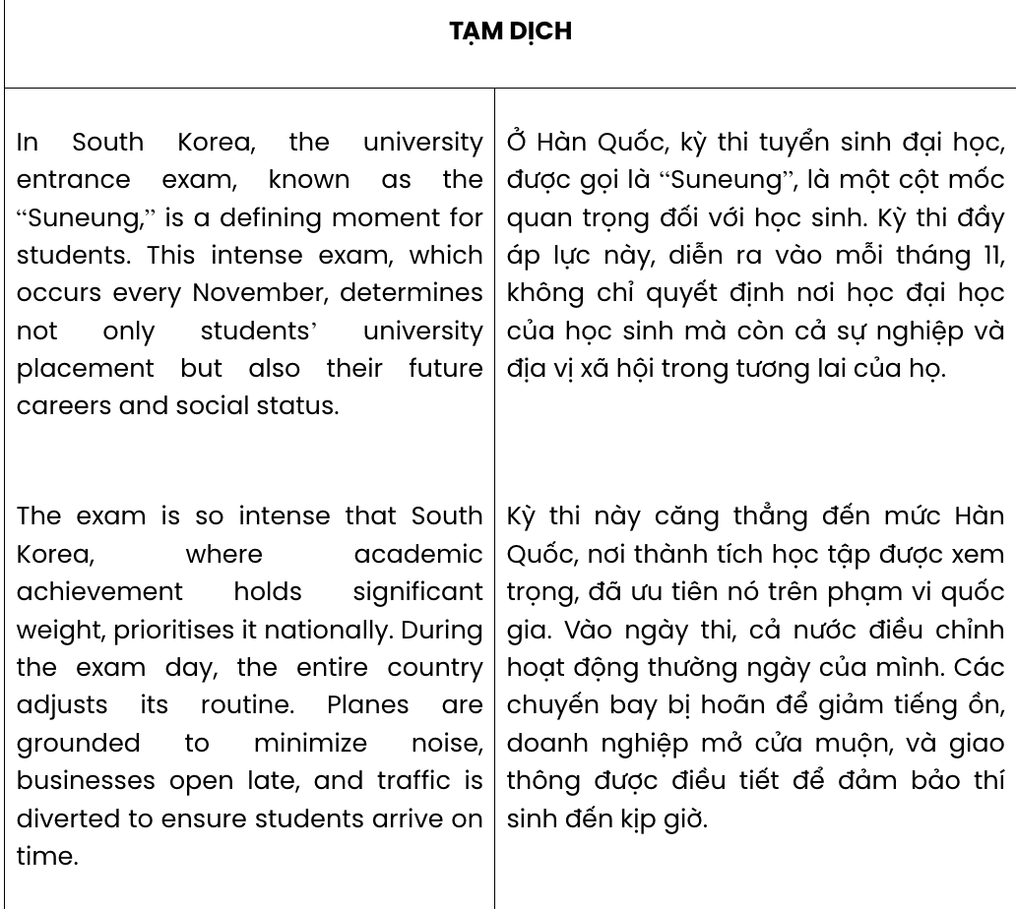
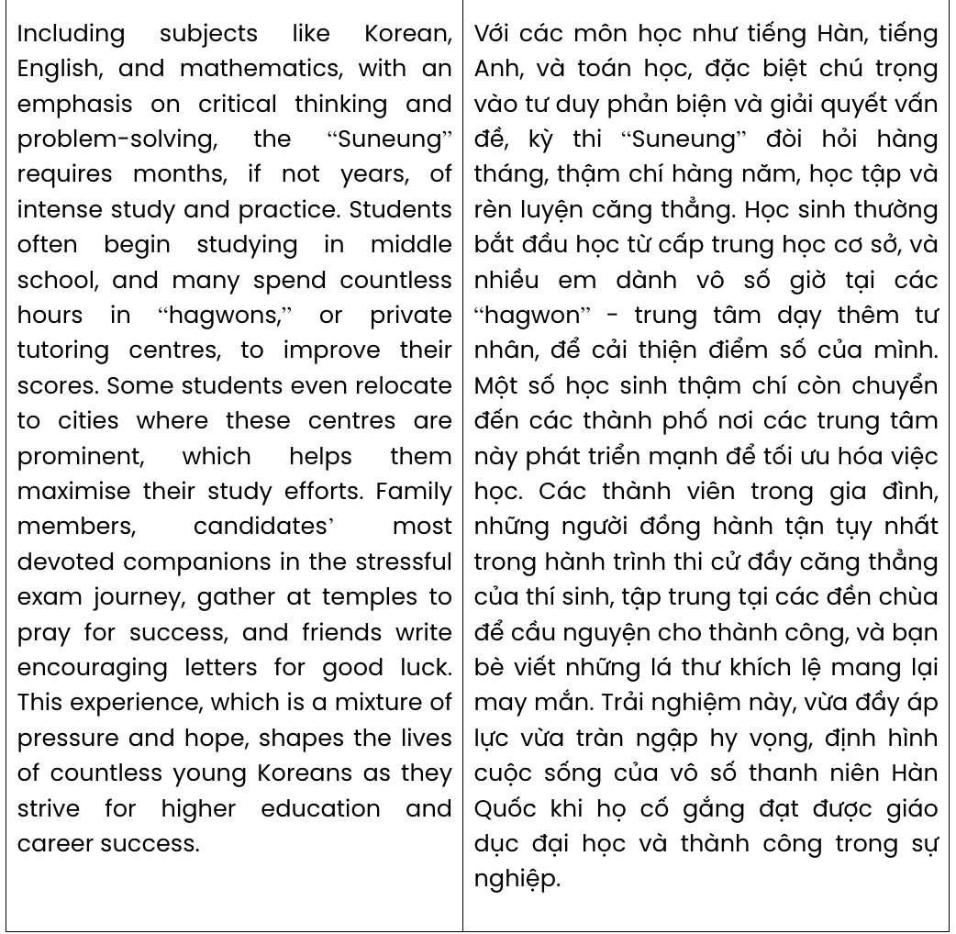

Question 18.
A. of which determination of students’ university placement, future careers and social status
B. what determines both students’ future careers and social status is their university placement
C. determines not only students’ university placement but also their future careers and social status
D. the determination of students’ university placement, careers and social status in the future ahead
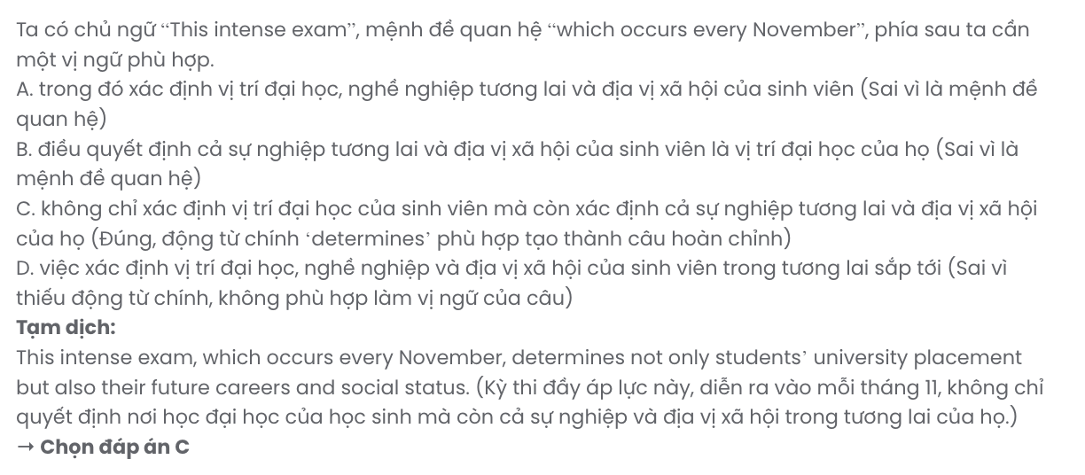

Question 19.
A. This can be considered the most important exam in this country
B. During the exam day, the entire country adjusts its routine
C. The government particularly emphasises the role of this exam
D. All activities nationwide will have to stop on the day of the exam
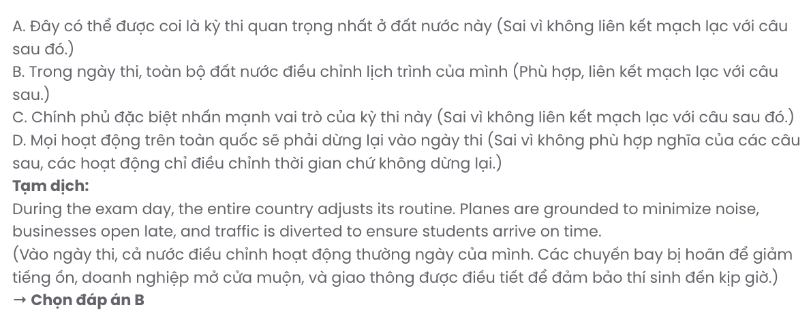

Question 20.
A. the “Suneung” requires months, if not years, of intense study and practice
B. students need comprehensive knowledge and skills to get good results
C. both students and teachers often spend months preparing for this exam
D. the preparation for skills is considered more important than that of knowledge

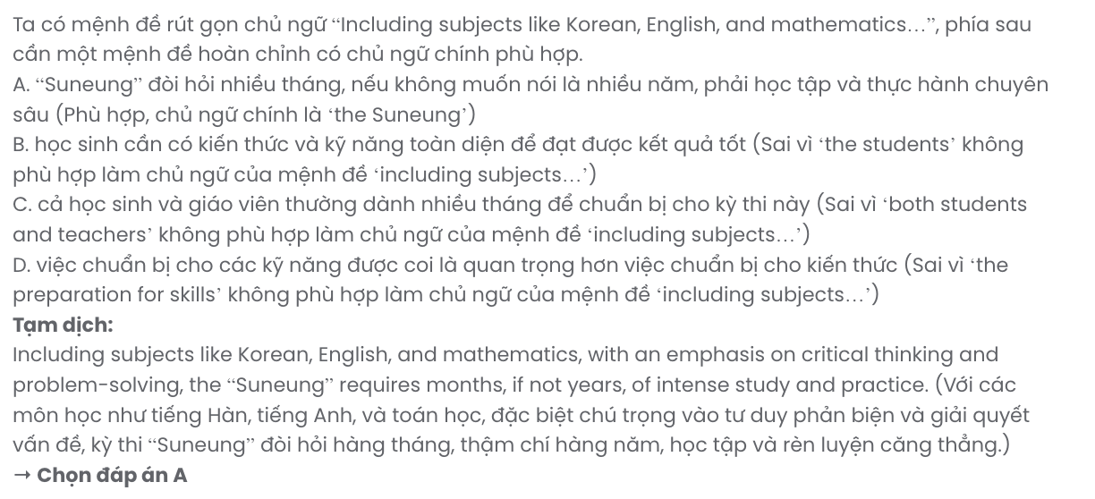

Question 21.
A. Many students decide to move to live closer to their dream university
B. Families must choose whether or not to send their children to these institutes
C. Almost all students have to depend heavily on these institutes for their studies
D. Some students even relocate to cities where these centres are prominent
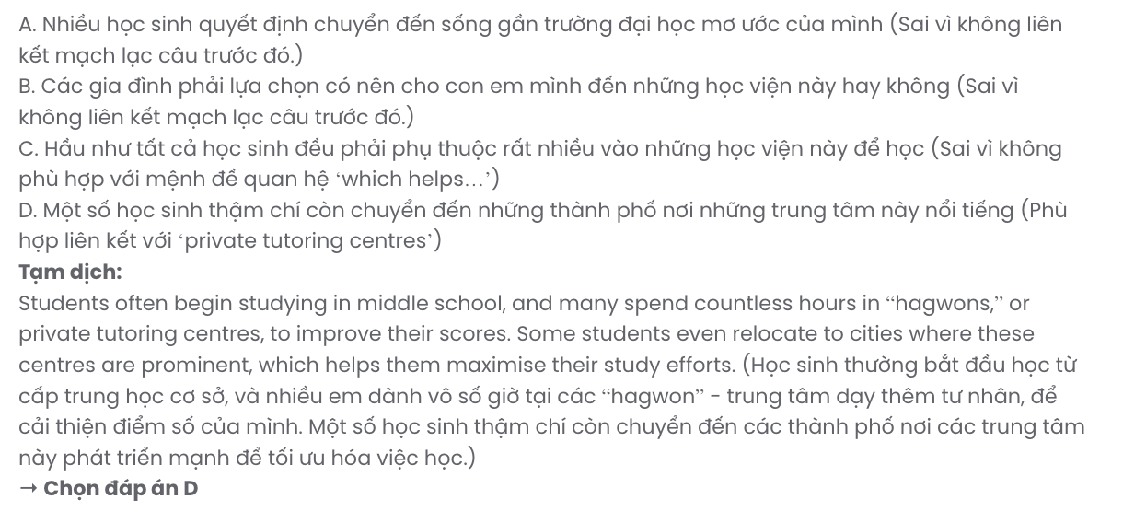

Question 22.
A. they are the most devoted companions on the stressful exam journey of candidates
B. candidates’ most devoted companions in the stressful exam journey
C. whose devotion along the stressful journey of exams to candidates
D. devoted the most to the stressful exam journey of every candidate


Read the following passage and mark the letter A, B, C, or D on your answer sheet to indicate the best answer to each of the following questions from 23 to 30.
Social media networks are the places where you relax, learn interesting things, and show people who you are. Social media users can choose what to show and what to hide, which could lead to the constant desire to be popular and look perfect, known as the pressure of online recognition.
We always want to be like the people around us. On social media, we see the best parts of other people’s lives — their vacations, their career success, even their stunning selfies! It’s easy to get frustrated if you don’t have similar career achievements or post remarkable selfies as they do. This can make you want to be more impressive online and show off all the time.
Social media even keeps a score of your posts and comments! Every like, comment, and follower becomes a number that results in daily pressure. It’s tempting to think that the more popular you are on social media, the better you are as a person. This can make you focus on being liked instead of being yourself.
All those kinds of pressure can be toxic for us. Wanting to be popular online can make people stressed, upset, and unsure of themselves. Trying to seem perfect all the time isn’t real, and it gets exhausting for many people. Sometimes, the best thing to do is to take a break! The bottom line is that you mustn’t let social media control you. It’s vital not to compare yourself with others all the time and just focus on being you. You’d better spend time having real-life fun with other people to experience true happiness instead.
(Adapted from English Workbook 12 – iLearn Smart World)
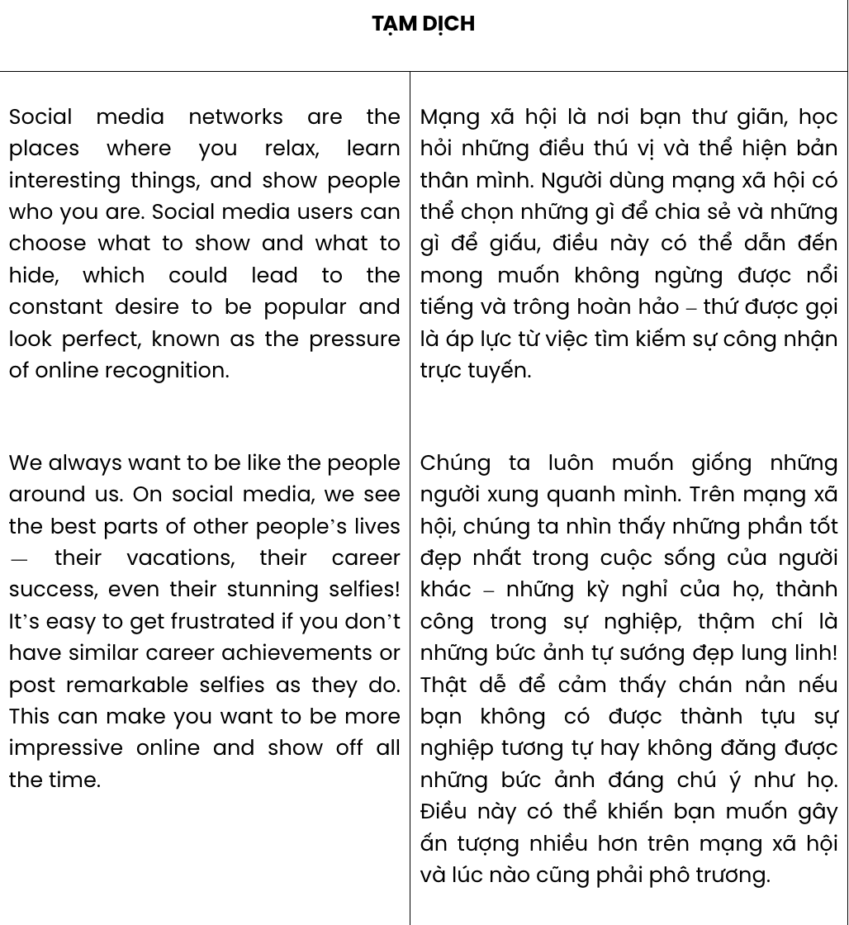
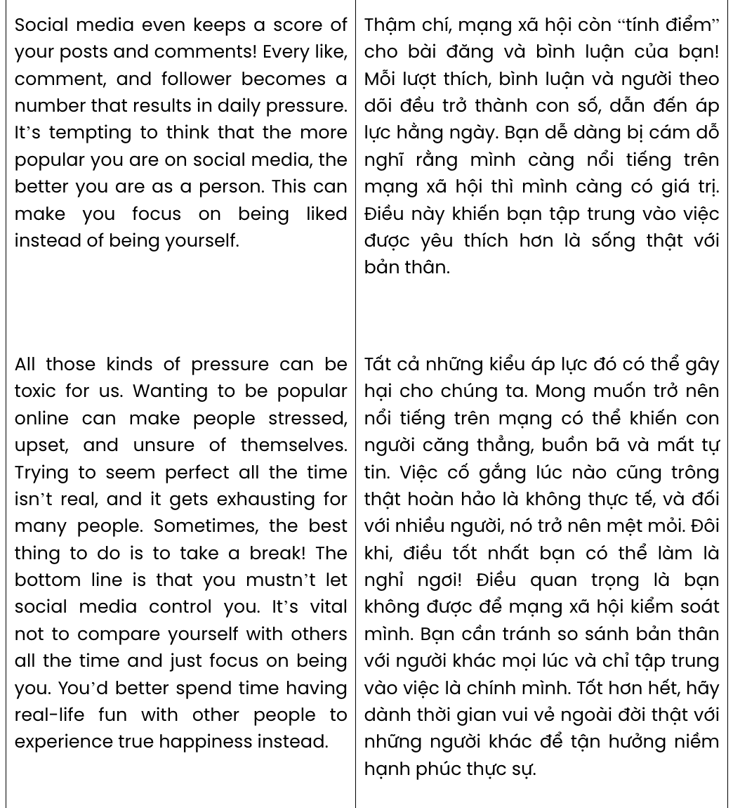
Question 23. Which of the following is NOT mentioned as one of the things you can do on social media?
A. learning B. working C. entertaining D. expressing yourself
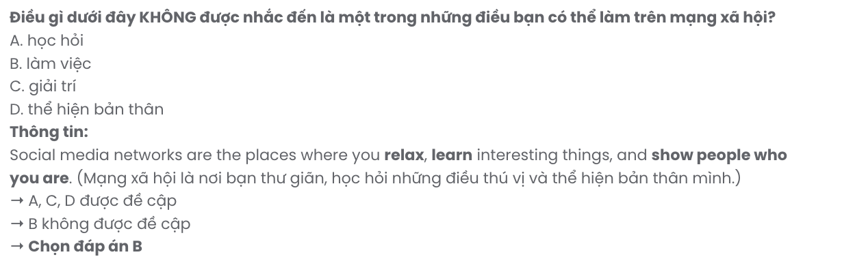
Question 24. The word remarkable in paragraph 2 is OPPOSITE in meaning to .
A. ordinary B. impressive C. creative D. unfamiliar
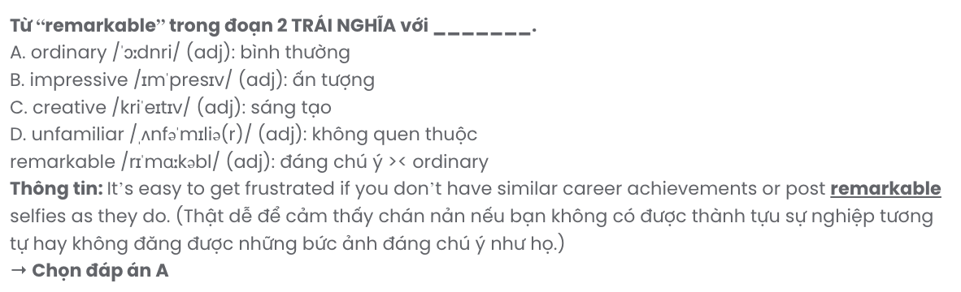
Question 25. The word their in paragraph 2 refers to .
A. lives B. vacations C. the best parts D. other people

Question 26. The word unsure in paragraph 4 can be best replaced by .
A. independent B. reliable C. unconfident D. irresponsible
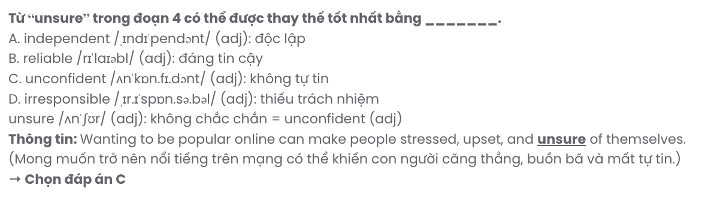
Question 27. Which of the following best paraphrases the underlined sentence in paragraph 4?

Trying to seem perfect all the time isn’t real, and it gets exhausting for many people.
A. Trying to achieve perfection is unrealistic and tiring for many people.
B. Perfection is not real and those who try to achieve it often get exhausted.
C. It’s impractical and tiring for many to put effort into always appearing perfect.
D. Perfection seems attainable but those who really achieve it must pay the price of fatigue.


Question 28. Which of the following is TRUE according to the passage?
A. Social media can lead people to seek approval rather than being authentic.
B. Social media is beneficial for personal development if we can take advantage of it.
C. Many tend to show off on social media but some prefer to hide themselves.
D. The more followers a person has, the more genuine they appear to others.
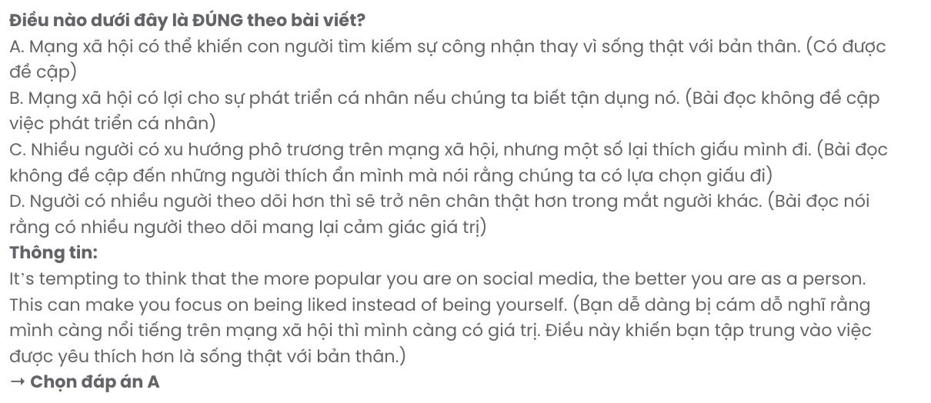
Question 29. In which paragraph does the author mention strain related to numbers?
A. Paragraph 1 B. Paragraph 2 C. Paragraph 3 D. Paragraph 4
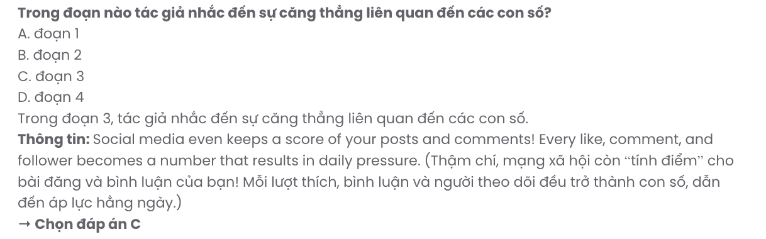
Question 30. In which paragraph does the author advise readers to focus on living in the real world?
A. Paragraph 1 B. Paragraph 2 C. Paragraph 3 D. Paragraph 4
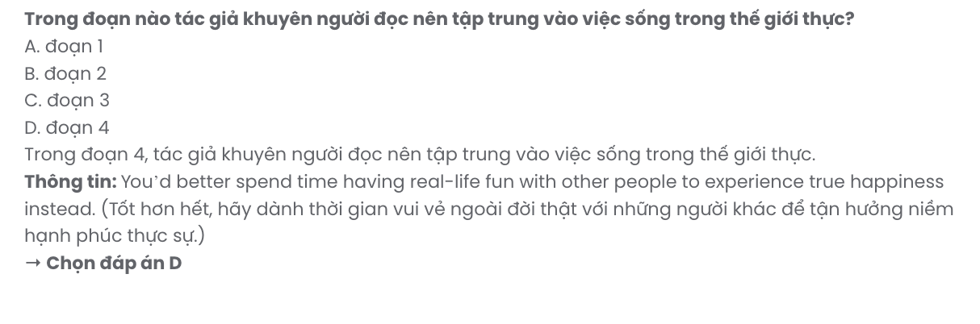
Read the following passage and mark the letter A, B, C, or D on your answer sheet to indicate the best answer to each of the following questions from 31 to 40.
Urbanisation occurs in many parts of the world, both in developed and developing nations. When properly planned, it can bring a number of benefits, especially for the economy and society. However, if it is poorly managed, it can pose a significant challenge to maintaining the sustainability of these areas.
Big cities attract a lot of people as they usually offer more employment opportunities as well as a better life for them. The economy of urban areas tends to grow rapidly as more businesses and factories are created, and more workers are needed. Economic growth also increases household income and spending. This also leads governments to spend money on better schools, hospitals, roads, public transport, and more. As cities expand, many more facilities such as public parks and gardens, swimming pools, libraries, cinemas, and sports centres are built. These are just some of the spaces that make city life exciting and appealing to people of all ages.
However, when too many people move to a big city, without good planning and investment, its infrastructure can become ineffective. [I] For example, big urban areas can easily get overcrowded as railway networks and roads can’t cope with the large number of passengers. [II] The economic growth and expansion of big cities come at a big price for local residents as house prices and rents go up, and they can’t afford to either buy or rent. [III] This can increase the risk of infections, heart disease, and lung cancer, and severely affect people who are ill. [IV]
Urbanisation is a process that cannot be stopped and the best way to minimise the problems caused by it is to plan for the growth and all the resources needed and make sure the infrastructure can support the increasing population.
(Adapted from English Workbook 12 – Global Success)
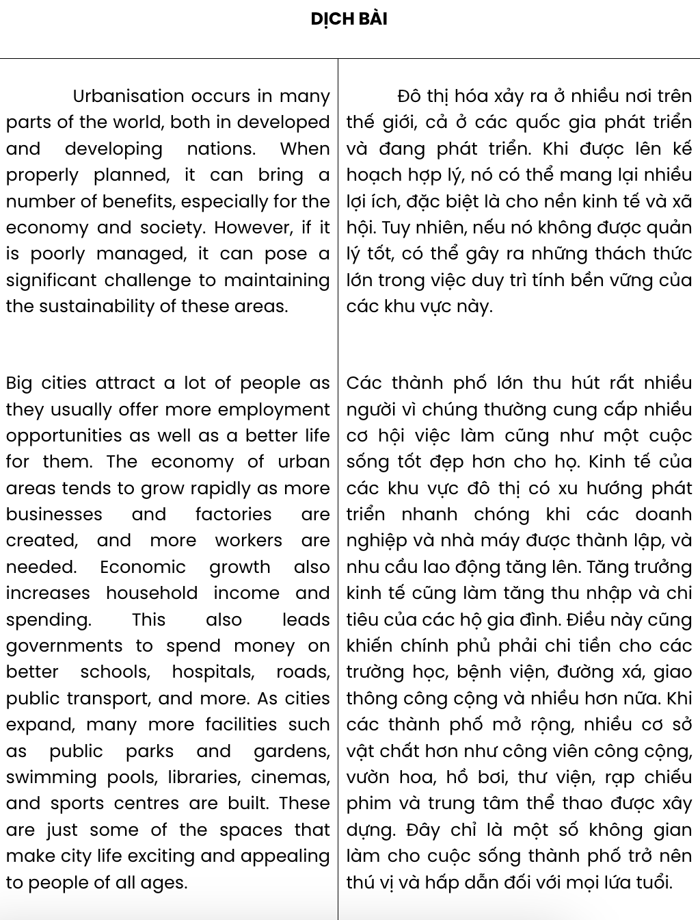
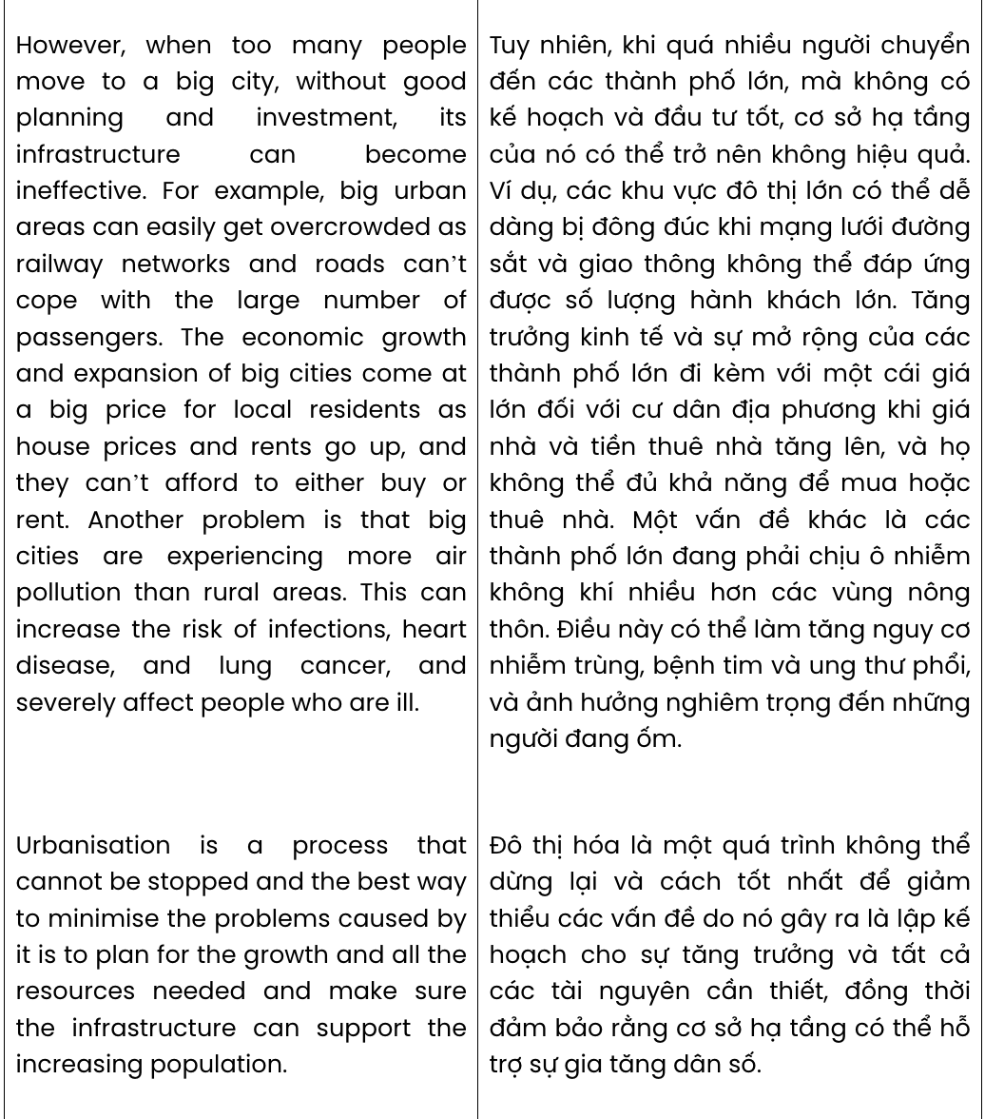
Question 31. The word them in paragraph 2 refers to .
A. areas B. people C. opportunities D. big cities
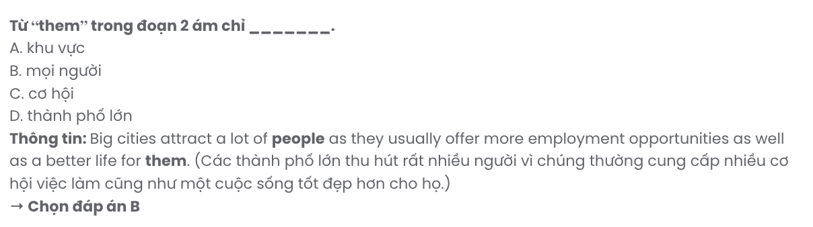
Question 32. Which of the following is NOT mentioned in paragraph 2 as one of the advantages of big cities?
A. higher costs B. better life C. lots of facilities D. job opportunities

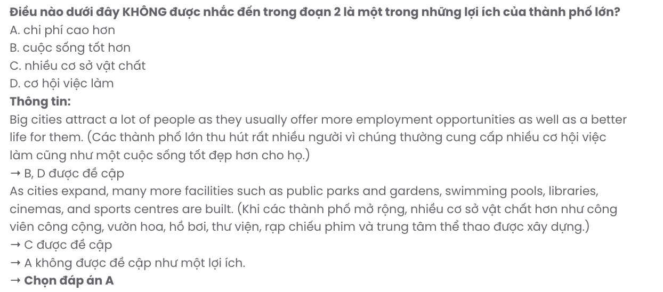
Question 33. Which of the following best summarises paragraph 2?
A. Rapid economic growth in urban areas encourages governments to invest in public services.
B. The expansion of urban areas provides various recreational facilities for people of all ages.
C. Big cities attract people by offering improved living conditions and professional growth.
D. Urban areas grow economically as businesses expand and more workers are needed.
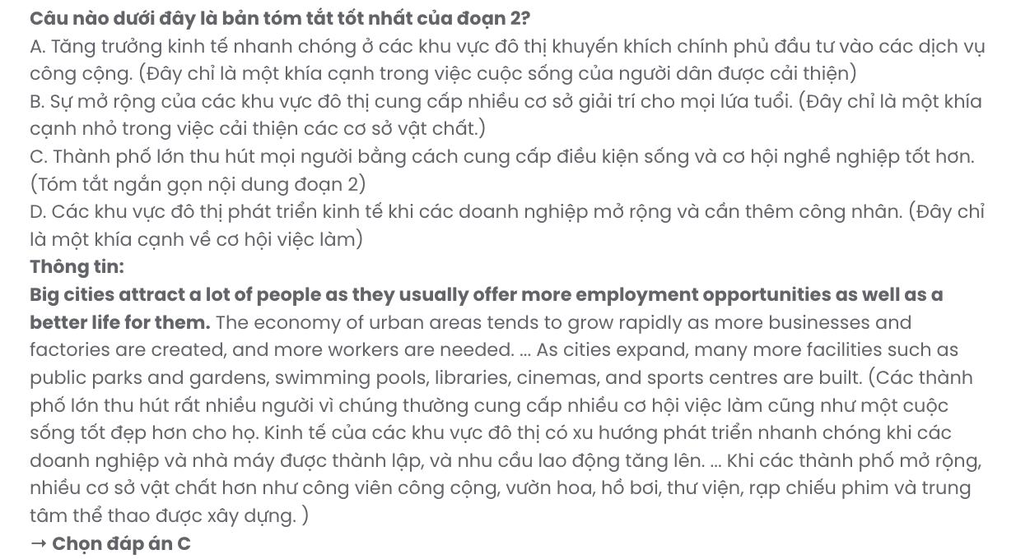
Question 34. The phrase come at a big price in paragraph 3 could be best replaced by .
A. bring many benefits B. cause an unpleasant consequence
C. create a lot of advantages D. open up many new opportunities

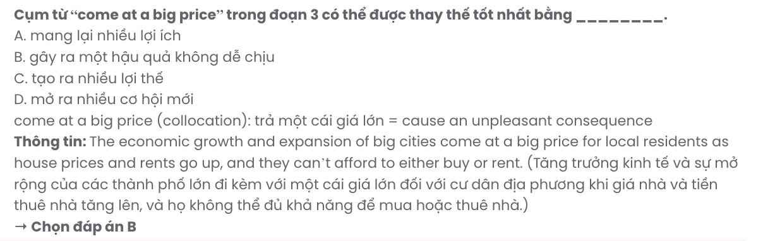
Question 35. Where in paragraph 3 does the following sentence best fit?

Another problem is that big cities are experiencing more air pollution than rural areas.
A. [I] B. [II] C. [III] D. [IV]
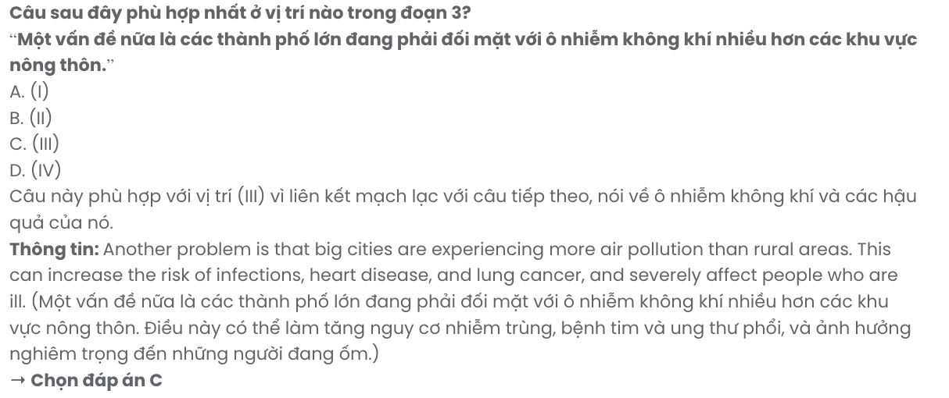
Question 36. The word appealing in paragraph 2 is OPPOSITE in meaning to .
A. unattractive B. enthusiastic C. interactive D. accessible
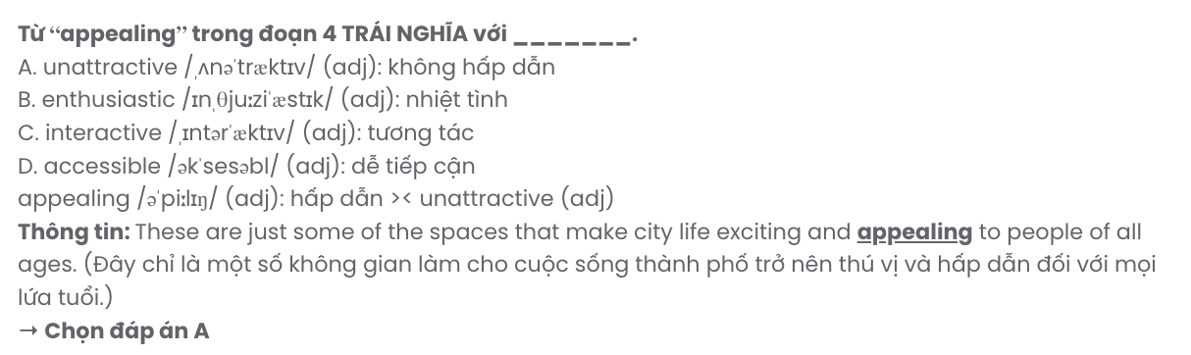
Question 37. Which of the following is TRUE according to the passage?
A. Without adequate urban planning, overcrowding can make city infrastructure ineffective.
B. The rise in population in large cities has significantly positive impacts on housing costs.
C. Economic growth leads to lower living costs and higher profits for governments.
D. Even though managed properly, urbanisation brings both advantages and disadvantages.
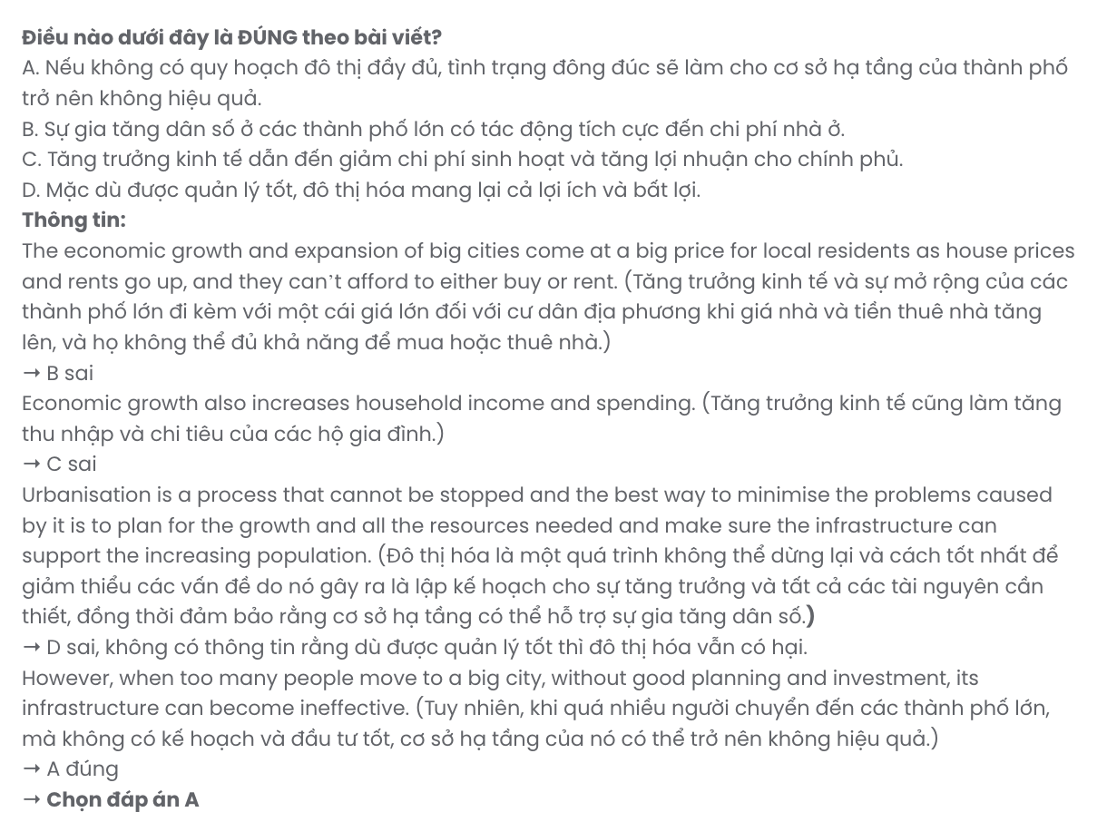
Question 38. Which of the following best paraphrases the underlined sentence in paragraph 2?

Economic growth also increases household income and spending.
A. As the economy grows, families both earn and spend more money.
B. Because of economic growth, people are more likely to invest.
C. With economic growth, governments focus on raising income levels.
D. Economic progress often reduces household expenses and increases incomes.
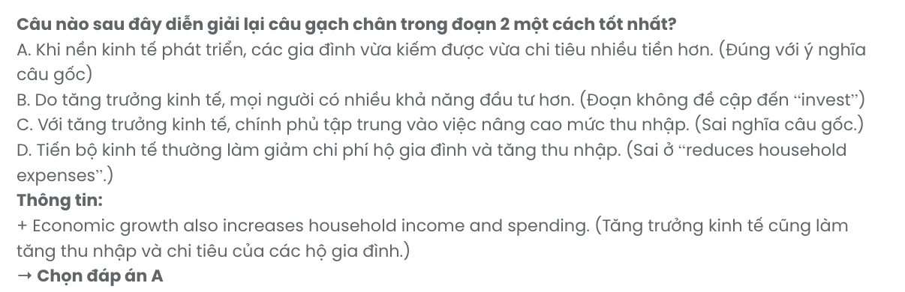
Question 39. Which of the following can be inferred from the passage?
A. The availability of facilities makes city life more convenient but polluted.
B. Expanding cities face no significant issues if the population growth is stable.
C. Careful planning for urban growth is the most effective in dealing with its drawbacks.
D. Most urban areas handle population growth without needing additional resources.
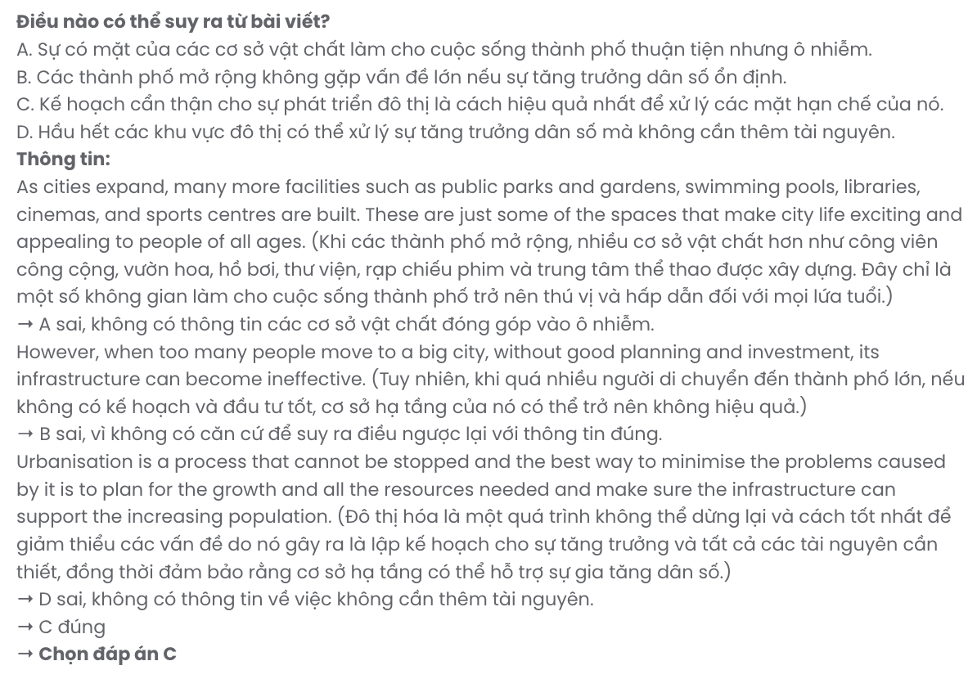
Question 40. Which of the following best summarises the passage?
A. Rapid urbanisation often increases income but leads to issues with sustainability.
B. City dwellers have many advantages but disadvantages as well.
C. Urbanisation offers both benefits to enjoy and challenges to address.
D. Big cities have to develop infrastructure to support their rapidly growing populations.

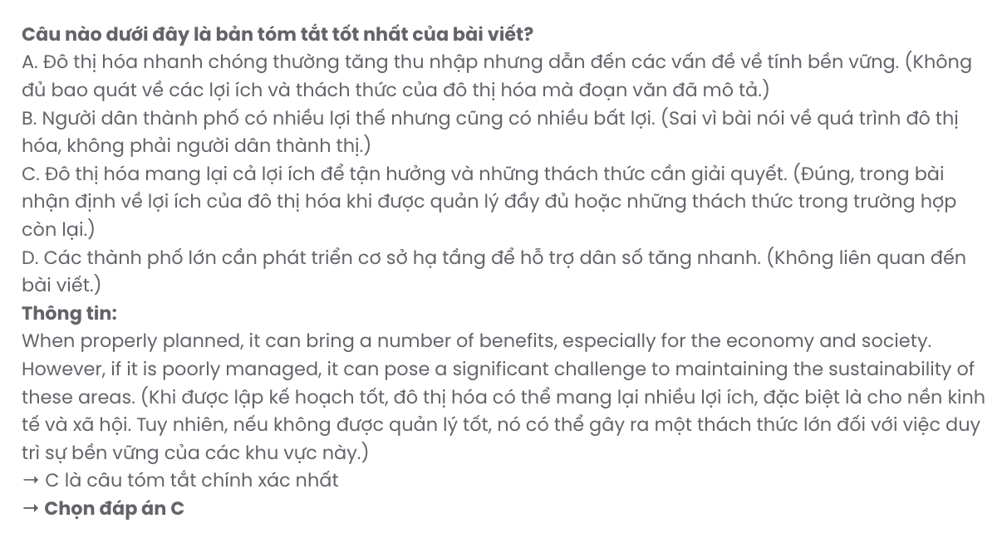

BẢNG TỪ VỰNG
STT | Từ vựng | Từ loại | Phiên âm | Nghĩa
1 | embrace | v | /ɪmˈbreɪs/ | ôm, chấp nhận
2 | withdrawal | n | /wɪðˈdrɔːəl/ | sự rút lui, sự rút tiền
3 | seamlessly | adv | /ˈsiːmləsli/ | một cách liền mạch
4 | gradually | adv | /ˈɡrædʒuəli/ | dần dần
5 | intake | n | /ˈɪnteɪk/ | lượng tiêu thụ
6 | sustainable | adj | /səˈsteɪnəbl/ | bền vững
7 | finite | adj | /ˈfaɪnaɪt/ | có hạn, hữu hạn
8 | consumption | n | /kənˈsʌmpʃn/ | sự tiêu thụ
9 | ensure | v | /ɪnˈʃʊə(r)/ | đảm bảo
10 | essential | adj | /ɪˈsenʃl/ | thiết yếu
11 | unforgettable | adj | /ˌʌnfəˈɡetəbl/ | không thể quên
12 | destination | n | /ˌdestɪˈneɪʃn/ | điểm đến
13 | intrigued | adj | /ɪnˈtriːɡd/ | tò mò, hứng thú
14 | getaway | n | /ˈɡetəweɪ/ | kỳ nghỉ ngắn
15 | itinerary | n | /aɪˈtɪnərəri/ | lịch trình
16 | thrive | v | /θraɪv/ | phát triển mạnh
17 | intricate | adj | /ˈɪntrɪkət/ | phức tạp
18 | intense | adj | /ɪnˈtens/ | mãnh liệt
19 | determine | v | /dɪˈtɜːmɪn/ | xác định
20 | prioritise | v | /praɪˈɒrɪtaɪz/ | ưu tiên
21 | minimize | v | /ˈmɪnɪmaɪz/ | giảm thiểu
22 | emphasis | n | /ˈemfəsɪs/ | sự nhấn mạnh
23 | countless | adj | /ˈkaʊntləs/ | vô số
24 | recognition | n | /ˌrekəɡˈnɪʃn/ | sự công nhận
25 | stunning | adj | /ˈstʌnɪŋ/ | tuyệt đẹp
26 | frustrated | adj | /ˈfrʌstreɪtɪd/ | nản lòng, bực bội
27 | remarkable | adj | /rɪˈmɑːkəbl/ | đáng chú ý
28 | impressive | adj | /ɪmˈpresɪv/ | ấn tượng
29 | tempting | adj | /ˈtemptɪŋ/ | hấp dẫn, lôi cuốn
30 | urbanisation | n | /ˌɜːbənaɪˈzeɪʃn/ | đô thị hóa
31 | properly | adv | /ˈprɒpəli/ | đúng cách
32 | sustainability | n | /səˌsteɪnəˈbɪləti/ | sự bền vững
33 | appealing | adj | /əˈpiːlɪŋ/ | hấp dẫn, lôi cuốn
34 | investment | n | /ɪnˈvestmənt/ | sự đầu tư
35 | infrastructure | n | /ˈɪnfrəstrʌktʃər/ | cơ sở hạ tầng
36 | overcrowded | adj | /ˌəʊvəˈkraʊdɪd/ | quá đông đúc
37 | drawback | n | /ˈdrɔːbæk/ | hạn chế, nhược điểm

BẢNG CẤU TRÚC
STT | Cấu trúc | Nghĩa
1 | encourage somebody to V | khuyến khích ai đó làm gì
2 | take control of | nắm quyền kiểm soát, quản lý
3 | lean on something | dựa vào
4 | cut down on | giảm
5 | plan to V | dự định, kế hoạch làm gì
6 | consider V-ing | xem xét, cân nhắc làm gì
7 | focus on V-ing | tập trung vào
8 | tend to V | có xu hướng làm gì

