Phòng GD&ĐT TP Hà Tiên  Trường Tiểu học Thuận Yên  Lớp:..................................................................  Họ và tên:……………………………………. |  | Bài kiểm tra cuối học kỳ I  Năm học: 2021 – 2022  Môn: Tiếng Anh  Khối: 5 - Thời gian: 40 phút  Ngày kiểm tra:……………………
Điểm | Nhận xét của giáo viên | Chữ ký giám thị:……………………  Chữ ký giám khảo: ………….……..

SPEAKING(2ms)
Greeting and test taker’s name check.
The examiner says “ My name is …It’s nice to talk to you today.”

Task 1: Getting to know each other
The examiner asks 3 questions below:
- What’s your name?
- What’s your address?
- What do you do in the morning/afternoon/evening?
Task 2. Let’s talk : Describe a picture
Teacher does this: | Teacher says this: | Minimum response expected from S: | Back-up questions:
Shows one of the pictures. Takes part in conversation | Now you look at the picture. Then describe it. OK? | Student describes the picture. S’s answers will vary.
Unit 6’s cards. 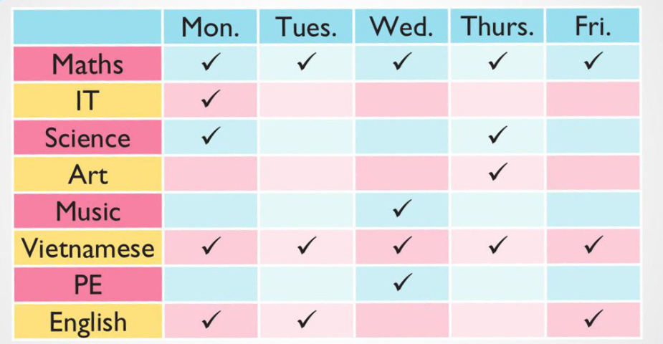 |  | Her/His school timetable  Her/His favourite subject | How often does she /he go to school?  How many lessons does she/he have on Monday?  How often does she/ he have Maths?  Does she/he like English?
Unit 7’s cards   |  | How does she/he learn English. | How does she/he learn it?
Unit 8’s cards   |  | Her/His favouire story | What’s his/her favourite story?/  What is she/he reading?  Who is the main character?  What’she/she like?
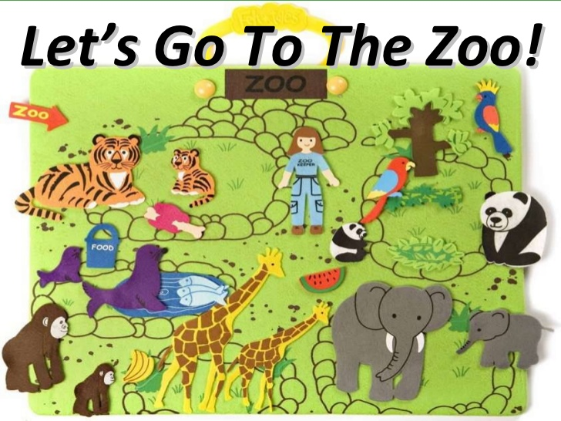  Unit 9’s cards |  | Animals in the zoo | When did she/he go to the zoo?  What animals did she/he see?  What did the animals do when she/he was there?
Unit 10’s cards  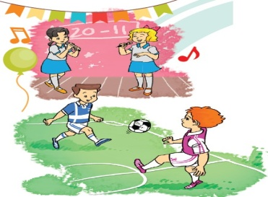 |  | Her/His school event  (Her/His favourite festival at school) | What school event is it?  When will it be?  What’s he/she going to do on this event?

