
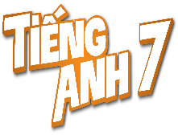
Tiết thứ ....
UNIT 7: TRAFFIC
Lesson 5: Skills 1

Class | Date of teaching | Attendence
7A | ..../09/2022
7B | ..../09/2022
7C | ..../09/2022
I. OBJECTIVES: By the end of this unit, students will be able to gain the following things:
1. Knowledge:
+ Reading:
- Read for specific information about some rules about road safety
+ Speaking:
- Talk about how to avoid traffic accidents.
+ Pronunciation:
+ Vocabulary: Use the words about means of transport.
- pedestrian (n) /pəˈdestrēən/: người đi bộ
- passenger (n) /ˈpasinjər/: hanh khách
- (to) obey / ōˈbā/: tuân thủ
- seatbelt (n) / ˈsēt ˌbelt/: dây an toàn
+ Grammar:
2. Competence:
a) General competencies:
- Students will be able to know more words and phrases about means of transport.
- Develop communication skills and cultural awareness
- Be collaborative and supportive in pair work and teamwork
- Actively join in class activities
b) Specific competencies:
- Group work and independent working, pair work, linguistic competence, cooperative learning and communicative competence.
- Sts can introduce themselves or one another fluently.
3. Qualities: The love of traffic; The awareness about importance of trafffic; Be ready to talk about means of transport; Know some daily activities in the street.
- Develop self-study skills.
II. PREPARATIONS
Teacher: Grade 7 text book, laptop, TV, pictures and realia, Computer connected to the Internet, Sach mem.vn
Students: Text books, pencils, pics, blank papers, realia,….
III. PROCEDURE:
In each activity, each step will be represented as following:
* Task delivering
** Task performance
*** Report and discussion
**** Judgement
Activity 1. WARM UP (5’-IW, GW)
* Aim:
To introduce the lesson.
To lead in the lesson.
* Content: Hangman
* Product: Having a chance to speak English and focus on the topic of the lesson.
* Implementation: Teacher’s instructions…
Teacher’s & Student’s activities | Content
Game: Hangman  * Teacher divides class into 2 teams and asks them to think of the word which has 9 letters in it related the topic “ON THE ROAD”.  ** Ss have 1 min to think of the words related to the topic or they can discuss with their partners.  *** Each member from each team turn by turn guesses the letter in the secret word.  **** Teacher corrects their answers.  - The team which can find or guess the secret first will be the winner.  READING  Teacher leads students into the lesson by telling what they are going to learn: “We are going to read a passage about some rules about road safety.” | Game: Hangman  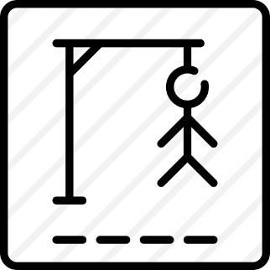  D A N G E R O U S
Activity 2. KNOWLEDGE FORMATION (15'- PW, IW)
* Aim:
To provide students with some lexical items before reading the text.
To introduce words related to skin conditions to Ss and help Ss have a general idea of what they are going to read.
* Content:
* Product: Ss learn how to use them.
* Implementation: Teacher’s instructions…
Teacher’s & Student’s activities | Content
Vocabulary  - Teacher introduces the vocabulary by:  + Providing the synonym or antonym of the words.  + Providing the pictures of the words.  + Providing the definition of the words.  Concept check: Rub out and Remember  DISCUSSION  * Teacher asks Ss to work in pairs to look at the Picture in Ex1 and discuss on what they see that is dangerous?  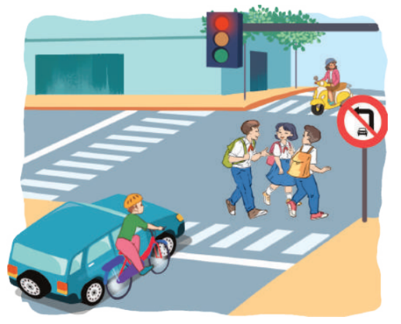  ** Ss work in pairs.  *** Teacher calls some Ss to check what they have discussed.  **** Teacher corrects. | Vocabulary  - pedestrian (n) /pəˈdestrēən/: người đi bộ  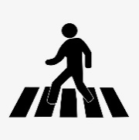  - passenger (n) /ˈpasinjər/: hanh khách  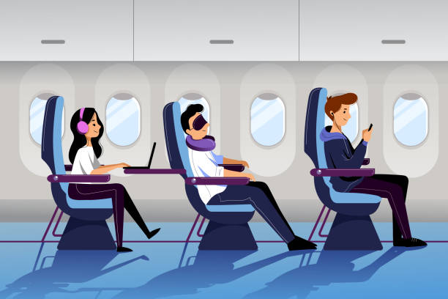  - (to) obey / ōˈbā/: tuân thủ  - seatbelt (n) / ˈsēt ˌbelt/: dây an toàn  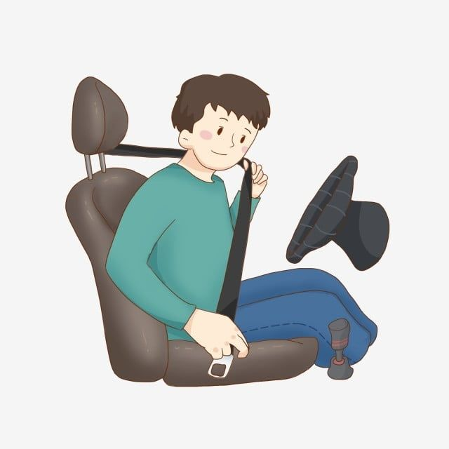  Concept check: Rub out and Remember  DISCUSSION  Answer keys:  The students who are crossing the road  Because they do not walk on the right place and they are not careful.
Activity 3. PRACTICE (15’-IW, PW, GW)
* Aim:
To help Ss develop their reading skill for main ideas and specific information (scanning) and help them focus on the road safety rules.
To help Ss further develop their reading skill for specific information (scanning).
To check students’ reading comprehension.
To help Ss talk about how they apply the rules in the reading to themselves.
To provide Ss an opportunity to practise giving advices on dangerous situations on the road.
* Product: Students’ answers.
* Implementation:
Teacher’s Student’s activities | Content
Task 1: Read the following text and choose the correct answer.  This text is about ______.  A. rules for pedestrians  B. traffic lights  C. traffic rules  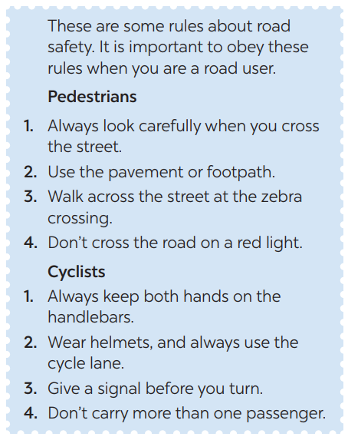  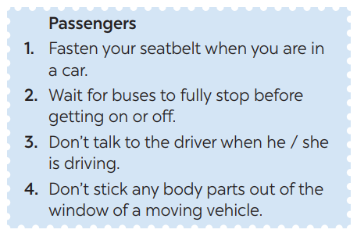  * Teacher has Ss read the first sentence of the text in detail to do the exercise and asks them how to do this kind of exercise.  ** Ss do the task independently  *** Teacher tells Ss to compare their answers in pairs before calling some of them to check.  **** Teacher confirms the correct answer and explains if needed.  Task 2: Read the text again and answer  the questions:  * Teacher asks Ss: reading each question, locating where the information appears in the text, reading that part carefully and circling the correct answer.  ** Ss do the task independently.  *** Teachers has Ss compare their answers in pairs and call some Ss to give their ideas.  **** Teacher checks and confirms the correct answers. | Task 1: Read the following text and choose the correct answer.  This text is about ______.  A. rules for pedestrians  B. traffic lights  C. traffic rules  Answer key: C  Task 2: Read the text again and answer  the questions:  Answer key:  1. They shoud cross the street at the zebra crossing.  2. We should always use the cycle lane.  3. We should give a signal before we turn while riding a bike  4. We must wait for buses to fully stop when you get on or off a bus.  5. We mustn’t stick any body parts out of the window when you are in a moving vehicle.
Task 3: Work in groups. Ask and answer  the following question:  “When you are a road user, what should you NOT do?”  Make a list in groups. Compare  your list with other groups’.  * Teacher asks Ss to work in groups and tells them to focus on the rules for road users in the text to talk about which one they have to obey everyday.  ** Ss work in groups. Teacher goes around and listens and gives help if needed.  *** Teacher calls on some Ss to share their answers with the class.  **** Teacher listens and gives comment. | Task 3: Work in groups. Ask and answer  the following question:  When being a road user, we had better not:  - Cross the road on a red light.  - Cycle in the pavement or footpath.  - Lose cocentration when driving.  - Stick any body parts out of the window of a moving vehicle.
Task 4: Read the following sentences  about these people. Then work in groups. Discuss who is being safe, and who isn’t  * Teacher has Ss work in groups and asks them to take turns to discuss the situations.  ** Ss work in groups to do the task. Teacher goes around, listens and gives help if needed.  *** Teacher calls on some groups to share their answers with the class.  **** Teacher comments | Task 4: Read the following sentences  about these people. Then work in groups. Discuss who is being safe, and who isn’t  1. Hoang is riding a bike, and he is wearing a helmet.  => Hoang is being safe when being a road user because he wearing a helmet when ride a bike.  2. It is raining hard, but Mr Long is driving quickly.  => Mr Long is not safe because when it rains hard, the road is very slippery causing danger if he drives quickly.  3. The students are standing in a line to get on the school bus.  => The students is being safe because they standing in a line to get on the school bus.  4. Mr Binh is taking his daughter to school on his motorbike. She is sitting in front of him.  => Mr Binh is not safe because his daughter is sitting in front of him.  5. Michelle is cycling to school and she is waving and shouting to her friends.  => Michelle is not safe because she loses concentration when cycling.
Activity 4. APPLICATION (7’-IW, PW, GW)
* Aim:
To help students apply what they have learnt in real life context.
* Content: Structure: S + should/shouldn’t + Vinf
* Product: Students’work.
* Implementation: Teacher’s instructions
Task 5: Give the advices on dangerous situations on the road.
Structure: S + should/shouldn’t + Vinf
* Teacher has students give advices on how to avoid the dangerous situations on the road.
*** Teacher calls on some groups to share their answers with the class.
**** Teacher comments and corrects if needed.
* Wrap up  - To consolidate what students have learnt in the lesson.  * Homework:  - Exercises in the workbook.  - To prepare for the next lesson:  Skills 2. | * Wrap up  Teacher asks students to talk about what they have learnt in the lesson.  * Homework:  - Exercises in the workbook  - To prepare for the next lesson:  Skills 2.
V. FEEDBACK:
With 7A ……………………………………………………………………………..…
With 7B …………………………...……………………………………..……………
With 7C ………………………………………………………………………….……

