**UNIT 4: INTERNATIONAL ORGANIZATIONS & CHARITIES**

**A. TOPIC VOCABULARY**

|  |  |
| --- | --- |
| 1. Aim (n)   /eɪm/ | Mục tiêu |
| 1. A**ware**ness (n)   /əˈweənəs/ | Nhận thức |
| 1. **Ch**arity (n)   /ˈtʃærəti/ | Làm từ thiện |
| 1. **Cha**llenge (n/v)   /ˈtʃælɪndʒ/ | Thách thức |
| 1. Com**mu**nity (n)   /kəˈmjuːnəti/ | Cộng đồng |
| 1. Conser**va**tion (n)   /ˌkɒnsəˈveɪʃn/ | Sự bảo tồn |
| 1. di**sa**ster (n)   /dɪˈzɑːstə(r)/ | Thảm họa |
| 1. Do**nate** (v)   /dəʊˈneɪt/ | Ủng hộ |
| 1. **Earth**quake (n)   /ˈɜːθkweɪk/ | Động đất |
| 1. Expe**di**tion (n)   /ˌekspəˈdɪʃn/ | Thám hiểm |
| 1. **Fund**raising (n)   /ˈfʌndreɪzɪŋ/ | Gây quỹ |
| 1. **Home**less (adj)   /ˈhəʊmləs/ | Vô gia cư |
| 1. In**spire (v)**   /ɪnˈspaɪə(r)/ | Truyền cảm hứng |
| 1. **Mea**ningful (a)   /ˈmiːnɪŋfl/ | Có ý nghĩa |
| 1. **O**rganize (v)   /ˈɔːɡənaɪz/ | Tổ chức |
| 1. Provide (n/v)   /prə**ˈvaɪd**/ | Cung cấp |
| 1. Sup**port** (n/v)   /səˈpɔːt/ | Hỗ trợ, ủng hộ |
| 1. **Ve**teran (n)   /ˈvetərən/ | Thương binh |
| 1. Volun**teer** (v/n)   /ˌvɒlənˈtɪə(r)/ | Tình nguyện, người tình nguyện |

**B. WORD PATTERNS**

|  |  |
| --- | --- |
| 1. **Provide sb with sth** 2. **Provide sth for sb** | Cung cấp cho ai cái gí |
| 1. **Raise sb ‘s awareness about/of sth** | Nâng cao nhận thức của ai về cái gì |
| 1. **Set up (v)** | Thành lập |
| 1. **Popular with (adj)** | Phổ biến với |
| 1. **In return for (n)** | Đổi lại |
| 1. **Call for (v)** | Kêu gọi |
| 1. **Participate in** 2. **Take part in** | Tham gia |
| 1. **Die of** | Chết vì |
| 1. **Take care of** | Quan tâm, chăm sóc |
| 1. **Ask for** | Xin |

**C. WORD FORMATION**

|  |  |  |  |
| --- | --- | --- | --- |
| **VERB** | **NOUN** | **ADJ** | **ADV** |
| 1. donate | donor |  |  |
| 1. organize | Organizer  organization |  |  |
| 1. volunteer | volunteer | voluntary | voluntaritly |

**LISTENING**

***Part 1: Fill in the blanks . Complete the notes below. Write ONE WORD OR A NUMBER for each answer.***

**SERVING MEALS FOR HOMELESS PEOPLE**

Steve Badt supervises meal preparation for more than two hundred people.

Bad left his job in the (1)_________industry seven years ago.

He now works for a (2)__________ group.

The government says more than (3)__________ Americans do not get enough to eat.

Their goal is by (4)______to have all this ready to go to serve a hot meal.

The work is not easy for the volunteers at Miriams Kichen, but Steven Badt has a waiting list of (5)___________

1. restaurant 2. Not-for-profit 3. 36 million 4. 7a.m 5. Willing workers

***Part 2 -5 Choose the correct letter, A, B, C or D.***

***You are going to hear about a charity organization. Read the questions and underline the key words.***

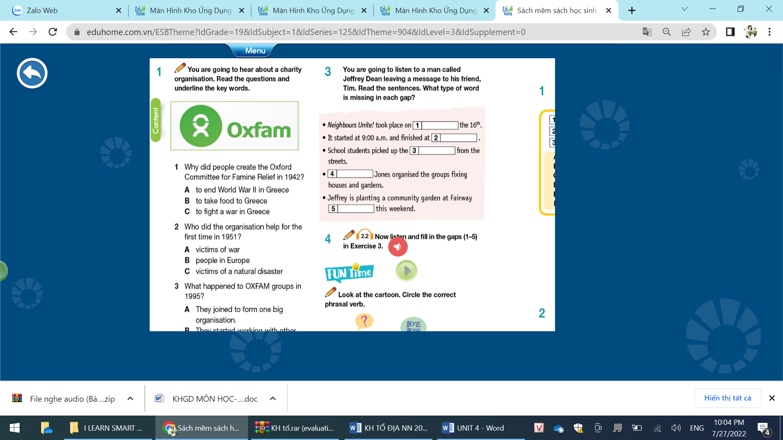

**1. Why did people create the Oxford Committee for Famine Relief in 1942?**

A. to end World War II in Greece B. to take food to Greece

C. to fight a war in Greece D. to provide salters in Greece

**2. Who did the organization help for the first time in 1951?**

A. victims of war B. people in Europe

C. victims of a natural disaster D. victims of famine

**3. When did The Oxford Committee change its name to OXFAM?**

A. 1955 B. 1965 C. 1975 D. 1995

**4. What happened to OXFAM groups in 1995?**

A. They joined to form one big organization

B. They started working with other charities.

C. They changed their name back to the Oxford Committee

D. They run projects in many countries.

**5. What does OXFAM believe is the best way to shave someone from poverty?**

A. giving them money B. teaching them new skills

C. donating food and medical supplies D. helping them get out of difficulties

**LEXICO- GRAMMAR**

**Part 3: Phonetics**

***Mark the letter A, B, C, or D on your answer sheet to indicate the word whose underlined part differs from the other three in pronunciation in each of the following questions.***

1. A. Provide**s** B. conserve**s** C. donat**es** D. inspire**s**

2. B. Support**ed** B. donat**ed** C. finish**ed** D. provid**ed**

3. A. m**o**ney B. bec**o**me C. s**o**mething D. av**o**id

4. A. char**i**ty B. prov**i**de C. priority D. commun**i**ty

5. A. pre**s**erve B. in**s**pire C. **s**upport D. con**s**erve

**Part 4: Stress**

***Mark the letter A, B, C, or D on your answer sheet to indicate the word that differs from the other three in the position of stress in each of the following questions***

6. A. receive B. supply C. arrange D. promise

7. A. overcome B. influence C. describe D. believe

8. A. donate B. study C. provide D. support

9. A. arrange B. conserve C. protect D. happen

10. A. decide B. complete C. finish D. inspire

**Part 5: Multiple choice (20)**

Mark the letter **A, B, C**, or **D** on your answer sheet to indicate the correct answer to each of the following questions.

*(vocabulary, collocations, phrasal verbs, prepositions, word forms, grammar, conversation)*

11. She wishes she could do some _____ work this summer.

A. voluntarily B. volunteerism C. volunteer D. volunteering

12. You can ____ books, clothes, medicine and money to this charity.

A. donor B. donate C. devote D. dedicate

13. Human Rights groups are ___________ the release of political prisoners.

A. paying for B. looking for C. calling for D. setting up

14. If you ___________ after your clothes they last a lot longer.

A. [name](https://www.ldoceonline.com/dictionary/economics) B. watch C. look D. take

15. Peter was painfully ___________ of his own shortcomings.

A. aware B. unaware C. arrogant D. [modest](https://www.ldoceonline.com/dictionary/identifiable)

16. These statistics offer further______for the scientist’s proposed theory.

A. provision B. support C. organization D. donation

17. These kind people give the refugees a place to stay and expect nothing in______

A. return B. expense C. award D. volunteerism

18. The United Nation’s FAO oversees food______for people in the war zone.

A. meals B. wastes C. crafts D. supplies

19. How long have you been interested _______ environmental issues? It seems that you have done your research.

A. in B. for C. with D. of

20. Facebook and Instagram are two popular ______ networking sites in Vietnam.

A. social B. sociable C. society D. socialize

21. Our project has received a generous amount of money and food from an anonymous ______

A. organizer B. manager C. donor D. founder

22. The candle lighting event is to commemorate people who have _______

 COVID-19.

A. die away B. die for C. die of D. die out

23. Imported ______usually cost much more than domestic things.

A. services B. goods C. outcomes D. consumers

24. We suggest having a craft fair to ______ money for the remote schools.

A. rise B. raise C. do D. make

25. This charity provides support ______ underprivileged people.

A. with B. to C. from D. on

26. It isn’t easy to set ______ a business at such a young age.

A. off B. forward C. in D. up

27. We are trying to deliver these food and medical ______ to the flooded areas.

A. meals B. programs C. funds D. supplies

28. Pioneers in science are often the ones who______other people to study and develop their discoveries.

A. decide B. inspire C. organize D. volunteer

29. Choose the option that best completes the sentences.

Thu: What has this Job Hunting group done? Lan: __________

A. It has helped thousands of unemployed people find jobs

B. They want you to give them your information such as qualifications and experience.

C. This group has been active for a long time.

D. I hope you can donate to help jobless people in this group

30. Choose the option that best completes the sentences.

Ninh: __________?

Luis: I’m currently helping them build schools in the countryside.

A. What does the charity do? B. Why are you volunteering?

C. How are you helping at the charity now D. How much have you donated?

***Part 6: Mark the letter A, B, C, or D on your answer sheet to indicate the word CLOSEST in meaning to the underlined word in each of the following questions. (2)***

31. The main **objective**of this event is to help people understand more about cancer.

A. policy B. device C. information D. aim

32. They are planning to **launch** an appeal for donations to the charity.

A. set up B. bring out C. pick up D. take away

***Part 7: your answer sheet to indicate the word(s) OPPOSITE in meaning to the underlined word(s) in each of the following questions. (2)***

33. She does **voluntary** work for the Red Cross two days a week.

A. simple B. identical C. common D. forced

34. Thank you for talking to me. It’s really a **meaningful** discussion.

A. minor B. significant C. essential D. pointless

***Part 8: Error Identification : Mark the letter A, B, C, or D on your answer sheet to indicate the underlined part that needs correction in each of the following questions***.

35. The charity provides earthquake victims for temporary shelters.

A B C D

with

36. Right now, my kids volunteer in a small village in Cambodia.

A B C D

Are volunteering

37. All volunteers agreed that it was one of their most amazing experience.

A B C D

experiences

38. It’s a challenge for such a big organization to do arrangements for meetings.

A B C D

make

**READING**

***Part 9: Read the following passage and mark the letter A, B, C, or D on your answer sheet to indicate the correct word or phrase that best fits each of the numbered blanks***

**MISSIONARIES OF CHARITY**

**Mother Teresa quickly translated her calling into concrete actions to help the city's poor. She began an open-air school and established a (1) _________ for the dying destitute in a dilapidated building she convinced the city government to donate (2) _________ her cause. In October 1950, she (3) ________ canonical recognition for a new congregation, the Missionaries of Charity, (4) ________ she founded with only a handful of members—most of them former teachers or pupils from St. Mary's School.**

**As the ranks of her congregation swelled and donations poured in from around India and across the globe, the scope of Mother Teresa's charitable activities (5) __________ exponentially. Over the course of the 1950s and 1960s, she established a leper colony, an orphanage, a nursing home, a family clinic and a string of mobile health clinics.**

(Retreive from <https://www.biography.com/religious-figure/mother-teresa> )

**1.** A. accommodation B. home C. house D. building

**2.**  A. from B. at C. in D. to

**3.**  A. won B. competed C. invaded D. robbed

**4.**  A. that B. whom C. which D. who

**5.**  A. tightened B. widened C. extended D. expanded

***Part 10: Read the following passage and mark the letter A, B, C, or D on your answer sheet to indicate the correct answer to each of the questions***

Anne Frank was a Jewish victim of the Holocaust known for keeping a diary of her experiences in a concentration camp. Anne was born in 1929 in Germany. She was given a diary for her 13th birthday. Ann started to write about everyday events in her diary, things that might appear trivial like what she ate or arguments she had with her mother. But later her diary helped form a picture of what life was like during this historical period. When the Nazis found eight people from Anne’s family in their hiding place, they sent them to concentration camps. As the conditions in the camp were so poor, Anne and her sister died of a disease called **typhus j**ust a few months before World War II ended. Anne’s diary was saved by one of the people who helped her family and returned to her father, Otto Frank, the only survivor in the family. He decided to publish the diary, realizing Anne’s dream of becoming a famous author. Since it was first published, her diary has sold millions of copies worldwide and been translated into more than 70 languages. The diary is an important **account**of how Jewish people were treated by the Nazis. Otto also published his daughter’s diary in the hope that it would raise readers’ awareness of the dangers of prejudice, discrimination, hostility, and hatred against others.

**1. What is the passage mainly about?**

A. Biography of Anne Frank B. Anne Frank’s diary

C. Anne Frank’s family stories D. Holocaust

**2. “Typhus” is the name of______**

A. Anne’s sister B. the camp C. a disease D. Anne’s hiding place

**3. The word “account” is CLOSEST in meaning to**

A. a banking arrangement B. a social media profile C. a written description D. a film

**4. What can be inferred from the passage?**

A. The diary helps readers imagine life in a concentration camp.

B. The diary describes different ways to deal with teenage problems.

C. The diary was saved by Anne’s father.

D. The diary receives little recognition worldwide.

**5. What was NOT mentioned as a purpose for the publication of Anne’s diary?**

A. to make her dream of becoming a famous writer come true

B. to raise the world’s awareness of how dangerous discrimination and hatred against others can be

C. to help people know more about how the Nazis treated the Jewish people

D. to teach youngsters how to become famous writers

**WRITING**

***Part 11: Write sentences using the prompts and the Present Perfect.***

1. They/raise/awareness/conversation/2003.

They’ve raised awareness about conversation since 2003

2. He/work/charity/ 5 years.

He has worked for the charity for 5 years.

3. World Wild Fund/work hard/many years/protect/the endangered species.

The World Wild Fund has worked hard for many years to protect the endangered species.

4. Volunteers/gain/useful experience/broad range/fields.

Volunteers have gained useful experience in a broad range of fields.

5. Our campaign/raise/funds/charity organization.

Our campaign has raised funds for charity organization.

6. Anonymous businesswoman/donate/one million dollars/the charity

An anonymous businesswoman has donated one million dollars to the charity.

7. She/run/charity/homeless young people.

She has run a charity for homeless young people.

8. She/do/voluntary work/Red Cross/10 years.

She has done voluntary work for the Red Cross for 10 years.

9. Fundraising/charity/become/meaningful things/everyone/do/help/community.

Fundraising for charity has become a meaningful thing for everyone to do to help the community.

10. A lot of generous businessmen/make/valuable contributions/helping needy people.

A lot of generous businessmen have made valuable contributions to helping needy people.

***Part 12: Writing an essay***

***Which international organization would you like to work for? Write an essay of 180 words to express the reasons why you choose the organization.***

**SPEAKING**

***Part 13: Answer the questions (like part 1 in IELTS tests)-5***

1. Have you ever work as a volunteer?

2. What kind of work do you often participate in ?

3. Why do you volunteer?

4. What is the most important volunteer activity in our area?

5. What are the benefits of doing volunteer work?

***Part 14: Make a presentation about a meaningful charity work that you have done***

**TAPESCRIPT FOR LISTENING 1**

*Steve Badt starts work early, while most people are sleeping. He supervises meal preparation for more than two hundred people. Badt left his job in the restaurant industry seven years ago. He wanted to continue his education and do something different. He now works for Miriams Kitchen, a not-for-profit group. It has been serving meals to homeless men and women for more than twenty-five years. The government says more than thirty-six million Americans do not get enough to eat. Many are homeless. STEVE BADT: "At seven oclock, we will open up the hot (food) line, and that is what everyone is working on. These guys over here are cracking eggs, preparing to do scrambled eggs. We are making biscuits here. These are cream biscuits. Another volunteer (is) on the griddle with ham. We have home fries over there going on. And, a fruit salad over here. Our goal is by 7 a.m. to have all this ready to go to serve a hot meal. The work is not easy for the volunteers at Miriams Kitchen. But Steve Badt has a waiting list of willing workers. Badt says he wanted to change the way soup kitchens like Miriams Kitchen operate. He would like to make them more energetic, like the restaurants where he was trained.*