TEST 9

***Choose the best answer A, B, C or D to indicate the word whose underlined part differs from the other three in pronunciation in the following questions.***

**Question 1.**

A. annoys B. arrives C. opens D. shuts

**Question 2.**

A. contain B. modern C. problem D. promise

***Choose the best answer A, B, C or D to indicate the word that differs from the other three in the position of primary stress in the following questions.***

***Question 3.***

A. awesome B. lifestyle C. challenge D. relax

***Question 4.***

A. different B. simplify C. humorous D. understand

***Choose the best answer A, B, C or D to indicate the correct answer to the following questions.***

**Question 5.** That's the old lady to ______ I spoke the other day.

A. whom B. which C. that D. who

**Question 6.** The company has suffered ______ declining sales due to increased competition in the market.

A. from B. up C. on D. about

**Question 7.** As he gained experience, he approached challenges ______.

A. so confidently B. less confidently

C. more confidently D. as confidently

**Question 8.** The museum offers a variety of ______ programs to students of all ages.

A. educator B. educationally C. educate D. educational

**Question 9.** Linda is asking Trang about her country's popular types of food.

Linda: 'What kinds of food are popular in your country?' - Trang: '______ '

A. Vietnamese cuisine has a rich variety of dishes.

B. The food in my country is very diverse.

C. I enjoy cooking traditional meals.

D. Rice and noodles are staples here.

**Question 10.** ______ factors contributed to the company's recent decline in profits.

A. Plenty B. A little C. A lot of D. Others

**Question 11.** If I ______ younger, I would pursue my dream of becoming a professional athlete.

A. were B. am C. will be D. would be

**Question 12.** I ______ my pen which I ______ last week and can't find it anywhere.

A. have lost – have bought B. have lost – bought

C. lost – bought D. lost – have bought

**Question 13.** Despite the challenges, they have made up their minds ______ a healthier lifestyle.

A. to adopting B. adopt C. adopting D. to adopt

**Question 14.** From now ______, nobody will be allowed to go out during the test.

A. on B. in C. up D. off

***Four phrases/ sentences have been removed from the text below. For each question, choose A, B, C or D to indicate the correct option that best fits each of the numbered blank.***

The Great Wall of China is one of the most remarkable architectural achievements in human history. It stretches over 13,000 miles across northern China and was built to protect the Chinese states from invasions. The construction of the wall began in the 7th century BC. (**15**) ______. The wall is made from a variety of materials, including stone, brick, and wood, and is often seen as a symbol of the strength and resilience of the Chinese people.

Over the centuries, the Great Wall has become a popular destination for tourists. (**16**) ______, the wall is visited by millions of people from all over the world every year. Many sections of the wall have been restored, allowing visitors to walk along the ancient structure and take in the breathtaking views of the surrounding landscapes.

The Great Wall is not just a historical monument; (**17**) ______. Its significance extends beyond China, as it is recognised as a UNESCO World Heritage Site and is one of the Seven Wonders of the Medieval World.

(**18**) ______, you will find that the Great Wall of China remains an enduring symbol of the country's cultural heritage and history.

A. Despite its age and immense size

B. Its construction represents the collective effort of thousands of workers

C. it also holds great cultural and symbolic importance

D. No matter where you come from

**Question 15.** ______ **Question 16.** ______

**Question 17. ______ Question 18.** ______

***Read the following sign or notice and choose the letter A, B, C or D to indicate the correct answer to each of the following questions.***

***Question 19.*** What does the sign say?

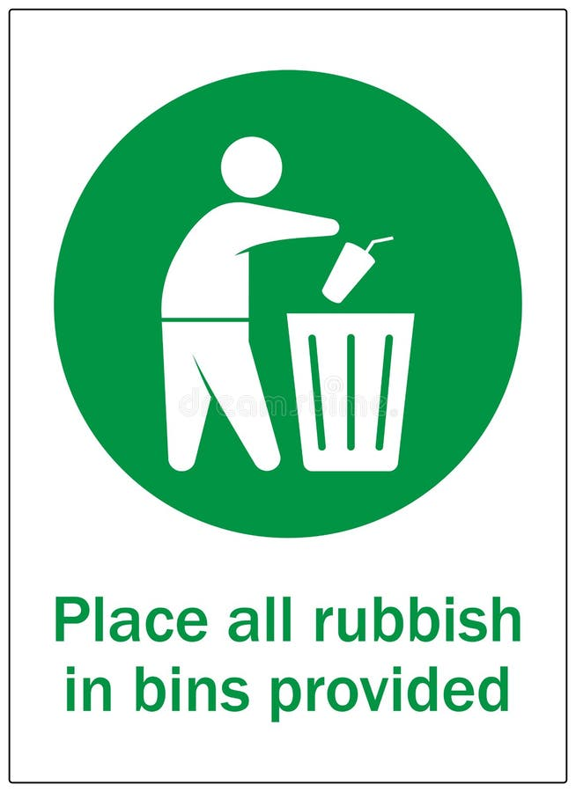

A. You can leave your trash anywhere in the park.

B. The park is only for those who clean.

C. Trash should be thrown in the bins provided.

D. There are no trash bins in the park.

***Question 20.*** What does the notice say?

**Gym hours: Monday to  
Saturday, 6:00 A.M. to 9:00 P.M.  
Closed on Sundays. Please  
bring your membership card  
to check in.**

A. The gym is open every day.

B. You need your membership card to enter the gym.

C. The gym closes at 10:00 P.M.

D. You can enter the gym without a membership card.

Read the following passage and choose the best answer A, B, c or D to indicate the correct word or phrase that best fits each of the numbered blanks.

FALL MUSIC FESTIVAL

Location: Central Park, Harmony High School, Melody Valley Academy

Dates: October 1$t - October 15th, 2024

Ages: All ages welcome

Overview: Welcome to our Fall Music Festival - the perfect event for music enthusiasts eager to explore and master their musical talents! Our Fall Music Festival (**21**) ______ a variety of workshops in guitar, piano, drums, and singing, allowing (**22**) ______ to display their creativity in a vibrant and encouraging setting. These Workshops are conducted by skilled musicians who are committed to helping each attendee hone their skills (**23**) ______ enjoy the beauty of music.

Highlights:

• Modern instruments and equipment

• Professional instructors

• Daily Workshops in small groups

• (**24**) ______ performances and showcases

• Indoor and outdoor (**25**) ______

**Question 21.**

A. offers B. attends C. shows D. develops

***Question 22.***

A. fans B. organisers C. planners D. participants

***Question 23.***

A. but B. and C. or D. so

***Question 24.***

A. Enthusiastic B. Enthusiastically C. Enthusiasm D. Enthusiasts

***Question 25.***

A. matters B. opportunities C. activities D. actions

***Read the following passage and choose the best answer A, B, C or D to indicate the correct answer to each of the questions.***

In my neighborhood, everyone knows about one another. There is a centrally located park where children engage in play and families **congregate.** The park is always busy with activities, from kids playing tag and riding their bikes to families having picnics and friends catching up on the latest news. On weekends, many community members unite to dean the park and plant flowers. It is a collective effort to maintain the beauty of our area.

We also have a modest community centre. Here, adults can enroll in classes such as culinary arts or computer skills, while children can join sports teams or art clubs. The community centre is a lively place, filled with laughter and the sounds of people learning and having fun in its hall.

Each month, we hold a community meeting where residents discuss issues and share ideas to enhance our neighborhood. These meetings provide a valuable opportunity for everyone to share their opinions and collaborate on finding solutions to any issues **that** may come up.

Sometimes, we host festivals with music, dancing, and plenty of food. These events bring us together and celebrate our community life. The streets come alive with vibrant decorations, local musicians play lively tunes, and everyone dances together, creating wonderful memories.

**Question 26.** According to the passage, which of the following best describes the role of the park in the neighborhood?

A. A place for children to play and learn

B. A gathering place for the community

C. A quiet place for relaxation

D. A symbol of the neighborhood's wealth

**Question 27.** What is the word **'congregate'** in the passage closest in meaning to?

A. meet B. leave C. contact D. date

**Question 28.** What does the passage say about the community centre?

A. It is very spacious and can accommodate lots of people.

B. It serves as a venue for musical performances.

C. It provides educational opportunities for local people.

D. It is more popular with children than with adults.

**Question 29.** What is NOT mentioned as a skill people can learn at the community centre?

A. cooking B. writing poetry C. playing sports D. using computers

**Question 30.** What does the word **'that** in the passage refer to?

A. meetings B. issues C. solutions D. opinions

***Choose the letter A, B, C or D to indicate the correct answer to each of the following questions.***

**Question 31.** Put the sentences (a - c) in the correct order, then fill in the blank to make a logical text.

Jack was a clever boy who loved solving puzzles. He would spend hours each day working on different challenges. ______

a. He finally figured out the answer and became the talk of the town.

b. One day, he came across a particularly difficult puzzle that no one could solve.

c. Jack decided to give it a try, and after many attempts, he succeeded.

A. a-c-b B. b-c-a C. c-b-a D. b-a-c

**Question 32.** Choose the sentence that can end the text (in Question 31) most appropriately.

A. Jack decided to open a puzzle shop in the village.

B. The puzzle remained unsolved forever.

C. Jack’s success inspired others to try solving puzzles.

D. The villagers forgot about Jack's achievement.

***Choose the best answer A, B, C or D to indicate the sentence that is closest in meaning to the original sentence in the following question.***

**Question 33.** Tom said to Peter, If I were you, I would spend more time on Maths'.

A. Tom apologised for spending more time on Maths.

B. Tom accused Peter of spending more time on Maths.

C. Tom advised Peter to spend more time on Maths.

D. Tom wished that he would spend more time on Maths.

**Question 34.** Of all the dresses she tried on, the blue one looked the nicest.

A. None of the dresses she tried on looked as nice as the blue one.

B. All the dresses she tried on were nicer than the blue one.

C. All the dresses she tried on looked as nice as the blue one.

D. None of the dresses she tried on looked nice.

**Question 35.** Put on your coat or you will catch a cold.

A. Unless you put on your coat, you will not catch a cold.

B. Unless you put on your coat, you will catch a cold.

C. If you don't put on your coat, you will not catch a cold.

D. You will catch a cold if you put on your coat.

**Question 36.** She didn't have enough money, so she couldn't buy the new phone she wanted.

A. The new phone she wanted was so expensive that she could buy it.

B. She couldn't buy the new phone she wanted because she had enough money.

C. She didn't have enough money to buy the new phone she wanted.

D. The new phone she wanted was too cheap for her to buy.

***Choose the best answer A, B, C or D to indicate the sentence that is made from the given cues.***

**Question 37.** Not all/ employees/ agree/ new company policy/ lead/ further discussions.

A. Not all employees agreed with the new company policy, that leads to further discussions.

B. Not all employees agreed with the new company policy, that led to further discussions.

C. Not all employees agreed with the new company policy, led to further discussions.

D. Not all employees agreed with the new company policy, which led to further discussions.

**Question 38.** She/ wish/ younger/ learn/ drive.

A. She wishes she is younger to learn to drive.

B. She wishes she were younger to learn to drive.

C. She wishes she will be younger to learn to drive.

D. She wishes she would be younger to learn to drive.

**Question 39.** My younger brother/ save money/ so/ buy/ favourite book.

A. My younger brother is saving money so as to buy his favourite book.

B. My younger brother is saving money so as buying his favourite book.

C. My younger brother is saving money so as buy his favourite book.

D. My younger brother is saving money so that he would buy his favourite book.

**Question 40.** It/ say/ he/ one/ greatest scientists/ all times.

A. It says that he was one of the greatest scientist of all times.

B. It is said that he was one of greatest scientists of all times.

C. It is said that he was one of the greatest scientists of all times.

D. It said that he was one of the greatest scientist of all times.