Date of preparing: ………………………………….
Date of teaching: ………………………………….

Period……
UNIT 2: SCHOOL
Lesson 2 - Part 3 (Page 19) – Pronunciation and Speaking

I. OBJECTIVES
By the end of the lesson, Ss will be able to…
1. Knowledge
- use intonation for positive and negative answers.
- ask and answer about school clubs.
2. Ability
- improve speaking skills.
3. Quality
- have positive attitude in English language learning so that they actively participate in all classroom activities, especially with the topic “School” conducted by the teacher.
- love their school and take part in school activities.

II. TEACHING AIDS AND LEARNING MATERIALS
Lesson plan, PPT slides, student’s book, workbook, notebook, personal computer (if any), projector/TV, speakers, DCR & DHA on EDUHOME, handouts…

III. PROCEDURES
A. Warm up: (5’)
a) Objective: to introduce the new lesson and set the scene for Ss to acquire new language; to get students' attention at the beginning of the class by means of enjoyable and short activities as well as to engage them in the steps that follow.
b) Content: Introduction of school clubs
c) Product: Ss know more school clubs and think about which is (are) suitable for them to sign up.
d) Competence: Collaboration, observation, critical thinking.
e) Organization of the activity:
Teacher’s Activities | Students’ Activities
- Give greetings  - Check attendance  - Option 1: School clubs  - Have Ss close all books  - Show pictures and ask Ss to look at the pictures (symbols) to guess the names of the clubs  - Have Ss give answers, call other Ss to give other answers if the first one is incorrect    - Ask Ss to list more school clubs they know  → Lead to the new lesson  - Option 2: “KIM’S GAME”  - Have Ss close all books  - Show a clip, or a picture with a lot of school clubs  - Have Ss observe, remember as many school clubs as they can in about 1 minute  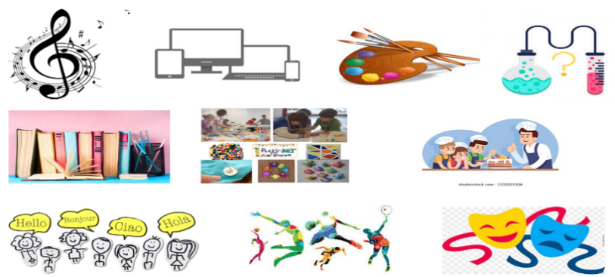  - Call Ss to say what school clubs they can remember  - Check, give feedback  → Lead to the new lesson | - Greet T  - Close books  - Look, give names of clubs  Answers keys    - Share more school clubs with the class  - Close books  - Look and remember  Answers keys  1. music club 2. I.T club  3. art club 4. science club  5. book club 6. arts and crafts club  7. cooking club 8. language club  9. dance club 10. drama club  - Give answers (Say or write)  - Listen

B. New lesson (35’)
- Activities 1: Pronunciation (10’)
a) Objective: Ss know how to use intonation for positive and negative answers.
b) Content:
- Introduction of intonation for positive and negative answers
- Listening and focusing the intonation, finding and correcting mistakes
- Practicing intonation
c) Products: Ss can use right intonation to improve their speaking skill.
d) Competence: Communication, collaboration, presentation
e) Organization of the activity:
Teacher’s Activities | Students’ Activities
a + b. Listen to the sentences and focus on how the intonation goes up or down  - Play the recording (CD1, track 24)  - Ask Ss to listen and pay attention to the intonation  - Call Ss to make their comments on the intonation of the positive and negative answers they’ve just listened to  - Give feedback, explain the pronunciation feature: intonation for positive answers goes up, for negative answers goes down  - Play the recording again, have Ss listen and repeat with a focus on the pronunciation feature  c + d. Listen and cross out the one with the wrong intonation, then read the sentences with the correct intonation to a partner  - Play the recording, have Ss listen and cross out the option that doesn’t use the correct intonation  - Call Ss to give answers  - Play the recording again and check answers as a whole class  - Then have Ss practice saying the sentences with a partner, using the correct intonation, then encourage Ss to use their own sentences  - Call some pairs to read in front of the class | - Listen  - Comment  - Listen  - Listen again and repeat  - Listen and cross out  - Give answers  - Listen again and check  - Work in pairs  - Present
- Activity 2: Practice (10’)
a) Objective: Ss can ask and answer questions about the school clubs they like or don’t like to sign up for.
b) Content: asking and answering about book club, IT club and other clubs.
c) Products: Ss can practice the target language learnt in communication.
d) Competence: Collaboration, communication, creativity, public speaking
e) Organization of the activity:
Teacher’s Activities | Students’ Activities
a. Practice the conversation. Swap the roles and repeat. (controlling practice)  - Option 1:  - Demonstrate the activity by practicing role-play with a student  - Have pairs practice the conversation  - Call some pairs to read in front of the class  - Have pairs swap roles and repeat-using the ideas on the right  - Have some pairs demonstrate the activity in front of the class  - Option 2: (for class with better students)  - Follow the same steps as option 1  - Then give Ss an extra activity: Practice the conversation in the textbook; however, they try to remember the conversation content  - Have some pairs demonstrate the activity in front of the class, not looking at the textbook; encourage Ss to present as naturally as possible  - Give feedback and evaluation  b. Practice with your own ideas. (Free practice)  - Have pairs practice the conversation with their own ideas, then swap roles  - Go round, observe Ss’ work and give help if necessary  - Call some pairs to demonstrate the activity in front of the class  - Give feedback and evaluation | - Listen  - Work in pairs  - Act out the conversation  - Listen to the instruction and work in pairs  - Act out the conversation  - Listen  - Work in pairs  - Present

- Activity 3: Speaking (15’)
a) Objective: Ss can discuss and decide on a club to join
b) Content: asking and answering questions about activities in school clubs
c) Products: Ss can use the target language learnt in communication.
d) Competence: Collaboration, communication, creativity, persuasion
e) Organization of the activity:
Teacher’s Activities | Students’ Activities
a. You want to sign up for some clubs for next year. Find out what activities your partner likes doing and then decide on one club to join together  - Option 1:  - Demonstrate the activity by practicing role-play with a student  - Remind Ss to use the structure: Like + V-ing and some structures of making suggestions  - Have Ss work in pairs, take turns suggesting two activities for their friends to join next year, let Ss try to be creative  - Have Ss decide on a club they can join together  - Have some pairs demonstrate their role-play in front of the class  - Option 2: (for class with many low-level students)  - Follow the same steps as option 1. However, before Ss work in pairs, T gives them some suggested activities in some school clubs  Suggested activities  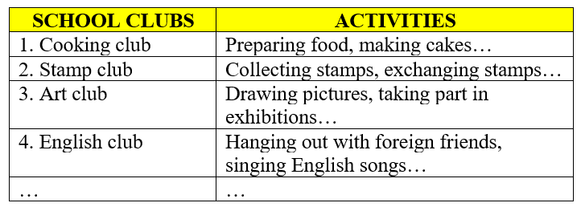  - T go round and give help if necessary  b. Join another pair. Which club do most people want to join?  - Have Ss join another pair and discuss which club most people want to join  - Ask Ss to share their findings with the class  - Give feedback and evaluation | - 1 S practices role-play with the teacher  - Work in pairs  - Decide  - Act out the role-play  Suggested conversation  T: Which club do you want to sing up for next year?  S: I don’t know.  T: Let’s join a cooking club? Do you like preparing food?  S: Hmm. It’s ok. But I want to try another club.  T: There’re also many other clubs in our school such as book club, arts and craft club, science club and even dancing club. Which one do you like?  S: Oh, I like making things by hand.  T: Oh, me too. Why don’t we sign up for an arts and crafts club?  S: Yes, good idea.  - Work in another pair  - Present

C. Consolidation (3’)
* Intonation: Intonation for positive answers goes up, for negative answers goes down.
* Asking and answering about school clubs you like to sign up for: Which club do you want to sign up for?
* Giving suggestions
How about / What about + V-ing / noun
Why don’t we + V _{bare infinitive}
Let’s + V _{bare infinitive}

D. Homework (2’)
- Practice using intonation for positive and negative answers
- Review school names and their activities.
- Make 2 sentences for each structure of giving suggestions
- Prepare: Lesson 3 – New Words and Listening (page 20 – SB)

