GLOBAL SUCCESS 8
UNIT 1: LEISURE TIME

Name: __________________ | Class: ____________ | Date: ____________

PART I | LISTENING (1.25 pts)
Listen to a talk about three teenagers and their leisure activities. Choose the best answer A, B, or C. You will listen twice.
1. What is the main topic of the talk?
A. School subjects in three countries | B. Weekend travel plans | C. The leisure activities of three teenagers
2. How does Sakura usually do origami?
A. With her family | B. On her own | C. At a school club
3. What benefit of snowboarding does Eric mention?
A. It improves balance and health. | B. It improves computer skills. | C. It improves memory.
4. How often does Lan play badminton?
A. Every morning | B. Once a month | C. Almost every afternoon
5. What will Tom do at 3 p.m. this Saturday?
A. Join Lan for badminton
B. Make origami with Sakura
C. Go snowboarding with Eric

PART II | PRONUNCIATION (1.0 pt)
Task 1. Choose the word whose bold part is pronounced differently from the others.
6. A. look B. June C. would D. push
7. A. school B. group C. move D. woman
Task 2. Choose the word whose stress pattern is different from the others.
 | 8. A. leisure |  | B. balance | C. detest |  | D. puzzle
9. A. origami |  | B. badminton |  |  | C. snowboarding | D. practical
PART III |  | LANGUAGE USE (2.5 pts)
Choose the best answer A, B, C, or D to complete each sentence.
10. Trang is keen on ________ DIY in her free time.
A. do | B. doing | C. to do | D. did
11. My brother is fond ________ messaging his friends after school.
A. in | B. at | C. of | D. about
12. Mai is not ________ cooking because she often burns the food.
A. about | B. into | C. of | D. to
13. Sakura enjoys ________ paper flowers and birds.
A. making | B. make | C. to making | D. made
14. Some teenagers prefer ________ comic books to ________ TV.
A. reading / watching | B. read / watch | C. to read / to watch | D. reading / watch
15. Would you like ________ to the cinema with us this Sunday?
A. going | B. go | C. to go | D. went
16. Tom detests ________ sport because he thinks it is tiring.
A. play | B. playing | C. to playing | D. played
17. Choose the best response to complete the dialogue.
Lan: “Do you fancy going for a walk in the park this afternoon?”
Mai: “________________________”
Lan: “Great! Let’s meet at the gate at 4 p.m.”
A. That’s a great idea. Thanks.
B. I don’t fancy.
C. Yes, I fancy.
D. No, I am not.
Choose the sentence that is closest in meaning to the original one.
18. Lan is crazy about playing badminton.
A. Lan dislikes playing badminton. | B. Lan is very interested in playing badminton.
C. Lan never plays badminton. | D. Lan prefers surfing the net to badminton.
19. My cousin prefers reading books to watching TV.
A. My cousin likes watching TV more than reading books. | B. My cousin does not like reading books.
C. My cousin likes reading books more than watching TV. | D. My cousin likes both activities equally.
PART IV | PRACTICAL SKILLS (1.0 pt)
Task 1. Look at the signs and choose the best answer.
20. What should a member of this club do?  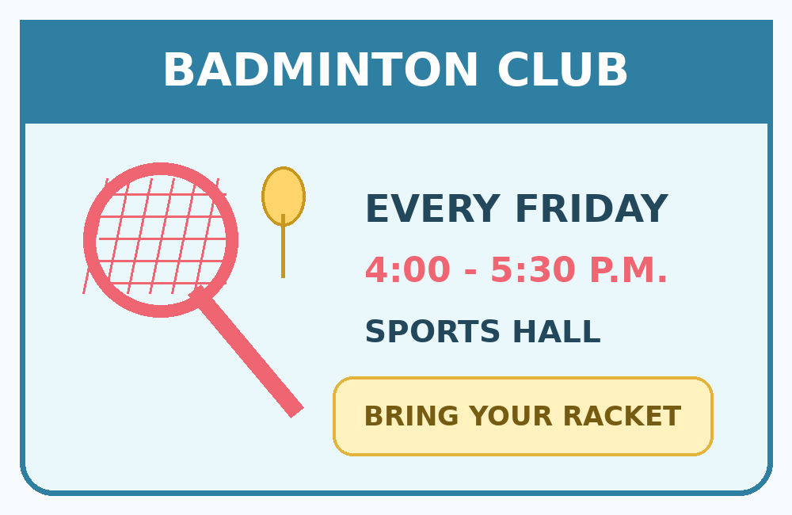  A. Come on Saturday afternoon.  B. Meet each Friday afternoon and bring a badminton racket.  C. Meet in the school library.  D. Arrive at 3 p.m every Friday and bring a badminton racket. | 21. What is the main message of this sign?  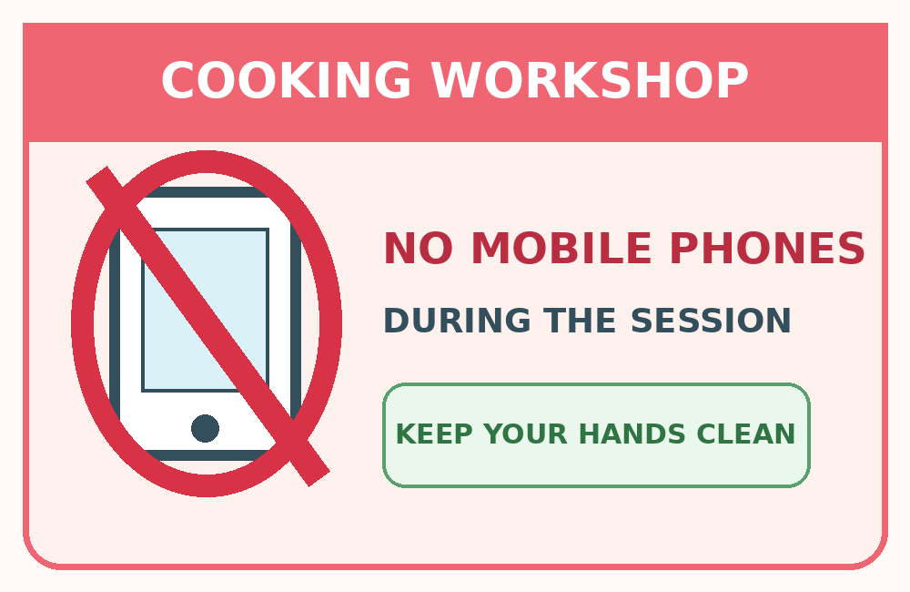  A. Students may use phones to take photos.  B. The workshop is only about mobile phones.  C. Do not use mobile phones during the workshop.  D. Students must bring their own phones.

Task 2. Read the notice and choose the best answer.
SUNRISE LOWER SECONDARY SCHOOL
WEEKEND LEISURE DAY
Come and try origami, DIY, badminton, and cooking with your classmates.
Time: 8:30 a.m. - 11:30 a.m., Saturday 21 September
Place: School Hall and Sports Yard
Fee: Free for all students
Register with Ms Lan by Thursday.
22. What is the main purpose of the notice?
A. To invite students to a school leisure event | B. To announce an exam timetable
C. To recruit members for a music club | D. To advertise a weekend holiday
23. What must students do before taking part?
A. Pay an entrance fee
B. Bring cooking equipment
C. Meet at the school library
D. Register with Ms Lan by Thursday

PART V | READING (2.25 pts)
Task 1. Read the announcement and choose the correct option A, B, C, or D for each blank.
LEISURE TIME SURVEY
Our class is doing a survey about free-time activities.
We want to know what students are (24) ________ in and which activities they enjoy (25) ________.
Some students prefer playing sport, while others would like (26) ________ creative activities such as origami or DIY.
Please complete the form today (27) ________ we can share the results on Friday.
Thank you for taking part!
 | 24. A. interesting | B. interested | C. interest | D. interests
 | 25. A. do | B. did | C. doing | D. to doing
 | 26. A. trying | B. try | C. to try | D. tried
 | 27. A. so | B. but | C. because | D. although
Task 2. Read the text and choose the correct answer A, B, C, or D.
Teenagers around the world spend their free time in different ways. Sakura, who lives in Kyoto, Japan, is keen on doing origami. She usually works on her own and uses coloured paper to make birds, flowers, and fans. She likes this activity because it helps her relax and develop her creativity. Eric lives in St. Gallen, Switzerland, near a famous ski resort. He is crazy about snowboarding and goes with his parents most weekends in winter. According to Eric, the sport improves his balance and keeps him fit. Lan is from Quang Binh, Viet Nam. She prefers playing badminton with her best friend to staying indoors. They meet at a sports centre near their school almost every afternoon. Lan says badminton is enjoyable, reduces stress, and gives her a chance to talk with her friend. Although their activities are different, all three teenagers believe that a good hobby can make life healthier and happier.
28. Why does Sakura enjoy doing origami?
A. It helps her travel. | B. It helps her relax and be creative.
C. It helps her make friends. | D. It helps her stay outdoors.
29. Who usually goes snowboarding with Eric?
A. His parents | B. His classmates
C. His brother | D. His teacher
30. Which statement about Lan is correct?
A. She plays only at weekends. | B. She prefers staying indoors. | C. She plays alone at home. | D. She often plays with a friend.
31. Which leisure activity in the text mainly requires coloured paper?
A. Snowboarding | B. Badminton
C. Origami | D. Surfing the net
32. What idea do all three teenagers share?
 | A. Hobbies should always be expensive.
 | B. Good hobbies can improve well-being.
 | C. Teenagers should choose the same hobby.
 | D. Outdoor activities are always better.
PART VI |  | ORDERING (0.5 pt)
Arrange the sentences to make a complete dialogue.
33.
a. I’d love to. What time shall we meet?
b. Do you fancy going to the DIY workshop this Saturday?
c. At 9 a.m. outside the school hall.
d. Great! See you then.
A. a - b - c - d | B. b - c - a - d | C. b - a - c - d | D. c - b - d - a
34.
a. Why do you like it?
b. What do you do in your free time?
c. I’m keen on surfing the net.
d. Because I can learn new things and keep in touch with friends.
A. a - b - c - d | B. c - a - b - d | C. b - a - d - c | D. b - c - a – d

PART VII | WRITING (1.5 pt)
Task 1. Rewrite each sentence so that it has a similar meaning to the original one. (1.0 pt)
35. My cousin is crazy about playing computer games.
→ My cousin loves ________________________________________________________.
36. Lan likes playing badminton more than surfing the net.
→ Lan prefers ___________________________________________________________.
37. Would you like to make paper flowers with me?
→ Do you fancy _________________________________________________________?
38. Tom really hates playing sport.
→ Tom detests __________________________________________________________.
Task 2. Write an email of 80-100 words to a friend about leisure activities. (0.5 pt)
In your email, you should:
• describe an activity you enjoy doing with friends
• say when and where you usually do it and why you like it
• invite your friend to join you this weekend
39. Email to a friend
················································································································
················································································································
················································································································
················································································································
················································································································
················································································································
················································································································
················································································································
················································································································
················································································································

GLOBAL SUCCESS 8
TEACHER’S COPY - UNIT 1: LEISURE TIME

A | LISTENING TRANSCRIPT

Hello. Today I’d like to tell you about three teenagers and the activities they enjoy in their free time. Sakura, from Kyoto in Japan, is keen on doing origami. She usually makes paper flowers and birds on her own. Origami helps her relax and become more creative. Eric lives near a ski resort in Switzerland. He is crazy about snowboarding and often goes with his parents at weekends. He says the sport improves his balance and keeps him healthy. Lan, from Quang Binh in Viet Nam, prefers playing badminton with her best friend. They play almost every afternoon after school. This Saturday, Lan has invited her cousin Tom to join them at three p.m., and he has accepted the invitation. Although their hobbies are different, all three teenagers believe leisure activities make life more enjoyable.

B | ANSWER KEY

Listening (Questions 1–5)
1. C | 2. B | 3. A | 4. C | 5. A

Pronunciation (Questions 6–9)
6. B | 7. D | 8. C | 9. A

Language Use (Questions 10–19)
10. B | 11. C | 12. B | 13. A | 14. A
15. C | 16. B | 17. A | 18. B | 19. C

Practical Skills (Questions 20–23)
20. B | 21. C | 22. A | 23. D

Reading (Questions 24–32)
24. B | 25. C | 26. C | 27. A | 28. B
29. A | 30. D | 31. C | 32. B

Ordering (Questions 33–34)
33. C | 34. D

C | LANGUAGE NOTES & ANSWER RATIONALE

Question(s) | Language point / rationale
6-7 | The bold parts test the Unit 1 sounds /ʊ/ and /uː/.
10-16 | The items assess expressions of likes/dislikes and gerund or to-infinitive patterns.
14 | Use prefer + gerund + to + gerund: “prefer reading ... to watching ...”.
17 | “That’s a great idea. Thanks.” naturally accepts an invitation.
20 | The sign explicitly tells club members to bring a racket.
27 | “So” introduces the intended result of completing the survey today.

D | WRITING KEY & ASSESSMENT

Sentence transformations
35. My cousin loves playing computer games.
36. Lan prefers playing badminton to surfing the net.
37. Do you fancy making paper flowers with me?
38. Tom detests playing sport.
Suggested email (about 90 words)
Hi Mai,
How are you? My favourite leisure activity with friends is playing badminton. We usually play at the sports centre near our school on Saturday afternoons. We sometimes play friendly matches with another class, so it is always exciting. I’m keen on it because it keeps me fit, reduces stress, and gives us time to talk and have fun together. This weekend, we are meeting at 3 p.m. on Saturday. Do you fancy joining us? You only need comfortable clothes and a racket. I’d love to see you there.
Best,
Lan

E | TEST SPECIFICATION – 39 ITEMS / 10 POINTS

Scoring: Questions 1–38 = 0.25 point each; Question 39 = 0.5 point. Suggested time: 45 minutes.
Part | Task type | Items | Questions | Points
I. Listening | Multiple choice | 5 | 1–5 | 1.25
II. Pronunciation | Sound (2) + stress (2) | 4 | 6–9 | 1.00
III. Language Use | Vocabulary, grammar, dialogue, closest meaning | 10 | 10–19 | 2.50
IV. Practical Skills | Signs (2) + notice (2) | 4 | 20–23 | 1.00
V. Reading | Cloze (4) + comprehension (5) | 9 | 24–32 | 2.25
VI. Ordering | Dialogue sequencing | 2 | 33–34 | 0.50
VII. Writing | Transformations (4) + email (1) | 5 | 35–39 | 1.50
TOTAL |  | 39 |  | 10.00

