Thời gian làm bài: 40 phút (Không kể thời gian giao đề)
-------------------------
Họ tên thí sinh: .................................................................
Số báo danh: ......................................................................
Mã Đề: 007.
Câu 1. What is the discount amount when buying two shirts?
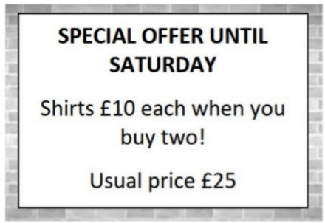
A. £5 off each shirt B. £15 off each shirt
C. £10 off each shirt D. £25 off the total purchase
Câu 2. What is the purpose of the charity event on November 10 at the Hilton Hotel?
You're invited to join us for our charity event on November 10 at 7 pm at the Hilton Hotel. We'll have a silent auction, live music, and cocktails, with all proceeds going towards supporting the homeless in our community. We hope you can make it!
A. To raise money for a political campaign B. To promote a new product
C. To celebrate the end of the year D. To support the homeless in the community
Câu 3. What is the minimum price for a car wash?
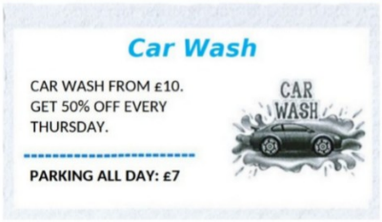
A. £15 B. £7 C. £10 D. £5
Câu 4. How many trains per hour will be running during the weekend?
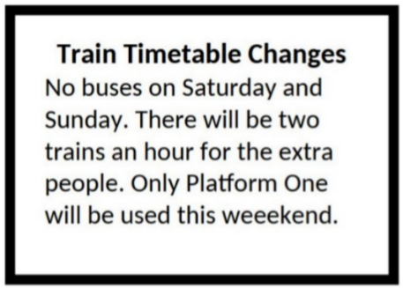
A. Four B. Three C. Two D. One
Câu 5. What is true about the announcement from the library?
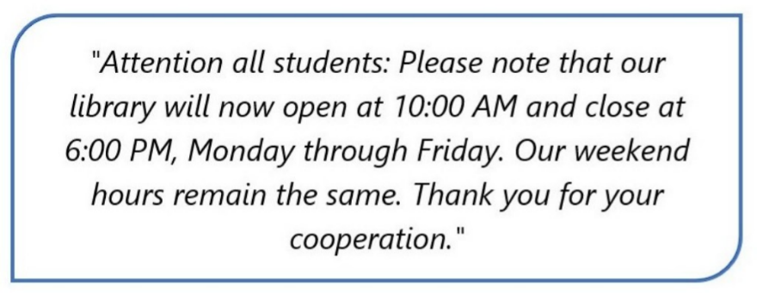
A. Change in the library's hours on weekends.
B. Change in the library's phone number.
C. Change in the library's opening and closing times on weekdays.
D. Change in the library's location.
Câu 6. What are students asked to do after using the kitchen?
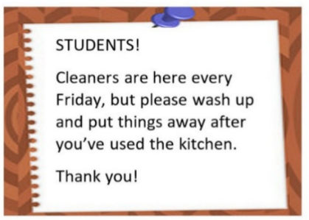
A. Leave everything as it is B. Deep clean the entire kitchen
C. Wash up and put things away D. Call the cleaners
Câu 7. What is the name of the new summer drink being offered at Andy's Coffee?
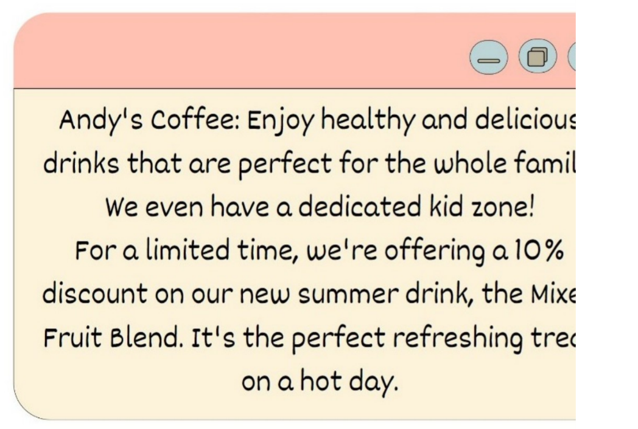
A. Hot Chocolate B. Mixed Fruit Blend C. Caramel Latte D. Iced Coffee
Câu 8. What is the current promotion at the store?

A. 50% discount on everything on Saturday B. 10% discount on everything on Saturday
C. 20% discount on everything on Sunday D. 20% discount on everything on Saturday
Câu 9. What does Emma offer to do?
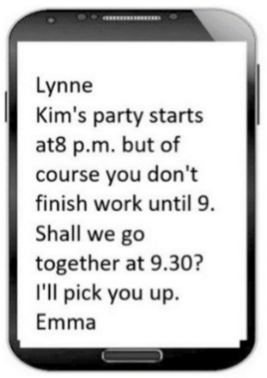
A. Pick Lynne up B. Meet Lynne at the party
C. Help Lynne finish work early D. Drive Lynne to work
Câu 10. What activity is being proposed in the message?
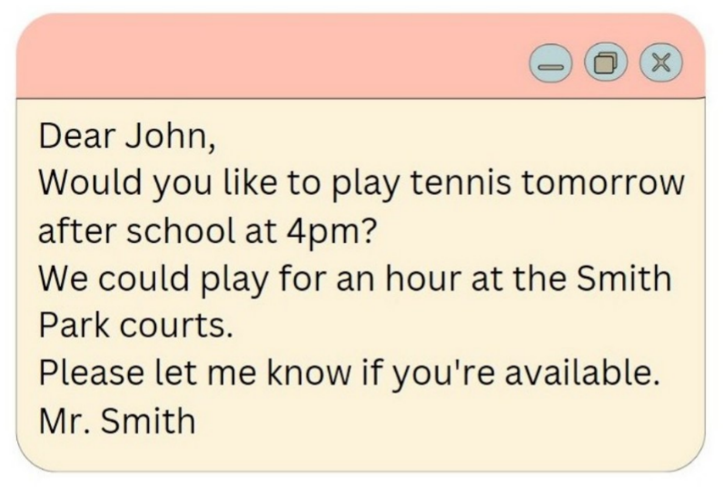
A. Going swimming B. Playing basketball C. Going for a run D. Playing tennis
----HẾT---

