UNIT 7. TRAFFIC
PART 1. THEORY
I. VOCABULARY
No. | English | Type | Pronunciation | Vietnamese
1 | accident | n | /'æksɪdənt/ | tai nạn
2 | bike | n | /baɪk/ | xe đạp
3 | bus | n | /bʌs/ | xe buýt
4 | bus stop | n | /bʌs stɒp/ | điểm dừng xe buýt
5 | car | n | /kɑː(r)/ | xe ô tô
6 | crossroad | n | /'krɒs,rəʊd/ | giao lộ
7 | crowded | adj | /'kraʊdəd/ | đông đúc
8 | cycle lane | n | /'saɪkl leɪn/ | làn đường dành cho xe đạp
9 | dangerous | adj | /'deɪndʒərəs/ | nguy hiểm
10 | drive | V | /draɪv/ | lái xe
11 | driving license | n | /'draɪvɪŋ 'laɪsns/ | bằng lái xe
12 | fly | V | /flaɪ/ | bay
13 | get off | V | /get ɒf/ | xuống (xe)
14 | get on | V | /get ɒn/ | lên (xe)
15 | hospital ahead | phr | /'hospɪtl ə'hed/ | phía trước có bệnh viện
16 | means of transport | n | /mi:nz ɒf 'trænspɔ:t/ | phương tiện giao thông
17 | motorbike | n | /'məʊtəbaɪk/ | xe máy
18 | no cycling | phr | /nəʊ 'saɪkliŋ/ | cấm xe đạp
19 | no parking | phr | /nəʊ 'pɑːkɪŋ/ | cấm đỗ xe
20 | no right turn | phr | /nəʊ raɪt tɜ:n/ | cấm rẽ phải
21 | parking | n | /'pɑːkɪŋ/ | (biển báo) cho phép đỗ
22 | pavement | n | /'peɪvmənt/ | vỉa hè
23 | plane | n | /pleɪn/ | máy bay
24 | railway station | n | /'reɪlweɪ 'steɪʃn/ | trạm xe lửa
25 | ride | V | /raɪd/ | cưỡi, lái (ngựa, xe 2 bánh)
26 | roof | n | /ru:f/ | mái nhà
27 | safety | n | /'seɪftɪ/ | sự an toàn
28 | sail | V | /seɪl/ | chèo (thuyền)
29 | school ahead | phr | /sku:l ə'hed/ | phía trước có trường học
30 | seat belt | n | /si:t belt/ | đai an toàn
31 | speed limit | n | /spi:d 'lɪmɪt/ | tốc độ giới hạn
32 | traffic jam | n | /'træfɪk dʒæm/ | tắc đường
33 | traffic light | n | /'træfɪk laɪt/ | đèn giao thông
34 | traffic rule | n | /'træfɪk ru:l/ | luật lệ giao thông
35 | train | n | /treɪn/ | xe lửa
36 | train ticket | n | /treɪn 'tɪkɪt/ | vé xe lửa
37 | truck | n | /trʌk/ | xe tải
38 | vehicle | n | /'vi:əkl/ | xe cộ
39 | zebra crossing | n | /'zebrə 'krɒsɪŋ/ | vạch kẻ sọc cho người đi bộ

II. GRAMMAR
1. "It" indicating distance ("It" dùng để nói về khoảng cách)
Chúng ta sử dụng it để chỉ khoảng cách giữa hai địa điểm/ người/ vật.
Cấu trúc:
Câu hỏi | How far is it from place A to place B?
Câu trả lời | It is (about) + khoảng cách.
Ex 1:
How far is it from your house to the nearest bank? (Khoảng cách từ nhà cậu tới ngân hàng gần nhất là bao xa?)
It is about 3 kilometres. (Khoảng 3km.)
Ex 2:
How far is it from your house to my house? (Khoảng cách từ nhà bạn đến nhà tớ bao xa?)
It is about 200m. (Khoảng 200m.)

iii. PHONETICS

Cách phát âm âm /aɪ/ và /eɪ/
1. Cách phát âm nguyên âm đôi /aɪ/
Bước 1: Bắt đầu từ âm /a/, sau đó di chuyển về phía âm /ɪ/.  Bước 2: Khi bắt đầu, miệng mở hình ô van, lưỡi hạ thấp chạm hàm răng dưới. Sau đó, môi dần kéo sang 2 bên về phía tai, hàm dưới nâng lên 1 chút.  Bước 3: Kết thúc âm, môi mở hờ. | 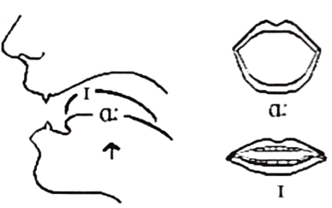
2. Cách phát âm nguyên âm đôi /eɪ/
Bước 1: Bắt đầu từ âm /e/, sau đó di chuyển về phía âm /ɪ/.  Bước 2: Khi bắt đầu, miệng mở rộng thoải mái, đầu lưỡi chạm hàm răng dưới, hàm hạ. Sau đó, môi dần kéo sang hai bên về phía tai, hàm dưới nâng lên một chút.  Bước 3: Kết thúc âm, môi mở hờ. | 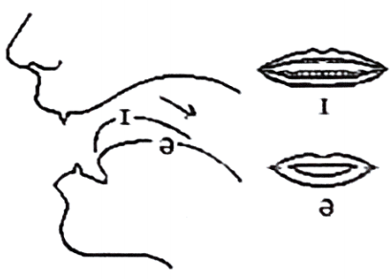
Listen and repeat these words. Track 01
/aɪ/ | bike | buy | guide | pie
 | /baɪk/ | /baɪ/ | /gaɪd/ | /paɪ/
/eɪ/ | gate | nation | rain | clay
 | /geɪt/ | /’neɪʃn/ | /reɪn/ | /kleɪ/
PART 2. LANGUAGE
I. VOCABULARY
Exercise 1. Find the odd one out among A, B, C or D.
1. A. riding | B. driving | C. gardening | D. flying
2. A. no cycling | B. no parking | C. no right turn | D. sign
3. A. train | B. plane | C. car | D. sail
4. A. by car | B. on foot | C. by bus | D. by bicycle
5. A. rule | B. ride | C. reverse | D. drive
Exercise 2. Look at the pictures and put the word/phrase under each sign.
parking | no parking | school ahead | no left turn
speed limit | no cycling | hospital ahead | no right turn
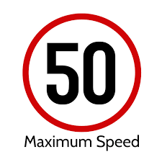 |  | 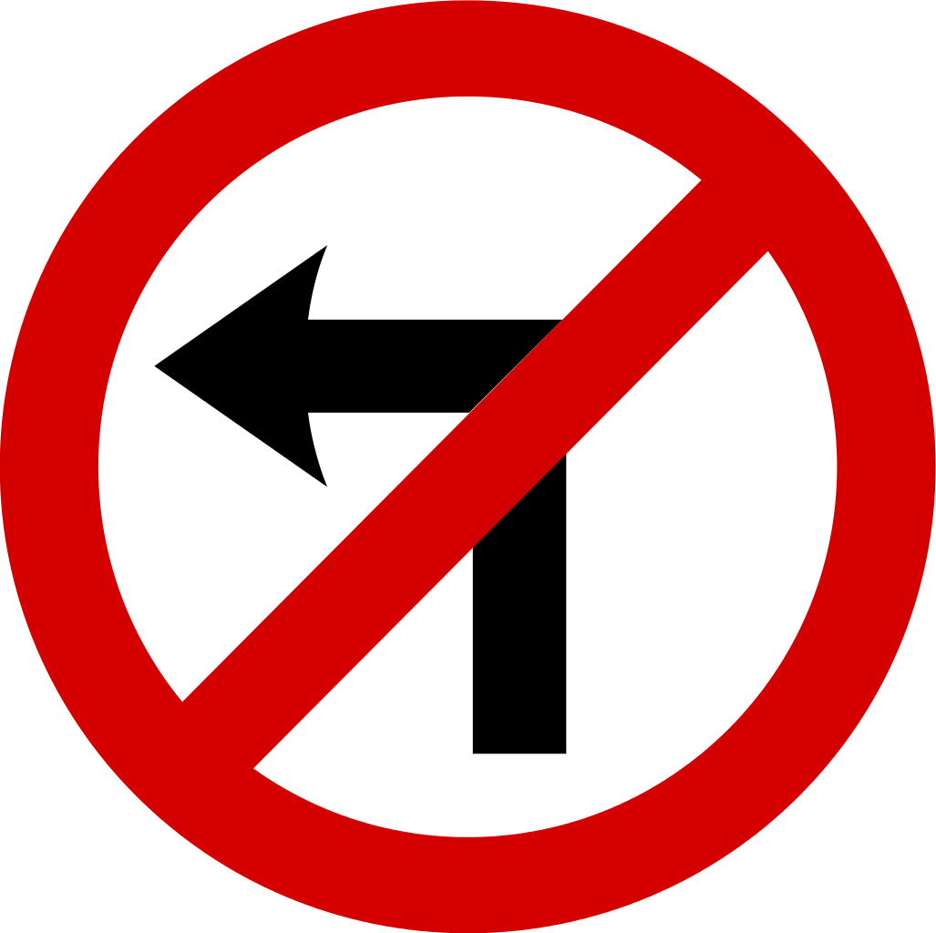 | 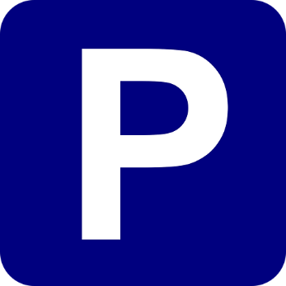
1. | 2. | 3. | 4.
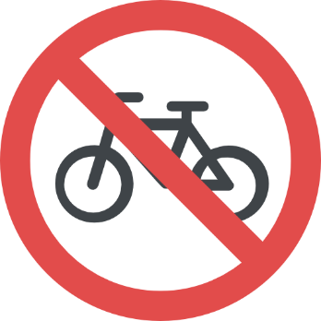 | 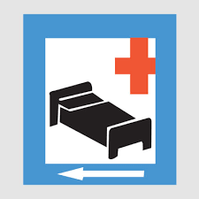 | 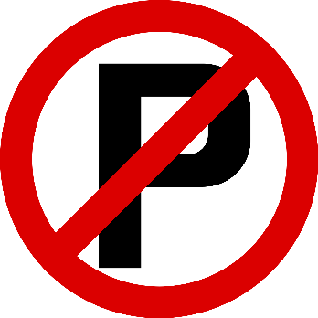 | 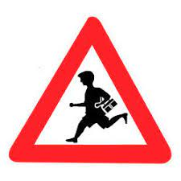
5. | 6. | 7. | 8.
Exercise 3. Look at the pictures and complete with suitable means of transport.
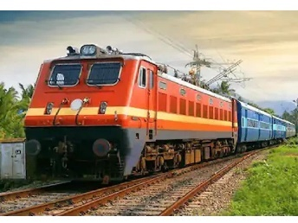 | 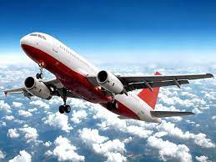 | 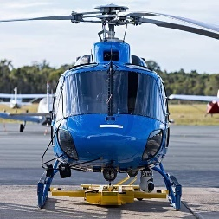 | 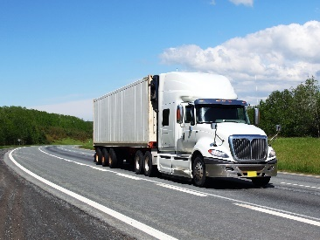
1. t_______________ | 2. p_______________ | 3. h_______________ | 4. t_______________
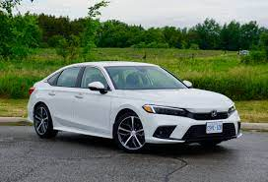 | 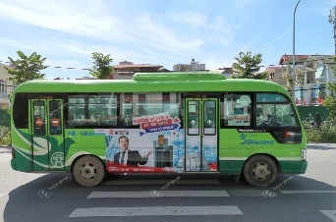 | 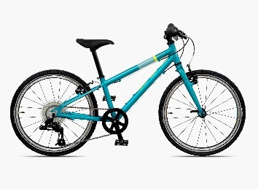 | 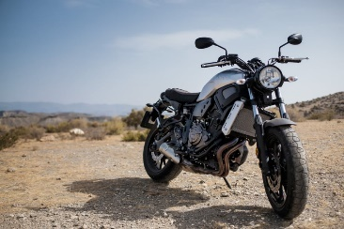
5. c_______________ | 6. b_______________ | 7. b_______________ | 8. m_______________
Exercise 4. Complete each phrase below.
1. zebra _______________ | 2. _______________ license
3. speed _______________ | 4. cycle _______________
5. railway _______________ | 6. _______________ of transport
7. traffic _______________ | 8. train _______________
9. _______________ lights | 10. traffic _______________
Exercise 5. Fill in each blank with a word in the box.
feels | rules | it | across | did
after | vehicles | break | ride | accidents
1. What _______________ you do last Sunday?
2. I stayed at home and looked _______________ my younger brother yesterday.
3. Does your bike ever _______________ down on the way to school?
4. We must always obey traffic _______________ for our safety.
5. How far is _______________ from your house to the bus stop?
6. He used to _______________ a tricycle when he was three years old.
7. Now there are more traffic _______________ than there used to be in this city.
8. There did not use to be many _______________ on the roads in my home town.
9. He lives in a small village in the mountains so he never _______________ worried about traffic jams.
10. You should remember to walk _______________ the streets at the zebra crossings.
II. GRAMMAR
Exercise 1. Choose the correct option to complete the sentence.
1. How far is it from your apartment (from/to) the zoo?
2. It is (at/ about) 2 kilometres.
3. It is not very (near/far) from my house to the bank. It is just 500 metres.
4. How far (is it/ it is) from your country to the USA?
5. How (far/ much) is it from your house to the train station?
6. My house is 2 kilometres (near/ far) from my grandparents’ house.
7. How far (is it/ are they) from here to the cinema?
8. I think it is about 400 (metres/ metre) from here to the nearest bus stop.
9. My school is not far (from/ to) my house. I can go to school on foot every day.
10. How far is it (from/ at) your office to the market?
Exercise 2. Fill in the blank with a correct word to complete the sentence.
1. How _______________ is it from your house to the park?
2. How far is it from this restaurant to the nearest _______________?
- It is about 1 kilometre from this restaurant to the nearest bank.
3. How far _______________ it from Hanoi to Ho Chi Minh City?
4. It is about 5 kilometres from my house _______________ yours.
5. How far is _______________ from your company to your apartment?
6. It is _______________ 3 kilometres.
7. How far is it from my school to yours? - _______________ is about 8 kilometres.
8. How far is it _______________ where you live to your company?
Exercise 3. Decide the following sentences are grammatically correct or incorrect.
1. How long is it from Hanoi to Noi Bai Airport? - It is about 30 kilometers.
A. True B. False
2. It is about 300 kilometers from Ho Chi Minh City to Phu Quoc.
A. True B. False
3. How far it is from Hanoi to Lao Cai?
A. True B. False
4. I think it is about 200 metres from our school to the bus stop.
A. True B. False
5. It is not very far from my school from the bus station.
A. True B. False
6. Is it far from here to Hung Yen City? - No, it's just 10 kilometers.
A. True B. False
Exercise 4a. Make questions for the answers.
1. _____________________________________________________________________________?
It is about 300 metres from here to the nearest post office.
2. _____________________________________________________________________________?
It is about 3,900 kilometres from New York to California.
3. _____________________________________________________________________________?
It is about 200 metres from my house to my family store.
4. _____________________________________________________________________________?
It is about 4576.89 miles from Beijing to Berlin.
5. _____________________________________________________________________________?
It is about 1 kilometer from my hotel to the beach.
Exercise 4 b. Answer the questions using the information in the brackets.
1. How far is it from here to the theatre? (about 400 metres)
_____________________________________________________________________________
2. How far is it from your hometown to Ha Noi? (about 100 kilometres)
_____________________________________________________________________________
3. How far is it from the park to the zoo? (about 2 kilometres)
_____________________________________________________________________________
4. How far is it from here to the city centre? (about 50 kilometres)
_____________________________________________________________________________
5. How far is it from your house to school? (about 1 kilometre)
_____________________________________________________________________________
Exercise 5. Give the correct form of the word given to complete the sentence.
1. Young children are expected to show to their parents. (obey)
_____________________________________________________________________________
2. When cycling on the roads, remember: first. (safe)
_____________________________________________________________________________
3. Children should avoid foods such as hamburgers and chips. (health)
_____________________________________________________________________________
4. Most road accidents happen because the motorists drive. (care)
_____________________________________________________________________________
5. It is unsafe and to pass another vehicle on the left. (legal)
_____________________________________________________________________________
6. My was delayed for over two hours due to bad weather. (fly)
_____________________________________________________________________________
7. Everyone should obey traffic rules for their own safety. (strict)
_____________________________________________________________________________
8. The policeman the car to stop with a flashlight. (sign)
_____________________________________________________________________________
9. Signs with red circles are mostly - that means you can’t do something. (prohibit)
_____________________________________________________________________________
10. This sign indicates that traffic lights are ahead. (warn)
_____________________________________________________________________________
III. PHONETICS
Divide these words into two columns as below. TRACK 02
while | pay | rice | fine | shade | tail | behind | child
eight | nice | steak | face | kind | silent | raise | guide
amazing | guy | hate | eye | baby | my | light | paper
later | potato | sigh | gray | island | they | day | buy

/aɪ/ | /eɪ/

PART 3. COMMUNICATION SKILLS
I. LISTENING
Listen and do the tasks followed. Track 03
Exercise 1. Listen and decide if each statement is True (T) or False (F).
1. Mr. Hoang has no day off except Saturday. __________
2. Mr. Hoang usually spends his day off in front of the TV screen. __________
3. Mr. Hoang doesn't like his job. __________
4. Mr. Hoang is going to retire. __________
5. Mr. Hoang’s wife does not want him to retire. __________
Exercise 2. Listen again and answer the questions.
1. What does Mr. Hoang do?
_____________________________________________________________________________
2. What time does he start his work?
_____________________________________________________________________________
3. What is the destination of his route?
_____________________________________________________________________________
4. Why does Mr. Hoang love his job?
_____________________________________________________________________________
5. How many hours does he work on Saturdays?
_____________________________________________________________________________
II. SPEAKING
Write questions for the underlined parts. Then practise the dialogue with your partner.
Mary: Hi Tony! (1) _____________________________________________________________
Tony: I came to class late this morning because I was stuck in a traffic jam.
Mary: Really? (2) _____________________________________________________________
Tony: Yes, my house is rather far from school.
Mary: (3) ___________________________________________________________________
Tony: Uhm... about 5 kilometres.
Mary: (4) ___________________________________________________________________
Tony: I go to school by bike.
Mary: (5) ___________________________________________________________________
Tony: It takes me about 30 minutes. And it takes longer when the traffic is jammed
Mary: (6) ___________________________________________________________________
Tony: I get stuck in a traffic jam once or twice a week.
Mary: (7) ___________________________________________________________________
Tony: I often get stuck in a traffic jam on Monday morning.
Mary: (8) ___________________________________________________________________
Tony: I usually go to school at 6.15.
Mary: So why don't you start going to school a little earlier on Monday?
Tony: Okay, I'll try.
III. READING
Exercise 1. Read the text and then choose the best answer A, B, C or D.
Yesterday, on the way home from school, I saw an accident. A boy was run over by a taxi when he was riding his bicycle. The boy's leg was broken and it was bleeding badly. Someone there tried to stop the bleeding. They put pressure on it and held it tight. A man used his mobile phone to call the emergency service. Some minutes later, an ambulance arrived and sent the boy to the hospital. Two policemen came to the scene immediately. Some people told the police that the taxi driver was driving at a very high speed when the accident happened. Some others began talking about the traffic accidents these days and blamed the increasing number of accidents on the roads for careless driving and drunk drivers.
1. What did the writer see yesterday?
A. A fire B. An accident C. A fighting D. A crash
2. The accident happened between a taxi and ________________.
A. a bus B. a car C. a bicycle D. motorbike
3. The boy was sent to the hospital by ________________.
A. a police B. a car C. an ambulance D. a passenger
4. What part of his body was hurt? – His ________________.
A. arm B. leg C. head D. shoulder
5. How was the driver driving when the accident happened?
- Very ________________.
A. slowly B. fast C. carefully D. well
Exercise 2. Fill in the blank with a word/ phrase in the box.
discourage | transport | pollution | expensive
problem | trains | cities | example
Traffic congestion in many (1) ________________ around the world is severe. One possible solution to this (2) ________________ is to impose heavy taxes on car drivers and use this money to make public transport better. One of the first benefits of such a measure is that the heavy taxes would (3) ________________ car owners from using their cars because it would become very (4) ________________ to drive. This would mean that they would begin to make use of public (5) ________________ instead, thus reducing traffic problems and (6) ________________ as well.
Another benefit would be that much more use would be made of public transport if it was improved. It is often the case that public transport in cities is very poor. For (7) ________________, we often see old buses and (8) ________________ that people would rather not use. High taxes would generate enough money to make the necessary changes.
Exercise 3. Read the texts about model good road safety behavior at all times for parents, and then answer the questions.
Top tips for pedestrian safety
- Teach your children to hold hands with an adult whenever they go out.
- Always use a zebra crossing when one is available and teach children that these are the safest places to cross.
- Teach children that it’s still important to stop, look and listen at a zebra crossing.
- Teach children always to stop at the kerb and look and listen for traffic (a third of children injured on roads said that they didn’t stop before stepping off the kerb and many said they didn’t look).
- Never use your mobile phone while crossing roads.
- Children learn to make decisions about crossing the road and parents gradually let them take a lead when you are crossing together.
- As children get older, practise routes with them before they walk alone.
Top tips for cycling
- Always encourage children to wear a cycle helmet when they are on their bikes, and set a good example by wearing one yourself.
- Children need to be able to judge speed and distance accurately before they cycle on public roads. They need to take lessons on cycling in order to travel more widely on their bikes.
- Make sure children wear bright coloured clothing and fluorescent items whenever they are cycling on the road. And if they are cycling in the dark, they will need lights on their bikes and reflective items too. And of course, make sure you do this yourself, to set a good example.
1. What should children do when they go out?
__________________________________________________________________________________
2. Where should children cross the street?
__________________________________________________________________________________
3. What should children do to cross the street?
__________________________________________________________________________________
4. Where should children stop to look and listen for the traffic?
__________________________________________________________________________________
5. Can they use their mobile phones while crossing roads?
__________________________________________________________________________________
6. What should parents do to help older children before they walk alone?
__________________________________________________________________________________
7. What should children wear when they are on the bikes?
__________________________________________________________________________________
8. What should children do before they cycle on public roads?
__________________________________________________________________________________
9. Which clothes should children wear whenever they are cycling on the road?
__________________________________________________________________________________
10. What should they do when they cycle in the dark?
__________________________________________________________________________________
IV. WRITING
Exercise 1. Make questions for the underlined parts in the following sentences using question words in brackets.
1. Nam usually goes to school by bus. Sometimes, he rides his bicycle. (How)
__________________________________________________________________________________
2. My father went to the stadium yesterday. (Where)
__________________________________________________________________________________
3. There are a lot of trucks and cars on the highway in the rush hour. (When)
__________________________________________________________________________________
4. The students learn about road signs when they studied in secondary school. (What)
__________________________________________________________________________________
5. Hung always drives his car very carefully. (How)
__________________________________________________________________________________
6. It is about 100 km from Ha Noi to Hai Phong. (How far)
__________________________________________________________________________________
Exercise 2. Reorder the words to have correct sentences.
1. from/ the/ to/ kilometers/ house/ my/ 3/ nearest/ park./ It’s
__________________________________________________________________________________
2. from/ far/ house I bus /the I it/ station?/ How/ is/ grandmas I your I to
__________________________________________________________________________________
3. father I gets I rush I My I often I hour. I stuck I in
__________________________________________________________________________________
4. can / go / You I foot. / on / far I here. I It’s I from / not
__________________________________________________________________________________
5. bus / 700 / the / my / metres / It’s / to / from / station./ office / about
__________________________________________________________________________________
Exercise 3. Look at the information in the box then write questions and answers.
No. | Place 1 | Place 2 | Distance | Vehicle
1. | Ha Noi | Ho Chi Minh City | 1000 kilometres | plane
2. | Ninh Binh | Da Nang | 800 kilometres | train
3. | The park | The zoo | 2 kilometres | bus
4. | The cinema | The museum | 900 metres | bike
1. How far is it from Ha Noi to Ho Chi Minh City?
It’s about 1000 kilometres.
How do you get there?
I go by plane.
2. _________________________________________________________________________________
___________________________________________________________________________________
___________________________________________________________________________________
___________________________________________________________________________________
3. _________________________________________________________________________________
___________________________________________________________________________________
___________________________________________________________________________________
___________________________________________________________________________________
4. _________________________________________________________________________________
___________________________________________________________________________________
___________________________________________________________________________________
___________________________________________________________________________________

