ĐỀ THI SINH GIỎI LỚP 9
NĂM HỌC 2023 – 2024
MÔN: TIẾNG ANH
Thời gian làm bài: 150 phút
(Đề thi này gồm có 08 trang)
Học sinh lưu ý:
+ Làm bài vào tờ giấy thi (Không làm bài vào đề thi này)
+ Phần trắc nghiệm: Chỉ cần ghi phần (A, B ...), câu (I, II…), ý (1, 2…) và đáp án.
+ Phần tự luận: Viết đầy đủ theo yêu cầu của từng bài.
A. LISTENING: 20 points
Part I (5points)
1. Where’s the girl going this afternoon?

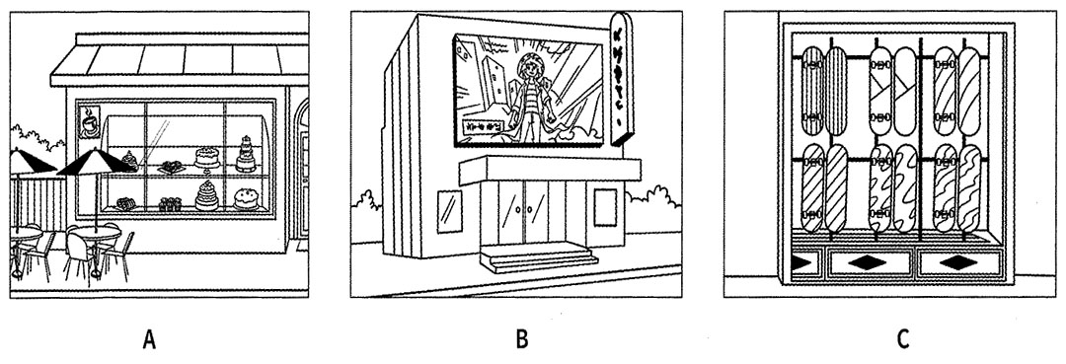

2 Which is the boy’s new desk?

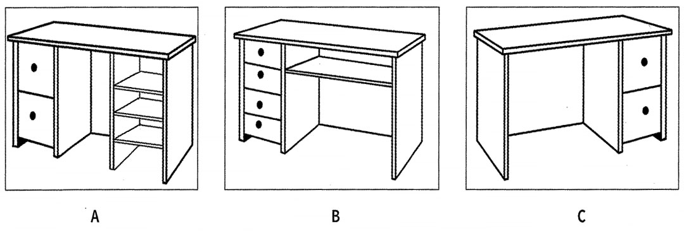

3 How will they get to their tennis class?

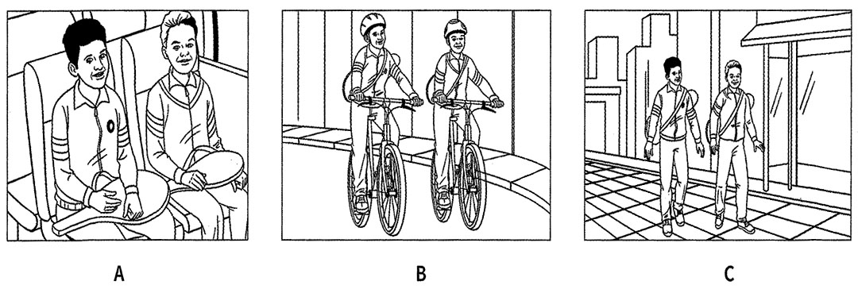

4 Which woman is Laura’s new English teacher?

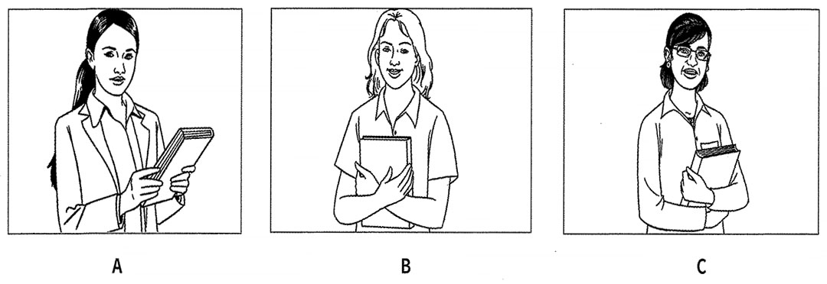

5. What might Harry do if it rains on Saturday?
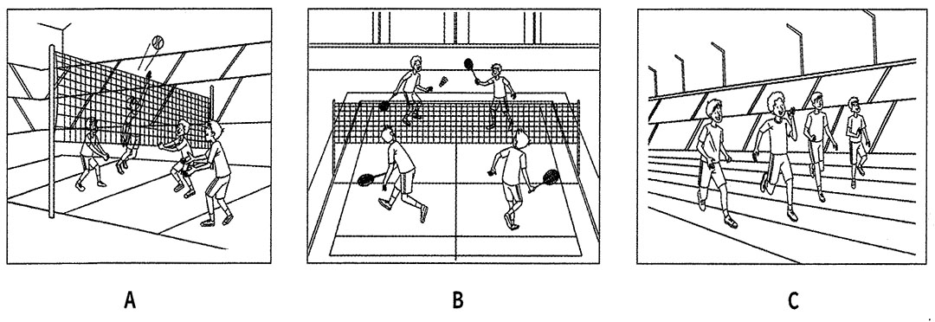

Part II. (5points): Listen to the recording twice. Complete the form below. Write no more than three words or numbers for each answer.

Hotel in Ireland
Best time to visit:  Name:  Where:  Hotel first built in :  Number of bedrooms:  Restaurant famous for: | June  (6) The __________Hotel  (7) _____________island  (8) ______________  (9) ______________  (10) ______________

Part III. Listen to part of a discussion about a book on laughter. Write NO MORE THAN THREE WORDS AND/OR A NUMBER taken from the recording for each answer in the spaces provided. (5pts)
11. Provine’s book proposes that laughter is used to improve human _______________________
12. Mark says that today people often only laugh at TV ________________________ .
13. Diana says that women think a good ________________________ is vital in personal male/female relationships.
14. Diana thinks that the fact that there haven’t been many ________________________ in the past reflects a commonly held attitude.
15. Although laughter is important in relationships, there is no evidence to suggest that our ________________________ would benefit.
Part IV. Listen to the recording and choose the best answer A, B, C or D for the following questions from 16 to 20. You will listen to the recording twice. (5pts)
16. Where is Arches National Park situated?
A. South of the city of Moab B. Northern desert of Utah
C. Southern desert of Utah D. North of the city of Moab
17. When can people visit Arches National Park?
A. In summer B. In winter C. Any time of year D. On rainy days
18. How can people get to some farther arches?
A. By bike B. By car C. By plane D. By train
19. What is NOT mentioned as necessary things we should bring along with when hiking in Arches National Park?
A. hiking shoes B. books C. GPS D. detailed map
20. According to the narrator, why should we bring a detailed map along with a compass and/or a GPS when hiking in this park?
A. To discover farther places in the park.
B. To let other people know your position.
C. To know where you are and find the way easily.

B. GRAMMAR- VOCABULARY-LANGUAGE FUNCTIONS
I. Choose the word, phrase or expression which best completes each sentence (20 points).
21. The Kinh have the largest number of people, ________ for 86% of the population.
A. holding B. taking C. accounting D. numbering
22. My sister has a ________ baby.
A. two- months-old B. two-month- olds C. two-months-olds D. two-month
23. John is talking to Sally about the news he watched on TV last night.
John: “The whole village was submerged in the flood.”
Sally: “……..………….”
A. That’s awful! B. That’s surprising! C. My fault. D. That’s a relief!
24. In my school, female students ……………… wear Ao dai every Monday. If you don’t follow it, you will be punished.
A. should B. can C. have to D. have
25. The Giong festival is held to ……………… Saint Giong who defeated the invaders.
A. remember B. commemorate C. miss D remind
26. All people should join hands in protecting the environment ………..………. we can gain better health.
A. because B. so that C. although D. with a view to
27. When you arrive, I …………..……. firework displays by Han River.
A. will be watching B. was watching C. watched D. will have watched
28. Hurry up! They have only got……………..….seats left.
A. a lot of | B. plenty of | C. a little | D. a few
29. A: “I don’t like playing soccer” – B: “______”
A. So do I B. I do, either C. Neither do I D. Neither am I
30. When my parents traveled to Singapore, they bought me a/an ……..………… piano.
A. ancient precious wooden B. wooden ancient precious
C. wooden precious ancient D. precious ancient wooden
31. A: “Thank you for a lovely evening.” – B: “____________”
A. Don’t mention it B. I’m glad you enjoy it
C. Yes, I’d like that. D. Yes, that would be very nice
32. Could you do me a favor, Madam? - …………………………………
A. Yes. How can I help you? B. No, thanks.
33. The robbers ……………as they …………the bank yesterday.
A. were caught/were leaving B. were caught/left
C. were being caught/were leaving D. caught/were leaving
34. ……..………… non – verbal language is ……..………… important aspect of interpersonal communication.
A. The/ Ø B. A/ the C. Ø/ an D. The/ a
35. That small restaurant has the _____ for serving delicious seafood.
A. knowledge B. tradition C. source D. reputation
36. If we ………………..wasting natural resources, they will be used up in a few decades.
A. tum on B. go on C. go off D. tum off
37. Neither Linh nor her classmates ______ the National Museum so far.
A. visit B. visited C. have visited D. has visited
38. You……..………… look at other students’ work. It’s against the rules.
A. don’t have to B. mustn’t C. can’t D. shouldn’t
39. Peter: “Is it important?” - Tom: “…………………..”
A. Not on your life! B. No, worry, that’s nothing.
C. It can make the world go around. D. It’s ridiculous.
40. Laura is in the ……………….. of writing in her dairy every day.
A. habit B. custom C. practice D. generation
II. Give the correct form of the words in brackets (5 points).
41. Minh ____________________ this morning, and was late for school. (SLEEP)
42. I got my trousers ____________________ because they were too short. (LONG)
43. The Gold Coast is famous for its most ___________________ theme parks in
Australia such as Dreamworld and White Water World. (ICON)
44. A ___________________ person is one who is kind. (THINK)
45. You must put all ____________________ and drugs in locked cupboards. (CHEMIST)
III. Choose the underlined word or phrase in each sentence that needs correcting (5 points).
46. Around the age of sixteen, you must do one of the biggest choices of your life:- Should I
A B
stay on at school or leave and start work?
C D 47. School children in the same grade in Vietnamese schools are usually the same old as their
A B C D
classmates.
48. She will pay less but she uses two energy-saving bulbs.
A B C D
49. The program begins with a short film devised by the “antis” – those opposing to women
A B
having the vote – depicting a suffragette.
C D
50. This will have a serious effect about agriculture.
A B C D

C. READING
Part I. Look at the text in each question. What does it say? Mark the correct letter A, B or C on your answer sheet. (5 points)
51.  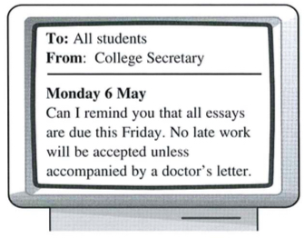 | A. The college secretary will post students their essays on Friday.  B. Students may hand in their essays after Friday if they can prove illness.  C. Unless your essay is due by Friday, you do not need to reply.
52.  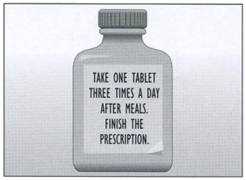 | A. Take the tablets regularly until the bottle is empty.  B. Take one tablet every day until they are finished.  C. Take three tablets after meals until you feel better.
53.  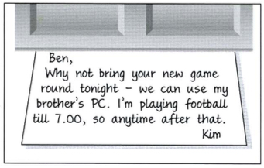 | Kim suggests  A. meeting at the football match  B. going to Ben's house later.  C. playing on his brother's computer.
54.   | A. John can deliver the sofa if the time is convenient  B. Anyone wanting this sofa must pick it up this week.  C. Call John with advice on how he can transport his sofa.
55.  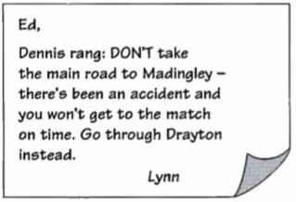 | A. To arrive punctually, Ed should use a different route.  B. Dennis suggests that it's quicker to go on the main road.  C. If there's enough time, Lynn would like to see the match.

II. Read the passage below and decide which option A, B, C or D best fits each space. (10 points)
Although some groups of people have always lived outdoors in tents, camping as we know it today only began to be (56)_______ about 50 years ago. The increase in the use of cars and improvements in camping equipment have (57) _______ more people to travel longer (58) _______ into the countryside and to stay there in greater comfort. Many campers like to be (59) _______ themselves in quiet areas, so they (60) _______ their tent and food and walk or cycle into the forests or the mountains. Others, preferring to be near people , drive to a public or privately-owned campsite (61) _____ has up-to-date facilities ,(62) _______ hot showers and swimming pools. Whether campers are (63) _______ in the mountains or on a busy site, they should remember to (64) _______ the area clean and tidy. In the forests, they must put out any fires and keep food hidden to avoid attracting (65) _______ animals.
56. A. famous B. popular C. favourite D. curent
57.A. asked B. let C. made D. allowed
58. A. part B. directions C. voyages D. distances
59. A. by B. at C. of D. on
60. A. take B. make C. pick D. do
61. A. where B. who C. which D. when
62. A. such B. like C. as D. just
63. A. single B. lonely C. alone D. separate
64. A. remain B. stay C. keep D. let
65. A. wild B. natural C. loose D. free
III. Read the following passage and choose the correct answer. (10 points)
The Hollywood sign in the hills that line the northern border of Los Angeles is a famous landmark recognized the world over. The white – painted, 50 – foot – high, sheet mental letters can be seen from great distances across the Los Angeles basin.
The sign was not constructed, as one might suppose, by the movie business as a means of celebrating the importance of Hollywood to this industry; instead, it was first constructed in 1923 as means of advertising homes for sale in a 500 – acre-housing subdivision in a part of Los Angeles called “Hollywood land”. The sign that was constructed at time, of course, said “Hollywood land”. Over the years, people began referring to the area by the shorten version “Hollywood” and after the sign and its site were donated to the city in 1945, the last four letters were removed.
The sign suffered for years of disrepair, and in 1973, it needed to be completely replaced, at a cost of $ 27,700 per letter. Various celebrities were instrumental in helping to raise needed funds. Rock star Alice Cooper, for example, bought an O in memory of Groucho Marx, and Hugh Hefner of Playboy fame held a benefit party to raise the money for the Y. The construction of the new sign was finally completed in 1978.
66. What is the topic of this passage?
A. A famous sign B. a famous city
C. World landmarks D. Hollywood versus Hollywood land
67. The expression “The world over” in line 2 could best be replaced by _________.
A. in the northern parts of the world B. on top of the world
C. in the entire world D. in the skies
68. It can be inferred from the passage that most people think that the Hollywood sign was first constructed by _______.
A. an advertising company B. the movie industry
C. a construction company D. the city of Los Angeles
69. The pronoun “it” in line 5 refers to _______.
A. the sign B. the movie business
C. the importance of Hollywood D. this industry
70. According to the passage, the Hollywood sign was first built in ________.
A. 1923 B. 1949 C. 1973 D. 1978
71. Which of the following is NOT mentioned about Hollywood land?
A. It used to be the name of an area of Los Angeles.
B. It was formerly the name of the sign in the hills.
C. There were houses for sale there.
D. It was the most expensive area of Los Angeles.
72. The passage indicates that the sign suffered for years of _________.
A. being damaged B. not being fixed
C. the bad weather D. being poorly constructed
73. How old was the Hollywood sign when it was necessary to replace it completely?
A. Ten years old B. Twenty – six years old
C. Fifty years old D. Fifty – five years old
74. The word “replaced” is closest in meaning to which of the following?
A. Moved to a new location B. Destroyed
C. Found again D. Exchanged for a newer one
75. According to the passage, how did celebrities help with new sign?
A. They played instruments.
B. They raised the sign.
C. They helped get the money.
D. They took part in work parties to build the sign.

IV. Read the passage carefully. Then decide whether each of the statements below is TRUE (T), or FALSE (F). (5 points)
Some recent research into conversation between men and women has produced results which will surprise few women. Men are always interrupting women when they talk. One researcher feels that men regard female talk as a kind of conversational housework. They expect women to play a supporting role. So a man interrupts in a display of dominance or control. Men also have a much more unpleasant listening style. Whereas a woman uses gestures or says “Mm”, a man will say such things as “right” or “OK”, thus, setting the stage for an interruption. Conversation of this kind is, then, hardly meaningful communication. Male talk is often argumentative while women are more tentative, asking more questions and tending to build up their replies on what the other person has said. The research would indicate that women are better listeners than men. Yet, listening secretly to conversations between groups of women, one has the impression of several simultaneous monologues into which no man would be able to get a chance to speak.
 | T | F
76. According the writer, men feel that women’s conversation is only a support to their own.
77. The conversation between men and women is not meaningful communication because men do not really listen to what women are saying.
78. The research shows that males are better at listening than females.
79. Men ask more questions and build up their replies on other people’s responses.
80. The writer says that when women talk together, they seem to talk at the same time.

D. WRITING
I. Rewrite each of the following sentences using the words provided. (5 points)
81. In spite of taking a taxi, Bill arrived late at the meeting.
→ Although Bill ..........................................
82. What particularly impressed me was her excellent command of English.
→ I .......................................................................................................................
83. " Let 's go for a walk in the park," said Andrew
→ Andrew suggested ... ..........................................
84. The result of the match was never in doubt.
→ At no time ...........................................................................................................
85. His second attempt on the world record was successful.
→ He broke.............................................
II. You have received some good news and want to tell your friend in Australia about it (10 points).
Your Singaporean pen pal, Susan, is going to visit Viet Nam for a week this summer. She has written to you. Read her letter and write a letter ( about 60 – 80 words) to answer her.

Dear Lan Phuong,
How is everything? My parents have agreed to let me come to Viet Nam this summer. I am going to stay in your country for a week. So, please tell me about the best time I should go? Where can I stay? What should I bring along? Where should I go when I am in Viet Nam? And what can I do?
Write to me soon.
Your friend,
Susan

......................................................................................................................................................………………………………………………………………………………………………………………………………………………………………………………………………………………………………………………………………………………………………………………………………………………………………………………………………………………………………………………………………………………………………………………………………………………………………………………………………………………………………………………………………………………………………………………………………………………………………………………………………………………………………………………………………………………………………………………………………………………………………………………………………………………………………………………………………………………………………
II. Write a paragraph of about 140 -160 words on the following topic:
“The benefits of being able to use a popular foreign language” (15points)

...…………………………………………………………………………………………………………………………………………………………………………………………………………………………………………………………………………………………………………………………………………………………………………………………………………………………………………………………………………………………………………………………………………………………………………………………………………………………………………………………………………………………………………………………………………………………………………………………………………………………………………………………………………………………………………………………………………………………………………………………….....................................
----------------- Hết-----------------

