Period
LESSON PLAN
TIẾNG ANH 10 FRIENDS GLOBAL
UNIT 2: ADVENTURE
LESSON 2A: VOCABULARY - LANDSCAPES
I. OBJECTIVES:
By the end of the lesson, Ss will be able to:
1. Knowledge:
- Know some new knowledge to describe landscapes
- Vocabulary: cliff, hill, valley, shore, stream, shallow, steep, narrow, icy
2. Ability:
- main skills: listening and speaking skills
- sub skills: reading and writing skills
- Apply new words to describe landscape’s features
3. Quality:
- have positive attitude in English language learning so that they can participate enthusiastically in all classroom activities, especially with the topic conducted by the teacher
- know how to describe landscapes
II. TEACHER AIDS AND LEARNING MATERIALS:
Lesson plan, PPT slides, student’s book, workbook, notebook, personal computer (if any), projector/TV. Speakers, IWB software.
III. PROCEDURES:
A. Warm-up (5’)
a) Objective: Introduce the new lesson and set the scene for Ss to acquire new language; get students' attention at the beginning of the class by means of enjoyable and short activities as well as to engage them in the steps that followed.
b) Content: Warm-up game
c) Outcomes: Students can gain more confidence and interest in the lesson
d) Competence: communication, guessing, collaboration
e) Organisation of the activity:

TEACHER’S ACTIVITIES | STUDENT’S ACTIVITIES | CONTENTS
Warm-up T-Ss- T/ Ss – Ss  Game “GUESS THE PICTURE”  - Divide class into groups.  - Each group answers the questions related to the pictures. With one correct answer, that group get one point.  - Lead to the lesson: “Landscapes”. | - Play game in groups.  - Volunteer to answer.  - Each group will answer the questions on screen. With a correct answer, students will get one point.  - Open the book page 22. | 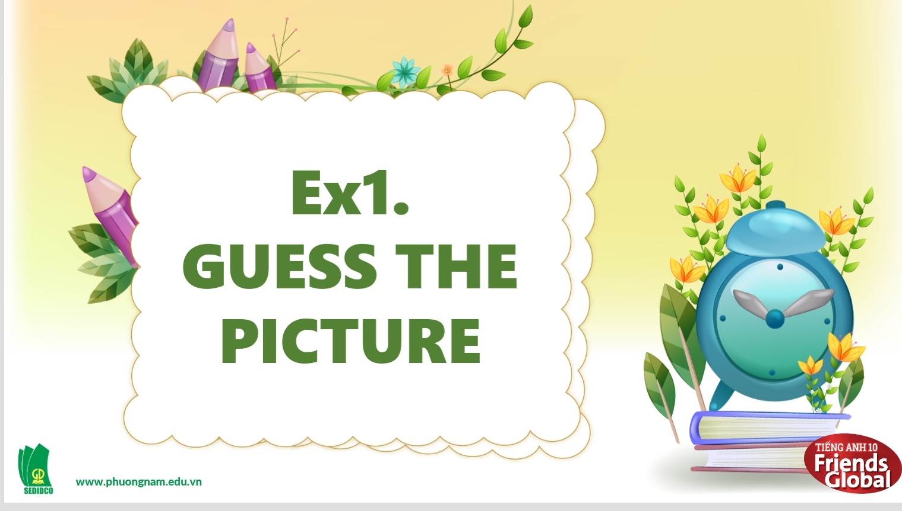  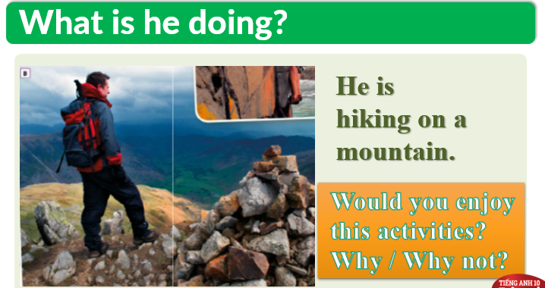  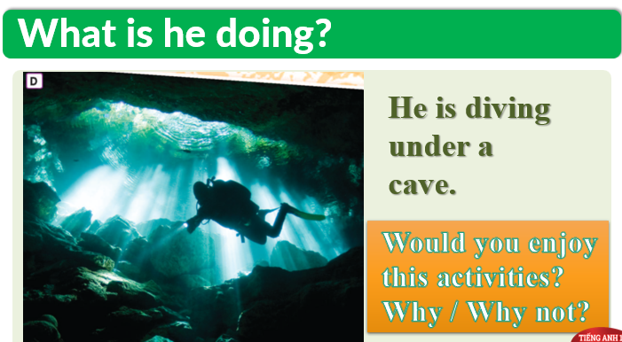

B. New lesson (35’)
- Activity 1: Vocabulary (15’)
a) Objective: Ss know more words about feelings
b) Content:
Vocabulary
Listening
c) Outcomes: Ss know how to pronounce the new words precisely and use them in appropriate contexts.
d) Competence: communication, collaboration, presentation
e) Organisation of the activity:

TEACHER’S ACTIVITIES | STUDENT’S ACTIVITIES | CONTENTS
PRESENTATION. T -Ss- T/ Ss- Ss/ Individual  Activity 1 (4’): Teach new vocabulary.  - Use pictures and explanation to present new words.  - Have students practice their pronunciation drills.  New words:  Cliff (n)  Hill (n)  Valley (n)  Shore (n)  Stream (n)  Activity 2 (2’): Show the differences in some places.  - Present some differences between ‘Hill’ and ‘Mountain’.  - Introduce some differences among ‘Stream’, ‘River’, ‘Lake’, ‘Ocean’. (optional)  - Tell students about ‘Water cycle’.  Activity 3 (5’): Task 2 page 22.  - Ask the students to match two or more of the nouns below with each photo (A-E).  - After students finish matching, play the audio of each picture for students to check their answers.  - Give the answers to the class.  Activity 4 (4’): Teach new words.  - Use pictures and explanation to present new words.  - Have students practice their pronunciation drills.  New words:  Shallow (a)  Steep (a)  Narrow (a)  Icy (a) | - Some students will answer the question.  - Listen to the teacher.  - Look, listen, and repeat in chorus and individuals  - Listen to the teacher carefully and take notes.  - Complete the task.  - Listen to the audios to check the answers.  - Check the answers with the teacher.  - Look, listen, and repeat in chorus and individuals | New words:  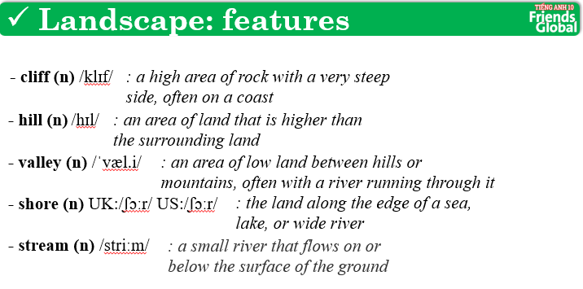  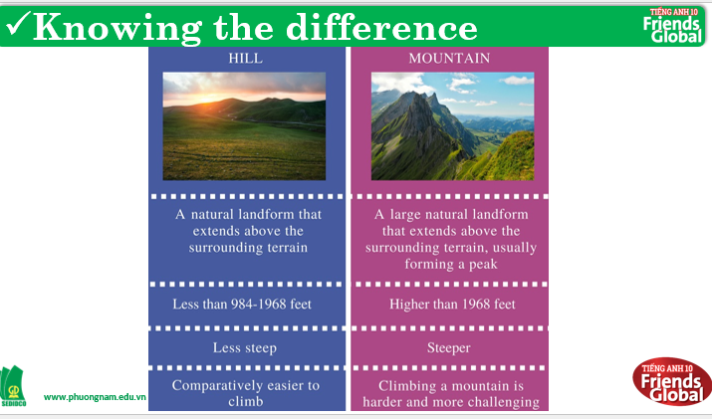  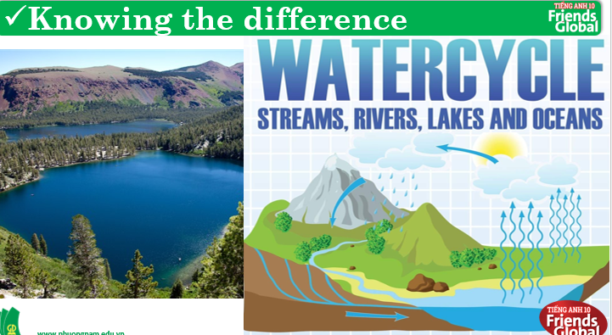  Water Cycle: There are four main parts to the water cycle: Evaporation, Convection, Precipitation and Collection. Evaporation is when the sun heats up water in rivers or lakes or the ocean and turns it into vapour or steam. The water vapour or steam leaves the river, lake or ocean and goes into the air.  Answers:  A. forest, river, rock, waterfall  B. hill, valley, rock  C. cliff, ocean, rock  D. cave, ocean, rock  E. lake, mountain, shore  New words:  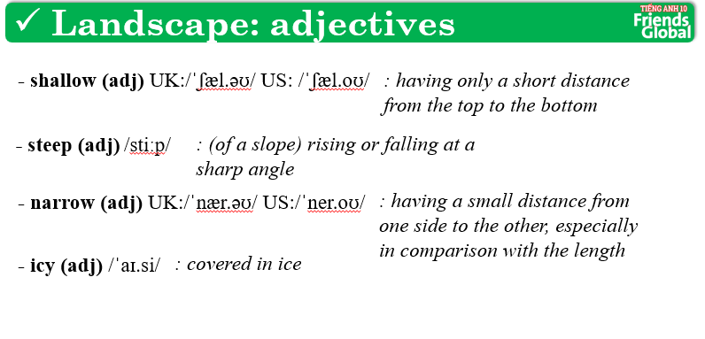
- Activity 2 Practice (15’)
a) Objective: Ss can answer the questions to critical thinking, and they can also finish the tasks in the textbook. Critical thinking skills (guessing/ reasoning) and communication can also be practiced.
b) Content: Students answer questions, classify words, choose the correct answer, listen and complete, listen and match.
c) Outcomes: Ss read and listen, and they can apply the useful language in everyday listening and speaking.
d) Competence: collaboration, guessing, matching, communication
e) Organisation of the activity:
TEACHER’S ACTIVITIES | STUDENT’S ACTIVITIES | CONTENTS
PRACTICE. T-Ss- T/ S – S/ Indiv.  Activity 1 (2’): Task 3 page 22.  - Ask students to look at the given words and find three pairs of opposites.  - Check the answers.  Activity 2 (3’): Work in groups. Match each adjective in exercise 3 with two or more nouns from exercise 2.  - Ask students to work in groups and match quickly. Which group get the fastest answers can have one bonus.  - Time limit is 2 minutes. Click ‘Start Timer’ to start the time. When time’s up, click ‘Check’ to show the answers.  Activity 3 (5’): Task 5 page 23. Listen and match.  - Ask students to listen to four adverts and match three of them with photos A-E.  - Play the audio.  - Check the answers.  Activity 4 (5’): Listen and complete.  - Ask students to listen and complete the extracts (1-6) using the prepositions below, nouns from exercise 2 and adjectives from exercise 3.  - Play the recording.  - Check the answers and play the small part of each sentence to make sure students can listen well. | - Find three pairs or opposites.  - Check the answers with the teacher.  - Volunteer to answer.  - With the quickest answers, students can get bonus point.  - Check the answers with the teacher.  - Listen to the teacher carefully.  - Complete the task.  - Check the answers with the teacher.  - Read the task carefully.  - Listen and complete.  - Check the answers with the teacher. | Answers:  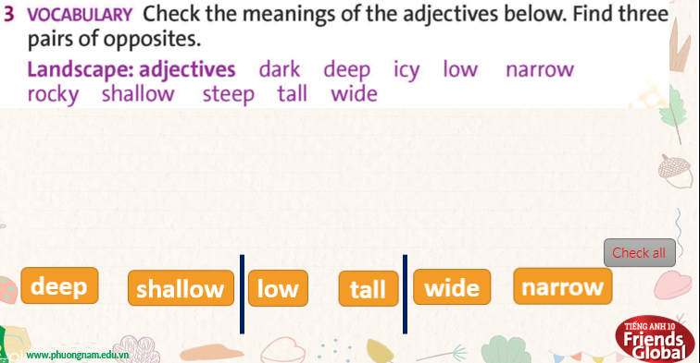  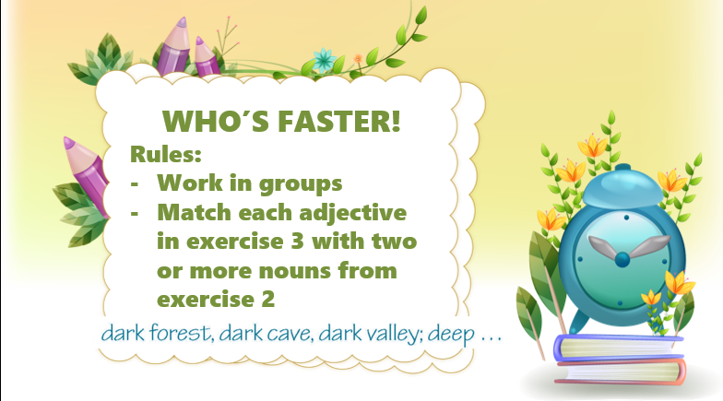  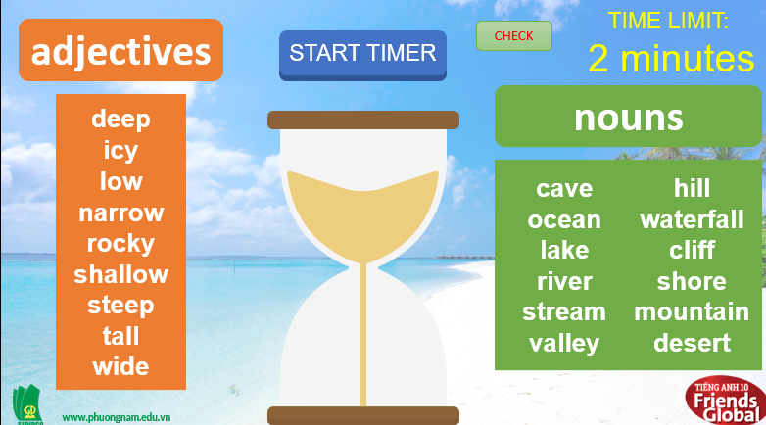  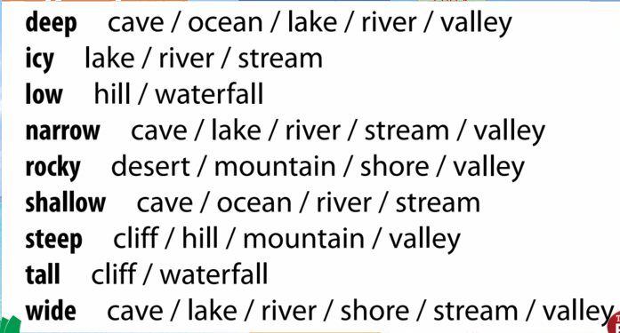  Answers:  1E  2D  3_  4A  Answers:  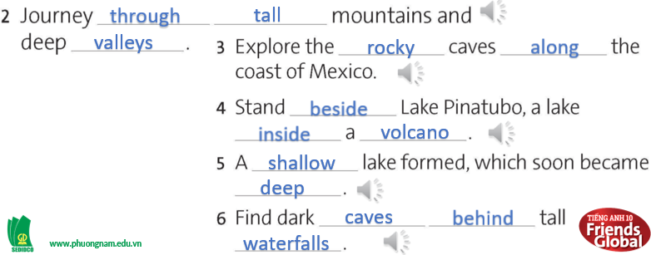

- Activity 3: Outcomes (5’)
a) Objective: Ss can answer the question to describe feelings in some situations. Communication is also be practiced.
b) Content: Game ‘Lucky Numbers’
c) Outcomes: Ss speak and listen mutually, they can new words they have learnt in their conversation.
d) Competence: Collaboration, communication
e) Organisation of the activity:
TEACHER’S ACTIVITIES | STUDENT’S ACTIVITIES | CONTENTS
PRODUCT. S – S/ T – Ss  Game ‘LUCKY NUMBERS’  - Give 6 pictures and names of six significant locations in Vietnam.  - Ask students work in pairs and pick a number from 1 to 6 to make sentences. One student will use suggested words to describe the picture. The other one will close his/her eyes and try to guess the place.  - Invite some pairs to play and click “Roll” to give points. Click on the red arrow to stop the wheel.  - After playing, click ‘‘Exit’’ to turn to page Homework. | - Work in pairs, discuss to make sentences.  - With one correct answer, students can get points.  - Some can volunteer to present their ideas. |   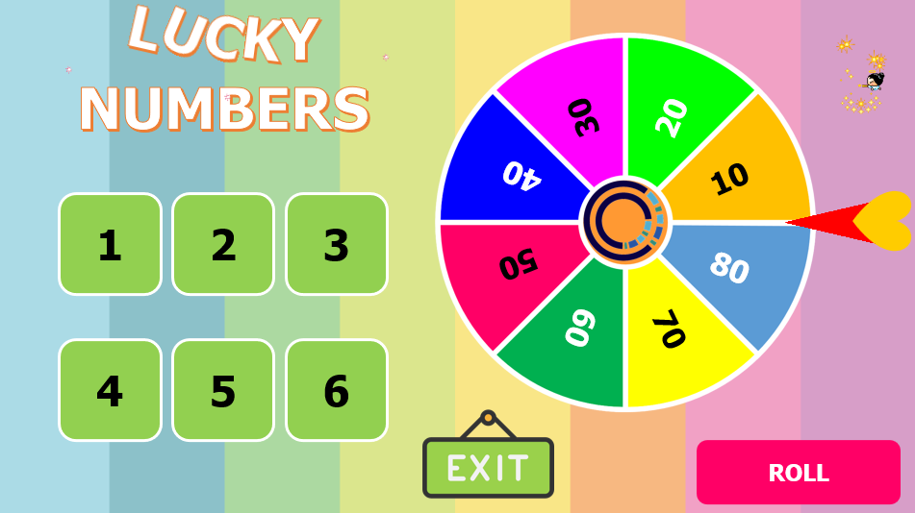  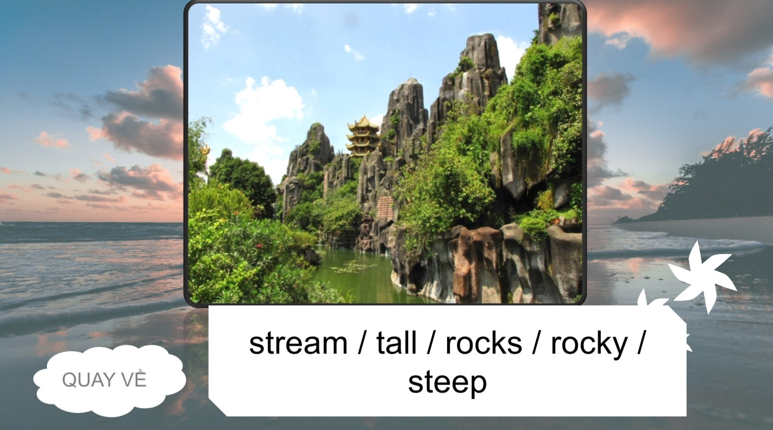
C. Consolidation (3’)
a) Vocabulary: cliff, hill, valley, shore, stream, shallow, steep, narrow, icy
b) Describe landscapes
D. Homework (2’)
- Learn by heart new words.
- Practice describing landscape’s features
- Do exercise in the workbook
- Prepare: Unit 1 – B-Grammar (page 24 – SB)

