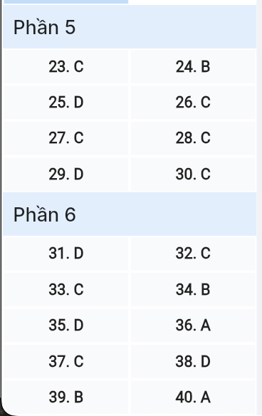
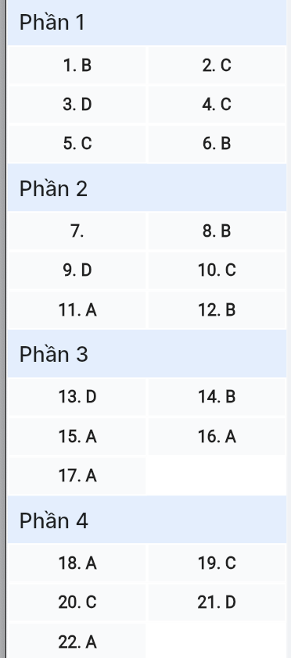
ĐỀ MINH HỌA SỐ 09
KỲ THI TỐT NGHIỆP TRUNG HỌC PHỔ THÔNG NĂM 2025
(Đề thi có 08 trang)
Môn thi: TIẾNG ANH
Thời gian làm bài: 50 phút, không kể thời gian phát đề

Read the following advertisement and mark the letter A, B, C or D on your answer sheet to indicate the option that best fits each of the numbered blanks from 1 to 6.

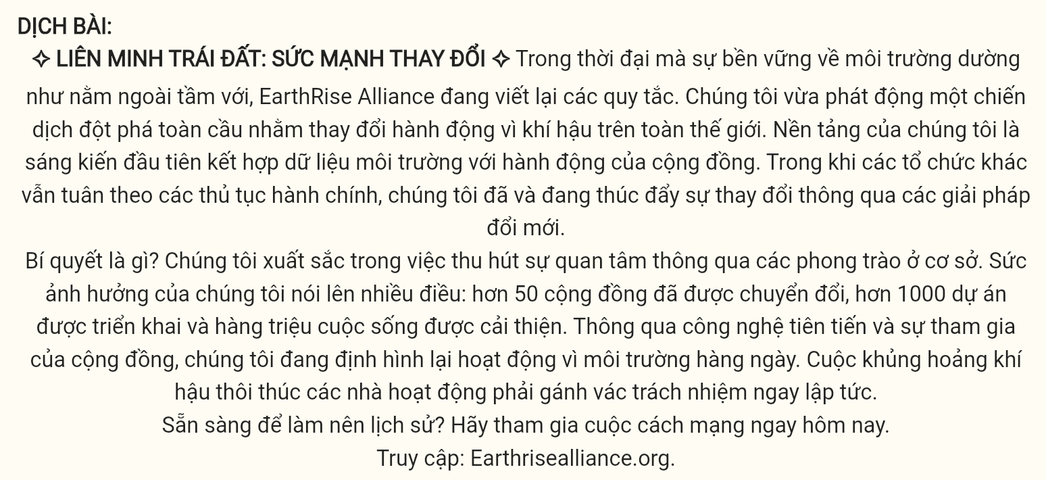
EARTHRISE ALLIANCE: POWER TO CHANGE ☀
In an era where environmental (1) ______ seems out of reach, EarthRise Alliance is rewriting the rules. We’ve just launched an (2) ______ that’s transforming climate action worldwide. Our platform stands as the first initiative (3) ______ environmental data with community action. While other organizations remain (4) ______ bureaucratic procedures, we’re already driving change through innovative solutions.
The secret? We excel at (5) ______ momentum through grassroots movements. Our impact speaks volumes: 50+ communities transformed, 1000+ projects launched, and millions of lives improved. Through cutting-edge technology and community engagement, we’re reshaping environmental activism daily. The climate crisis urges activists (6) ______ immediate responsibility.
Ready to make history? Join the revolution today. Visit: earthrisealliance.org
(Adapted from Global Environmental Review)
Question 1 [696224]: A. sustainment B. sustainability C. sustainable D. sustaining
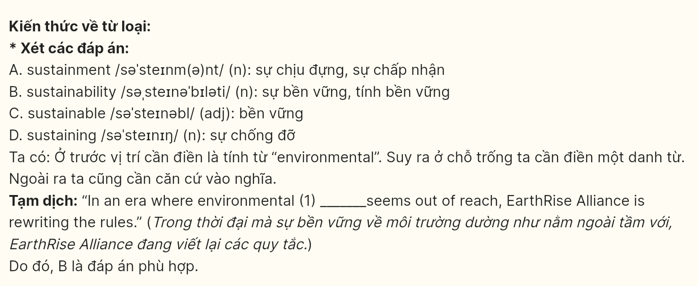
Question 2 [696225]: A. breakthrough global campaign B. campaign breakthrough global
C. global breakthrough campaign D. campaign global breakthrough
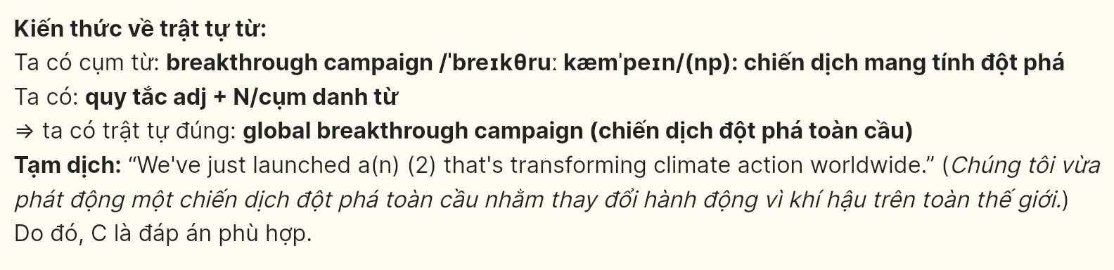
Question 3 [696226]: A. merging B. merge C. merged D. to merge
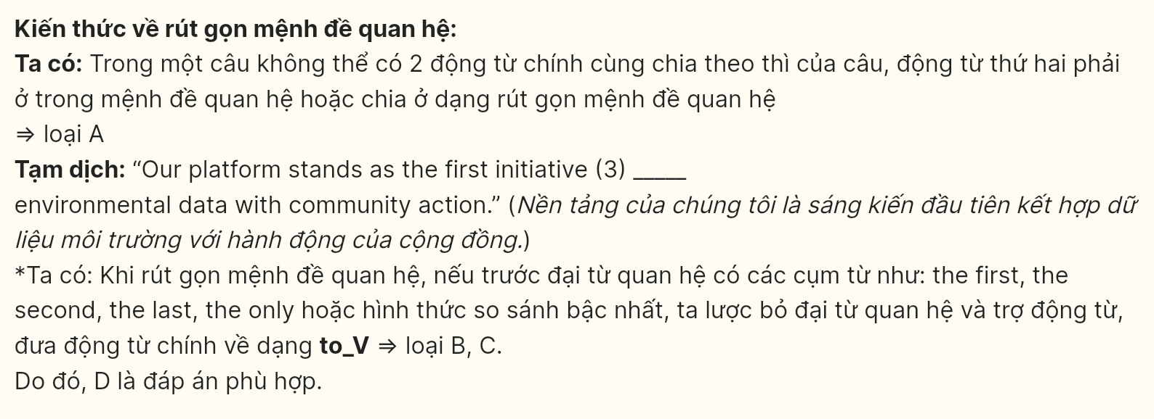
Question 4 [696227]: A. in B. at C. under D. within
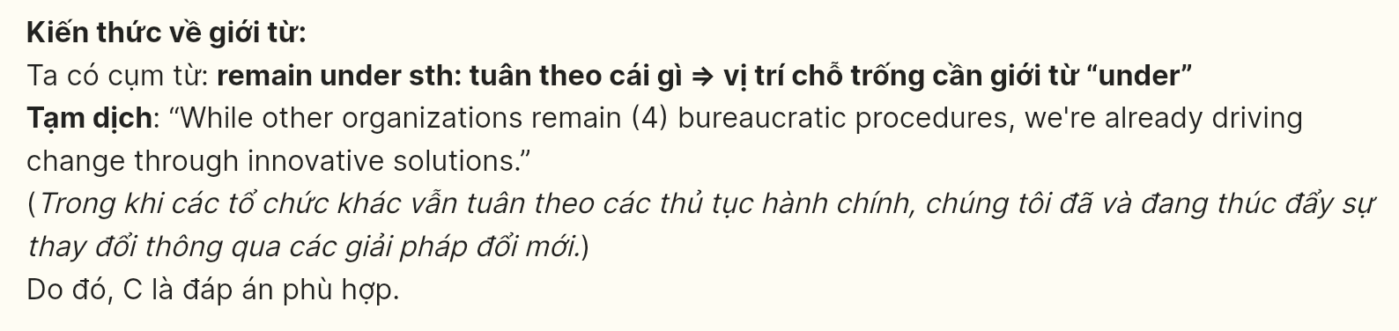
Question 5 [696228]: A. attaining B. building C. gathering D. mounting
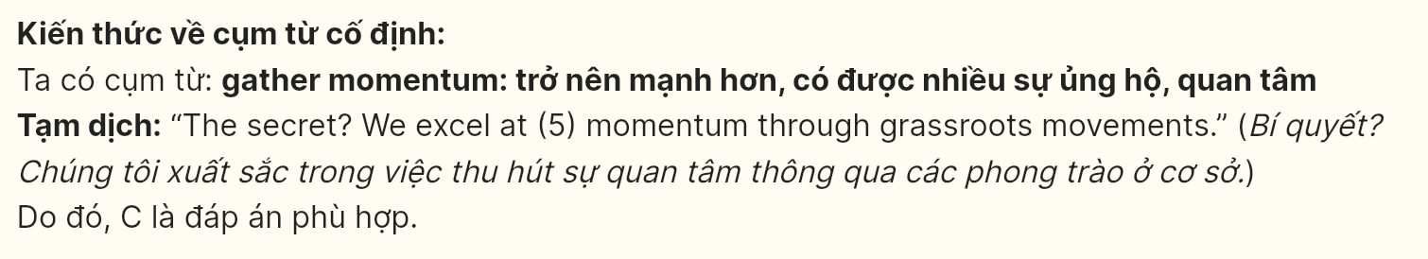
Question 6 [696229]: A. taking B. to take C. to taking D. take
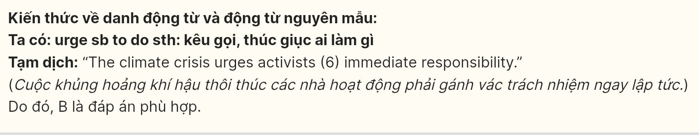
Read the following leaflet and mark the letter A, B, C or D on your answer sheet to indicate the option that best fits each of the numbered blanks from 7 to 12.
Understanding the Generation Gap
In today’s fast-paced world, the concept of the generation gap has become increasingly (7) ______. It reflects the differences in values between various age groups, often leading to misunderstandings and conflicts. While older generations may value stability and tradition, younger generations often prioritize innovation and change.
This divergence can be particularly evident in interactions and communication (8) ______ where technology plays a significant role. (9) ______ while the younger demographic tends to favor social media platforms for engagement, their elders might prefer face-to-face conversations or emails.
Such differences can (10) ______ tension within families and workplaces, prompting the need for effective dialogue. Bridging this gap is crucial for fostering understanding and collaboration across age groups. How can we approach this challenge? By recognizing that (11) ______ perspectives are valid, we can work towards a more harmonious (12) ______.
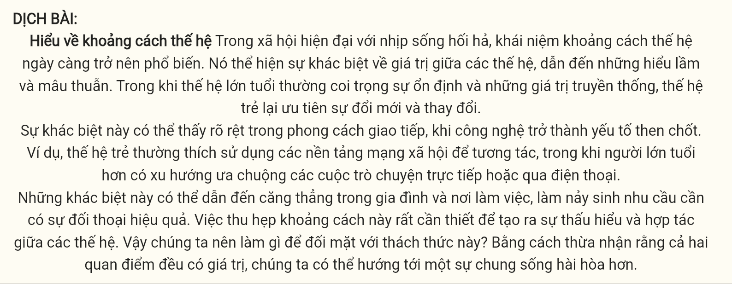
Question 7 [696230]: A. prevalent B. wealthy C. aggressive D. idealistic
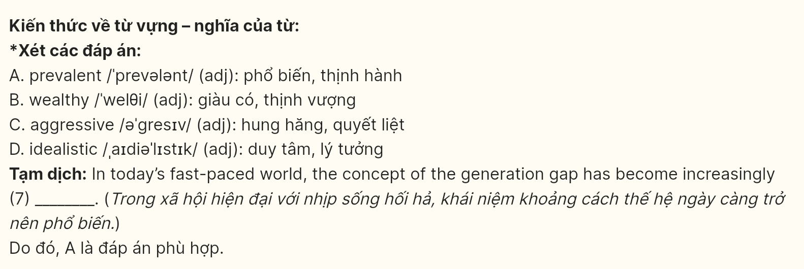
Question 8 [696231]: A. kinds B. styles C. sorts D. types
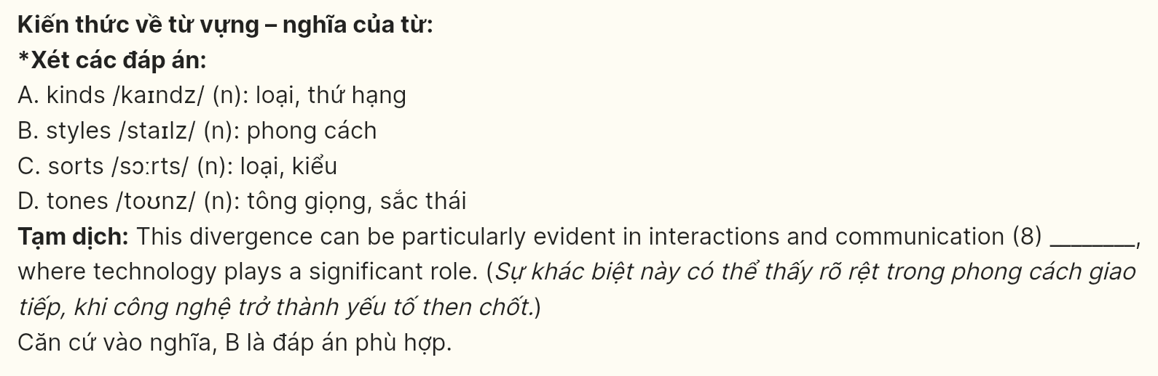
Question 9 [696232]: A. After all B. In case C. Along with D. For instance
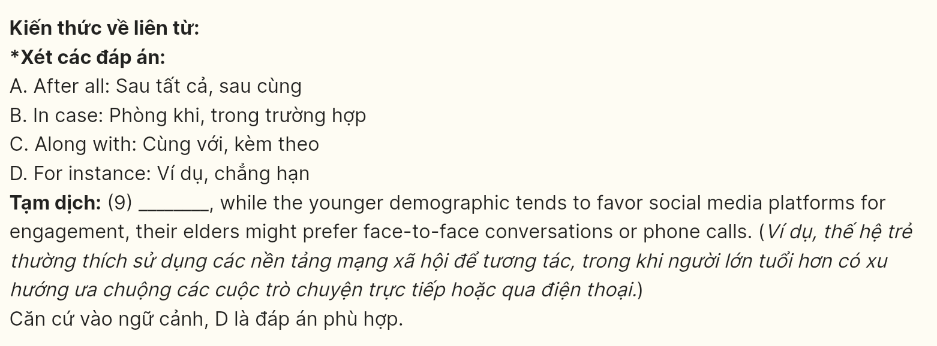
Question 10 [696233]: A. spread over B. dispose of C. result in D. fall behind
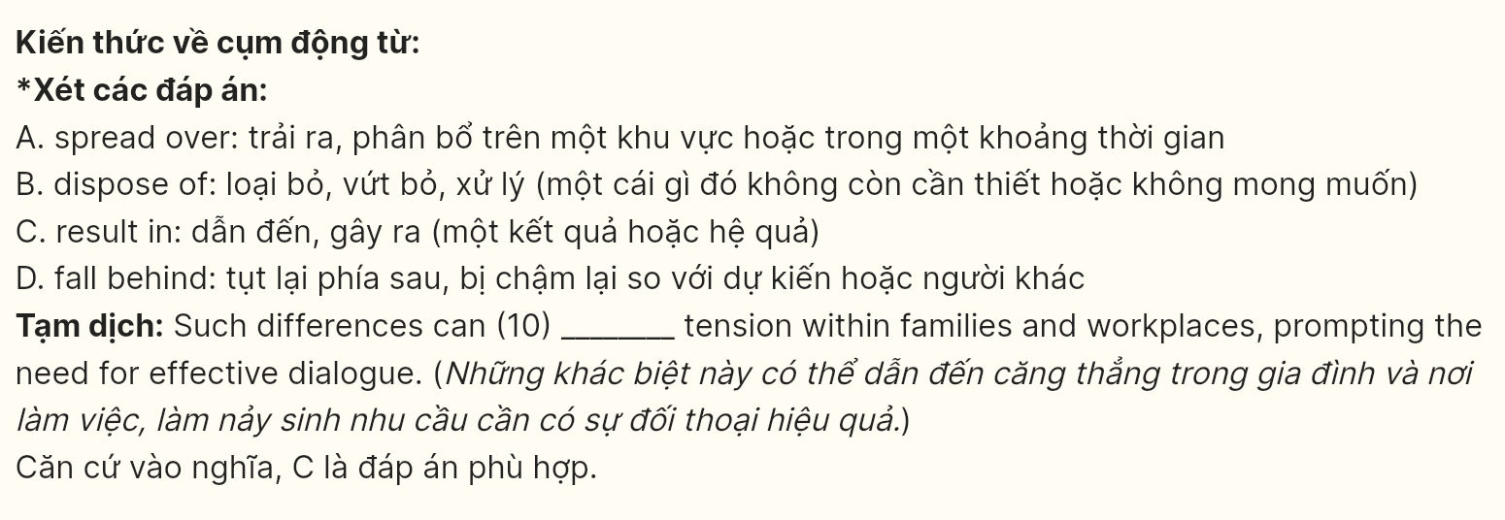
Question 11 [696234]: A. both B. much C. none D. each
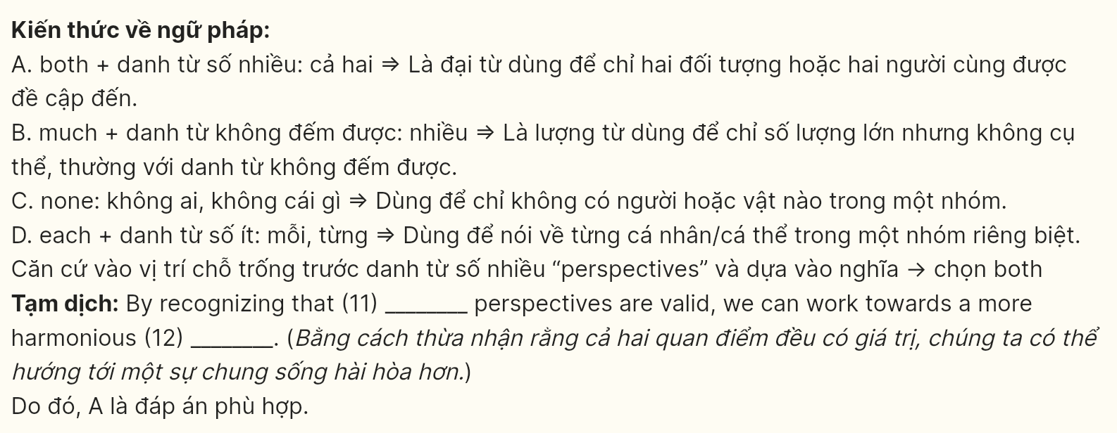
Question 12 [696235]: A. inclusiveness B. coexistence C. characteristic D. disagreement
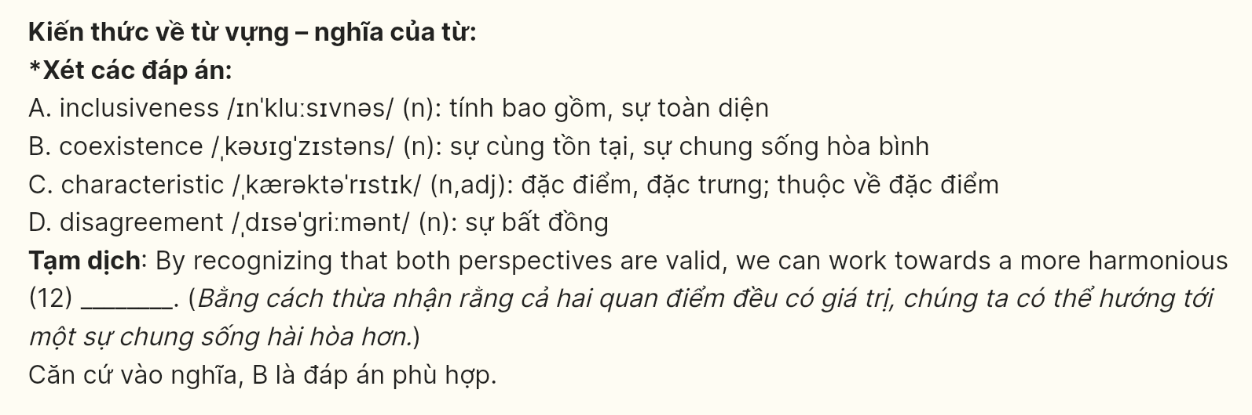
Mark the letter A, B, C, or D on your answer sheet to indicate the best arrangement of utterances or sentences to make a meaningful exchange or text in each of the following questions from 13 to 17.
Question 13 [696236]:
a. Alice: Hey, how have your classes been this week?
b. Alice: That sounds tough! I’ve been busy with my essays, but I’m trying to manage my time better.
c. Bob: They’ve been challenging, especially in science. I have a lot of homework!
A. a - b – c B. c - a – b C. b - a – c D. a - c - b
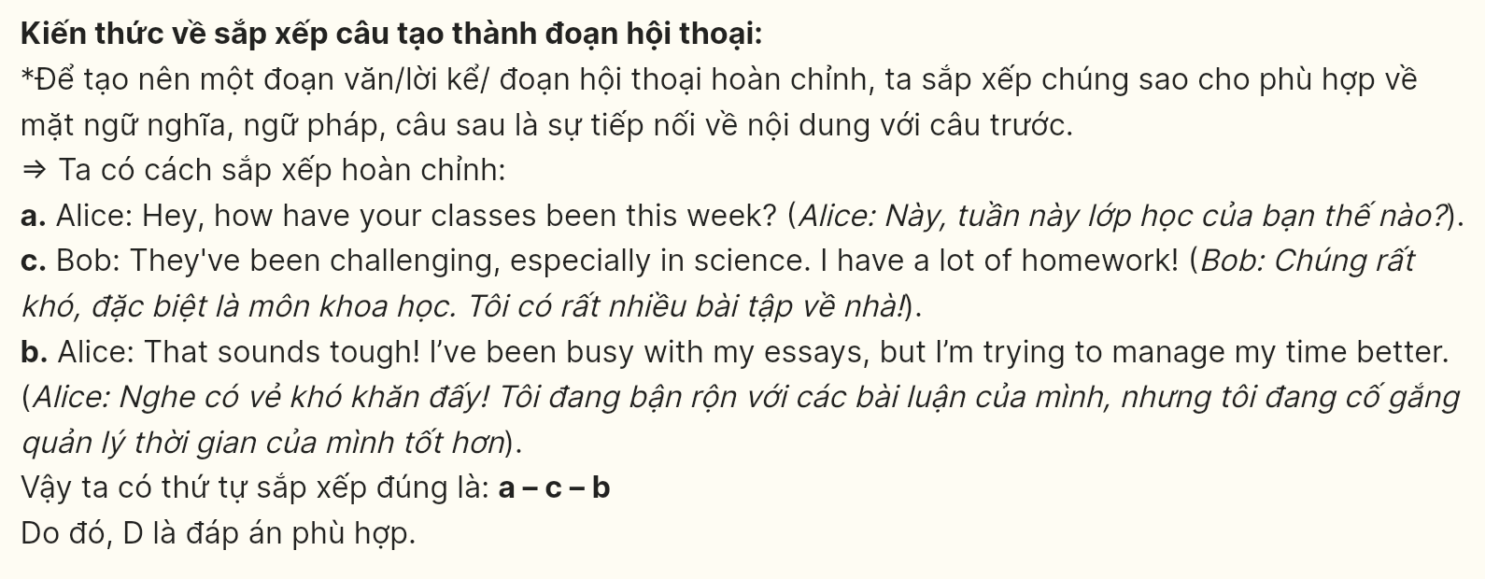
Question 14 [696237]:
a. James: Not really. I’ve been so busy with schoolwork. How about you?
b. Emily: Hey, have you been keeping up with your exercise routine lately?
c. Emily: I’ve been trying to stay active by going for runs on the weekends. It really helps me feel better!
d. James: That sounds great! I should probably start doing something similar to relieve some stress.
e. Emily: Definitely! Maybe we could go for a run together sometime?
A. b-c-a-e-d B. b-a-c-d-e C. d-e-a-b-c D. d-e-c-a-b
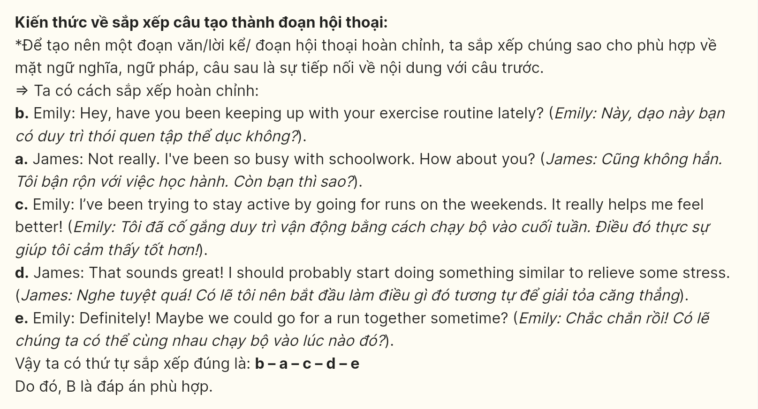
Question 15 [696238]:
Dear Emily,
a. They work tirelessly to save abandoned and injured animals, providing them with shelter and medical care.
b. I think it would be wonderful if we could volunteer together, helping to care for these animals and finding them loving homes.
c. I want to tell you about an amazing organization called “Animal Rescue Team.”
d. They have regular events where we can meet other animal lovers and make a difference in our community.
e. Let me know if you’re interested, and we can plan a visit!
Write back soon,
Mike
A. c - a - d - b – e B. b - d - e - c – a C. a - c - b – d - e D. d - e - a - c - b
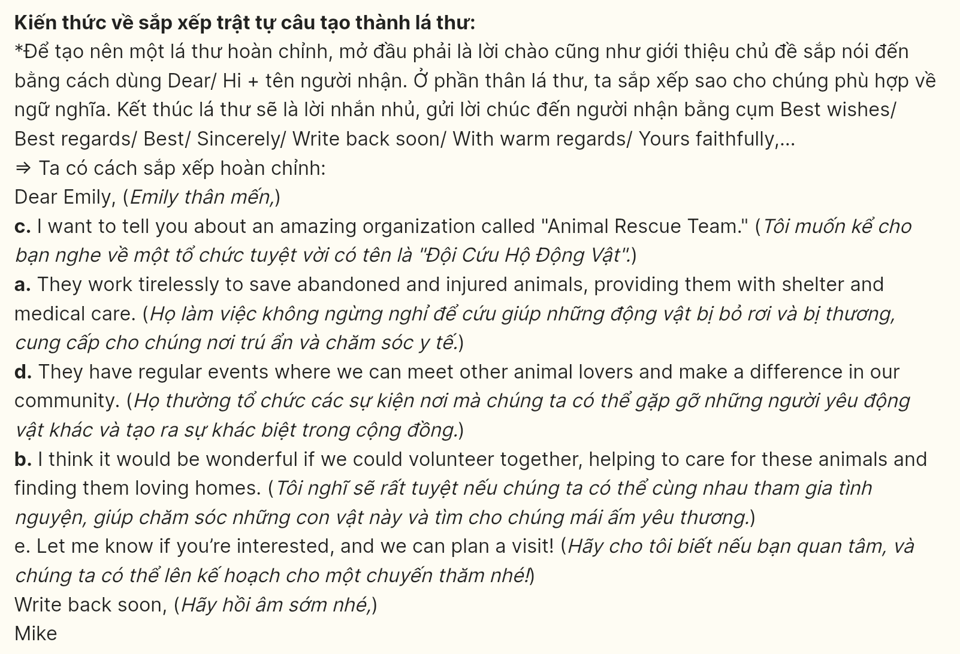
Question 16 [696239]:
a. Ultimately, cultural identity empowers young individuals to celebrate who they are while engaging with the world around them.
b. This blend of tradition and modernity enriches the global community, fostering understanding and respect among different cultures.
c. By embracing their cultural roots, youth can confidently share their unique perspectives and creativity.
d. In today’s globalized world, cultural identity plays a vital role in helping young people express themselves.
e. It provides a sense of belonging and pride, allowing them to connect with their heritage while navigating diverse influences.
A. d - e - c - b – a B. b - c - d - e – a C. c - e - b - d – a D. b - d - c - e - a
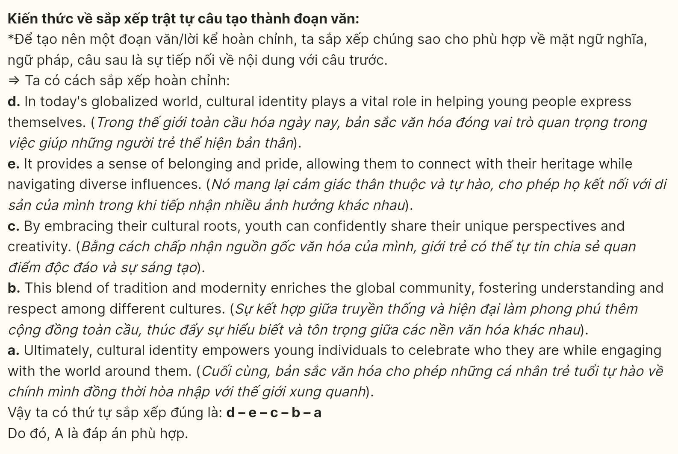
Question 17 [696240]:
a. This technology is increasingly being utilized in sectors such as healthcare, finance, and transportation, improving efficiency and decision-making.
b. Artificial Intelligence (AI) has rapidly transformed various industries, making significant strides in recent years.
c. As AI continues to evolve, its impact on society and the economy will only grow, shaping the future of work and innovation.
d. For instance, AI algorithms can analyze medical data to provide diagnostic assistance, potentially reducing diagnostic errors by up to 30%.
e. According to a report by McKinsey, the global AI market is projected to reach $126 billion by 2025, reflecting a compound annual growth rate of 20%.
A. b-e-a-d-c B. b-a-e-c-d C. b-c-e-d-a D. b-c-a-d-e
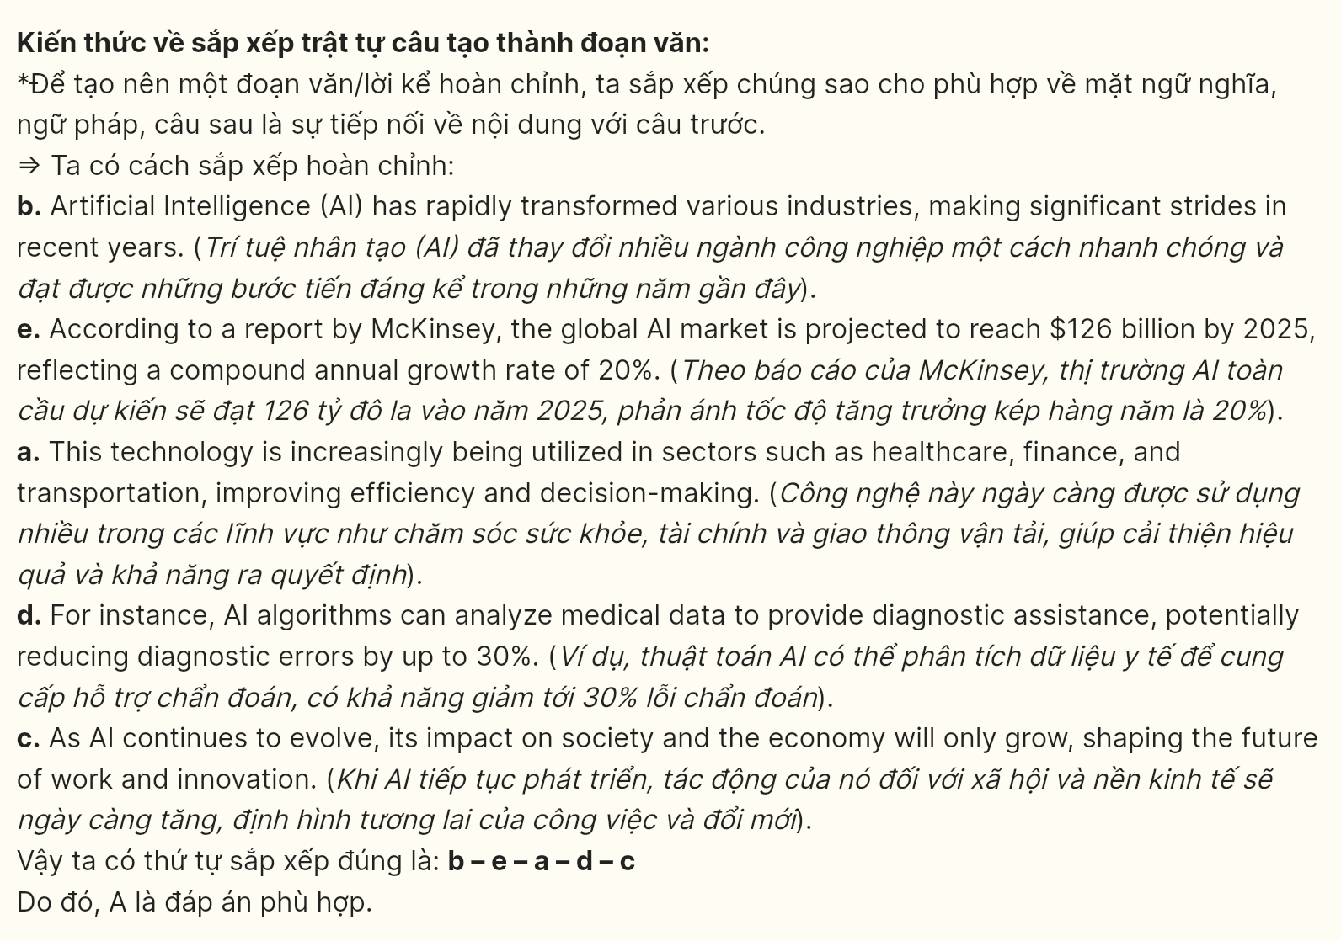
Read the following passage and mark the letter A, B, C or D on your answer sheet to indicate the option that best fits each of the numbered blanks from 18 to 22.
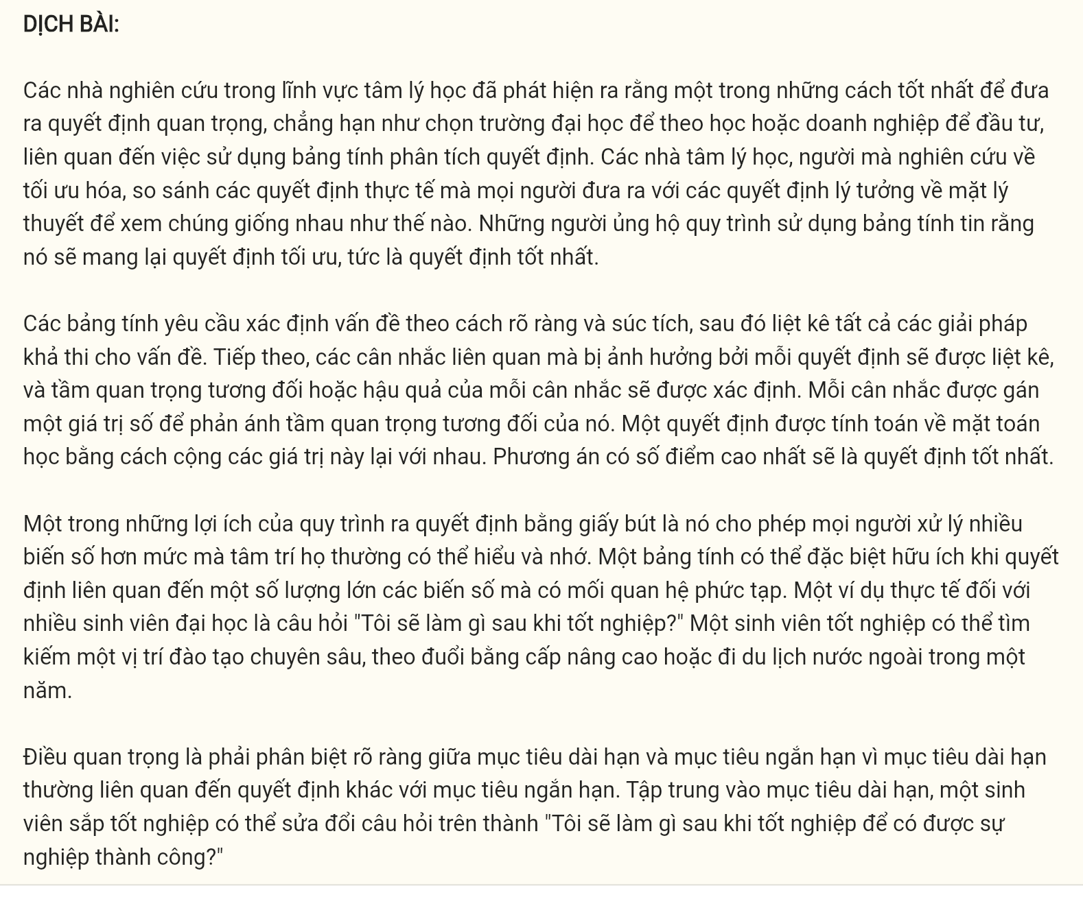
Researchers in the field of psychology have found that one of the best ways to make an important decision, such as choosing a university to attend or a business to invest in, is (18) ______. Psychologists (19) ______ to see how similar they are. Proponents of the worksheet procedure believe that it will yield optimal, that is, the best decisions.
Worksheets require defining the problem in a clear and concise way and then listing all possible solutions to the problem. Next, the pertinent considerations that will be affected by each decision are listed, and the relative importance of each consideration or consequence is determined. Each consideration is assigned a numerical value to reflect its relative importance. (20) _________. The alternative with the highest number of points emerges as the best decision.
One of the benefits of a pencil-and-paper decision-making procedure is that it permits people to deal with more variables than their minds can generally comprehend and remember. (21) ______ A realistic example for many college students is the question “What will I do after graduation?” A graduate might seek a position that offers specialized training, pursue an advanced degree, or travel abroad for a year. It is important to be clear about the distinction between long-range and immediate goals because long-range goals often involve a different decision than short-range ones. Focusing on long-range goals, (22) ______.
Question 18 [696241]:
A. involves the utilization of a decision worksheet
B. involving the utilization of a decision worksheet
C. the utilization of which involves a decision worksheet
D. that involves the utilization of a decision worksheet
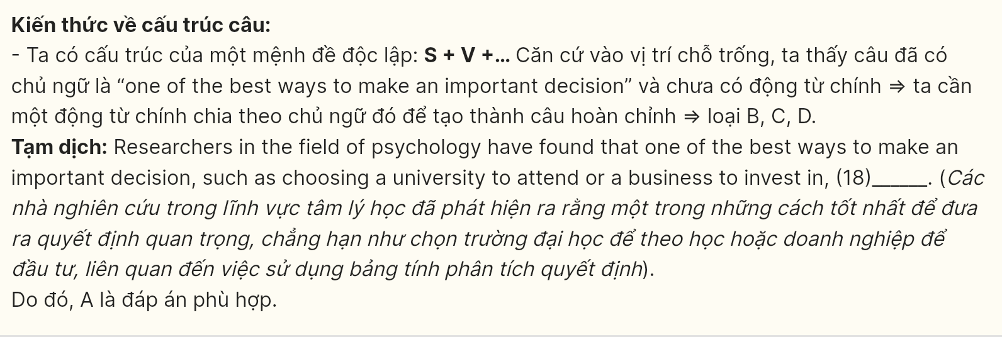
Question 19 [696242]:
A. that studies optimization compare the actual decisions made by people to theoretical ideal decision
B. study optimization compares the actual decisions made by people to theoretical ideal decision
C. who study optimization compare the actual decisions made by people to theoretical ideal decisions
D. study optimization comparing the actual decisions made by people to theoretical ideal decision
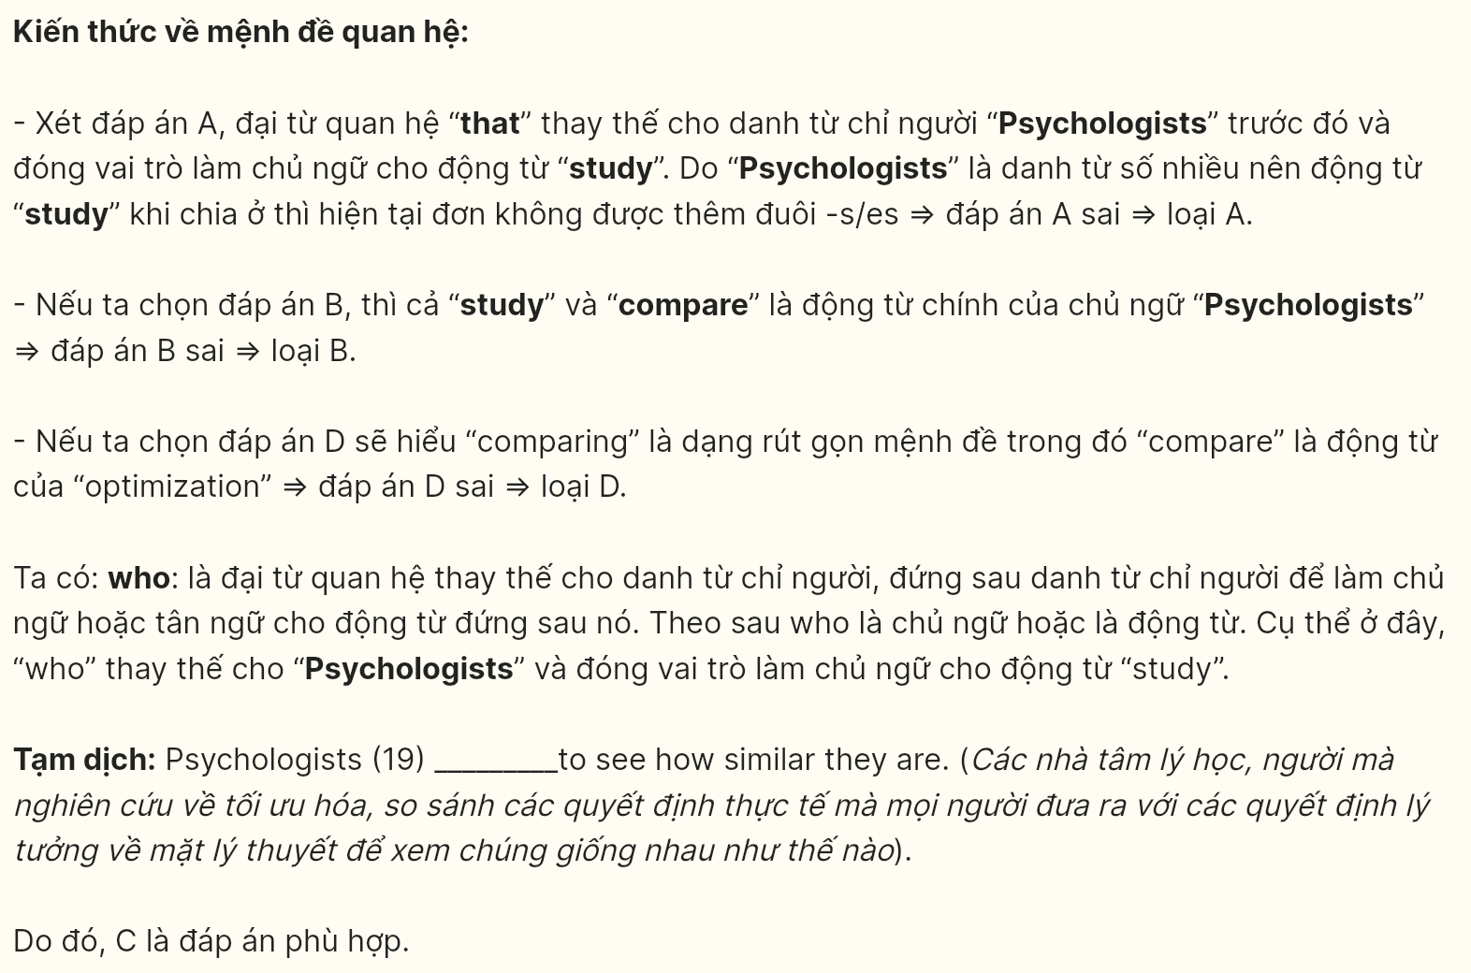
Question 20 [696243]:
A. Many calculations are used to find out the final result
B. A mathematical decision can be calculated at once
C. A decision is mathematically calculated by adding these values together
D. The calculated result may be incorrect in some cases
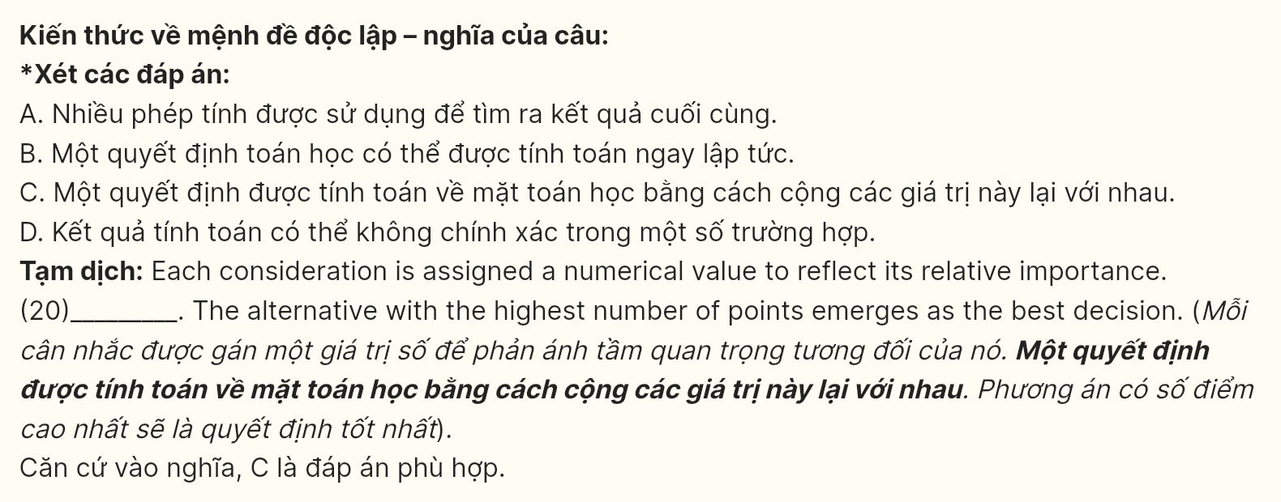
Question 21 [696244]:
A. People have become too reliant on technology despite their capability to complete tasks on their own
B. In these cases, human decisions can surpass worksheets because they can incorporate intuition, emotions, and complex understanding
C. A worksheet can be entirely unnecessary when it comes to dealing with complex relationships with several variables
D. A worksheet can be especially useful when the decision involves a large number of variables with complex relationships
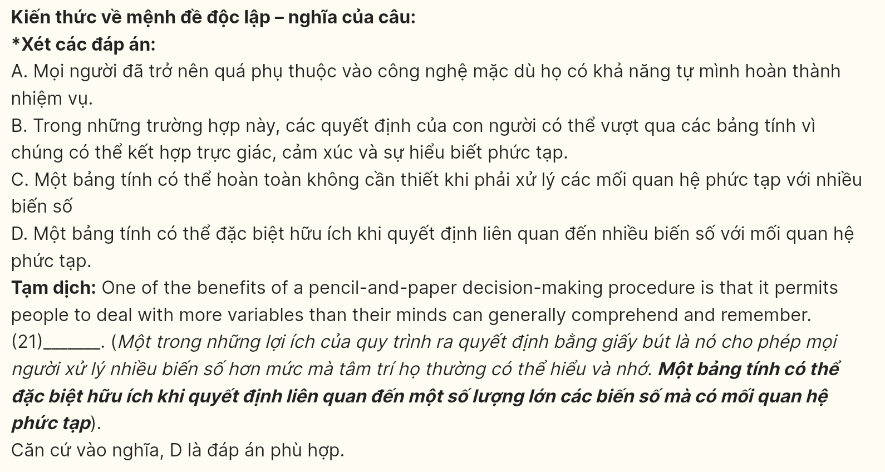
Question 22 [696245]:
A. A graduating student might revise the question above to "What will I do after graduation that will lead to a successful career?"
B. Their answer to the aforementioned question of a graduating student can easily be given thanks to his/her friends' advice.
C. Decisions made by worksheets can make a graduating student struggle to find a stable and successful career path.
D. A graduating student may lose their independence in thinking due to being excessively reliant on advanced technology.
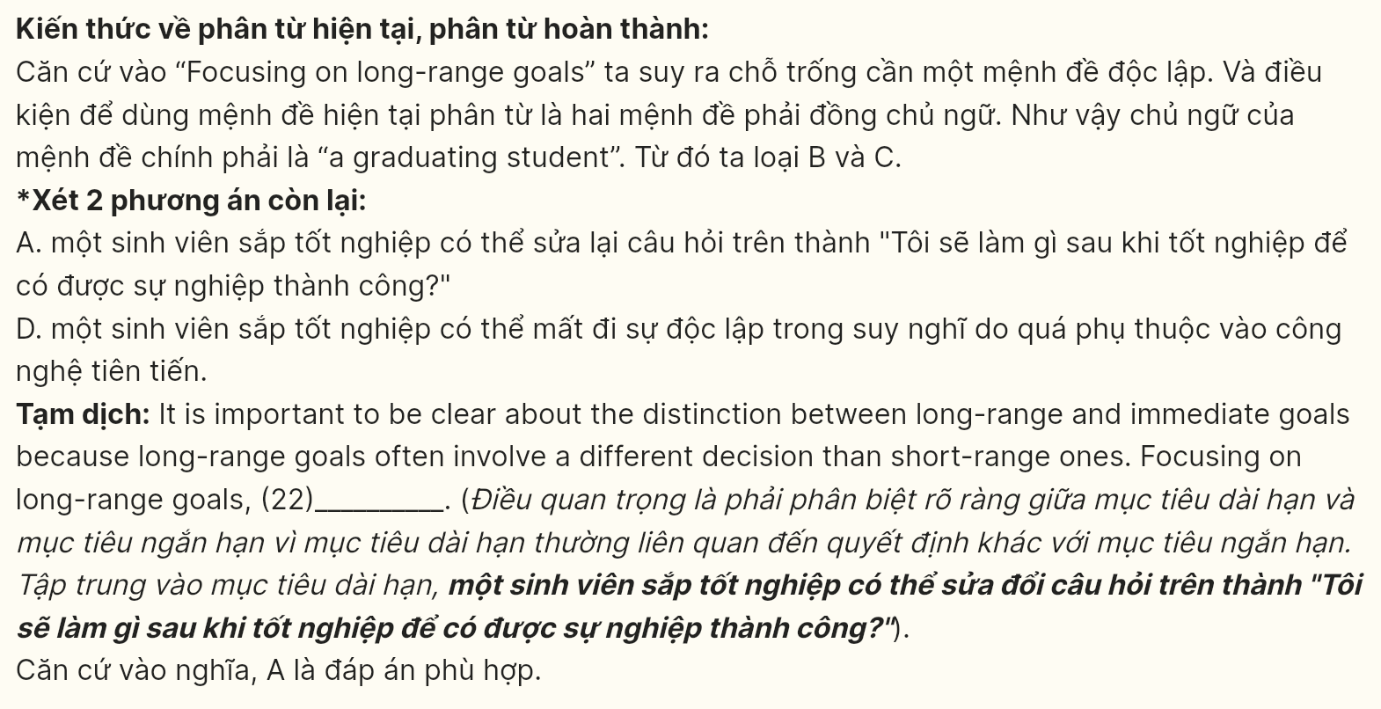
Read the following passage about family conflicts and mark the letter A, B, C or D on your answer sheet to indicate the best answer to each of the following questions from 23 to 30.
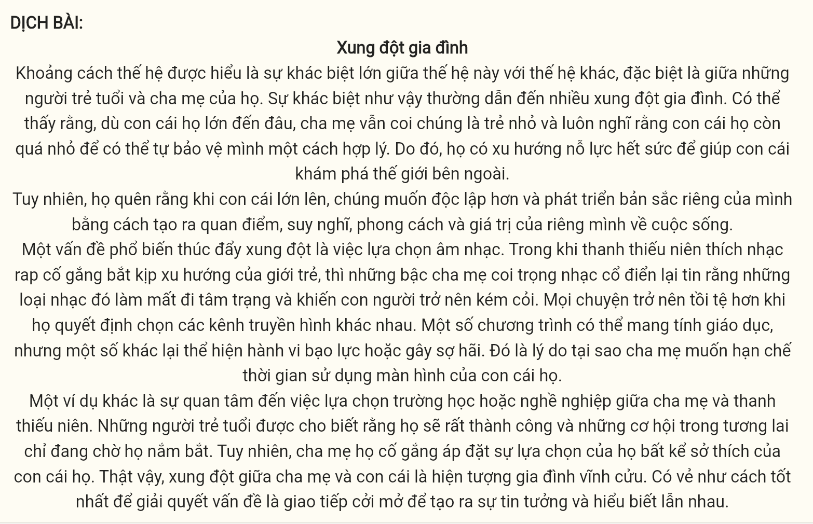
Family Conflicts
The generation gap is understood as a broad difference between one generation and another, especially between young people and their parents. Such a difference usually leads to numerous family conflicts. It can be seen that, however old their children are, parents still see them as small kids and keep in mind that their offspring are too young to protect themselves reasonably. Therefore, they tend to make a great effort to help their children to discover the outside world.
However, they forget that when children grow up, they want to be more independent and develop their own identity by creating their own opinions, thoughts, styles and values about life.
One common issue that drives conflicts is the selection of music. While teens are keen on rap music which tries to catch up with the youth trends, parents who value classical music believe that those kinds of music violate the mood and cause poor human sense. It becomes worse when they decide on different TV channels. Some programs can be educational, but others show violent behaviors or fear. That is the reason why parents want to limit their children's screen time.
Another example is the interest in choosing schools or careers between parents and teenagers. Young people are told that they have the world at their feet and that future opportunities are just waiting for them to seize. However, their parents try to impose their choices regardless of their children's preferences. Indeed, conflicts between parents and children are an everlasting family phenomenon. It seems that the best way to solve the matter is open communication to create mutual trust and understanding.
(Adapted from C21 Smart 11 - Course Book)
Question 23 [696246]: Which of the following best paraphrases the underlined sentence in paragraph 1?
A. Thus, they usually neglect to support their children in understanding the outside environment.
B. Consequently, parents often find it challenging to allow their children to experience life independently.
C. As a result, parents usually work hard to assist their children in exploring the world around them.
D. Hence, they frequently discourage their children from learning about the world outside their home.
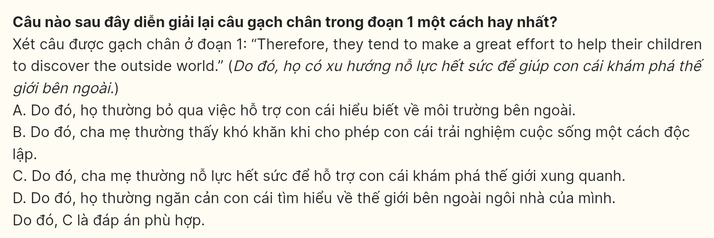
Question 24 [696247]: The word keep in mind in paragraph 1 could be best replaced by ______.
A. regret B. suppose C. impose D. forget
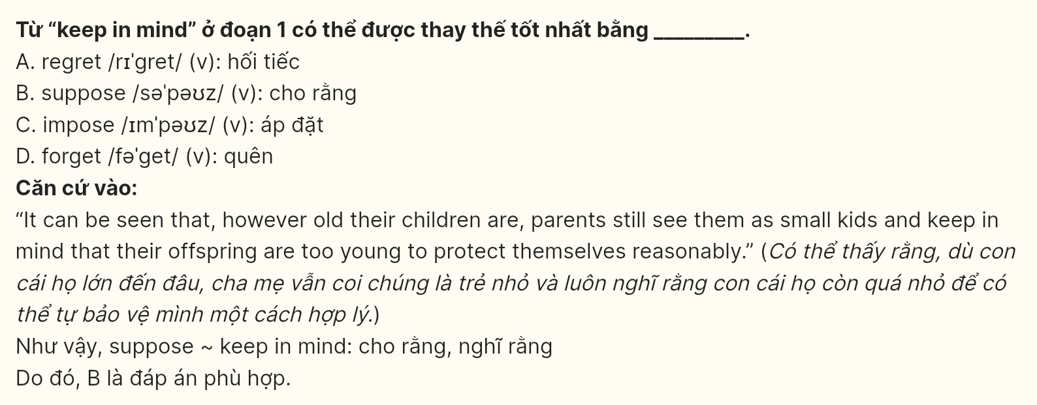
Question 25 [696248]: The word others in paragraph 3 refers to ______.
A. TV channels B. youth trends C. classical music D. programmes
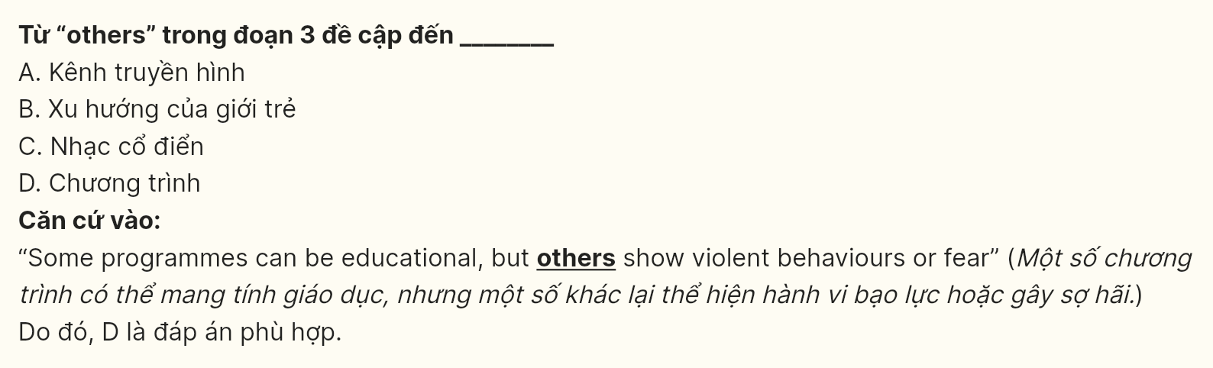
Question 26 [696249]: The word seize in paragraph 4 is OPPOSITE in meaning to ______.
A. demolish B. forbid C. neglect D. control
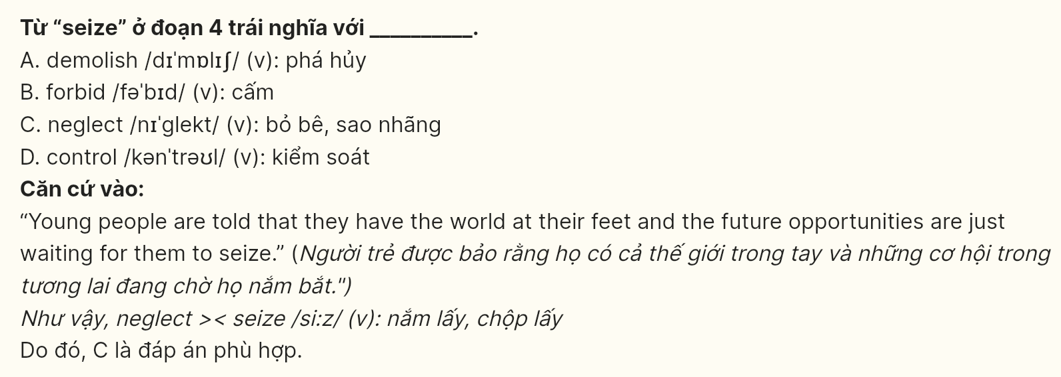
Question 27 [696250]: According to the passage, what solution is suggested to reduce conflicts between parents and children?
A. Limiting children's activities. B. Imposing strict rules.
C. Encouraging open communication. D. Ignoring each other's opinions.
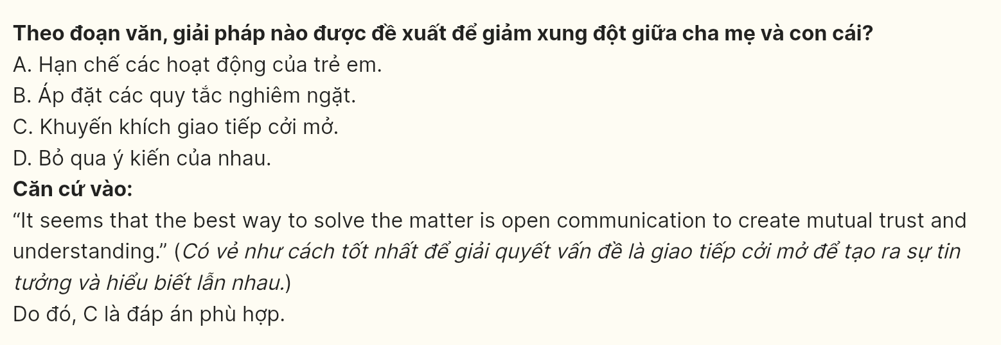
Question 28 [696251]: Which of the following is true, according to the passage?
A. Teens and parents generally have similar tastes in music and television.
B. The generation gap is a recent phenomenon affecting only a small number of families.
C. Parents often view their adult children as needing protection and guidance.
D. Open communication is unnecessary for resolving conflicts between parents and children.
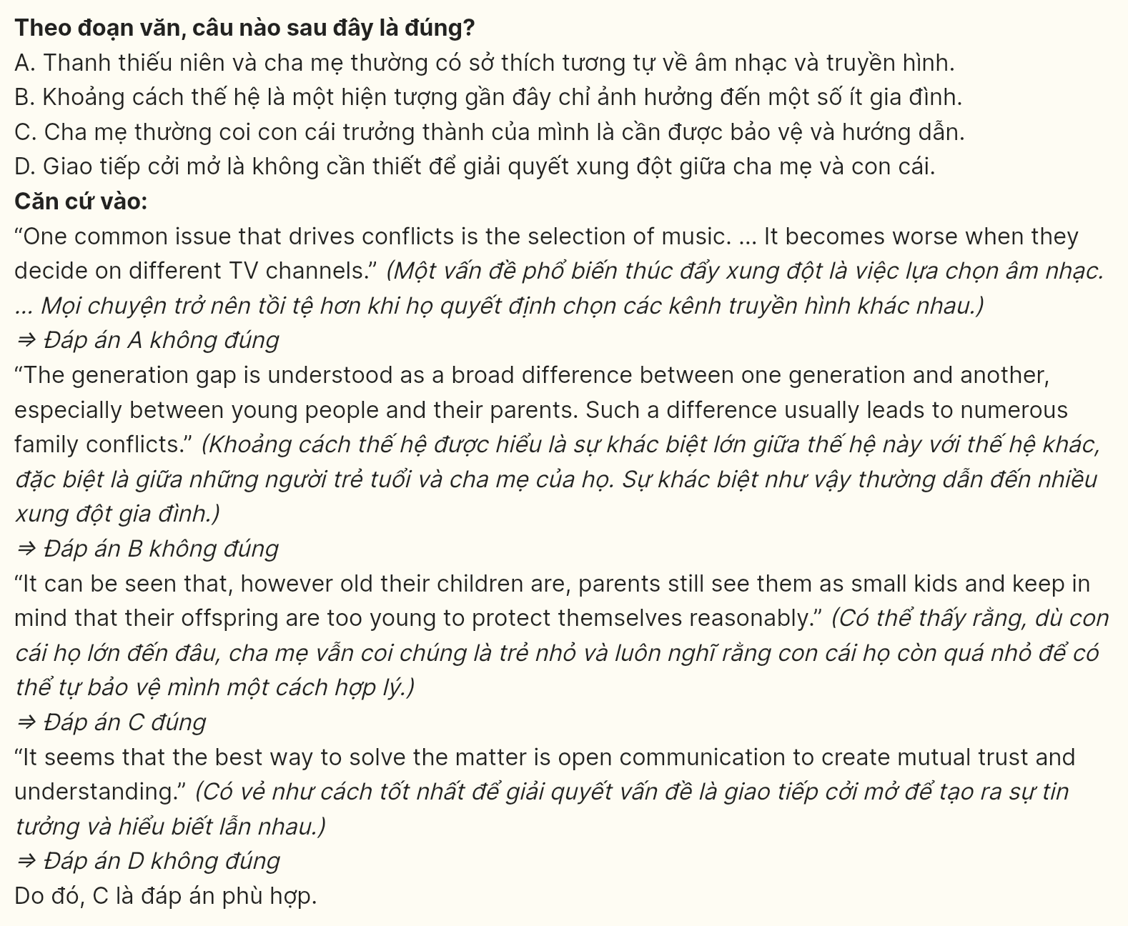
Question 29 [696252]: In which paragraph does the writer mention that parents often impose their choices on their children?
A. Paragraph 1 B. Paragraph 2 C. Paragraph 3 D. Paragraph 4
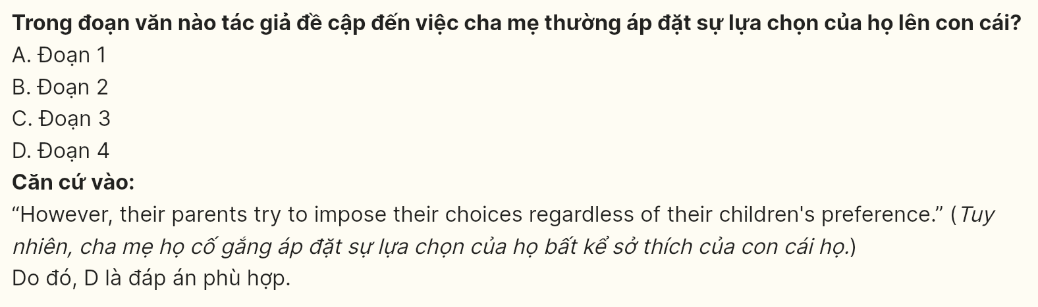
Question 30 [696253]: In which paragraph does the writer mention a constant relationship?
A. Paragraph 1 B. Paragraph 2 C. Paragraph 3 D. Paragraph 4
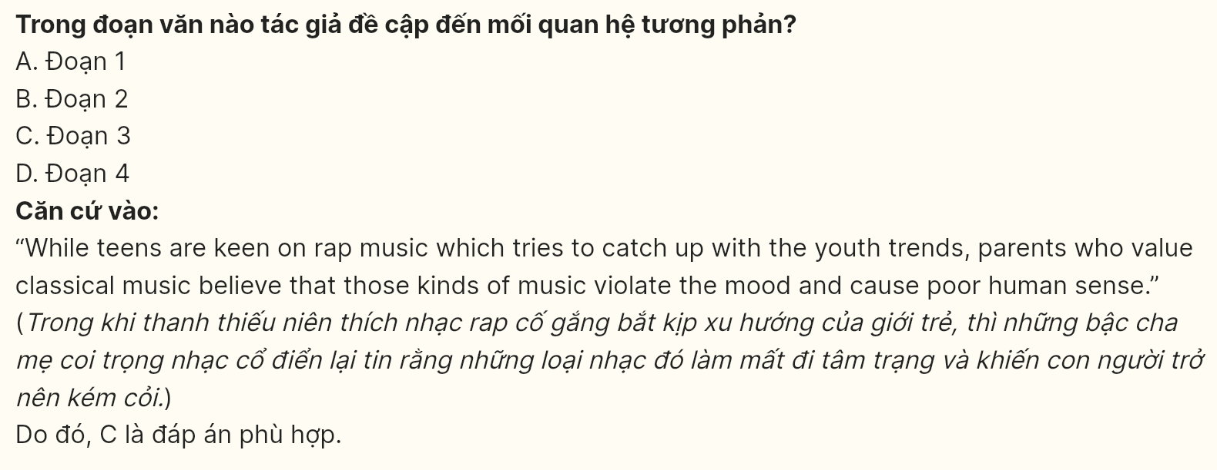
Read the following passage about the e-waste crisis and mark the letters A, B, C, D on your answer sheet to indicate the best answer to each of the following questions from 31 to 40.
[I] Electronic waste, commonly known as e-waste, refers to discarded electronic devices like smartphones, computers, and household appliances. [II] As technology rapidly advances, many of these devices become outdated quickly, leading to an increase in e-waste globally. [III] Experts estimate that millions of tons of e-waste are generated annually, and the number continues to rise as people upgrade their gadgets more frequently. [IV]
The improper disposal of e-waste presents significant environmental and health risks. When e-waste is dumped in landfills, it often releases harmful chemicals, such as lead and mercury into the soil and water, which can wreak havoc on ecosystems and pose serious health risks to nearby communities. Moreover, a large portion of e-waste is transported to developing countries, where regulations on electronic disposal may be less strict. Here, workers, often without adequate protection, dismantle electronic devices by hand to retrieve valuable metals like gold and copper, exposing themselves to toxic substances.
To address this growing problem, many countries and organizations are promoting e-waste recycling programs. These initiatives encourage consumers to recycle old electronics responsibly, rather than discarding them. By doing so, valuable materials can be reused, reducing the demand for mining new resources and helping to minimize environmental damage. Additionally, some companies are adopting sustainable design strategies, producing products that are easier to repair or upgrade, thereby extending their lifespan.
Public awareness about the impacts of e-waste is gradually increasing, and more people are becoming motivated to make eco-friendly choices. However, achieving global cooperation remains challenging, as effective solutions require collaboration across borders.
(Adapted from The Guardian)
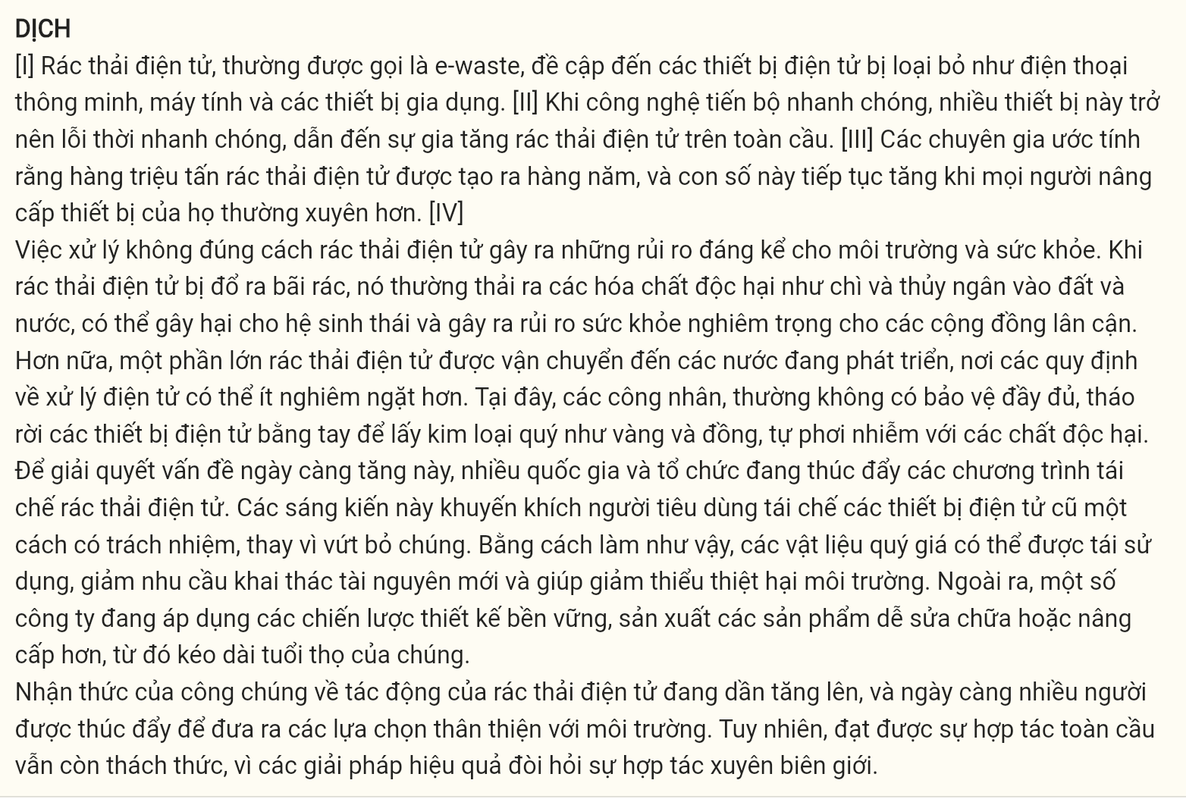
Question 31 (696254): Where in paragraph 1 does the following sentence best fit?
"This mounting waste poses environmental challenges, as it often contains toxic substances that can harm ecosystems if not disposed of properly."
A. [I] B. [II] C. [III] D. [IV]
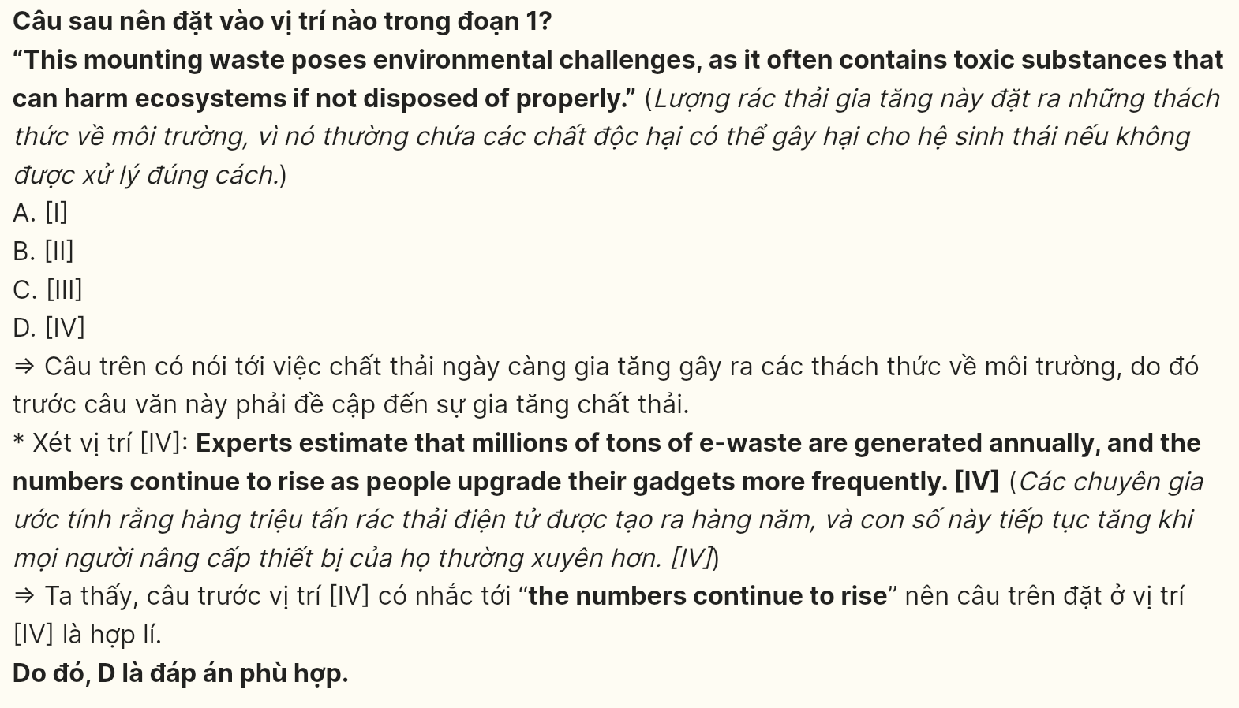
Question 32 (696255): The phrase "wreak havoc on" in paragraph 2 could be best replaced with:
A. deteriorate B. accelerate C. devastate D. flourish
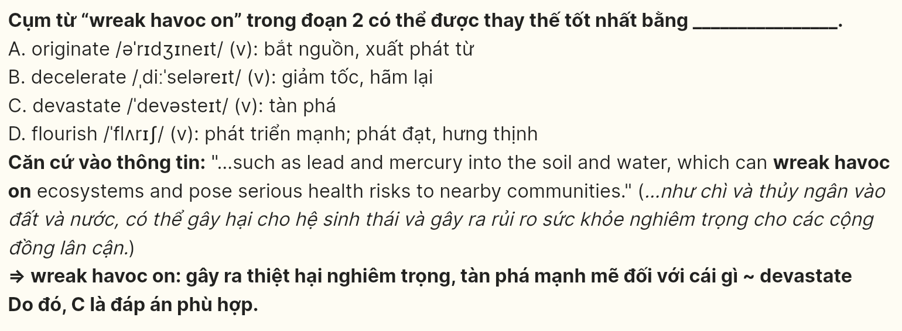
Question 33 (696256): According to paragraph 2, which of the following is NOT a consequence of improper e-waste disposal?
A. Release of harmful chemicals into the environment
B. Health risks to nearby communities
C. Increased regulations on electronic disposal
D. Exposure of workers to toxic substances
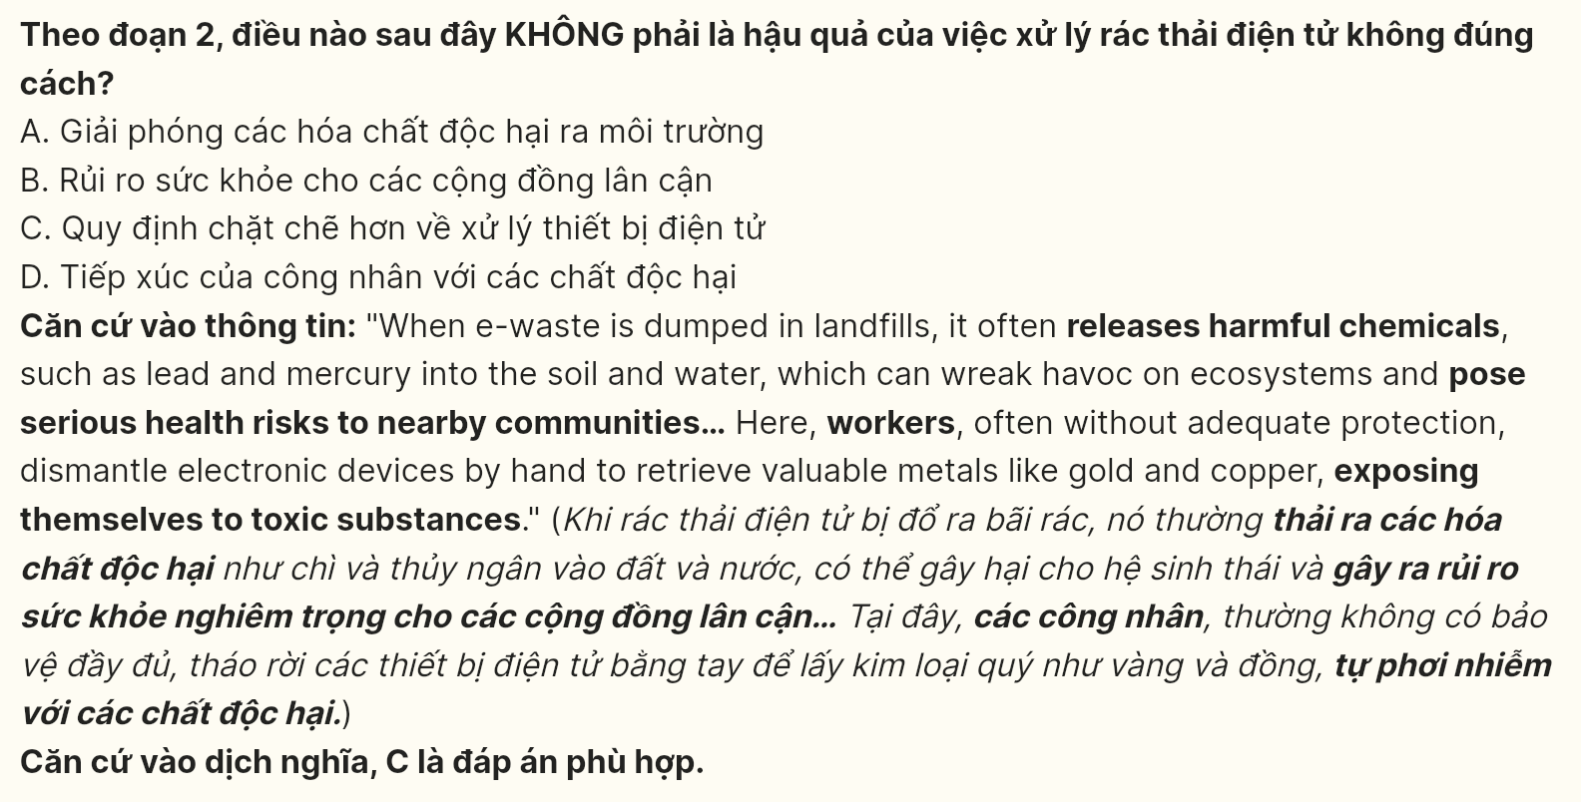
Question 34 (696257): Which of the following best summarizes paragraph 3?
A. Countries are increasing e-waste production due to rising consumer demand for electronics.
B. E-waste recycling programs and sustainable design strategies are being promoted to reduce environmental damage.
C. Consumers are encouraged to throw away old electronics to make room for new devices.
D. Companies are focusing on mining new resources to meet the growing demand for electronics.
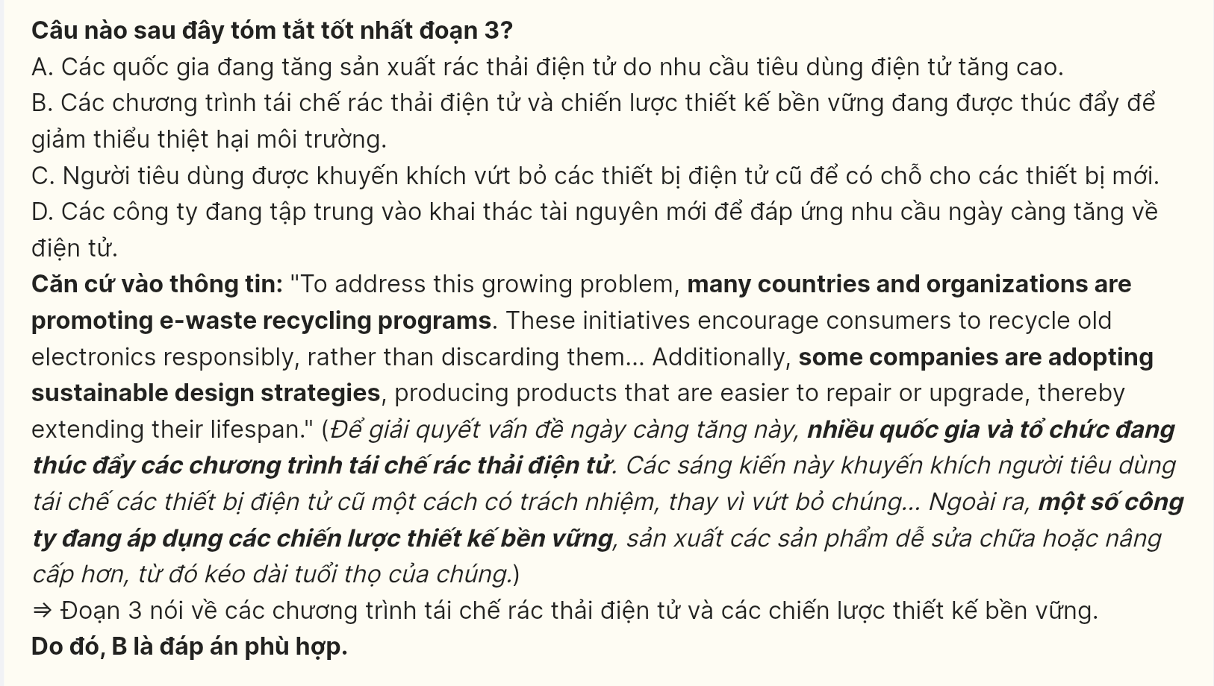
Question 35 (696258): The word "extending" in paragraph 3 is OPPOSITE in meaning to ________:
A. approaching B. expanding C. increasing D. shortening
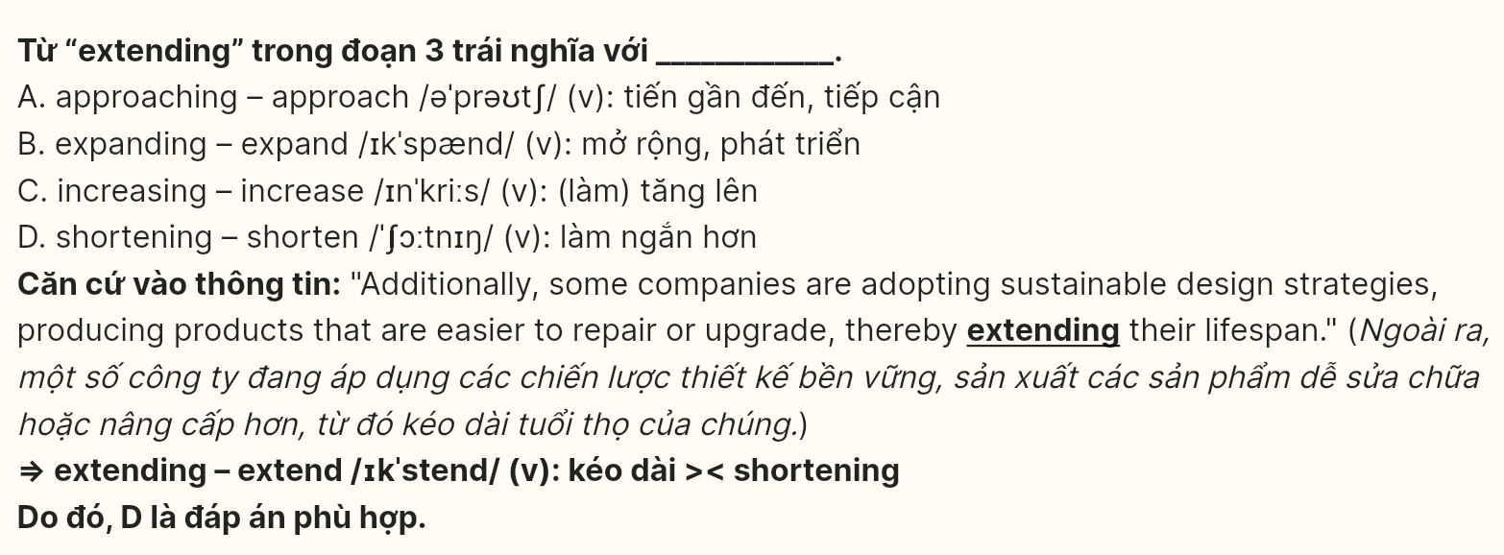
Question 36 (696259): Which of the following best paraphrases the underlined sentence in paragraph 4?
A. More individuals are starting to recognize the effects of e-waste and are inspired to adopt environmentally friendly practices.
B. There is a decline in public interest regarding the consequences of e-waste, leading to fewer eco-friendly decisions.
C. More people are unaware of the impacts of e-waste, and this is hindering their ability to make eco-friendly choices.
D. Public knowledge about e-waste is static, and few individuals are making environmentally conscious choices.
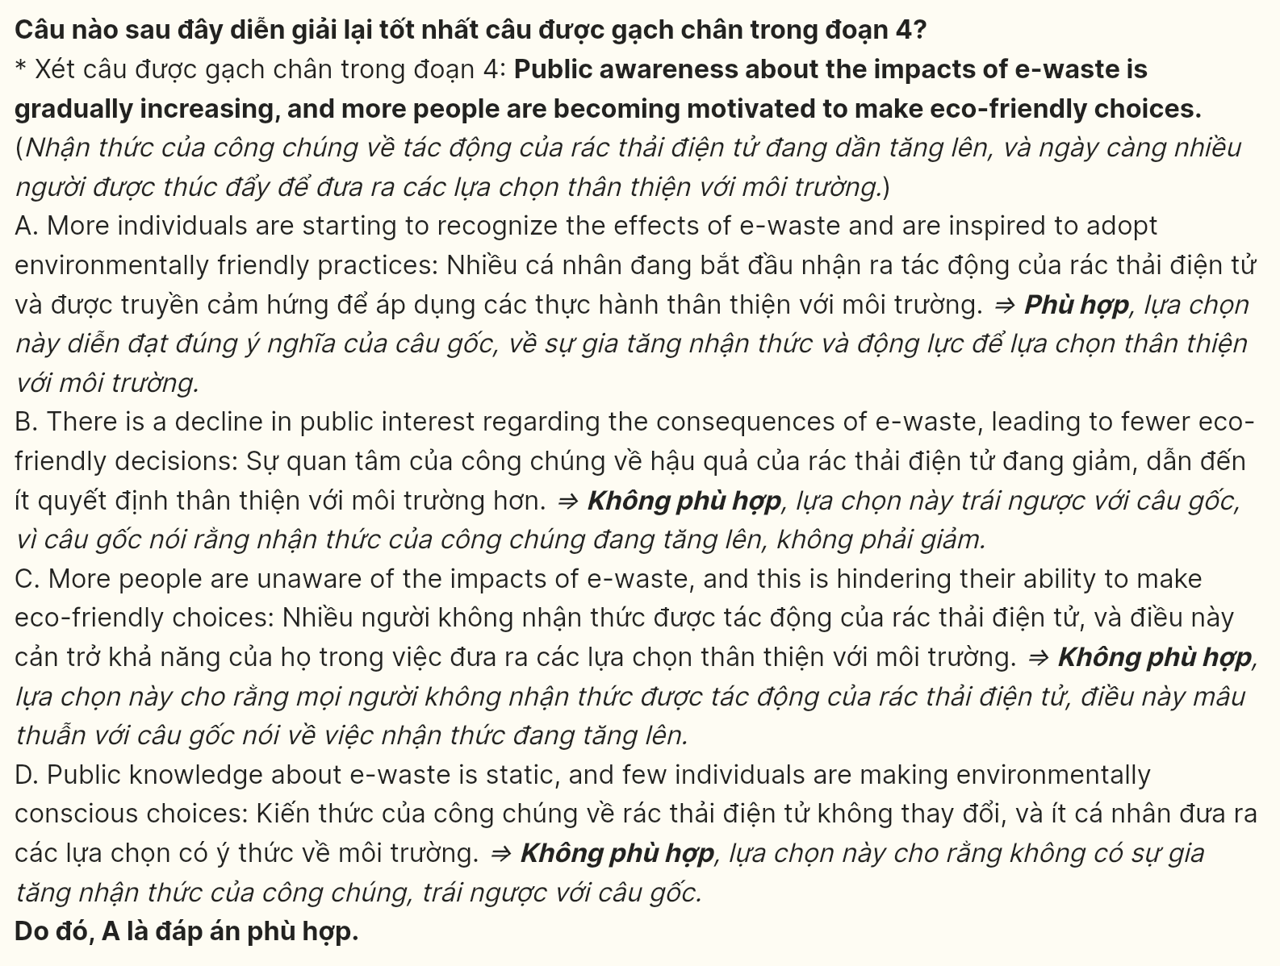
Question 37 (696260): The word "them" in paragraph 3 refers to _________:
A. Initiatives B. consumers C. old electronics D. programs
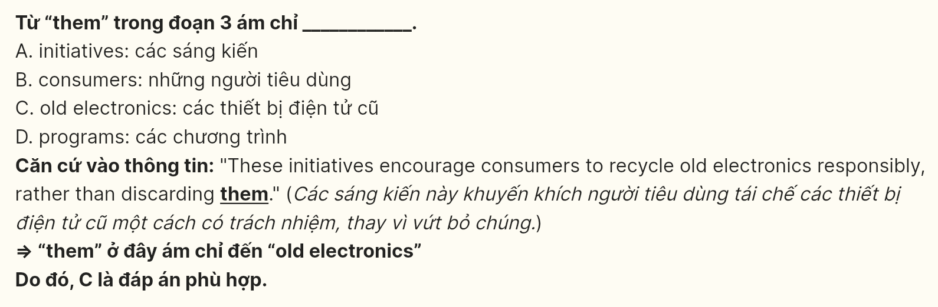
Question 38 (696261): Which of the following is TRUE according to the passage?
A. Workers in developing countries are always well protected while dismantling e-waste.
B. Public awareness about e-waste is declining, leading to fewer eco-friendly choices.
C. Sustainable design strategies are being abandoned by most companies in the electronics industry.
D. Many countries are promoting e-waste recycling initiatives to encourage responsible disposal.
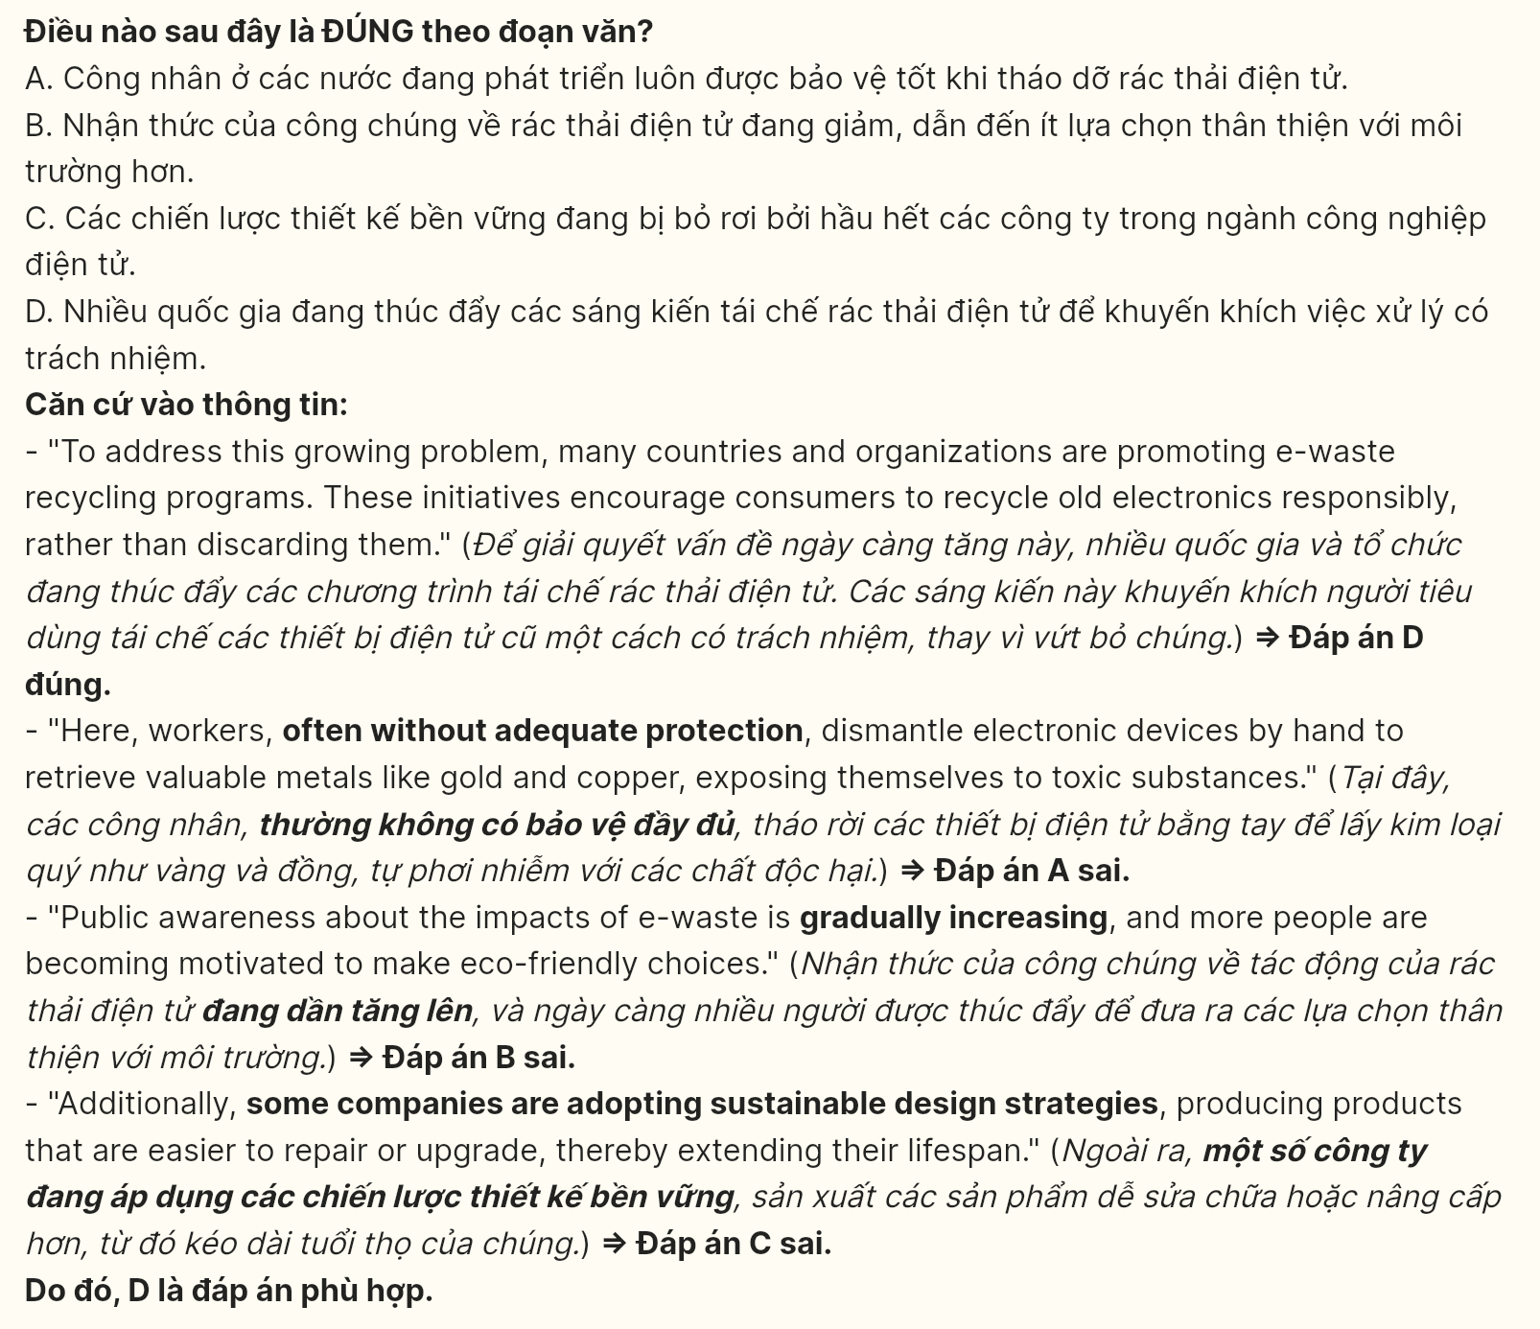
Question 39 (696262): Which of the following can be inferred from the passage?
A. E-waste recycling programs are a waste of resources and do not help the environment.
B. The lack of strict regulations in developing countries may worsen the health risks associated with e-waste.
C. The demand for new electronic devices will decrease as public awareness increases.
D. People in developing countries are not aware of the dangers associated with e-waste disposal.
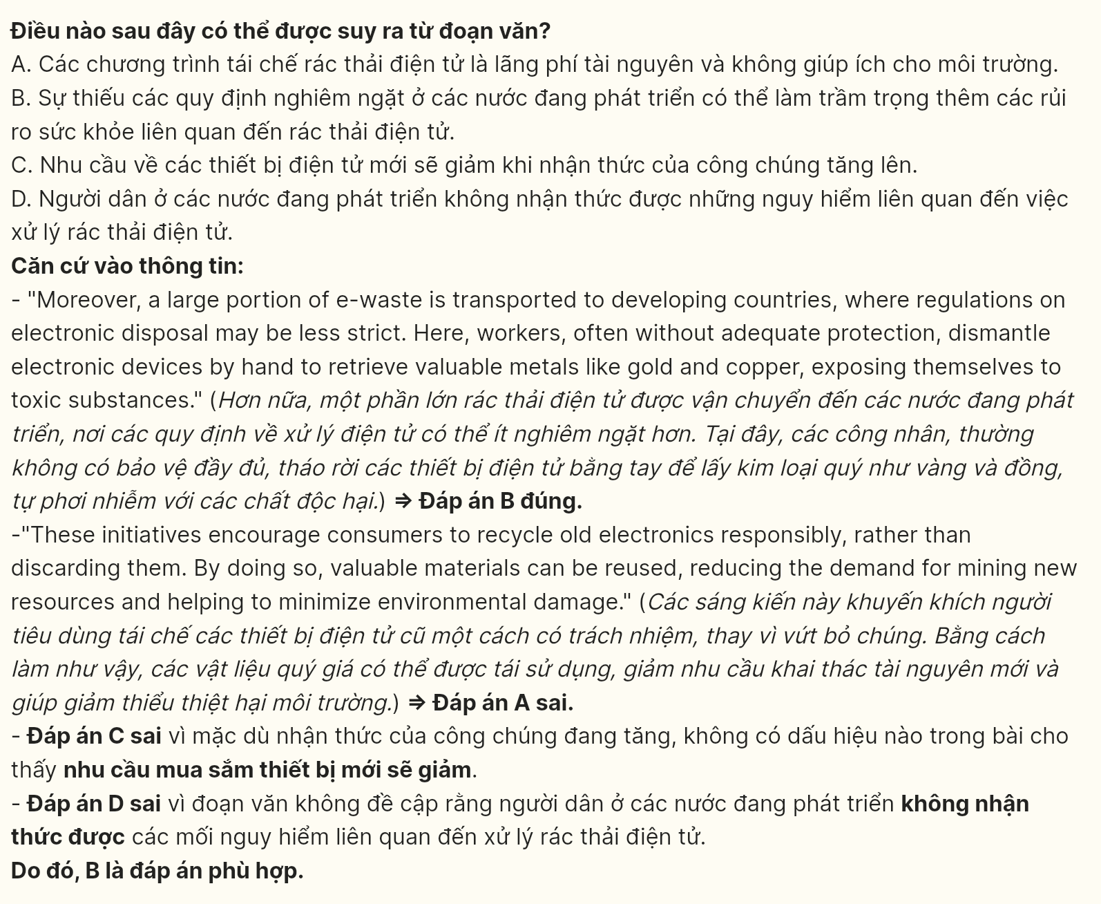
Question 40 (696263): Which of the following best summarises the passage?
A. E-waste, generated from discarded electronic devices, creates major environmental hazards and health concerns, leading to initiatives aimed at responsible recycling and sustainable product design.
B. Growing public awareness and the promotion of recycling programs can help mitigate the health and environmental risks associated with the improper disposal of e-waste.
C. As technology evolves, e-waste management becomes unimportant due to rising health risks and environmental damage, highlighting the importance of recycling and sustainable practices.
D. The rapid advancement of technology is causing a significant increase in e-waste, which poses environmental issues that require immediate attention.
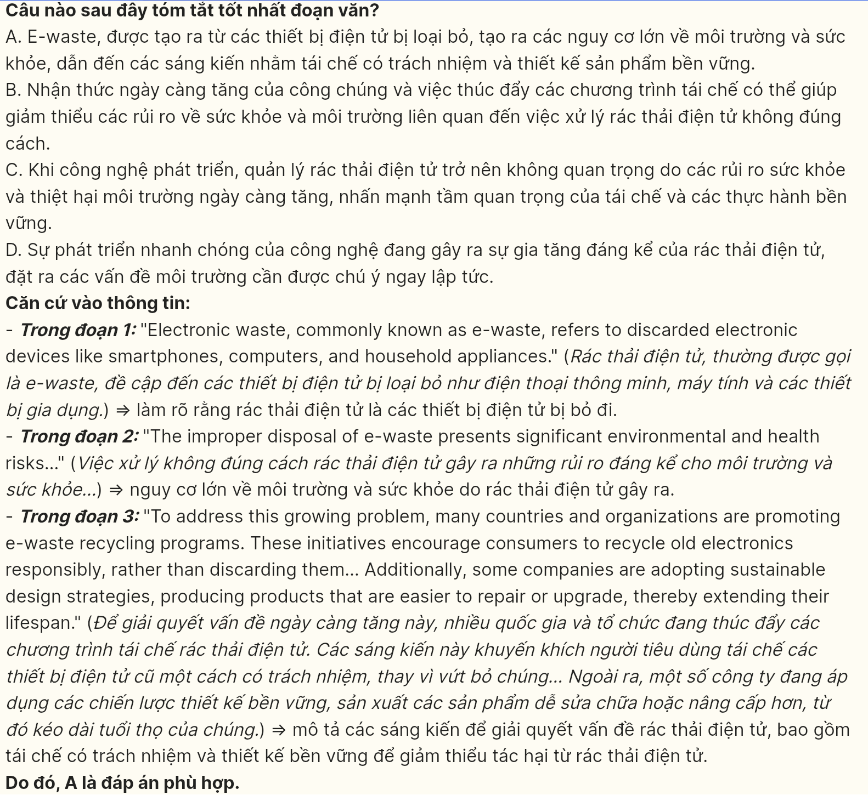
----- THE END -----

