Mã đề 6.1.5 | ĐỀ KIỂM TRA GIỮA HỌC KÌ I  NĂM HỌC 2022 - 2023  MÔN: TIẾNG ANH LỚP 6

A. LISTENING:(2pts)
- Listen and tick(1pt)
- What’s Tom playing?
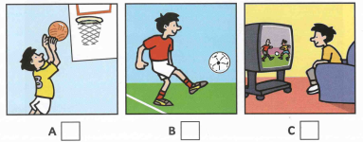
- What Nick doing?
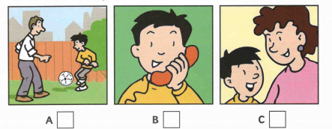
- What’s Ben doing?
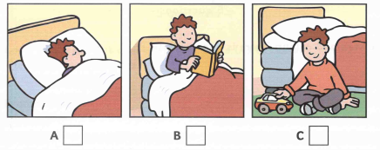
- What’s Kim doing?
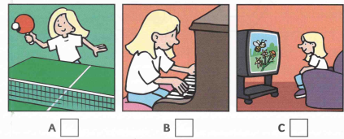
- What’s Anna painting?
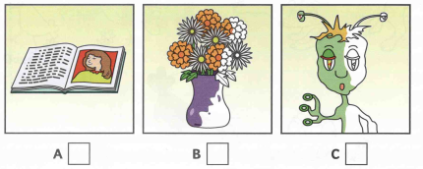
II.Listen and complete (1.0pt)
What’s the boy’s name: Nick
How old is he? 9
1.What is the name of Nick’s dog? ………………………………
2.How old is the dog? ………………………………
3.Where is Nick’s flat? In…………………………Street
4.Where is Nick going now? To………………………..Park
5.What number is Nick’s bus? ………………………………
B. LANGUAGE (3.0 pts)
Choose the best option marked A, B or C to complete each sentence.
1. What time ______ you go to school?
A. do B. does C. are
2. Kate and Jenny are in their ___________ room.
A. live B. living C. lives
3. Is the boy strong or weak? - ________________ is weak.
A. She B. He C. They
4. What is your bag? - It's green.
A. size B. colour C. money
5. My mother has black hair.
A. tall B. long C. fat
6. There many green trees and flowers around my school.
A. is B. be C. are
7. He to school with his friends now.
A. is going B. go C. goes
8. Thanh: “How is your first day at school? ”- Nam: “_____________”.
A. By bicycle B. Five days a week C. Really exciting
9. Are ___________ your pens?
A these B. this C. it
10. Nga: “Would you like to come to my party?” – Vinh: “_____________.”
A. Yes, I’d love to | B. Yes, please | C. No, I don’t
11.The post office is…………..the hotel and the bank.
A. between B. next to C. in front of
12. ________ two ceiling fans in the waiting room?
A. Is there B. Are there C. Does have
13.The chairs are ____________ the bookshelf.
A. in front B. near to C. next to
14. Remember to bring a ________ for the Maths test.
A. notebook B. sharpener C. calculator
15. Hoa: “Why_______we go to the movies” - Tom: “Good idea!”
A. do B. don’t C. are
C. READING(3.0 pts)
I. Choose the best option marked A, B or C for each gap to complete the passage(1.5 pts)
Our family lives (1) ______ a big apartment in the city centre. There are four (2) _____, a living room, a kitchen and two bathrooms. The living room is next (3) ______ the kitchen. There is a bookshelf between them. In the living room, we hang many posters on the wall. There is also a sofa and a coffee table.
The most (4) _______ place is my bedroom. I have many posters on the wall about my favourite music bands. There is also a (5) ________. I can play my favourite songs when I am stressed.
1. A. at  2. A. apartment  3. A. to  4. A. nice  5. A. piano | B. in  B. bedroom  B. of  B. favourite  B. clock | C. on  C. bedrooms  C. with  C. good  C. lamp

II. Read the passage carefully and choose the correct answer A, B or C for each question. (1.5 pt)

Hi, my name is Anna. There are six people in my family: my grandmother, my grandfather, my mother, my father, my elder brother and me. My grandparents are old and retired. They love gardening and doing morning exercise. My father is forty-one and he is a doctor. He works in a big hospital. My mother is thirty-eight. She is an Art teacher. She teaches in a secondary school. My elder brother is Jack. He is sixteen and he is a high school student. I'm ten and I'm the youngest in my family. Our family lives in a small but it's lovely. There is a living room, two bedrooms, a bathroom and a kitchen in my house. However, the thing I love best is the garden behind the house. I like to relax in the garden on weekends.
1. How many people are there in Anna’s family?
A. 5 B. 6 C. 7
2. Who loves gardening and doing morning exercise?
A. Anna’s parents B. Anna’s grandparents C. Anna’s brother
3. Where does Anna’s father work?
A. in a big hospital B. in a secondary school C. in the garden
4. How many rooms are there in Anna’s house?
A. seven B. six C. five
5. What does Anna like to do on weekends?
A. relax in the garden B. do the housework C. do morning exercise
D. WRITING(3.0 pts)
I. Rewrite each of the following sentences so that it means the same. (1.5 pt)
1. I don’t have a bookshelf in my bedroom.
=> There ___ _________________________________________________________
2. The dog is in front of the microwave.
=> The microwave ____________________________________________________
3. His eyes are blue and big.
=> He has ___________________________________________________________
4. Do you want some coffee?
=> Would you _______________________________________________________?
5. What is your favourite subject?
=> What subject______________________________________________________?

II. Use the suggested words to complete the passage (1.5 pt)

I / be / Nam. I / be / student / class 6B. There / be / forty students in my class. We / be/ from Hai Duong. The students / my school / be/ kind / friendly. Every day, we / study / school from 7.00 am / 11.30 am. We / not go / school / Sundays. I/ love / school.

=========== The end ============

TRƯỜNG THCS CẨM HOÀNG | HƯỚNG DẪN CHẤM ĐỀ KIỂM TRA GIỮA KÌ I  NĂM HỌC: 2022 - 2023  MÔN: T.Anh 6  Hướng dẫn chấm gồm: 01 trang

Câu | Đáp án | Điểm
A. LISTENING  (2.0pts) | I. 1. A 2. B 3. A 4. A 5. C  II. 1.Pat 2. 3/ Three 3. old 4. Green (park ) 5.12/ twelve | 0.2/1sent
B. LANGUAGE  ( 3.0pts) | I. 1- A 2- B 3- B 4- B 5- B 6. C 7. A 8. C 9.A 10. A 11.A 12.B 13.C 14.C 15.B | 0.2/1sent
C. READING(3.0 pts) | I. 1. B 2. C 3. A 4. B 5. A  II. 1. B 2. B 3. A 4. C 5. A | 0.3/1sent
D. WRITING(3.0 pts) | I. 1.There isn’t a bookshelf in my bedroom  2. The microwave is behind the dog  3. He has blue and big eyes.  4. Would you like some coffee?  5. What subject do you like best?  II.  I am Nam. I am a student in class 6B. There are forty students in my class. We are from Hai Duong. The students in my school are kind and friendly. Every day, we study at school from 7.00 am to 11.30 am. We do not go to school on Sundays. I love my/ our school. | 0.3/1sent  0.1/1word
***The end***

