|  |  |  |
| --- | --- | --- |
| **Mã đề 6.2.44** | **ĐỀ KIỂM TRA GIỮA KÌ II**  **NĂM HỌC 2022-2023**  Môn : Tiếng Anh  Thời gian làm bài 60 phút | **ĐIỂM-NHẬN XÉT** |

**SECTION 1 : LISTENING**: **I. Listen and tick (☑) the box. (1pt)**

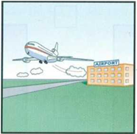1. Where does her brother work?

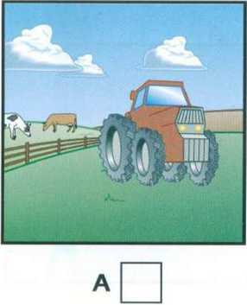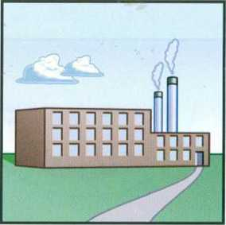

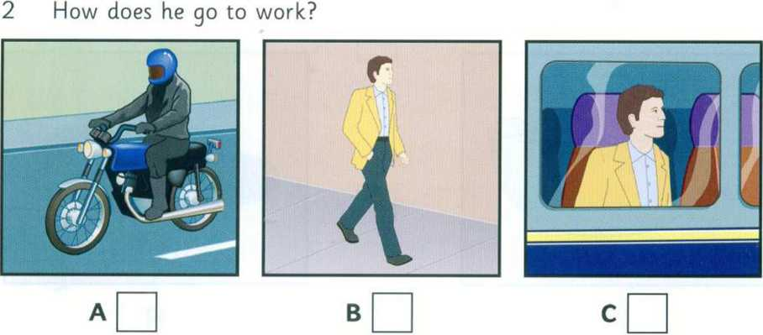 A B C

3. When does he start work?

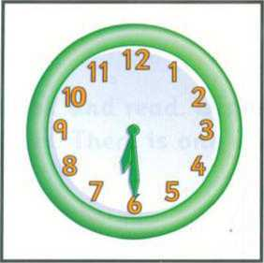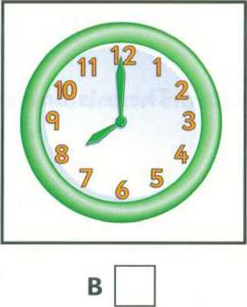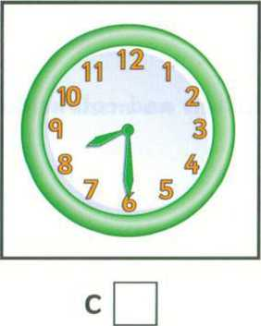

A

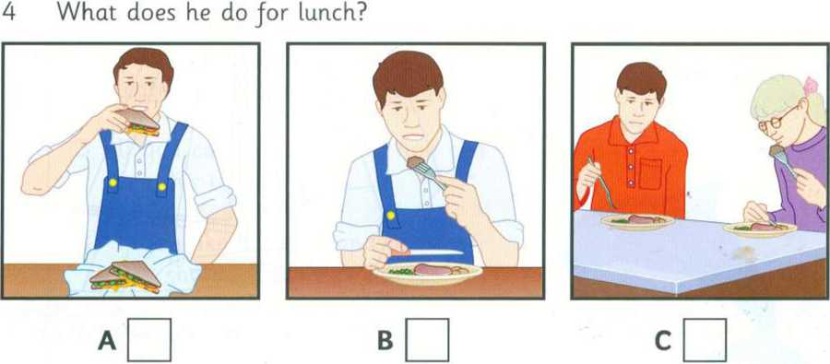

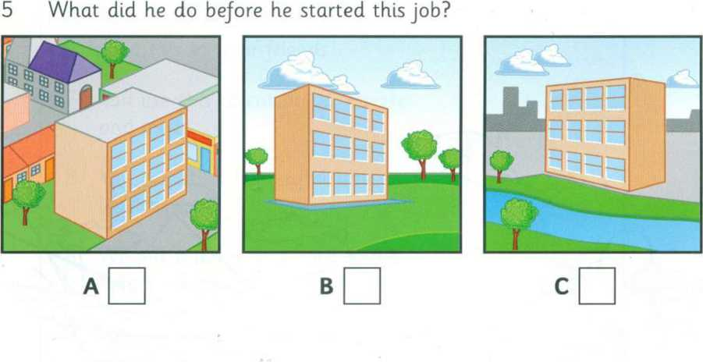

**II. Listen and fill in the blanks with no more than three words or numbers.(1pt)**

|  |  |
| --- | --- |
| TENNIS COMPETITION | |
| Full name | Betty Barratt |
| Age: | (1)…………………… |
| Address: | 17 (2)………………… Street. |
| Phone number: | (3)…………………… |
| Years of tennis: | (4)…………………… |
| Time preferred: | (5)…………………… |

**SECTION 2: LANGUAGE(3PTS)**

**I.Chose the word whose underlined part pronouned differently from that of the others by circling A,B,Cor D(0.4point)**

1. A. home B. come C. open D. cold

2. A. opens B. gets C. kicks D. speaks

**II.Choose the best option(A,B,Cor D) to complete the sentences (2.6pts)**

1. ……………..pen is this? Can I borrow it?

A. Whose B. Whom C.Who D. Which

2. ………………is your favorite tennis player? – I don’t like tennis.

A. Where B. Who C. How often D. How long

3. My brother can’t swim ……………..he’s afraid (sợ) of water.

A. because B. and C.but D. so

4. My sister likes going to the cinema……………I like watching TV at home.

A. and B. but C. because D. or

5. I ........................ born on the first of May.

A. were B. was C. are D. is

6. Did you ever ........................ of such a thing?

A. hear B. hears C. heard D. heart

7. He ........................ some eggs to make cakes.

A. buys B. buy C. buied D. bought

8. There ........................ any eggs in the packet when I ........................ the kitchen.

A. was/ come B. weren’t/ come C. was/ came D. weren’t/ came

9. We ........................ to our friend last night.

A. spoke B. speak C. speaked D. spoken

10. This is the most interesting novel…………………

A. I’ve read B. I had read C. I’ve never read D. I’ve ever read

11. I haven’t seen you ………………

A. since a long time B. for ages C. ages D. for long existence

12. It ………………every day so far this week.

A. rained B.has rained C. rains D.is raining

13. I………………her since I……………..a student.

A. know/ am B. knew/ was C. have known/ am D. have known/ was

**SECTION 3:READING(3 POINTS)**

**I. Read the passage and choose the best word (A, B,C or D ) to put in each space(1.5pts).**

Hoi An is one of the (1) ................. towns in Viet Nam. It (2) ................. on the lower section of the Thu Bon river. It is a very beautiful town with a s lot of colour (3) ................. which are hung around the town. Hoi An is famous for one-(4) ................. tailoring. Customers order clothes in the morning and get them in the evening. The price is not really expensive . If you want to find the place of the (5) ................. time, Hoi An is a good choice.

1. A. newer B. newest C. oldest D.older

2. A. are B. is C. are being D.am

3. A. lanterns B. stars C. balloons D.pens

4. A. month B. week C. day D. year

5. A. modern B. newer C. new D. old

**II. Read the passage and choose the best answer for each question(1.5pts).**

WHO WANTS TO BE A MILLIONAIRE?

One of the most popular quiz programmes on television in the world is called *Who Wants To Be A Millionaire*? In Britain, the quiz master is Chris Tarrant. He asks the contestants fifteen questions. The first questions are easy but later they are more difficult. If you can answer the fourteenth question, you can win £500,000. You can win a million pounds if you can answer the last question. Of course, the last question is very difficult.

All the questions on *Who Wants To Be A Millionaire*? are multiple-choice questions. After you hear the question, you see four answers. Only one answer is correct. You have to choose the correct answer. If you don’t know the answer to a question, there are three ways you can get help: you can ask the quizmaster to take away two wrong answers; you can ask the studio audience which answer is right; or you can telephone a friend and ask for help. You can only do these things once. Very few people win the million pounds. The first person won a million pounds one year after the programme started.

Today, *Who Wants To Be A Millionaire*? can be seen in more than 100 countries and is now the world’s most popular quiz programme.

1. Who is the quizmaster in Britain?

A. Chris Tarrant B. Chris Tarrante C. Peter Tarrant D. Tarrant

2. How many questions do you have to answer?

A.12 B. 13 C. 14 D. 15

3. How much do you win for the fourteenth question?

A. 300.000 B. 400.000 C. 500.000 D. 600.000

4. How many ways can you get help?

A. one B. two C. three D. four

5. How many countries can see *Who Wants To Be A Millionaire ?*

A.less than 100 B.more than 100 C.more than 1000 D. over 10

**SECTION 4 : WRITING(2PTS)**

**I.Rewrite these sentences (1pt)**

1. We/ travel/ Nha Trang/ next week

………………………………………………………….

2. Nga and Lan/ visit/ their grandparents/tomorrow.

…………………………………………………………..

7. I was feeling tired. I went to bed when I got home.(so)

3. It started raining an hour ago.

It has ……………………………………………………………………

5. I began to study English three years ago.

I have studied ……………………………………………………………

**II.Nam is discribing his city.Use the given words to make complete sentences about it.(1pt)**

1 Da Nang / a population /nearly 800,000 people.

………………………………………………………………………………………………………………………………………

2.It / one of the/ peaceful cities / Viet Nam .

……………………………………………………………………………………………..

3. Life here / not so busy as that / Ho Chi Minh City.

……………………………………………………………………………………………

4.There/a lot of/beautiful beaches/famous bridges/Da Nang.

…………………………………………………………………………………………….

5. The food here / very fresh/ and /the price / cheap .

…………………………………………………………………………………………….

**II. Choose the word or phrase that is best completes each unfinished sentences below.(4ms)**

1. is the most expensive city in the world? - I think it’s Tokyo.

A.What B. Who C. When

2. is your favorite tennis player? – I don’t like tennis.

A. Where B. Who C. How often

3. My brother can’t swim he’s afraid (sợ) of water.

A. because B. and C.but

4. My sister likes going to the cinema I like watching TV at home.

A. and B. but C. because

5. pen is this? Can I borrow it?

A. Whose B. Whom C.Who

6. I ........................ born on the first of May.

A. were B. was C. are

7. The enemy ........................ by night.

A. attack B. attacks C. attacked

8. Mind about what I just ........................ now.

A. said B. say C. did say

9. This is the most interesting novel

A. I’ve read B. I had read C. I’ve ever read

10. I haven’t seen you .

A. since a long time B. for ages C. ages

11. It every day so far this week.

A. rained B.has rained C. rains

12. I any letter from him yet.

A.haven’t received B.will receive C.don’t receive

**III. Read and choose the best answer.(2ms)**

WHO WANTS TO BE A MILLIONAIRE?

One of the most popular quiz programmes on television in the world is called *Who Wants To Be A Millionaire*? In Britain, the quiz master is Chris Tarrant. He asks the contestants fifteen questions. The first questions are easy but later they are more difficult. If you can answer the fourteenth question, you can win £500,000. You can win a million pounds if you can answer the last question. Of course, the last question is very difficult.

All the questions on *Who Wants To Be A Millionaire*? are multiple-choice questions. After you hear the question, you see four answers. Only one answer is correct. You have to choose the correct answer. If you don’t know the answer to a question, there are three ways you can get help: you can ask the quizmaster to take away two wrong answers; you can ask the studio audience which answer is right; or you can telephone a friend and ask for help. You can only do these things once. Very few people win the million pounds. The first person won a million pounds one year after the programme started.

Today, *Who Wants To Be A Millionaire*? can be seen in more than 100 countries and is now the world’s most popular quiz programme.

1. Who is the quizmaster in Britain?

A. Chris Tarrant B. Chris Tarrante C. Peter Tarrant D. Tarrant

2. How many questions do you have to answer?

A. 12 B. 13 C. 14 D. 15

3. How much do you win for the fourteenth question?

A. 300.000 B. 400.000 C. 500.000 D. 600.000

4. How many ways can you get help?

A. one B. two C. three D. four

**IV.Which notice (A-F) says this (1-5)1.5ms**

Danger! No hard hat? No boots ?

No entrace

1.You can’t leave your bike here. A

No bicycle against this window

2. Adults shouldn’t let the children play with this. B

Exit to Shoemaker Road

3. You can buy children’s clothes here. C

D

School uniform department- This floor

4. Do not come in if you are not wearing right clothes.

Danger !

keep away from the children

5. Use this door to go outside. E

1 - , 2- , 3 - , 4 - , 5 - .

**V.Rearrange these sentences (1.5ms)**

1.you / Would / a / like / coffee / or / tea?

…………………………………………………………………………………………..

2. will / to / They / go / the movies / tonight

………………………………………………………………………………………….

3. will / We / travel / Nha Trang / to / next week

…………………………………………………………………………………………

4. years / He / hasn’t / to / gone / Ha Noi / for / ten

……………………………………………………………………………………….

5. painted / She / has / since / that / picture / last year.