School: ……………………………………….. | Date:……………………………………..
Class: ……………………………..................... | Period: 69

UNIT 4: ALL THINGS HIGH-TECH
Progress Check (Page 77)

1. Objectives
By the end of this lesson, students will be able to…
1.1. Language knowledge/ skills
- practise a dialogue.
- practise reading for specific information.
1.2. Competences
- improve Ss’ communication, collaboration, analytical, critical thinking skills.
1.3. Attributes
- encourage Ss to study hard.
- build their interests for high technology.
2. Teaching aids and materials
- Teacher’s aids: Student’s book and Teacher’s book, class CDs, IWB – Phần mềm tương tác trực quan, projector/interactive whiteboard /TV (if any), PowerPoint slides.
- Students’ aids: Student’s book, Workbook, Notebook.
3. Assessment evidence
Performance Tasks | Performance Products | Assessment Tools
- Complete a dialogue.  - Read the entries and decide if the  Statements are Right or Wrong.  - Self-reflect. | - Ss’ answers.  - Ss’ answer.  - Ss’ answer. | - Observation.  - Observation.  - Observation.

4. Procedures
A. Speaking: 20 minutes
a. Objectives: to help Ss to practise speaking skills.
b. Content: task 7.
c. Expected outcomes: Ss can complete a dialogue.
d. Organization

Teacher’s activities | Students’ activities
Task 7: Complete the dialogue. Use sentences (a-e).  a Got it!  b Could you help me print the  worksheets for homework?  c What’s next?  d Thank you, Mr Aston.  e What do I do then?  A Excuse me, Mr Aston. 1) ____  B Sure. First, open your Internet browser and go to the electronic classroom.  A OK. 2) ___  B Then click on where it says Log in.  A 3) ____ That’s where I sign in.  B Yes, exactly! Now click Enter.  A OK. 4) ____  B Now choose Year 7 and click on my name. Open the file with today’s date on it and select File and then Print.  A 5) ____  B You’re welcome, Mary  - Explain the task using IWB.  - Give Ss time to complete the dialogue.  - Check answers using IWB. | - Listen to teacher’s explanation.  - Complete the dialogue.  - Check answers.  Answer keys  1.b 2.e 3.a 4.c 5.d

B. Reading: 10 minutes
a. Objectives: to help Ss to practise reading skills.
b. Content: task 8.
c. Expected outcomes: Ss can improve reading skills; do the task correctly.
d. Organization

Teacher’s activities | Students’ activities
Task 8: Read the entries and decide if the  statements (1-5) are R (right) or W (wrong).  1 Sally got a smartphone on her birthday.  2 Sally doesn’t use her smartphone a lot.  3 Sally thinks not having a smartphone makes her behave badly.  4 Paul can’t live without his smartphone.  5 Paul feels better now.  - Ask Ss to underline key words in each statement.  - Give Ss time to do the task.  - Check Ss’ answers using IWB. | - Underline key words in the sentences.  - Do the task individually.  - Check answers.  Answer keys  1.R 2.W 3.R 4.W 5.R

C. Self- Reflection: 10 minutes
a. Objectives: to help Ss to reflect what they have learnt and rank how well they master the lesson.
b. Content: competences.
c. Expected outcomes: Ss can self-reflect and know how well they master the lesson.
d. Organization
Teacher’s activities | Students’ activities
- Ask Ss to reflect what they have learnt and rank how well they master the lesson.  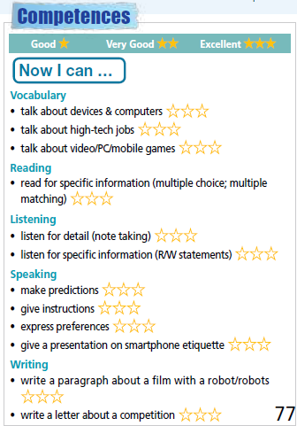  - Explain more whatever Ss don’t understand. | - Reflect what they have learnt and rank how well they master the lesson.

D. Consolidation and homework assignments: 5 minutes
- Practise speaking about Everyday English.
- Read for specific information.
- Do the exercises in workbook on pages 72, 73.
- Prepare for the next lesson: Unit 5 Overview (pages 78, 79).
5. Reflection
a. What I liked most about this lesson today:
…………………………………………………………………………………………
b. What I learned from this lesson today:
…………………………………………………………………………………………
c. What I should improve for this lesson next time:
…………………………………………………………………………………………

