**LỚP HỌC THẦY (CÔ) ___________________________** **ĐỀ ÔN TẬP: READING SIGNS/ NOTICES – A2**

**Test 8**

*Thời gian làm bài: [Time]*

Họ và tên: ________________________________________________ Lớp: 9/___

**Nội dung:**

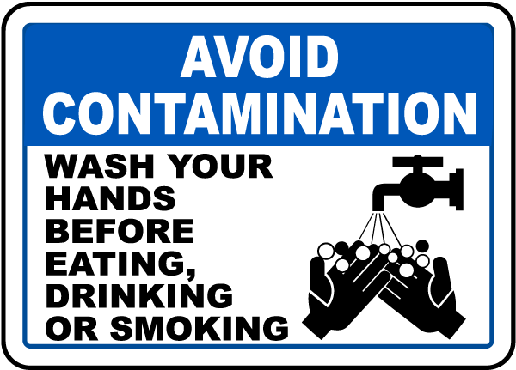**Question 1:** What does the sign instruct?

**A.** Wash your hands only if they look dirty before eating.  
**B.** It is fine to eat without washing your hands first.  
**C.** Wash your hands before you eat to keep everything clean and safe.  
**D.** Wash your hands after eating, not before you start.

**Question 2:** What should you bring?

Join us for a beach clean-up day! Meet at the main entrance at 8 a.m. Please bring gloves and a bottle of water

**A.** A picnic basket. **B.** Gloves and a bottle of water.  
**C.** A towel. **D.** Sunglasses.

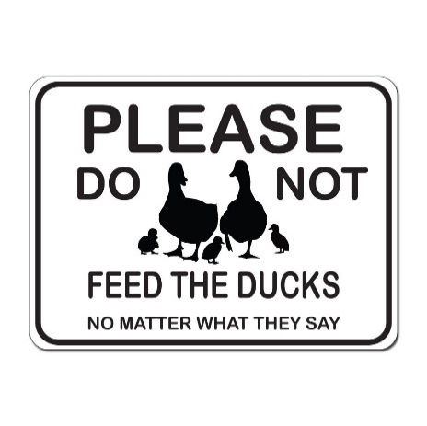**Question 3:** What does the sign instruct?

**A.** You can feed ducks as much as you like, with any type of foo**d.**

**B.** Feeding ducks can be harmful to their health and development.

**C.** You should not feed ducks because they will follow you.

**D.** You can feed ducks bread or other food if you have it.

**Question 4:** Call this number if you want to ____________.

*If you enjoy playing the guitar and hanging out making music, contact us, Neil and Joe. No plans to play as a band - we just relax and play!*

*Call 07796 245798*

**A.** play music with others **B.** learn the guitar

**C.** join a band **D.** *play as a band*

**Question 5:** What does the sign mean?

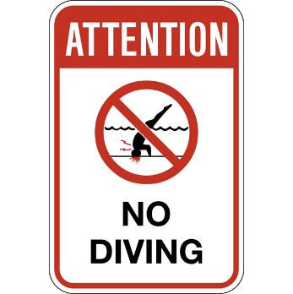

**A.** The shallow water is only for children.

**B.** Do not dive here because it is not safe; the water is shallow.

**C.** Diving is allowed here, so you should dive into the water.

**D.** Swimming is not allowed here, so you cannot enter the water.

**Question 6:** Which information is correct from the announcement?

*From 1 October.*

*Please do not enter the pool before you have used the shower.*

**A.** The pool is closed on October 1st. **B.** You need to wash before you swim.

**C.** There will be a new shower at the pool. **D.** You must dry off before entering the pool.

**Question 7:** What does the sign mean?

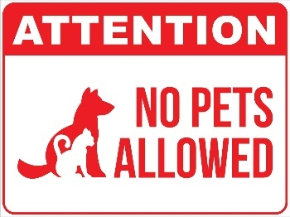

**A.** Only pets with short fur are allowed here.

**B.** No pets are allowed here unless you have permission.

**C.** Only big pets are allowed; small pets are not allowe**d.**

**D.** Pets and other animals are not allowed here.

**Question 8:** What does Mark want to do?



Jim, Any chance your mum could take me home in the car after school today? I forgot to bring the money for my bus ticket!

Mark

**A.** Borrow some money **B.** Travel home with Jim

**C.** Invite Jim to visit him **D.** Hire Mark's Mom Home

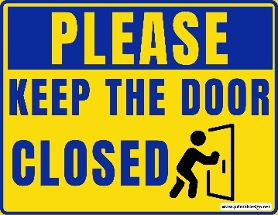**Question 9:** What does the sign mean?

**A.** The door should always be open and you should never lock it unless there is no one aroun**d.**

**B.** You should always make sure to close the door after use and always close it.

**C.** Only open the door at specific times when allowed and close it otherwise.

**D.** You should leave the door open at all times and never close it.

**Question 10:** Where might you see this text?



**A.** in a computer shop **B.** on the screen of a computer

**C.**on the wall in the computer classroom **D.** On the lock screen

**[HẾT]**