|  |  |
| --- | --- |
|  |  |

**Họ tên thí sinh: .................................................................**

**Số báo danh: ......................................................................**

**Mã Đề: 017.**

**Câu 1.** What is the offer at the Tennis Club?

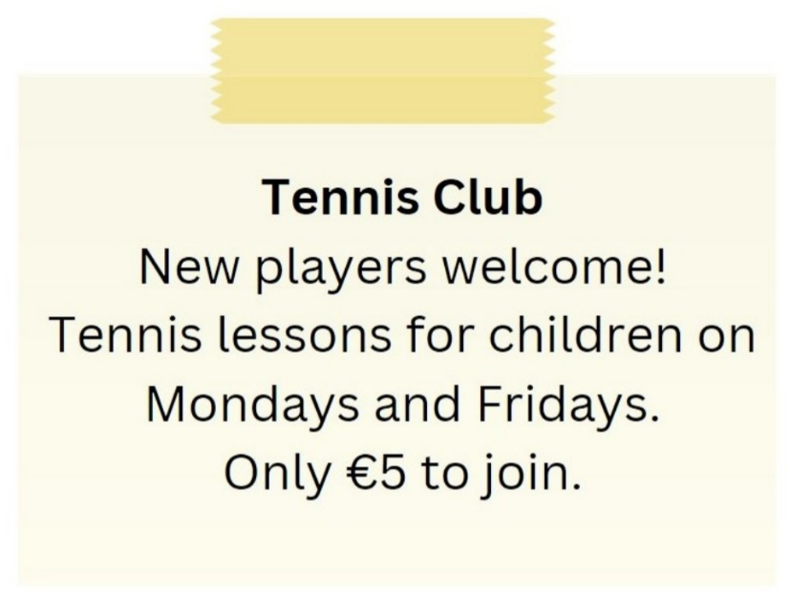

**A.** Tennis lessons for children on Tuesdays and Thursdays

**B.** Tennis lessons for children on Mondays and Fridays for €5 to join

**C.** Tennis lessons for adults on Mondays and Fridays

**D.** €10 to join the club

**Câu 2.** **Look at the signs. Choose the best answer for the question.**

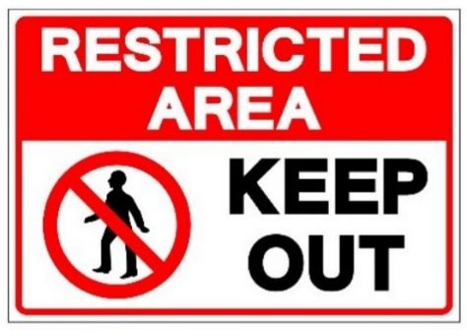

**A.** People aren’t allowed to enter this area.  **B.** This area is open to everyone.

**C.** We should keep this area out.  **D.** This area is kept open.

**Câu 3.** How long is the flight to France?

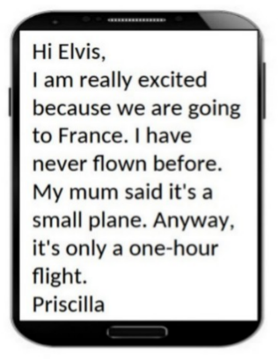

**A.** One hour  **B.** Two hours  **C.** Three hours  **D.** 30 minutes

**Câu 4.** Where is the proposed meeting location for the activity?

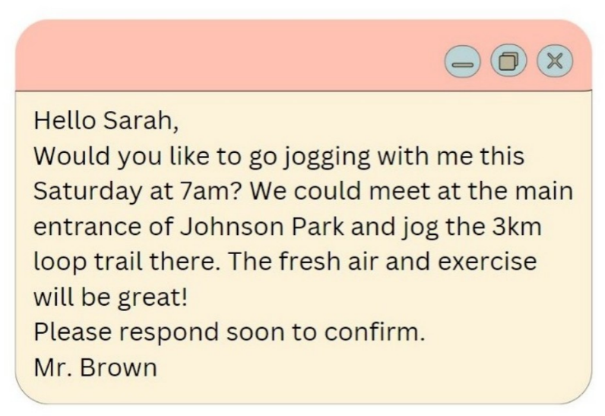

**A.** Central Park  **B.** Smith Park  **C.** Hyde Park  **D.** Johnson Park

**Câu 5.** What does this sign mean?

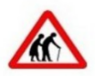

**A.** Be careless as elderly people may be crossing the road.

**B.** Be cautious as elderly people may be crossing the road.

**C.** They are wearing traditional clothing.

**D.** There are two old people here.

**Câu 6.** **Look at the signs. Choose the best answer for the question.**



**A.** You mustn’t throw trash on the ground.  **B.** Waste is not available in this place.

**C.** Littering is not good for the environment.  **D.** You don’t need to litter in this place.

**Câu 7.** What does this sign mean?

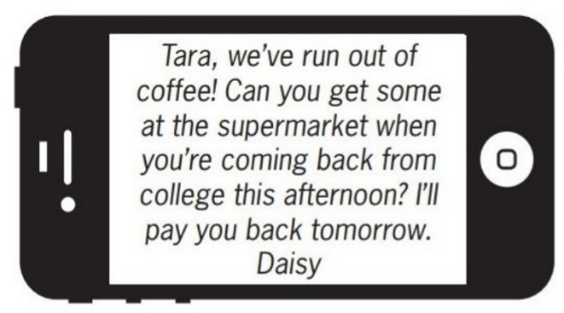

**A.** Daisy wants Tara to buy some coffee this afternoon.

**B.** Tara should give Daisy some money to buy coffee.

**C.** Tara will go to the supermarket tomorrow.

**D.** Daisy will buy coffee tomorrow when she returns home.

**Câu 8.** **Look at the signs. Choose the best answer for the question.**

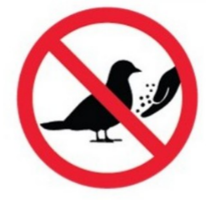

**A.** Do not touch the birds with your hands.  **B.** You can’t catch any birds in this area.

**C.** There aren’t any birds in this area.  **D.** Do not feed the birds.

**Câu 9.** **Look at the signs. Choose the best answer for the question.**

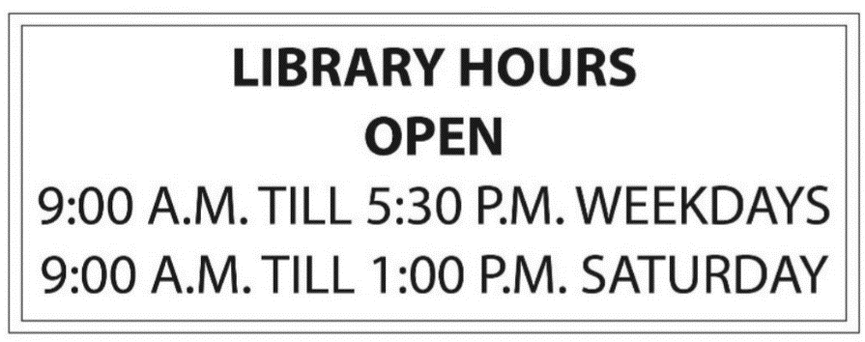

**A.** The library closes after 1 o’clock on Saturday afternoons.

**B.** The library is not open at noon.

**C.** People cannot come to the library on the weekends.

**D.** People can come to the library from 9 a.m. to 5.30 p.m. every day.

**Câu 10.** What is the discount amount when buying two shirts?

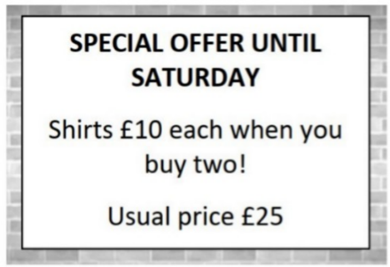

**A.** £25 off the total purchase  **B.** £10 off each shirt

**C.** £15 off each shirt  **D.** £5 off each shirt

**----HẾT---**