 | 1  How old are you? | 2  Have you been naughty or nice this year? | 3  Go Back to Start | 4  What presents would you like for Christmas? | 5  What colour is Santa’s beard?
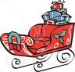  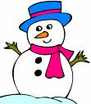  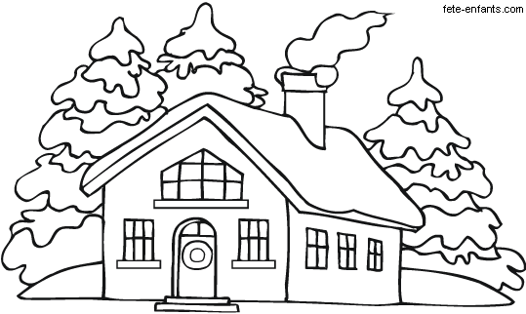 |  |  |  |  | 6  How many reindeer has Santa got?
22  What do Santa’s reindeer eat? | 23  Xmas Speaking Board Game  Does Santa drive a car? | 24  How does Santa travel? | 25  What do children hang up on Christmas Eve? | 26  Does Santa have chidlren? | 7  Where does Santa live?
21  Move Ahead  2 Spaces | 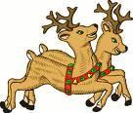 |  |  | 27  Do you have to go to school at Christmas? | 8  Miss a Turn
20  What do you think Santa likes to eat? |  |  |  | 28  Which day of the year is Christmas? | 9  What colour is a Christmas tree?
19  How old do you think Santa is? |  | 31  Who are Santa’s little helpers? | 30  What do we put on top of the Christmas tree? | 29  Which reindeer has a red nose? | 10  What do people eat for Christmas?
18  Is Santa thin or fat? | 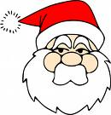  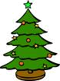 |  |  |  | 11  What’s your favourite Christmas present?
17  What question would you like to ask Santa? | 16  Roll Again | 15  What is white, has two black eyes and a long orange nose? | 14  What colour is snow? | 13  Do you know any names of Santa’s reindeer? | 12  What is the weather like at Christmas?

Answer key
5. white
6. nine
7. at the North Pole
13. Dasher, Dancer, Prancer, Vixen, Comet, Cupid, Donner, Rudolph and Blitzen.
15. a snowman
24. in a sleigh
25. Children hang up a stocking.
26. No, not biologically. Yes, he considers all the children in the world part of his family.
28. 25 December
29. Rudolph the Reindeer has a red nose.
30. A star.
31. The Elves.

For more info on Santa:
http://www.northpole.com/Den/Q&A/santa.asp

