School: ……………………………………….. | Date:………………………………..
Class: ……………………………..................... | Period: ……………………….........

UNIT 5: FOOD and DRINKS
Lesson 3.1 - Listening and Reading (Page 42)

I. OBJECTIVES
By the end of the lesson, Ss will be able to:
1.1. Language knowledge and skills
- talk about unusual foods in Vietnam.
- practice listening and understanding a recording about an unusual dish in Hà Giang Province (for general and specific information).
- read and understand a food blog post.
1.2. Competences
- improve communication, collaboration, analytical and critical thinking skills.
1.3. Attributes
- choose healthy food for meals.
- respect the culture and customs of other provinces all over the country.

II. TEACHING AIDS AND LEARNING MATERIALS
1. Teacher’s aids: Student book and Teacher’s book, class CDs, Digital Book (DCR phần mềm tương tác SB, DHA (từ vựng/ cấu trúc) phần mềm trò chơi tương tác), projector/interactive whiteboard / TV (if any), PowerPoint slides.
2. Students’ aids: Student’s book, workbook, notebook.

III. ASSESSMENT EVIDENCE
Performance Tasks | Performance Products | Assessment Tools
- Let’s Talk: What unusual foods can you think of? What's the strangest? | - Ss’ answers / presentation. | - T’s feedback/Peers’ feedback.
- A tour guide is talking to a group of tourists in Hà Giang Province. Where are the people? | - Ss’ answers. | - T’s feedback/Peers’ feedback.
- Listen and choose the best word(s) to complete the sentences. | - Ss’ answers. | - T’s feedback/Peers’ feedback.
- Read the blog post and match the pictures to the underlined words. | - Ss’ answers. | - T’s feedback/Peers’ feedback.
- Now, read and fill in the blanks. | - Ss’ answers. | - T’s feedback/Peers’ feedback.
-Speaking: Which strange foods do you want to try? | - Ss’ answers / presentation. | - T’s observation/ DCR and T’s feedback.

IV. PROCEDURES
A. Warm up: (5’)
a) Objective: Introduce the new lesson and set the scene for Ss to acquire new language; get students' attention at the beginning of the class by giving enjoyable and short activities as well as to engage them in the follow-up steps.
b) Content: Introduce an unusual dish: Dried worms.
c) Expected outcomes: Ss have general ideas about the topic “unusual foods in Vietnam”, which they are going to listen and read in the new lesson.
d) Organization of the activity:
TEACHER’S ACTIVITIES | STUDENTS’ ACTIVITIES
- Option 1: Let’s Talk!  What unusual foods can you think of? What's the strangest?  - Use the “Let’s talk!” part in the textbook– page 42 for warm-up activity.  - Ask Ss to work in pairs to answer the question: What unusual foods can you think of? What's the strangest?  - Call Ss to share their answers with the whole class.  - Give feedback and evaluation.  - Lead to the new lesson.  - Option 2:  - Show a video clip about an unusual dish: Dried worms.  - Have Ss watch and answer some questions:  1. Do you know the name of this dish? Have you ever tried it?  2. Do you know where in Vietnam is this dish famous?  3. Do you like insects?  - Call Ss to give answers.  - Check and give comment.  - Lead to the new lesson.  *Link:  https://www.youtube.com/watch?v=ux3vd0zIg78  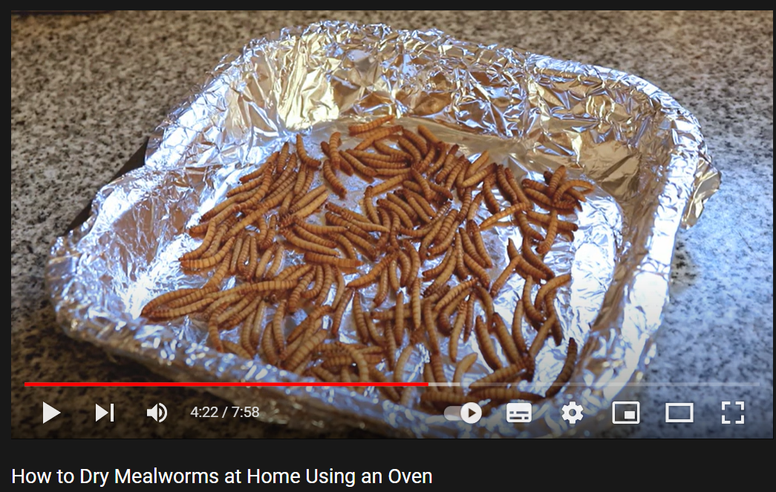 | - Work in pairs to discuss.  - Present.  - Watch the video clip, then answer T’s questions.  - Give answers.  - Listen.

B. New lesson (35’)
- Activity 1: Listening (17’)
a) Objective: Students can develop their listening skill.
b) Content: Listen to a conversation about an unusual dish in Hà Giang Province: A tour guide is talking to a group of tourists in Hà Giang Province. Where are the people? Then, listen and choose the best answer.
c) Expected outcomes: Students can practice listening and understanding general + specific information about an unusual dish.
d) Organization of the activity:

TEACHER’S ACTIVITIES | STUDENTS’ ACTIVITIES
Task a. A tour guide is talking to a group of tourists in Hà Giang Province. Where are the people?  - Have Ss read the question.  - Play audio (CD1 - Track 57).  - Have Ss listen and circle the correct answer.  - Call Ss to give answer, explain.  - Play the audio again and check the answer as a whole class using DCR.  Task b. Now, listen and choose the best word(s) to complete the sentences.  - Have Ss read through the content of Task b first.  - Play the audio again (CD1 - Track 57).  - Have Ss listen and choose the best word(s) to complete the sentences.  - Have Ss check answers with their partners.  - Call Ss to give answers, explain.  - Check answers as a whole class using DCR. | - Listen and take notes.  - Read.  - Listen and circle the correct answer.  - Give answer, explain.  Answer keys  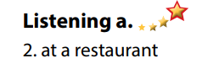  - Read.  - Listen and choose the best word(s) to complete the sentences.  - Exchange answers.  - Give answers.  Answer keys  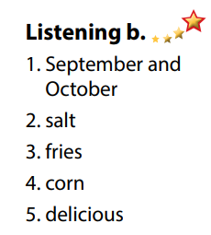

- Activity 3: Reading (18’)
a) Objective: Students can develop their reading skill.
b) Content:
- Read the blog post and match the pictures to the underlined words.
- Now, read and fill in the blanks.
c) Expected outcomes: Students can read a blog post about an unusual dish for gist and detail, and they can talk about strange foods they want to try.
d) Organization of the activity:
TEACHER’S ACTIVITIES | STUDENTS’ ACTIVITIES
Task a. Read the blog post and match the pictures to the underlined words.  - Have Ss read Task a.  - Ask Ss to look at the pictures, then read the blog post quickly to guess the meaning of the underlined words.  - Have Ss match the pictures to the underlined words.  - Call Ss to give answer.  - Check the answers as a whole class using DCR.  Task b. Now, read and fill in the blanks.  - Have Ss read the content in Task b and underline the key words.  - Have Ss read the blog post again and fill in the blanks.  - Have Ss check their answers with a partner.  - Call Ss to give answers.  - Check the answers as a whole class using DCR.  Task c. Speaking: In pairs: Which strange foods do you want to try?  - Have Ss discuss the questions in pairs.  - Call some Ss to share their answers with the whole class.  - Give feedback and evaluation. | - Read and guess the meaning of the underlined words.  - Do the matching.  - Give answer.  Answer keys  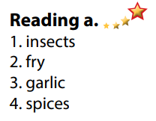  - Read and underline the key words.  - Read the text again for details.  - Exchange answers.  - Give answers.  Answer keys  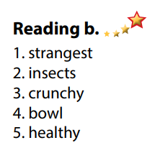  - Discuss in pairs.  - Present.

C. Consolidation and homework assignments (5’)
*Consolidation:
- Vocabulary: insects, fry, spices, garlic, crunchy, taste, tasty.

*Homework
- Find out more special and unusual foods in Vietnam.
- Do the exercises in WB: Listening and Reading (page 30).
- Do the vocabulary exercise in Tiếng Anh 7 i-Learn Smart World Notebook (page 32).
- Play consolation games in Tiếng Anh 7 i-Learn Smart World DHA App on www.eduhome.com.vn
- Prepare: Lesson 3 – Writing and Speaking (page 43 – SB).

D. Reflection
a. What I liked most about this lesson today:
…………………………………………………………………………………………
- What I learned from this lesson today:
…………………………………………………………………………………………
c. What I should improve for this lesson next time:
…………………………………………………………………………………………

