UNIT 11: TRAVELLING IN THE FUTURE

Lesson 1: Getting started – I hope we will have a hyperloop soon!

  - I. Objectives
By the end of this lesson, students will be able to gain:

1. Knowledge
- An overview about the topic TRAVELLING IN THE FUTURE.
- Vocabulary to talk about future means of transport.

2. Core competence
- Develop communication skills and creativity
- Be collaborative and supportive in pair work and team work
- Actively join in class activities

3. Personal qualities
- Develop self-study skills

  - II. Materials
- Grade 7 textbook, Unit 11, Getting started
- Pictures, maps and CD player
- sachmem.vn

  - Language analysis
Form | Meaning | Pronunciation | Vietnamese equivalent
1. eco – friendly (a) | Eco-friendly products have been designed to do the least possible damage to the environment | /ˈiː.kəʊˌfrend.li/ | thân thiện với môi trường
2. fume (n) | strong, unpleasant, and sometimes dangerous gas or smoke | /fjuːm/ | khói
3. hyperloop (n) | an extremely high-speed transportation system in which trains glide above a track inside a sealed tube or tunnel with very low air pressure, supported by magnetic repulsion and propelled by a linear motor | /ˈhaɪ.pərluːp/ | hệ thống giao thông tốc độ cao
4. teleporter (n) | an imaginary very fast form of transport that uses special technology or special mental powers | /ˈtel.ɪ.pɔː.tər/ | phương tiện di chuyển tức thời
5. campsite (n) | a piece of land where people on holiday can camp, usually with toilets and places for washing | /ˈkæmp.saɪt/ | địa điểm cắm trại

Anticipated difficulties | Solutions
1. Students may lack knowledge and experiences about the topic. Prepare some handouts. | Encourage students to work in pairs, in groups so that they can help each other.
2. Students may have underdeveloped listening, speaking and co-operating skills. Play the recording again if necessary. | Provide feedback and help if necessary.

  - Board Plan
Date of teaching
UNIT 11: Travelling in the future
Lesson 1: Getting started – I hope we will have a hyperloop soon!
* Warm-up
Chitchatting
I. Vocabulary
1. eco – friendly (a) /ˈiː.kəʊˌfrend.li/: thân thiện với môi trường
2. fume (n) /fjuːm/: khói
3. hyperloop (n) /ˈhaɪ.pərluːp/: hệ thống giao thông tốc độ cao
4. teleporter (n) /ˈtel.ɪ.pɔː.tər/: phương tiện di chuyển tức thời
5. campsite (n) /ˈkæmp.saɪt/: địa điểm cắm trại
II. Practice
Task 1: Listen and read. What are Ann and Minh talking about? (Ex 1, 2, p. 114, 115)
Task 2: Read the conversation again and tick T (True) or F (False). (Ex 3, p. 115)
Task 3: Find the words and phrases that describe the means of transport in the conversation and write them in the correct columns. (Ex 4, p. 115)
Task 4: Quiz (Ex 5, p. 115)
* Homework

Procedures
Notes
In each activity, each step will be represented as following
* Deliver the task
** Implement the task
*** Discuss
**** Giving comments or feedback

Stage | Stage aim | Procedure | Interaction | Time
Warm-up | To set the context for the listening and reading text.  To introduce the topic of the unit. | Chitchatting:  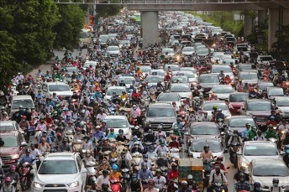  + How do you people travel every day?  + What do you think about the traffic in the picture?  + How about traffic in the future?  * Teacher has Ss to look at the picture and talk about it by answering these questions.  ** Ss work in pairs to do the task.  *** Teacher calls on some Ss to give their ideas about it.  **** Teacher listens, comments, then leads Ss to the new lesson.  Teacher says: “In the lesson today we are going to learn a new unit about “Travelling in the future”. Let’s start to see and find out more information related to our new topic”. | T-Ss  Pairs work  T- Ss | 5 mins
Presentation  (Vocab-  pre-teach) | To introduce the new words.  To set the context for the introductory conversation; | Vocabulary:  * Teacher introduces the vocabulary by:  + showing the pictures illustrating the words  + providing the synonym or antonym of the words  + providing the definition of the words  1. eco – friendly (a): [visual + explanation]  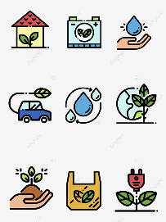  2. fume (n): [visual + explanation]    3. hyperloop (n): [visual + explanation]  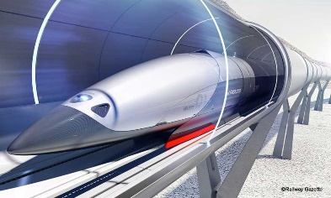  4. teleporter (n): [visual + explanation]  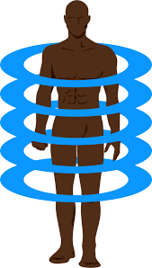  5. campsite (n): [visual + explanation]    ** Ss say the words.  *** Other Ss correct if the previous answers are incorrect.  **** Teacher shows and says the words aloud and asks Ss to repeat them.  Checking techniques: Rub out and Remember  GETTING STARTED  I HOPE WE WILL HAVE A HYPERLOOP SOON!  SET THE SCENE: PRE- QUESTIONS  * Teacher draws students’ attention to the pictures in the textbook and asks them some questions about the pictures. Teacher don’t confirm whether theirs are right or wrong.  + Who are they?  + Where are they?  + Where are they going?  + What can you see outside the coach?  + What can you see in the bubble?  + What could they be talking about?  Suggested answers:  + They are Minh and Ann.  + They are on a coach.  + They are going to the campsite.  + Outside the coach, we can see the crowded street. There is a traffic jam.  + In the bubble, there is a system of tubes. Minh is thinking about a means of transport.  ** Ss work out and answer questions in pairs.  *** Ss share their answers as a whole class.  **** T asks them to read and listen to the conversation to check their answers. | T-Ss | 8 mins
Practice | To practice the targeted language and the background knowledge  To help Ss read for specific information about Ann and Minh’s conversation.  – To help Ss recognise the words / phrases used to describe means of transport; – To help Ss further understand the text. | Task 1: Listen and read. What are Ann and Minh talking about?  (Ex 1, 2, p. 114, 115)  * Teacher plays the recording, asks students to underline the words related to the topic. (Teacher may check the meaning of some words if necessary.)  - Teacher can play the recording more than once.  - Students listen and read.  ** Teacher can invite some pairs of students to read aloud.  *** Teacher refers to the questions previously asked.  **** Then, teacher confirms the correct answer: “Ann and Minh are talking about future modes of travel.  Answer key: 2B  Task 2: Read the conversation again and tick T (True) or F (False). (Ex 3, p. 115)  * Teacher asks Ss to work in pairs to read the conversation again and underline the key words in each sentence.  ** Ss work in pairs to do the task.  *** Ss answer and point out where in the conversation they find the information for their answers.  **** Teacher checks the answers as a class.  Answer keys:  1. T 2. F 3. F 4. T 5. T  Task 3: Find the words and phrases that describe the means of transport in the conversation and write them in the correct columns. (Ex 4, p. 115)  * Teacher asks Ss to work in pairs to read the conversation again and to underline the words / phrases that describe means of transport: hyperloop and teleporter.  ** Ss work in pairs to pick out words / phrases they have found to write down in the correct column.  *** Teacher asks some Ss to read out words / phrases they have found in the conversation to put into each column.  **** Teacher checks the answers as a class  Answer keys:  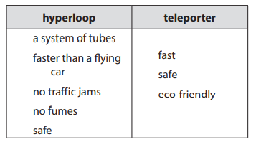 | T-Ss  S  T-Ss  T- Ss  Pair works  T -Ss  T-Ss  Pair works  T-Ss | 20 mins
Production | – To help Ss review vocabulary related to different means of transport;  – To give Ss a chance to develop creative thinking; | Task 4: Quiz (Ex 5, p. 115)  * Teacher asks Ss to work in pairs to discuss to find out the vehicles in these sentences.  ** Ss work in pairs to do the task  *** Teacher reads out loud each question and the pairs answer. The pair who correctly completes its first wins  **** Teacher confirms the answers.  Answer keys:  1. bicycle / bike  2. car  3. train  4. sailing boat  5. rocket / spaceship  * Then, teacher has Ss work in pairs again to discuss how the vehicles they have thought of will be like in 50 years.  ** Ss work in pairs to do the task.  *** Teacher calls SS give any description about future means of transport they can imagine.  **** Teacher corrects grammar or pronunciation mistakes if needed. | T- Ss  Pair works  T- Ss  T- Ss  Pair works  T- SS | 9 mins
Consolidation | To consolidate what students have learnt in the lesson. | - Ask one or two students to tell the class what they have learnt.  - Ask students to say aloud some words they remember from the lesson. If there is an overhead projector in the classroom, show the dialogue, highlight the key words related to the topic. | T-Ss | 2 mins
Homework | To prepare vocabulary for the next lesson. | - Do Ex in WB | T-Ss | 1 min

UNIT 11: TRAVELLING IN THE FUTURE

Lesson 2: A closer look 1

I. Objectives
By the end of this lesson, students will be able to:
1. Knowledge
- Vocabulary:
+ use the lexical items related to the topic Travelling in the future.
Pronunciation: say sentences with correct stress
2. Core competence
- Develop communication skills .
- Be collaborative and supportive in pair work and teamwork.
- Actively join in class activities.
3. Personal qualities
- Be ready to know the words about future means of transport.
- Develop self-study skills.
II. Materials
Grade 7 textbook, Unit 11, A closer look 1
Computer connected to the internet
TV/ Projector/ Pictures/ Cards
sachmem.vn

Language analysis
Form | Meaning | Pronunciation | Vietnamese equivalent
1. bamboo - copter (n) | also known as the bamboo dragonfly or Chinese top, is a toy helicopter rotor that flies up when its shaft is rapidly spun. | /bæmˈbuːˈkɒp.tər/ | chong chóng tre
2. skyTran (n) | skyTran is a patented, high-speed, low-cost, elevated Personal Rapid Transit (PRT) system. | /skaɪtræn/ | hệ thống tàu điện trên không
3. solar- powered (a) | electricity produced by using the energy from the sun | /ˌsəʊ.lə -ˈpaʊər/ | chạy bằng năng lượng mặt trời
4. (to) sail | o control a boat that has no engine and is pushed by the wind: | /seɪl/ | lướt buồm

Anticipated difficulties | Solutions
1. Students may lack knowledge about some lexical items. | Provide students with the meaning and pronunciation of some lexical items.
2. Students may have underdeveloped listening, speaking and co-operating skills. | Play the recording many times if necessary.  Encourage students to work in pairs, in groups so that they can help each other.  Provide feedback and help if necessary.
3. Some students might excessively talk in the class. | Define expectation in explicit detail.  Have excessive talking student’s practise.  Continue to define expectations in small chunks (before every activity).

Board Plan
Date of teaching
Unit 11: Travelling in the future
Lesson 2: A closer look 1
* Warm-up
Game: Miming
I. Vocabulary: Future means of transport
1. bamboo - copter (n) /bæmˈbuːˈkɒp.tər/: chong chóng tre
2. skyTran (n) /skaɪtræn/: hệ thống tàu điện trên không
3. solar- powered (a) /ˌsəʊ.lə -ˈpaʊər/: chạy bằng năng lượng mặt trời
4. (to) sail/seɪl/: lướt buồm
Task 1: Write the words or phrases under the correct pictures. Then listen, check, and repeat. (Ex. 1, p. 116)
Task 2: Write words or phrases from 1 in the correct columns. (Ex 2, p. 116)
Task 3: Complete the sentences, using the words from the box. (Ex 3, p. 116)
II. Pronunciation: Sentence stress
Task 4: Listen to the sentences and repeat. Pay attention to the bold syllables. (Ex 4, p. 116)
III. Production:
Task 5: Listen to the sentences and repeat. How many stresses are there in each sentence? (Ex 5, p.116)

* Homework

Procedures
Notes
In each activity, each step will be represented as following
* Deliver the task
** Implement the task
*** Discuss
**** Giving comments or feedback

Stage | Stage aim | Procedure | Interaction | Time
Warm-up | To help Ss review the previous lesson.  – To create a fun atmosphere in the class. | Game: Miming  * Teacher calls 1 student come to the board and whispers into Ss’ ears one means of transport.  ** Ss think of how to mine it, and the others are ready to guess  *** Ss mine the action for the others to guess the means of transport.  **** Teacher confirms the correct answer. The student who guesses correctly is the winner.  Suggested answers:  1. hyperloop  2. flying car  3. train  4. bike  5. motorbike  6. boat | T – Ss  Ss-Ss  T-Ss | 5 mins
Lead in | To lead in the lesson about vocabulary and pronunciation. | Teacher leads students into the lesson by telling them that “In today lesson, we are going to learn more words to talk about Future means of transport and how to say sentences with correct stress.” | T-Ss | 1 min
Presentation  (Vocab-  pre-teach) | To introduce visually some words related to the topic | VOCABULARY  * Teacher introduces the vocabulary by:  + providing the synonym or antonym of the words  + providing the pictures of the words  - Teacher have students read the phrases aloud and correct their pronunciation if needed.  - Teacher asks students for the Vietnamese meanings of these phrases.  1. bamboo - copter (n): [visual + explanation]    2. skyTran (n): [visual + explanation]  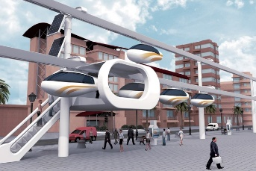  3. solar - powered (a): [visual + explanation]  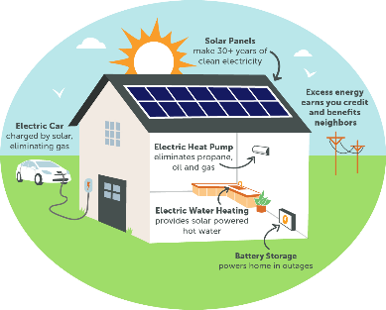  4. (to) sail: [visual + explanation]    ** Ss say the words.  *** Other Ss correct if the previous answers are incorrect.  **** Teacher shows and says the words aloud and asks Ss to repeat them  Checking techniques:  “Rub out and remember” | T-Ss | 8 mins
Practice/ Controlled practice | To introduce some modes of future travel.  To help Ss learn to use the right verbs for the appropriate mode of travel.  To help Ss practise using the learnt words in the right context. | Task 1: Write the words or phrases under the correct pictures. Then listen, check, and repeat. (Ex. 1, p. 116)  * Teacher asks students to choose the words and phrases in the box to write under the correct pictures with their partners.  ** Ss work in pairs to do the task.  *** Teacher calls on some students to read aloud the words and asks them why they think a word / phrase should go with a picture  **** Teacher plays the recording for Ss to check their answers, has them to repeat chorally and individually, corrects their pronunciation and explain the meaning of these words/ phrases if needed.  Answer keys:  1. solar-powered ship  2. flying car  3. bamboo-copter  4. hyperloop  5. skyTran  Task 2: Write words or phrases from 1 in the correct columns. (Ex 2, p. 116)  * Teacher asks students to look at Ex 2 to write words and phrases in 1 in the correct columns  ** Ss work independently to do the task.  *** Some Ss give their answers.  **** Teacher checks students ‘answers as a class.  Answer keys:  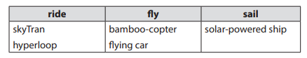  * Then, teacher asks Ss work in pair to add more words to each column.  ** Ss work in pairs to di the task.  *** Teacher calls on some Ss to give their answers.  **** Teacher confirms and corrects.  Suggested answers:  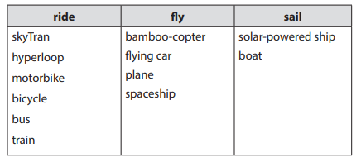  Task 3: Complete the sentences, using the words from the box. (Ex 3, p. 116)  * Teacher has Ss look at the box, practice saying the words, then work individually to complete the sentence.  ** Ss work individually to do the task.  *** Some Ss read aloud the complete sentences  **** Teacher confirms the correct answers.  Answer keys:  1. bamboo-copter  2. fly  3. ride  4. hyperloop  5. eco-friendly | T - Ss  Pair work  T-Ss  T- Ss  Pair wok  T- Ss  T – Ss  Pair work  T – Ss  T- Ss  S  T- Ss | 11 mins
Presentation  (Pre-teach the SENTENCE STRESS | To help Ss be aware of which words in a sentence should be stressed, which are not;  – To help Ss say sentences with correct stress | PRONUNCIATION  SENTENCE STRESS  * Teacher writes the words “Sentence stress” on the board and asks them “What is sentence stress?”. Then, teacher has Ss watch the video to understand more about it.  https://www.youtube.com/watch?v=d2SF3DHXeC8&t=228s  ** Ss work independently to do the task.  *** Teacher calls some Ss to check their understanding.  **** Teacher confirms, then asks them to read “Remember” in 1 minute.  + What are stressed words?  + What are unstressed words? | T- Ss | 8 mins
Practice/ Controlled practice | To help students practise pronouncing sentences with correct stress. | Task 4: Listen to the sentences and repeat. Pay attention to the bold syllables. (Ex 4, p. 116)  * Teacher has students read the sentences and underline the stressed words. Then, ask them to listen to the recording once first and pay attention to the stressed syllables.  ** SS do the task independently, try to listen and repeat sentences as many times as possible as a class, a group and individually  *** Teacher calls some students to read out the sentences.  **** Teacher corrects their pronunciation and stress if needed.  Suggested answers:  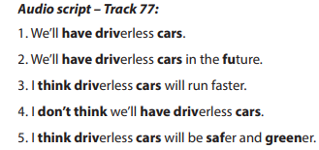 | T-Ss  S  T- Ss | 6 mins
Production/ Less controlled practice | To help Ss be aware of the words they have to stress in a sentence  – To help Ss practise saying sentences with correct stress | Task 5: Listen to the sentences and repeat. How many stresses are there in each sentence? (Ex 5, p.116)  * Teacher plays the recording for Ss to listen and repeat; then ask Ss to count the number of stresses in each sentence.  ** Ss do the task individually.  *** Teacher calls on some Ss to read the sentences in front of the class.  **** Teacher corrects their pronunciation if needed.  Suggested answers:  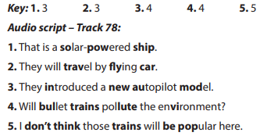 | T- SS | 4 mins
Consolidation | To consolidate what students have learnt in the lesson. | Teacher asks students to talk about what they have learnt in the lesson. | T-Ss | 1 min
Wrap up  Homework | To revise what they have learnt. | Practice saying the sentences at home. | T-Ss | 1 min

UNIT 11: TRAVELLING IN THE FUTURE

Lesson 3: A closer look 2

The future simple: Will + Possessive pronouns

  - I. Objectives
By the end of this lesson, students will be able to:
1. Knowledge
know how to recognize “The future simple: Will”
a. We use will + V:
+ to talk about future activities
Eg: We will buy an electric scooter soon.
+ to make predictions
Eg: We will probably use electric cars because normal cars cause too much pollution.
b. Possessive pronouns
+ to demonstrate ownership
Eg: This is our house. It’s ours.
2. Core competence
- Develop communication skills
- Be collaborative and supportive in pair work and team work
- Actively join in class activities
3. Personal qualities
Be responsible and hard working
  - II. Materials
- Grade 7 textbook, Unit 11, A closer look 2
- Computer connected to the internet
- TV/ Projector/Pictures, sets of word cards
- sachmem.vn

Anticipated difficulties | Solutions
1. Students may lack knowledge and experiences about the topic. | Prepare some hand-outs.
2. Some students might excessively talk in the class. | - Define expectation in explicit detail.  Have excessive talking student’s practise.  - Continue to define expectations in small chunks (before every activity).

Board Plan
Date of teaching
Unit 11: Travelling in the Future
Lesson 3: A closer look 2
* Warm-up
CHATTING
I. Grammar 1: The future simple
+ to talk about future activities
Eg: We will buy an electric scooter soon.
+ to make predictions
Eg: We will probably use electric cars because normal cars cause too much pollution.
Task 1: Complete the sentences with will or won’t. (Ex 1, p. 117)
Task 2: Rearrange the words and phrases to make sentences. (Ex 2, p. 117)
Task 3: Use the correct form of the verbs in brackets to complete the conversation. (Ex 3, p. 117)
II. Grammar 2: Possessive pronouns.
+ to demonstrate ownership
Eg: THIS IS YOUR BICYCLE. THAT BICYCLE IS HER BICYCLE. → HERS
Task 4: Replace the underlined phrases with possessive pronouns. (Ex 5, p. 118)
III. Production
Task 5: Look at the pictures and tell your partner if you will / won’t travel by these means of transport. Give reason(s). (Ex 4, p. 118)
* Homework

Procedures
Notes
In each activity, each step will be represented as following
* Deliver the task
** Implement the task
*** Discuss
**** Giving comments or feedback

Stage | Stage aim | Procedure | Interaction | Time
Warm-up | To activate students’ prior knowledge and vocabulary related to the targeted grammar | GAME: CHATTING  * Teacher asks Ss some questions to lead into the lesson.  + How does your father go to work every day?  + What color is it?  + How will you travel when you are 30?  ** Ss work in dependently to do the task.  *** Teacher calls on some Ss to answer.  **** Teacher confirms and write some key sentences on the board.  Mine is white  I will…. | T- Ss | 5 mins
Lead in | To introduce the targeted grammar of the lesson. | Teacher says: “Today, we are going to learn how to use Will in the future and possessive pronouns.” | T-Ss | 1 min
Presentation | To introduce students the form and the usage of the future simple. | GRAMMAR 1: THE FUTURE SIMPLE  * Teacher has Ss read “Remember box” in some minutes.  ** Ss work independently to read.  *** Teacher calls on some Ss to answer teacher’s questions to make sure they can understand how to use and form The Future Simple well.  + “Do we use The Future Simple to talk about past, present or future activities?”  + Teacher writes on the board: “People will go to school by solowheel in 2030” and asks Ss: “In this situation, what do we use the future tense for?”  + “To make a negative form, do we say will not or not will?” (Just add NOT behind Will)  + “For questions, where we can put Will?” (Before subjects)  **** Teacher confirms, and corrects grammar if needed, then write on the board:  + Usage: to talk about future activities and to make predictions.  + Form: (+) S + will + V  (-) S + will + not (won’t)  (?) Will + S + V?  GRAMMAR 2: POSSESSIVE PRONOUNS (review)  * Teacher writes on the board an example then asks Ss some questions to remind them.  This is your bicycle.  That bicycle is her bicycle. → hers  + Do we use a possessive pronoun instead of a phrase? (hers = her bicycle)  + Does a possessive pronoun come before a noun?  + Let’s complete this table:  +** Ss work individually to answer teacher’s questions  *** Teacher calls on some Ss to give their ideas.  **** Teacher confirms and corrects. | T-Ss  Ss-Ss | 9 mins
  Personal pronouns | Possessive adjectives | Possessive pronouns
  I | my | mine
  You | your | yours
  We | our | ours
  They | their | theirs
  He | his | his
  She | her | hers
  It | its | its
Practice/ Controlled practice | To help Ss use the right verb form to talk about future activities.  To help Ss practise making full sentences about future activities using prompts.  To help Ss use the correct forms of future simple to make predictions.  To review possessive pronouns. | Task 1: Complete the sentences with will or won’t. (Ex 1, p. 117)  * Teacher asks students to do the exercise individually and then compare their answers with a classmate.  ** Ss do the task individually.  *** Some Ss explain their choices.  ****Teacher confirms the correct answers.  Answer key:  1. won’t  2. will  3. will  4. won’t  5. Will  Task 2: Rearrange the words and phrases to make sentences. (Ex 2, p. 117)  * Teacher has students work individually to rearrange the words to make sentences.  ** Ss do the task individually.  *** Some Ss write their answer on the board.  ****Teacher confirms the correct answers.  Answer key:  1. We will have driverless cars in 2030.  2. Cities won’t allow cars in 2050.  3. Will electric cars be popular?  4. We will use solar-powered buses soon.  5. Will we have enough parking places in ten years?  Task 3: Use the correct form of the verbs in brackets to complete the conversation. (Ex 3, p. 117)  * Teacher asks Ss to work in pairs to complete the conversation.  ** Ss work in pairs to do the task.  *** Teacher calls on Ss to read aloud the complete conversation.  **** Teacher confirms the correct answers helps them to correct mistakes if needed.  Suggested answers:  1. will take  2. won’t have  3. Will ... have  4. won’t drive  5. won’t be  Task 4: Replace the underlined phrases with possessive pronouns. (Ex 5, p. 118)  * Teacher asks Ss to do the task individually to replace the underlined phrases with the correct possessive pronouns.  ** Ss do the task individually and compare with their partners.  *** Some Ss read aloud their answers on the board.  **** Teacher confirms the correct answers.  Suggested answers:  1. theirs  2. mine  3. His  4. Yours  5. Ours | T- Ss  S  T – Ss  T- Ss  S  T – Ss  T- Ss  In pairs  T- Ss  T- Ss  S  T- Ss | 20 mins
Production/ Less controlled practice | To help Ss practise talking about some future means of transport  – To help Ss learn reasoning skills by giving reasons for their choice. | Task 5: Look at the pictures and tell your partner if you will / won’t travel by these means of transport. Give reason(s). (Ex 4, p. 118)  * Teacher asks Ss to work in pairs to describe the picture.  ** SS work with their partners to do the task.  ***Some pairs talk about their choices and reasons why they will / won’t use those means of  travelling.  **** Teacher listens to Ss to correct common errors after Ss finish speaking.  Suggested answers:  - In picture 1, I can see a / an (electric) bus / coach. I can see many people on this bus / coach. I think I will go  to school by electric coach because it has no fumes, and it can carry many people at the same time.  - In picture 2, I can see a flying car. It is flying over a city. I think I will travel by flying car. It will be fun to fly in  one. I will be able to see the city below (or I can fly it when the roads are congested).  - In picture 3, I can see a ship. It has solar panels. I will travel on a solar-powered ship to visit some islands.  It will be comfortable / fun to travel by solar-powered ship.  - In picture 4, I can see a bamboo-copter. I will fly a bamboo-copter to work. It will be fun / fast. (or I won’t use a bamboo-copter to travel from one place to another. It will be dangerous. You might get hurt when it  is windy …).  - In picture 5, I can see a car with a lot of smoke behind it. I won’t go by car in the future. It pollutes the  environment. | T-Ss  Pair work  T- Ss | 7 mins
Consolidation | To consolidate what students have learnt in the lesson. | Teacher asks students to talk about what they have learnt in the lesson. | T-Ss | 2 mins
Wrap up  Homework | To revise what they have learnt. | Do exercises in the workbook. | T-Ss | 1 min

UNIT 11: TRAVELLING IN THE FUTURE

Lesson 4: Communication

  - I. Objectives
By the end of this lesson, students will be able to:
1. Knowledge
- learn how to how to make predictions.
- practise using some grammar points and vocabulary related to the topic.
2. Core competence
- Develop communication skills
- Be collaborative and supportive in pair work and team work
- Actively join in class activities
3. Personal qualities
- Be benevolent and responsible
  - II. Materials
- Grade 7 textbook, Unit 11, Communication
- Computer connected to the internet
- TV/ Pictures/ Projector
- sachmem.vn

Language analysis
Anticipated difficulties | Solutions
1. Students may lack knowledge about the topic. | Provide students with information about the knowledges they do not know.
2. Students may have underdeveloped reading, speaking and co-operating skills. | - Encourage students to work in pairs, in groups so that they can help each other.  - Provide feedback and help if necessary.
3. Some students might excessively talk in the class. | - Define expectation in explicit detail. Have excessive talking students practise.  - Continue to define expectations in small chunks (before every activity).

Board Plan
Date of teaching
Unit 11: Travelling in the future
Lesson 4: Communication
*Warm-up
Chatting
I. Everyday English:
Making predictions
  - Structure: to make predictions
- We certainly will/ won’t
- It probably won’t/ will
Task 1: Listen and read the conversation. (Ex 1, p. 119)
Task 2: Make similar conversation. (Ex 2, p. 119)
II. Practice: How will children go to school?
Task 3: Complete the conversation between Mark and Lan with the questions and answers from the box. (Ex 3, p, 119)
Task 4: Choose one means of transport below and make a similar conversation as in 3. (Ex 4, p. 119)
III. Production
Task 5: Choose one means of transport that you would like to use to travel to school. Give reasons. (Ex 5, p. 119)
* Homework

Procedures
Notes
In each activity, each step will be represented as following
* Deliver the task
** Implement the task
*** Discuss
**** Giving comments or feedback

Stage | Stage aim | Procedure | Interaction | Time
Warm-up | To revise the old lesson and introduce the new lesson. | CHATTING  * Teacher checks Ss’ knowledge of the previous lessons by asking them to make sentences using The Future Simple or possessive pronouns.  ** Ss think of a sentence individually.  *** Teacher calls on some Ss to read aloud their sentences.  **** Teacher confirms, corrects grammar and pronunciation if needed. | T-Ss | 5 mins
Lead in | To lead in the lesson. | Teacher leads students into the lesson by telling what they are going to learn: “We are going to learn how to make predictions and use the grammar and the vocabulary related to our topic Travelling in the future” | T-Ss | 1 min
* EVERYDAY ENGLISH
Presentation | To introduce to Ss how to make predictions  – To have Ss practise the conversation of making predictions | Task 1: Listen and read the conversation. (Ex 1, p. 119)  * Teacher plays the record for SS to listen and read the conversation  ** Ss listen and practice saying with their partners.  *** Teacher calls some pairs to read aloud.  **** Teacher corrects pronunciation if needed.  * Teacher asks Ss to pay attention to the highlighted parts and asks them some questions to elicit the new structure  ** Ss answer teacher’s questions to find out new structure to express preferences.  *** Some students give the new structure to the teacher.  **** Teacher corrects and writes on the board:  - Structure: to make predictions  - We certainly will/ won’t …  if you are sure about your predictions.  - It probably won’t/ will …  if you are not sure about your predictions. | T-Ss | 10 mins
Practice | To help Ss practise making predictions. | Task 2: Make similar conversation. (Ex 2, p. 119)  * Teacher has SS look at the situation in Ex 2 to make similar dialogue:  1. travelling long distances by hyperloop.  2. travelling to other planets for holidays.  ** Ss work in pairs to make similar dialogue.  *** Teacher calls some pairs to present it in front of the class.  **** Teacher gives feedback and some comments.  Suggested answers:  Situation 1:  A: Do you think we will travel long distances by hyperloop?  B: We certainly / probably will.  A: Will it allow us to travel to other planets?  B: It probably / certainly won’t.  Situation 2:  A: Do you think people will travel to other planets for their holidays?  B: They certainly / probably will.  A: Will holidays on other planets be expensive / interesting?  B: They certainly will (be). | Pair work  T-Ss | 7 mins
* HOW WILL CHILDREN GO TO SCHOOL?
Presentation | - To help Ss learn more about what information they can discover when talking about a means  of transport  – To help Ss practise asking and answering questions about a future means of transport. | Task 3: Complete the conversation between Mark and Lan with the questions and answers from the box. (Ex 3, p, 119)  * Teacher asks Ss to work in pairs to read the conversation and complete it with the questions and answers from  the box  ** Ss do the task in pairs  *** Teacher calls some Ss to give their answer and explain it.  **** Teacher confirms the correct answers.  Answer key:  1. B  2. A  3. D  4. C | T- Ss  In pairs  T-Ss | 5 mins
Practice/ Controlled practice | To help Ss practise asking and answering questions about which means of transport they  would like to use to travel to school;  – To help Ss be aware of what information they should use when asking about a means of  transport. | Task 4: Choose one means of transport below and make a similar conversation as in 3. (Ex 4, p. 119)  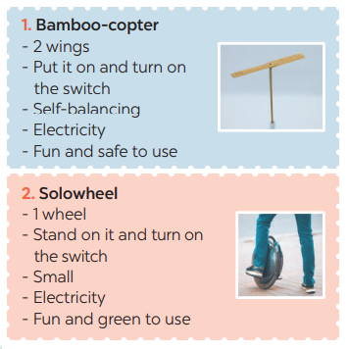  * Teacher asks Ss to n pairs to ask and answer questions about which means of transport they would like to  use to travel to school. Ask them to use the example in 3. Elicit any other questions and answers they  can ask and answer about a means of transport.  ** Ss work in pairs.  *** Teacher invites some pairs to role-play, asking and answering the questions in front of the class  **** Teacher confirms and corrects if needed.  Suggested answer:  For the conversation about bamboo-copter, for example, T may guide Ss to ask questions:  1. So what means of transport will students use to go to school?  2. How many fans does it have?  3. How will it work?  4. What will it run on?  5. Why would you like to go to school by bamboo-copter?  – For the Solowheel, T instructs Ss to ask similar questions. | T-Ss  Pair work  T- Ss | 5 mins
Production/ Less controlled practice | To help Ss practise talking about which means of transport they would like to use to travel to  school  – To help Ss practise giving reasons  – To help Ss practise reporting. | Task 5: Choose one means of transport that you would like to use to travel to school. Give reasons. (Ex 5, p. 119)  * Teacher asks Ss to work in group to discuss which means of transport they would like to use to travel to  school  ** Ss work in groups to take notes several means of transport for Ss to think of such as a bamboo-copter, a solowheel , a scooter or a bicycle and reasons for them to use:  + It is safe / fast / green / fun / economical / convenient.  + It doesn’t cause noise or pollution.  + It doesn’t make fumes.  + It doesn’t pollute the environment.  - Teacher goes round the class to monitor and give support if necessary.  *** Ss from each group present their ideas to the class.  **** Teacher comments on their clarify, language, fluency, grammar, etc. | Groupwork  T-Ss | 6 mins
Consolidation | To consolidate what students have learnt in the lesson. | Teacher asks students to talk about what they have learnt in the lesson. | T-Ss | 1 min
Homework | To prepare for the next lesson:  Skills 1. | Do exercises in the workbook. | T-Ss | 1 min

UNIT 11: TRAVELLING IN THE FUTURE

Lesson 5: Skills 1

  - I. Objectives
By the end of this lesson, students will be able to gain:
1. Knowledge
+ Reading:
- read for general and specific information about a future car.
+ Speaking:
talk about why a means of transport will / won’t be popular
2. Core competence
- Develop communication skills
- Be collaborative and supportive in pair work and team work
- Actively join in class activities
3. Personal qualities
Be benevolent and responsible
  - II. Materials
- Grade 7 textbook, Unit 11, Skills 1
- Computer connected to the internet
- TV/ Pictures, cards
- sachmem.vn

  - Language analysis
Form | Meaning | Pronunciation | Vietnamese equivalent
1. (to) charge | to put electricity into an electrical device such as a battery. | /tʃɑːdʒ/ | sạc pin
2. passenger (n) | a person who is travelling in a vehicle but is not driving it, flying it, or working on it | /ˈpæs.ən.dʒər/ | hành khách
3. economical (a) | not using a lot of fuel, money, etc. | /ˌiː.kəˈnɒm.ɪ.kəl/ | tiết kiệm nhiên liệu
4. autopilot (adj, n) | a device that keeps aircraft, spacecraft, and ships moving in a particular direction without human involvement | /ˈɔː.təʊˌpaɪ.lət/ | lái tự động
5. function (n) | the natural purpose (of something) or the duty (of a person) | /ˈfʌŋk.ʃən/ | chức năng
6. (to) run on | If a machine runs on a particular type or supply of power, it uses that power to work | /rʌn ɒn/ | chạy bằng (nhiên liệu nào)

Anticipated difficulties | Solutions
1. Students may lack knowledge about some lexical items. | Provide students with the meaning and pronunciation of words.
2. Students may have underdeveloped reading, speaking and co-operating skills. | - Let students read the text again  (if needed).  - Create a comfortable and encouraging environment for students to speak.  - Encourage students to work in pairs, in groups so that they can help each other.  - Provide feedback and help if necessary.
3. Some students might excessively talk in the class. | - Define expectation in explicit detail.  Have excessive talking students practise.  - Continue to define expectations in small chunks (before every activity).

  - Board Plan
Date of teaching
Unit 11: Travelling in the future
Lesson 5: Skills 1
* Warm-up
Networking
I. Reading:
1. Vocabulary
a. (to) charge /tʃɑːdʒ/: sạc pin
b. passenger (n) /ˈpæs.ən.dʒər/: hành khách
c. economical (a) /ˌiː.kəˈnɒm.ɪ.kəl/: tiết kiệm nhiên liệu
d. autopilot (adj, n) /ˈɔː.təʊˌpaɪ.lət/: lái tự động
e. function (n) /ˈfʌŋk.ʃən/: chức năng
f. (to) run on/rʌn ɒn/:chạy bằng (nhiên liệu nào)
2. Brainstorming: Look at the picture and find the words or phrases to describe it. (Ex 1, p. 120)
3. Practice
Task 1: Read the passage and answer the question. (Ex 2, p. 120)
Task 2: Read the passage again and complete the fact file with no more than two words or a number. (Ex 3, p. 120)
Task 3: Retelling
II. Speaking:
Task 4: Look at the fact file in 3 then ask and answer questions about it. (Ex 4, p. 120)
Task 5: Discuss why Roadrunner’s cars will or won’t become popular in the near future. Report your reasons to the class. (Ex 5, p. 120)
* Homework

Procedures
Notes
In each activity, each step will be represented as following
* Deliver the task
** Implement the task
*** Discuss
**** Giving comments or feedback

Stage | Stage aim | Procedure | Interaction | Time
Warm-up | To introduce the topic of reading. | Game: NETWORKING  * Teacher asks Ss to think of the forms of transport they have used and any that they would like to experience.  ** Ss in groups to share.  *** Teacher calls on groups to see how many different forms of transport they can list. The group which has more corrects ones will be the winner.  **** Teacher confirms and corrects.  Suggested answers:  tank, hot-air balloon, helicopter, yacht, bicycle, horse and carriage, RollsRoyce, hang glider, mule, double – decker bus, elephant, spaceship, etc. | Group work | 5 mins
Lead in | To lead in the lesson about Skills 1. | READING  Teacher leads students into the lesson by telling what they are going to learn: “In the lesson today, we are going to read and find some information about a kind of means of transport.” | T-Ss | 1 min
Pre-Reading (Pre-teach vocabulary)  Pre-Reading | To provide students with some lexical items before reading the text  To prepare Ss with some general ideas before they read. | 1. Vocabulary  - Teacher introduces the vocabulary by:  + Providing the synonym or antonym of the words.  + Providing the pictures of the words.  + Providing the definition of the words.  a. (to) charge [ visual + explanation]  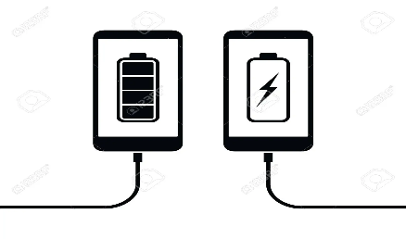  b. passenger (n) [ visual + explanation]  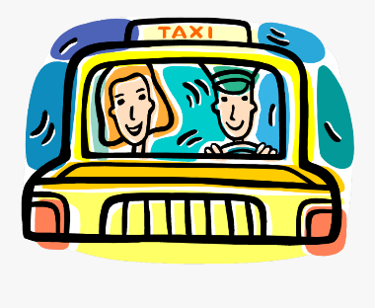  c. economical (a) [ visual + explanation]    d. autopilot (adj, n) [ visual + explanation]  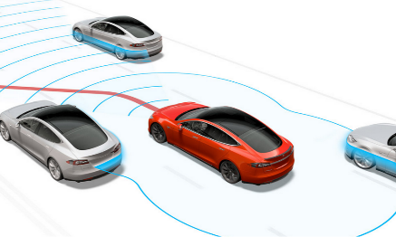  e. function (n) [ visual + explanation]  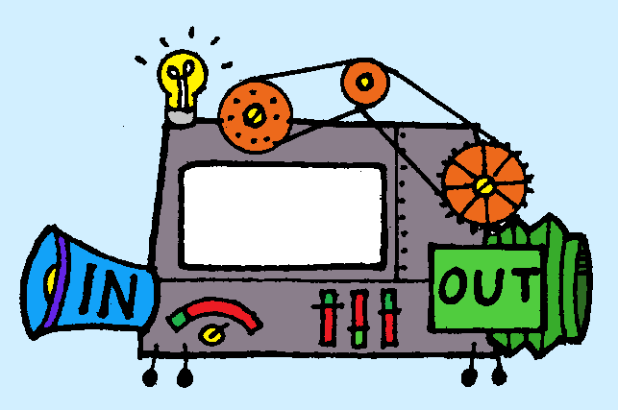  f. (to) run on [ visual + explanation]  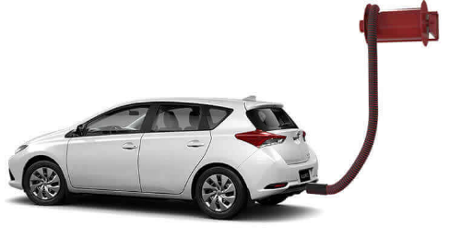  Concept check: Rub out and Remember  2. BRAINSTORMING: Look at the picture and find the words or phrases to describe it. (Ex 1, p. 120)  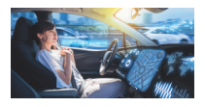  * Teacher asks SS to work in pairs to look at the picture and answer the question: “What can you see in the picture?”  ** Ss work with their partner to think of words to describe the car and the words or phrases about the driver.  *** Teacher calls on some Ss to read loud the listed words/ phrases.  **** Teacher writes on the board, corrects pronunciation or grammar if needed.  Suggested answer:  The car: convenient, safe, comfortable, modern, automatic, automated, autopilot, etc.  The driver: relaxing / isn’t driving, etc. | T-Ss  T – Ss  Pair works  T - Ss | 6 mins
While-Reading | To improve Ss’ skills of reading for the general idea.  To improve Ss’ skills of reading for details. | Task 1: Read the passage and answer the question. (Ex 2, p. 120)  * Teacher tells Ss to read the text quickly and find out the main idea of the paragraph individually.  ** Ss work independently to read.  *** Some Ss read out their answer and explain their choices.  **** Teacher confirms, corrects, and explains that B and C are just facts.  Answer key: A  Task 2: Read the passage again and complete the fact file with no more than two words or a number. (Ex 3, p. 120)  * Teacher tells Ss that they are going to read to passage again to complete the table about the company and its car. Teacher also reminds Ss to look at the information on the left first before doing the task to guess what types of information they need to scan.  ** Ss work independently to do the task.  *** Teacher calls on some Ss to give their answers and points out where they can find the information.  **** Teacher corrects and confirms.  Answer key:  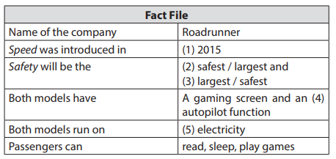 | T- Ss  S  T- Ss  T- Ss  S  Ss-Ss  T-Ss | 8 mins
Post-Reading | To check students’ reading comprehension. | Task 3: Retelling  * Teacher asks Ss to close their books and just look at the table in task 2 to retell what they have read about “Roadrunner”.  ** Ss work on pairs, take turns to retell.  *** Some Ss retell all the information about “Roadrunner”.  **** Teacher listens and corrects if needed | T- Ss  Pair work  T- SS | 6 mins
Pre-Speaking | To enable Ss to ask and answer questions about a car company | Task 4: Look at the fact file in 3 then ask and answer questions about it. (Ex 4, p. 120)  * Teacher asks Ss to work in pairs to look at the table once more times to make questions about Roadrunner and its car based on the fact file in 3.  ** Ss work in pairs to make questions, then answer these questions.  *** Teacher calls on some pairs to role – play it in front of the class.  **** Teacher corrects Ss’ grammar and pronunciation mistakes if needed.  Suggested questions:  * When was Speed introduced? / When did they introduce Speed?  • What do you know about Safety? / What is special about Safety?  • What functions do these models have?  • What do these models run on?  • What can passengers do when they are travelling in the car? | T-Ss  Pair works  T- Ss | 7 mins
While-Speaking | To help Ss practise reasoning skill | Task 5: Discuss why Roadrunner’s cars will or won’t become popular in the near future. Report your reasons to the class. (Ex 5, p. 120)  * Teacher writes on the board: “Why Roadrunner’s cars will or won’t become popular in the near future?” and asks Ss to work in groups to discuss it.  ** Ss work in groups to do the task. Teacher goes around to help them if needed.  *** Teacher invites one representative of each group to report the answers of their own group to the class  Suggested answers:  + Roadrunner’s cars will become popular in the near future, because they are fast / safe / comfortable /  modern.  + Roadrunner’s cars run on electricity, so they are eco-friendly / green / they do not pollute the  environment.  + Roadrunner’s cars have an autopilot function, so they are very comfortable and modern | T- Ss  Group works  T- Ss | 7 mins
Post-Speaking | To help students improve next time. | - Have students give comments on their friends and vote for the most interesting and informative presentation.  - Teacher gives feedback and comments. | T-Ss  Ss-Ss | 3 mins
Consolidation | To consolidate what students have learnt in the lesson. | Teacher asks students to talk about what they have learnt in the lesson. | T-Ss | 1 min
Homework | To prepare for the next lesson Skills 2. | Do exercises in the workbook. | T-Ss | 1 min

UNIT 11: TRAVELLING IN THE FUTURE

Lesson 6: Skills 2

  - I. Objectives
By the end of this lesson, students will be able to:
1. Knowledge
+ Listening
listen for general and specific information about some future means of transport;
+ Writing: write about the advantages of a future means of transport.

2. Core competence
- Develop communication skills
- Be collaborative and supportive in pair work and team work
- Actively join in class activities
3. Personal qualities
Be benevolent and responsible

  - II. Materials
- Grade 7 textbook, Unit 11, Skills 2
- Computer connected to the internet
- Pictures
- sachmem.vn

  - Language analysis
Form | Meaning | Pronunciation | Vietnamese equivalent
1. bullet train (n.phr.) | a very fast train with a smooth, pointed shape, especially one used in Japan: | /ˈbʊl.ɪt ˌtreɪn/ | tàu cao tốc
2. (to) use up | to use all of something, so that nothing is left | /juz up/ | sử dụng hết
3. comfortable (a) | Comfortable furniture and clothes provide a pleasant feeling and do not give you any physical problems | /ˈkʌm.fə.tə.bəl/ | thoải mái

Anticipated difficulties | Solutions
1. Students may lack knowledge and experiences about the topic. | Prepare some hand-outs.
2. Students may have underdeveloped listening, writing and co-operating skills. | - Play the recording many times if any necessary.  - Encourage students to work in pairs, in groups so that they can help each other.  - Provide feedback and help if necessary.
3. Some students might excessively talk in the class. | - Define expectation in explicit detail.  Have excessive talking students practise.  - Continue to define expectations in small chunks (before every activity).

  - Board Plan
Date of teaching
Unit 11: Travelling in the future
Lesson 6: Skills 2

* Warm-up
Discussion (Ex 1, p.121)
I. Listening
Vocabulary
1. bullet train (n.phr.) /ˈbʊl.ɪt ˌtreɪn/: tàu cao tốc
2. (to) use up/juz up/: sử dụng hết
3. comfortable (a) /ˈkʌm.fə.tə.bəl/: thoải mái
Task 1: Listen to a talk between Mr Ha and his students. How many means of transport are they talking about? Circle the correct answer. (Ex 2, p. 121)
Task 2: Listen to the talk again and complete each sentence with ONE word. (Ex 3, p. 121)
Task 3: True or False statements.
II. Writing: the advantages of a future means of transport
Task 4: Choose one future means of transport in 3 and tick (✓) the words and phrases that describe its advantages. Can you add more words and phrases? (Ex 4, p. 121)
Task 5: Write a paragraph of about 70 words about the advantages of the means of transport you’ve chosen. (Ex 5, p. 121)
* Homework

Procedures
Notes
In each activity, each step will be represented as following
* Deliver the task
** Implement the task
*** Discuss
**** Giving comments or feedback

Stage | Stage aim | Procedure | Interaction | Time
Warm-up | To prepare Ss for the listening by focusing them on some words / phrases | DISCUSSION  * Teacher asks Ss to look at the words or phrases in Ex 1 (p. 121) and think of which ones are used to describe the future means of the transport.  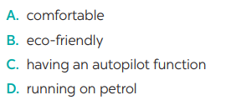  ** Ss thinks of it individually, then discuss with their partners. Teacher encourages Ss to give reasons for their answers.  *** Teacher calls some students to give their answers.  **** Teacher listens and give comments. | T-Ss  S  Pair work  T- Ss | 3 mins
Lead in | To introduce the new lesson. | Teacher introduces students the content of the lesson: “In the lesson today, we are going to listen to a talk between Mr. Ha and his students about future means of transport.” | T-Ss | 1 min
Pre-Listening (Pre-teach vocabulary)  Pre-Listening | To provide students with some lexical items before listening the text  To activate Ss’ knowledge of the topic of the listening text  To improve Ss’ skills of listening for general information | Vocabulary  - Teacher introduces the vocabulary by:  + Providing the synonym or antonym of the words.  + Providing the pictures of the words.  + Providing the definition of the words.  1. bullet train (n) [visual + explanation]  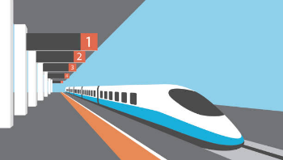  2. (to) use up [visual + explanation]  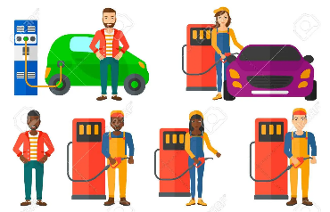  3. comfortable (a) [visual + explanation]    Concept check: Rub out and Remember  Task 1: Listen to a talk between Mr Ha and his students. How many means of transport are they talking about? Circle the correct answer. (Ex 2, p. 121)  * Teacher asks Ss to guess how many means of transport they are talking about before listening.  ** Ss do the task individually to guess. Then teacher plays the recording once for Ss to listen and circle the correct answer. | T-Ss  T- Ss  S  T- Ss | 5 mins
While-Listening | To improve Ss’ listening comprehension and note taking skills. | Task 1: Listen to a talk between Mr Ha and his students. How many means of transport are they talking about? Circle the correct answer. (Ex 2, p. 121 - cont)  *** After listening once, T calls on some Ss to give their answer.  **** Teacher plays the recording again and confirms the correct answer.  Answer key: C  Task 2: Listen to the talk again and complete each sentence with ONE word. (Ex 3, p. 121)  * Teacher asks Ss to read the sentences and to predict the words they need to fill in each blank.  ** Ss works in pairs to do the task. Then teacher plays the recording for Ss to listen and fill in the blank.  *** Teacher calls on some Ss to give theirs answers and writes them on the board.  **** Teacher plays the recording again as many times as needed for Ss to check their answers and clearly understand the conversation.  Answer key:  1. accidents  2. autopilot  3. expensive  4. Bamboo-copters  5. eco-friendly  Audio script – Tracks 80 + 81:  - Mr Ha: Now, let’s turn to future means of transport. How do you think people will travel in 2050, Tom?  - Tom: I think people will use bullet trains. Bullet trains will be faster and safer than cars and they can help avoid traffic accidents.  - Lan: I think skyTrans will also be popular, too. They will not use up much space and will be safe because they run on autopilot. - Tom: But skyTrans may be too expensive for students to use. Bamboo-copters will be cheaper and easier for them to use. They will just put on their bamboo-copters and fly to school.  - Mr Ha: Sounds interesting. How about travelling on sea?  - Lan: I think people will use solar-powered ships to travel on sea. They will be eco-friendly and comfortable … | T-Ss  T- Ss  Pair work  T - Ss | 10 mins
Post-Listening | To check Ss’ memory about what they have listened. | Task 3: True or False statements.  * Teacher asks to look at these statements, read, and decide them are True or False without listening again.  ** Ss do the task individually.  *** Teacher calls on some Ss to check.  **** Teacher confirms the correct answers.  Answer keys:  1. F  2. F  3. T  4. T  5. F | T- Ss  S  T- Ss | 3 mins
  Statements | True | False
  1. Tom thinks that bullet trains will be the fastest transport in the future.
  2. Lan said that SkyTrans would not use up much space.
  3. It may be too expensive for students to use SkyTrans
  4. Students will use bamboo – copters to fly to school.
  5. Lan thinks solar – power ships will be eco- friendly and uncomfortable.
Pre-Writing | To prepare Ss for the writing activity | Task 4: Choose one future means of transport in 3 and tick the words and phrases that describe its advantages. Can you add more words and phrases? (Ex 4, p. 121)  * Teacher asks Ss to choose a future means of transport in Ex 3 and discuss with their partner by ticking the boxes or add as many words/ phrases as possible.  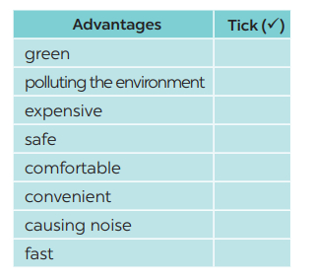  ** Ss do the task in pairs.  *** Teacher calls on some Ss to read out loud and encourages Ss to make sentences with the words/ phrases.  **** Teacher corrects and confirms.  Suggested answers: economical, carrying many passengers, avoiding traffic jams, having an autopilot function, driverless, etc. | T-Ss | 7 mins
While-Writing | To help Ss practise writing. | Task 5: Write a paragraph of about 70 words about the advantages of the means of transport you’ve chosen. (Ex 5, p. 121)  * Teacher tells Ss that they are going to write about the advantages of the means of transport they ‘ve chosen. Teacher reminds them to start their writing as shown below.  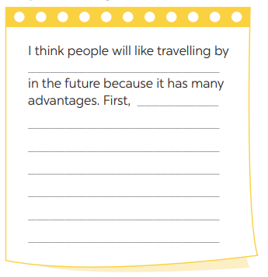  ** Ss do the task independently. | T-Ss | 9 mins
Post-Writing | To peer check, cross check and final check students’ writing. | Task 5: Class gallery  *** Teacher asks Ss to share their writing with their partners. Then, call on some Ss to show their writing in front of the class.  **** Teacher checks ideas, grammar, vocabulary and gives comments. | Ss-Ss  T-Ss | 4 mins
Consolidation | To consolidate what students have learnt in the lesson. | Teacher asks students to talk about what they have learnt in the lesson. | T-Ss | 1 mins
Homework | To allow students finalize their letter after being checked by friends and the teacher. | Rewrite the letter on the notebook. | T-Ss | 1 min

UNIT 11: TRAVELLING IN THE FUTURE

Lesson 7: Looking back & Project

  - I. Objectives
By the end of this lesson, students will be able to:
1. Knowledge
- review the vocabulary and grammar of Unit 11
- apply what they have learnt (vocabulary and grammar) into practice through a project.

2. Core competence
- Develop communication skills and creativity
- Be collaborative and supportive in pair work and team work
- Actively join in class activities
3. Personal qualities
- Be benevolent and responsible
- Develop self-study skills
  - II. Materials
- Grade 7 textbook, Unit 11, Looking back & Project
- Computer connected to the internet
- TV/ Pictures, A0 paper
- sachmem.vn

Anticipated difficulties | Solutions
1. Students may have underdeveloped speaking, writing and co-operating skills when doing project. | - Encourage students to work in pairs, in groups so that they can help each other.  - Provide feedback and help if necessary.
2. Some students might excessively talk in the class. | - Define expectation in explicit detail.  Have excessive talking students practise.  - Continue to define expectations in small chunks (before every activity).

  - Board Plan
Date of teaching
Unit 11: Travelling in the future
Lesson 7: Looking back & Project

* Warm-up
Mindmap
I. Looking back
Task 1: Write three adjectives or phrases to describe each picture. (Ex. 1, p. 122)
Task 2: Complete the sentences with the words and phrases from the box. (Ex. 2, p. 122)
Task 3: Find one mistake in each sentence and correct it. (Ex. 3, p. 122)
Task 4: Read the passage and put the verbs in brackets in the correct future form. (Ex 4, p. 122)
II. Project
OUR FUTURE MEANS OF TRANSPORT
Task 5: Discussion
Task 6: Posters exhibition
* Homework

Procedures
Notes
In each activity, each step will be represented as following
* Deliver the task
** Implement the task
*** Discuss
**** Giving comments or feedback

Stage | Stage aim | Procedure | Interaction | Time
Warm-up | To help students revise the vocabulary items they have learnt in the unit.  Unit 11  Vocabulary  Grammar  Pronunciation  To enhance students’ skills of cooperating with team mates. | Mindmap  * Teacher writes on the board “Unit 11” asks Ss to think of what they have learnt already in this unit.  ** Ss work in pairs to do the task.  ***Teacher calls some students to retell.  **** Teacher confirms and leads them to do all the exercises in books. | T- Ss  Pair work  T - Ss | 3 mins
Looking back | To help Ss revise the learnt vocabulary.  – To help Ss use the right adjectives / phrases to describe the appropriate means of transport  To help Ss review the words / phrases about music and arts used in the context of a passage;  – To give Ss some information of the Louvre Museum - the world’s largest art museum.  – To help Ss revise the learnt vocabulary  – To help Ss use the right words and phrases in the right contexts.  To help Ss revise the possessive pronouns.  To help Ss revise the future simple | Task 1: Write three adjectives or phrases to describe each picture. (Ex. 1, p. 122)  * Teacher asks Ss to work individually to look at the three pictures and think of the words or phrases they have learnt to describe means of transport.  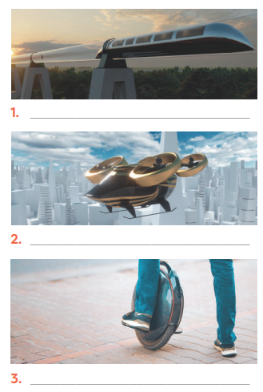  ** Ss do the task independently.  *** Teacher asks for Ss’ answers. **** Teacher confirms the correct ones  Answer keys:  1. fast, green, carrying many passengers  2. fast, convenient, autopilot function  3. electric, green, convenient  Task 2: Complete the sentences with the words and phrases from the box. (Ex. 2, p. 122)  * Teacher has Ss work individually to put the right words / phrases into the correct blanks.  ** Ss do this activity individually, then compare their answers with their partners.  *** Teacher asks for some Ss to read aloud the sentences.  **** Teacher confirms the correct answer.  Answer keys:  1. eco-friendly  2. runs on  3. bamboo-copter  4. driverless  5. Bullet trains  Task 3: Find one mistake in each sentence and correct it. (Ex. 3, p. 122)  * Teacher asks Ss to find one mistake in each sentence and correct it  ** Ss do the exercise individually and swap with their partners.  *** Teacher calls some Ss to check their answers.  **** Teacher confirms the correct answer.  Answer keys:  1. Her → Hers  2. Our → Ours  3. My → Mine  4. its → his  5. yours → your  Task 4: Read the passage and put the verbs in brackets in the correct future form. (Ex 4, p. 122)  * Teacher asks Ss to put the verbs in brackets in the correct form  ** Ss work individually to do the task.  *** Teacher calls 1- 2 Ss to read out the passage.  **** Teacher checks and confirms their answers.  Answer keys:  1. will travel  2. won’t go  3. will need  4. won’t carry  5. Will … come | T-Ss  S  Ss-Ss  T-Ss | 16 mins
Project | – To help Ss revise vocabulary about various future means of transport and their advantages  – To improve Ss’ creativity, teamwork and public speaking skills | Task 5: Discussion  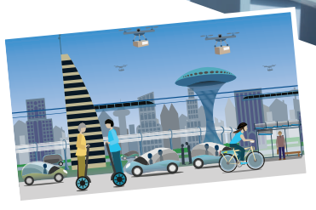  * Teacher asks Ss to look at the picture and imagine a future means of transport they would like to see in the future. Teacher tells SS that they can draw pictures or pin the pictures or photos on A0 paper to illustrate their ideas.  ** Ss do the task in group. Teacher goes around to help if necessary and check their progress.  Task 6: Posters exhibition  *** Teacher calls some groups to present their poster to the class  **** Ss in other groups comment. Teacher confirms and corrects. | Group work | 23 mins
Consolidation | To consolidate what students have learnt in the lesson. | Teacher asks students to talk about what they have learnt in the lesson. | T-Ss | 2 mins
Homework | To prepare for the next lesson. | Prepare for the next lesson: Unit 5 – Getting started. | T-Ss | 1 min
* Pictures' source: From Internet

