**Tiếng Anh 6 i-Learn Smart World - Endterm 1.1  
Time allotted: 60**

**PART 1. Listening (4 questions)**

**You will hear a teacher talking to her new class. Listen and complete each question. (4 questions)**

Name of teacher: Susan Brown  
1. Lessons start at: 9/9 a.m./9 o’ clock  
2. In the morning, everybody studies math, English, science and   
3. Food for lunch soup, sandwich, and orange juice  
4. On Sunday puppet show.

**PART 2. Pronunciation (2 questions)**

**Find the word that differs from the other three in the position of primary stress.**

5. A. noodles B. dessert C. order D. sweater

6. A. performance B. festival C. library D. customer

**PART 3. Choose the word/ phrase (10 questions)**

**Choose the word/ phrase that best suits the blank in each sentence.**

7. We ______________ the sausages on the barbecue. They taste wonderful.

A. fry B. serve C. pour D. grill

8. Would you like to see the dessert ______________?

A. menu B. order C. tip D. service

9. There’s a ______________ on TV tonight. You can see many dancers in their traditional clothes.

A. fashion show B. tug of war C. dance performance D. fireworks

10. Do you have this skirt ______________ a medium size?

A. with B. on C. for D. in

11. I like ______________ shoes by the window. Do you have ______________ in black?

A. that/ it B. this/ them C. those/ them D. these/ it

12. Would you like ______________ bread and cheese for lunch?

A. a B. some C. any D. the

13. Waiter: “What would you like for dessert?”  
Customer: “______________”

A. I’d like an omelet. B. A cupcake, please. C. I don’t like coffee. D. I prefer tea.

14. Customer: “Do you have this dress in white?”  
Sales assistant: “______________”

A. Yes, I am. B. Yes, it is. C. Yes, here you are. D. Yes, it’s OK.

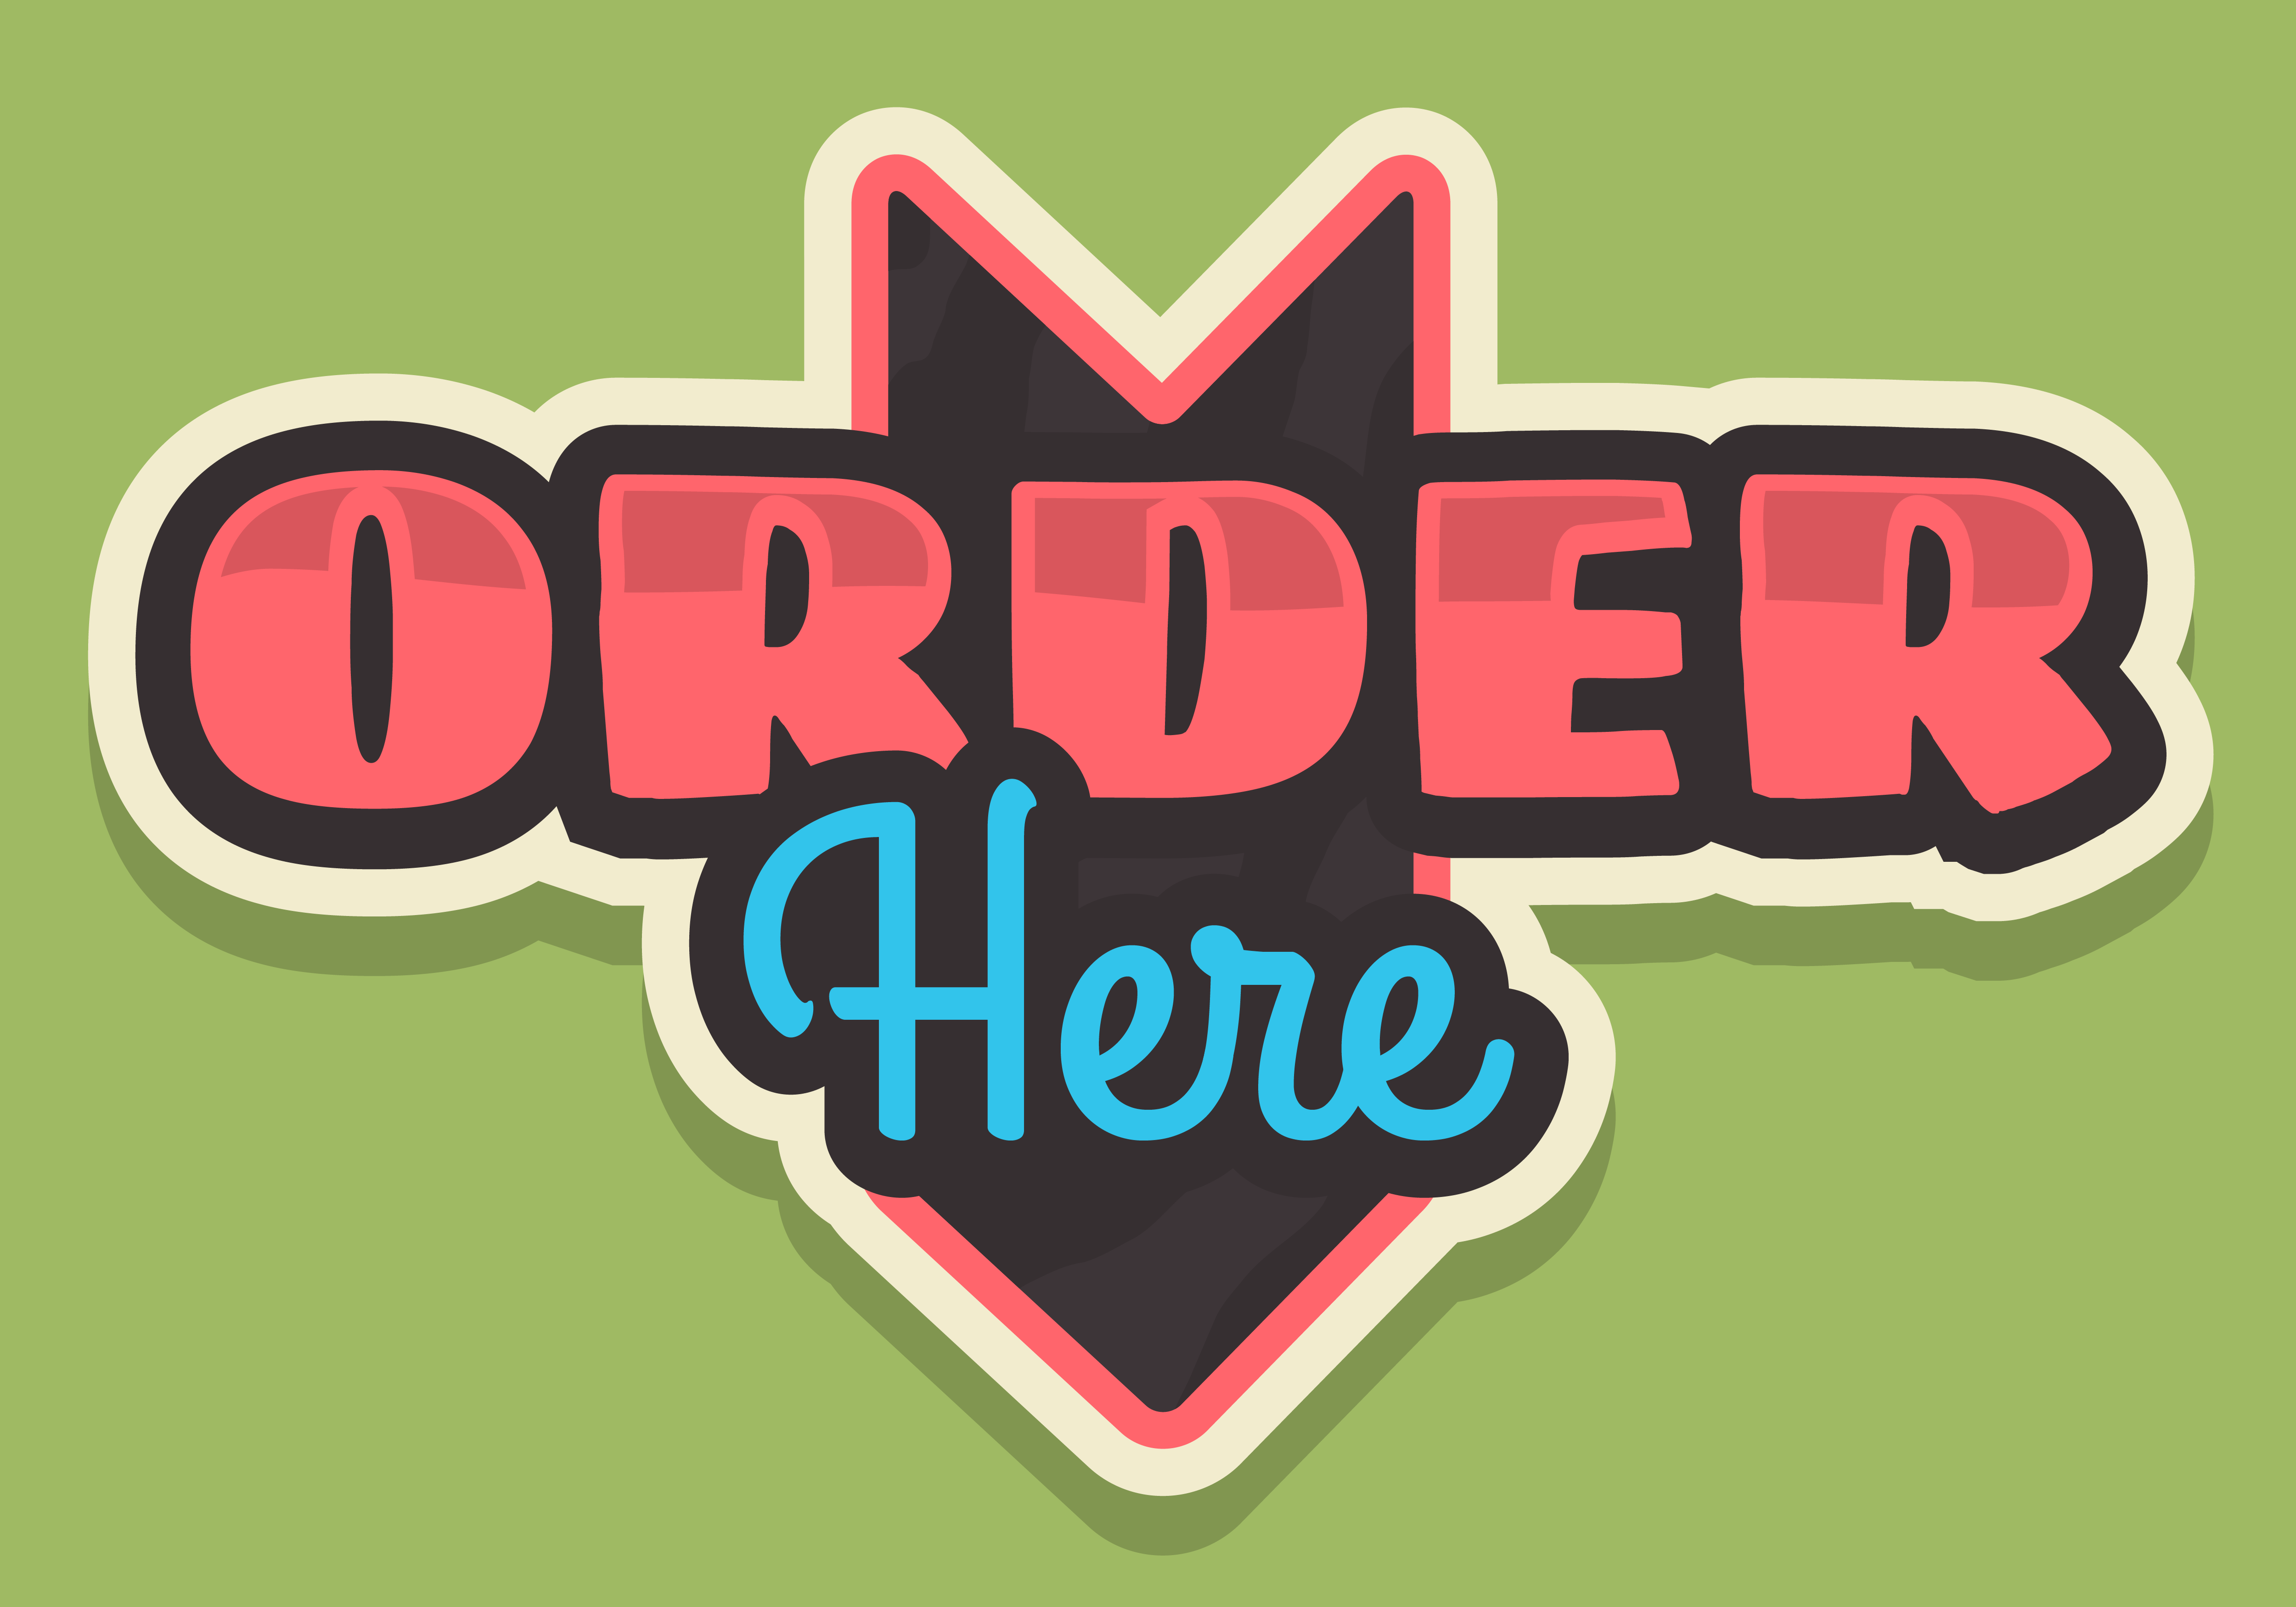

15. What does the sign mean?

A. There is a lot of food here.

B. Please order your food here.

C. You can find your food here.

D. Please eat and drink here.

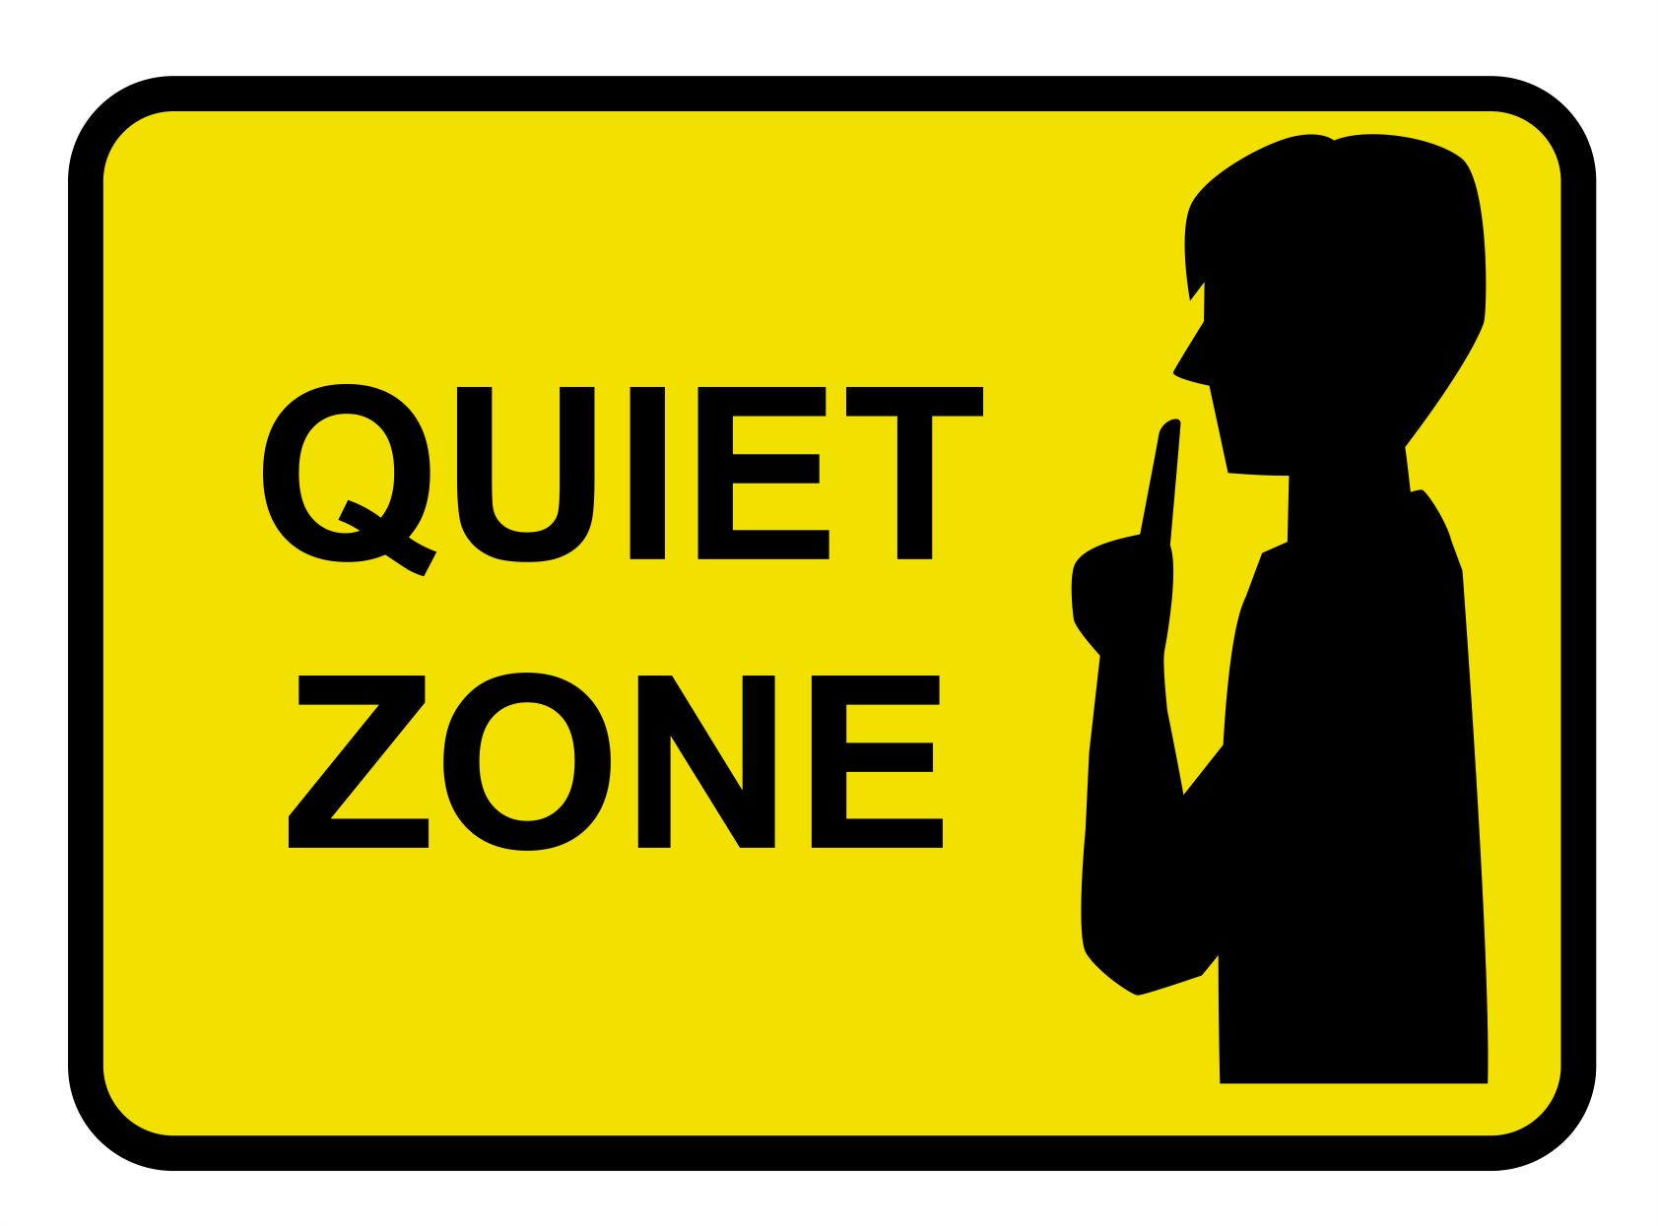

16. What does the sign mean?

A. Please be quiet here.

B. Please don’t play here.

C. There aren’t any people here.

D. You can’t be here.

**PART 4. Reading comprehension (6 questions)**

**Read the following passage and complete the tasks. (6 questions)**

|  |
| --- |
| My name is Quanzhou and I’m from China. My favorite time of the year is Chinese New Year. People decorate houses and streets with lanterns and flowers many days before New Year festival. Everything is red and gold, because they’re the lucky colors. People give children lucky money in red envelops, and they also give friends mandarin oranges for good luck. The New Year’s Eve dinner is called Reunion Dinner. People in the family sit together, talk and enjoy the traditional food. One special dish is Nian Gao. People make Nian Gao with sugar and rice. We also eat fish, chicken and dumplings. After dinner we watch the New Year music performance on TV. At midnight, we can see fireworks in the sky. The colors are amazing. There are parades and lion dances in the streets, too. |

**Task 1: Decide whether the statements that follow are True or False or Not given**

| **Answers** | **True** | **False** |
| --- | --- | --- |
| 17. People decorate their houses during New Year festivals. | **◯** | **⦿** |
| 18. Red and gold are lucky colors in China. | **⦿** | **◯** |
| 19. Children receive lucky money in red envelops. | **⦿** | **◯** |
| 20. People eat fish, chicken and mandarin oranges for Reunion Dinner. | **◯** | **⦿** |

**Task 2: Choose the word or phrase that best answers each question.**

21. What do people give to friends for good luck?

A. Nian Gao B. mandarin oranges C. money D. flowers

22. What do people make Nian Gao with?

A. fish and chicken B. rice and dumplings C. sugar and rice D. fish and rice

**PART 5. Cloze test (6 questions)**

**Read the passage, choose the word/ phrase that best suits the blank. (6 questions)**

My best friend is Joe. He’s nine years old like me. Joe lives in a small house with his parents. Joe’s tall and quite fat. He (23) ___________ big brown eyes and short hair. Joe and I spend a lot of time together. We both like sports. We often (24) ___________ martial arts after school. We are in the school’s karate club. Joe is a great friend. He’s very (25) ___________ . He helps me when I can’t do my homework. He’s also good at magic. He’s going to sign up for the (26) ___________ next month. Next Saturday is his birthday. We (27) ___________ a party with chicken pasta and cola. I’ll buy a T-shirt for him. His favorite color is blue, so I’m going to look for a beautiful one (28) ___________ blue.

(23) A. wears B. has C. is D. looks

(24) A. do B. play C. go D. join

(25) A. funny B. friendly C. selfish D. helpful

(26) A. tug of war B. puppet C. talent show D. fashion show

(27) A. are having B. has C. have D. having

(28) A. on B. for C. with D. in

**PART 6. Verb forms and verb tenses (4 questions)**

**Complete the sentences with the correct form of the verbs in brackets.**

29. My sister and I are going shopping tomorrow. Do you want to join us? ***(go)***

30. Harry practices the piano on Fridays. ***(practice)***

What time (31) does the festival (32) open?

**PART 7. Rearrange the words (2 questions)**

**Rearrange the groups of words in a correct order to make complete sentences.**

33. Keywords: often/with/on/play/I/weekends/hopscotch/my/the/friends/.

→ I often play hopscotch with my friends on the weekends

34. Keywords: children/on/costumes/trick-or-treating/Halloween/wear/go/and/./,

→ Children wear costumes and go trick-or-treating ,on Halloween ./on Halloween , children wear costumes and go trick-or-treating .

**PART 8. Make questions (3 questions)**

**Make questions for the underlined part.**

35. Sam rarely goes running.

→ How often does Sam go running?

36. The new teacher is very kind and funny.

→ What is the new teacher like?

37. This jacket is twenty dollars.

→ How much is this jacket? / How much does this jacket cost?

**PART 9. Rewrite the sentences (3 questions)**

**Rewrite the following sentences without changing the meaning.**

38. I want to have a cheeseburger.

→ I would like to have a cheeseburger.

39. Why don’t we go to the movie theater?

→ Let’s go to the movie theater.

40. Simon likes playing soccer in his free time.

→ Simon’s hobby is playing soccer in his free time.

**---THE END---**