**ĐỀ MINH HỌA SỐ 19**  
**KỲ THI TỐT NGHIỆP TRUNG HỌC PHỔ THÔNG NĂM 2025**  
(Đề thi có 08 trang)  
**Môn thi: TIẾNG ANH**  
**Thời gian làm bài: 50 phút, không kể thời gian phát đề**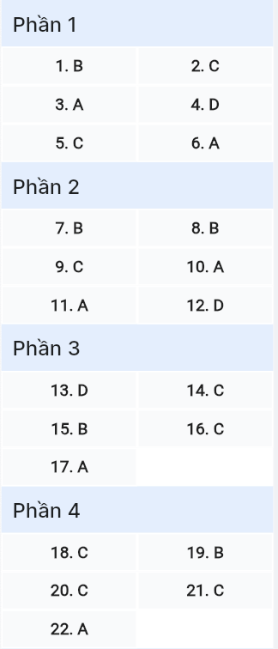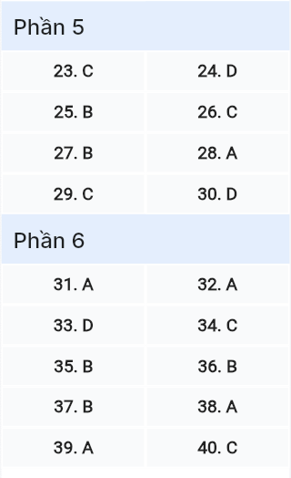

***Read the following advertisement and mark the letter A, B, C or D on your answer sheet to indicate the option that best fits each of the numbered blanks from 1 to 6.*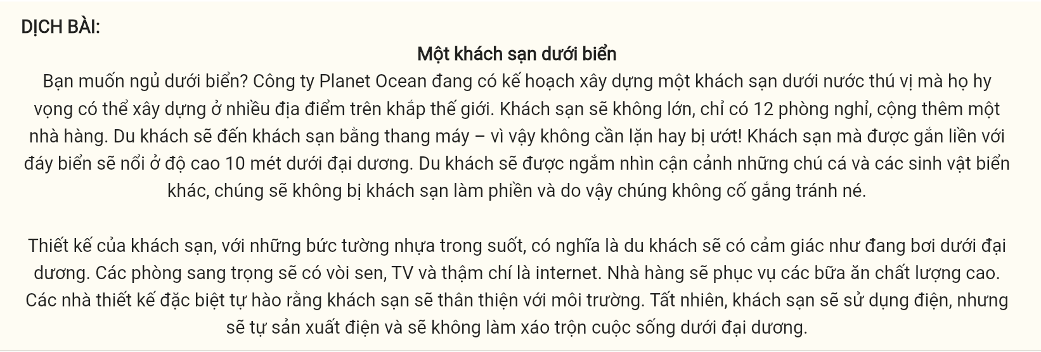**

**A hotel under the sea**

Want to sleep under the sea? The company Planet Ocean has plans for an exciting underwater hotel, which they hope to build in locations all over the world. The hotel won’t be large, with only 12 guest rooms, plus a restaurant. Guests will get to the hotel in a lift – so no (1) ______ or getting wet! The hotel (2) ______ to the sea bed will float 10 metres under the ocean. Guests will get (3) ______ of the fish and other sea creatures, which won’t be bothered by the hotel and so won’t (4) ______ any effort to avoid it.

The hotel’s design, with clear plastic walls, means guests will get the feeling that they are swimming (5) ______ the ocean. The luxury rooms will have a shower, TV and even the internet. The restaurant will serve high-quality meals. The designers are especially proud of the fact that the hotel will be environmentally friendly. It will use (6) ______, of course, but it will produce its own, and won’t disturb ocean life at all.

*(Adapted from Exam Booster)*

| Question 1 | [697656]: | A. to dive | B. diving | C. dive | D. to diving |
| --- | --- | --- | --- | --- | --- |
|  | | | | | |
| Question 2 | [697657]: | A. which attached | B. attaching | C. attached | D. will be attached |
|  | | | | | |
| Question 3 | [697658]: | A. great close-up views | B. great views close-up | C. views great close-up | D. close-up great views |
|  | | | | | |
| Question 4 | [697659]: | A. bring | B. do | C. create | D. make |
|  | | | | | |
| Question 5 | [697660]: | A. on | B. at | C. in | D. below |
|  | | | | | |
| Question 6 | [697661]: | A. electricity | B. electrician | C. electric | D. electrical |

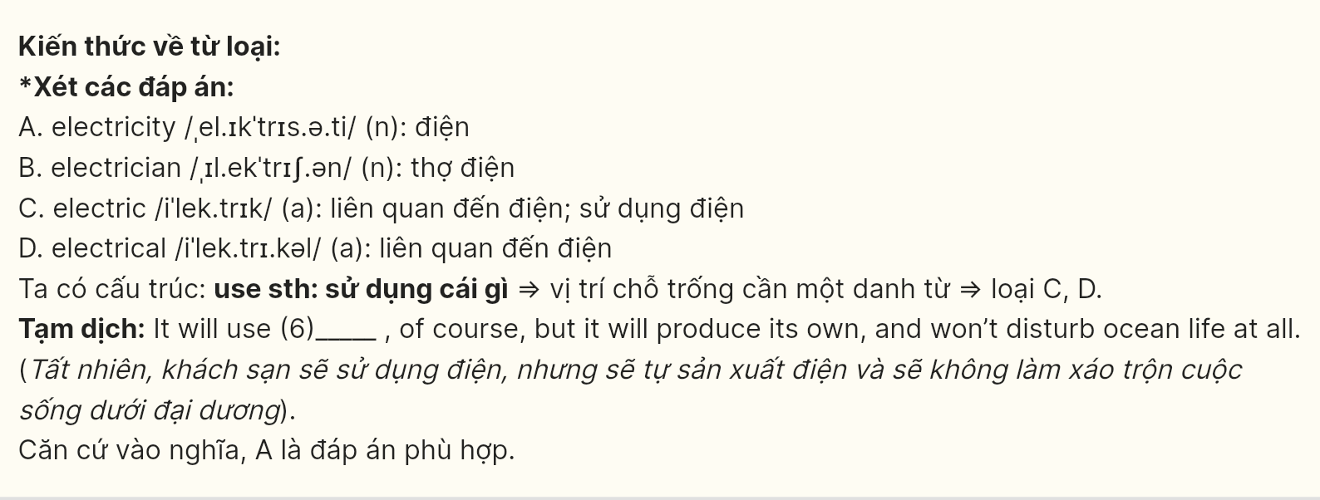

**Read the following leaflet and mark the letter A, B, C or D on your answer sheet to indicate the option that best fits each of the numbered blanks from 7 to 12.**

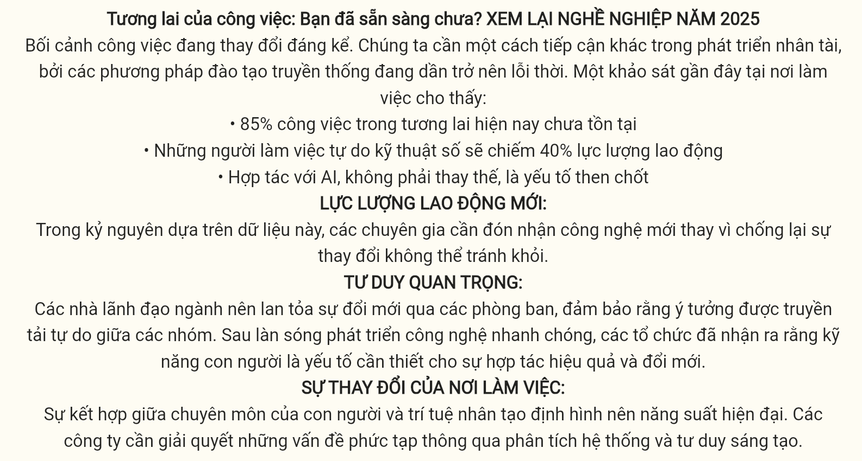

**The Future of Work: Are You Ready?**

**RETHINKING CAREERS IN 2025**

The landscape of work is shifting dramatically. We need (7) ______ approach to talent development, as traditional training methods become obsolete. A recent workplace survey reveals:

* 85% of tomorrow’s jobs don’t exist today
* Digital nomads will comprise 40% of the workforce
* AI collaboration, not replacement, is key

**THE NEW WORKFORCE:**  
 In this data-driven era, professionals must (8) ______ new technologies rather than resisting inevitable change.

**MINDSET MATTERS:**  
 Industry leaders should (9) ______ innovation across departments, ensuring ideas flow freely between teams.

(10) ______ rapid technological advancement, organizations have recognized that human skills are essential for effective collaboration and innovation.

**WORKPLACE EVOLUTION:**  
 The (11) ______ between human expertise and artificial intelligence defines modern productivity. Companies must (12) ______ complex problems through systematic analysis and creative thinking.

*(Adapted from Career Insights Institute)*

**Question 7 [697662]:** A. others B. another C. the other D. the others

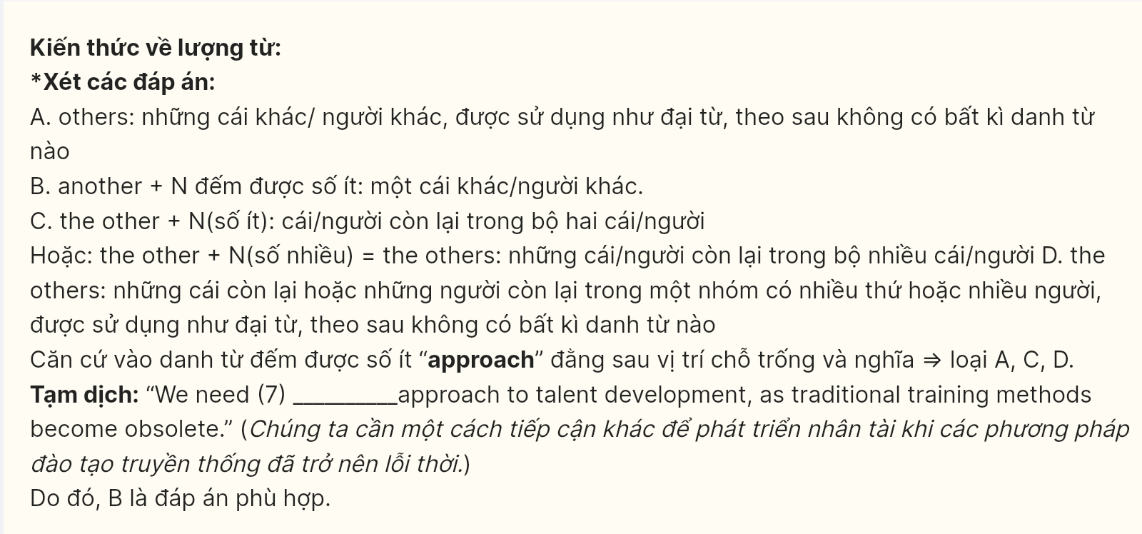

**Question 8 [697663]:** A. see through B. warm to C. turn D. lean on

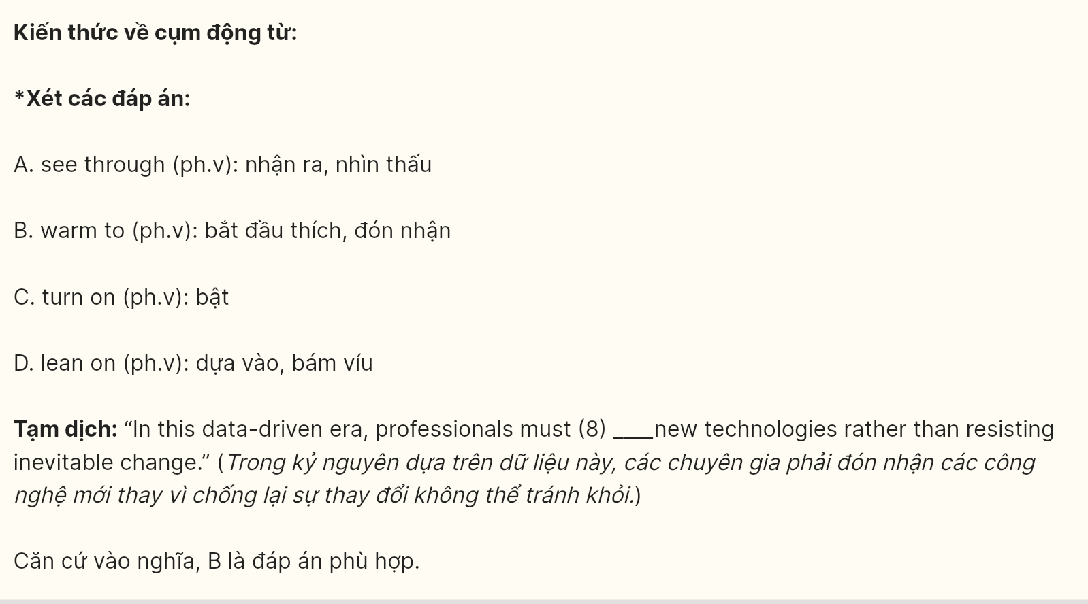

**Question 9 [697664]:** A. allocate B. divert C. circulate D. project

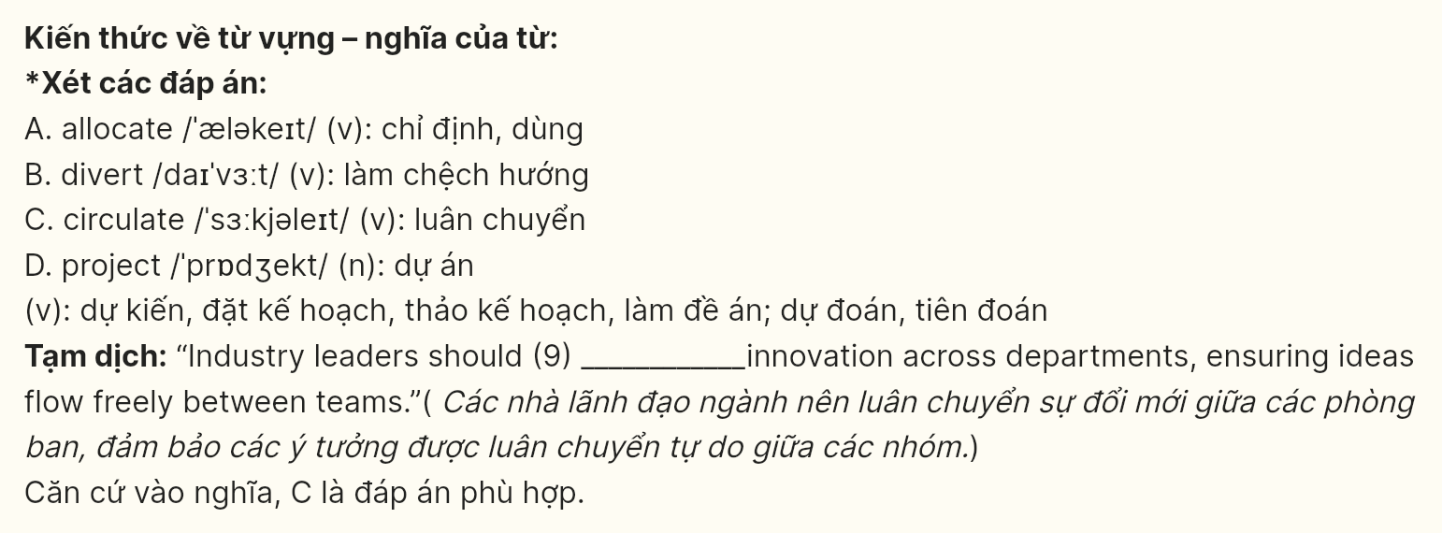

**Question 10 [697665]:** A. In the wake of B. At the close of  
 C. On the verge of D. In the area of

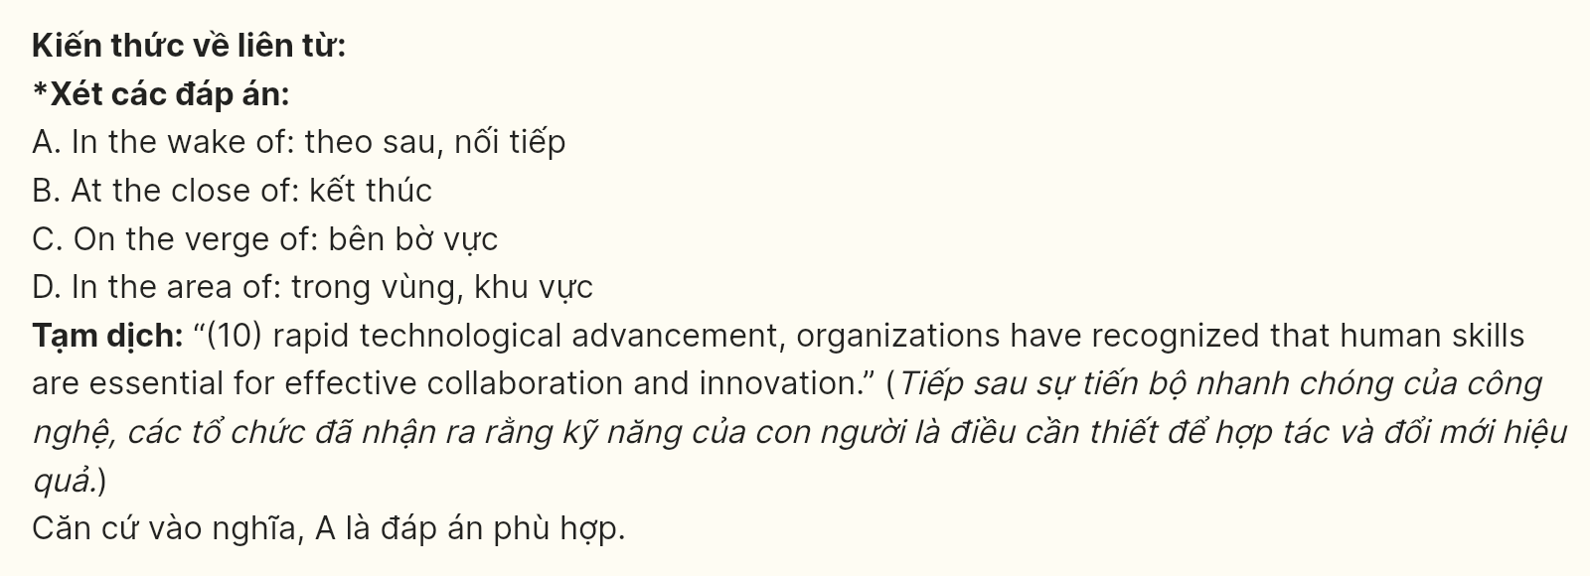

**Question 11 [697666]:** A. synergy B. alliance C. coalition D. mixture

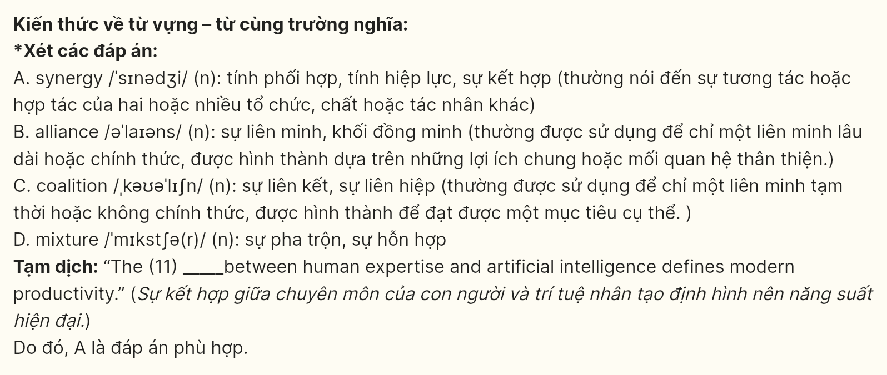

**Question 12 [697667]:** A. disentangle B. decode C. decipher D. untangle

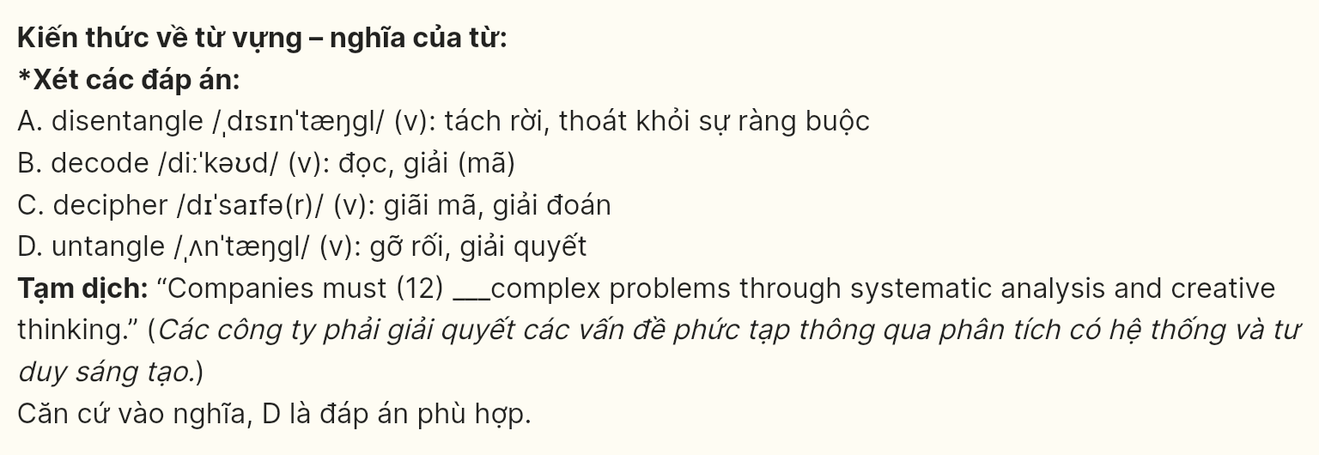

***Mark the letter A, B, C, or D on your answer sheet to indicate the correct arrangement of the sentences to make a meaningful exchange or text in each of the following questions.***

**Question 13 [697668]:** GIA SƯ TẠI HUẾ (ZALO: 0793833272)a. Catherine: I totally agree! Making mistakes is an essential part of growing up, and we’re better at it.  
b. Pam: It’s important to reflect on the past and learn from the mistakes we made as kids.  
c. Pam: Yeah, I’m really grateful for those experiences - they taught me so much.

A. b - c - a B. a - b - c C. c - b - a D. b - a - c

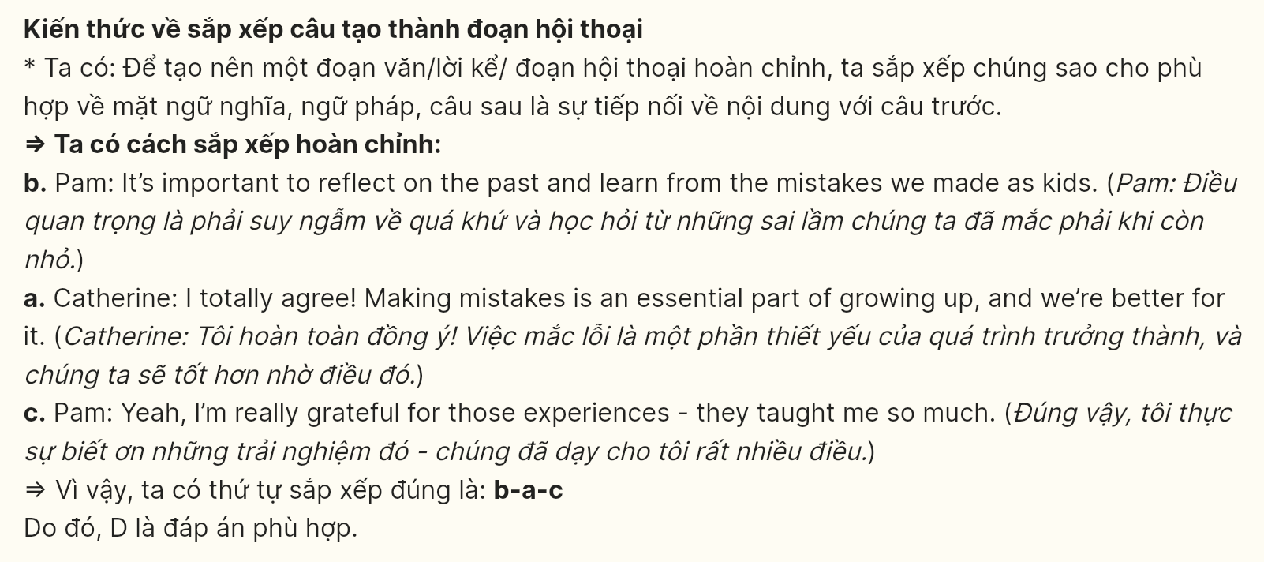

Question 14 [697669]:  
a. Emma: Let’s remember to ask about discounts and warranties before purchasing.  
b. Nick: Yes! I think I’ll go with a new laptop for both work and travel.  
c. Emma: Great choice! I’ll make a list of features you need so we can compare options.  
d. Emma: Have you decided on what you want to buy?  
e. Nick: Definitely, they can make a big difference in the total cost!

A. d - b - c - e - a B. c - d - e - a - b C. d - b - c - a - e D. c - a - d - e - b

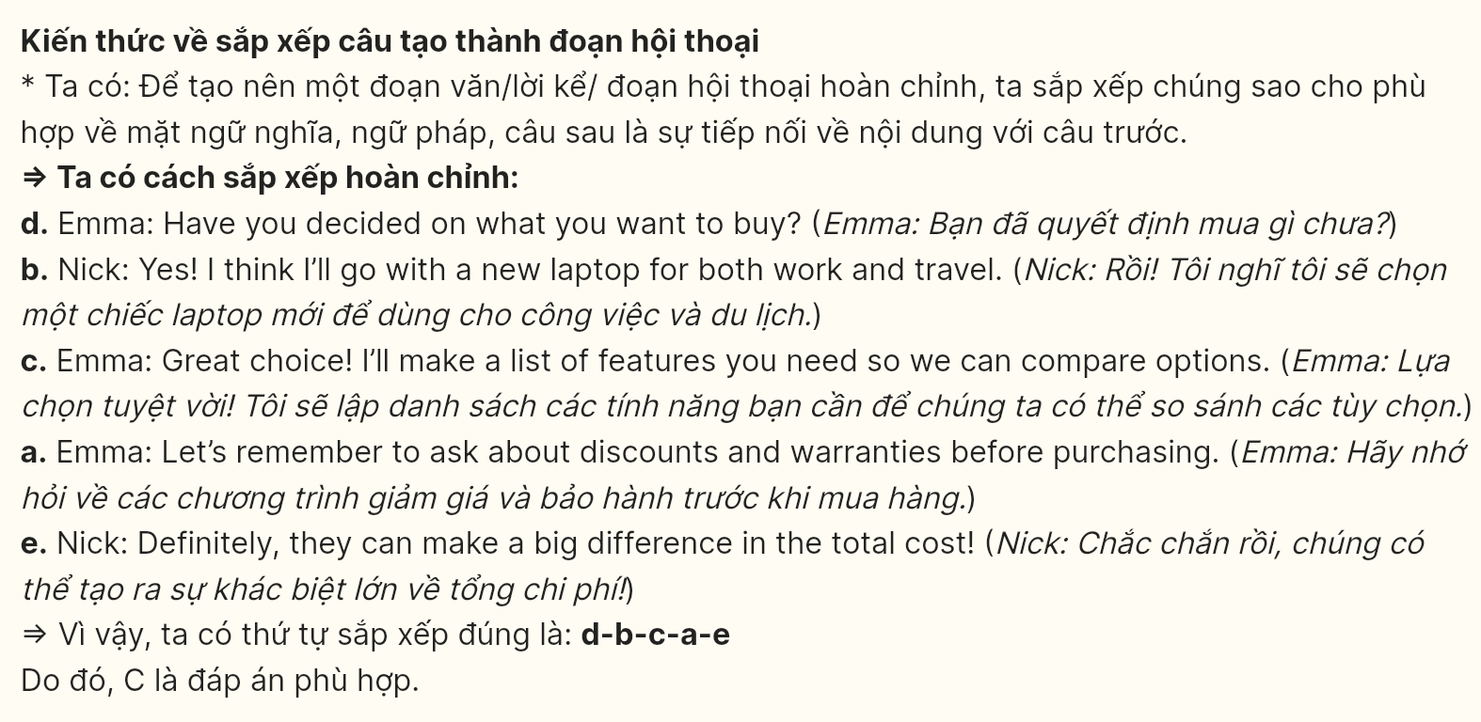

**Question 15 [697670]:**

To the Local Police Department,  
a. Despite attempts to ask the participants to lower the volume, the noise remains excessive and disruptive.  
b. This has caused significant stress for many, particularly for families with young children and elderly individuals.  
c. Therefore, I kindly request your assistance in addressing this matter to restore peace in our community.  
d. While evenings in our neighborhood are usually peaceful, there has been a repetitive disruption due to loud karaoke sessions late into the night.  
e. These activities, which start around 11 PM, continue past midnight, making it difficult for residents to rest.

Sincerely,

Thomas GIA SƯ TẠI HUẾ (ZALO: 079-3833272)

**A.** d - e - a - c – b **B.** d - e - a - b – c **C.** e - b - d - e – a **D.** e - d - a - c - b

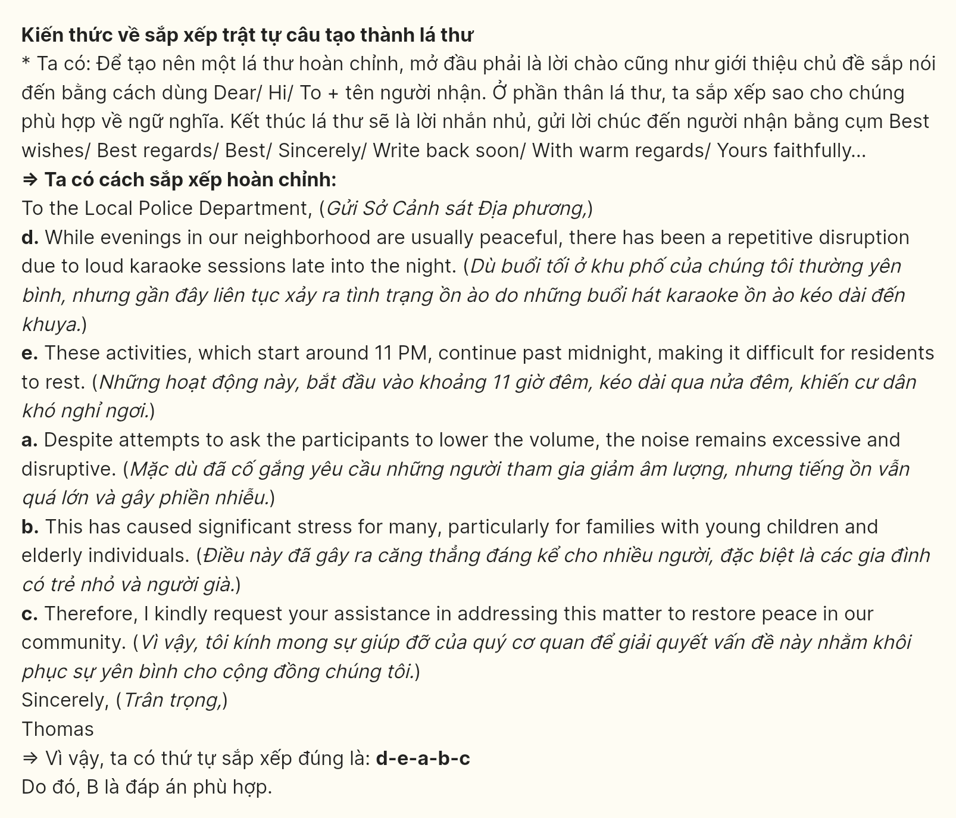

**Question 16 [697671]:**

a. Additionally, deforestation negatively contributes to climate change by releasing stored carbon dioxide into the atmosphere.  
b. Therefore, efforts to combat deforestation include reforestation initiatives and sustainable land management practices.  
c. The loss of trees also disrupts water cycles, resulting in soil erosion and decreased water quality.  
d. Deforestation is the large-scale removal of trees from forests.  
e. This environmental issue poses significant threats to biodiversity, as many species lose their habitats and face extinction. GIA SƯ TẠI HUẾ (ZALO: 079.3833.272)

**A.** d - e - a - b – c **B.** c - e - a - b – d **C.** d - e - a - c – b **D.** c - a - d - b - e

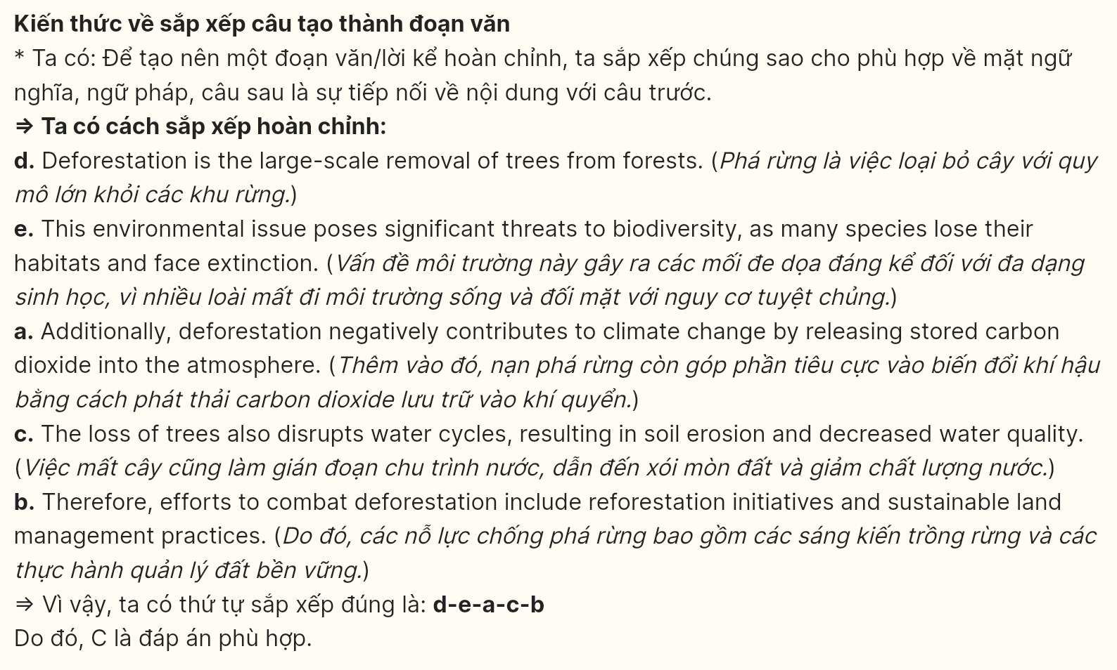

**Question 17 [697672]:**

a. As a result, there has been a noticeable increase in community events, bringing people closer together.  
b. New recreational areas have also been created, promoting a sense of community and providing places for families to spend time together.  
c. However, some residents have raised concerns about losing the neighborhood’s original character as the area becomes more developed.  
d. Many local businesses have adapted by offering more family-oriented services, attracting both residents and visitors.  
e. Over the years, Ernesta has shifted from a primarily commercial area to a more family-friendly community.

**A.** e - d - a - b – c **B.** e - d - b - a – c **C.** b - c - e - a – d **D.** e - a - d - b - c’

GIA SƯ TẠI HUẾ (ZALO: 0793833272)

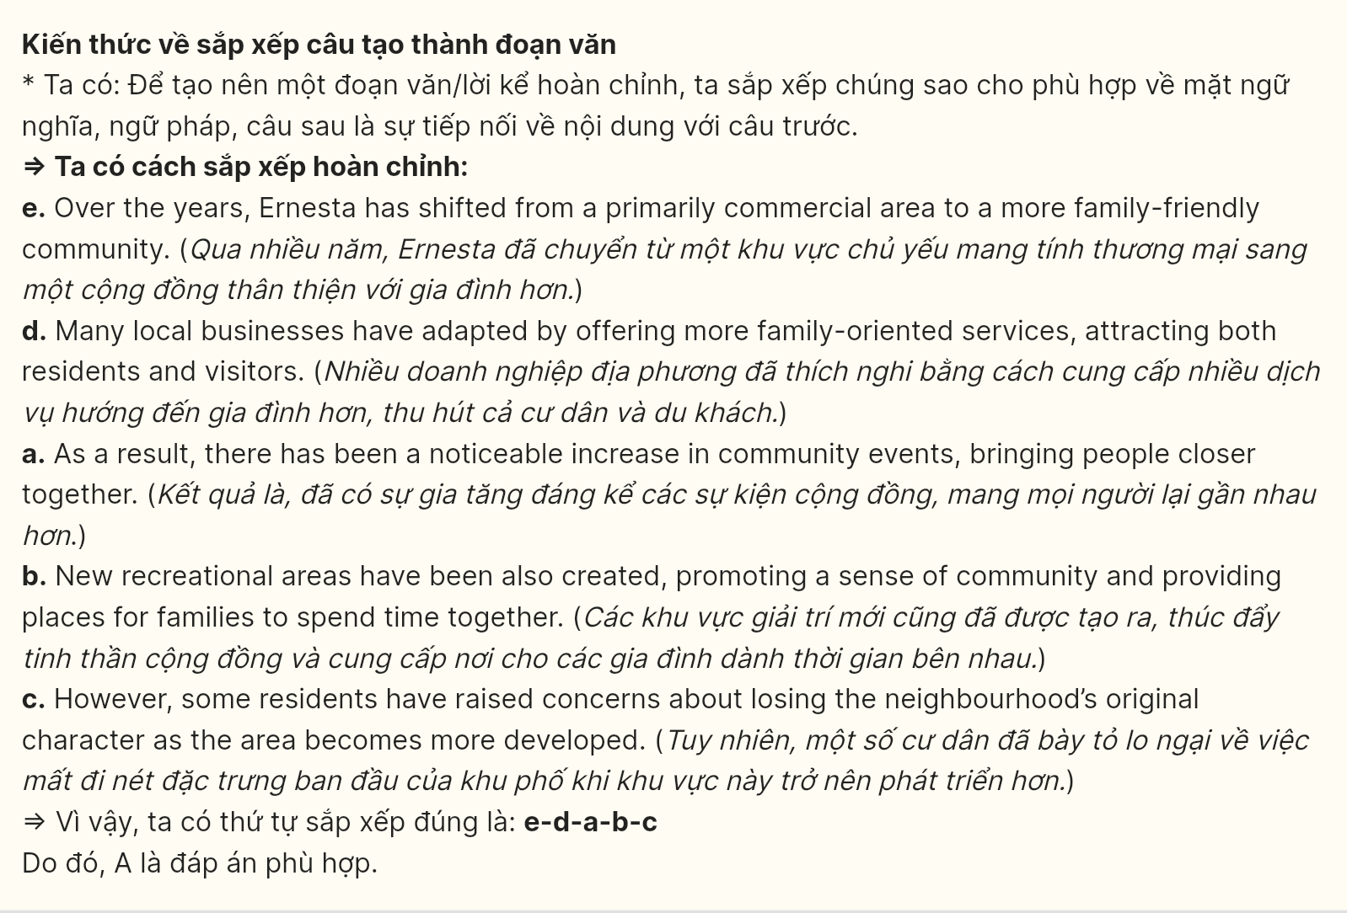

***Mark the letter A, B, C, or D on your answer sheet to indicate the correct option that best fits each of the numbered blanks from 18 to 22.***



Traveling offers a unique way to explore the world and expand one’s horizons. It gives people the chance to experience different cultures, taste new foods, and meet diverse individuals. People (18) ______. They realize that different customs and traditions enrich the human experience, making them more open-minded and adaptable.

One of the greatest advantages of traveling is the opportunity to face new challenges. By stepping out of your comfort zone, (19) ______. Travelers who navigate foreign lands also gain valuable life skills, such as independence and confidence.

Historic landmarks, for example, (20) ______, allowing travelers to witness the rich history of other nations. (21) ______, they understand how different regions have shaped the world. Exposed to new environments, they return with a fresh perspective, becoming more compassionate and globally aware. Traveling makes people (22) ______.

Question 18 [697673]:

A. traveled regularly often develop a better understanding of global diversity  
B. have a better understanding of global diversity often travel  
C. who travel regularly often develop a better understanding of global diversity  
D. whose are travel regularly want to develop a understanding of global diversity

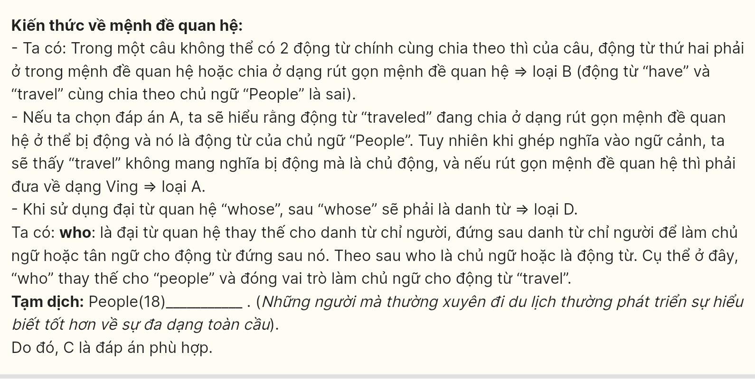

Question 19 [697674]:

A. allows you to easily solve problems and adapt to situations you already know  
B. you learn to solve problems and adapt to unfamiliar situations  
C. you fail to learn how to address challenges and adjust to known situations  
D. you struggle to find solutions and adapt to new circumstances

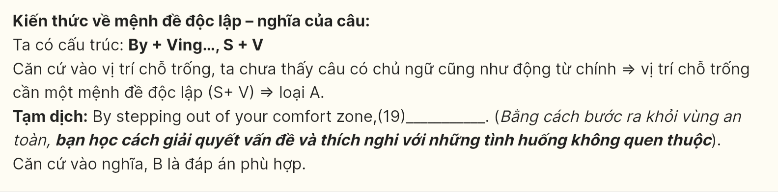

Question 20 [697675]:

A. where visited by millions of people every year  
B. that had millions of people visited every year  
C. are visited by millions of people every year  
D. visiting by millions of people every year



Question 21 [697676]:

A. It is filled with stories and cultural significance  
B. Which places are filled with stories and cultural significance  
C. Having explored these places which are filled with stories and cultural significance  
D. Stories and cultural significance which are exploring by these places

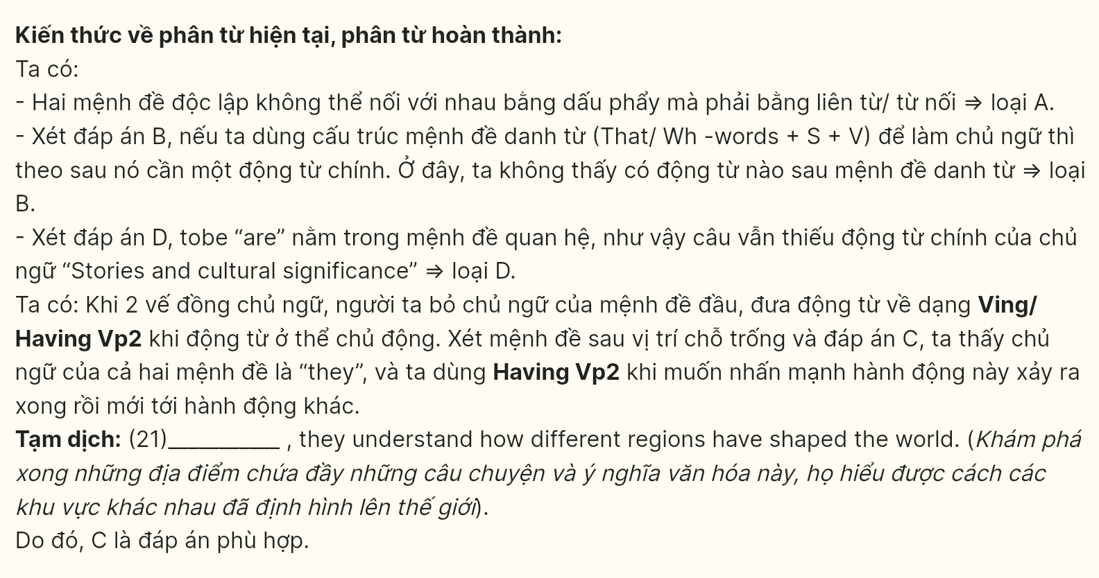

Question 22 [697677]:

A. not only more knowledgeable but also more understanding of the world around them  
B. neither more understanding of the world around them nor more knowledgeable  
C. become knowledgeable, yet they remain ignorant about their surroundings  
D. but it does not help them comprehend the world around them

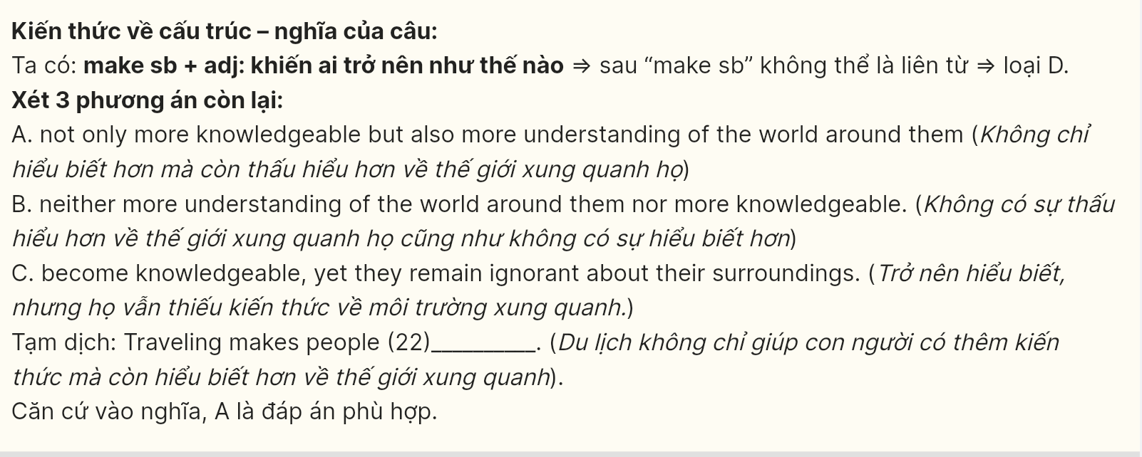

***Read the following passage about science and mark the letter A, B, C or D on your answer sheet to indicate the option that best fits each of the numbered blanks from 23 to 30.***

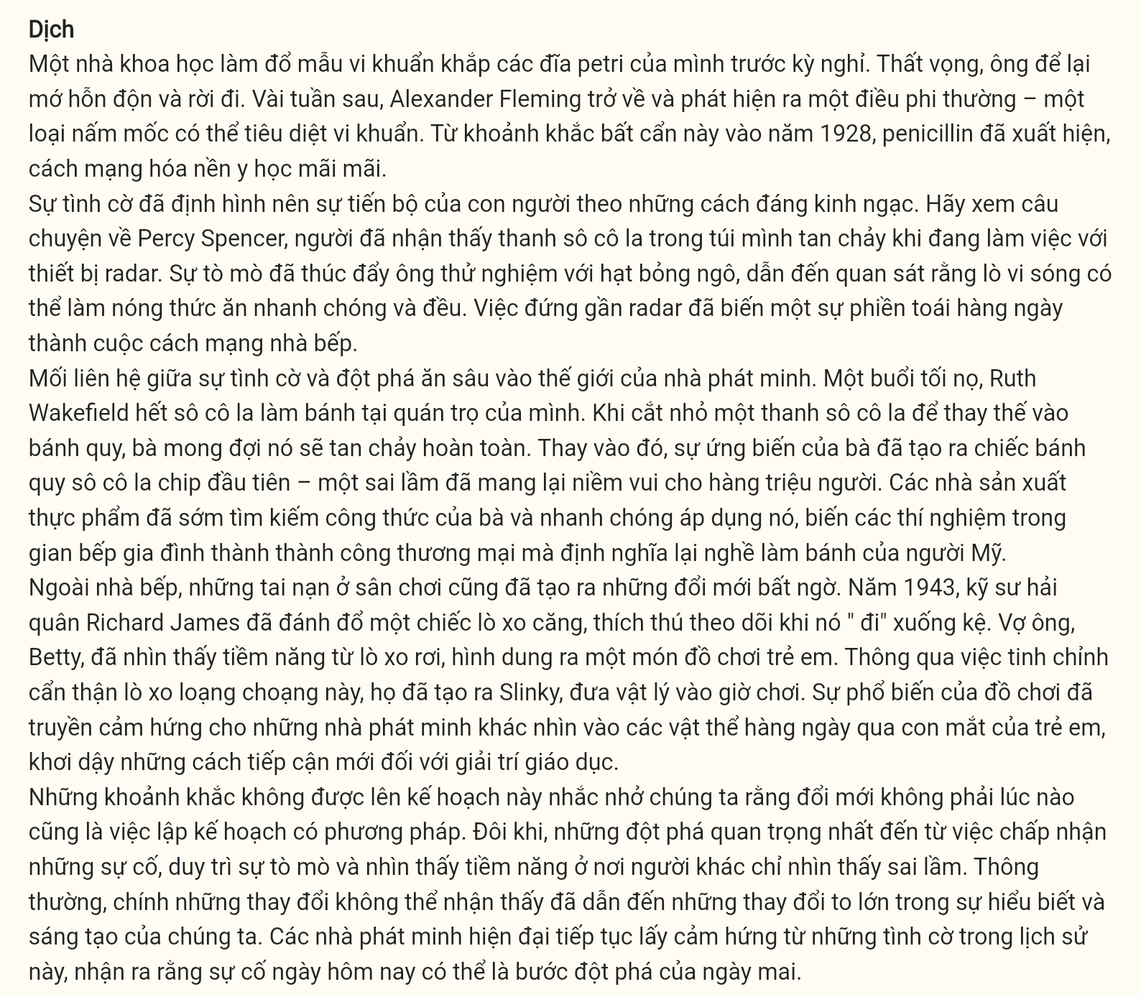

A scientist spills bacteria samples all over his petri dishes before vacation. Frustrated, he leaves the mess behind. Returning weeks later, Alexander Fleming finds something extraordinary – a mold that kills bacteria. From this careless moment in 1928 emerged penicillin, revolutionizing medicine forever.

**Serendipity** has shaped human progress in remarkable ways. Take the story of Percy Spencer, who noticed a chocolate bar melting in his pocket while working with radar equipment. His curiosity drove him to experiment with popcorn kernels, leading to observations that microwaves could heat food rapidly and evenly. Standing near that radar transformed an everyday annoyance into a kitchen revolution.

The connection between accidents and breakthroughs runs deep in the inventor’s world. Ruth Wakefield ran out of baker’s chocolate one evening at her inn. Chopping up a chocolate bar to substitute in her cookies, she expected it to melt completely. Instead, her improvisation created the first chocolate chip cookie – a mistake that brought joy to millions. Food manufacturers soon sought her recipe and quickly adopted it, transforming home kitchen experiments into a commercial success that redefined American baking.

Beyond the kitchen, playground accidents sparked unexpected innovations. In 1943, naval engineer Richard James knocked over a tension spring, watching in fascination as it "walked" down a shelf. His wife Betty saw beyond the falling spring, envisioning a children's toy. Through careful refinement of this stumbling spring, they created the Slinky, bringing physics into playtime. The toy’s popularity inspired other inventors to look at everyday objects through children’s eyes, sparking new approaches to educational entertainment.

These unplanned moments remind us that innovation isn’t always about methodical planning. Sometimes, the most significant breakthroughs come from embracing accidents, maintaining curiosity, and seeing potential where others see mistakes. Often, it’s the **imperceptible** changes that lead to monumental shifts in our understanding and creativity. **Modern inventors continue drawing inspiration from these historical accidents, recognizing that today’s mishap might be tomorrow’s breakthrough.**

*(Adapted from APS Home)* GIA SƯ TẠI HUẾ (ZALO: 0793833272)

**Question 23 [697678]**: Which of the following is **NOT** mentioned as an accidental invention in the passage?

A. chocolate chip cookies B. microwave heating

C. rubber vulcanization D. penicillin

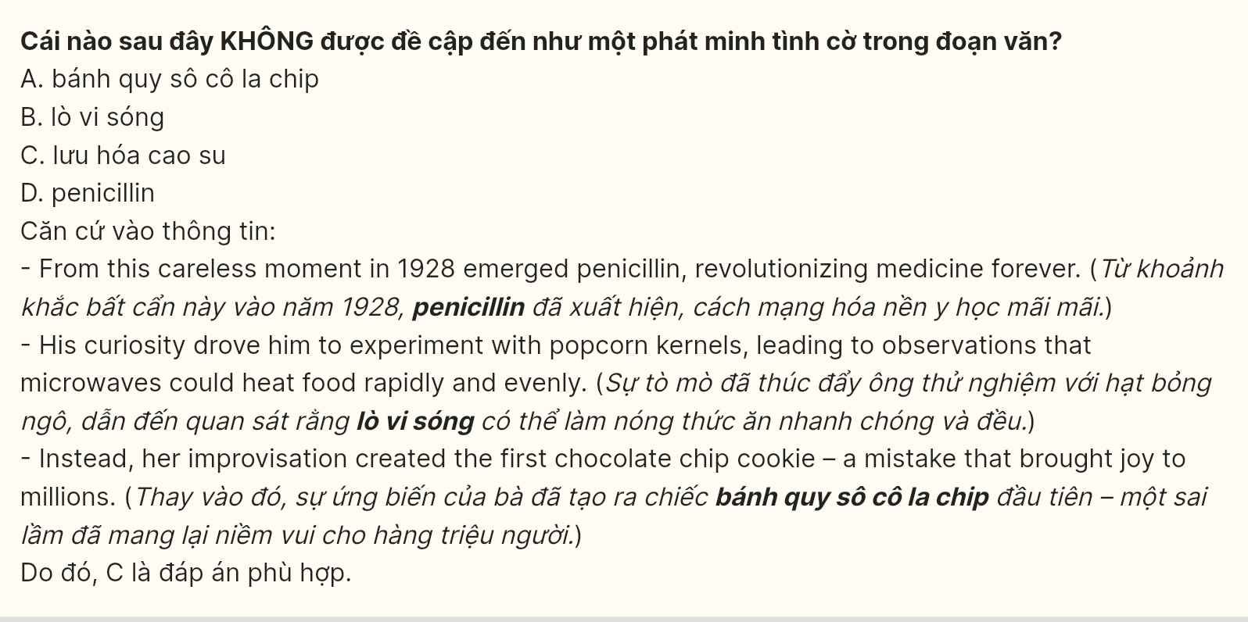

**Question 24 [697679]**: The word "**Serendipity**" in paragraph 2 is **OPPOSITE** in meaning to ______.

A. Deliberation B. Fortuity C. Misfortune D. Planning

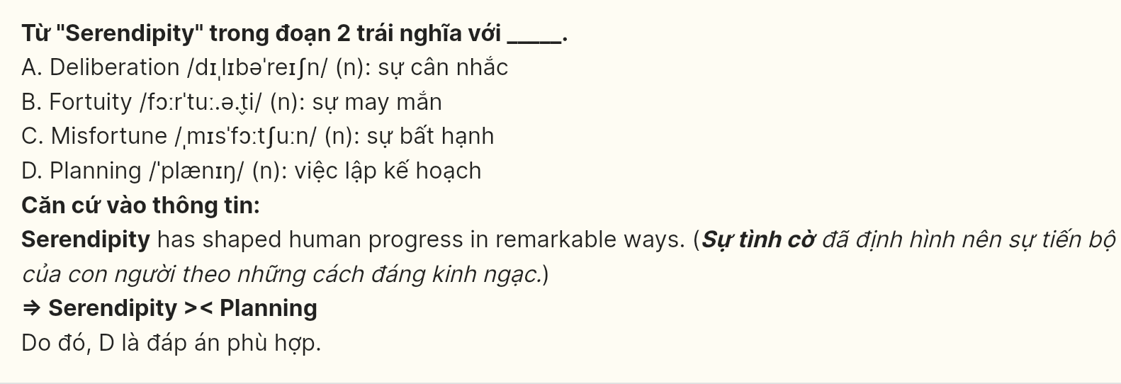

**Question 25** [697680]: The word "**It**" in paragraph 3 refers to ______.

A. the cookie B. a chocolate bar C. the baker D. improvisation

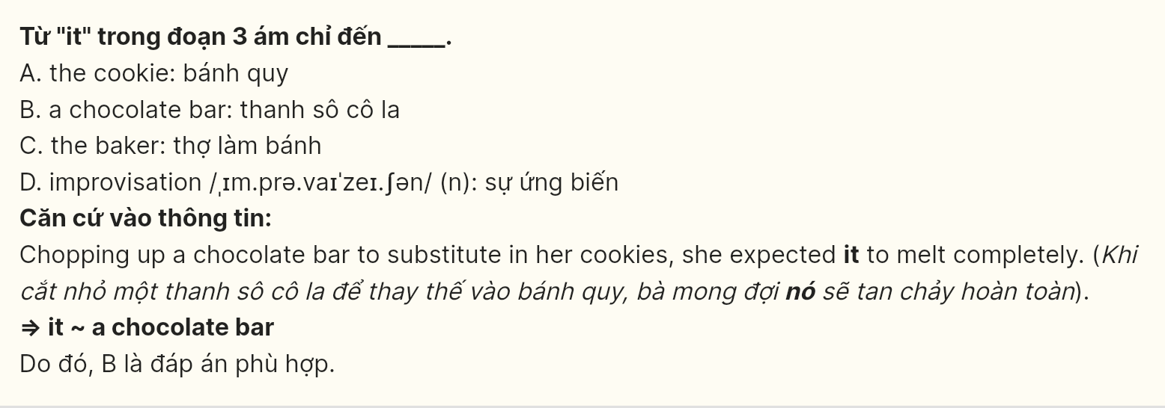

**Question** **26** [697681]: The word "**imperceptible**" in paragraph 5 could be best replaced by ______.

A. elusive B. obscure C. subtle D. veiled

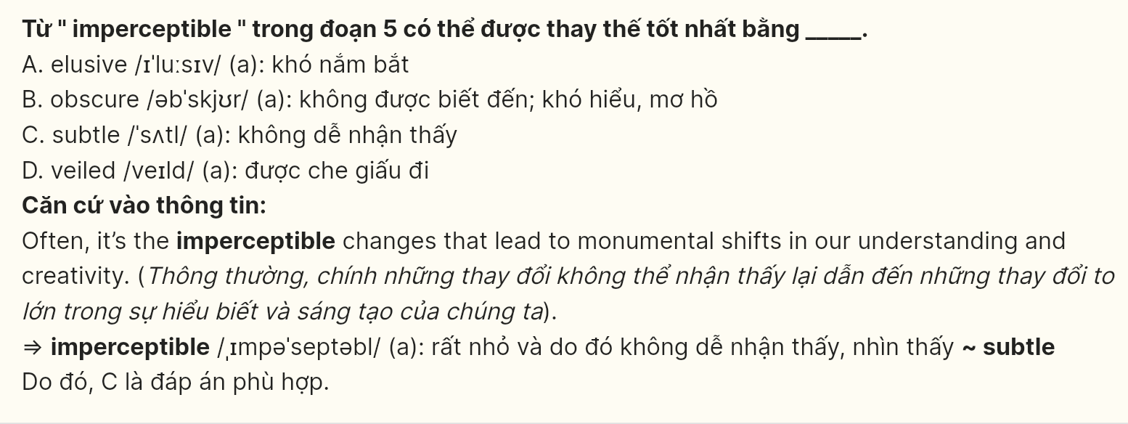

**Question 27** [697682]: Which of the following best paraphrases the underlined sentence in the final paragraph?

A. Modern creators have been extracting wisdom from past mistakes, turning unexpected events into groundbreaking discoveries.

B. Present-day innovators are learning from earlier accidents, seeing potential breakthroughs in present-day mishaps.

C. Modern developers keep deriving insights from historical blunders, believing that even a failure might eventually lead to innovation.

D. Current inventors have continued gaining knowledge from previous accidents, expecting future success to come.

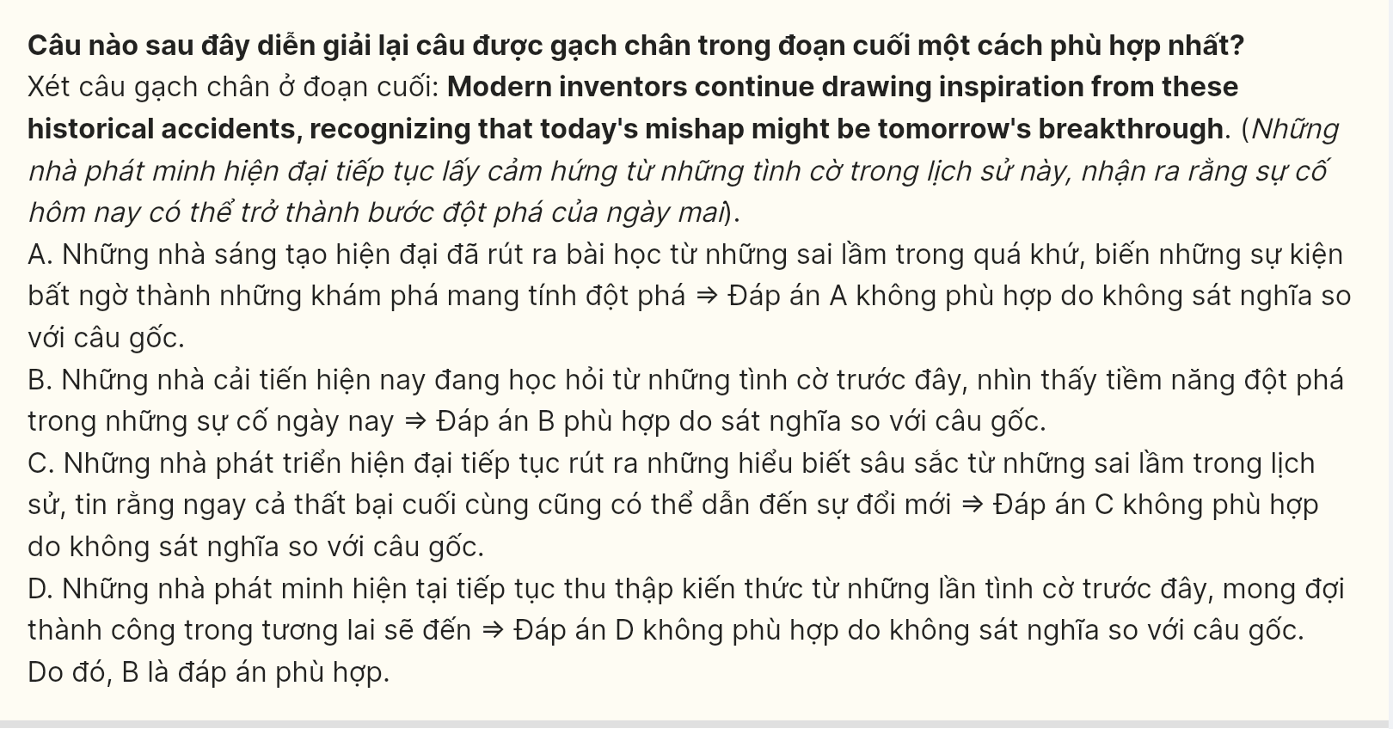

**Question 28** [697683]: Which of the following is TRUE according to the passage?

A. When Ruth Wakefield ran short of baker's chocolate for her recipe, she used chocolate bits instead.

B. Percy Spencer experimented with popcorn kernels while finding melted chocolate in his pocket.

C. Richard James and his wife Betty commercialized the Slinky after watching a spring fall from height.

D. Alexander Fleming researched the bacteria-killing properties of mold following his vacation time.

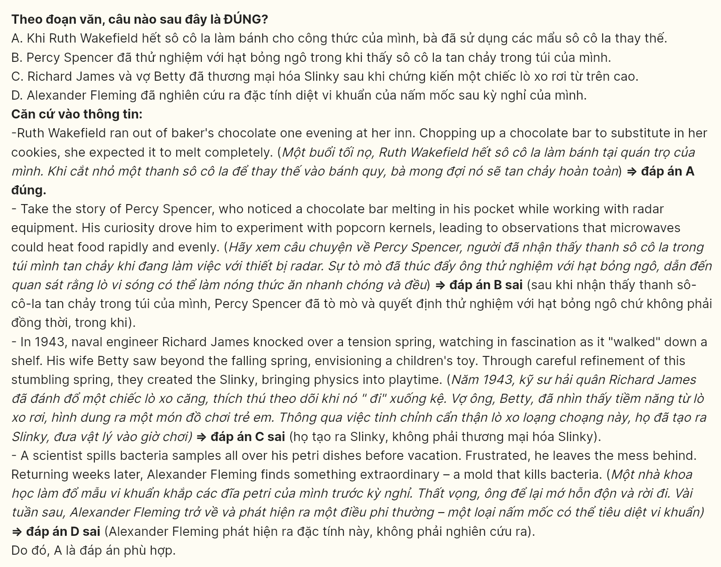

**Question 29** [697684]: In which paragraph does the writer demonstrate the relationship between home innovation and industry?

A. Paragraph 1 B. Paragraph 2 C. Paragraph 3 D. Paragraph 4

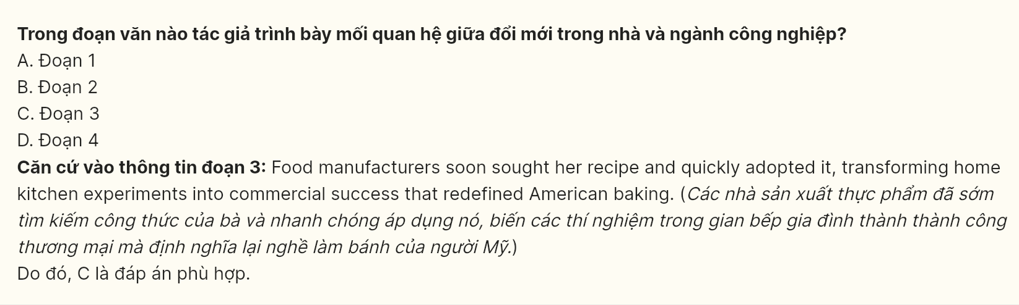

Question 30 [697685]: In which paragraph does the writer illustrate the intersection between scientific principles and recreational development?

A. Paragraph 1 B. Paragraph 2 C. Paragraph 3 D. Paragraph 4

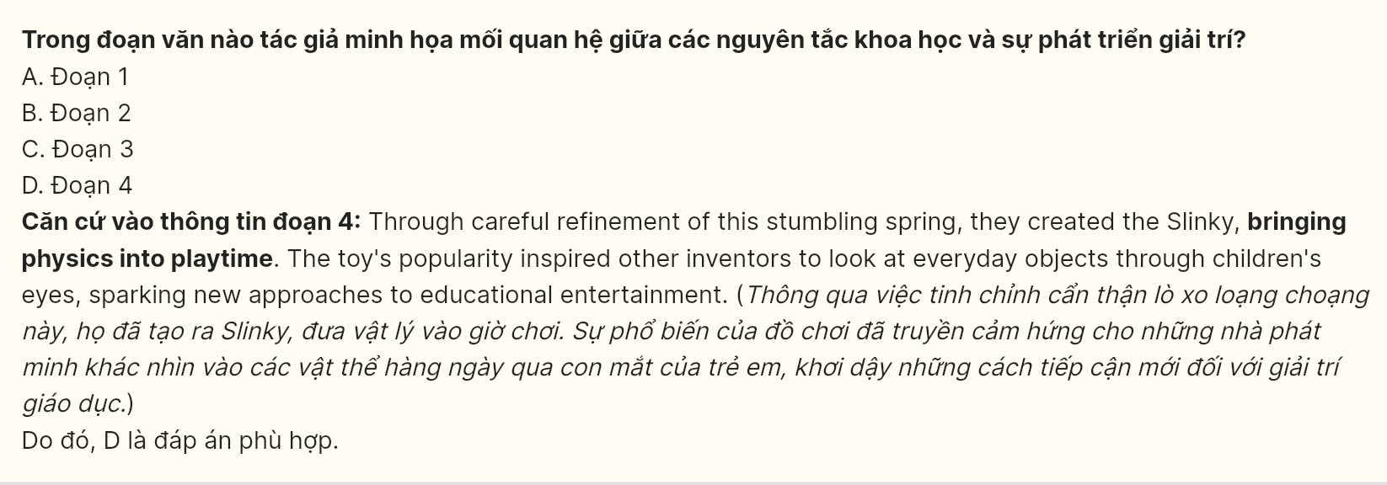

***Read the following passage about the article "Can your child be a genius?" and mark the letter A, B, C or D on your answer sheet to indicate the best answer to each of the following questions from 31 to 40.***

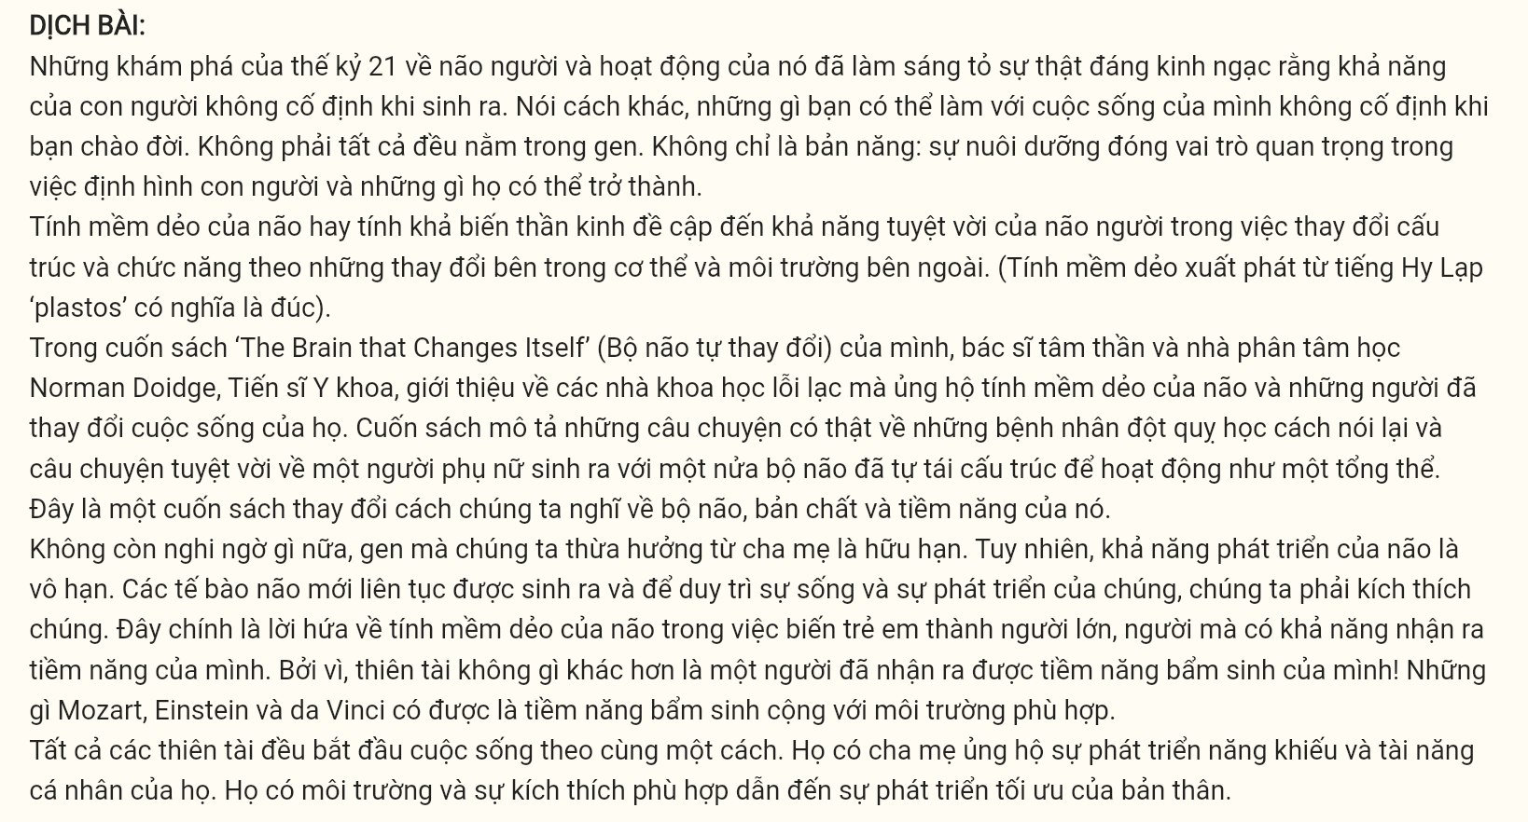

The 21st-century discoveries about the human brain and its functioning have **brought to** **light** the astounding fact that human abilities are not fixed at birth. In other words, what you are able to do with your life is not fixed when you are born. It is not all in the genes. It is not just nature: nurture plays a significant part in the molding of what a person is, and what he/she can be.

Brain plasticity or neuroplasticity refers to the amazing ability of the human brain to modify **its** structure and functions according to the changes within the body and in the external environment. (“Plasticity” comes from the Greek word ‘plastos’ meaning molded).

In his book ‘The Brain that Changes Itself’ psychiatrist and psychoanalyst Norman Doidge, M.D., offers an introduction to the brilliant scientists advocating neuroplasticity and the people whose lives they’ve transformed. The book describes real life stories of stroke patients learning to speak again and the amazing story of a woman born with half a brain that restructured itself to work as a whole. It is a book that changes the way we think about our brain, its nature, and its potential.

**[I].** The genes we inherit from our parents are finite, no doubt about that. However, our brain’s ability to develop is infinite. **New brain cells are being born all the time, and to keep them alive and growing, we have to stimulate them.** [**II**]. Herein lies the promise of neuroplasticity in the moulding of children into adults who are capable of realizing their potential. [**III**]. What Mozart, Einstein and da Vinci had was **innate** potential plus the right environment. [**IV**].

All geniuses started life in exactly the same way. They had parents who supported the development of their individual gifts and talents. They had the right environment and stimuli that led to the optimal development of themselves.

*(Adapted from kidsworldfun.com)*

**Question 31** [697686]: The phrase “**brought to light**” in paragraph 1 could be best replaced by ______.

A. revealed B. negotiated C. implemented D. facilitated

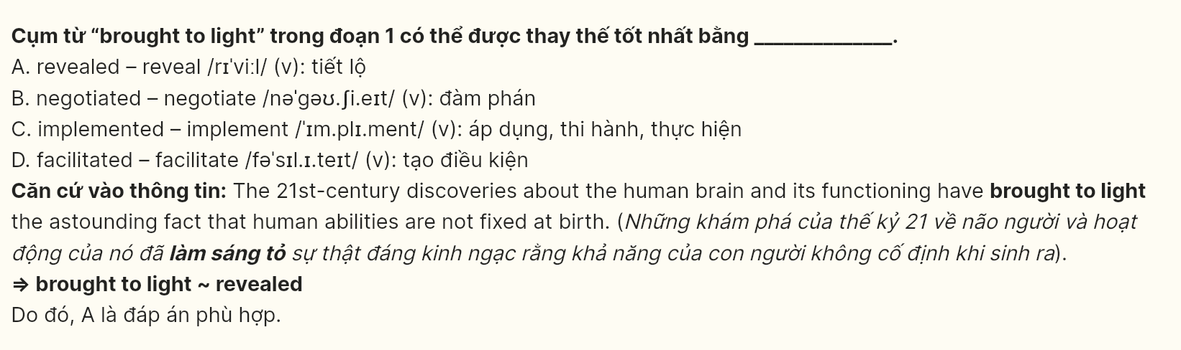

**Question 32** [697687]: The word **its** in the paragraph 2 refers to ______.

A. the human brain’s B. neuroplasticity’s C. ability’s D. nature’s

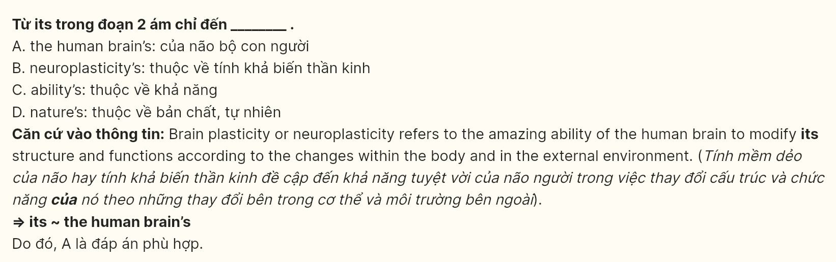

**Question 33** [697688]: Which of the following best summarizes paragraph 3?

A. The book “The Brain That Changes Itself” by Norman Doige introduces a woman born with half a brain.

B. Norman Doide’s book introduces the concept of neuroplasticity and stories about disability.

C. Norman Doidge has won a prestigious award for his exceptional book about neuroplasticity.

D. Norman Doidge has reshaped our understanding of the brain’s potential through inspiring real-life stories in his book.

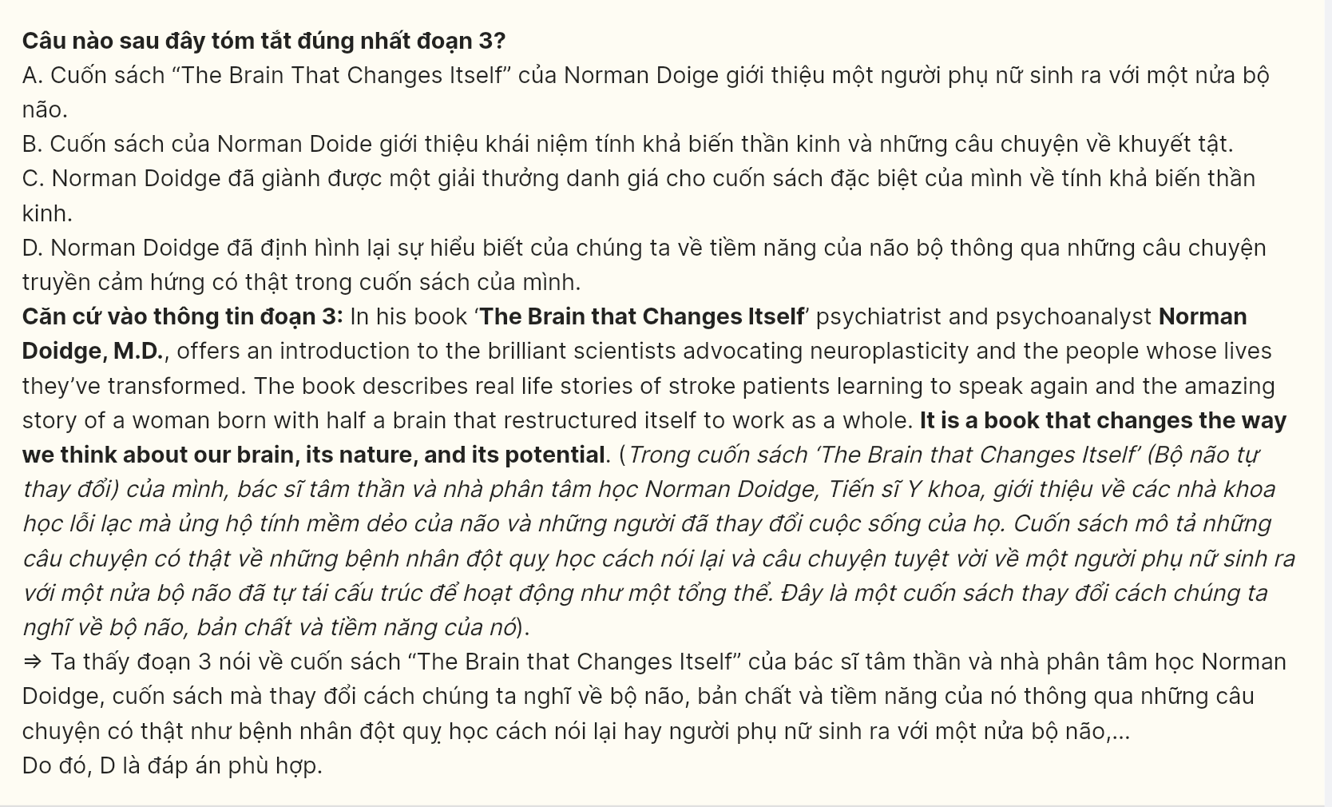

**Question 34** [697689]: Where in paragraph 4 does the following sentence best fit?

**“For, genius is nothing but a human being who has realized his/her innate potential!**

A. [I] B. [II] C. [III] D. [IV]

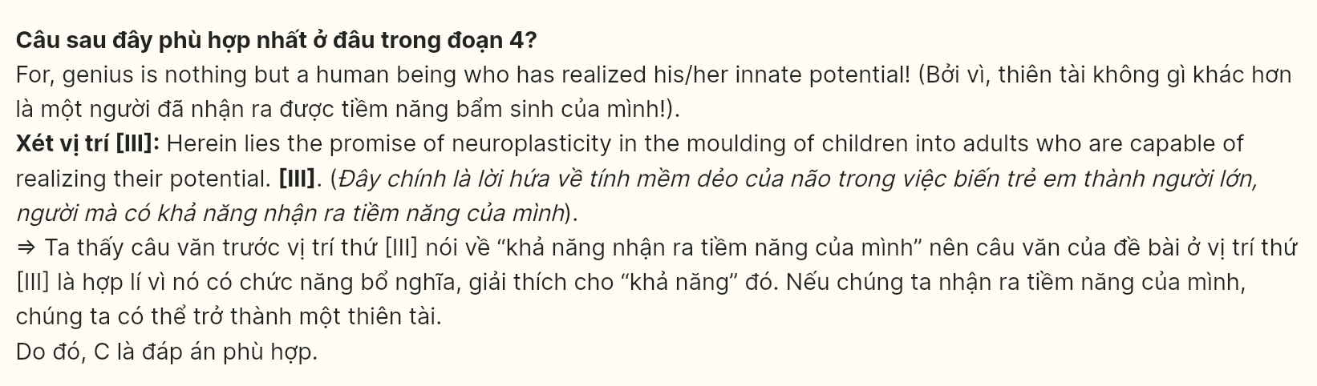

**Question 35** [697690]: The word “**innate**” in paragraph 4 is **OPPOSITE** in meaning to ______.

A. inborn B. acquired C. extraordinary D. infinite

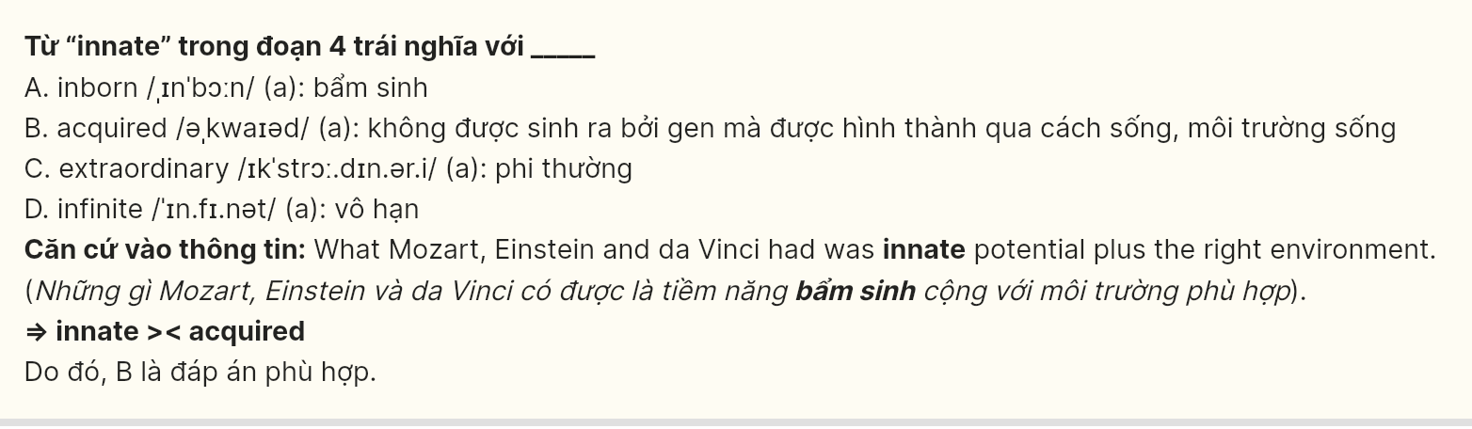

**Question 36** (697691): According to paragraph 4, which of the following is **NOT** an example of geniuses having innate potential and the right environment?

A. Enstein B. Galileo C. Mozart D. Leonardo da Vinci

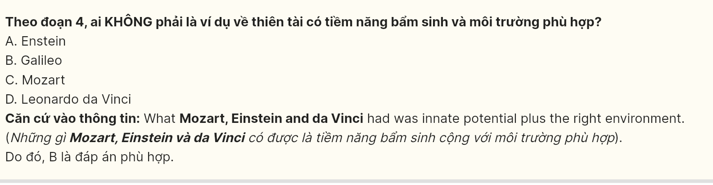

**Question 37** (697692): Which of the following best paraphrases the underlined sentence in paragraph 4?

A. New neurons are constantly born, their survival can be maintained by avoiding any stimulation.  
B. New brain cells are continuously generated, and their survival and growth depend on consistent stimulation.  
C. Lack of stimulation from the external environment can result in the death of newly generated brain cells.  
D. We have to invest a significant amount of our time and effort into enhancing the development of brain cells.

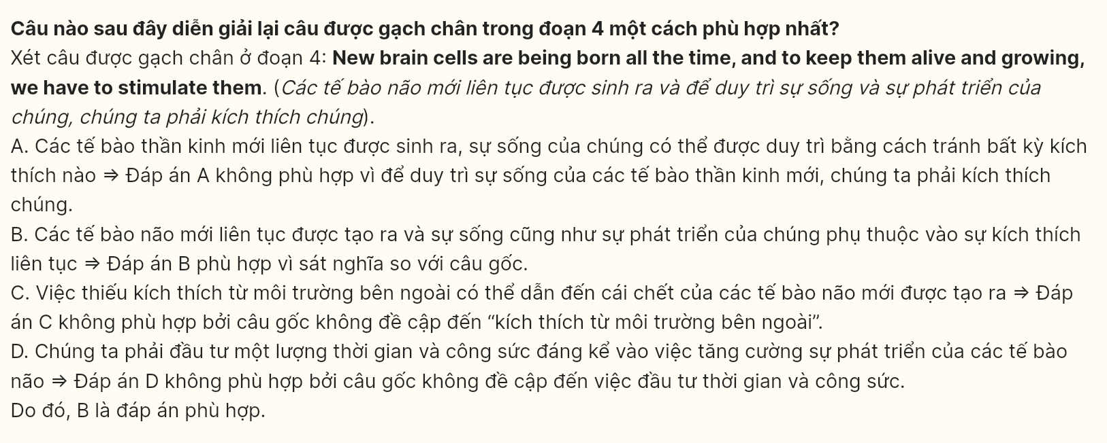

**Question 38** (697693): Which of the following is TRUE according to the passage?

A. The genetic traits we inherit from our parents are limited, but our brain's capacity for development is boundless.  
B. Only nature influences a person's development, nurture has no impact.  
C. Under no circumstances can neuroplasticity alter the structural and functional capacities of the human brain.  
D. All talented people in the world do not need the environment or support to achieve their success.

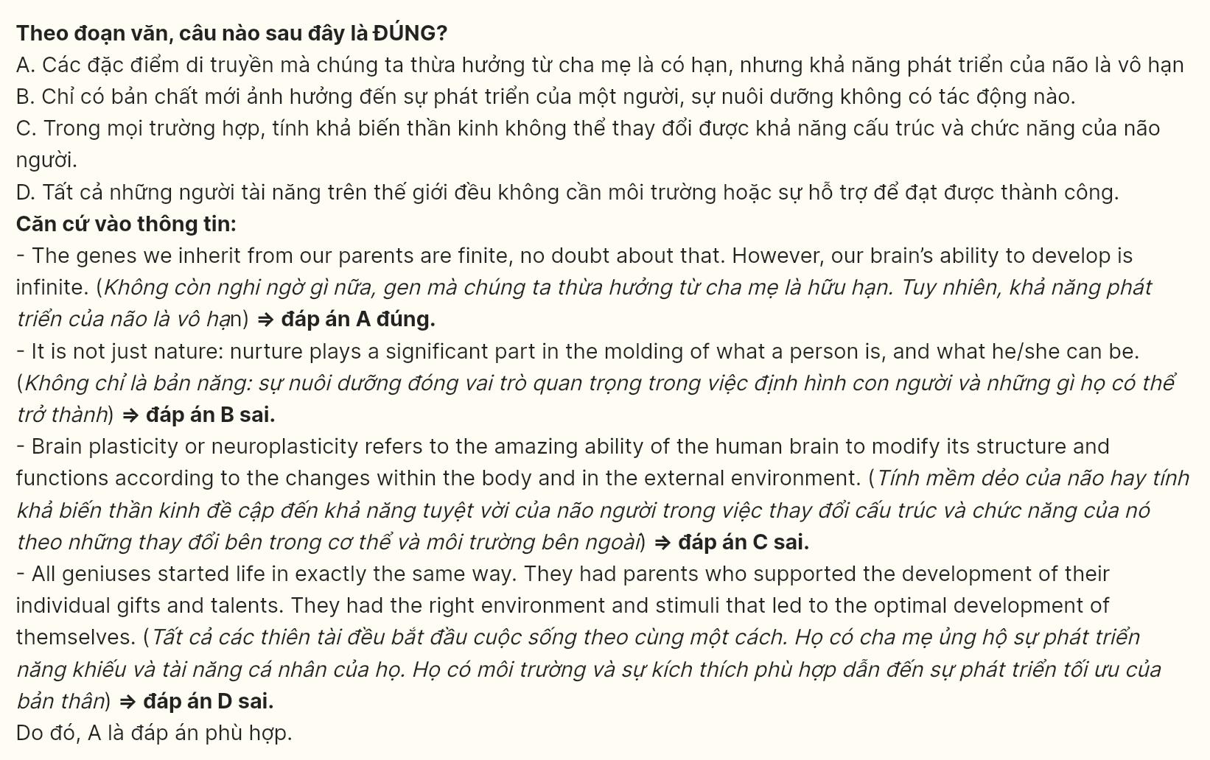

**Question 39** (697694): Which of the following can be inferred from the passage?

A. Both natural talent and a supportive nurturing environment enable people to realize their abilities.  
B. Children with unsupportive parents can still achieve optimal development.  
C. Children with poor genetic inheritance can never be successful despite any external support.  
D. The book written by Norman only reinforces the traditional views about our brain, which is not helpful in transforming preexisting beliefs.

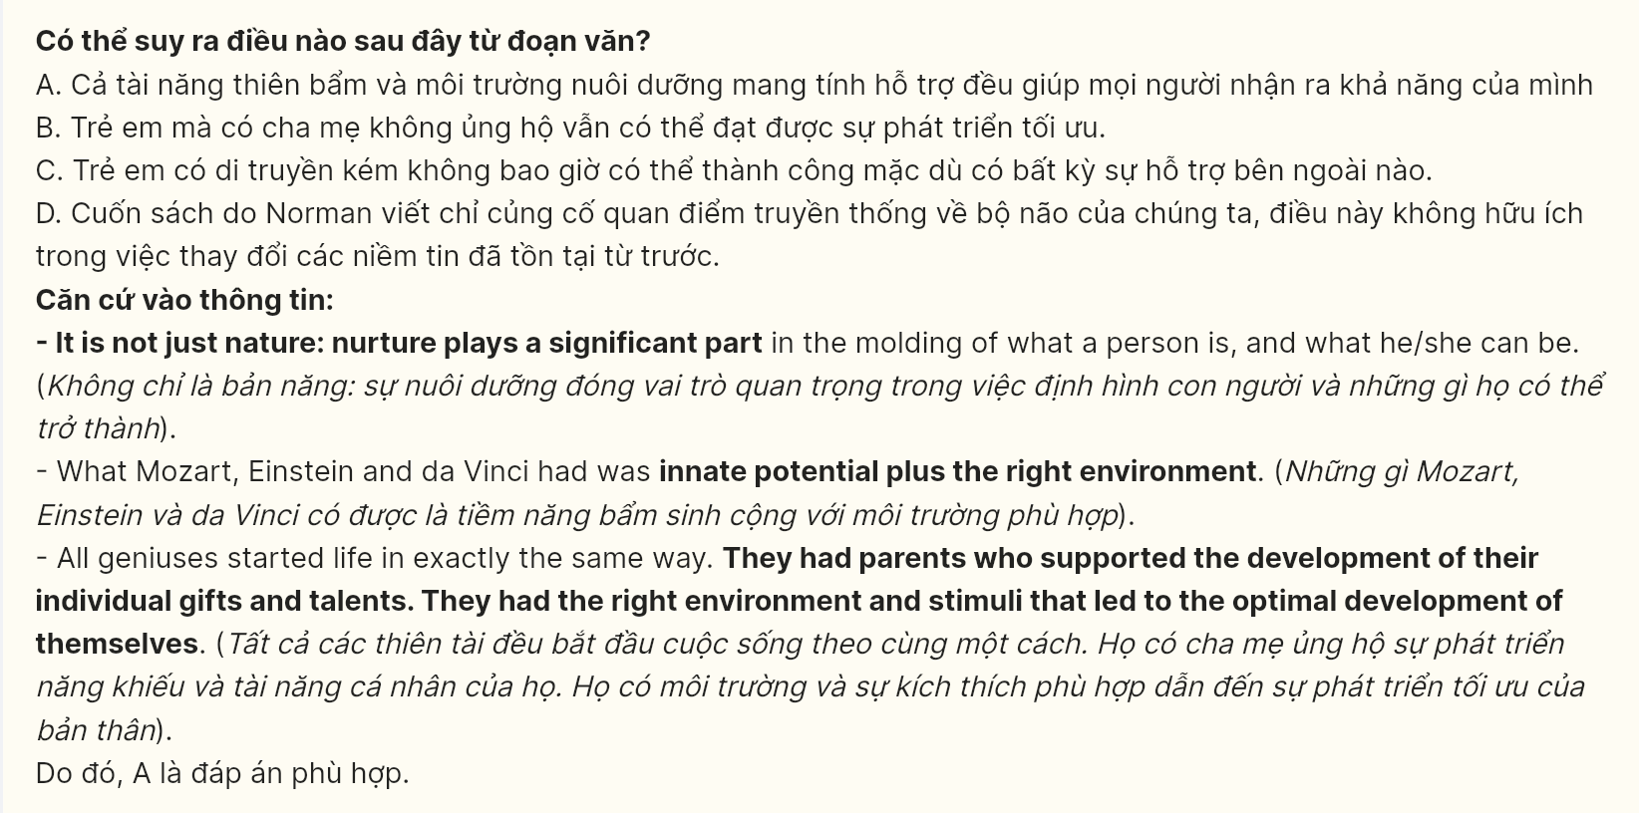

**Question 40** (697695): Which of the following best summarises the passage?

A. All children are born with a natural ability to think and learn like geniuses.  
B. If children have opportunities to develop their natural curiosity and thinking capacity, they will learn faster and better.  
C. All children can become geniuses if they are provided with the right environment, the right stimuli and the right guidance. GIA SƯ TẠI HUẾ (ZALO: 0793833272)  
D. The kids should be surrounded by lots of interesting books in all fields.

