School: ……………………………………….. | Date: ………………………………
Class: ……………………………..................... | Period: ……………………….........

UNIT 5: SCIENCE AND TECHNOLOGY
Lesson 3.1 – Reading & Writing (pages 52 & 53)

I. OBJECTIVES
By the end of the lesson, Ss will be able to ….
1.1. Language knowledge and skills
- practice reading for specific information.
- practice writing longer and more interesting sentences using conjunctions.
1.2. Competences
- improve Ss’ communication, collaboration, and critical thinking skills.
1.3. Attributes
- to understand how electronic devices work and their impacts on daily life.
II. TEACHING AIDS AND LEARNING MATERIALS
1. Teacher’s aids: Student book and Teacher’s book, class CDs, Digital Book (DCR phần mềm tương tác SB, DHA (từ vựng/ cấu trúc) phần mềm trò chơi tương tác), projector/interactive whiteboard / TV (if any), PowerPoint slides.
2. Students’ aids: Student’s book, workbook, notebook.
III. ASSESSMENT EVIDENCE
Performance Tasks | Performance Products | Assessment Tools
- Let’s Talk: What are the people using their smartphones for? What do you use your smartphone for? | - Ss’ answers / presentation.  - Ss’ answers. | - T’s feedback/Peers’ feedback.  - T’s feedback/Peers’ feedback.
- Reading: Read Kate's email to her friend. Which of the following features is NOT mentioned? | - Ss’ answers. | - T’s feedback/Peers’ feedback.
- Read and fill in the blanks.  - Speaking: In pairs: Would you like the phone Kate chose? Why (not)? | - Ss’ answers.  - Ss’ answers. | - T’s feedback/Peers’ feedback.  - T’s feedback/Peers’ feedback.
- Writing: Read about using conjunctions to make longer, more interesting sentences. Then, read the email again and underline the conjunctions. | - Ss’ answers. | - T’s feedback/Peers’ feedback.
- Fill in the blanks with a word from the box. | - Ss’ answers. | - T’s feedback/Peers’ feedback.

IV. PROCEDURES
A. Warm up: (5’)
a) Objective: Introduce the new lesson and set the scene for Ss to acquire new language; get students' attention at the beginning of the class by giving enjoyable and short activities as well as to engage them in the follow-up steps.
b) Content: Reading information of an email to a friend sharing information about a new electronic device.
c) Expected outcomes: Ss have general ideas about the topic “Science and technology”, which they are going to read and write in the new lesson.
d) Organization of the activity:
TEACHER’S ACTIVITIES | STUDENTS’ ACTIVITIES
* OPTION 1: Let’s Talk!  Look at the pictures. What are the people using their smartphones for? What do you use your smartphone for?  - Use the part “Let’s talk!” in the textbook– page 52 for warm-up activity.  - Ask Ss to work in pairs to answer the questions  - Divide the class into pairs.  - Have Ss discuss the questions.  - Elicit answers from some Ss.  - Call Ss to share their answers with the whole class.  - Give feedback.  - Lead to the new lesson. | - Work in pairs to discuss.  - Present.  - Share the answers.

B. New lesson (35’)
- Activity 1: Reading (17’)
a) Objective: Students can develop their reading skill regarding email format.
b) Content: Practicing reading and writing on an email to a friend sharing information about a new electronic device.
- Read Kate's email to her friend. Which of the following features is NOT mentioned?
- Read and fill in the blanks.
- Speaking: In pairs: Would you like the phone Kate chose? Why (not)?
c) Expected outcomes: Students can practice reading and understanding general and specific information of an email between two friends discussing a new electronic device.
d) Organization of the activity:
TEACHER’S ACTIVITIES | STUDENTS’ ACTIVITIES
*Pre-reading:  Task a. Read Kate's email to her friend. Which of the following features is NOT mentioned?  - Have Ss read the question.  - Have Ss read the email and answer the question.  - Check the answer as a whole class.  *While-reading:  Task b. Now, read and fill in the blanks.  - Have Ss read the questions.  - Have Ss read the email and fill in the blanks.  - Have Ss check their answers with a partner.  - Check answers as a whole class.  * Remind Ss of reading techniques for gap-fill exercises:  - Skim the email  - Look for context clues (keywords and the words before or after the blank)  - Guess based tone of the email (positive or negative)  - Read the email again slowly and carefully to check.  - Have Ss check their answers with a partner.  - Check answers as a whole class.  - Give feedback.  Tasks c. Listen and read.  - Have Ss listen to the audio and read along.  - Give feedback.  *Post-Reading:  Task d. In pairs: Would you like the phone  Kate chose? Why (not)?  - Have Ss discuss the questions in pairs.  - Elicit answers from some Ss.  - Call some Ss to share their answers with the whole class.  - Give feedback. | - Read the question.  - Read the text and choose the correct answer.  - Give answer and explain.  Answer keys    - Read, identify and underline the key words.  - Read and answer the questions.  Answer keys  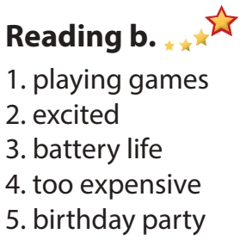  - Listen to the audio and read along.  - Discuss in pairs.  - Present.  Suggested answer  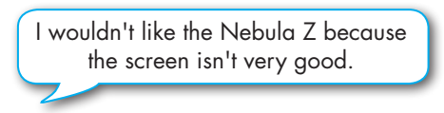

- Activity 3: Writing (18’)
a) Objective: Students can develop their writing skill.
b) Content: Reading about using conjunctions and filling in the blanks.
- Read about using conjunctions to make longer, more interesting sentences. Then, read the email again and underline the conjunctions.
- Fill in the blanks with a word from the box.
c) Expected outcomes: Students can enhance writing skills by using conjunctions.
d) Organization of the activity:
TEACHER’S ACTIVITIES | STUDENTS’ ACTIVITIES
Task a. Read about using conjunctions to make longer, more interesting sentences. Then, read the email again and underline the conjunctions.  - Have Ss read the Writing Skill box and the email again, then underline the conjunctions.  - Have Ss check their answers with a partner.  - Check answers as a whole class.  - Give feedback.  Task b. Fill in the blanks with a word from the box.  - Have Ss read the sentences.  - Have Ss fill in the blanks with words from the  box.  - Have Ss check their answers with a partner.  - Check answers as a whole class.  - Give feedback. | - Read the box and the text, underlining the conjunctions.  Answer keys  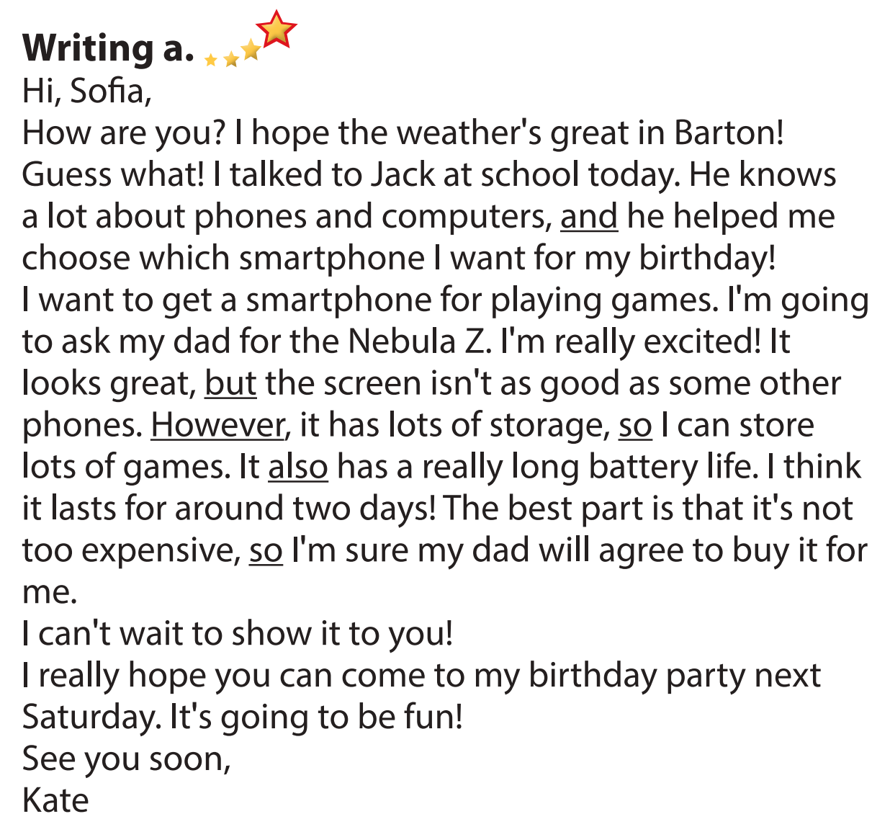  Answer keys  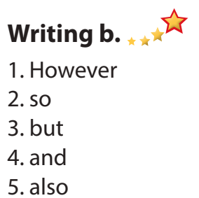
C. Consolidation and homework assignments (5’)
*Consolidation: Reading the email format to a friend sharing information about a new electronic device. Reading about writing using conjunctions to make longer, more interesting sentences.
Combine the sentences using conjunctions.
- It has long battery life. It's very expensive.
- It has a great screen. It has a really good speaker.
- It has a lot of storage. It can store lots of music and photos.
Answer keys:
- It has long battery life, but it's very expensive./
It has a great screen. It also has a really good speaker.
2. It has a great screen, and the speaker is really good./
It has long battery life. However, it's very expensive.
3. It has a lot of storage, so it can store lots of music and photos.
*Homework
- Do the exercises in WB: Listening and Reading (page 30).
- Do the exercises in Tiếng Anh 8 i-Learn Smart World Notebook (pages 44 & 45).
- Play the consolidation games in Tiếng Anh 8 i-Learn Smart World DHA App on www.eduhome.com.vn
- Prepare: Unit 6 - Lesson 3 – Speaking and Writing (page 53 – SB).

V. Reflection
a. What I liked most about this lesson today:
…………………………………………………………………………………………
- What I learned from this lesson today:
…………………………………………………………………………………………
c. What I should improve for this lesson next time:
…………………………………………………………………………………………

