**Tiếng Anh 6 i-Learn Smart World - Midterm 2.1  
Time allotted: 60**

**PART 1. Pronunciation (2 questions)**

**Find the word that differs from the other three in the position of primary stress.**

1. A. reuse B. wildlife C. offer D. cleanup

2. A. funny B. awful C. asleep D. program

**PART 2. Use of English (10 questions)**

**Choose the word/ phrase (A, B, C or D) that best suits the blank in each sentence.**

3. You can catch a bus at the ______________.

A. train station B. police station C. street D. bus station

4. Alice is ill so she ______________ to school today.

A. goes B. don’t go C. can’t go D. should go

5. Mr. Simon is going to ______________ $1,000 for the charity.

A. donate B. carry C. pick D. buy

6. I’m going to see a movie ______________ Sunday ______________ 6 p.m.

A. in/ at B. on/ at C. on/ in D. at/ on

7. Student 1: “Excuse me, is there ______________ supermarket near here?”  
 Student 2: “Yes, ______________ supermarket is on King Street, next to the police station.”

A. the/ the B. the / a C. a/ a D. a/ the

8. We stayed in a hotel ______________ the beach. We had to cross the road when we wanted to go swimming.

A. in front B. between C. opposite D. next

9. Student A: “Did you enjoy your school trip?”  
 Student B: “______________”

A. Yes, I do. B. Yes, I enjoyed. C. Yes, I did. D. Yes, I was.

10. Student A: “I think recycling paper is important.”  
 Student B: “______________”

A. Yes, it was. B. I agree. C. No, I don’t think. D. Yes, you can.

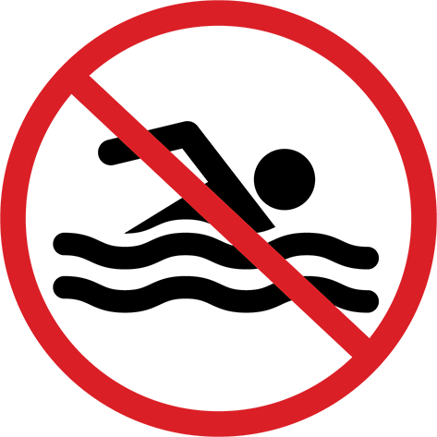

11. What does the sign mean?

A. You can swim here.

B. You can’t swim here.

C. You should swim here.

D. You swim here.

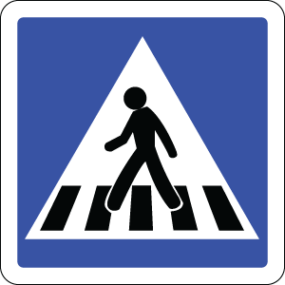

12. What does the sign mean?

A. People should cross the road at the crosswalk.

B. People can’t cross the road here.

C. People are crossing the road at the crosswalk.

D. People shouldn’t cross the road here.

**PART 3. Reading comprehension (6 questions)**

**Read the following passage and complete the tasks. (6 questions)**

|  |
| --- |
| My name is Owen and my favorite animated films are Toy Story 1, 2 and 3. They made the first one in 1995. That was before I was born. Toy Story 2 was the first film I saw at the cinema. It was my sister’s birthday, so my parents took us to the cinema. I was very young but I loved the film. In 2010, eleven years after Toy Story 2, there was Toy Story 3. This time I went with my friends. We were all fourteen and we loved it so much. The films were about a boy called Andy and his toys. His toys, including Woody and Buzz Lightyear, were great characters. They were heroes but each film had a bad character. These bad characters always planned to harm the toys, but after lots of exciting, funny and frightening events, the toys always won. |

**Task 1: Decide whether the statements that follow are True or False**

| **Answers** | **True** | **False** |
| --- | --- | --- |
| 13. They made Toy Story 1 before Owen was born. | **⦿** | **◯** |
| 14. He saw Toy Story 2 with his family at home. | **◯** | **⦿** |
| 15. Andy, Woody and Buzz Lightyear are the names of the toys. | **◯** | **⦿** |
| 16. In the end of each movie, the toys were always the winners. | **⦿** | **◯** |

**Task 2: Choose the word or phrase that best fits the blank space in each sentence.**

17. Owen saw Toy Story 2 ______________.

A. in 1995 B. in 1999 C. in 2010 D. when he was fourteen

18. Owen saw Toy Story 3 with ______________.

A. his parents B. his sister C. his friends D. his family

**PART 4. Cloze test (6 questions)**

**Read the passage, choose the word/ phrase (A, B, C or D) that best suits the blank. (6 questions)**

Yesterday, I watched ‘Darkest Hours’ – a war (19) ___________ about Winston Churchill. It was really fantastic. Winston Churchill was a famous British politician and military leader. He (20) ___________ in Oxfordshire, England, (21) ___________ 30th November, 1874. He studied at the Royal Military College in Sandhurst. After he finished his education in 1896, he became a journalist and worked for a newspaper. (22) ___________ he became a politician. He became Prime Minister in 1940. He was famous (23) ___________ his strength and wisdom. He helped his country very much against the (24) ___________ Nazi Germany during the Second World War. Churchill died at home in 1965. He was 91 years old.

|  |  |  |  |  |
| --- | --- | --- | --- | --- |
| (19) | A. animated | B. drama | C. omedy | D. science fiction |
| (20) | A. was born | B. born | C. is born | D. were born |
| (21) | A. in | B. at | C. on | D. during |
| (22) | A. Three years ago | B. In three years | C. Three years before | D. Three years later |
| (23) | A. for | B. with | C. in | D. because |
| (24) | A. battle | B. army | C. invade | D. general |

**PART 5. Verb forms and verb tenses (4 questions)**

**Complete the sentences with the correct form of the verbs in brackets.**

25. Ben tidied his room yesterday. ***(tidy)***

26. We didn’t watch the film on TV last night. ***(not/watch)***

27. Where were Freddie and his brother at one o’clock this morning? ***(be)***

28. We had a great time at the party last night. ***(have)***

**PART 6. Writing (8 questions)**

**Rearrange the words to make correct sentences.**

29. Keywords: store/empty/jars/reuse/glass/to/./food/We

→ We reuse empty glass jars to store food.

30. Keywords: wash/them/recycle/bottles/should/before/you/You/.

→ You should wash bottles before you recycle them

**Make a suitable question for the underlined part in each sentence.**

31. Iron Man is a science fiction movie.

→ What kind of movie is Iron Man?/ What type of movie is Iron Man?

32. It takes four hours to get to Blackwood Forest.

→ How long does it take to get to Blackwood Forest?

33. George Washington was the first president of the USA.

→ Who was George Washington?

**Rewrite the following sentences without changing the meaning.**

34. The library is to the left of the supermarket and the bus station is to the right of the supermarket.

→ The supermarket is between the library and the bus station./The supermarket is between the bus station and the library.

35. It’s not good for you to go hiking today.

→ You shouldn’t go hiking today.

36. We took the bus to the campsite.

→ We went to the campsite by bus.

**PART 7. Listening (4 questions)**

**Listen to the conversation and decide whether the statements are True or False. (4 questions)**

| **Answers** | **True** | **False** |
| --- | --- | --- |
| 37. Students can’t touch or feed the animals. | **⦿** | **◯** |
| 38. The bus leaves at 7:45 tomorrow morning. | **◯** | **⦿** |
| 39. Students should wear comfortable shoes and hats. | **⦿** | **◯** |
| 40. Students should bring sandwiches and drinks. | **◯** | **⦿** |

**---THE END---**