|  |  |
| --- | --- |
| **TRƯỜNG THPT TRẦN NGUYÊN HÃN** | **ĐỀ KHẢO SÁT ĐỘI TUYỂN HSG 10,11**  **NĂM HỌC 2023-2024**  **MÔN: TIẾNG ANH 11**  Thời gian*: 90 phút, không kể thời gian giao đề* |

**PART 1. Questions 1-10**

*You will hear a conversation between a man who wants to make an insurance claim and a woman who works for an insurance company. Write* ***NO MORE THAN THREE WORDS AND / OR*** *a number in each blank from question 1 to 10. You will hear the conversation twice.*

|  |  |
| --- | --- |
| **INSURANCE CLAIM FORM**  *Example* **Client details**  Name: **Greg** *Williams* | |
| Policy reference:  Address:  Phone number: | **1**.**……………..**  **2**. 102 **……………,** Northbridge  **3**. **…………….** |
| **Description of damage**  Date of incident:  Cause of incident: | Sunday, 17th June  the house was damaged during a **4**. **…………..** |
| Items client is claiming for | a pair of child’s **5**. **…………..**  a new **6**. **……………**  a torn **7**. **……………**  repairs to the door of the **8**. **…………..** |
| **Builder dealing with damage**  Full name: | Steven **9**. **……………** |
| Client to spend in photographs of damaged **10**. **…………..** before building work starts | |

**PART 2: Questions 11-14**

*Choose the correct letter,****A****,****B****or****C****.*

**Local council report on traffic and highways**

***11.*** *A survey found people’s main concern about traffic in the area was*

**A.** cuts to public transport. **B.** poor maintenance of roads. **C.** changes in the type of traffic.

***12****. Which change will shortly be made to the cycle path next to the river?*

**A.** It will be widened. **B.** It will be extended. **C.** It will be resurfaced.

***13****. Plans for a pedestrian crossing have been postponed because*

**A.** the Post Office has moved. **B.** the proposed location is unsafe.

**C.** funding is not available at present.

***14****. On Station Road, notices have been erected*

**A.** telling cyclists not to leave their bikes outside the station ticket office.

**B**. asking motorists to switch off engines when waiting at the level crossing.

**C.** warning pedestrians to leave enough time when crossing the railway line.

**PART 3: Questions 15-20**

*Label the map below.*

*Write the correct letter,****A-I****, next to Questions 15-20.*

**Recreation ground after proposed changes**

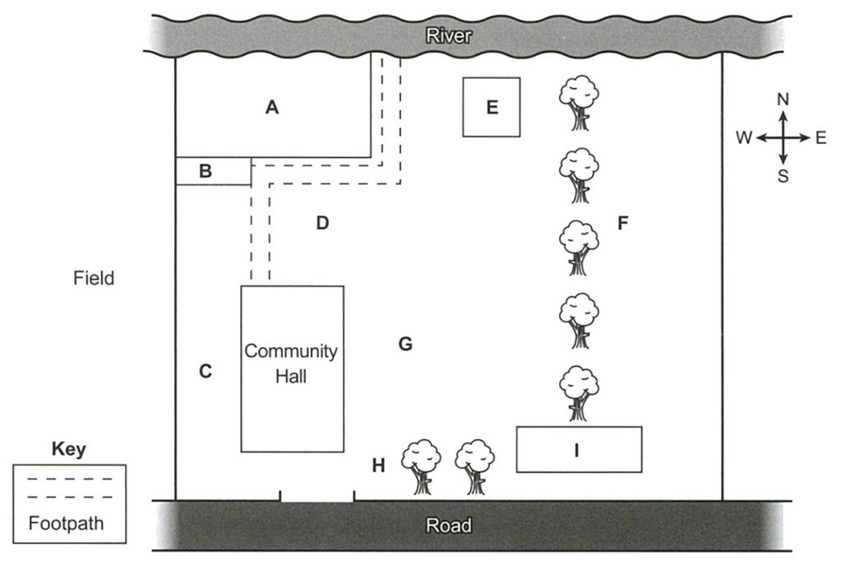

**15**   New car park ……………

**16**   New cricket pitch                    ……………

**17**   Children’s playground             ……………

**18**   Skateboard ramp ……………

**19**   Pavilion ……………

**20**   Notice board ……………

**B. VOCABULARY AND GRAMMAR**

***Choose the answer A, B, C, or D that best completes each of the following sentences.***

**21.**We should remove all the mould and mildew ________ on the school walls.

**A.** were growing **B.** grown **C.** growing **D.** to grow

**22.** ____ to a new office with a salary half as much did he appreciate his former boss’s generosity.

**A.** He had been transferred **B.** Having been transferred

**C.** Until being transferred **D.** Only when transferred

**23**. Unfortunately, our school had to ______ the music department because of lack of funds.

|  |  |  |  |
| --- | --- | --- | --- |
| **A.** Give up | **B**. take back | **C.** get away | **D.** do away with |

**24.** I can’t tell you very much about the subject since I only have a very _____ knowledge of it myself.

A. fundamental B. primary C. elemental D. rudimentary

**25.** _______ the reservoir, the ancient village couldn’t have been discovered.

A. Had the drought not lowered B. If had the drought not lowered

C. The drought had not lowered D. Not had the drought lowered

**26.** The management are making ________ to increase the company’s efficiency.

**A.** measures **B.** steps **C.** deeds **D.** moves

**27.** ______ off the Hawaiian coastline are living, others are dead.

|  |  |
| --- | --- |
| **A**. Coral reefs | **B**. Some types of coral reefs |
| **C**. There are many types of coral reefs | **D**. While some types of coral reefs |

**28. Martin:** “Oh, Jesus, it’s scorching hot today!” - **Sarah:** “________ It’s just unbearable.”

**A.** You can say that again! **B.** I’m of the opposite opinion!

**C.** That is to say. **D.** There’s something to be said for it.

**29.** What I found most _____ about it is that he didn’t even have the decency to say that he was sorry.

A. furious B. touchy C. resentful D. galling

**30.** Harry was offered a scholarship to study in Spain and he _______ the opportunity with both hands.

A. held B. grabbed C. grasped D. passed

**31.** The government has agreed to _______ an additional £5 million to schools in underprivileged regions.

A. dole out B. tip off C. crack down D. toss off

**32.** Don’t waste your time telling Janet a joke. She is totally ______ of a sense of humour.

|  |  |  |  |
| --- | --- | --- | --- |
| A. deficient | B. missing | C. devoid | D. lacking |

**33.** Charlotte ______ the new girl immediately, within hours of meeting each other they were best of friends.

A. took issue with B. took heart from C. took a shine to D. took his hat off to

**34.** The relations between the two countries have become tense since both ______ their claim to the disputed territory.

A. placed B. laid C. assumed D. put

**35.** You’ll be glad to know that Yuki’s work is showing a ___________ improvement.

A. mediocre B. minimal C. prominent D. pronounced

**C. READING COMPREHENSION**

***Part 1:* Choose the correct answer to complete the following passage by writing the corresponding letter A, B, C or D on your answer sheet.**

United Parcel Service (UPS) believes that its employees should give the firm a fair day’s work for a fair day’s pay. The package delivery firm seems willing to give more than a fair day’s pay. But in **(36)**____, UPS expects maximum output from its employees. Since 1920s, the firm’s industrial engineers have been studying every detail of every task **(37)**____ by most UPS employees. From their studies have come time and motion standards that **(38)**____ how those tasks are performed and how long they should take. Drivers, for example, are expected to walk to a customer’s door at a speed of exactly three feet per second. They are told to knock as soon as they get there, rather than waste time **(39)**____ a doorbell. Work engineers are **(40)**____ riding with drivers, timing everything from stops at traffic lights, wait at customers’ doorway, stairway climbs, to coffee break. And they are not **(41)**____ to pointing out the occasional inefficiency. Additionally, supervisors ride with the least good drivers, noting how they work and constantly **(42)**____ them until their work is up to standard. The **(43)**____of all this engineering work is efficiency, and UPS has been called one of the most efficient companies anywhere. It's also a highly profitable company. Most drivers take the regimentation in stride: many show **(44)**____ in meeting the UPS standards each day. Others, however, feel that they are constantly being pushed, and that it is impossible for them to **(45)**____ at work. UPS officials claim that the standards provide accountability. And, they say, employees who work according to UPS standards should feel less tired at the end of the day.

**36. A.** fact **B.** exchange **C.** return **D.** short  
**37. A.** hold **B.** performed **C.** accepted **D.** made  
**38. A.** indicate **B.** govern **C.** demonstrate **D.** tell  
**39. A.** looking at **B.** look at **C.** look for **D.** looking for  
**40. A.** consistently **B.** continually **C.** constructively **D.** chronically  
**41. A.** impolite **B.** brave **C.** intimate **D.** averse  
**42. A.** scolding **B.** criticizing **C.** encouraging **D.** correcting  
**43. A.** task **B.** reason **C.** object **D.** job  
**44. A.** pride **B.** passion **C.** interest **D.** pleasure  
**45. A.** rest **B.** relieve **C.** relax **D.** restrain

***PART 2: Fill in each numbered blank with ONE appropriate word: (10 points)***

Before television, live matches could only be viewed in **(46)** ______. For the majority of fans, who were unable to afford tickets to the top-flight matches, or to travel the long distances required to see them, the only option was to attend a local game **(47)** ______, where the stakes were much lower. As a **(48)** ______, thriving social networks and sporting communities formed around the efforts of teams in the third and fourth divisions and below. With the adventof live TV, however, premier matches suddenly became affordable and accessible to hundreds of millions of new **(49)** ______. This shift in viewing patterns vacuumed out the support base of local clubs, many of **(50)** ______ ultimately folded.

For those on the more prosperous side of this shift in viewing behaviour, **(51)** ______, the financial rewards are substantial. Television assisted in derailing long-held concerns in many sports about **(52)** ______ athletes should remain amateurs or ‘go pro’, and replaced this system with a new paradigm where **(53)** ______ all athletes are free to pursue stardom and to make money from their sporting prowess. For the last few decades, top-level sports men and women have signed lucrative endorsement deals and sponsorship contracts, turning many **(54)** ______ multi-millionaires and also allowing them to focus full-time on what really drives them. **(55)** ______ they can do all this without harming their prospects at the Olympic Games and other major competitions is a significant benefit for these athletes.

**Part 3. Read the following extract and choose the option (A, B, C or D) which best answers each of the following questions**

The human **criterion** for perfect vision is 20/20 for reading the standard lines on a Snellen eye chart **without a hitch**. The score is determined by how well you read lines of letters of different sizes from 20 feet away. But being able to read the bottom line on the eye chart does not approximate perfection as far as other species are concerned. Most birds would consider us very visually handicapped. The hawk, for instance, has such sharp eyes that it can spot a dime on the sidewalk while perched on top of the Empire State Building. It can make fine visual distinctions because it is **blessed with** one million cones per square millimeter in its retina. And in water, humans are farsighted, while the kingfisher, swooping down to spear fish, can see well in both the air and water because it is endowed with two foveae – areas of the eye consisting mostly of cones - **that** provide visual distinctions. One foveae permits the bird, while in the air, to scan the water below with one eye at a time. This is called monocular vision. Once it hits the water, the other fovea joins in, allowing the kingfisher to focus both eyes, like binoculars, on its prey at the same time. A frog’s vision is distinguished by its ability to perceive things as a constant motion picture. Known as “bug detectors”, a highly developed set of cells in a frog’s eyes responds mainly to moving objects. So, it is said that a frog sitting in a field of dead bugs wouldn’t see them as food and would starve.

The bee has a “compound” eye, which is used for navigation. It has 15,000 facets that divide what it sees into a pattern of dots, or mosaic. With this kind of vision, the bee sees the sun only as a single dot, a constant point of reference. Thus, the eye is a superb navigational instrument that constantly measures the angle of its line of flight in relation to the sun. A bee’s eye also gauges flight speed. And if that is not enough to leave our 20/20 “perfect vision” **paling into insignificance**, the bee is capable of seeing something we can’t – ultraviolet light. Thus, what humans consider to be “perfect vision” is in fact rather limited when we look at other species. However, there is still much to be said for the human eye. Of all the mammals, only humans and some primates can enjoy the pleasures of color vision.

**56.** What does the passage mainly discuss?

**A.** limits of the human eye **B.** perfect vision

**C.** different eyes for different uses **D.** eye variation among different species

**57.** The word “**criterion**” in paragraph 1 is closest in meaning to ______.

**A.** standard **B.** need **C.** expectation **D.** rule

**58.** The phrase “**without a hitch**” in paragraph 1 is closest in meaning to ______.

**A.** unaided **B.** without glasses **C.** with little hesitation **D.** easily

**59.** According to the passage, why might birds and animals consider humans very visually handicapped?

**A.** humans can’t see very well in either air or water **B.** human eyes are not as well suited to our needs

**C.** the main outstanding feature of human eyes is color vision**D.** human eyes can’t do what their eyes can do

**60.** The word “**that**” in paragraph 1 refers to ______.

**A.** foveae **B.** areas of the eye **C.** ones **D.** visual distinctions

**61.** The phrase “**blessed with**” in paragraph 1 is closest in meaning to ______.

**A.** parted with **B.** supplied for **C.** endowed with **D.** ruled out

**62.** According to the passage, which of the following is NOT true ______.

**A.** kingfishers have monocular vision

**B.** The facets in a bee’s “compound” eye enable it to see patterns of dots or mosaic.

**C.** hawks eyes consist mostly of cones that can allow it to scan with one eye at a time

**D.** humans are farsighted in water

**63.** Where in the passage does the author discuss that eyes are useful for avoiding starvation?

**A.** lines 1-5 **B.** lines 7-10 **C.** lines 12-15 **D.** lines 21-24

**64.** The phrase “**paling into insignificance**” in paragraph 2 is closest in meaning to ______.

**A.** fading away **B.** of great importance

**C.** without colored light **D.** being reduced to little importance

**65.** Which of the following can be inferred from the passage?

**A.** eyes have developed differently in each species **B.** humans should not envy what they don’t need

**C.** bees have the most complex eye **D.** perfect vision is perfect

**D. WRITING**

**PART 1. Rewrite each of the following sentences in such a way that it has a similar meaning to the original ones.**

**66.** Sam was really anxious, waiting to see if he had got a place in the cricket team.

*->*Sam was on tenterhooks_________________________________________________________.

**68.** Please don’t make me annoyed by such silly questions

🡪I’d rather you ___________________________________________________________.

**68.** It was an impressive building but it wasn’t to my taste.

🡪 Impressive ________________________________________________________________.

**69.** She is now leading a normal life as a result of all the support she received from social workers.

→ Had it ____________________________________________________________________.

**70.** Tony had rescued the kids from the fire. People admired him for that.

→ People admired _____________________________________________________________.

**PART 2. Rewrite the following sentences using the words in parentheses. Do not alter the words given.**

**71.** Immediately after winning the race, Sandy began training for the next one. (**had**)

→No sooner __________________________________ for the next one.

**72.** We were all surprised when she announced that she was engaged to be married. (**announcement)**

->The __________________________________________all by surprise.

**73**. People think that bilingual children were disadvantaged in the past. (**thought)**  
→ Bilingual children______________________________ in the past.

**74.** Jane may have been rich and famous, but she didn’t think she was better than others. (**down**)

→ Jane didn’t ________________________________even though she was rich and famous.

**75.** Whatever happens, I will never trust him again. **(ever)**

→ Under ____________________________________ trust him again.

**The end**