Họ tên thí sinh: .................................................................
Số báo danh: ......................................................................
Mã Đề: 021.
Câu 1. What is the main reason James cannot attend the concert?
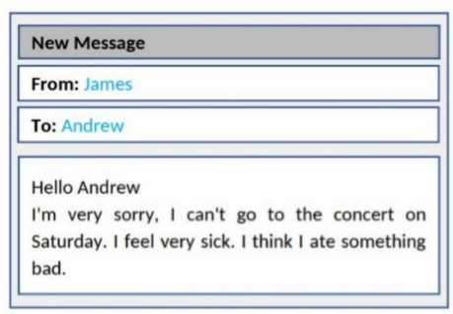
A. He is feeling unwell B. He has another commitment
C. He doesn't like the music D. He lost his ticket
Câu 2. "What does the person sending the message want to do?"
Hi there! I hope you're doing well. I wanted to see if you're interested in going to a show this weekend. There's a new play that just opened at the local theatre, and I've heard great things about it. Let me know if you're free and we can get tickets together.
A. Watch a movie B. Visit a museum C. Go to a show D. Attend a concert
Câu 3. Which of the following is NOT mentioned about the apartment?

A. It has a balcony B. It has a double bedroom
C. It has been recently painted D. It has a new kitchen
Câu 4. Which day is the City Zoo closed?
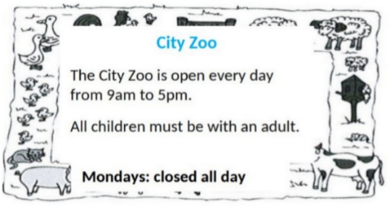
A. Monday B. Friday C. Saturday D. Sunday
Câu 5. Which of the following statements is true?

A. The IT course does not provide a certificate.
B. The IT course is for advanced learners.
C. The IT course starts on 1st October.
D. The IT course covers hardware, software, networking, and security.
Câu 6. Look at the signs. Choose the best answer for the question.
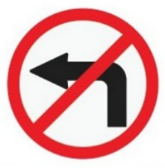
A. Only vehicles which turn left have to stop. B. You have to stop and turn left.
C. You mustn’t turn left. D. You don’t have to turn left at this point.
Câu 7. Look at the signs. Choose the best answer for question.
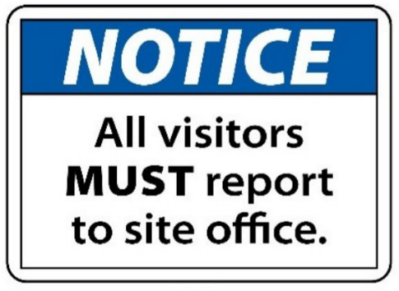
A. Anyone who visits must go to the site office and check in.
B. All visitors can enter the place through the site office.
C. Guests are reported to visit the site office.
D. The site office is for everyone to make a report.
Câu 8. What does this sign mean?
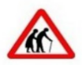
A. Be cautious as elderly people may be crossing the road.
B. There are two old people here.
C. Be careless as elderly people may be crossing the road.
D. They are wearing traditional clothing.
Câu 9. How much ice cream do you need to buy to get the discount?

A. 2kg or more B. 1kg or more C. Exactly 1kg D. 500g or more
Câu 10. What time was the theatre originally scheduled to open?
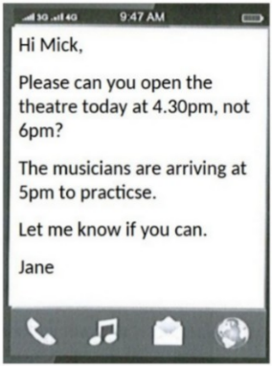
A. 5:00pm B. 5:30pm C. 4:30pm D. 6:00pm
----HẾT---

