|  |  |
| --- | --- |
| **Mã đề 9.1.45** | **ĐỀ KIỂM TRA CUỐI HỌC KÌ I**  **MÔN: TIẾNG ANH 9**  Năm học: 2022- 2023  Thời gian: 45 phút |

**A. LISTENING (2 pts)**

I. Part 1. **Listen to 5 short conversations TWICE and choose correct answers. (1.0 pt)**

*(Nghe 5 đoạn hội thoại ngắn HAI LẦN rồi chọn câu trả lời đúng)*

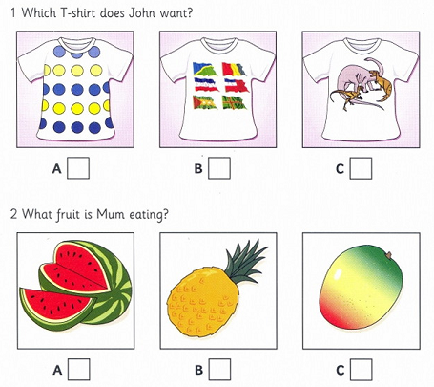

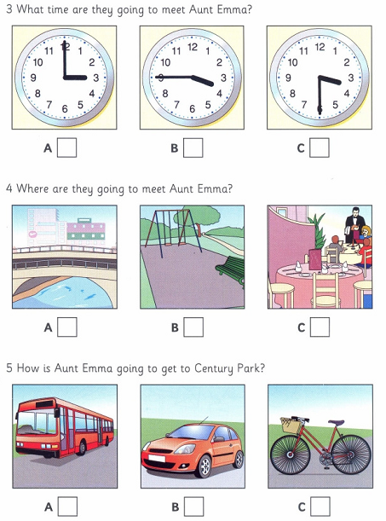

**II. Listen and write.(1pt)**

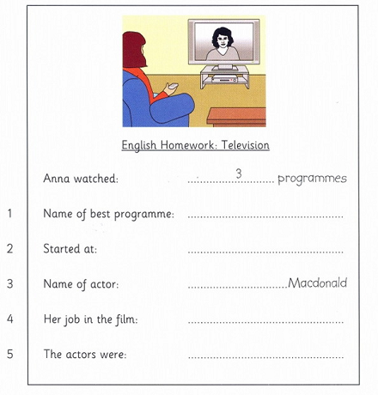

**B. LANGUAGE (2pts)**

**1**. Choose the word which is pronounced differently from the others.

(THÔNG HIỂU)

A. rem*o*te B. cl*o*se C. sch*o*larship D. l*o*cal

**2**. The flower was _.........._ out of a single piece of valuable wood.

(THÔNG HIỂU)

A. carved B. moulded C. cast D. given

**3**. I love going to this place _............___ it’s the quietest place in the city.

(VẬN DỤNG)

A**.** so B**.** though C**.** so that D**.** as

**4**.They keep changing the decoration of the shop ……..__they can attract more young people. (VẬN DỤNG)

A.so thatB.becauseC.althoughD**.** when

**5**._.....................____ she’s young, she’s the most famous artisan in the village.

(THÔNG HIỂU)

A.When B**.** Although C.Whereas D. In order to

**6.**You have to ***read*** the instruction before making models. (VẬN DỤNG)

A. look up B. look through C. look for D. look up

**7**.The city has recently set _..........__ a new library in the West Suburb.

(THÔNG HIỂU)

A. off B. out C. up D. on

**8.** He did very well at the examination this morning so he feels very _........__at the moment. (VẬN DỤNG)

A. sad B. unhappy C. worried D. relaxed

**9.** Find the word which has different sound in the part underlined.

(NHẬN BIẾT)

A. expected B. stopped C. missed D. worked

**10**. In the past many people were _...........___; they couldn’t read and write.

(THÔNG HIỂU)

A. responsible B. enthusiastic C. illiterate D. friendly

**C. READING (2pts)**

**I. Read and fill in the blanks with ONE word given in the box. (1pt)**

Hello! My name is Herman. I live in a big city in Germany and it’s quite exciting! There are lots of things to do. My parents bought a flat near a park where I can ride my bike or (1) skateboarding. My brother is older than me and I also go to the cinema with him. The city library is a great place. I usually meet my friends there and we do our school (2) or study together.

Of course living in a big city is not easy. City life can be fast, tiring and stressful. The streets are always (3) and noisy. Because of the cars is polluted sometimes. People are so busy that they (4) have time for their neighbors or friends. But I can’t see myself moving to the (5) . I just love living in the city too much.

1. A. go B. do C. play D. sail

2. A. workshop B. projects C. playgrounds D. competitions

3. A. bored B. surprised C. crowded D. exhausted

4. A. usually B. always C. often D. rarely

5. A. university B. countryside C. mountain D. building

**II. Read the passage and do the tasks below ( 1pt)**

Practical stress management can help students deal with their worries and become more productive, competent and efficient. First of all, students must be able to design and stick to a timetable. Choose a relaxing break between work and study, even if it’s just taking out time to breathe. In addition, a healthy lifestyle is essential for students. Let’s drink more water as well as take out time to get some air and exercise. Furthermore, organization is very important in academic life for dealing with stress. By keeping academic notes organized, turning in assignments on time, and keeping track of all deadlines, stress can be reduced to a great extent. Stress can also get worse if a person feels lonely. Therefore, by letting out all your thoughts to someone you trust, you immediately feel a lot better. However, if you feel extremely stressed out, take a break and do something you love. Whether it is painting or listening to music, doing something you enjoy can cheer up your mood and distract you from a stressor. It’s about time that we students accept that we can achieve just as much in life without all the stress.

1. Practical stress management can help students .

A.deal with stress B. have more time C. face up to the worst situation

D.think critically

2. What should students pay attention to when designing a timetable?

A.They have to arrange time to breathe. B.They need to set time for relaxation.

C.They don’t need to take notice of certain tasks.

D. They should stop working and studying

3. What can students do to lead a healthy lifestyle?

A.Visit their doctor as scheduled.

B.Not to put much pressure on time management.

C. Go outside for fresh air, do regular exercises and drink more water.

D. Follow the timetable strictly

4. Why is organization important in academic life?

A.Because it can help students get good grades.

B.Because it is a must for all students.

C. Because it leads to better results.

D.Because it can help students reduce stress.

5. Which of the following sentences is true?

A.You should stay alone when being under pressure.

B.The more lonely you are, the more stress you can have.

C. When you feel lonely, you should grab someone to talk.

D..It is believed that stress can control itself.

**D. WRITING (2pts)**

**I. Complete the second sentence so that it has similar meaning to the first sentence. (1 pt)**

1. They often rode the buffalo when they were in the countryside. (VẬN DỤNG)

They used

2. Why don’t we call the magic number for help? (VẬN DỤNG)

I suggest

3. It rains heavily. (VẬN DỤNG)

I wish

4. “What should I do first?” said Linh(VẬN DỤNG)

Linh wondered

5. People expect that the report will suggest some major reforms. (VẬN DỤNG)

It is

**II. Nowadays, many people like living in the city, but life in the city has a lot of drawbacks such as pollution, traffic jams, overcrowding, noise, crime … In about 80 – 100 words, write a paragraph about drawbacks of city life (1.0p)** (VẬN DỤNG CAO)

**HƯỚNG DẪN VÀ BIỂU ĐIỂM CHẤM ĐỀ KIỂM TRA CUỐI KÌ I**

**MÔN TIẾNG ANH 9**

**A. Listening**

**I. Listen and tick the box. (1.0pt)** I. *(0.25 x 4 = 1.0 pt)*

1. B 2. A 3. B 4. C 5. C

**II. Listen and write.(1.0pt)** I. *(0.25 x 4 = 1.0 pt)*

1. Chopsticks 2. 6/six (o’clock)/ (pm)/ 6.00 // 18.00

3. Margie 4. (a) cook // she is / ’s a cook

5. (all) excellent

**B. Language** *(0.2 x 10 = 2.0 pt)*

1 – C 2 – A 3 – D 4 – A 5 – B

6 – B 7 – C 8 – D 9 – A 10 - C

**C. Reading**

**I.** *(0.2 x 5 = 1.0 pt)*

|  |  |  |  |  |
| --- | --- | --- | --- | --- |
| 1. A | 2 . B | 3. C | 4.D | 5.B |

**II.** *(0.2 x 5 = 1.0 pt)*

1. A 2. B 3. C 4. D 5. B

**D. Writing**

**I. Complete the second sentence so that it has similar meaning to the first sentence.**

1. They used to ride the buffalo when they were in the countryside.

2. I suggest doing morning exercise regularly.

OR: I suggest (that) we should do morning exercise regularly.

3. I wish it didn’t rain (so) heavily.

4. Linh wondered what to do first/ what she should do first.

5. It is expected that the report will suggest some major reforms.

**II. Write a paragraph (100 -120 words ) about a wonder of Viet Nam you know.**

- correct form: 0.2 pt

- reasonable ideas: 0.4 pt

- accurate grammar: 0.3 pt

- appropriate vocabulary: 0.3 pt

- good linking of sentences: 0.3 pt