Phòng GD&ĐT TP Hà Tiên  Trường Tiểu học Thuận Yên  Lớp:..................................................................  Họ và tên:……………………………………. |  | Bài kiểm tra cuối học kỳ II  Năm học: 2021 – 2022  Môn: Tiếng Anh  Khối: 5 - Thời gian: 40 phút  Ngày kiểm tra:……………………
Điểm | Nhận xét của giáo viên | Chữ ký giám thị:……………………  Chữ ký giám khảo: ………….……..

SPEAKING: .......
LISTENING
Part1: Listen and circle:
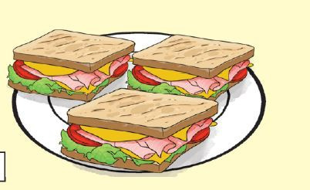
1. a/ 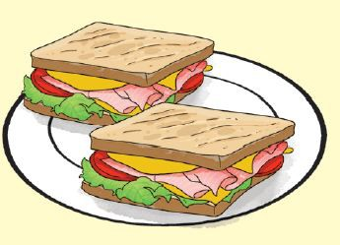 b/ 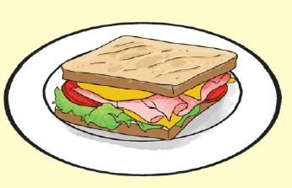 c/

2. a/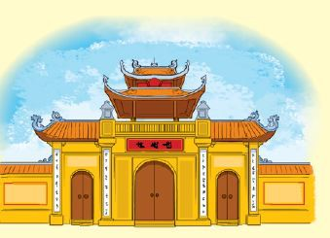 b/  c/


3. a/  b/ 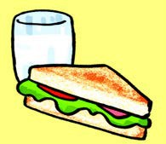 c/
4. a/ 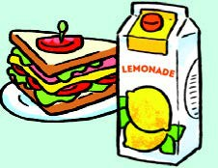 b/ 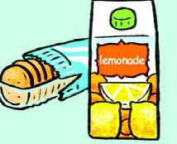 c/
Part 2: Listen and circle a, b, c:
1. Trung would like to be…………….?
a. an artist b. an engineer c. an architect
2. Mai would like to be …………….?
a. a singer b. a nurse c. a teacher
3. Tom thinks Phu Quoc is more ……… than he expected?
a. attactive b. beautiful c. exciting
4. Phong thinks Dam Sen Park is more ………….. than he expected.
a. interesting b. exciting c. beautiful
READING
Part 1: Read and complete:
Watch weather forecast cold go
Mai: Let’s (1)…… for a picnic tomorrow.
Phong: What will the (2)….. be like tomorrow?
Nam: Well, it will be (3)….. and stormy.
Mai: How do you know that?
Nam: I watched the weather (4) …… on TV.
Phong: We can’t go for a picnic if it’s stormy.
Mai: Ok, let’s stay home, eat popcorn and (5)………..cartoons.
Nam and Phong: Great idea!
1_ go , 2_................. , 3 _.................. , 4 _....................., 5_....................
Part 2: Read and tick: () Đọc và đánh dấu :()(True or False)( Đúng hoặc sai)
My name’s Tom. Yesterday, I visited Tran Quoc pagoda. It is on an island in the middle of West Lake and not far from the centre of Ha Noi. I went there by bike. Tran Quoc Pagoda is very quiet. It is more beautiful than I expected. There are a lot of statues and trees in the yard. I met some friends there. My friends and I learn more about the history of Ha Noi after the visit.
Sentences: | True ( T ) | False ( F )
0) My name is Tom
1) Tran Quoc Pagoda is on an island in the middle of West Lake
2) He went there by motobike
3) Tran Quoc Pagoda is very noisy
4) It is more beautiful than I expected
WRITING
Part 1: Write (viết)- Answer the questions (Trả lời các câu hỏi)
Example: what do you do in your free time? I often watch TV
- What would you like to be in the future?
_____________________________________________________
- What would you like to drink?
_____________________________________________________
- What’s spring like in your country?
_____________________________________________________
- What do you think of Ha Tien?
_____________________________________________________

Part 2: Arrange the following words to make meaningful sentences:
Example: Where/ you/ going?/ are/
Where are you going?
- teacher?/ Why / like / you /be/ to/a/would/
................................................................................................................................
- would/ Which / Phu Quoc Island? / place/ Da Lat/ or/you/like/ visit/ to/
................................................................................................................................
- much/water/ How/ drink/you/ do/day?/ every/
................................................................................................................................
- supermaket? / can / I / to / the/ get / How/
................................................................................................................................
The end

