Date of planning:………….  Date of teaching: ………..…  WEEK: | Peroid .....: UNIT 3: COMMUNITY SERVICE  Lesson 2 : A CLOSER LOOK -2
I. OBJECTIVE: By the end of this lesson, students will be able to gain the following things :
1. Knowledge:
- Understand the use of the past simple tense.
- Practice using the past simple to talk about past activities.
+ Vocabulary: Use the lexical items related to community activities.
- Pronouncing the sounds /t/, /d/, and /id/ .
+ Grammar: - Past simple tense.
2. Competence: Students will be able to practice listening for specific information about some community activities and their benefits; Practicing writing an email about community activities one did last summer.
- Develop communication skills and creativity.
- Be co-operative and supportive in pair work and teamwork.
- Actively join in class activities
3. Qualities : - Raise students’ awareness of the need to keep their neighbourhood green.
- Have the good attitude to working in groups, individual work, pair work, cooperative learning.
- Develop self-study skills.
II. TEACHING AIDS:
- Teacher: Grade 7 text book, laptop, projector / TV/ pictures and cards.....
- Students : Text books, studying equipment….
- Computer connected to the Internet.
- Sach mem.vn
III. PROCEDURE:
Notes: In each activity, each step will be represented as following:
* Deliver the task.
* Implement the task.
* Discuss.
* Give comments or feedback.

1. WARM UP & INTRODUCTION (5’)
Aims:
- To create an active atmosphere in the class before the lesson;
- To lead into the new lesson.
* Content: Review the previous lesson or have some warm-up activities to create a friendly and relaxed atmosphere to inspire Ss to warm up to the new lesson.
* Outcome: Having a chance to speak English and focus on the topic of the lesson..
* Organisation :Teacher’s instructions…

Teacher’s & Student’s activities | Content
+ Greeting  + CHATTING  * Teacher asks students some questions:  What did you do last weekend?  What did you watch yesterday?  Who did you meet two days ago?  - Students answer the questions, using the past simple.  - Teacher and students discuss the answers.  - Teacher corrects students answers if needed and confirms the use of the past simple (to talk about completed actions in the past).  - Teacher asks students to study the Grammar box.  - Teacher draws students’ attention to the meaning and use of the past simple.  - Teacher then asks some more able students to give some more examples.  * We use the past simple to talk about completed actions in the past.  - We often use specific time expressions, such as yesterday, last month, 3 weeks ago, or in 1999 with the past simple  - Teacher and students discuss the answers.  - Teacher confirms the answers and gives feedback.  - Ask Ss to open their book and introduce what they are going to study…. | + Greeting  + CHATTING  - T_Ss  - Students answer the questions, using the past simple.  - Teacher and students discuss the answers.  ................  - Students (Ss) listen and learn how to do.  - Open their book and write .
2. PRESENTATION/ NEW LESSON (12’)
ACTIVITY 1:
Aim: To review Ss' knowledge of the past simple tense.
* Content: Form and use the use of the past simple tense.
* Outcome: Ss can learn how to form and use the past simple tense.
* Organisation : Teacher’s instructions…
Grammar: The past simple
Positive | S + V-ed (played)
Negative | S + did not / didn’t V (did not / didn’t play)
Questions and short answers | Did + S + V (play)?  - Yes, S + did.  - No, S + didn’t.
- Focus Ss’ attention on the Remember! box.
- Explain the uses of the past simple.
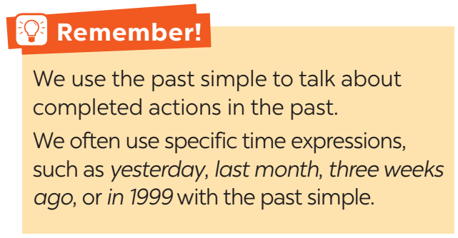

Teacher’s & Student’s activities | Content
1. Circle the correct answer A, B, or C to complete each sentence.  * Remember!/ Page 31.  - Ask Ss to work individually to circle the correct answers.  - Ask Ss to take turns to give their answers.  - Check the answers as a class.  - Ask several Ss to read aloud full sentences with the correct answers. Correct their pronunciation if necessary.  - Teacher lets students work in pairs and exchange the answers before checking with the whole class (explain each sentence if necessary).  - Teacher confirms the answers and gives feedback. | 1. Circle the correct answer A, B, or C to complete each sentence.  - T_ Ss  + Students (Ss) listen to the instructions carefully and learn how to do the tasks.  - Answer the teacher’s questions.  * Key:  1. B 2. A 3. B 4. A 5. C
3. PRACTICE (18’)
ACTIVITY 2:
Aim: To raise Ss' awareness of the past simple tense and the past form of some verbs.
* Content: Complete the sentences by circling the correct answer A, B or C.
* Outcome: Ss understand more using Past simple tense. Complete the sentences correctly.
* Organisation : Teacher’s instructions…

Teacher’s Student’s activities | Content
2. Complete the sentences with the past simple form of the given verbs.  - Have Ss work individually to complete the sentences with the past simple form of the given verbs.  - Ask some Ss to read out their sentences. Correct grammar and pronunciation mistakes if necessary.  - Check the answers as a class | 2. Complete the sentences with the past simple form of the given verbs.  - T_ Ss  - Listen carefully and learn how to do.  - Ss work individually  - Give the answers  * Key:  1. took 2. joined 3. helped 4. sent  5. volunteered
ACTIVITY 3:
Aim: To help Ss distinguish between the present simple, present continuous and past simple in specific context.
* Content: Complete the sentences with the correct form of verbs.
* Outcome: Ss can complete the sentences with the correct form of verbs correctly.
* Organisation :
3. Complete the sentences with the correct forms of the verbs from the box.  - Ask the whole class to read aloud the verbs in the box. Then have Ss work individually to complete the sentences with the correct forms of the verbs from the box.  - Ask some Ss to read out the complete sentences. Correct grammar and pronunciation mistakes if necessary.  - Check the answers as a class.  - Comment on their performance. | 3. Complete the sentences with the correct forms of the verbs from the box.  - Ss to work individually  - Ss do themselves. - Copy them  * Key:  1. cook 2. planted 3. are picking up  4. recycled 5. read
ACTIVITY 4:
Aim: To help Ss write full sentences using the correct form of the verbs.
* Content: Write complete sentences from the prompts.
* Outcome: Ss can write complete sentences from the prompts correctly.
* Organisation :
Teacher’s Student’s activities | Content
4. Write complete sentences from the prompts.  - Have Ss work individually to write complete sentences from the prompts. Then ask them to work in pairs to swap their answers.  - Check the answers as a class.  - Have the class read out the sentences. Correct grammar and pronunciation mistakes if necessary.  - Invite one or two Ss to say out their answers in front of the class.  - Check the answers as a class. | 4.Write complete sentences from the prompts.  - T_ Ss  - Do the tasks and share the answers.  Key:  1. Last year, our club donated books to children in rural areas.  2. Children sent thank-you cards to us a week ago.  3. I taught two children in grade 2 last summer.  4. Last spring, we helped the elderly in a nursing home.  5. We helped people in flooded areas last year.
4. FURTHER PRACTICE ( 8’)
ACTIVITY 5:
Aim: To enable Ss to ask and answer questions related to past activities;
* Content: Ask and answer about Tom’s project in 2016 and 2018.
* Outcome: Further practice using past simple tense. Answer the questions.
* Organisation :

5. Work in pairs. Tom is from the Red Cross. Look at the fact sheet and ask Tom about his projects in 2016 and 2018.  - To help Ss be aware of some community activities that Ss in other countries do.  - Introduce the Red Cross projects and activities in 2016 and 2018.  - Have Ss work in pairs to practise asking and answering questions based on the fact sheet.  - Tell Ss to follow the example. Remind them to use the past simple when they ask and answer questions about the past activities.  - Invite some pairs to make short conversations as an example.  - Correct any grammar and pronunciation mistakes if necessary. | 5. Work in pairs. Tom is from the Red Cross. Look at the fact sheet and ask Tom about his projects in 2016 and 2018.  - T_ Ss  * Tom’s project:  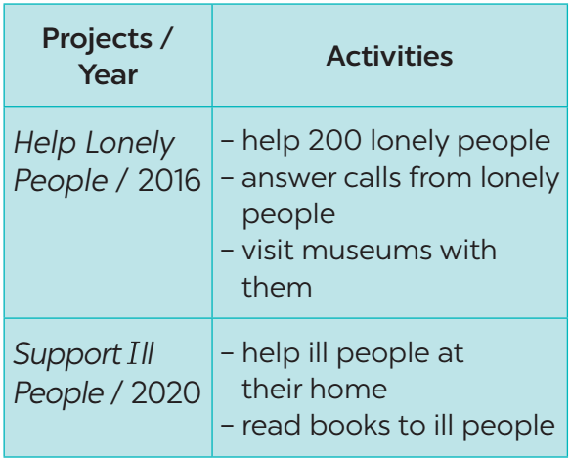  Example:  Tom: I’m from the Red Cross. I worked on the Help Lonely People project in 2016.  Lan: What did you do?  Tom: We helped 200 lonely people…
5. WRAP-UP & HOME WORK (2’)
- Ask Ss to summarise what they have learnt in the lesson.
- Reactivate the knowledge that students have gained
- Have them say out loud the past forms of the verbs they learnt in the lesson.
Extention: Alphabet game
- Put Ss in groups of three or four.
- Ss take turns to use the past simple in a sentence. The first letter of the verbs must follow the sequence of the alphabet. If Ss can't think of one, they are out of the game. The next student continues with the next letter.
For example:
A: He asked me my name.
B: I bought a hat.
C: I came here last month.
*HOME WORK
- Remember the form and use the past simple tense.
- Do more exercises in workbook.
- Prepare new lesson: COMMUNICATION.
Phương Hằng – Vũ Hùng: zalo: 034.989.5579
=======================

