Week 20 Preparing date: January ……. 2023
Period 77 Teaching date: January ……, 2023

Unit 11: My family
Lesson 3 (1, 2, 3)
A. OBJECTIVES:
By the end of the lesson, Ss will be able to:
1. Knowledge:
- correctly repeat the sounds of the letters o and ure in isolation, the words old and sure, and the sentences How old is your brother? and Are you sure? with the correct pronunciation and intonation.
- identify the target words old and sure while listening.
- say the chant with the correct rhythm and pronunciation.
- Vocabulary: Review
- Skills: speaking, listening, reading and writing.
2. Competences:
- Co-operation: ready to help friends in pair work/ group work.
- Self-control and independent learning: perform listening tasks.
3. Attitude/ Qualities:
- Kindness: Help partners to complete learning tasks.
- Honesty: tell the truth about feelings and emotions
B. TEACHING AIDS:
- Teacher: Teacher’s guide Pages 147, 148; audio Tracks 9, 10, 11; website sachmem.vn, posters, laptop, pictures, textbook, lesson plan, TV or projector.
- Students: Pupil’s book Page 10, notebooks, workbooks, school things.
C. PROCEDURES:
Teacher’s activities | Students’ activities
1.Warm- up: (5’)  Game: What is missing?  *Aims: to create a friendly and active atmosphere in the class to beginning the lesson.  *Procedure:  - Divide the class into teams.  - Place some flashcards on the board (father, mother, brother, sister, thirteen, fifteen…).  - Have Ss from the teams close their eyes.  + Remove one of the pictures.  + Ss have to remember and say the missing pictures.  +Give the first team to guess correctly one point.  +The team that gets the most points wins.  - Say “Open your book page 10” and look at “Unit 11, Lesson 3 (1,2,3)”.  2. Presentation (9’)  Activity 1. Listen and repeat:  *Aims: Ss will be able to correctly pronounce the sounds of the letters o and ure in isolation, in the words old and sure, and in the sentences How old is your brother? and Are you sure? with correct pronunciation and intonation.  *Procedure:  - T gives instruction to the letter o and ure in isolation, in the words old and sure, and in the sentences How old is your brother? and Are you sure?  - Play the recording for the letter o, ure.  - Encourage Ss to point at the letter/ word/ sentence while listening.  - Play the recording again and encourage Ss to listen and repeat.  - Do this several times until Ss feel confident.  - T calls some Ss to practice.  - T gives feedbacks.  3.Practice: (19’)  Activity 2. Listen and circle.  *Aims: Ss will be able to identify the target words old and sure while listening.  *Procedure:  - Elicit the sentences and explain that they have to listen.  - T ask Ss to guess the answers.  + T writes Ss’guessing on the board.  - Listen to the tape:  + Play the recording  + Play the recording again and get Ss to swap books with their partners.  + Play the recording again to check answers together as a class.  + Write the answers on the board for Ss to correct their answers. Then checks Ss’ guessing.  - Play the recording, sentence by sentence, for the class to listen and repeat in chorus.  - Invite one or two Ss to stand up and read the completed sentences.  Key: 1.a 2.a  Activity 3. Let’s chant  *Aims: Ss will be able to say the chant with the correct rhythm and pronunciation.  *Procedure:  - Introduce the title and lyrics of the chant.  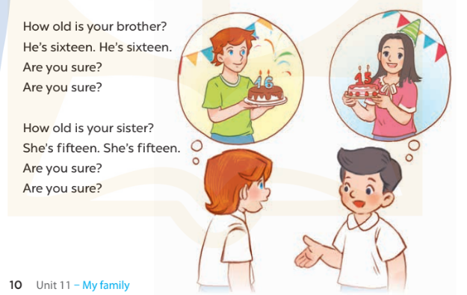  - Play the recording for Ss to listen to the whole chant.  + Have them repeat the title and lyrics line by line.  + Ask Ss to attend to the sounds of the letters o and ure and the words old and sure.  - Play the recording all the way through for Ss to listen to pronunciation and melody.  - Play the recording line by line for Ss to listen and repeat  - Play the recording for Ss to chant and clap along.  - Ask Ss to practice chant and clap along in pairs or groups.  - Invite groups to the front of the classroom to perform the chant  -T gives feedback.  *Consolidation  *Aims: Ss will be able consolidate and wrap up the content of the lesson.  *Procedure:  - T asks ss to answer the following questions:  + What have you learnt from the lesson today?  +What are the core values of the lesson? (if the teacher can take from the lesson).  - T praises some Ss who are hardworking / active/ good…. as well as encourage others to try more.  4. Homework. (2’)  - Practice the chant more.  -Prepare a picture of their family  - Prepare the new lesson: Unit 11, Lesson 3 (4,5,6). | - Ss listen  -Ss play game  - Ss open their books  - Ss recognize the differences about color of letter  - - Ss listen  - Ss listen and point  - Ss listen again and repeat  -Ss listen again and repeat  -Ss practice  -Ss listen  -Ss listen and say:  + Number 1: I’m ten years old.  + Number 2: Are you sure?  -Ss guess the answers  - Ss listen to the tape and circle  - Ss listen again, circle and swap books with their partners.  - Ss check their answers and guessing  -Ss listen and repeat.  -Ss read the sentences  - Ss look and listen.  -Ss listen to the chant  - Ss listen and repeat line by line without clap their hands  -Ss note the sounds, words  -Ss listen to melody of the chant  - Ss listen and chant line by line.  - Ss chant and clap along.  - Ss work in groups (two groups) to chant  -Ss perform in front of the class.  -Ss listen  -Ss listen.  -Ss answer the questions  -Ss listen and clap their hands  -Ss listen and take note

D. ADJUSTMENTS (if necessary):
………………………………………………………………………………………….…..……………………………………………………………………………...………………………………………….…..……………………………………………………………………………….……………………………………………………………………...

Week 20 Preparing date: January ……. 2023
Period 78 Teaching date: January ……, 2023

Unit 11: My family
Lesson 3 (4, 5, 6)
A. OBJECTIVES:
By the end of the lesson, Ss will be able to:
1. Knowledge:
- read and complete a paragraph with the words in the box.
- read, understand and complete a gapped text.
- collect a picture of their family and show it to the class by telling the class about their family members.
- Vocabulary: Review
- Skills: speaking, listening, reading and writing.
2. Competences:
- Critical Thinking: talk about someone
- Co-operation: ready to help friends in pair work/ group work.
- Self-control and independent learning: perform reading tasks.
3. Attitude/ Qualities:
- Kindness: Help partners to complete learning tasks.
- Honesty: tell the truth about feelings and emotions.
- Diligence: complete learning tasks.
B. TEACHING AIDS:
- Teacher: Teacher’s guide Pages 148, 149, website sachmem.vn, posters, laptop, pictures, textbook, lesson plan, TV or projector.
- Students: Pupil’s book Page 11, notebooks, workbooks, school things.
C. PROCEDURES:
Teacher’s activities | Students’ activities
1.Warm- up: (5’)  Game: Matching  *Aims: to review the vocabulary and structure about greet and respond to greetings.  *Procedure:  -T divides class into 2 teams  - Ss in 2 teams take turn to open the boxes to match the questions and answers to their pictures (open: click the numbers -close: click the red signs).  - Ss of each team will get points if their matching is correct.  - Review: father, brother, fifteen, siister, eighteen…  - Say “Open your book page 11” and look at “Unit 11, Lesson 3 (4, 5, 6)”.  2.Practice: (8’)  Activity 1. Read and complete:  *Aims: Ss will be able to read and complete a paragraph with the words in the box.  *Procedure:  - Tell Ss about the activity  - Ask Ss attend to the blank in sentence 1 and find the missing word from the box.  - Write the missing word on the board and get the class to read the completeed sentence together.  - Have Ss work in pairs and complete  - Tell Ss to swap books with a partner, then check answers together as a class.  - Write the correct answers on the board for pupils to correct their answers.  - Invite Ss to read the complete text aloud  -T gives feedbacks.  Key: 1. my 2.sister 3.old 4.I’m  3.Production: (19’)  Activity 2. Let’s write  *Aims: Ss will be able to read, understand and complete a gapped text.  *Procedure:  - Explain to the class the goal of this activity.  - Ask Ss to read each gapped sentence, guess the missing information and complete the sentence with their own personal information.  - Give Ss time to write their answers  - Ask Ss to swap and correct their answers in pairs.  - Check the answers as a class.  Key: Pupils’ answer.  Activity 3. Project.  *Aims: Ss will be able to collect a picture of their family and show it to the class by telling the class about their family members.  *Procedure:  - Explain the goal of this activity to Ss.  - Point at the picture and explain what they should do to complete the project.  - Tell Ss to work in groups.  - Give the class time to introduce about the family members.  +Example: This is my family. This is my father. This is my mother. This is my sister, she is four years old. And this is me, I’m eight years old.  - Invite some Ss to show their pictures to the class and tell the class.  *Consolidation  *Aims: Ss will be able consolidate and wrap up the content of the lesson.  *Procedure:  - T asks ss to answer the following questions:  + What have you learnt from the lesson today?  +What are the core values of the lesson?  - T praises some Ss who are hardworking / active/ good…. as well as encourage others to try more.  4. Homework. (3’)  - Prepare the new lesson: Unit 12: Lesson 1 (1,2,3). | - Ss listen  -Ss play game  - Ss open their books  -Ss listen  - Ss read and answer  -Ss read and complete  -Ss work in pairs  -Ss swap books and check  -Ss check the correct their answers  -Ss read  -Ss listen  -Ss listen  -Ss read and answer  -Ss write  My name is………………..….  I’m………………....years old. My brother/ sister is………..  He/ She is……..…..years old  -Ss swap books and check their answers  -Ss check  -Ss listen  -Ss listen  -Ss work in groups  -Ss show the picture and say.  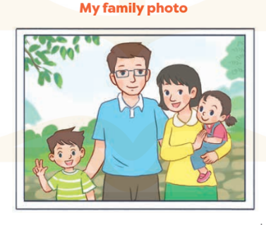  -Ss perform in front of the class.  -Ss answer the questions  -Ss listen and clap their hands  -Ss listen and take note
D. ADJUSTMENTS (if necessary):
………………………………………………………………………………………….…..……………………………………………………………………………...…………

Week 20 Preparing date: January 20th, 2023
Period 79 Teaching date: January 23rd, 2023

Unit 12: Jobs
Lesson 1 (1, 2, 3)
A. OBJECTIVES:
By the end of the lesson, Ss will be able to:
1. Knowledge:
- understand and correctly repeat the sentences in two communicative contexts (pictures) to ask and answer questions about the job of a family member.
- correctly say the words and use What’s his / her job? – He’s / She’s ………..to ask and answer questions about someone’s job.
- enhance the correct use of What’s his / her job? – He’s / She’s ………. to ask and answer questions about someone’s job in a freer context.
- Vocabulary: doctor, driver, teacher, worker, job
- Model sentences:
A: What’s his / her job?
B: He’s / She’s ……….
- Skills: speaking and listening
2. Competences:
- Critical Thinking: talk about jobs
- Co-operation: ready to help friends in pair work/ group work.
Oral Communication: speak about jobs, ask and answer the questions.
3. Attitude/ Qualities:
- Kindness: Help partners to complete learning tasks.
- Honesty: tell the truth about feelings and emotions
B. TEACHING AIDS:
- Teacher: Teacher’s guide Pages 150, 151, audio Tracks 12, 13, website sachmem.vn, posters, laptop, pictures, textbook, lesson plan, TV or projector.
- Students: Pupil’s book Page 12, notebooks, workbooks, school things.
C. PROCEDURES:
Teacher’s activities | Students’ activities
1.Warm- up: (3’)  Game: jigsaw puzzle  *Aims: to create a friendly and active atmosphere in the class to beginning the lesson.  *Procedure:  - Divide class into 4 groups: Doreamon, Nobita, Xuka and Xeko.  - Ask Ss look at the pieces of picture.  - Ask Ss go to the board and jigsaw puzzle into the correct picture    -T checks who’s the winner?  - Ask Ss look at the pieces of picture  - Say “Open your book page 12” and look at “Unit 12, Lesson 1 (1,2,3)”.  2. Presentation (16’)  Activity 1. Vocabulary.  *Aims: Ss will be able to know the vocabulary in front of starting the new lesson.  *Procedure:  -T elicits the new words  + doctor : bác sĩ (situation)  + driver : tài xế (picture)  + teacher : giáo viên (situation)  + worker : công nhân (picture)  + job : nghề nghiệp(translation)  - T models (3 times).  - T writes the words on the board.  - Checking: Rub out and remember  Activity 2. 1. Listen, point and repeat:  *Aims: Ss will be able to understand and correctly repeat the sentences in two communicative contexts (pictures) to ask and answer questions about the job of a family member.  *Procedure:  - Have Ss look at Pictures a and b and identify the characters in the pictures.  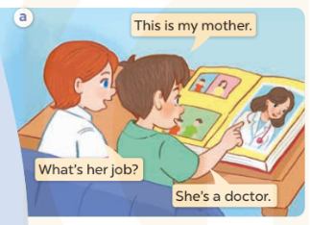  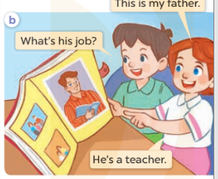  - Play the audio twice (sentence by sentence). Correct their pronunciation where necessary.  - Have Ss to practice the dialogue  - T invites a few pairs to the front of the class to practice.  - T checks pronunciation for ss.  Activity 3 Listen, point and say.  *Aims: Ss will be able to correctly say the words and use What's his / her job? – He’s / She’s …….. to ask and answer questions about someone’s job.  *Procedure:  * Model sentences:  - T asks Ss look at picture a , b and helps Ss know the structure from the dialogue.  - T introduces new structure for Ss.  - T explains, models and gives meaning.  -Have Ss repeat the model sentences.  A: What's his / her job?  B: He’s/ She’s a doctor.  3.Practice: (7’)  *Drill pictures  - Elicit and check comprehension the name of each character.  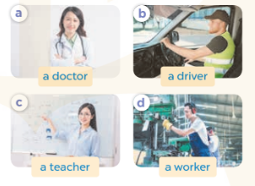  - Run through all the pictures.  - Run through model sentences.  + Run through the questions.  + Run through the answers  - Have Ss to practise:  + T says asks and Ss answer (change role).  + Ss – Ss (change role).  - Ask Ss to work in pairs.  - T controls and corrects.  - Invite a few pairs to come to the front of the classroom, point at the relevant character in each picture, and act out his/her role.  - Encourage Ss to practise speaking English.  - T gives feedbacks.  4.Production: (7’)  Activity 4. Let’s talk.  *Aims: Ss will be able to enhance the correct use of What's his / her job? – He’s / She’s …….. to ask and answer questions about someone's job in a freer context.  *Procedure:  - Hold up the flash cards for doctor, driver, teacher and worker to elicit the question and answer about his or her job.  - Have Ss look at the picture.  - Point at the adults in the picture and elicit mother and father and the questions What’s his job? and What’s her job?  - Give Ss time to practise in pairs to ask and answer What's his / her job? He’s / She’s …….  - Go around the classroom to offer support.  - Invite some pairs to the front of the class to perform their conversations.  *Consolidation  *Aims: Ss will be able consolidate and wrap up the content of the lesson.  *Procedure:  - T asks ss to answer the following questions:  + What have you learnt from the lesson today?  - T review the vocabulary and model sentences.  - T praises some Ss who are hardworking / active/ good…. as well as encourage others to try more.  5. Homework. (2’)  - Learn the number by heart  - Prepare the new lesson: Unit 12, Lesson 1 (4,5,6). | - Ss listen  - Ss play the game  - Ss open their books  -Ss listen and answer  - - Ss listen and repeat  + Choral repetition (3 times).  + Individual repetition (3 ss)  - Ss take note  - Ss look, remember and write  -Look at the pictures and get to know the characters in the pictures.  + Minh says This is my mother Lucy asks What’s her job? And Minh answers She’s a doctor in picture a.  + Lucy says This is my father ? Minh asks What’s his job? And Lucy answers: He’s a teacher.in picture b.  -Ss listen and repeat in chorus (twice)  -Ss work in pairs to practice  -Ss practice the dialogue  -Ss listen  -Ss look at the picture and answer.  -Ss listen  -Ss listen and repeat  -Ss repeat  - Ss look, listen and repeat  -Ss practice in chorus  -Ss work in pairs to practice  -Ss point and say  -Ss listen.  -Ss listen  -Ss listen and answer  -Ss look at the picture  - Ss listen and asnwer  -Ss work in pairs  -Ss perform in front of the class.  -Ss answer the questions  - Ss listen  -Ss listen and clap their hands  -Ss listen and take note

D. ADJUSTMENTS (if necessary):
………………………………………………………………………………………….…..……………………………………………………………………………...………………………………………….…..……………………………………………………………………………….……………………………………………………………………...

Week 20 Preparing date: January 20th, 2023
Period 80 Teaching date: January 23rd, 2023

Unit 12: Jobs
Lesson 1 (4, 5, 6)
A. OBJECTIVES:
By the end of the lesson, Ss will be able to:
1. Knowledge:
- listen to and understand two communicative contexts to ask and answer questions about the jobs of family members and tick the correct pictures.
- complete the two gapped sentences and two gapped dialogues with the help of the picture cues.
- sing the song My mother and my father with the correct melody and pronunciation.
- Vocabulary: Review
- Skills: speaking, listening, reading and writing.
2. Competences:
- Co-operation: ready to help friends in pair work/ group work.
- Self-control and independent learning: perform listening tasks.
3. Attitude/ Qualities:
- Kindness: Help partners to complete learning tasks.
- Honesty: tell the truth about feelings and emotions.
- Diligence: complete learning tasks.
B. TEACHING AIDS:
- Teacher: Teacher’s guide Pages 152, 153; audio Tracks 14, 15; website sachmem.vn, posters, laptop, pictures, textbook, lesson plan, TV or projector.
- Students: Pupil’s book Page 13, notebooks, workbooks, school things.
C. PROCEDURES:
Teacher’s activities | Students’ activities
1.Warm- up: (5’)  Game: “Throw the ball”  *Aims: to create a friendly and active atmosphere in the class to beginning the lesson.  *Procedure:  - Divide the class into 2 teams.  - Stick the pictures of activities on the board.  - T says a word, a pupil from each team has to point/throw the ball to the right picture and says the word three times.  + The one says faster will get points.  - Encourage pupils take part in the game.  - Give points for pupils.  - Say “Open your book page 13” and look at “Unit 12, Lesson 1 (4,5,6)”.  2.Practice: (27’)  Activity 1. Listen and tick:  *Aims: Ss will be able to listen to and understand two communicative contexts to ask and answer questions about the jobs of family members and tick the correct pictures.  *Procedure:  - Elicit the word for each family member 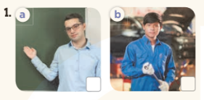    - T ask Ss to guess the answers.  + T writes Ss’guessing on the board.  - Listen to the tape:  + Play the recording  + Play the recording again and get Ss to swap books with their partners.  + Play the recording again to check answers together as a class.  + Write the answers on the board for Ss to correct their answers. Then checks Ss’ guessing.  - Play the recording, sentence by sentence, for the class to listen and repeat in chorus.  Key: 1.a 2.b  Activity 2. Look, complete and read.  *Aims: Ss will be able to complete two sentences and two gapped dialogues with the help of the relevant picture cues.  *Procedure:  - Have Ss look at the pictures and identify the jobs in the pictures.  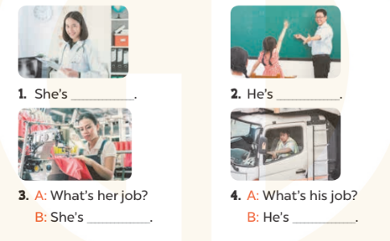  - Have Ss look at the four incomplete sentences and dialogues and elicits the missing words in the sentences.  - T models with sentence 1  + Ask Ss what is missing in the sentence.  + Have Ss look at the picture and complete the gap, then read the completed sentence in chorus.  -Have Ss work in groups and complete the sentences 2,3 and 4.  - Ask a few Ss to stand up and read the completed sentences aloud.  -T gives feedbacks.  Key:  1. a doctor 2. a teacher  3. a worker 4. a driver  Activity 3. Let’s sing.  *Aims: Ss will be able to sing the song My mother and my father with the correct pronunciation and melody. *Procedure:  - Introduce the title and lyrics of the song: “My mother and my father” song.  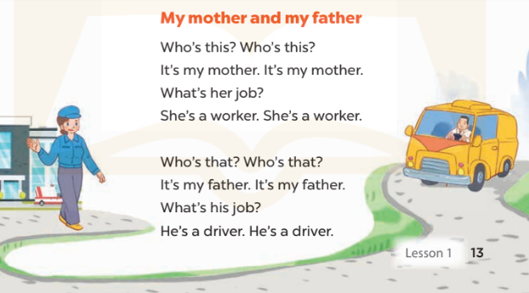  - Play the recording for Ss to listen to the whole song.  + Have them repeat the title and lyrics line by line.  + Tell Ss to point at the relevant character while singing his or her name.  - Play the recording all the way through for Ss to listen to pronunciation and melody of the song.  - Play the recording line by line for Ss to listen, repeat and point at the relevant character.  - Play the recording for Ss to sing and do actions.  - Ask Ss to practice singing and doing actions in pairs or groups.  - Invite groups to the front of the classroom to perform the song  -T gives feedback.  *Consolidation  *Aims: Ss will be able consolidate and wrap up the content of the lesson.  *Procedure:  - T asks ss to answer the following questions:  + What have you learnt from the lesson today?  +What are the core values of the lesson? (if the teacher can take from the lesson).  - T praises some Ss who are hardworking / active/ good…. as well as encourage others to try more.  3. Homework. (3’)  - Learn the number by heart  - Prepare the new lesson: Unit 12, Lesson 2 (1,2,3). | - Ss listen  -Ss play the game  -Ss listen  - Ss open their books  -Look at the pictures and say:  + Picture 1a: teacher  + Picture 1b: worker  + Picture 2a: doctor  + Picture 2b: driver  -Ss guess the answers  - Ss listen to the tape and tick  - Ss listen again, tick and swap books with their partners.  - Ss check their answers and guessing  -Ss check Ss’ guesing  -Ss listen and repeat.  -Ss look at the picture and say  -Ss look and answer  -Ss answer: doctor  -Ss look, complete and read the completed sentence in chorus.  -Ss complete the sentence  -Ss read aloud  - Ss look and listen.  -Ss listen to the song  - Ss listen and repeat line by line without the action.  -Ss point to the character while singing  -Ss listen to melody of the song  - Ss listen and sing line by line.  - Ss sing and do actions.  + Ss work in groups (two groups) to sing.  -Ss perform in front of the class.  -Ss listen  -Ss answer the questions  -Ss listen and clap their hands  -Ss listen and take note

D. ADJUSTMENTS (if necessary):
………………………………………………………………………………………….…..……………………………………………………………………………...………………………………………….…..……………………………………………………………………………….……………………………………………………………………...

