Date of preparing: ………………………………….
Date of teaching: ………………………………….

Period……
UNIT 3: FRIENDS
Lesson 1 - Part 1 (Page 22) - Vocabulary and Listening

I. OBJECTIVES
By the end of the lesson, Ss will be able to…
1. Knowledge
- describe someone’s personal appearance.
- use some sentences / phrases to end a friendly conversation.
- listen for gist and details about someone’s personal appearance.
2. Ability
- improve Listening and Speaking skills.
3. Quality
- have positive attitude in English language learning so that they actively participate in all classroom activities, especially with the topic “Friends” conducted by the teacher.
- love their school, love their friends.

II. TEACHING AIDS AND LEARNING MATERIALS
Lesson plan, PPT slides, student’s book, workbook, notebook, personal computer (if any), projector/TV, speakers, DCR & DHA on Eduhome…
III. PROCEDURES
A. Warm up: (5’)
a) Objective: Introduce the new lesson and set the scene for Ss to acquire new language; get students' attention at the beginning of the class by means of enjoyable and short activities as well as to engage them in the steps that follow.
b) Content: Introduction of new words about personal appearance.
c) Product: Ss can use some adjectives to describe someone’s appearance.
d) Competence: Collaboration, communication, guessing.
e) Organization of the activity:
Teacher’s Activities | Students’ Activities
- Give greetings  - Check attendance  - Option 1: Game “COOL PAIR MATCHING”  - Explain the rules of the game  - Give each group a picture with words and small pictures inside  - Have Ss work in groups to match word with its correct picture in about a minute and a half  - Call Ss to give answers (hang their pictures on the board)  - The group which has all correct answers in the shortest time will be winner  - Check, give feedback and give a small gift to the winner  - Lead to the new lesson  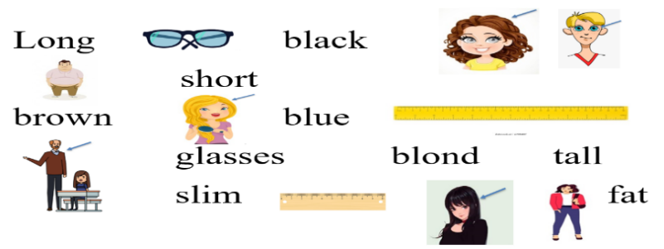  - Option 2: Game “FIND SOMEONE WHO …”  - Have Ss play the game as a whole class  - Ask Ss to stand up if they are the one(s) the teacher is looking for. Example  T says: I want to find someone who has long hair  I want to find someone who has brown eyes  I want to find someone who has short hair  I want to find someone who is over 1.50 meters  I want to find someone who wears glasses.  - Give feedback and lead to the new lesson | - Greet T  - Listen  - Work in groups  - Show answers  Expected answers  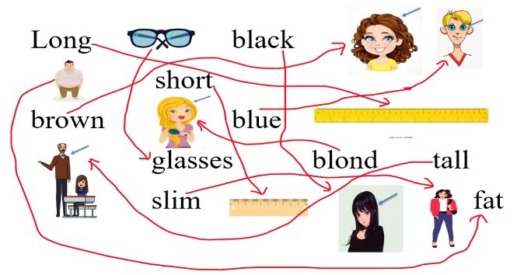  - Take part in the game  - Listen

B. New lesson (35’)
- Activities 1: Vocabulary (15’)
a) Objective: Ss know more words about personal appearance.
b) Content:
- Vocabulary study
- Speaking
c) Products: Ss know how to pronounce the new words correctly and use them in appropriate situations.
d) Competence: communication, collaboration, presentation, creativity.
e) Organization of the activity:
Teacher’s Activities | Students’ Activities
a. Write the words in the table. Listen and repeat.  - Option 1:  - Demonstrate the activity, using the example  - Have Ss write the words in the correct columns of the table  - Divide class into pairs and have them check their answers with their partners  - Play audio (CD1 – Track 29). Have Ss listen and repeat  - Correct Ss’ pronunciation  - Option 2:  - Ask Ss to work in pairs to write the words in the correct columns of the table  - Play the audio for Ss to check their answers, let Ss repeat after listening to each word  - Call some Ss to read the words aloud, check pronunciation if necessary  b. Describe yourself using the new words  - Option 1:  - Have Ss use the new words to describe themselves.  - Give some suggested structures to help Ss describe themselves more easily  I have + adj + noun (I have long hair)  My +noun is/are + adj (My hair is long)  - Encourage Ss to be creative, add more adjectives to make their dialogue more interesting  - Have some Ss share their ideas with the class  - Make comments on Ss’ presentation, give evaluation (marks) if necessary  - Option 2:  - Give some suggested structures to help Ss describe themselves more easily  I have + adj + noun (I have long hair)  My +noun is/are + adj (My hair is long)  - Have Ss use the new words to describe themselves. (Have Ss write on their notebooks)  - Encourage Ss to be creative, add more adjectives, noun to make their dialogue more interesting.  - Have some Ss share their ideas with the class  - Collect some Ss’ notebooks (randomly)  - Have 1S choose his/her friend’s writing and read, ask the whole class to guess who is being described  Example: “I have long hair. My eyes are brown. I have a pair of glasses”  Class: Is that Mai?  - Give feedback and evaluation | - Look and listen  - Work individually  - Work in pairs  - Listen and repeat  Answer keys  Body: tall, slim, short  Hair: red, blond, long, brown, short  Eyes: blue, brown, glasses  - Work in pairs  - Listen and check  - Pronounce the words  - Work in pairs  - Present  - Listen and take notes  - Work individually  - Present  - 1 S reads and the rest of the class guess which student in the class is being described
- Activity 2: Listening (20’)
a) Objective: Ss can make questions or answer the questions to develop a conversation, and they can aslo finish the listening task in the textbook.
b) Content: Listening to a girl trying to find her friend at a summer camp.
c) Products: Ss can see how the language learnt to be used in real context and listen for specific information.
d) Competence: collaboration, critical thinking, analytical skill, communication, presentation.
e) Organization of the activity:

Teacher’s Activities | Students’ Activities
a. Listen to a girl trying to find her friend at a summer camp. Tick ✓ the person she is looking for.  - Have Ss look at the pictures  - Play the audio once (CD 1 – Track 30)  - Have Ss listen and tick the correct box  - Play the audio again. Check answers as a whole class  b. Now, listen and circle “True” or “False”  - Have Ss read the sentences and guess whether they are True or False  - Play the audio. Have Ss listen and choose “True” or “False”  - Check answers as a whole class  c. Conversation skill  - Focus attention on the Conversation Skill box  - Explain that we often end conversation y saying: “See you soon” or “Talk to you later”  - Play the audio. Have Ss listen and repeat  - Have some Ss practice the conversation skill in front of the class  - Give feedback, and provide more ways to end a friendly conversation  See you soon  Talk to you later  See you later  Take care  Catch you later  Peace out  …  -Ask Ss to use these sentences / phrases to make up a simple conversation about school or friends and then end it in a friendly way.  -Have Ss present  - Give feedback and evaluation | - Look at the pictures  - Listen and tick the correct box  - Check answers  Answer key: A  - Look and read  - Listen and choose “True” or “False”  - Check answers  Answer keys  1. True 2. False 3. False 4. True  - Listen and read  - Listen and repeat  - Practice  - Listen and take notes  - Prepare, then act out the dialogue

C. Consolidation (3’)
* Words to describe body: Tall, short, fat, thin, slim, …
* Words to describe hair: Long, short, brown, blond, curly, …
* Words to describe eyes: Big, small, blue, brown …
* Ways to end a friendly conversation
See you soon
Talk to you later
See you later
Take care
Catch you later
Peace out
…

D. Homework (2’)
- Learn by heart the new words.
- Practice describing someone’s personal appearance.
- Do exercises in Workbook: Lesson 1 - New words and Listening (page 14).
- Prepare: Lesson 1 – Grammar (page 23 – SB).

