**Mã đề 9.1.30**

**ĐỀ KIỂM TRA CUỐI KỲ I NĂM HỌC: 2022-2023**

**MÔN: TIẾNG ANH LỚP 9**

*Thời gian làm bài: 60 phút*

**A. LISTENING (2.0 POINTS**)

**I. Listen and choose the correct answer (1.0 point)**

1. How does the man travel to Liverpool? (nhận biết)

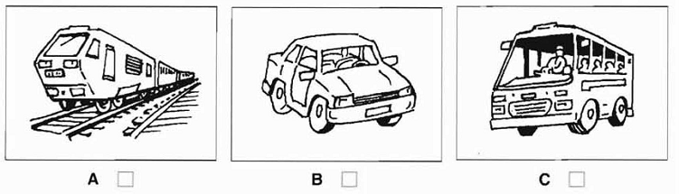

2.Which bill has just arrived? (nhận biết)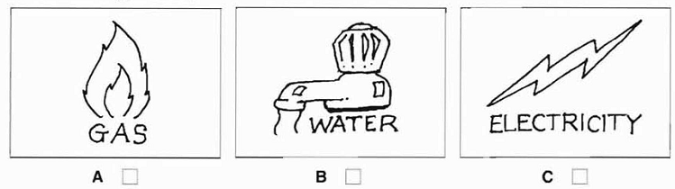

3. What will they do tomorrow afternoon? (thông hiểu)

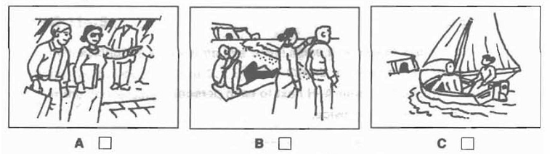

4.How did the man hear about the fire? (thông hiểu)

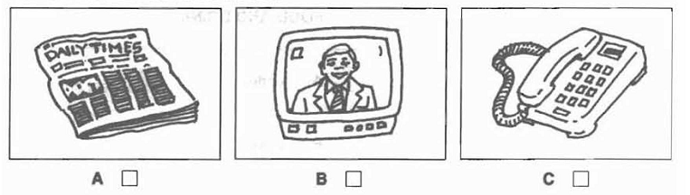

5.What time did Mr Thompson ring? (thông hiểu)

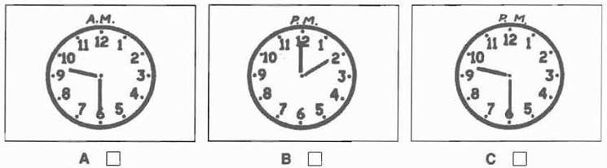

**II. Listen and write (1.0 point)**

**SPORT CLUB**

1. Where is it: Next to the ______________________factory (nhận biết)

2. Open which day: From_________________to Tuesday (nhận biết)

3. Times: Opens______________________ closes 10.30 (thông hiểu)

4. Club name: The ____________________Sports Club (thông hiểu)

5. Club phone number: ______________________ (nhận biết)

**B. GRAMMAR- VOCABULARY AND LANGUAGE FUNCTION (2.0 POINTS**)

**Choose the best answer to complete the sentence:**

1. My grandparents __________this workshop 30 years ago. (ngữ pháp - thông hiểu)

|  |  |  |
| --- | --- | --- |
| A. set up | B. passed down | C. faced up to |

2. Bat Trang is famous for its __________products. (từ vựng – nhận biết)

|  |  |  |
| --- | --- | --- |
| A. pottery | B. conical hat | C. silk |

3. I was born in Scotland but I ________ in Northern Ireland. (ngữ pháp - thông hiểu)

A. grew up B. raised C. brought up

4. Air pollution is the__________problem in Beijing. (ngữ pháp – nhận biết)

A. more serious B. most serious C. most seriously

5. Mr. Long said that he________in Ho Chi Minh City. (ngữ pháp – nhận biết)

A. has lived B. is living C. lived

6. Some people think that schools put too much _____ on students nowadays. (từ vựng – thông hiểu)

A. interest B. emotion C. pressure

7. Overcoming negative feelings is a/ an ___________ control skill. (từ vựng – thông hiểu)

A. cognitive B. emotion C. house- keeping

8. It was very dark,_________ we decided to come home. (từ vựng – nhận biết)

|  |  |  |
| --- | --- | --- |
| A. because | B. if | C. so |

9. Nhung: “I am from Tay Ho village” - Mark: “_________” (chức năng NN – thông hiểu)

|  |
| --- |
| A. Conical hats are beautiful. B. Is it a craft village in Hue? C. I own a workshop. |

10. **A**: Would you mind lending me your bike? **B:** _______. (chức năng NN – nhận biết)

A. No, of course not B. Yes, let’s C. Good idea

**C. READING COMPREHENSION (2.0 POINTS)**

**I. Choose the word that best fits the blank space in the following passage (1.0 point)**

Living in a city has a number of drawbacks. Firstly, there is the problem of traffic (1)___ and traffic accidents. The increase in population and the increasing number of vehicles have (2)___ many accidents to happen every day. Secondly, air pollution (3) ___ affects people's health, and it also has a bad (4)___ on the environment. More and more city dwellers suffer from coughing or breathing problems. Thirdly, the city is noisy, even at night. Noise pollution comes from the traffic and from construction sites. Buildings are always being knocked down and rebuilt. These factors contribute to making city life (5)___ difficult for its residents.

1. A. calm B. jams (nhận biết) C. light D. legacy

2. A. caused (thông hiểu) B. made C. done D. got

3. A. actively B. negatively (thông hiểu) C. positively D. weakly

4. A. pressure B. consequence C. influence (thông hiểu) D. result

5. A. mostly B. very C. much D. more (thông hiểu)

**II. Read the following passage then choose the correct answer (1.0 point)**

You can do a few things to make homework less stressful. First, be sure you understand what you have to do in your assignment. Write it down in your notebook if you need to, and don’t be afraid to ask questions about what is expected.

Second, use any extra time you have at school to work on your homework. Many schools have libraries that are specifically designed for students to study or to get their homework done.

Third, pace yourself. You need to plan your time. If it is a heavy homework day, you will need to **devote** more time to your homework.

Whenever you need some help, the first person you should ask for help is your teacher. Sometimes, it is good to have someone explain something that you are not completely sure of. In addition, you might also be able to get some help from another student. If there is a friend who is a good student, think about asking that person to study with you.

*36. In order to make homework less stressful, the first thing to do is ______.*(nhận biết)

A. to remember the deadline

B. to go to the school library as soon as possible

C. to understand what you have to do in your assignment

D. to know who can do it for you

*37. If you have any extra time at school, you should______.* (nhận biết)

A. use it to make your day planner B. study or get your homework done

C. use it to understand the assignment D. spend time with your friends

*38. When a student needs some help, the first person to ask for help is ______.* (nhận biết)

A. the best student at school B. his teacher

C. a member in his family D. his friend

*39. The word "devote" in the third paragraph can be best replaced by the word "______".* (thông hiểu)

A. reduce B. develop C. waste D. spend

*40. What is the main idea of the passage?* (thông hiểu)

A. Students can follow some advice to avoid worrying about homework.

B. Students should ask their teachers for help when they need it.

C. Students can do their homework in school libraries.

D. Students might get some help from their friends.

**D. WRITING (2.0 POINTS)**

**I. Rewrite the sentences in other way with the same meaning (1.0 point)**

1. Peter said: “I am listening to K-pop now”. (vận dụng)

=> Peter said that ………………………………………………………...….

2. No one in my class is more intelligent than Lan. (vận dụng)

=> Lan is .........................................................................................................

3. Marry couldn’t decide when she should start her journey. (vận dụng)

=> Marry couldn’t decide when………………………………………………

4. David has good relationship with most of his colleagues. (vận dụng cao)

=> David gets ………………………………………………………………

5. Lan was ill, so she did not go to Dong Ho village with her friends. (vận dụng)

=> Because …………………………………………………………………

**II. (1.0 point)** **Imagine that your Australian pen friend is coming to Viet Nam and will spend a day in your hometown/city. He/She has asked for your advice on the places of interest they should go to and the things they can do there.**

**Write an email to give him/her some information.** (vận dụng cao)

**E. SPEAKING (2.0 POINTS)**

Topic 1: Talk about the advantages of city life.

Topic 2: Talk about the disadvantages of city life.

Topic 3: Talk about one of the famous wonder of Viet Nam.

Topic 4: Talk bout your stress or pressure at school/ at home.

THE END

|  |
| --- |
| **HƯỚNG DẪN CHẤM ĐỀ KIỂM TRA HỌC KỲ I**  **NĂM HỌC: 2022 – 2023**  **Môn: Tiếng Anh 9 (Hệ 10 năm)** |

**A. LISTENING( 2.0 POINTS)**

**I. Listen and tick (🗸) the boxes.(1.0 point). 02x5= 1point**

|  |  |  |  |  |
| --- | --- | --- | --- | --- |
| 1.C | 2. B | 3. B | 4. C | 5.A |

**II. Listen and write. (1 point): 02x5= 1pt (wrong spelling: 0pt)**

|  |  |  |  |  |
| --- | --- | --- | --- | --- |
|  |  |  |  |  |

1. Chocolate 2. Friday 3. 9.15(a.m)/nine fifteen 4. Hurley 5. 400319

**B. GRAMMAR- VOCABULARY AND LANGUAGE FUNCTION( 2.0 POINTS)**

**Choose the best answer to complete the sentence:**

1. A 2. A 3. A 4. B 5. C

6. C 7. B 8. C 9. B 10. A

**C. READING( 2.0 POINTS)**

**I. (1,0 point): 0.2pt/1**

|  |  |  |  |  |
| --- | --- | --- | --- | --- |
| 1. B | 2. A | 3. B | 4. C | 5. D |

**II. (1,0 point): 0.2pt/1**

|  |  |  |  |  |
| --- | --- | --- | --- | --- |
| 1. C | 2. B | 3. B | 4. D | 5. A |

**D. WRITING ( 2.0 POINTS)**

**I. Rewrite these sentences (1.0 point): 0.2pt/1**

1. Peter said (that) he was listening to K-pop then.

2. Lan is the most intelligent in my class.

3. Marry couldn’t decide when to start her journey.

4. David gets on well with most of his colleagues.

5. Because Lan was ill, she did not go to Dong Ho village with her friends.

**II. Write an email (1.0 point)**

**1. Form:**

- Correct form **(**0.1 point)

**2. Task fulfillment:**

- Task completed with relevant information (0.2 point)

- Well-organized (0.2 point)

**3. Language**:

- Accurate grammar (0.2 point)

- Appropriate vocabulary (0.2 point)

- Correct spelling and punctuation (0.1 point)

**E. SPEAKING (2.0 POINTS)**

*1. Introduction:*

Introduce yourself with basic information (name, class, age, hobby, family, etc.)(0.5 point)

2. Each of Ss will draw lots to choose one of the following topics: (1.5 point)

Topic 1: Talk about the advantages of city life.

Topic 2: Talk about the disadvantages of city life.

Topic 3: Talk about one of the famous wonder of Viet Nam.

Topic 4: Talk bout your stress or pressure at school/ at home.