Date of preparing: ………………………………….
Date of teaching: ………………………………….

Period …
UNIT 1: HOME
Lesson 2 - Part 2 (Page 10) - Grammar

I. OBJECTIVES
By the end of the lesson, Ss will be able to…
1. Knowledge
- use the Present Simple and Wh-questions to ask about things that are facts.
- use ‘s’ to express possession.
2. Ability
- improve speaking skill, writing skill.
- improve the use of English.
3. Quality
- have positive attitude in English language learning so that they actively participate in all classroom activities.
- share household chores with family members.

II. TEACHING AIDS AND LEARNING MATERIALS
Lesson plan, PPT slides, student’s book, workbook, notebook, personal computer (if any), projector/ TV, speakers, DCR & DHA on EDUHOME, handouts.

III. PROCEDURES
A. Warm up: (5’)
a) Objective: Introduce the new lesson and set the scene for Ss to acquire new language; get students' attention at the beginning of the class by means of enjoyable and short activities as well as to engage them in the steps that follow.
b) Content: Revision of vocabulary about housework.
c) Product: Ss review vocabulary and ready for the new lesson.
d) Competence: Collaboration, communication, guessing.
e) Organization of the activity:
Teacher’s Activities | Students’ Activities
- Give greetings  - Check attendance  - Option 1: ACTOR / ACTRESS  - Invite 1 or 2 volunteers to stand in front of the class. He/ She will be the actor/ actress  - Have the volunteers express or act (use body language – gestures) to illustrate the housework  - Have the rest of the class guess which housework is being simulated  - Give a big applause or a small gift to the S who can give a correct answer  Lead to the new lesson  - Option 2: Do or Make  - Show on the screen or give handouts  - Have Ss review old vocabularies about housework by adding “do” or “make”  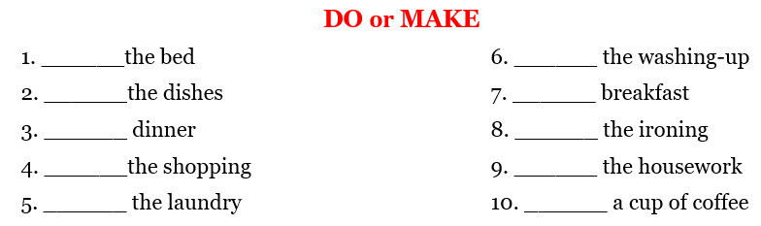  - Have Ss give answers  - Check answers as a whole class  - Lead to the new lesson | - Greet T  - Volunteer  - Act  - Guess and give answers  - Work in pairs and give the answers  Answer keys  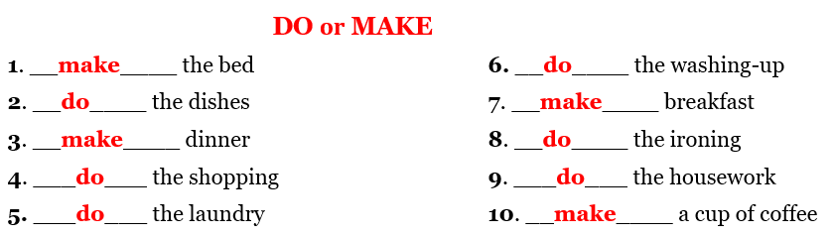

B. New lesson (35’)
- Activities 1: Grammar: The Present Simple with Wh-questions (15’)
a) Objective: Ss know how to use the Present Simple with Wh-questions.
b) Content:
- Listening and repeating.
- Grammar explanation.
c) Products: Ss can use the Present Simple and Wh-questions to ask about things that are facts.
d) Competence: Communication, collaboration, creativity.
e) Organization of the activity:
Teacher’s Activities | Students’ Activities
a. Listen and repeat  - Have Ss look at the picture  - Play the audio (CD1 – Track 09), ask Ss to listen and read the speech bubbles  - Play the audio again and have Ss listen and repeat  *Grammar explanation  - Have Ss read the Grammar box  - Ask Ss to make comments on the black bold verb form in the examples  - Have Ss give the form and usage of the Present Simple tense  - Lead to the grammar table and explain the Present Simple and Wh-questions to ask about things that are facts  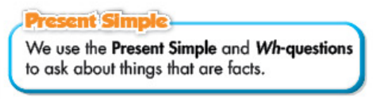  - Ask Ss to pay attention to way to show possession  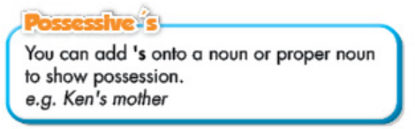  - Have some Ss read the sentences aloud  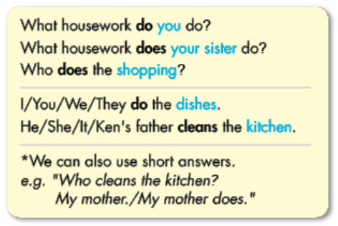  - Have Ss work in pairs to make questions and answer, using Wh-questions and the Present Simple tense  - Get feedback | - Look  - Listen and read  - Listen and repeat  - Comment  - Give answers  Expected answers  The Preset Simple tense  Be: S + am / is / are (not) …  (?) Am / Is / Are + S …  Normal verb:  (+) S + V_{s/es}  (-) S + don’t / doesn’t + V. _{bare infinitive}  (?) Do / Does + S + V. _{bare infinitive}  - Listen and take notes.  - Read  - Work in pairs
- Activity 2: Practice (20’)
a) Objective: Ss can get used to using the Present Simple and Wh-questions.
b) Content:
- Filling in the blanks, using the Present Simple of the verbs in the box.
- Using the prompts to write sentences.
c) Products: Ss produce the new language successfully, and they can apply the use of the Present Simple and Wh-questions in speaking and writing.
d) Competence: Collaboration, creativity, communication.
e) Organization of the activity:
Teacher’s Activities | Students’ Activities
b. Fill in the blanks, using the Present Simple of the verbs in the box  - Option 1:  - Use the example to demonstrate this activity  - Have Ss use the Present Simple to fill in the blanks, draw attention to the singular and plural form  - Have pairs check each other’s work  - Have Ss share their answers with the class by writing down on the board  - Check Ss’ answers, correct if necessary  - Option 2:  - Use the example to demonstrate this activity  - Have Ss use the Present Simple to fill in the blanks, draw attention to the singular and plural form  - Have pairs check each other’s work  - Call Ss to give answers by answering multiple choice questions (format: game “Lucky Number?”)  - Check Ss’ answers, correct if necessary  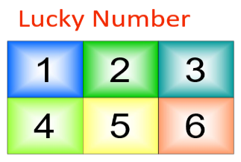  c. Write sentences, using the prompts  - Demonstrate the activity, using the example  - Have Ss work in groups of 3-4 to write sentences, using the prompts  - Go round and give help if necessary  - Call Ss to write answers on the board  - Check and correct Ss’ answers  d. Write what housework you do on the line. Ask your partner    - Option 1:  - Have Ss write what housework they do on the line  - Have Ss practice the conversation in pairs  - Have some Ss demonstrate the activity in front of the class  - Give feedback and evaluation  - Option 2:  - Follow the same steps as option 1  - Give an extra activity: Have Ss use more questions to develop their conversation:  What housework does your mother do?  What housework does your father do?  What housework does your sister / brother do?  Or: Who does the laundry?  Who makes dinner?  Who prepares breakfast?  Who does the cooking?  - Remind Ss to use the right form of do or make they have studied in the Warmup activity  - Have some Ss demonstrate the activity in front of the class  - Give feedback and evaluation | - Look and listen  - Work in pairs  - Write answers  Answer keys  2. do 3. cleans 4. make  5. does 6. makes  - Look and listen  - Work in pairs  - Give answers  Answer keys  2. do 3. cleans 4. make  5. does 6. makes  - Look and listen  - Do the task in groups  Answer keys  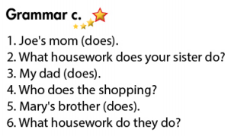  - Work individually  - Work in pairs  - Present  - Write answers  - Listen and take notes  - Work in pairs  - Ask and answer

C. Consolidation (3’)
* Present Simple
Form: Be: S + am / is / are (not) …
(?) Am / Is / Are + S …
Normal verb:
(+) S + V_{s/es}
(-) S + don’t / doesn’t + V. _{bare infinitive}
(?) Do / Does + S + V. _{bare infinitive}
Usage: The Present Simple and Wh-questions to ask about things that are facts.
* Wh-questions
Form: Question word + do / does + S + V. _{bare infinitive}
Question word + do / does / make / makes /clean / cleans + housework.

D. Homework (2’)
- Practice asking and answering about housework, using the Present Simple and Wh-questions.
- Do exercises in WB: Lesson 2 - Writing (page 5).
- Prepare: Lesson 2 – Pronunciation and Speaking (page 11 – SB).

