Date of preparing: ………………………………….
Date of teaching: ………………………………….

Period……
UNIT 2: SCHOOL
Lesson 1 - Part 3 (Page 16) – Pronunciation and Speaking

I. OBJECTIVES
By the end of the lesson, Ss will be able to…
1. Knowledge
- use intonation for lists.
- ask and answer about favorite subjects.
- conduct a survey about school subjects.
2. Ability
- improve speaking skills.
3. Quality
- have positive attitude in English language learning so that they actively participate in all classroom activities, especially with the topic “School” conducted by the teacher.
- love their school, identify their favorite subject(s) and even orient themselves toward what they want to do in the future, using the knowledge from the subject(s) they like.

II. TEACHING AIDS AND LEARNING MATERIALS
Lesson plan, PPT slides, student’s book, workbook, notebook, personal computer (if any), projector/TV, speakers, DCR & DHA on EDUHOME, handouts…

III. PROCEDURES
A. Warm up: (5’)
a) Objective: Introduce the new lesson and set the scene for Ss to acquire new language; get students' attention at the beginning of the class by means of enjoyable and short activities as well as to engage them in the steps that follow.
b) Content: Revision of vocabulary about school subjects.
c) Product: Ss remember school subjects and use them in other speaking activities.
d) Competence: Collaboration, observation, critical thinking skill.
e) Organization of the activity:
Teacher’s Activities | Students’ Activities
- Give greetings  - Check attendance  - Option 1: Game “WORD SQUARE”  - Design game “Word Square”, ask Ss to look and find names of the subjects they have learnt as many as possible. Words can be put in horizontal, vertical or diagonal line  - Show word square on the screen or give out handouts to Ss  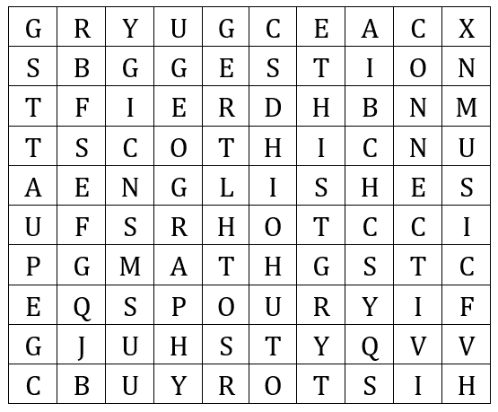  - Give a small gift to each S who can find a correct word  - Lead to the new lesson  - Option 2: SONG  - Let Ss listen to the song “What subject do you like the most?”. Ss can sing together while the song is being played  - Link from YouTube: https://www.youtube.com/watch?v=PnQkVUb1efQ 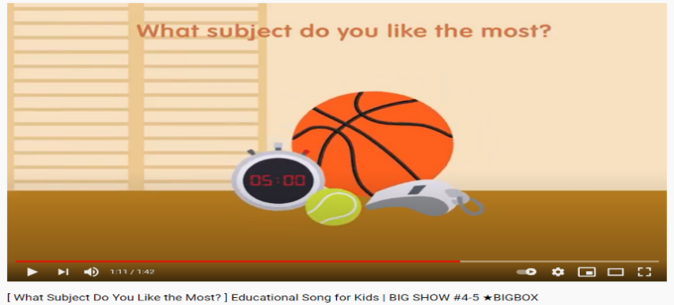  - Then, ask Ss to list subjects they can hear from the song  - Raise a question for Ss to think: How do we use intonation when we list things?  Lead to the new lesson | - Greet T  - Take part in the game as a whole class  Answers keys  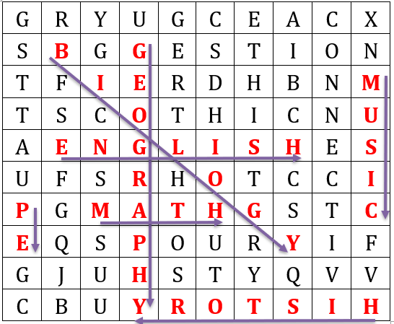  - Listen and sing together  - List  - Think and give answers  - Listen

B. New lesson (35’)
- Activities 1: Pronunciation (10’)
a) Objective: Ss know how to use intonation when listing things.
b) Content:
- Recognizing the intonation for lists
- Listening and check, find mistakes
- Practicing
c) Products: Ss can use intonation correctly to improve their speaking skill.
d) Competence: Communication, collaboration, listening, presenting
e) Organization of the activity:
Teacher’s Activities | Students’ Activities
a + b. Listen to the sentences and focus on the intonation  - Play the recording (CD1, track 20)  - Ask Ss to listen and pay attention to the intonation  - Call Ss to make their comments on the intonation of the list they’ve just listened to  - Give feedback, explain the pronunciation feature: intonation for lists goes up, up, then down. We use down intonation for the last word in the list  - Play the recording again, have Ss listen and repeat with a focus on the pronunciation feature  c + d. Listen and cross out the one with the wrong intonation, then read the sentences with the correct intonation  - Play the recording, have Ss listen and cross out the option that doesn’t use the correct intonation  - Call Ss to give answers  - Play the recording again and check answers as a whole class  - Then have Ss practice saying the sentences with a partner, using the correct intonation, encourage Ss to use their own idea  - Call some pairs to read in front of the class | - Listen  - Comment  - Listen  - Listen again and repeat  - Listen and cross out  - Give answers  - Listen again and check  - Work in pairs  - Present
- Activity 2: Practice (10’)
a) Objective: Ss can ask and answer questions about the subjects they like or don’t like
b) Content: Expressing “like” or “don’t like” by using icon or, then speak
c) Products: Ss can express what they like/ don’t like in communication.
d) Competence: Collaboration, communication, creativity.
e) Organization of the activity:
Teacher’s Activities | Students’ Activities
a. Circle or. Ask and answer. Swap the roles and repeat  - Option 1:  - Demonstrate the activity by asking and answering with a student  - Have Ss work in pairs, circle or  - Have pairs ask and answer, using the pictures  - Have some pairs demonstrate the activity in front of the class  - Option 2: (for class with better students)  - Demonstrate the activity by asking and answering with a student  - Have Ss work in pairs, circle or  - Have pairs ask and answer, using the pictures, Ss can ask and answer 2 questions:  What subjects do you like?  What subjects don’t you like?  - Remind Ss to use “and” or “or” to join the nouns (they learnt about them last period)  - Have some pairs demonstrate the activity in front of the class  - Give feedback and evaluation  b. Practice with your own ideas  - Have pairs practice the conversation with their own ideas, then swap roles  - Call some pairs to demonstrate the activity in front of the class  - Give feedback and evaluation | - Listen  - Work in pairs  - Present  - Listen  - Work in pairs  - Present  - Listen  - Work in pairs  - Present
- Activity 3: Speaking (15’)
a) Objective: Ss can conduct a survey about school subjects.
b) Content: Asking questions, then filling in the survey
c) Products: Ss can know how to conduct a small survey and use target language learnt in communication.
d) Competence: Collaboration, communication, public speaking.
e) Organization of the activity:
Teacher’s Activities | Students’ Activities
a. Do a survey about school subjects. Fill in the survey for yourself. Ask 3 friends about school subjects and draw faces in the table  - Have Ss fill in the survey for themselves  - Demonstrate the activity by asking and answering with a student, example:  T: Do you like Math?  S: Yes, I like it. ()  T: Do you like P.E?  S: It’s ok. (😐)  T: Do you like History?  S: I don’t like it. ()  - Ask Ss to work in groups of 4 and draw faces in the table  - Have Ss take turns asking and answering the questions, then complete the survey  - Observe, give help if necessary  b. Which three subjects are the most popular in your group?  - Have Ss look at their answers and decide which three subjects are the most popular in their group  - Ask Ss to send a representative in their group to share their findings with the class, ask Ss to remember to use intonation for their list  - Give feedback and evaluation | - Fill in the survey for themselves  - Observe and listen  - Work in groups  - Ask, answer, complete the survey  - Work in groups  - Present

C. Consolidation (3’)
* Intonation: Intonation for lists goes up, up, then down.
* Asking and answering about school subjects you like / don’t like
What subjects do you like?
What subjects don’t you like?
* Asking and answering about school subjects:
Asking: Do you like + name of subject?
Answering: I like it. () / It’s ok (😐) / I don’t like it. ()

D. Homework (2’)
- Practice using intonation for lists
- Review subject names
- Complete the survey for those who haven’t finished it in class.
- Prepare: Lesson 2 – New Words and Reading (page 17 – SB)

