UNIT 2 TEST
I. Listening
Listen to Mai talking about her new house. Decide whether the statements are TRUE (T) or FALSE (F).
Statements | TRUE | FALSE
1. Mai lives in a new flat near her school.
2. There are six rooms in her house.
3. Her favourite room is the living room.
4. The sofa is next to the window.
5. Mai and her brother usually do homework at their desks in their bedrooms.

II. Pronunciation
A. Choose the word whose bold part is pronounced differently.
6. A. lamps B. sinks C. rooms D. toilets
7. A. sofas B. cupboards C. beds D. books
B. Choose the word that has a different stress pattern from the others.
8. A. kitchen B. bedroom C. behind D. bathroom
9. A. furniture B. department C. family D. cupboard

III. Language use
Choose the best answer A, B, C or D.
10. This is __________ bedroom. She keeps it very tidy.
A. Elena B. Elena's C. Elenas D. Elenas'
11. The dog is __________ the table. I can only see its tail.
A. under B. on C. between D. next to
12. There are two __________ in my house: one upstairs and one downstairs.
A. bathroom B. bathrooms C. bath D. shower
13. We cook dinner in the __________.
A. living room B. bedroom C. kitchen D. hall
14. The picture is __________ the clock and the window.
A. between B. under C. on D. in
15. "How about putting a picture on the wall?" - "__________"
A. Yes, I am. B. Great idea! C. No, there is not. D. It is my chair.
IV. Signs & Notices
Look at the signs and choose the best explanation.
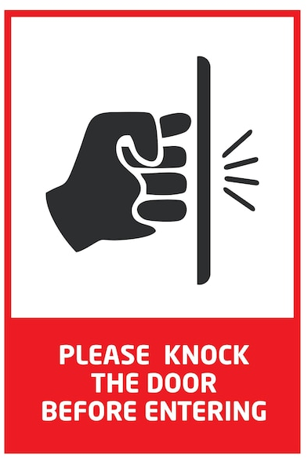 | 16. What does this sign mean?  A. You need to knock on the door before you go into the room.  B. You must lock the door carefully when you leave.  C. You can open the door and walk right in without waiting. D. You should keep the door open at all times.

 | 17. What does this sign mean?  A. You should wash your hands with soap before you leave. B. You must use water to clean the toilet when you finish.  C. You cannot use this toilet because it is broken.  D. You need to close the door carefully after using the room.

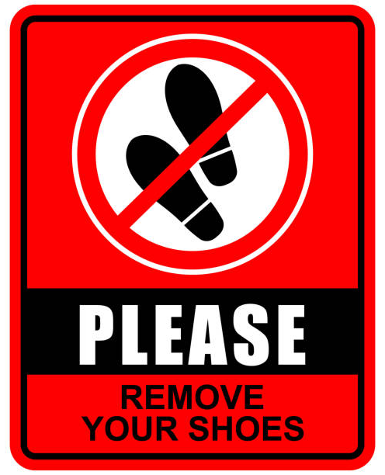 | 18. What is TRUE about the sign?  A. You must take off your shoes before you go into the house. B. You can wear your shoes inside if they are clean.  C. You need to buy new shoes before you enter this room.  D. You should wash your shoes carefully before you go out.

 | 19. What does this sign you?  A. You can buy or sell friendly puppies at this house.  B. You should be careful because there is a dangerous dog here.  C. You must feed the pet dog before you walk into the yard. D. You cannot bring your own animals into this area.

V: Rearrange the sentences (a-d) to make a complete conversation.
20.
a. Nick: It is on the first floor, next to the kitchen.
b. Mi: Your house is very beautiful.
c. Mi: Where is the living room?
d. Nick: Thank you. Come in, please.
A. b - d - c - a B. c - a - b - d C. b - c - a - d D. d - b - a - c
21.
a. Mum: Great idea. We can buy one this weekend.
b. Elena: My bedroom is not nice.
c. Mum: How about putting a picture on the wall?
d. Elena: That sounds good.
A. b - c - d - a B. c - b - a - d C. b - d - c - a D. a - b - c - d
22.
a. Tom: It is behind the door.
b. Anna: Where is your school bag?
c. Anna: Oh, I see. Is there a TV in your room?
d. Tom: No, there is not.
A. b - a - c - d B. c - d - b - a C. b - c - a - d D. a - b - d - c
23.
a. Linda: This is my sister's desk.
b. Peter: Whose desk is this?
c. Peter: It is very tidy.
d. Linda: Yes, she always keeps her room clean.
A. d - b - a - c B. a - b - c - d C. b - c - a - d D. b - a - c - d
VI: READING
A. Read and choose the correct word for each blank.
My name is Elena. I live in a small house with my parents and my brother. There are six rooms in our house: a living room, a kitchen, two bedrooms and two bathrooms. My bedroom is not very big, but it is my favourite room. There is a bed, a desk and a (24) _________ in it. I put my books in the cupboard. There is a picture (25) _________ the wall. My brother's room is next to (26) _________ room. He has many toys, but his room is not tidy. At weekends, we often clean our rooms (27) _________ our parents.
24. A. sofa B. cupboard C. shower D. toilet
25. A. on B. under C. between D. behind
26. A. I B. me C. my D. mine
27. A. with B. at C. in D. on
B. Read the text and choose the best answer A, B, C or D.
Nick lives in a country house with his parents, his younger sister and his aunt. His house is not very modern, but it is large and comfortable. There is a living room, a kitchen, three bedrooms and two bathrooms. The living room is Nick's favourite room. There is a sofa in front of the TV, and there are two lamps next to the sofa. His father's books are on the shelf near the window. Nick's bedroom is upstairs. His bed is next to the door, and his desk is between the bed and the wardrobe. He likes his room because it is quiet. At weekends, Nick's family often has dinner together in the kitchen.
28. What is the text mainly about?
A. Nick's country house B. Nick's school
C. Nick's summer holiday D. Nick's favourite food
29. Who does Nick live with?
A. His friends B. His parents, sister and aunt
C. His teachers D. Only his sister
30. How many bedrooms are there in Nick's house?
A. One B. Two C. Three D. Four
31. What is Nick's favourite room?
A. The kitchen B. The living room C. The bathroom D. The hall
32. Where is the sofa?
A. Behind the TV B. In front of the TV C. Under the shelf D. Between two doors
33. Where are his father's books?
A. On the shelf B. In the wardrobe C. Under the bed D. Next to the door
34. Why does Nick like his bedroom?
A. Because it is noisy B. Because it is quiet
C. Because it is very crowded D. Because it has a TV
35. What does Nick's family often do at weekends?
A. They have dinner together B. They go to school
C. They paint the house D. They buy a new sofa
VII: WRITING
A. Rearrange the words to make complete sentences.
36. has / My house / six rooms / and / a big kitchen /.
_______________________________________________________________________.
37. the sofa / is / in front of / the TV /.
_______________________________________________________________________.
B. Rewrite the sentences without changing their meanings.
38. This is the desk of my sister.
This is _________________________________________________________________.
39. The cat is behind the sofa.
The sofa is _____________________________________________________________.
40. There are two bathrooms in my house.
My house ______________________________________________________________.

AUDIO SCRIPT (PHẦN I: LISTENING)
Hello. My name is Mai. I live in a new town house near my school. It is not very big, but I like it very much. There are five rooms in my house: a living room, a kitchen, two bedrooms and a bathroom. My favourite room is my bedroom because it is quiet. There is a bed next to the window and a desk between the bed and the wardrobe. In the living room, there is a sofa in front of the TV and two lamps next to the sofa. My brother and I usually do our homework at the desk in our bedrooms. At weekends, my family often cleans the house together.
*************************************
Đáp án tham khảo
Listening: 1. F | 2. F | 3. F | 4. F | 5. T
II. Pronunciation: 6. C | 7. D | 8. C | 9. B
III. Language use: 10. B | 11. A | 12. B | 13. C | 14. A | 15. B
IV. Signs & Notices: 16. B | 17. A | 18. A | 19. B
V. Logic: 20. A | 21. A | 22. A | 23. D
VI. Reading - Cloze Test: 24. B | 25. A | 26. C | 27. A
Reading Comprehension: 28. A | 29. B | 30. C | 31. B | 32. B | 33. A | 34. B | 35. A
VII. Writing:
36. My house has six rooms and a big kitchen.
37. The sofa is in front of the TV.
38. This is my sister's desk.
39. The sofa is in front of the cat.
40. My house has two bathrooms.

