ĐỀ SỐ 15
Thời gian làm bài: 120 phút

PART A: LISTENING (10 pts)
Part I. You will hear five short conversations. You will hear each conversation twice. There is one question for each conversation. For question 1-5, put a tick ()
1. What doesn’t the girl like about her photo?
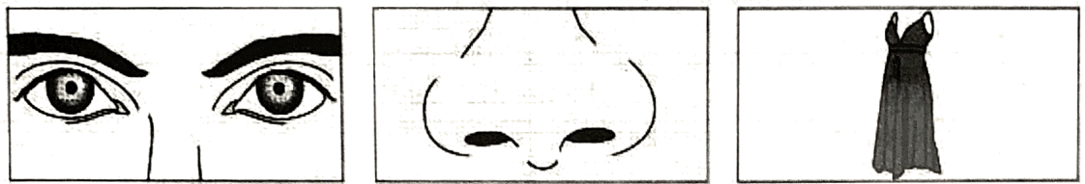
A | B | C
2. Which the boy’s next lesson?
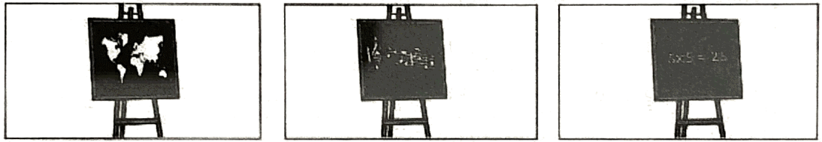
A | B | C
3. What will the woman do first?
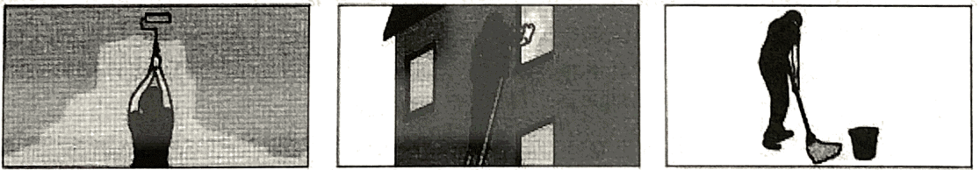
A | B | C
4. What do they need to buy for dinner?
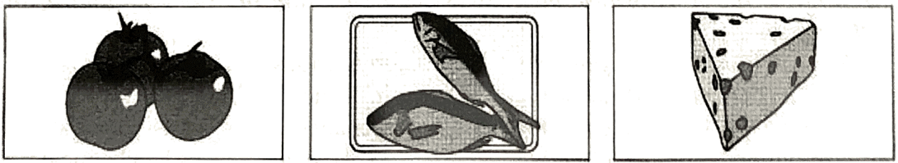
A | B | C
5. What did Joe get for his birthday?
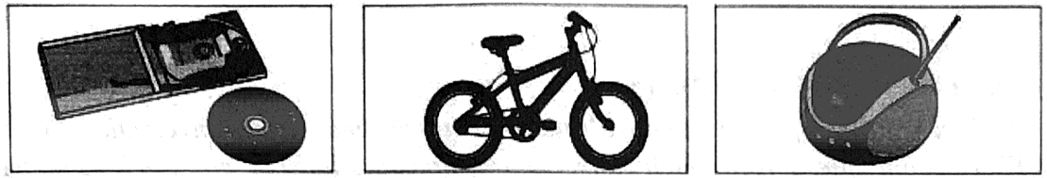
A | B | C
Part II. You will hear a man leaving a message. Listen and complete questions.
Phone Message
From: | Bike shop
Colour of bike: | (6) ______________________
Bike costs: | (7) £ ____________________
Shop has also got: | (8) bicycle ____________________
Come tonight before: | (9) ____________________ p.m.
Address to go to: | (10) ____________________ King Street
PART B: PHONETICS (5 pts)
I. Choose the word A, B, C or D whose underlined part is pronounced differently from the others.
1. A. looked | B. watched | C. stopped | D. carried
2. A. bath | B. father | C. theater | D. health
3. A. study | B. success | C. surprise | D. sugar
4. A. children | B. charity | C. charm | D. champagne
5. A. danger | B. angry | C. language | D. passage
II. Choose the word whose main stress is not the same as that of the others.
1. A. humorous | B. generous | C. mysterious | D. precious
2. A. favorite | B. identify | C. influence | D. government
3. A. orchestra | B. collector | C. teenager | D. moderate
4. A. biology | B. effective | C. experience | D. chemical
5. A. veteran | B. lifeguard | C. campaign | D. harvest
PART C: VOCABULARY AND GRAMMAR (40 pts)
I. Choose the correct answer to complete the following sentences.
1. Someone ________ tickets are free.
A. said me B. said me that C. told me D. told to me
2. When she lived in the countryside, she ________ in the river.
A. was swimming B. used to swim C. has swum D. is used to swimming
3. Saigon ________ more than three hundred years ago.
A. was built B. has been built C. was building D. built
4. It is nearly ten years ________ I saw her.
A. when B. since C. for D. while
5. Would you mind if I ________ a photo?
A. take B. took C. would take D. am going to take
6. Last week I ________ my children to the biggest zoo in town.
A. got B. brought C. fetch D. took
7. They ________ me if I could speak Japanese.
A. told B. said C. asked D. talked
8. Are you proud ________ your country and its tradition?
A. about B. on C. of D. for
9. Do you collect stamps or other things? - Yes, I am a stamp ________.
A. collecting B. collector C. collect D. collection
10. There were ________ flowers that I couldn’t decide what to buy.
A. so many B. so few C. so little D. so much
11. She doesn’t like Spanish ________ she has to study the language.
A. so B. though C. but D. when
12. It took him six years to ________ a doctor and now he is a good doctor.
A. make B. do C. qualify D. become
13. She asked me ________.
A. if I like pop music or not B. whether I like pop music or not
C. if I liked pop music or no D. if I liked pop music or not
14. My brother and I ________.
A. am having a wonderful time here B. am having a wonder time here
C. are having a wonderful time here D. are having a wonder tune here
15. Don’t shout, dear. I can’t ________ the shout!
A. stand B. sit C. listen D. hear
II. Use the correct form of the verbs in parentheses to complete the following sentences.
1. Mary spent hours (repair) ________________ her bike.
2. They advised him (not/ cross) ________________ the street against the red lights.
3. He and his sister (not/ meet) ________________ my friends since last Christmas.
4. ________________ (she / work) here since she left school?
5. Everyone (read) ________________ this novel, let us (discuss) ________________ it.
III. Complete the following sentences with the correct form of words in brackets.
1. I know all the boys who live in my ________________. (neighbor)
2. People in the countryside is ________________. (friend)
3. All ________________ between Paris and Hanoi have been cancelled due to fog. (fly)
4. Do you know the ________________ of s.t Paul’s Cathedral? (high)
5. Taxi drivers have to have a very good ________________ on the street names. (know)
6. The hotel was large and ________________. (comfort)
7. During his ________________ the family lived in Cornwall. (child)
8. Every woman nowadays seems to want to loose ________________. (weigh)
9. It’s a nice shop and the assistants are all polite and very ________________. (help)
10. The keys were locked inside the car. ________________, aside window was open. (luck)
IV. Find the mistakes in the following sentence and correct them (one mistake in each sentence).
1. You know (A), it is difficult to me (B) to make him understand (C) what I mean (D).
2. My dear (A) friends, I wish (B) you will (C) visit us someday (D) this summer.
3. I will come and stay (A) with you (B) and your family (C) on March (D).
4. Let’s (A) gathering (B) somewhere for a coffee (C) after this wonderful meeting (D).
5. I look (A) forward to hear (B) from (C) my mother in Singapore (D).
6. The collect (A) of stamps made (B) him become (C) famous in the country (D).
7. Let’s practise (A) listening (B) to English (C) programs in the radio (D).
8. What about (A) play tennis (B) instead of (C) going to (D) the cinema?
9. Don’t turn on (A) the TV, please (B). I am so (C) tired to watch (D) it.
10. They turn in (A) the radio (B) to listen to (C) some news (D).
PART D. READING COMPREHENSION (15 pts)
I. Read the passage and choose the correct answer in the blanket
For many people, traveling by plane is an exciting experience. Others, however, find the whole idea quite terrifying, (1) _________ flying is no more dangerous (2) _________ any other form of travel and some experts say it is considerably safer. It is known, however, that most accident occurs (3) _________ taking off and landing when a (4) _________ decisions are vitally important.
The people (5) _________ job it is to look (6) _________ the passengers, the stewards and stewardesses play an important part in helping passengers to (7) _________ safe and comfortable. Indeed for many passengers being (8) _________ such care of is all part of the total experience. (9) _________ other form of travel involves waiting for people in quite the same (10) _________, with food, drink, newspapers, magazines, music, and even video films.
1. A. although | B. too | C. and | D. because
2. A. than | B. as | C. then | D. with
3. A. while | B. during | C. for | D. through
4. A. leader’s | B. chiefs | C. driver’s | D. pilot’s
5. A. whose | B. which | C. their | D. that
6. A. for | B. up | C. after | D. round
7. A. feel | B. rest | C. experience | D. lie
8. A. given | B. kept | C. shown | D. taken
9. A. Any | B. No | C. All | D. Not
10. A. way | B. kind | C. sort | D. part

II. Read the following passage then choose the correct answer for the questions below.
Every year people in many countries learn English. Some of them are young children. Others are teenagers. Many are adults. Some learn at school. Others study by themselves. A few learn English just by hearing the language in films, on television, in the office or among their friends. Most people must work hard to learn English.
Why do all these people learn English? It’s not difficult to answer this question. Many boys and girls learn English at school because it is one of their subjects. Many adults learn English because it is useful for their work. Teenagers often learn English for their higher studies because some of their books are in English at the college or university. Other people learn English because they want to read newspapers or magazines in English.
1. According to the writer. English is learned by _________.
A. young children B. adults C. teenagers D. all are correct
2. In the line 2 of the second part, the word “it” refers to _________.
A. country B. young children C. English D. question
3. Where do many boys and girls learn English?
A. at home B. at school
C. in evening classes D. in the office
4. Why do adults learn English?
A. Because they want to see movies in English.
B. Because they need it for their job.
C. Because they are forced to learn it
D. Because it’s not difficult to learn.
5. What of the following is NOT mentioned in the passage?
A. Children like reading English newspapers.
B. People in many countries learn English.
C. English is one subject in school.
D. Some books are written in English.
PART E: WRITING (30 pts)
I. Build sentences based on the words given.
1. There/ used/ be/ church/ near/ post office/ my town.
2. While/I/ open/ letter/,/phone/ ring.
3. I/ be/ very pleased/ see/ Tom/ again/ after/ long time.
4. You/ look/ thinner. You/ lose/ weight?
5. You/ think/ you/ make/ radio/ work again?
6. I/ buy/ book/ 5 days ago.
7. A man/ said/girl/ there/ cafe/ nearby.
8. When/ I/ see/ Nancy/ yesterday/ she/ drive/ car.
9. They/ know/ each other/ 3 months.
10. Nam’s teacher/ teach/ him/ he/ come/ here/ 2000.

II. Complete the second sentence so that it has a similar meaning to the first.
1. “Can you lend me some money?” Henry said to Susan.
Henry
2. Both of the chairs are uncomfortable.
Neither of
3. They will have to change the date of the meeting again.
The date
4. Peter spent three hours repainting his house.
It
5. They’ve lived here for six years.
They moved
6. I’ve never read a more romantic story.
It’s the
7. Noone works harder than Barbara.
Barbara
8. I haven’t met him for two years.
It’s
9. Richard can cook very well.
Richard is a
10. The film’s ending is dramatic.
The film
III. Paragraph writing. (10 points)
Participating in extracurricular activities plays an important role in students’ life. Write a paragraph of about 180 words about the benefits of extracurricular activities.
________________________________________________________________________________________________
________________________________________________________________________________________________
________________________________________________________________________________________________
________________________________________________________________________________________________
________________________________________________________________________________________________
________________________________________________________________________________________________
________________________________________________________________________________________________
________________________________________________________________________________________________
________________________________________________________________________________________________
________________________________________________________________________________________________
________________________________________________________________________________________________
________________________________________________________________________________________________
________________________________________________________________________________________________
________________________________________________________________________________________________
________________________________________________________________________________________________
________________________________________________________________________________________________
________________________________________________________________________________________________
________________________________________________________________________________________________
________________________________________________________________________________________________
________________________________________________________________________________________________
________________________________________________________________________________________________
________________________________________________________________________________________________
________________________________________________________________________________________________
________________________________________________________________________________________________
________________________________________________________________________________________________
________________________________________________________________________________________________
________________________________________________________________________________________________
________________________________________________________________________________________________
________________________________________________________________________________________________
________________________________________________________________________________________________
________________________________________________________________________________________________
________________________________________________________________________________________________
________________________________________________________________________________________________
________________________________________________________________________________________________
________________________________________________________________________________________________
________________________________________________________________________________________________
________________________________________________________________________________________________
________________________________________________________________________________________________
________________________________________________________________________________________________
________________________________________________________________________________________________
________________________________________________________________________________________________
________________________________________________________________________________________________
________________________________________________________________________________________________
________________________________________________________________________________________________
________________________________________________________________________________________________
________________________________________________________________________________________________
________________________________________________________________________________________________
________________________________________________________________________________________________
________________________________________________________________________________________________

