SPEAKING ASSESSMENT ENGLISH 6
UNIT 8: SPORTS AND GAMES
- Introduction - 0.4 pt (~2 ideas):
Share something about your family, school, house, friends, neighborhood,…
- Topic Speaking (Cue pictures) – 1.0 pt (~4 questions):
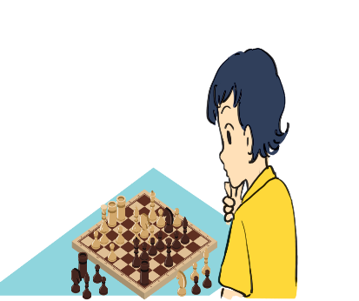  1 | 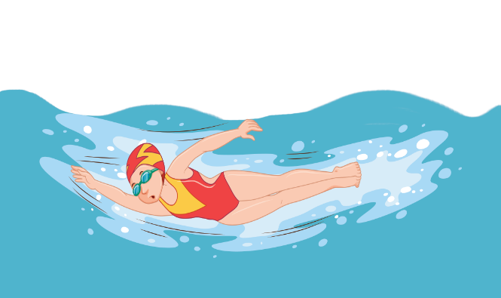  2 | 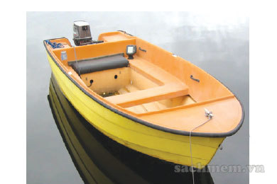  3
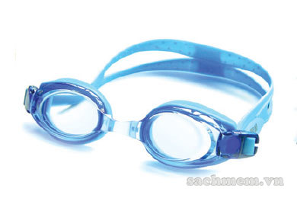  8 | - - What is this?  - What do you see in the picture?  - - How do you spell it?  - - What are they doing?  - What are they wearing?  - - It’s one of the objects to protect your eyes when you swim.  - It’s a round object that is hit or thrown or kicked in games.  8  7  - It’s small vehicle for travelling on water .  - It’s an object used for hitting the ball when playing badminton. | 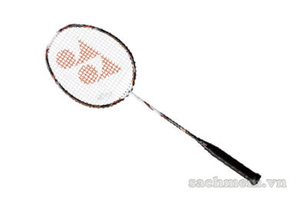  4
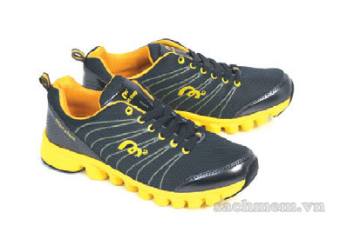  7 | 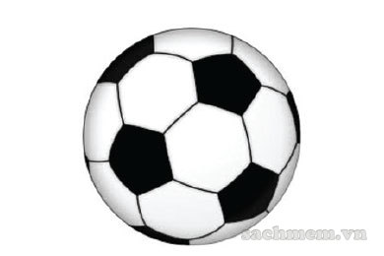  6 | 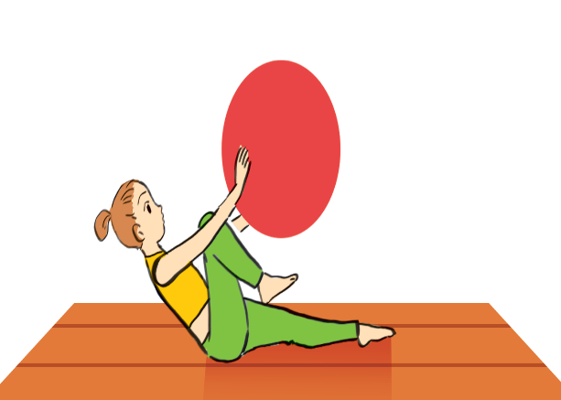  5

