UNIT 2. HEALTHY LIVING
PART 1. THEORY
I. VOCABULARY
No. | English | Type | Pronunciation | Vietnamese
1 | chapped lips | n | /tʃæpt lɪps/ | môi bị nứt nẻ
2 | dentist | n | /'dentɪst/ | nha sỹ
3 | dim light | n | /dɪm laɪt/ | ánh sáng yếu, mờ
4 | doctor | n | /'dɒktə(r)/ | bác sỹ
5 | earache | n | /’ɪəreɪk/ | đau tai
6 | fever | n | /'fi:və(r)/ | sốt
7 | flu | n | /flu:/ | cúm
8 | headache | n | /'hedeɪk/ | đau đầu
9 | lip balm | n | /lɪp bɑːm/ | son dưỡng môi
10 | lunch box | n | /lʌntʃ bɒks/ | hộp cơm trưa
11 | medicine | n | /'medsn/ | thuốc
12 | neighbourhood | n | /'neɪbərhʊd/ | hàng xóm, láng giềng
13 | nurse | n | /nɜ:s/ | y tá
14 | patient | n | /'peɪʃnt/ | bệnh nhân
15 | pharmacy | n | /'fɑːməsɪ/ | hiệu thuốc
16 | red spot | n | /red spɒt/ | đốm đỏ
17 | soft drink | n | /sɒft drɪηk/ | nước ngọt
18 | sore throat | n | /sɑː'θrəʊt/ | đau họng
19 | stomach ache | n | /'stʌmək eɪk/ | đau bụng
20 | sunburn | n | /'sʌnbɜ:n/ | cháy nắng, sạm da
21 | sun cream | n | /'sʌn krɪrm/ | kem chống nắng
22 | temperature | n | /'temprətʃə(r)/ | sốt
23 | toothache | n | /'tu:θeɪk/ | đau răng

II. GRAMMAR
Simple sentences
- Câu đơn là cầu diễn tả 1 ý. Nó thường có 1 chủ ngữ và 1 động từ.
Ex. Tom sleeps. (Tom ngủ.)
James is reading. (James đang đọc.)
- Một số cầu đơn có thêm tân ngữ
Ex. I go to school. (Tôi đi học.)
He plays football. (Anh ấy chơi đá bóng.)
- Một số câu đơn có thêm cả trạng ngữ.
Ex. Tom drives carefully. (Tom lái xe cẩn thận.)
They often play football on Sunday. (Họ thường chơi đá bóng vào Chủ nhật.)
iii. PHONETICS

Sound /f/ and /v/

1. Cách phát âm âm /f/ và âm /v/
a. Cách phát âm âm /f/
/f/ là một phụ âm vô thanh. Âm này rất đơn giản. Để phát âm âm này, ta để răng chạm vào môi dưới. Sau đó, thổi hơi ra qua răng và môi. Dây thanh không rung. | 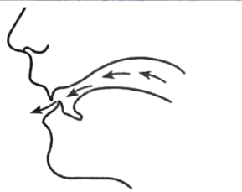

b. Cách phát âm âm /v/
/v/ là một phụ âm hữu thanh. Âm này cũng rất đơn giản. Để phát âm âm này, ta để răng chạm vào môi dưới. Sau đó thổi hơi ra qua răng và môi rồi đẩy luồng hơi ra. Đây là âm hữu thanh nên dây thanh quản có rung. | 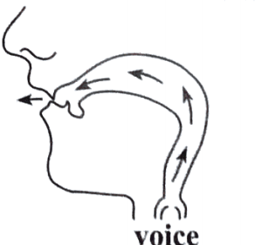
2. Listen and repeat these words. Track 04
/f/ | food | five | face | famous
 | /fu:d/ | /faɪv/ | /feɪs/ | /'feɪməs/
/v/ | voice | advice | victory | volume
 | /vaɪs/ | /əd'vaɪs/ | /'vɪktərɪ/ | /'vɒlju:m/

PART 2. LANGUAGE
I. VOCABULARY
Exercise 1. Find the odd one out among A, B, C or D.
1. A. cough B. weak C. headache D. sore throat
2. A. sunburn B. toothache C. earache D. unhealthy
3. A. sick B. temperature C. tired D. weak
4. A. flu B. stomachache C. allergy D. fat
5. A. sleep B. happy C. live D. smile
6. A. sick B. tired C. sore D. fit
7. A. cough B. flu C. sunshine D. sunburn
8. A. sleep B. rest C. relax D. work
9. A. and B. but C. so D. although
10. A. healthy B. fit C. well D. sick
Exercise 2. Fill in each blank with the correct health problem from the box according to the description.
toothache | headache | stomachache | flu
gore throat | backache | earache | cough
1. ______________: a pain caused by something being wrong with one of your teeth.
2. ______________: a pain in your back.
3. ______________: a very severe pain that you feel in your head.
4. ______________: pain in your stomach.
5. ______________: a pain in the inside part of your ear.
6. ______________: a problem which is like a very bad cold, but which causes a temperature.
7. ______________: a pain in your throat.
8. ______________: a health problem that you make a lot of loud sounds.
Exercise 3. Look at the pictures and complete with suitable words.
sore throat | pharmacy | allergy | plaster | cough | hot
flu | dizzy | dentist | doctor | surgeon | backache

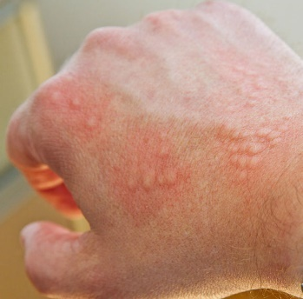 | 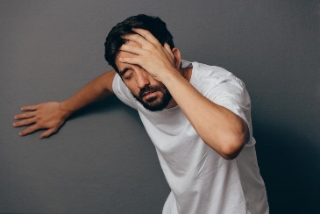 | 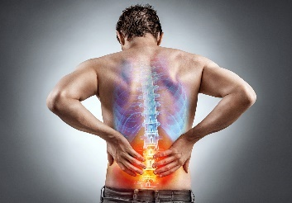 | 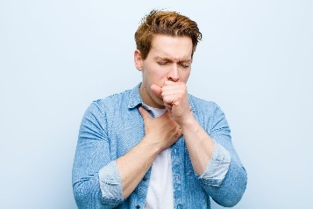
1. _______________ | 2. _______________ | 3. _______________ | 4. _______________
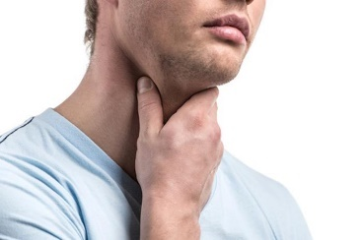 | 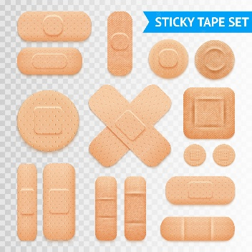 |  | 
5. _______________ | 6. _______________ | 7. _______________ | 8. _______________
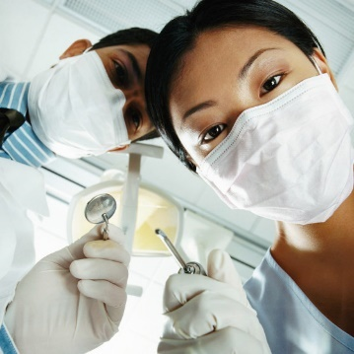 | 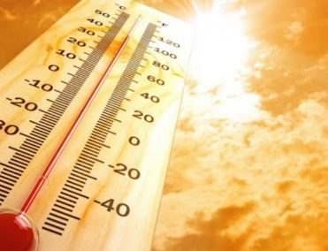 | 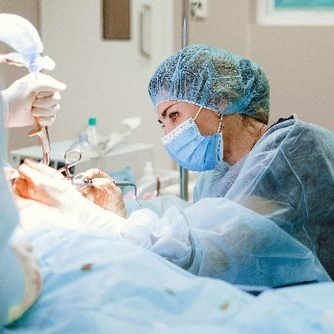 | 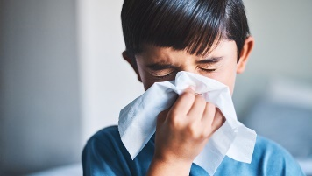
9. _______________ | 10. _______________ | 11. _______________ | 12. _______________
Exercise 4. Fill in the blank with a word in the box.
obesity | rest | sun hat | allergic | clean
exercise | bright eyes | put on | tooth decay | spending
1. If you brush your teeth regularly, you will not have _____________.
2. You look tired. You should more _____________.
3. Today the weather is cold, so you should _____________ your warm clothes.
4. Some people are _____________ to crabs.
5. If you want to be healthy, you should eat less fast food and do more _____________.
6. Today it is very hot. Please wear a _____________ when you go out.
7. Eating too many sweets and fast foods causes health problems such as tooth decay, _____________.
8. Eating carrots regularly will help you have _____________.
9. You can avoid some diseases by keeping your hands _____________.
10. _____________more time on computer games may lead to sore eyes.
Exercise 5. Fill in each blank with a word in the box.
dry | provide | health | swimming | stay
physical | flu | weight | getting | exercise
1. In order to have good _____________, you should eat lightly and laugh cheerfully.
2. My father does morning _____________ every day.
3. Do you want to know how you can _____________ healthy?
4. You should eat a lot of fruits and vegetables because they _____________ vitamin A, which is good for the eyes.
5. If you want to be fit, stay outdoors more and do more _____________ activities.
6. Eat less junk high-fat food to keep you from _____________ fat.
7. He plays computer games and watches TV a lot so his eyes are often _____________.
8. He eats a lot of burgers and chips so he's putting on _____________.
9. They sometimes go _____________ even when it's cold.
10. To prevent _____________, you should eat a lot of garlic and keep your body warm.
II. GRAMMAR
Exercise 1. Write T for the simple sentences. Write F for not simple sentences.
1. I like fish but I don’t like pork. _______
2. James drinks two bottles of water every day. _______
3. My mother often drinks orange juice. _______
4. Linda is tall and beautiful. _______
5. You should eat more vegetables. _______
6. My sister always wears sunglasses when she goes out in summer.
Exercise 2. Reorder the words to have correct sentences.
1. food./ mother/ My/ healthy/ often/ eats/
__________________________________________________________________.
2. likes/ pizzas,/ fast food/ Tom/ sandwiches./ and Linda/ such as/
__________________________________________________________________.
3. sometimes/ We/ beef noodles./ eat/
__________________________________________________________________.
4. usually/ and fruit./ eats/ Mr. Long/ vegetables/
__________________________________________________________________.
5. often/ What/ breakfast?/ do/ you/ have/ for/
__________________________________________________________________.
6. hot/ today./ go out/ Don’t/ very/ because/ it’s/
__________________________________________________________________.
7. you/ How often/ morning/ exercise?/ do/ do/
__________________________________________________________________.
8. avoids/ Tuan/ and/ soft drinks./ often/ sweetened food/
__________________________________________________________________.
Exercise 3. Write complete sentences basing on the given words.
1. It/ cold/ outside./ Not go out.
__________________________________________________________________.
2. Apples/ very good/ health.
__________________________________________________________________.
3. Lots/ children/ have/ chapped lips/ this season.
__________________________________________________________________.
4. Long and Tuan/ not do/ morning exercise/ every day.
__________________________________________________________________.
5. You/ shouldn’t/ eat/ too much/ fast food./ You/ should/ eat/ more vegetables/ and fruit.
__________________________________________________________________.
6. We/ often/ play football/ school.
__________________________________________________________________.
7. My friends/ love/ outdoor/ and/ indoor/ activities.
__________________________________________________________________.
8. We/ should/ wear/ hat/ and sunscreen/ avoid damage from/ sun.
__________________________________________________________________.
Exercise 4. Write complete sentences basing on the given words.
1. How/ you/ go to school/ ?
__________________________________________________________________.
2. what/ your/ job/ ?
__________________________________________________________________.
3. where/ John/ come from/ ?
__________________________________________________________________.
4. how long/ it/ take/ from London/ Paris/ ?
__________________________________________________________________.
5. how often/ she/ go to the cinema/ ?
__________________________________________________________________.
6. when/ you/ get up/ ?
__________________________________________________________________.
7. how often/ you/ study English/ ?
__________________________________________________________________.
8. what time/ film/ start/ ?
__________________________________________________________________.
9. where/ you/ play tennis/ ?
__________________________________________________________________.
10. what sports/ Linda/ like/ ?
__________________________________________________________________.
Exercise 5. Put the verbs in brackets in the correct form.
1. I (be) __________ at school at the weekend.
2. She (not study) __________ on Friday.
3. My students (be) __________ hard-working.
4. He (have) __________ a new haircut today.
5. I usually (have) __________ breakfast at 7.00.
6. (She/ live) __________ in a house?
7. Where (be) __________ your children?
8. My sister (work) __________ in a bank.
9. Dogs (like) __________ meat.
10. She (live) __________ in Florida.
11. It (rain) __________ almost every day in Manchester.
12. We (fly) __________ to Spain every summer.
13. My mother (fry) __________ eggs for breakfast every morning.
14. The bank (close) __________ at four o'clock.
Exercise 6. Put the verbs in brackets in the correct form.
1. Nam looks brown. He was on holiday last week. He (get) __________ sunburn.
2. Relaxing is very good. It (help) __________ you to avoid depression.
3. The Japanese (eat) __________ a lot of fish so they are very intelligent.
4. If you wash your hands more, you (have) __________ less chance of catching flu.
5. Eating carrots regularly (help) __________ you see better.
6. It is very hot outside. Please (wear) __________ a sun hat when you go out.
7. Do more exercise and you (feel) __________ healthier.
8. I don’t want (be) __________ tired tomorrow, so I go to bed early.
9. Nowadays, I don’t feel well. I often (feel) __________ sick and weak.
10. People who (smile) __________ more are happier and live longer.
III. PHONETICS
Listen and circle the words you hear. TRACK 5
1. fan/van  2. fight/vice  3. photo/vote  4. fat/vet  5. field/view  6. Feast/vest  7. fine/vine  8. food/move  9. furious/various  10. orphan/oven | 11. half/halve  12. fill/veal  13. leaf/leave  14. fiction/victory  15. feasible/available  16. fight/invite  17. prove/proof  18. fictitious/vicious  19. phrase/vase  20. sniff/Steave

PART 3. COMMUNICATION SKILLS
I. LISTENING
Listen and do the tasks followed. Track 06
Exercise 1. Listen and decide if each statement is True (T) or False (F).
1. Mary doesn’t have dinner.  2. Mary has a brother called Tim.  3. Tim doesn’t have breakfast.  4. Tim doesn’t do any kind of exercises.  5. Tim is a hard-working person, and he may not get enough sleep. | ________________  ________________  ________________  ________________  ________________
Exercise 2. Listen again and answer the questions.
1. Where does Mary study?
_________________________________________________________________.
2. What does Mary usually have for breakfast?
_________________________________________________________________.
3. Does Mary like milk?
_________________________________________________________________.
4. What does Mary have for lunch?
_________________________________________________________________.
5. Does Mary do any kind of exercises?
_________________________________________________________________.
II. SPEAKING
Exercise 1. Read the conservation and answer the questions.
Phong: What time do you usually come home from school?
Nick: I usually come home at 11.30.
Phong: When do you often have lunch?
Nick: I often have lunch at 12 o’clock.
Phong: What do you usually have for lunch?
Nick: I often have fish and eggs.
Phong: What do you do after dinner?
Nick: I sometimes go to the cinema, but I usually stay at home, watch TV and do my homework.
Phong: Do you often watch TV?
Nick: Yes, I do. I like watching sports very much.
Phong: When do you go to bed?
Nick: I always go to bed at 9.30.1 never stay up late.
Questions:
1. What time does Nick usually come home from school?
_________________________________________________________________.
2. When does he often have lunch?
_________________________________________________________________.
3. What does he usually have for lunch?
_________________________________________________________________.
4. What does he often do after dinner?
_________________________________________________________________.
5. What TV programme does he like watching?
_________________________________________________________________.
Exercise 2. Rearrange the conversation in the correct order then write your answers in each blank.
a. Mary: You shouldn't eat so much in the evening.
b. Mary: Oh, dear. How long have you had that?
c. Daisy: I know. What should I do now?
d. Mary: You don’t look very well. Are you OK?
e. Daisy: No. I have a stomachache.
f. Mary: So take some medicine and go to bed.
g. Daisy: I don’t like going to the doctor.
h. Daisy: Good idea.
i. Daisy: It started last night. I ate a big Chinese meal.
j. Mary: You should go to the doctor.
Your answer:
1. | 2. | 3. | 4. | 5. | 6. | 7. | 8. | 9. | 10.
III. READING
Exercise 1. Choose the word which best fits each gap.
Breakfast is the (1) _____________ important meal of the day. It provides the nutrients your body needs for good health, the calories it needs for (2) _____________ and helps to maintain your blood sugar level. Studies have shown that people who don’t have breakfast have a low blood sugar level and are often slow, tired, hungry and (3) _____________ to concentrate. Surprisingly, breakfast actually plays a part in weight control. It's easier to (4) _____________ weight if you eat in the morning rather than later in the day. Dividing the day’s calories (5) _____________ three meals helps take off weight more efficiently than (6) _____________ breakfast and having two larger meals a day does.
1. A. healthy B. tasty C. main D. most
2. A. strength B. power C. energy D. effort
3. A. able B. enable C. unable D. capable
4. A. lose B. put C. gain D. drop
5. A. in B. into C. up D. for
6. A. skipping B. making C. buying D. serving
Exercise 2. Read the text and choose the best option.
It’s important to (1) _____________ well, especially when you are studying. If you are at primary (2), _____________ you may not go home for lunch and have a cooked meal of meat or (3) _____________ and vegetables. A chicken and lettuce sandwich, with some (4) _____________ fruit would be a light but (5) _____________ lunch. Many people around the world eat plain, boiled (6) _____________ two or three times a day. Pupils and students often don’t eat (7) when they’re revising for an exam - they eat chocolate and (8) lots of black coffee! And by the way, doctors say everybody should start the day with healthy (9). It’s also good for you to drink a lot of (10) through the day.
1. A. launching B. emitting C. eat D. peaking
2. A. school B. weapons C. spaceships D. rockets
3. A. to B. towards C. with D. fish
4. A. as soon as B. fresh C. as well as D. such as
5. A. burnt B. explored C. went off D. healthy
6. A. rice B. audience C. observatories D. watcher
7. A. sent back B. returned to C. well D. except for
8. A. weightlessness B. drink C. wavelengths D. length
9. A. space B. atmosphere C. vacant D. breakfast
10. A. scientists B. drivers C. water D. astronauts
Exercise 3. Choose the correct word A, B, or C for each gap to complete the following passage.
We need calories or (1) to do the things every day. For example, when we walk to school or (2) a bike to school we spend a certain amount of (3) and even when we sleep, we also use them. But how many calories should we (4) a day to stay in shape? It’s difficult (5) us to calculate. If people want to keep (6), they should remember that everyone should have between 1600 and 2500 calories a day.
We get calories (7) the food we eat. If we get too many food and don’t take part (8) any activities, we can get fat quickly. So besides studying, we should do some (9), play sports or do the housework, such as cleaning the floor, cooking etc. Otherwise, we don’t eat enough, we will be (10) and weak.
1. A. food B. energy C. drink
2. A. ride B. come C. drive
3. A. things B. food C. calories
4. A. do B. spend C. have
5. A. for B. with C. in
6. A. health B. fit C. Active
7. A. in B. of C. from
8. A. with B. in C. on
9. A. exercise B. activity C. healthy
10. A. good B. tired C. thirsty
IV. WRITING
Exercise l. Make sentences using the words and phrases given.
Example: Dr. Minh / diet / expert/.
Dr. Minh is a diet expert.
1. Relaxing/ really/ important.
_____________________________________________________________________.
2. It/ easy/ get/ flu/./ we/ should/ try/ avoid/ go out/ cold weather./
_____________________________________________________________________.
3. I/ have/ toothache/ yesterday/ because/1 eat/ many/ sweets/.
_____________________________________________________________________.
4. He/ has/ flu/./ he/ keep/ sneezing/ coughing/.
_____________________________________________________________________.
5. Which/ activity/ use/ more/ calories:/ walking/ or/ riding/ bicycle/ ?
_____________________________________________________________________.
6. You/ not/ play/ computer games/ in/ free time.
_____________________________________________________________________.
7. Doctor/ asking/ Mai/ questions/ about/ health problems.
_____________________________________________________________________.
8. Vitamins/ play/ important/ role/ our diet.
_____________________________________________________________________.
9. We/ keep/ our bodies/ warm/ avoid/ cold.
_____________________________________________________________________.
10. Getting/ enough/ rest/ help/ you/ concentrate/ school.
_____________________________________________________________________.
Exercise 2. Find a mistake in the four underlined parts of each sentence.
1. Laughing (A) is good (B) with (C) health (D).
2. Some (A) people have a (B) very bad (C) habit in (D) littering in public.
3. People who live (A) in a dusty area (B) often suffer (C) on (D) diseases.
4. In (A) prevent flu, we should keep (B) our hands clean (C), and our feet warm (D).
5. She (A) has (B) a (C) sore throat yesterday (D).
Exercise 3. Make sentences using the words and phrases given. Choose the correct answer for each sentence.
1. Do / exercise I regularly / help I you I stay I healthy.
A. Doing exercise regularly helps you stay healthy.
B. Doing exercise regularly help you stay healthy.
C. Do exercise regularly helps you stay healthy.
D. Doing exercise regularly helps you are stay healthy.
2. We I need I calories I or I energy I do / things / every day.
A. We need calories or energy do things every day.
B. We need calories or energy doing things every day.
C. We needs calories or energy do things every day.
D. We need calories or energy to do things every day.
3. We I should I balance / calories I we I get/from/food / with / calories / we / use/physical activity.
A. We should balance calories we get from food with calories we use physical activity.
B. We should balance calories we get from food with calories we use for physical activity.
C. We should be balance calories we get from food with calories we use physical activity.
D. We should balances calories we get from food with calories we use to physical activity.
4. Eat / healthy/ be / important /part / maintain / good / health.
A. Eat healthily is important part to maintain good health.
B. Eat healthily is an part important to maintain good health.
C. Eating healthily is an important part to maintain good health.
D. Eating healthily is a important part to maintain good health.
5. Eat / less / sweet/food / and / eat / more/fruit / vegetables.
A. Eating less sweet food and eat more fruits and vegetables.
B. Eating less sweet food and eating more fruits and vegetables.
C. Eating less sweet food and to eat more fruits and vegetables.
D. Eat less sweet food and eat more fruits and vegetables.
6. Drink I lots I water I be /good / our health.
A. Drinking lots of water is good for our health.
B. Drink lots of water is good for our health.
C. Drinking a lots of water is good for our health.
D. Drink a lots of water is good for our health.
7. I / have / toothache / so /I / have to /see / dentist.
A. I have a toothache so I have to see dentist.
B. I have toothache so I have to see dentist.
C. I have a toothache so I have to see the dentist.
D. I have toothaches so I have to see the dentists.
8. Watch / much / TV / not/good/your eyes.
A. Watch much TV is not good for your eyes.
B. Watching much TV are not good for your eyes.
C. Watch too much TV is not good for your eyes.
D. Watching too much TV is not good for your eyes.
9. When/I/ ten/ begin/play football.
A. When I was ten, I began to play football.
B. When I was ten, I begin to play football.
C. When I am ten, I began to play football.
D. When I was ten, I began play football.
10. Calories/important/human /health.
A. Calories are important for human health.
B. Calories is important for human health.
C. Calories are important with human health.
D. Calories is important with human health.

