Unit 8: Shopping

A. VOCABULARY

No. | Word/ Phrase | Type | IPA | Meaning
1 | access | n | /ˈækses/ | nguồn để tiếp cận, truy cập vào
2 | addicted | adj | /əˈdɪktɪd/ | say mê, nghiện
3 | advertisement | n | /ədˈvɜːtɪsmənt/ | quảng cáo
4 | bargain | v | /ˈbɑːɡən/ | mặc cả
5 | complaint | n | /kəmˈpleɪnt/ | lời phàn nàn / khiếu nại
6 | convenience store | n | /kənˈviː.ni.əns ˌstɔːr/ | (cửa hàng) tiện ích
7 | customer | n | /ˈkʌstəmə(r)/ | khách hàng
8 | discount shop | np | /ˈdɪs.kaʊnt ʃɒp/ | (cửa hàng) hạ giá
9 | display | n/v | /dɪˈspleɪ/ | sự trưng bày; bày biện; trưng bày
10 | dollar store | n | /ˈdɒl.ə ˌstɔːr/ | cửa hàng đồng giá (1 đô la)
11 | fair | n | /feə(r)/ | hội chợ
12 | goods | n | /ɡʊdz/ | hàng hóa
13 | farmers’ market | n | /ˈfɑː.məz ˌmɑː.kɪt/ | chợ nông sản
14 | home-grown | adj | /ˌhəʊmˈɡrəʊn/ | tự trồng
15 | home-made | adj | /həum meid/ | tự làm
16 | item | n | /ˈaɪ.t̬əm/ | món hàng
17 | on sale | adj | /ɒn seɪl/ | đang (được bán) hạ giá
18 | open-air market | np | /ˌəʊ.pənˈeər ˌmɑː.kɪt/ | chợ ngoài trời
19 | price tag | np | /ˈpraɪs ˌtæɡ/ | nhãn giá một mặt hàng
20 | schedule | n | /ˈʃedjuːl/ | lịch trình, thời gian biểu
21 | shopaholic | n | /ˌʃɒp.əˈhɒl.ɪk/ | người nghiện mua sắm
22 | shopping | n | /ˈʃɒpɪŋ/ | việc mua sắm
23 | shopping center | np | /ˈʃɒp. ɪŋ ˌsen.tər/ | trung tâm mua sắm
24 | shopping list | np | /ˈʃɒp.ɪŋ lɪst/ | danh sách những thứ cần được mua
25 | speciality (shop) | n | /ˌspeʃiˈæləti/ | (cửa hàng) bán đồ chuyên dụng
26 | similar | adj | /ˈsɪmələ(r)/ | tương tự
27 | rarely | adv | /ˈreəli/ | hiếm khi
28 | fixed price | np | /fɪkst praɪs/ | giá cố định
29 | browse | v | /braʊz/ | duyệt
30 | supermarket | n | /ˈsuːpəmɑːkɪt/ | siêu thị
31 | online shop | np | /ˈɒn.laɪn ʃɒp/ | cửa hàng trực tuyến
32 | outdoor | adj | /ˈaʊtdɔː(r)/ | ngoài trời
33 | specific | adj | /spəˈsɪfɪk/ | cụ thể
34 | outstanding | adj | /aʊtˈstændɪŋ/ | nổi bật
35 | assistant | n | /əˈsɪstənt/ | trợ lí
36 | spicy | adj | /ˈspaɪsi/ | cay
37 | never | adv | /ˈnevə(r)/ | không bao giờ
38 | whole | adj | /həʊl/ | toàn bộ, trọn
39 | birthday cake | np | /ˈbɜːθdeɪ/ /keɪk/ | bánh sinh nhật
40 | neighborhood | n | /ˈneɪ.bə.hʊd/ | hàng xóm / khu phố
41 | expire | v | /ɪkˈspaɪər/ | hết hạn
42 | backpack | n | /ˈbækpæk/ | balo
43 | advertise | v | /ˈædvətaɪz/ | quảng cáo
44 | yellowish | adj | /ˈjel.əʊ.ɪʃ/ | hơi vàng
45 | buy goods | vp | /baɪ gʊdz/ | mua hàng
46 | attract | v | /əˈtrækt/ | thu hút
47 | touch | v | /tʌtʃ/ | chạm
48 | try on | phr.v | /traɪ ɒn/ | mặc thử
49 | year-round | adv | /ˌjɪə ˈraʊnd/ | quanh năm
50 | wander | v | /ˈwɒndə(r)/ | đi lang thang
51 | popularity | n | /ˌpɒpjuˈlærəti/ | sự phổ biến
52 | advantage | n | /ədˈvɑːntɪdʒ/ | lợi thế
53 | disadvantage | n | /ˌdɪsədˈvɑːntɪdʒ/ | bất lợi
54 | mainly | adv | /ˈmeɪnli/ | chủ yếu
55 | credit card | np | /ˈkred.ɪt ˌkɑːrd/ | thẻ tín dụng
56 | worth | adj | /wɜːθ/ | đáng giá
57 | shuttle bus | np | /ˈʃʌt.əl bʌs/ | xe buýt đưa đón
58 | brand | n | /brænd/ | thương hiệu
59 | service | n | /ˈsɜːvɪs/ | dịch vụ
60 | episode | n | /ˈepɪsəʊd/ | tập phim

B. WORD FORM
1. advertise (v): quảng cáo  => advertisement (n): quảng cáo, mẩu quảng cáo  => advertising (n): ngành/hoạt động quảng cáo  => advertiser (n): người/công ty quảng cáo  => advertised (adj): được quảng cáo | 6. advantage (n): lợi thế  => advantageous (adj): có lợi  => advantageously (adv): một cách có lợi  => disadvantage (n): bất lợi  => disadvantageous (adj): bất lợi
2. service (n/v): dịch vụ / phục vụ  => serviceable (adj): có thể sử dụng được, hữu ích  => servicing (n): việc bảo dưỡng, phục vụ  => server (n): người phục vụ, máy chủ | 7. specific (adj): cụ thể  => specifically (adv): một cách cụ thể  => specification (n): sự chỉ rõ, bản mô tả chi tiết  => specify (v): chỉ rõ, nêu cụ thể  => specificity (n): tính cụ thể
3. access (n/v): quyền truy cập / truy cập  => accessible (adj): có thể tiếp cận được  => inaccessible (adj): không thể tiếp cận  => accessibility (n): khả năng tiếp cận  => accessibly (adv): một cách dễ tiếp cận | 8. assist (v): hỗ trợ  => assistance (n): sự hỗ trợ  => assistant (n): người trợ lý  => assisted (adj): được hỗ trợ  => assisting (adj): đang hỗ trợ
4. attract (v): thu hút  => attraction (n): sự thu hút, điểm thu hút  => attractive (adj): hấp dẫn, thu hút  => attractively (adv): một cách hấp dẫn  => attractiveness (n): sự hấp dẫn  => unattractive (adj): không hấp dẫn | 9. complain (v): phàn nàn  => complaint (n): lời phàn nàn, khiếu nại  => complainer (n): người hay phàn nàn  => complaining (adj/n): đang phàn nàn / sự phàn nàn  => uncomplaining (adj): không phàn nàn
5. popular (adj): phổ biến  => popularly (adv): một cách phổ biến  => popularity (n): sự phổ biến  => popularize (v): làm cho phổ biến  => unpopular (adj): không phổ biến | 10. discount (n/v): giảm giá / chiết khấu  => discounted (adj): được giảm giá  => discounting (n): việc giảm giá  => discountable (adj): có thể được giảm giá  => discounter (n): cửa hàng giảm giá

C. GRAMMAR (ADVERBS OF FREQUENCY & PRESENT SIMPLE FOR FUTURE EVENTS) (Trạng từ tần suất & thì hiện tại đơn cho sự việc tương lai)
Mục | Quy tắc / Cấu trúc | Ghi chú nhanh | Ví dụ
1) Adverbs of Frequency là gì? | Trạng từ chỉ tần suất: always, usually, often, sometimes, rarely/seldom, never | Dùng để nói mức độ “hay/ít khi” xảy ra | I usually walk to school.
2) Thang tần suất (cao → thấp) | always (100%) → usually → often → sometimes → rarely/seldom → never (0%) | Không cần thuộc % chính xác; chỉ nhớ thứ tự | She always helps. / He rarely cooks.
3) Vị trí trong câu (1) – với động từ thường | S + adv + V | Đặt trước động từ chính | They often go shopping.
4) Vị trí trong câu (2) – với “be” | S + be + adv | Đặt sau am/is/are/was/were | She is always polite.
5) Vị trí trong câu (3) – trợ động từ | S + aux + adv + V | Aux: do/does, will, can, have… | I don’t usually eat late. / He has never been there.
6) “Sometimes / Usually / Often” đầu câu | Adv + S + V… | Dùng để nhấn mạnh/đa dạng câu | Sometimes, I study at night.
7) Present Simple (hiện tại đơn) – công thức | (+) S + V(s/es); (-) S + don’t/doesn’t + V; (?) Do/Does + S + V? | He/She/It → V(s/es) | She works. / He doesn’t work. / Does she work?
8) Hiện tại đơn + trạng từ tần suất | Kết hợp theo đúng vị trí ở mục 3–5 | Rất hay dùng trong nói thói quen | He often plays football. / She is never late.
9) Present Simple dùng cho tương lai khi nào? | Dùng cho lịch trình cố định / thời khóa biểu / lịch tàu xe / chương trình | Không phải “kế hoạch cá nhân” (kế hoạch cá nhân thường dùng be going to / will) | The train leaves at 6:30 tomorrow.
10) Dấu hiệu nhận biết “future events” | Từ chỉ thời gian tương lai: tomorrow, next week, on Monday, in January… nhưng nội dung phải là schedule | Có thể có “tomorrow/next…” vẫn là Present Simple nếu là lịch cố định | The show starts next Friday.
11) Câu hỏi về lịch trình (future) | What time does + S + V…? / When does + S + V…? | Hỏi giờ khởi hành/mở cửa/bắt đầu… | What time does the bus arrive tomorrow?
12) So sánh nhanh: Present Simple vs be going to | Present Simple: lịch cố định; be going to: kế hoạch/dự định cá nhân | Mẹo: “có timetable không?” Nếu có → Present Simple | The plane departs at 9. / I’m going to travel next week.
13) Lỗi thường gặp | (a) Đặt sai vị trí adv; (b) Dùng Present Simple cho kế hoạch cá nhân; (c) “never” không đi với “not” | “never” đã mang nghĩa phủ định | Sai: He goes often. → Đúng: He often goes. / Sai: I don’t never…
14) Mẫu câu nhanh để áp dụng | S + usually/often/sometimes + V… / S + be + always/never… / The + schedule + V(s/es) + time + tomorrow | Dùng luôn để viết câu | I usually study at 8. / The bus leaves at 10:05 tomorrow.

D. EXERCISES
❖ PHONETIC
Exercise 1: Choose the word (A, B, C, or D) whose underlined part is pronounced differently from the others.
1. A. bag B. sale C. cash D. map
2. A. discount B. amount C. about D. boutique
3. A. cheap B. change C. machine D. purchase
4. A. reduce B. return C. refund D. receipt
5. A. price B. till C. list D. bill
6. A. shop B. store C. cost D. money
7. A. pay B. trade C. sale D. staff
8. A. goods B. food C. floor D. choose
9. A. customer B. push C. budget D. run
10. A. shelf B. sell C. deal D. check

Exercise 2: Choose the word (A, B, C, or D) whose main stress is different from the others in the group.
1. A. customer B. quality C. delivery D. popular
2. A. receipt B. coupon C. voucher D. trolley
3. A. exchange B. purchase C. payment D. counter
4. A. product B. service C. display D. fashion
5. A. online B. website C. shopping D. discount
6. A. basket B. checkout C. cashier D. bargain
7. A. expensive B. available C. department D. customer
8. A. clothing B. footwear C. jewelry D. reduce
9. A. grocery B. promotion C. customer D. furniture
10. A. manager B. computer C. assistant D. department

❖ VOCABULARY AND GRAMMAR
Exercise 1: Choose the word/ phrase/ sentence (A, B, C, or D) that best fits the space in each sentences or best answers the question.
1. My mother always writes a shopping _____ before going to the supermarket to buy food.
A. book B. list C. paper D. note
2. This fashion shop has a big window _____ showing all the new summer clothes.
A. display B. picture C. sign D. poster
3. I need to buy a new _____ to carry my heavy books to school every day.
A. basket B. pocket C. bag D. backpack
4. The small _____ on this blue shirt says it costs $15 after discount.
A. label B. price tag C. sticker D. mark
5. My sister is a real _____ — she goes shopping at the mall every single day!
A. shopaholic B. buyer C. spender D. collector
6. You can _____ through different websites to compare prices before buying online.
A. search B. look C. browse D. check
7. The new shopping _____ near my house has over 100 stores and restaurants.
A. center B. place C. area D. building
8. This winter jacket is _____ this week — it was 50, now it′s only 30!
A. cheap B. on sale C. free D. reduced
9. I buy fresh vegetables and fruits at the local _____ market every Saturday morning.
A. farmers' B. sellers' C. growers' D. planters'
10. You should always _____ the shoes in the store before buying them.
A. wear B. put C. try on D. test
11. Many young people prefer shopping at an _____ shop because it's convenient and fast.
A. internet B. online C. web D. digital
12. The big _____ in our town sells everything from fresh food to electronics.
A. supermarket B. restaurant C. library D. hospital
13. I saw an interesting TV _____ for a new smartphone yesterday evening.
A. advertisement B. show C. program D. movie
14. This organic store only sells _____ vegetables grown by local farmers without chemicals.
A. house-made B. home-grown C. self-made D. hand-picked
15. All the _____ at this luxury shop are high quality but quite expensive.
A. things B. objects C. goods D. materials
16. You need a valid _____ to pay for things online without using cash.
A. bank note B. credit card C. check book D. pay slip
17. My grandmother makes delicious _____ jam from fresh fruits in her garden.
A. home-made B. self-done C. house-built D. hand-done
18. The milk in the fridge will _____ tomorrow, so please drink it today.
A. finish B. end C. expire D. stop
19. Nike is a very famous international _____ for sports shoes and clothing.
A. name B. brand C. type D. model
20. This is a cheese _____ shop that only sells different types of cheese.
A. special B. unique C. single D. speciality
21. The convenience store near the station is open _____ — even during holidays.
A. all-time B. year-round C. every-season D. full-year
22. The 7-Eleven near my apartment is a 24-hour _____ store.
A. comfort B. easy C. convenience D. simple
23. I bought only three _____ at the store today: milk, bread, and eggs.
A. items B. pieces C. units D. parts
24. Everything at the _____ store on Main Street costs exactly one dollar.
A. cheap B. dollar C. single D. penny
25. The weekend _____ market sells fresh local produce in the open air.
A. outside B. outdoor C. external D. outer
26. Bright window displays _____ more customers to enter the store.
A. pull B. bring C. attract D. call
27. This store has _____ prices — you cannot negotiate or ask for discounts.
A. fixed B. stuck C. solid D. hard
28. This TV was a real _____ — I saved $200 during the clearance sale!
A. purchase B. bargain C. price D. cost
29. The opening _____ on the door shows the store hours for each day.
A. timetable B. schedule C. list D. plan
30. Many companies _____ their new products on social media to reach young customers.
A. show B. advertise C. present D. announce
31. I _____ make a complaint when the service is bad at a store.
A. rarely B. rare C. rarer D. rarity
32. She _____ goes to the farmers' market because she prefers fresh vegetables.
A. never B. always C. not D. no
33. My mom is _____ careful when checking the price tag before buying.
A. usually B. usual C. unusually D. use
34. The discount shop _____ opens at 9 AM every morning, including weekends.
A. usual B. usually C. always D. ever
35. We _____ shop at the convenience store because it's expensive.
A. often don't B. don't often C. not often D. doesn't often
36. _____ do you browse online shops for new clothes?
A. How often B. How many C. How much D. How long
37. The shopping center _____ at 10 PM tomorrow for the special sale event.
A. close B. closes C. is closing D. will closing
38. My sister _____ forgets to bring her shopping list to the supermarket.
A. sometimes B. sometime C. some time D. some times
39. The outdoor market _____ from 6 AM to noon on Saturdays.
A. open B. opens C. is open D. opening
40. He _____ tries on clothes before buying them from the store.
A. usual B. usually C. is usually D. does usually
41. _____ your neighborhood have a dollar store nearby?
A. Do B. Does C. Is D. Are
42. The fair _____ next Monday at the town square at exactly 8 AM.
A. start B. starts C. is starting D. will starting
43. I am _____ satisfied with the goods from this shop.
A. always B. every time C. all time D. each time
44. She doesn't _____ advertise her products on social media.
A. usually B. usual C. never D. ever
45. The open-air market is _____ crowded on Sunday mornings.
A. usual B. usually C. ever D. every
46. What time _____ the speciality shop open tomorrow morning?
A. do B. does C. is D. are
47. My credit card _____ expires after two years, so I renew it regularly.
A. never B. usually C. always D. rarely
48. They _____ go shopping together because they have different schedules.
A. rare B. rarely C. never often D. not
49. The store's schedule _____ that it opens at 9 AM on weekdays.
A. say B. says C. is saying D. will say
50. We _____ access this website to check product prices.
A. often B. are often C. often are D. do often
51. _____, I find a bargain at the weekend market.
A. Sometimes B. Sometime C. Some time D. Some times
52. The year-round sale _____ tomorrow at all brand stores.
A. begin B. begins C. is begin D. beginning
53. My backpack _____ lasts more than two years because I'm careful.
A. usual B. usually C. is usually D. does usually
54. She is _____ a shopaholic — she can't stop buying things!
A. always B. never C. definitely D. surely
55. The advertisement _____ on TV every evening at 7 PM.
A. show B. shows C. is show D. showing
56. Do you _____ buy home-made products from local sellers?
A. often B. often do C. do often D. are often
57. The new shopping mall _____ next month with fixed prices for all items.
A. open B. opens C. is open D. opening
58. I _____ never late for the store's outstanding clearance sales.
A. am B. do C. have D. will
59. _____ the online shop attract many customers with free shipping?
A. Do B. Does C. Is D. Are
60. She _____ shops for specific items; she just buys whatever she likes.
A. always B. usually C. often D. never

Exercise 2: Fill in the blank with the most suitable word/phrase.
1. I ________ go to expensive boutiques because I can't afford them.
2. The supermarket ________ at 10 PM every day, including weekends.
3. She is ________ late for the morning flash sales at the mall.
4. How ________ do you visit the farmers' market?
5. My father doesn't ________ buy things without comparing prices first.
6. The Christmas sale ________ tomorrow at exactly 9 AM.
7. ________, I find amazing deals at the thrift shop near my house.
9. What time ________ the store open on Sundays?
10. They ________ shop at that store because of the poor customer service.
11. The shopping center ________ a big sale next Monday morning.
12. I ________ often forget to bring my reusable shopping bags.
13. ________ the pharmacy close early tomorrow for inventory?
14. She sometimes ________ to use discount coupons when shopping.
15. The new mall branch officially ________ next week on Tuesday.

Exercise 3: Circle the correct option in brackets.
1. I (always / always am) check the expiry date before buying food products.
2. The shopping mall (opens / will open) at 8 AM tomorrow according to the schedule.
3. She (usually is / is usually) very careful when selecting fresh vegetables.
4. (How often / How many) do you go grocery shopping each month?
5. My mother (never shops / doesn’t shop) online because she prefers physical stores.
6. The clearance sale (starts / is starting) next Monday at all branches.
7. They (rarely go / go rarely) to expensive department stores.
8. (Does / Do) the convenience store open 24 hours on weekends?
9. We (don't usually / usually don't) buy products without reading customer reviews.
10. (Sometimes, / Sometimes) I find great bargains at the night market.
11. The supermarket (has always / always has) fresh bread in the morning.
12. What time (does / is) the store close on public holidays?
13. She (often forgets / forgets often) to bring her loyalty card when shopping.
14. The annual sale (begins / will beginning) tomorrow at 9 AM sharp.
15. He (is never / never is) satisfied with the customer service at that shop.

Exercise 4: Choose the letter A, B, C, or D to indicate the word(s) OPPOSITE in meaning to the underlined word(s) in each of the following sentences
1. My sister is addicted to shopping online; she can't stop buying things every day.
A. interested in B. independent from C. excited about D. worried about
2. These two shopping bags look very similar in size and color.
A. same B. equal C. different D. alike
3. I rarely go to the luxury stores because everything is too expensive.
A. seldom B. sometimes C. never D. frequently
4. The shop assistant was very helpful when I couldn't find the right size.
A. unhelpful B. friendly C. polite D. kind
5. My mother doesn't like spicy food, so she never buys hot chili sauce at the supermarket.
A. salty B. mild C. sour D. bitter

Exercise 5: Choose the letter A, B, C, or D to indicate the word(s) CLOSEST in meaning to the underlined word(s) in each of the following sentences
1. I spent the whole afternoon shopping for a birthday gift at the mall.
A. half B. some C. entire D. little
2. Customers can touch the fabric to feel its quality before buying clothes.
A. see B. smell C. hear D. feel
3. I like to wander around the night market looking at different items.
A. walk around B. run quickly C. sit down D. stand still
4. The popularity of online shopping has increased significantly among young people.
A. price B. fame C. quality D. size
5. The customer service at this store is excellent; they always help customers politely.
A. product B. assistance C. payment D. location

Exercise 6: Fill in each blank with the appropriate form of the word in brackets.
1. The new shopping mall has many colorful _______ on billboards to attract customers. (ADVERTISE)
2. The customer _______ at this supermarket is excellent; the staff are always helpful and polite. (SERVE)
3. This online store is easily _______ from any device with internet connection. (ACCESS)
4. The window display is very _______ with bright lights and beautiful decorations. (ATTRACT)
5. Online shopping has become increasingly _______ among teenagers in recent years. (POPULAR)
6. Shopping online has many _______, such as saving time and comparing prices easily. (ADVANTAGE)
7. Please _______ the size and color of the shoes you want to order. (SPECIFIC)
8. The shop _______ helped me find the perfect gift for my mother's birthday. (ASSIST)
9. If you have any _______ about the product quality, please contact our customer service. (COMPLAIN)
10. All winter clothes are _______ by 50% during the end-of-season sale. (DISCOUNT)

❖ COMMUNICATION
Exercise 1: Choose the word or phrase (A, B, C, or D) that best completes each of the following exchanges.
1. Shop assistant: "Can I help you with anything?"
Customer: "_________"
A. Yes, I'm looking for a blue T-shirt. B. No, you can't.
C. I don't like you. D. That's very expensive.
2. Anna: "How much is this dress?"
Shop assistant: "_________"
A. It's beautiful. B. It's 500,000 VND.
C. It's too small. D. I don't know anything.
3. Customer: "Do you have this shirt in size M?"
Shop assistant: "_________"
A. We don't sell shirts. B. The shirt is red.
C. Let me check for you. D. Size M is too big.
4. Tom: "The shoes I bought yesterday don't fit. Can I exchange them?"
Shop assistant: "_________"
A. That's your problem. B. Of course, if you have the receipt.
C. We never exchange anything. D. You should buy new ones.
5. Lisa: "This jacket is really nice but quite expensive."
Her friend: "_________"
A. You should wait for the sale next week. B. Don't buy any jacket.
C. I hate shopping. D. Expensive things are bad.
6. Customer: "Can I pay by credit card?"
Cashier: "_________"
A. We only accept cash. B. Credit cards are dangerous.
C. I don't have a credit card. D. You must pay now.
7. Mom: "Let's go to the supermarket to buy some groceries."
Son: "_________"
A. I never eat anything. B. OK, I'll help you carry the bags.
C. Supermarkets are boring. D. We don't need food.
8. Shop assistant: "Would you like to try it on?"
Customer: "_________"
A. I don't like trying. B. Yes, where is the fitting room?
C. No, I hate this store. D. Trying is difficult.
9. Jane: "Look! Everything is 30% off today!"
Mary: "_________"
A. That's terrible news. B. I don't believe in sales.
C. Great! Let's buy something. D. 30% is too little.
10. Customer: "Thank you for your help."
Shop assistant: "_________"
A. Don't thank me. B. I don't care.
C. That's not necessary. D. You're welcome. Have a nice day!

Exercise 2: Choose the correct answer (A, B, C, or D) to arrange the following sentences into a meaningful conversation.
1.
a. Lisa: I prefer online shopping. It's convenient and saves time.
b. Tom: Where do you usually go shopping?
c. Tom: Do you ever worry about the quality of products?
d. Lisa: Sometimes, but I always read reviews before buying anything.
A. a-b-c-d B. b-a-c-d C. c-d-a-b D. b-c-a-d
2.
a. Mom: We need milk, bread, eggs, and some vegetables.
b. Son: Should we go to the supermarket or the local market?
c. Mom: Let's go to the supermarket. They have a sale today.
d. Son: What do we need to buy for dinner?
e. Son: Great! I'll bring the shopping bags.
A. d-a-b-c-e B. a-b-c-d-e C. b-a-d-c-e D. a-d-b-c-e
3.
a. Customer: Yes, but do you have it in black?
b. Shop assistant: Good morning! Can I help you?
c. Shop assistant: Let me check our stock. Yes, we have black in your size.
d. Customer: I'm looking for a winter jacket, size L.
e. Shop assistant: This one is very popular. Would you like to try it?
f. Customer: Perfect! I'll take it.
A. b-d-e-a-c-f B. d-b-e-a-c-f C. b-e-d-a-c-f D. a-b-c-d-e-f

❖ READING
Exercise 1: Look at the sign or the notice. Choose the best answer (A, B, C or D) for these questions.
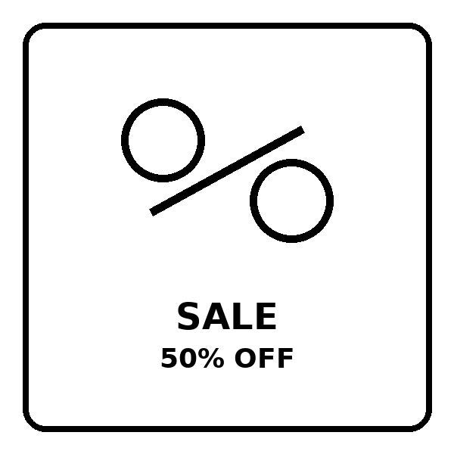 | 1. What does the sign tell shoppers?  A. Prices are higher today.  B. Items are discounted by 50 percent.  C. Buy one, get one free.  D. The shop is closed.

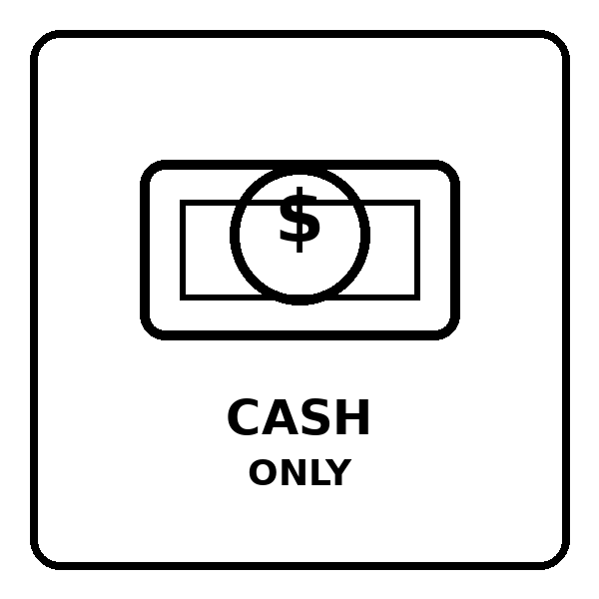 | 2. What does the notice ask customers to do?  A. Pay with cash only.  B. Pay with any credit card.  C. Get free cash at the counter.  D. Pay online only.

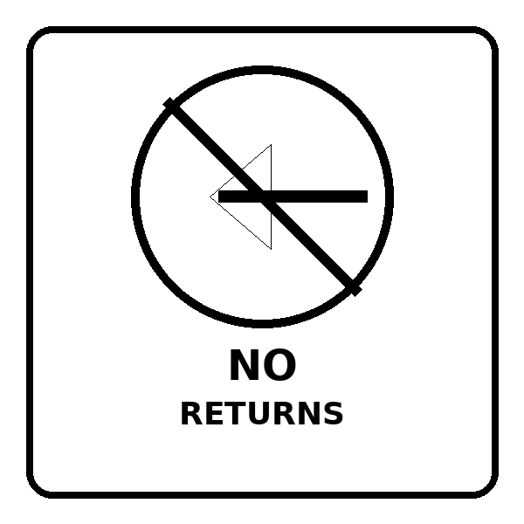 | 3. What does the sign mean?  A. You can return items anytime.  B. You must exchange every item.  C. You cannot return items after purchase.  D. Returns are free for all items.

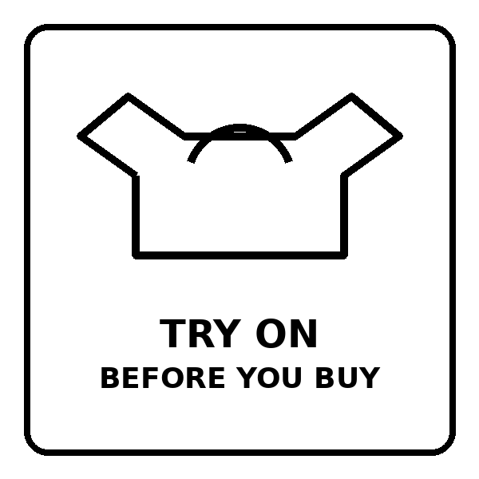 | 4. What does the sign advise you to do?  A. Try the clothes on before paying.  B. Do not use the fitting room.  C. Buy the item online.  D. Do not touch any products.

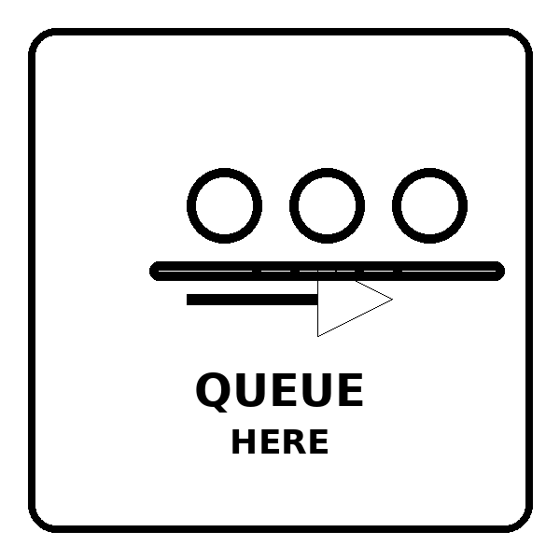 | 5. What should you do when you see this sign?  A. Enter through the back door.  B. Stand in line here.  C. Leave the store quickly.  D. Skip the line.

Exercise 2: Read the following advertisement/ notice/ flyer/ announcement and mark the letter A, B, C or D to indicate the correct option that best fits each of the numbered blanks
GRAND OPENING - SUNSHINE SHOPPING MALL
Your New Shopping Destination!
We are excited (1)_____ the opening of Sunshine Shopping Mall this Saturday! Located in the city center, our mall offers everything you need under one roof.
Special Opening Week Offers:
50% discount on all clothing items
Buy 2 Get 1 Free at the bookstore
Free parking for the first 100 customers
Shopping at our mall is (2)_____ because we have over 100 stores including fashion boutiques, electronics shops, and restaurants. You can spend (3)_____ whole day here with your family!
Our customer service team is always ready to (4)_____ you find what you need. We accept cash, credit cards, and mobile payment for your (5)_____.
Opening Hours: 9:00 AM - 10:00 PM daily
Don't miss our grand opening (6)_____! Free gift bags for children and special performances throughout the day.
Visit us at: 256 Main Street, City Center
For more information, call: 028-1234-5678
1. A. announcing B. to announce C. announce D. announced
2. A. boring B. convenient C. difficult D. expensive
3. A. a B. an C. the D. Ø
4. A. help B. helping C. helps D. helped
5. A. convenient B. conveniently C. convenience D. inconvenient
6. A. celebration B. celebrate C. celebrating D. celebrated

Shopping Habits in Modern Life
Shopping has changed a lot in recent years. Many people prefer (1)_____ online because it saves time and money. We can buy anything from clothes to food with just a few clicks on our phones.
My family usually (2)_____ shopping at the weekend. We make a list before going to avoid buying unnecessary things. At the supermarket, we always compare prices to find (3)_____ best deals. My mother teaches me to check the expiry dates on food products carefully.
However, online shopping also has some disadvantages. We cannot try on clothes or check the quality before buying. Sometimes the products look different from the pictures. That's why many people still enjoy going to (4)_____ shops to see and touch items directly.
Young people should learn (5)_____ money wisely when shopping. It's important not to spend more than we have. My parents always tell me to think twice before buying expensive things. Shopping can be fun, but we must be smart shoppers!
Remember, whether shopping online or in stores, always keep your receipts for exchanges or returns.
1. A. shop B. to shop C. shopping D. shopped
2. A. go B. goes C. going D. went
3. A. a B. an C. the D. Ø
4. A. physics B. physical C. physically D. physic
5. A. use B. using C. to use D. used

Exercise 3: Read the following passage and mark the letter A, B, C, or D to indicate the correct word that best fits each of the numbered blanks.
1.
Smart Shopping in Modern Times
Shopping has become much easier with technology. People can (1)_____ products online and receive them at home within days. This convenience has changed how we spend our money completely.
Young shoppers prefer buying from websites (2)_____ they can compare prices easily. They read reviews from other customers before making decisions. Online stores offer discounts and free delivery, which attracts more buyers every day.
(3)_____, traditional markets and stores are still popular. Many people enjoy the experience of touching products and trying clothes before buying. Shopping malls provide entertainment with cinemas, restaurants, and play areas for children. Families often spend their (4)_____ together at these places.

During special occasions like Tet holiday, Vietnamese people love shopping for new clothes and decorations. Markets become (5)_____ with colorful flowers, red envelopes, and traditional foods. The atmosphere is exciting and joyful.
To be a smart shopper, we should make lists, set budgets, and avoid buying things we don't (6)_____. Whether shopping online or offline, being careful with money helps us save for important things in life.
1. A. order B. ordering C. to order D. ordered
2. A. but B. because C. although D. despite
3. A. Therefore B. Moreover C. However D. Besides
4. A. weekends B. homework C. housework D. meetings
5. A. crowd B. crowding C. crowded D. crowds
6. A. want B. need C. have D. like

2.
Shopping Festival at Our Town
Yesterday, our town organized (1)_____ amazing shopping festival in the central square. Many local shops and businesses participated in this exciting event. The sellers who (2)_____ preparing for weeks finally showed their best products to everyone.
The most crowded area was the food section with different (3)_____ from many restaurants. They offered free samples and special discounts on traditional dishes. One shop owner taught visitors how (4)_____ delicious spring rolls at home. Children enjoyed watching candy makers create colorful sweets.
Everyone thought the festival was very (5)_____ for our community. It helped small businesses attract new customers, brought neighbors together, and made shopping more fun. Local products like handmade bags, pottery, and fresh vegetables sold out (6)_____.
After visiting the festival, my family decided to support local shops more often. We realized that buying from our community stores helps everyone. Next month, the town will organize another festival, and we can't wait to go again!
1. A. a B. an C. the D. some
2. A. are B. were C. had been D. having been
3. A. vendor B. vendor's C. vendors D. vending
4. A. make B. making C. to make D. made
5. A. success B. successful C. successfully D. succeed
6. A. quick B. quicker C. quickly D. quickness

Exercise 4: Read the following passage and mark the letter A, B, C, or D to indicate the correct answer to each of the questions.
Mai's School Shop
Mai is a 13-year-old student who loves helping others. Two months ago, she opened a small charity shop at school called "Students Helping Students." She wanted to sell affordable school supplies and help poor students in her community.
First, Mai asked her teachers for permission to use an empty classroom. They agreed and helped her arrange tables and shelves. Mai collected used books, pens, notebooks, and bags from her classmates. Everything was still in good condition. She cleaned them carefully and organized them by type. Books cost only 5,000 dong, and notebooks were 2,000 dong each.
Every break time, Mai and her friends took turns managing the shop. They kept a notebook to record what they sold. Students loved shopping there because prices were very cheap. Some teachers also donated new supplies for the shop. After selling items, Mai saved all the money in a special box.
The hardest part was finding enough products to sell. Many students wanted to buy things, but donations were limited. Mai solved this problem creatively. She organized a "Donation Day" every month when students brought items they no longer needed. She also made beautiful handmade bookmarks and sold them for 1,000 dong each.
After two months, Mai raised 2 million dong. She used this money to buy new uniforms and books for five poor students. Her shop showed everyone that small actions can create big changes. Now, more students want to help run the shop!
1. Which of the following is the best title for the text?
A. How to Save Money at School
B. A Student's Charity Shop Success
C. Problems with School Supplies
D. Learning to Make Bookmarks
2. What did Mai do with the money she earned?
A. She kept it for herself
B. She bought new shelves for the shop
C. She helped poor students with supplies
D. She gave it to her teachers
3. What was the biggest challenge for Mai's shop?
A. Teachers didn't allow her to open it
B. Students didn't want to buy anything
C. There weren't enough products to sell
D. The classroom was too small
4. The word "them" in paragraph 2 refers to ______.
A. teachers
B. the collected items
C. tables and shelves
D. classmates
5. Why did students love shopping at Mai's shop?
A. Because it was open all day
B. Because the prices were very cheap
C. Because Mai forced them to buy
D. Because teachers required it

The New Shopping Mall Problem
Sunny Town is a peaceful neighborhood with small family shops. For years, residents enjoyed buying from local stores where owners knew everyone's names. However, everything changed when MegaMall opened downtown last month. The mall owners promised to make shopping more convenient for everyone.
Initially, residents were excited about the modern facilities. MegaMall had fifty stores, restaurants, a cinema, and free parking. They offered huge discounts during the opening week. Even provided free shuttle buses from neighborhoods. Everyone thought shopping would become easier and cheaper.
After three weeks, small shop owners noticed fewer customers. Mr. Nam's bookstore, which operated for thirty years, had almost no buyers. The bakery next door sold only half their usual bread. When shop owners talked to the mall manager, he said people simply preferred modern shopping. He suggested they should modernize their stores too. This upset many owners because they couldn't afford expensive renovations.
Mrs. Thanh, who owned a clothing shop, found the real issue. MegaMall was selling products below cost to eliminate competition. She organized a meeting with other shop owners and created a plan. They started "Local Saturday" - a special day with unique products, personal service, and community activities.
The mayor supported their initiative and limited MegaMall's discount period. He required the mall to charge fair prices after one month. Now both MegaMall and local shops have customers. Although some small shops still struggle, most owners learned that personal service and community connection matter more than low prices.
1. According to the passage, what is Sunny Town's main problem?
A. They don't have modern shopping facilities.
B. MegaMall threatened local family shops.
C. They want more shopping malls nearby.
D. The town is too far from downtown.
2. What did MegaMall offer to the community?
A. Free products only
B. Jobs for shop owners
C. Fifty stores, restaurants, cinema, and free parking
D. Money for Mr. Nam's bookstore
3. When shop owners complained to the mall manager, he ______.
A. closed some mall stores
B. said people preferred modern shopping
C. gave them compensation
D. reduced mall prices more
4. According to the passage, what was the real issue?
A. Local shops were too expensive.
B. People didn't like shopping anymore.
C. MegaMall sold products below cost to eliminate competition.
D. Mrs. Thanh's plan failed completely.
5. Which of the following is NOT true about MegaMall?
A. It had fifty stores inside.
B. It provided free shuttle buses.
C. It always charged fair prices.
D. It offered huge opening discounts.

❖ WRITING
Exercise 1: Reorder the words to make correct sentences.
1. often / mother / goes / My / shopping / Saturday. / on / supermarket / to / the
→ ________________________________________________________________________________
2. never / I / clothes / buy / online / expensive / stores. / from
3. → ________________________________________________________________________________
4. usually / We / list / make / a / shopping / going / before / market. / to / the
→ ________________________________________________________________________________
5. rarely / brother / My / me / with / shopping. / goes / younger
→ ________________________________________________________________________________
6. always / The / crowded / mall / is / shopping / weekends. / on
→ ________________________________________________________________________________
7. never / are / Local / expensive / shops / too / students. / for
→ ________________________________________________________________________________
8. usually / Fresh / are / vegetables / morning. / available / the / in
→ ________________________________________________________________________________
9. doesn't / father / My / usually / the / remember / list. / shopping
→ ________________________________________________________________________________
10. can / always / You / discounts / find / good / sales. / during
→ ________________________________________________________________________________
11. have / I / never / credit / used / a / card / shopping. / for
→ ________________________________________________________________________________
12. opens / The / at / tomorrow / supermarket / morning. / 7:00 /
→ ________________________________________________________________________________
13. sale / The / next / big / starts / Friday / midnight. / at
→ ________________________________________________________________________________
14. closes / shop / What / the / time / does / Sunday? / on
→ ________________________________________________________________________________
15. Sometimes, / buy / I / things / need. / don't / I / that
→ ________________________________________________________________________________
16. Often, / compare / customers / before / prices / buying. / products
→ ________________________________________________________________________________

Exercise 2: Write in full sentences using the given words.
1. I / never / go / shopping / alone / night
→ ________________________________________________________________________________
2. The discount store / always / crowded / Friday afternoons
→ ________________________________________________________________________________
3. My parents / rarely / shop / online / because / they / prefer / see / products
→ ________________________________________________________________________________
4. What time / the shopping center / close / tomorrow?
→ ________________________________________________________________________________
5. We / often / check / prices / different stores / before / buy / anything
→ ________________________________________________________________________________
6. The supermarket / open / 6:30 a.m. / every Sunday
→ ________________________________________________________________________________
7. Sometimes, / I / forget / bring / shopping bags / the store
→ ________________________________________________________________________________
8. My grandmother / not / usually / spend / much money / clothes
→ ________________________________________________________________________________
9. The big sale / start / next Monday / 9:00 a.m.
→ ________________________________________________________________________________
10. You / can / always / find / fresh bread / the bakery / early morning
→ ________________________________________________________________________________

Exercise 3: Choose the letter A, B, C or D on your answer sheet to indicate the sentence that is closet in meaning to the original sentence in each of following questions
1. I never buy clothes without trying them on first.
A. I always try on clothes before buying them.
B. I sometimes buy clothes without trying them.
C. I never try on clothes in the store.
D. I buy clothes first and try them later.
2. The supermarket usually offers discounts on weekends.
A. Weekend discounts are never available at the supermarket.
B. Discounts at the supermarket are common on weekends.
C. The supermarket only opens on weekends.
D. Weekends are the only time for supermarket discounts.
3. My mother rarely goes shopping alone.
A. My mother always goes shopping by herself.
B. My mother often shops alone.
C. My mother doesn't often go shopping by herself.
D. My mother never goes to the shops.
4. The shopping mall will open at 9:00 a.m. tomorrow morning.
A. Tomorrow, the shopping mall opens at 9:00 a.m.
B. The shopping mall opened at 9:00 a.m. yesterday.
C. The shopping mall closes at 9:00 a.m. tomorrow.
D. The shopping mall opens at 8:00 a.m. every day.
5. We often compare prices before making a purchase.
A. We never check prices when shopping.
B. We frequently check prices before we buy something.
C. We buy things without looking at prices.
D. We compare prices after buying products.
6. The store is always crowded during sales events.
A. Sales events make the store empty.
B. The store is never busy during sales.
C. There are always many people in the store when there are sales.
D. The store doesn't have sales events.
7. Sometimes, I forget my shopping list at home.
A. I always remember to bring my shopping list.
B. I never make a shopping list.
C. I occasionally leave my shopping list at home.
D. I always forget my shopping list on purpose.
8. My father doesn't usually spend much time shopping.
A. My father always spends hours shopping.
B. My father rarely takes a long time to shop.
C. My father enjoys spending time shopping.
D. My father usually shops for a long time.
9. Fresh vegetables are usually available early in the morning.
A. You can never find fresh vegetables in the morning.
B. Fresh vegetables are only sold at night.
C. You can typically find fresh vegetables in the morning.
D. Morning vegetables are never fresh.
10. The big sale starts at midnight next Friday.
A. Next Friday's big sale will begin at 12:00 a.m.
B. The sale ended at midnight last Friday.
C. The sale starts at noon next Friday.
D. Every Friday has a midnight sale.

Exercise 4: Choose (A, B, C, or D) to indicate the correct arrangement of the sentences to make a meaningful paragraph/letter in each of the following questions.
1.
Dear Anna,
a. I bought a new school bag and some notebooks.
b. How are you? I went shopping with my mom yesterday.
c. The school bag was blue - my favorite color!
d. We went to the shopping center near our house.
e. I hope to go shopping with you next time.
f. Everything was on sale, so we saved a lot of money.
Best wishes,
Lily
A. b-d-a-c-f-e B. d-b-a-c-f-e C. b-a-d-c-f-e D. b-d-c-a-f-e
2.
a. First, I always make a shopping list at home.
b. I usually go shopping with my family on Saturdays.
c. Then, we go to the supermarket by car.
d. Finally, we pay for everything at the checkout counter.
e. At the supermarket, we buy food, drinks, and household items.
f. This helps us remember what to buy.
A. b-a-f-c-e-d B. a-b-f-c-e-d C. b-c-a-f-e-d D. b-a-c-f-e-d
3.
a. The shop assistants there are very friendly and helpful.
b. My favorite shop is the bookstore in the city center.
c. I usually spend one or two hours there every weekend.
d. It has many books, magazines, and school supplies.
e. Sometimes they give me good advice about new books.
f. The prices are reasonable, and students get a 10% discount.
A. b-d-f-a-e-c B. d-b-a-e-f-c C. b-d-a-e-f-c D. b-a-d-e-f-c

Exercise 5: Choose (A, B, C, or D) to indicate the correct answer to each of the following questions.
1.
Put the sentences (a-c) in the correct order, then fill in the blank to make a logical text.
Shopping at the weekend is a popular activity for many families. ___________. At the end of the day, everyone goes home happy with their purchases.
a. Children often go to toy stores while their parents shop for clothes.
b. They usually arrive at the shopping mall early in the morning.
c. After shopping, many families eat lunch together at the food court.
A. b - a - c B. a - b - c C. b - c - a D. a - c - b
Choose the sentence that can COMPLETE the blank most appropriately.
A. However, some people prefer to shop online instead.
B. Most shops close at 9 PM on weekends.
C. Shopping centers have many different stores.
D. Online shopping is becoming more popular.

2.
(1) ______. Saving energy not only reduces electricity bills but also helps protect the environment. (2) ______. With these simple changes, any family can significantly reduce their energy consumption.

Choose the TOPIC SENTENCE that can BEGIN the text most appropriately.
A. My family started saving energy last month.
B. There are many simple ways to save energy at home.
C. LED bulbs use less electricity than regular bulbs.
D. Some people waste too much energy every day.
Put the sentences (a-c) in the correct order, then fill in the blank (2) to make a logical text.
a. Also, unplug electronic devices when not in use because they still consume power in standby mode.
b. Start by replacing regular light bulbs with energy-saving LED bulbs throughout your home.
c. Additionally, adjust your thermostat a few degrees lower in winter and higher in summer.
A. b - c - a B. a - c - b C. b - a - c D. c - b - a

❖ LISTENING
Exercise 1: Listen to Lisa talking about shopping with her family. Choose the correct answer A, B, C, or D for each question.
Question 1: When does Lisa's family go shopping?
A. Every Sunday
B. Every Saturday
C. Every Friday
D. Every Monday
Question 2: What does Lisa's mom do before going shopping?
A. She cooks breakfast
B. She cleans the house
C. She makes a shopping list
D. She calls the supermarket
Question 3: How does Lisa's family go to the supermarket?
A. By bus
B. By bicycle
C. On foot
D. By car
Question 4: What section does the family visit FIRST in the supermarket?
A. The meat section
B. The vegetable section
C. The bakery
D. The dairy section
Question 5: How much money does the family usually spend on shopping?
A. About 500,000 dong
B. About 1,000,000 dong
C. About 2,000,000 dong

Exercise 2: Listen to David talking about shopping for school supplies. Read the sentences and write TRUE or FALSE.
Question 1: David went shopping with his father yesterday.
Question 2: The bookstore "Student World" is on the second floor of the shopping mall.
Question 3: David bought a red backpack for three hundred thousand dong.
Question 4: David needed ten notebooks for all his subjects.
Question 5: The cashier gave David a free pencil as a gift.

