ĐỀ MINH HỌA SỐ 17
KỲ THI TỐT NGHIỆP TRUNG HỌC PHỔ THÔNG NĂM 2025
(Đề thi có 08 trang)
Môn thi: TIẾNG ANH
Thời gian làm bài: 50 phút, không kể thời gian phát đề
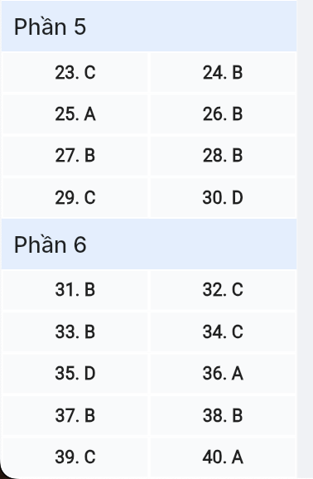
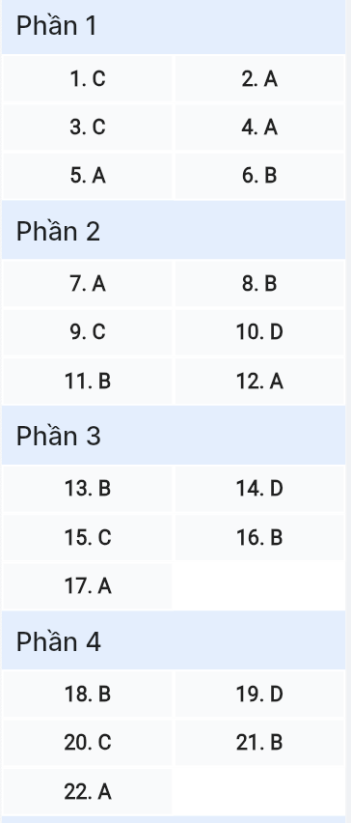
Read the following advertisement and mark the letter A, B, C or D on your answer sheet to indicate the option that best fits each of the numbered blanks from 1 to 6.

COMMUNITYCORE: REIMAGINE BELONGING
Local initiatives (1) ______ when residents unite in meaningful ways! CommunityCore unveils a(n) (2) ______ that revolutionizes neighborhood dynamics. We celebrate stories (3) ______ communities from isolation to vibrant connection. Our dedicated team remains versed (4) ______ grassroots development, which fuels our revolutionary approach to building stronger neighborhoods.
The platform enables neighborhoods to (5) ______ alive through collaborative projects, from local festivals to sustainability initiatives. The program instructs members (6) ______ monthly feedback about their experiences, ensuring continuous improvement. Through our framework, we've witnessed elderly residents finding new purpose, young families creating support networks, and businesses strengthening local economies.
Transform your community today: communitycore.io.
(Adapted from CommunityCore Guide)
Question 1 [697497]: A. flourishes B. flourishing C. flourish D. flourished

Question 2 [697498]: A. cutting-edge digital framework B. digital cutting-edge framework
C. framework digital cutting-edge D. framework cutting-edge digital

Question 3 [697499]: A. that are led B. led C. which lead D. to lead

Question 4 [697500]: A. in B. with C. to D. by

Question 5 [697501]: A. come B. bring C. make D. put

Question 6 [697502]: A. submitting B. to submit C. submit D. to submitting

Read the following leaflet and mark the letter A, B, C or D on your answer sheet to indicate the option that best fits each of the numbered blanks from 7 to 12.

Take Care of Your Mind!
Mental health is just as important as physical health. (7) ______ your mental well-being can lead to a happier, more fulfilling life.
Facts and figures: According to the World Health Organization, 1 in 4 people will experience a mental health issue at (8) ______ points in their lives. Stress and anxiety are on the rise, especially among young adults.
Positive action!
Engage in daily mindfulness exercises, such as meditation (9) ______ yoga, to help reduce stress (10) ______.
Make time for friends and family. Social (11) _________ are vital for maintaining mental health.
Don’t hesitate to (12) _______ to a mental health professional if you’re feeling overwhelmed. It’s okay to ask for support
Question 7 [697503]: A. Prioritizing B. Analyzing C. Customizing D. Harmonizing
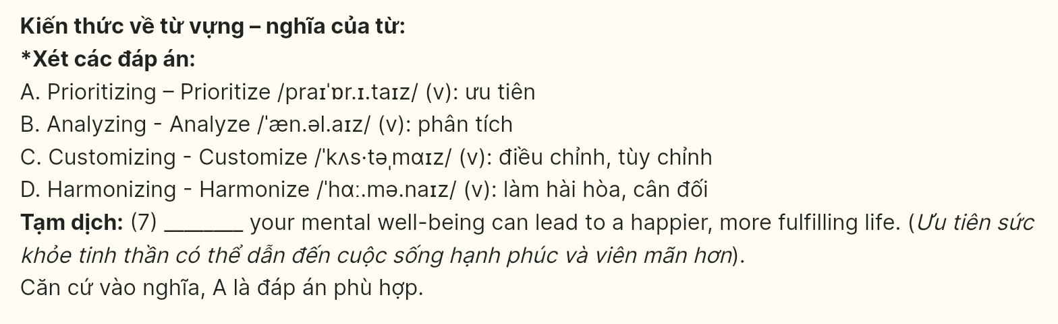
Question 8 [697504]: A. any B. some C. none D. every
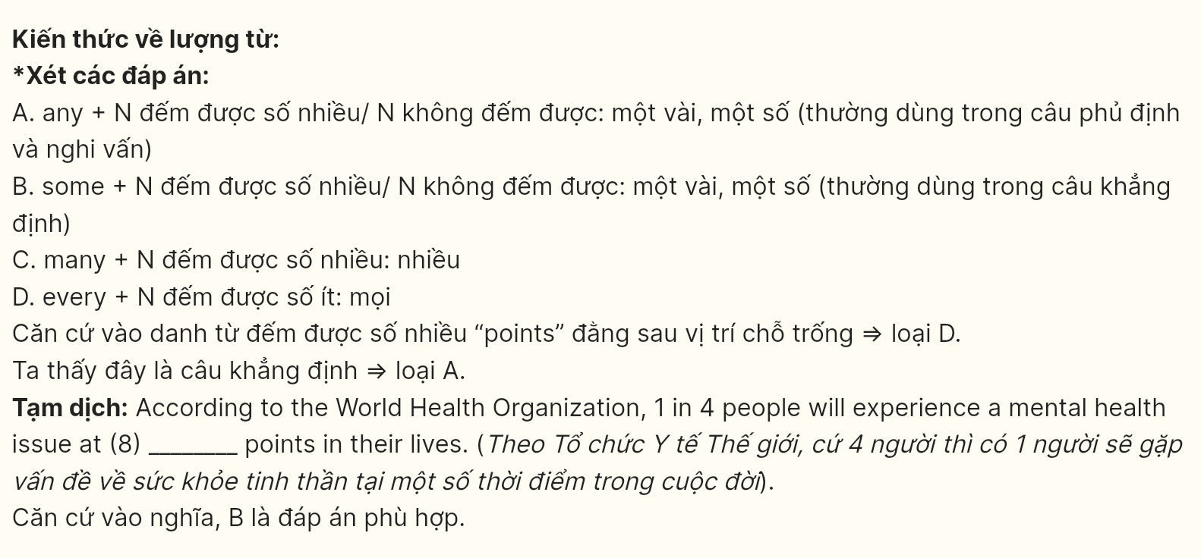
Question 9 [697505]: A. nor B. yet C. or D. but
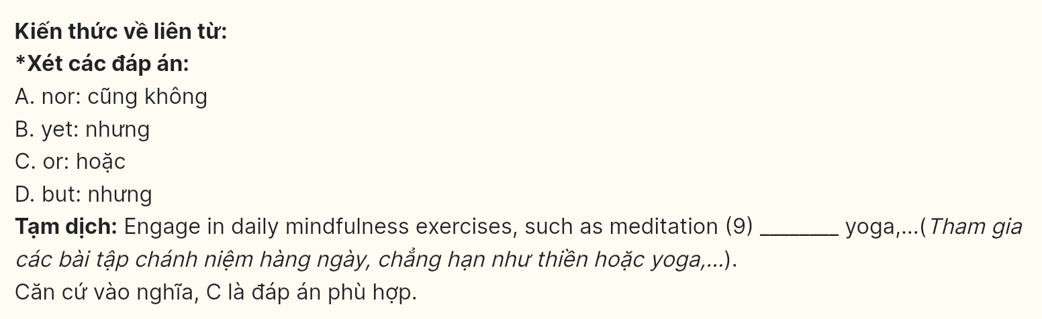
Question 10 [697506]: A. qualities B. amounts C. numbers D. levels
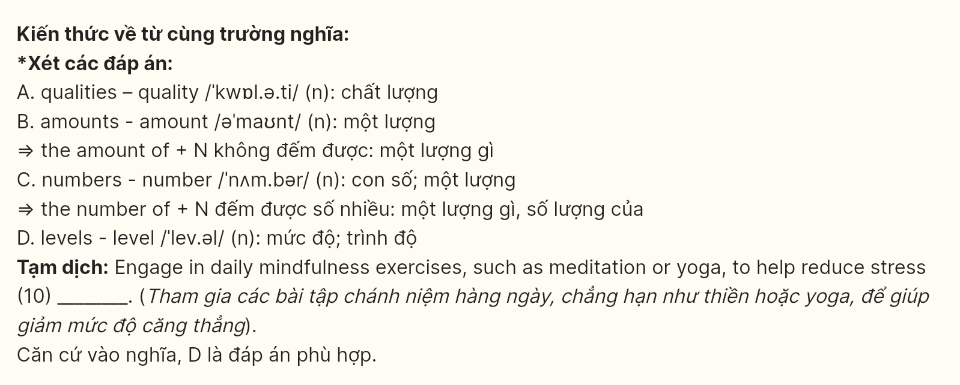
Question 11 [697507]: A. attachments B. connections C. applications D. relations

Question 12 [697508]: A. reach out B. come up C. look forward D. talk back

Mark the letter A, B, C or D on your answer sheet to indicate the best arrangement of utterances or sentences to make a meaningful exchange or text in each of the following questions from 13 to 17.
Question 13 [697509]:
A. Lily: That sounds incredible! I'll be going there this summer.
B. Lily: Have you ever been to Japan? I've heard it's an amazing place to visit.
C. Mia: Yes, I went last year, and I absolutely loved it! The culture, food, and beautiful landscapes were unforgettable.
A. C-a-b B. B-c-a C. A-b-c D. B-a-c

Question 14 [697510]:
A. Anna: That sounds lovely! Do you also have any traditions at home?
B. Anna: How does your family usually spend weekends together?
C. John: Yes, every Sunday, we cook a big family dinner together, and everyone helps out.
D. Anna: That's such a nice way to bond! It must be a lot of fun.
E. John: We often go for walks in the park and have a picnic if the weather is nice.
A. d-b-a-e-c B. b-c-a-e-d C. c-b-a-e-d D. b-e-a-c-d

Question 15 [697511]:
Hi Ethan,
a. I tried it yesterday, and it was amazing! The instructor was great, and I felt so much more relaxed afterward.
b. Thanks for the suggestion about the yoga class - I think it will really help me unwind after a long week.
c. I also plan to take some time off next month to travel and recharge a bit.
d. I’ve been really busy lately with work, so I haven't had much time to relax.
e. Hopefully, I can make it a regular part of my routine.
Write back soon,
Jordan
A. d-a-e-b-c B. e-d-a-b-c C. d-b-a-e-c D. a-e-b-d-c

Question 16 [697512]:
a. In addition to eating well, regular exercise is key to boosting energy levels and maintaining a healthy weight.
b. A balanced diet, rich in whole foods like fruits, vegetables, and lean proteins, provides the essential nutrients our bodies need to function properly.
c. It’s also important to stay hydrated throughout the day and ensure you’re getting enough sleep to help your body recover.
d. By making these simple changes, we can greatly improve our overall well-being.
e. Adopting a healthy lifestyle is crucial for improving both physical and mental health in the long run.
A. c-a-b-e-d B. e-b-a-c-d C. c-d-b-e-a D. e-d-b-c-a

Question 17 [697513]:
a. It has provided us with advanced tools that make tasks more efficient and convenient.
b. However, while technology brings numerous benefits, it also poses challenges, such as privacy concerns and the risk of job displacement.
c. Technology has drastically changed the way we live and work.
d. Therefore, as we continue to innovate, it is crucial to balance progress with careful consideration of its potential impacts on society.
e. For instance, the development of artificial intelligence has led to automation in many industries, reducing the need for manual labor.
A. c-a-e-b-d B. c-d-b-a-e C. e-b-a-c-d D. e-c-a-d-b
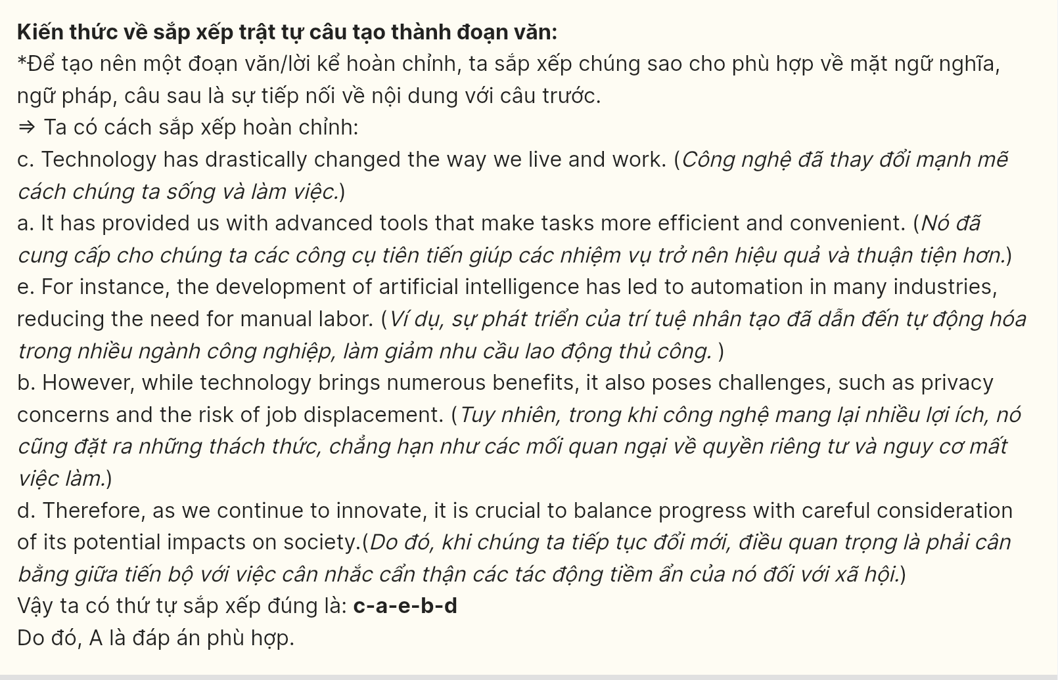
Read the following passage about AI innovation, and mark the letter A, B, C or D on your answer sheet to indicate the option that best fits each of the numbered blanks from 18 to 22.

Gemini, Google’s advanced AI model, (18) ______, aiming to compete with other powerful AI systems. This new model serves as a successor to Google’s previous AI models and promises to bring significant advancements in natural language understanding and generation. (19) ______.
The model is designed to help users with a wide range of tasks. It can assist with simpler functions, such as drafting emails and providing recommendations, as well as more complex functions, like summarizing lengthy documents or aiding in research. Gemini’s capabilities make it a versatile tool for both personal and professional needs, appealing to users (20) ______.
One of Google’s goals with Gemini is to integrate it across multiple platforms. Users will see Gemini’s influence in Google Search and Google Workspace, where it will make these tools smarter and more responsive. (21) ______.
Overall, Gemini represents Google’s commitment to creating an intuitive digital environment that adapts to users’ needs in real time. Positioning Gemini as a cornerstone of its AI strategy. (22) ______
(Adapted from BBC News)
Question 18 [697514]:
A. for which the development marked a significant shift in AI technology
B. is part of the company’s ambitious journey into the realm of artificial intelligence
C. having been introduced to push the boundaries of language understanding
D. to be the latest of Google’s AI models that bring significant advancements in user experience

Question 19 [697515]:
A. Many users have expressed concerns about its capabilities, fearing that the advancements in AI could lead to job displacement
B. Through Gemini, Google aims to limit its AI advancements to specialized research applications
C. Gemini primarily functions as an innovative vehicle designed for efficient transportation within urban areas
D. With Gemini, Google hopes to push the boundaries of AI capabilities and offer users a more seamless digital experience

Question 20 [697516]:
A. where advanced features help them accomplish a variety of tasks
B. empowering by its advanced features to complete a wide range of tasks
C. whose demands vary from basic tasks to intricate ones
D. sought assistance in managing complex projects and simple tasks

Question 21 [697517]:
A. Users will pay an additional subscription fee to access the advanced features offered by Gemini
B. This integration aims to save time and improve productivity for users everywhere
C. Google plans to phase out its older tools and replace them entirely with the new capabilities offered by Gemini
D. Users will have the opportunity to experience Gemini as a completely standalone product

Question 22 [697518]:
A. Google continues strengthening its role as a leader in the evolving AI landscape
B. the integration of AI has reduced the need for human oversight in various processes
C. users are expected to learn complex commands to fully utilize its features
D. extensive resources have been allocated to ensure that AI can operate independently

Read the following passage and mark the letter A, B, C or D on your answer sheet to indicate the option that best fits each of the numbered blanks from 23 to 30.

Inside a dimly lit warehouse in Brooklyn, vintage arcade machines illuminate rows of eager visitors with their neon glow. Weekly attendance at Retro Gaming Haven has quadrupled since its opening last spring, reflecting a broader cultural phenomenon. As economic uncertainty looms, consumer spending on nostalgic entertainment and memorabilia continues to surge across demographics.
Market analysis from the Consumer Behavior Institute shows unprecedented growth in memory-centric industries. Vinyl record sales have climbed 80% annually, while retro gaming platforms thrive through archived content. Contemporary audiences gravitate toward past-era entertainment, as it evokes emotional resonance through shared cultural touchstones. Digital platforms curating vintage content report viewer retention rates 35% higher than modern entertainment channels, highlighting a significant shift in consumption patterns across various age groups and social demographics.
Research by Social Psychology Quarterly shows nostalgia-driven consumption intensifies during social change periods. Consumers direct significant entertainment spending toward reimagined cultural artifacts. Visual aesthetics from previous decades permeate contemporary design, garnering particular appeal among young professionals. Studies show audiences engage more deeply with content invoking collective memory, spending 45% more time with vintage-inspired media formats across multiple platforms and entertainment categories, from streaming services to interactive experiences.
In response, entertainment conglomerates reshape marketing around memory-driven experiences. Production studios amalgamate period-specific elements into contemporary offerings while streaming platforms spotlight archived content through recommendation algorithms. Industry metrics show that vintage-inspired content maintains strong viewer engagement across demographics. Cultural analysts observe how retrospective entertainment elements crystallize community connections through shared historical references, fostering social cohesion. Memory-centric programming drives robust discussion in digital forums, where audiences examine cultural significance through modern perspectives and shared experiences, creating lasting connections between past and present entertainment forms while building bridges across different consumer segments.
(Adapted from Digital Entertainment Weekly)
Question 23 [697519]: Which of the following is NOT mentioned as a benefit of nostalgic content?
A. emotional connection B. viewer retention
C. educational value D. social bonding
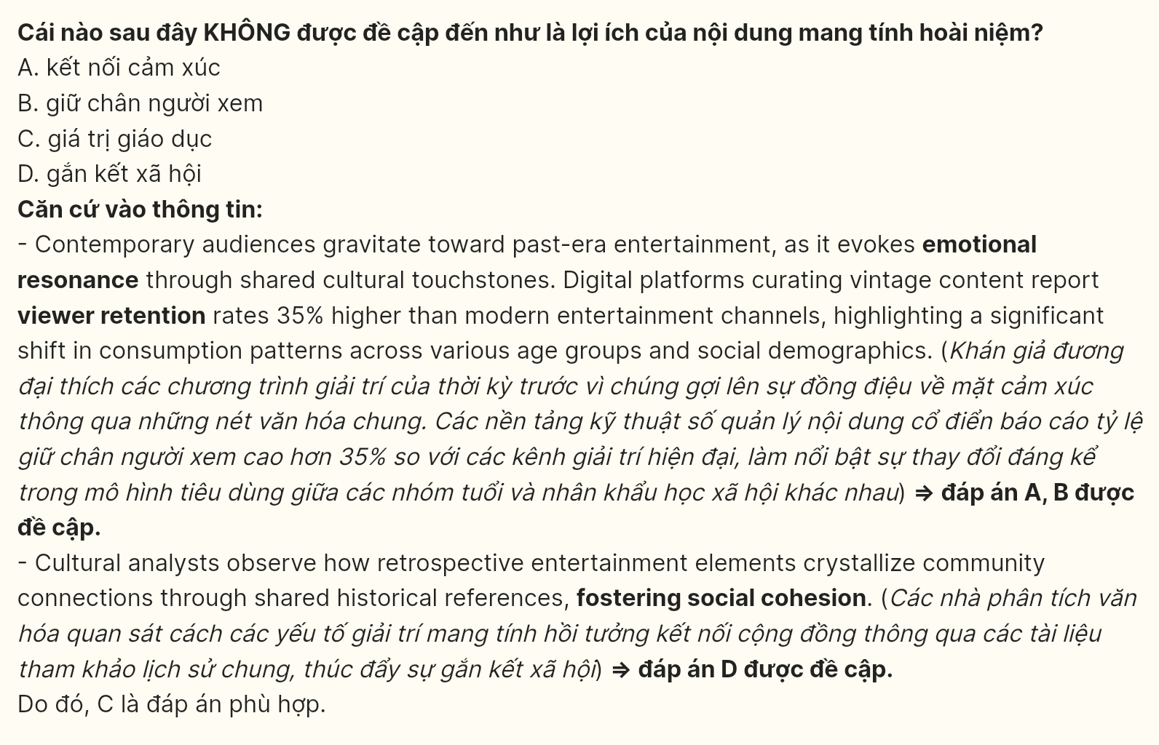
Question 24 [697520]: The word “it” in paragraph 2 refers to ______.
A. emotional resonance B. past-era entertainment
C. archived content D. vinyl record
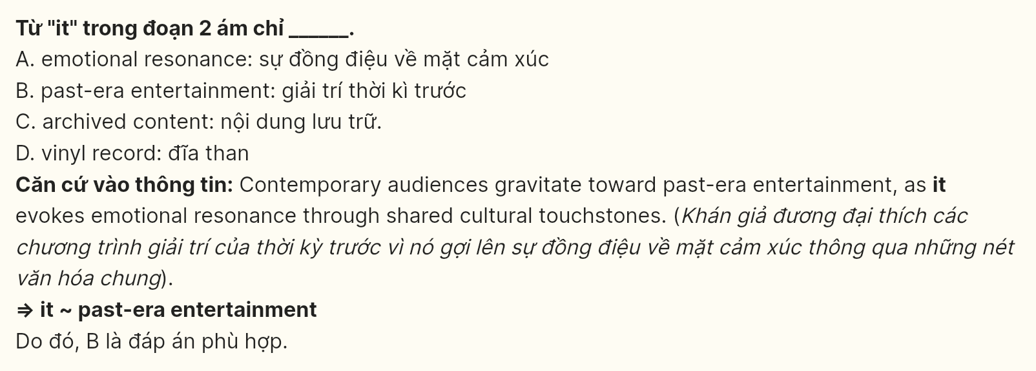
Question 25 [697521]: Which of the following best paraphrases the underlined sentence in paragraph 3?
A. Modern audiences pour substantial financial resources into entertainment that reinterprets classic elements.
B. The entertainment market thrives when cultural pieces from the past return with fresh perspectives.
C. Among various spending choices, revamped nostalgic content attracts respectable portions of consumer budgets.
D. Cultural products that blend historical roots with new forms command impressive consumer expenditure.
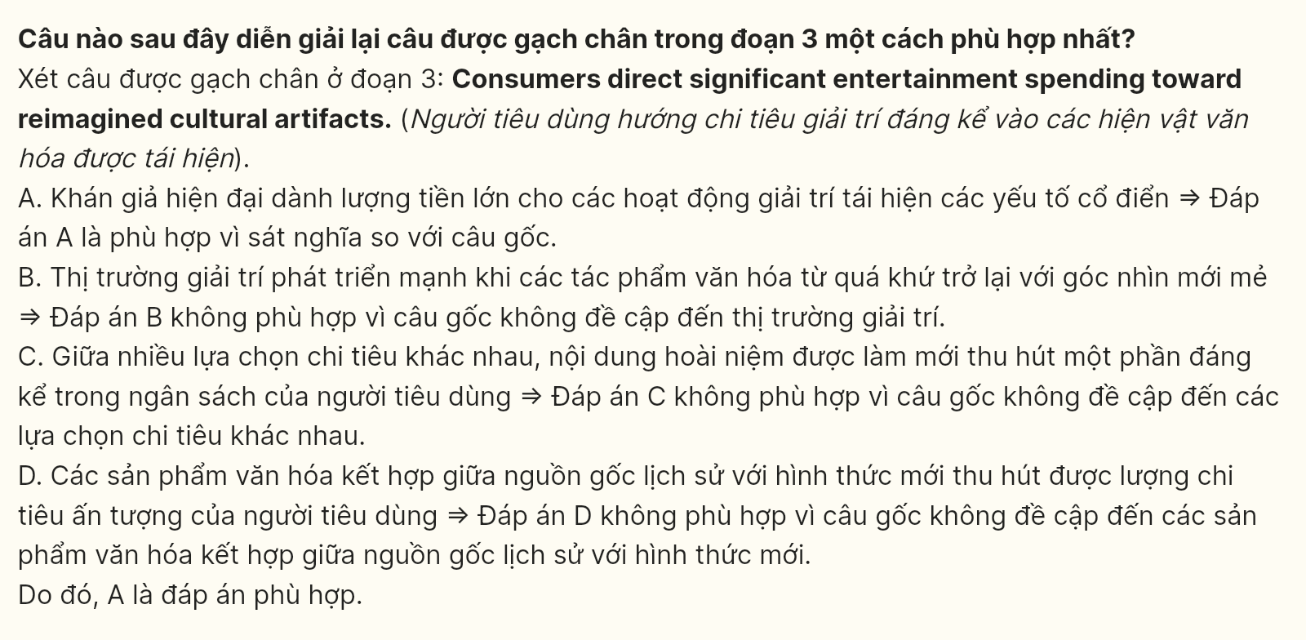
Question 26 [697522]: The word “amalgamate” in paragraph 4 is OPPOSITE in meaning to ______.
A. bifurcate B. segregate C. dislodge D. disengage

Question 27 [697523]: The word “robust” in paragraph 4 could best be replaced by ______.
A. resilient B. vigorous C. sturdy D. tough

Question 28 [697524]: Which of the following is TRUE according to the passage?
A. Modern entertainment platforms incorporate nostalgic elements to sustain audience participation.
B. Audiences display heightened responsiveness to memory-based content in digital spaces.
C. The fusion of historical references with modern formats shapes collective viewing experiences.
D. Archived content emerges as a catalyst for meaningful social bonds among diverse consumers.

Question 29 [697525]: In which paragraph does the writer examine the relationship between social change and consumer spending patterns?
A. Paragraph 1 B. Paragraph 2 C. Paragraph 3 D. Paragraph 4
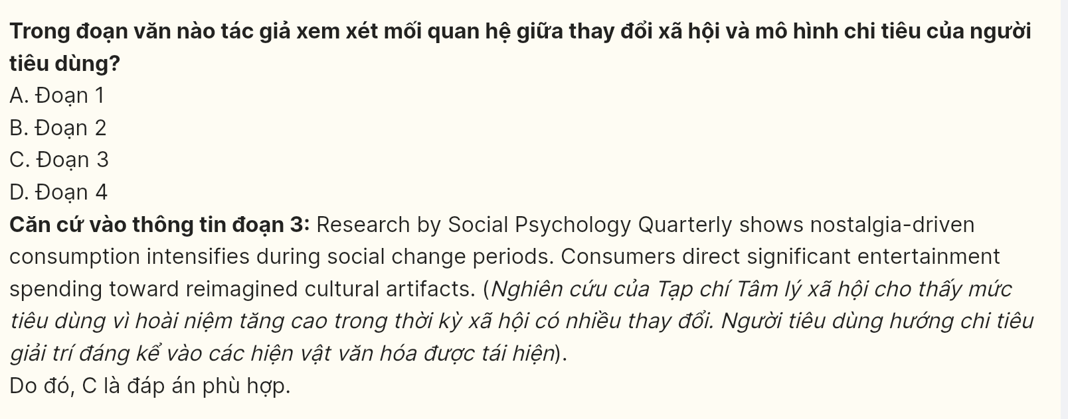
Question 30 [697526]: In which paragraph does the writer explore content curation strategies?
A. Paragraph 1 B. Paragraph 2 C. Paragraph 3 D. Paragraph 4
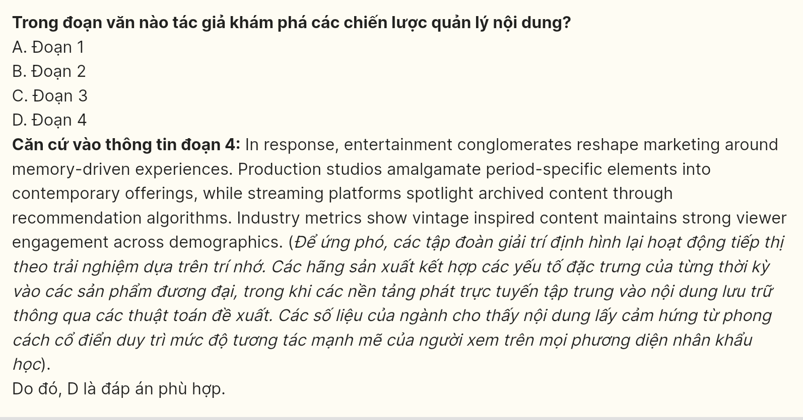
Read the following passage and mark the letter A, B, C or D on your answer sheet to indicate the best answer to each of the following questions from 31 to 40.

[I] Prior to the pandemic, annual deaths from drug overdoses in the U.S. were already a dreadful 65,000 per year. [II] By 2023, that number had nearly doubled, to more than 110,000. [III] Roughly 70 percent of those deaths are due to fentanyl, the powerful synthetic opioid. [IV] Fentanyl is now the leading cause of death for Americans between the ages of 18 and 45.
Although everyone can agree the death toll is horrific, there is no consensus about how to address it. For Republicans, the right approach to fentanyl is a combination of stricter law enforcement, tougher sentencing laws, and tighter border security. Many lawmakers want to stiffen penalties for possession of even small amounts of the drug, in reverse of the recent trend toward lowering sentences for simple possession. Individuals selling or trafficking fentanyl would face substantially longer sentences.
Many Democrats have accepted the need to stiffen penalties, due not only to the scourge of fentanyl but the apparently endless emergence of ever-more-potent drugs. Fatalities from a sedative called xylazine have increased dramatically across the country, particularly in the South. A class of opioids known as nitazenes can be as much as 40 times as powerful as fentanyl.
The fact that synthetic opioids are so readily available means that a supply-side approach is doomed to failure, some Democrats and public health officials believe. Even if it were possible to cut off supply from China and Mexico, there would be plenty of domestic production. Last year, law enforcement seized more than 360 million doses of fentanyl across the country. Still, the drug remained plentiful.
(Adapted from governing.com)
Question 31 (697527): Where in paragraph 1 does the following sentence best fit?
"The opioid crisis has expanded quickly over the past decade, contributing to a public health emergency."
A. [I] B. [II] C. [III] D. [IV]
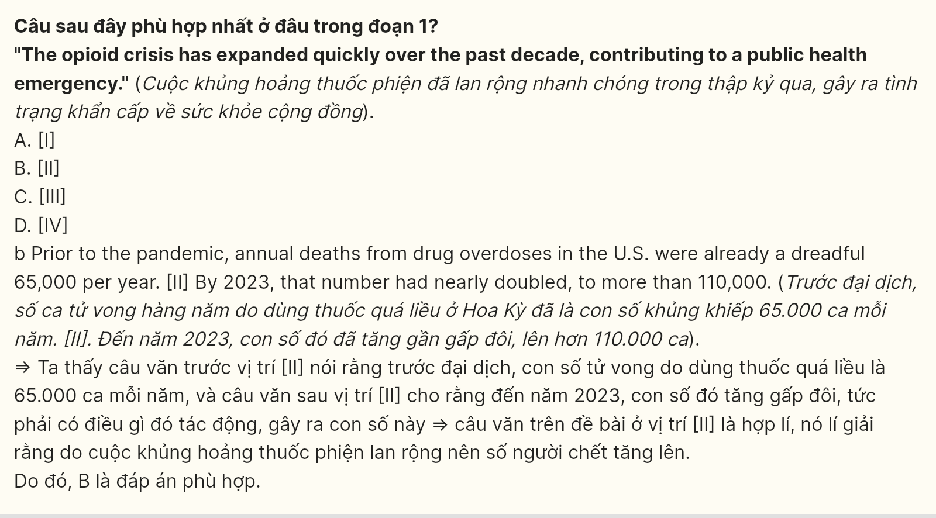
Question 32 (697528): The phrase doomed to failure in paragraph 4 could best be replaced by _____.
A. certain to succeed B. likely to collapse
C. bound to break down D. impossible to control
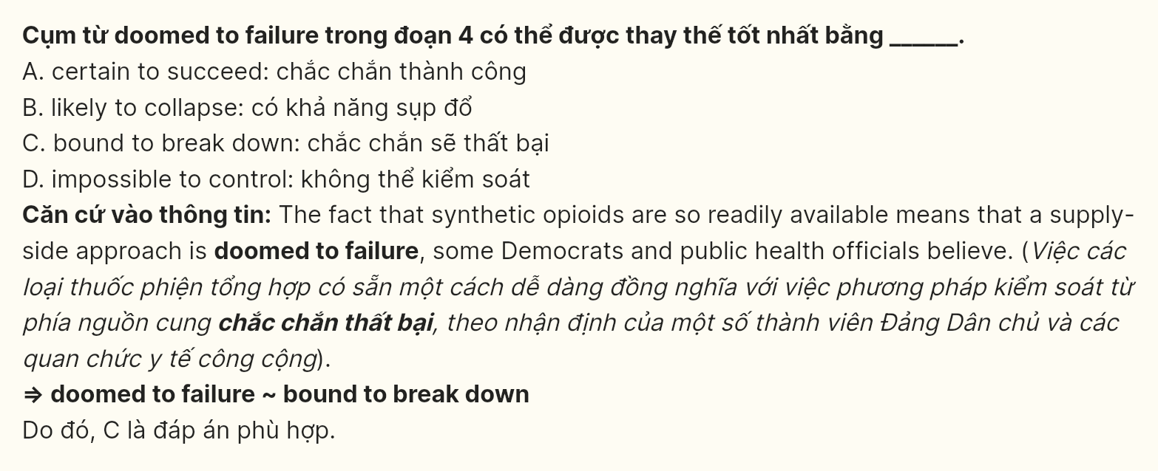
Question 33 (697529): The word scourge in paragraph 3 most likely refers to _____.
A. an increasing interest B. a widespread problem
C. a legislative solution D. a controlled substance
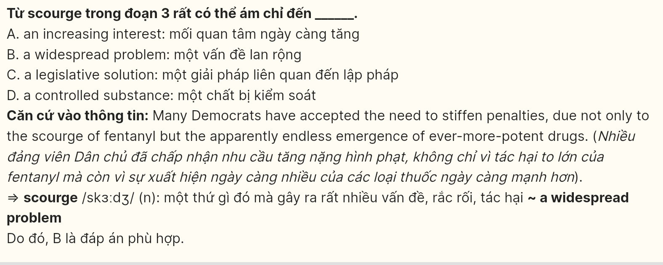
Question 34 (697530): According to the passage, which of the following is NOT a policy focus of Republicans in addressing the fentanyl crisis?
A. Stricter law enforcement B. Tighter border security
C. Increased domestic production D. Tougher sentencing laws
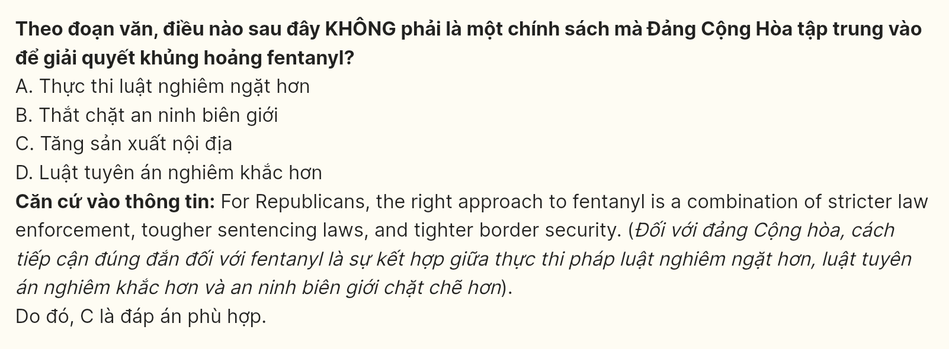
Question 35 (697531): Which of the following best summarizes paragraph 4?
A. Lawmakers are optimistic about ending the opioid crisis through supply reduction.
B. Most Democrats believe that stricter sentencing laws will limit synthetic opioid deaths.
C. Law enforcement has been successful in reducing domestic production of fentanyl.
D. Synthetic opioids are difficult to control, and supply reduction may not be feasible.

Question 36 (697532): The word plentiful in paragraph 4 is OPPOSITE in meaning to _____.
A. rare B. adequate C. ample D. exuberant
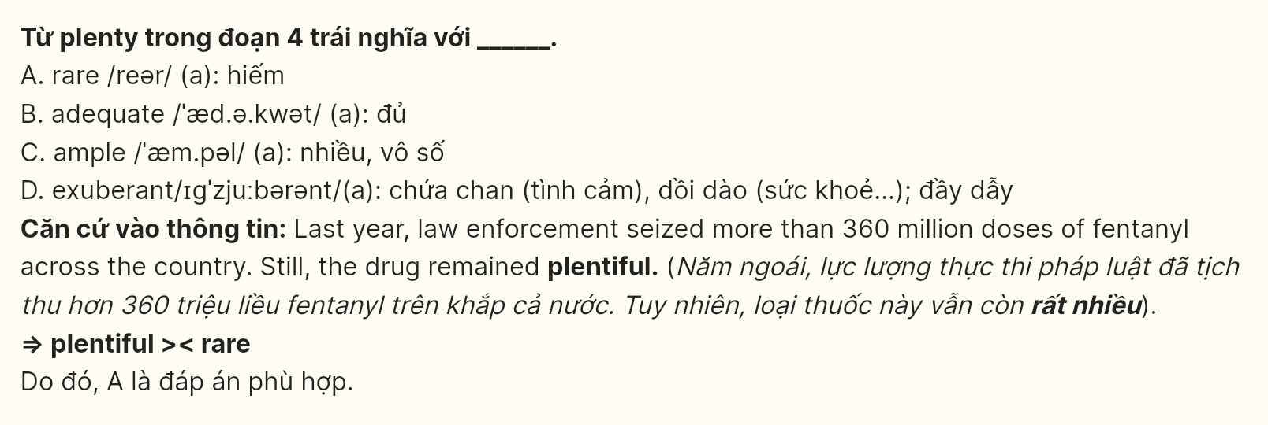
Question 37 (697533): Which of the following is TRUE according to the passage?
A. Both parties agree that tougher sentencing is essential but differ on the role of border security.
B. Republicans emphasize enforcement measures, while some Democrats question the effectiveness of focusing solely on limiting supply.
C. Democrats believe that increasing domestic production will reduce reliance on foreign supply, unlike Republicans.
D. Both parties support border security as the primary solution but differ on penalties for possession.
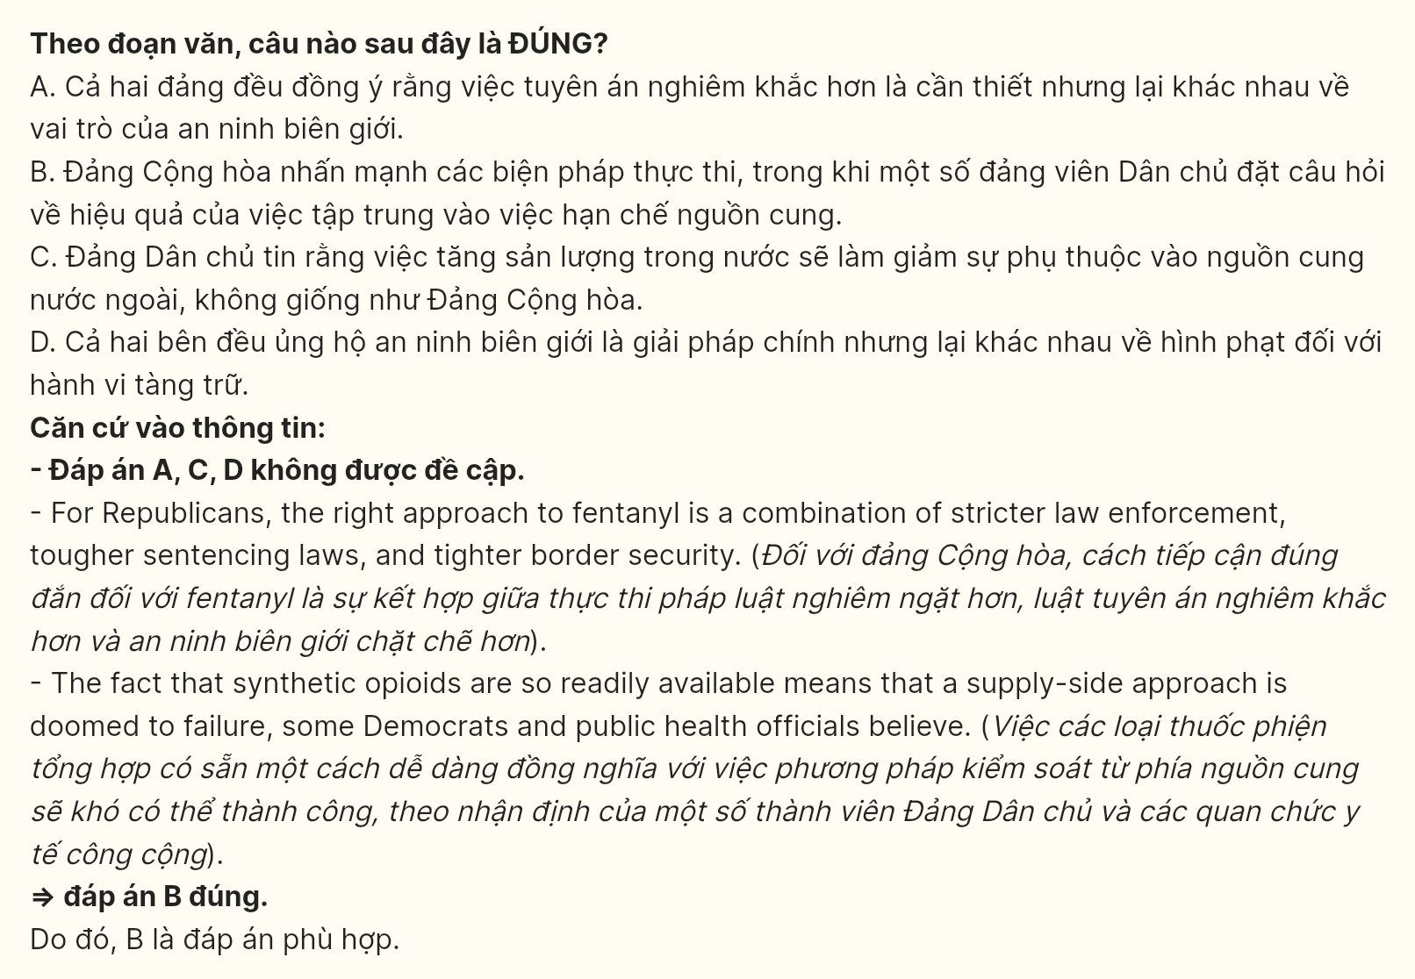
Question 38 (697534): Which of the following best paraphrases the underlined sentences in paragraph 4?
A. The ongoing availability of synthetic opioids in the U.S. suggests that a focus on limiting supply will not be effective.
B. Republicans emphasize enforcement measures, while some Democrats question the effectiveness of focusing on limiting supply.
C. The current market for synthetic opioids means that efforts to restrict their supply may not yield significant results.
D. Despite significant law enforcement efforts, fentanyl remains easily accessible due to domestic production.
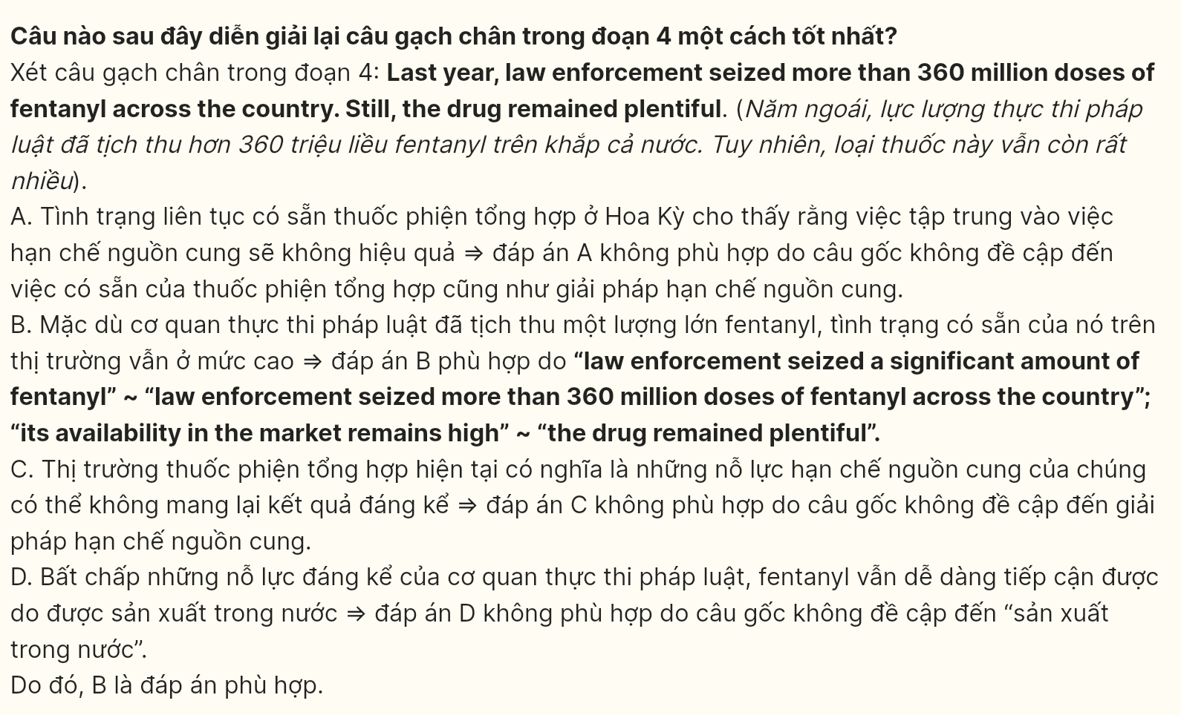
Question 39 (697535): Which of the following can be inferred from the passage?
A. There is strong bipartisan support for reducing drug overdose deaths.
B. Fentanyl is no longer a significant cause of overdose deaths.
C. Law enforcement has limited success in reducing fentanyl availability.
D. Only synthetic opioids are responsible for overdose deaths in the U.S.

Question 40 (697536): Which of the following best summarizes the passage?
A. The increase in drug overdose deaths is driven by both fentanyl and other powerful drugs, with differing views on addressing the crisis.
B. Fentanyl has become a leading cause of death in the U.S., and lawmakers agree on increasing law enforcement efforts.
C. Efforts to stop synthetic opioids from entering the U.S. have been successful, but stricter laws are still needed.
D. The opioid crisis is nearing an end due to bipartisan cooperation on sentencing laws.
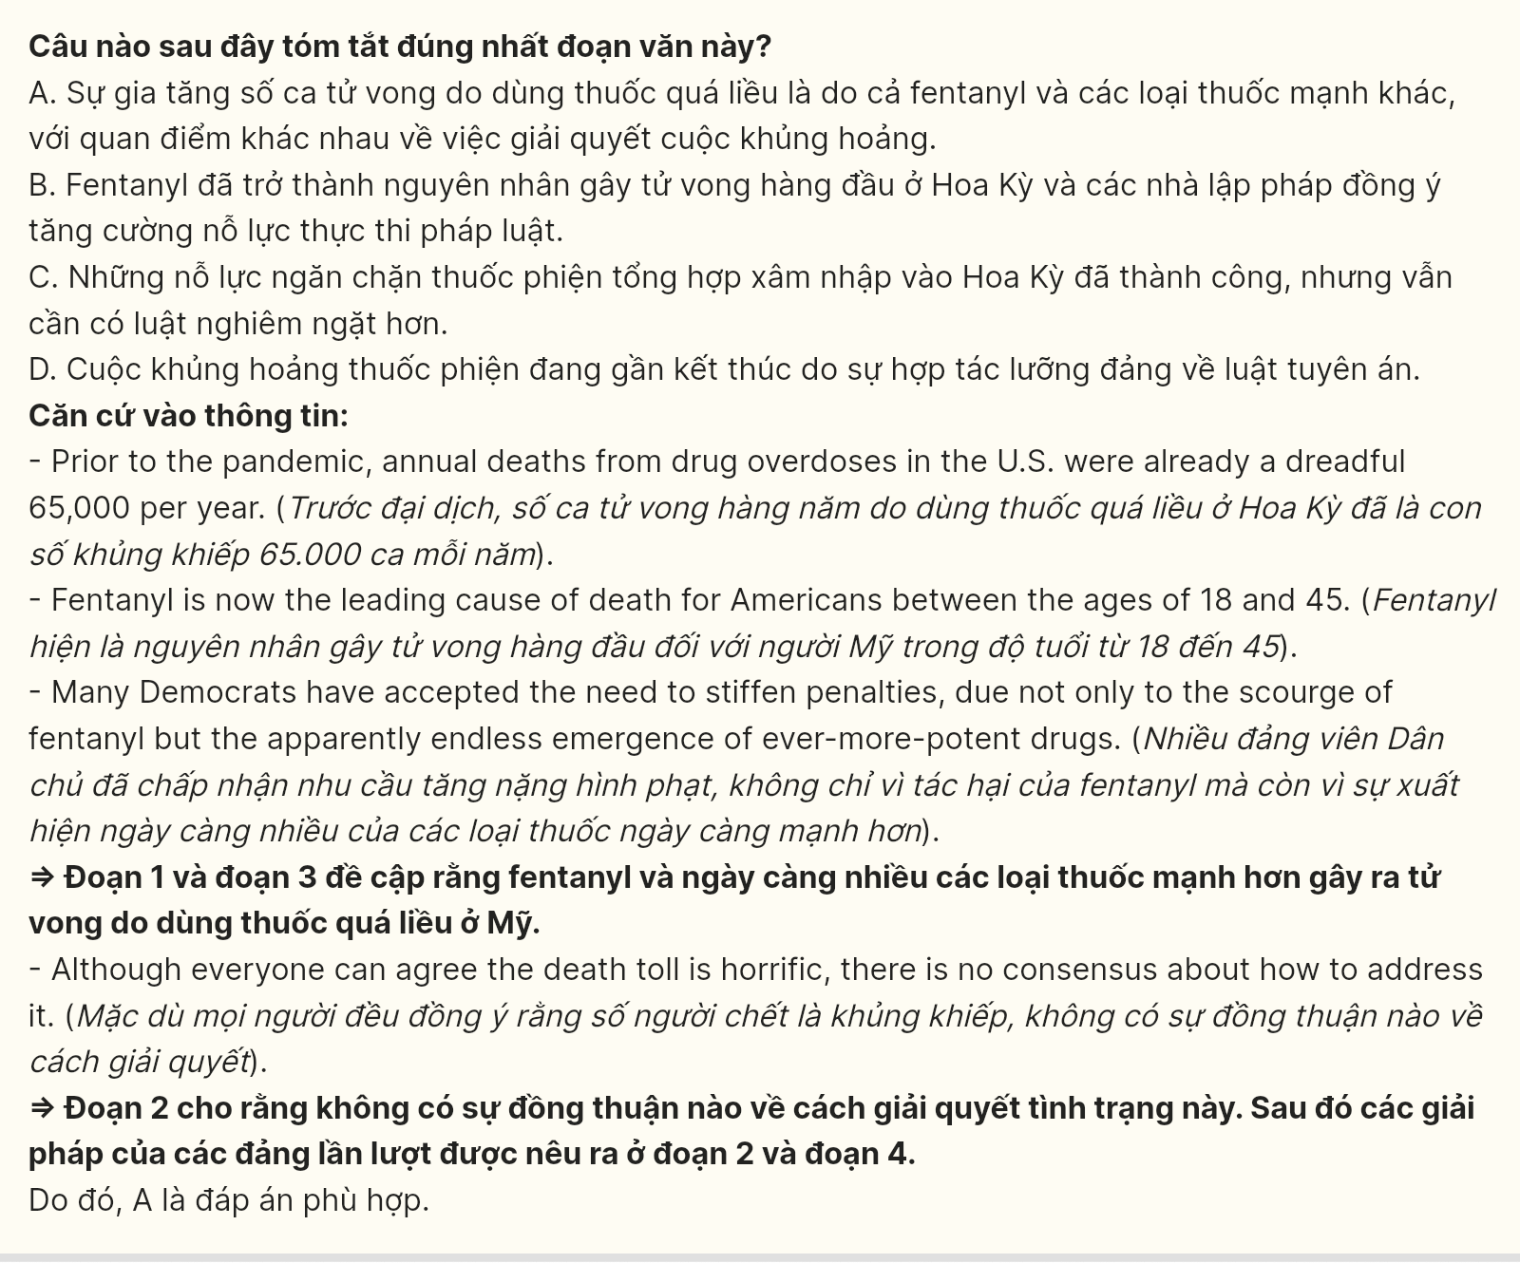
----- THE END -----

