|  |  |
| --- | --- |
|  | *Thời gian làm bài: 40 phút (Không kể thời gian giao đề)*  *-------------------------* |

**Họ tên thí sinh: .................................................................**

**Số báo danh: ......................................................................**

**Mã Đề: 001.**

**Câu 1.** **Look at the signs. Choose the best answer for the question.**

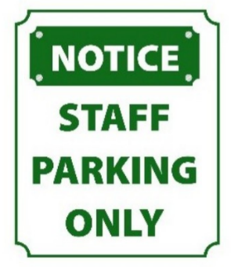

**A.** No one is allowed to park in this area.

**B.** This parking area is for everyone.

**C.** You have to contact the staff if you want to park in this area.

**D.** Only people who work here can park in this area.

**Câu 2.** **Look at the signs. Choose the best answer for the question.**

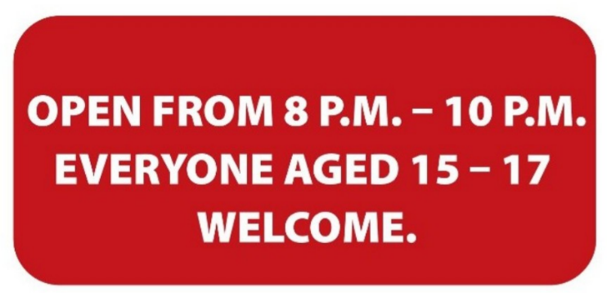

**A.** Only 15-17 people can enter the place from 8 p.m. to 10 p.m.

**B.** Only teenagers who are over 15 are allowed to enter this place.

**C.** The venue is open to all teenagers under the age of 17.

**D.** Teenagers aged 15-17 can visit the venue from 8 p.m. to 10 p.m.

**Câu 3.** What is the main reason James cannot attend the concert?

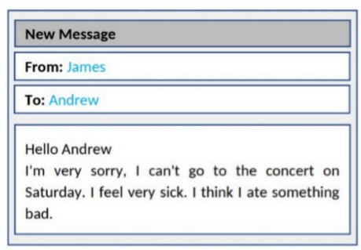

**A.** He lost his ticket  **B.** He doesn't like the music

**C.** He has another commitment  **D.** He is feeling unwell

**Câu 4.** **Look at the signs. Choose the best answer for the question.**



**A.** Today you can buy apples at a cheaper price before 6 p.m.

**B.** You can’t buy any apples before 6 p.m.

**C.** You can buy cheaper apples after 6 p.m.

**D.** You can only buy apples today.

**Câu 5.** What does this sign mean?

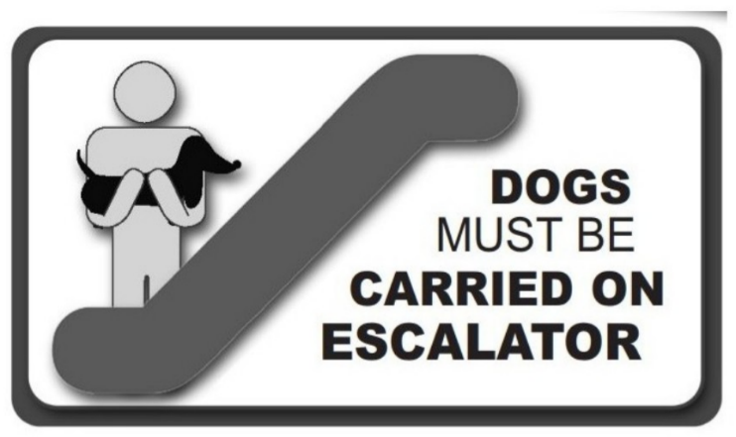

**A.** If you want, you can ride the escalator with your dog.

**B.** You don’t have to carry your dog on the escalator.

**C.** When using the escalator, you should carry your dog in your arms.

**D.** If you have a dog, you can't use the escalator.

**Câu 6.** What can you see at the circus?

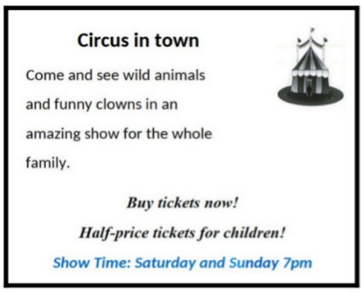

**A.** Only funny clowns  **B.** Only acrobats

**C.** Only wild animals  **D.** Wild animals and funny clowns

**Câu 7.** **Look at the signs. Choose the best answer for the question.**

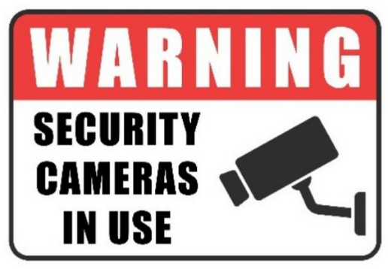

**A.** You must look after your cameras in this area.  **B.** Cameras can only be used for security purposes.

**C.** Cameras can be used in this area.  **D.** This area is supervised by camera.

**Câu 8.** What activities will be allowed when the pool reopens?

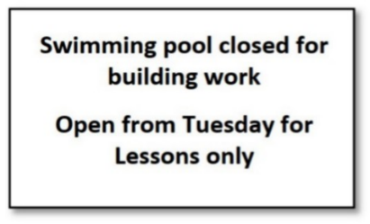

**A.** All regular activities  **B.** Only swimming lessons

**C.** The notice doesn't specify allowed activities  **D.** Building work and swimming lessons

**Câu 9.** **Look at the signs. Choose the best answer for the question.**

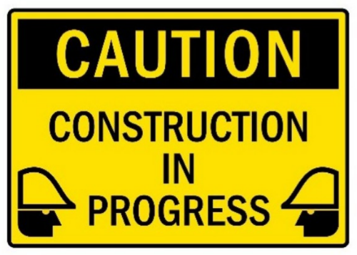

**A.** Be careful because building work is happening.  **B.** You have to construct buildings with caution.

**C.** There is careful construction.  **D.** Construction must be carefully done in progress.

**Câu 10.** **Look at the signs. Choose the best answer for the question.**

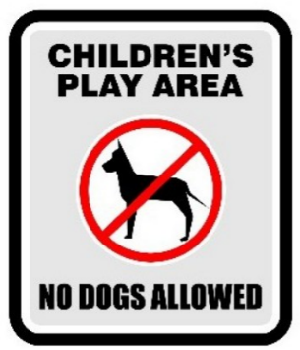

**A.** Dogs are not safe for children in this play area.

**B.** Dogs cannot be taken into this place as it is a children’s play area.

**C.** Don’t let your children play here because of the dogs.

**D.** Dogs are not allowed to play with children in this area.

**----HẾT---**