**Job and career**

**Task 1. Read the job advertisements. Then match each ad (A–E) to the statements (1–8). Each letter can be used more than once.**

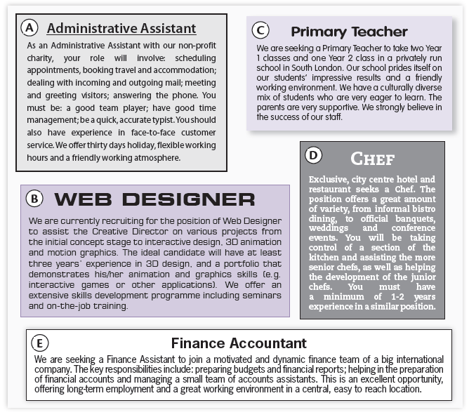

| **Statements** | **Ads** |
| --- | --- |
| 1. You will be helping to train other employees. |  |
| 1. You will be working in a place which is proud of its achievements. |  |
| 1. You will have many opportunities to develop your skills. |  |
| 1. You must prove your skills by showing something specific that you have done. |  |
| 1. You will be responsible for the work of a group of employees. |  |
| 1. You will be working for an organisation whose aim is to help people, not make money. |  |
| 1. You will not have to work the same hours every day. |  |
| 1. You shouldn't have problems getting to work. |  |

**Task 2. Read the texts and do the tasks that follow.**

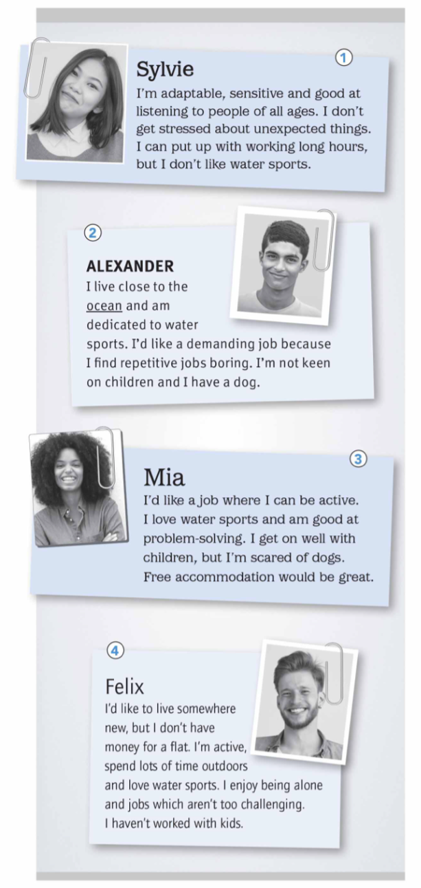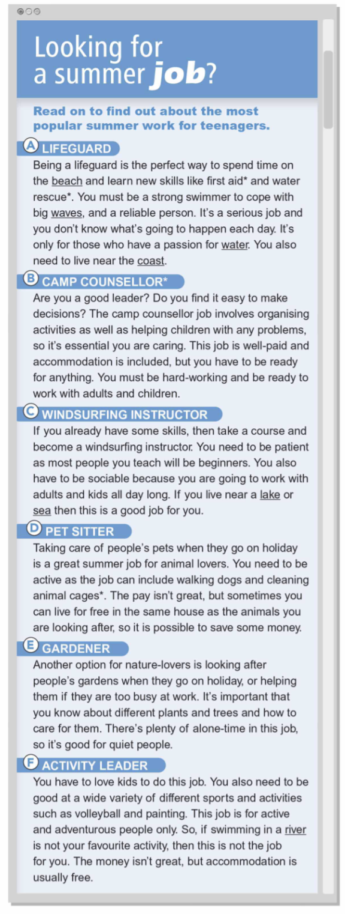

**a. Four teenagers are looking for summer jobs. Read the texts and write a suitable job A–F for each person. There are two extra jobs.**

| Person 1 – Sylvie _____________ | Person 3 – Mia ____________ |
| --- | --- |
| Person 2 – Alexander ____________ | Person 4 – Felix ___________ |

**b. Read the texts again. Are statements 1–8 True or False?**

| **Statements** | **True** | **False** |
| --- | --- | --- |
| **1**. Pet sitters have to sleep with the animals they look after. |  |  |
| **2**. Camp counsellors work with kids, but older people too. |  |  |
| **3**. Working as a gardener is a good job for introverted people. |  |  |
| **4**. You learn how to deal with accidents when you work as a lifeguard. |  |  |
| **5**. Lifeguards follow the same routine every day. |  |  |
| **6**. Teaching people how to windsurf is a repetitive job. |  |  |
| **7**. Activity leaders have to pay for a place to stay. |  |  |
| **8**. Camp counsellors can make quite a lot of money. |  |  |

**ANSWER KEY**

**Task 1.**

1. D 2. C 3. B 4. B 5. E 6. A 7. A 8. E

**Task 2.**

**a.**

Person 1 – B Person 2 – A Person 3 – F Person 4 - D

**b.**

1. False 2. True 3. True 4. True

5. False 6. True 7. False 8. True