School: ……………………………………….. | Date: ………………………………..
Class: ……………………………..................... | Period: ………………………..........

UNIT 5: SCIENCE AND TECHNOLOGY
Lesson 4 – Review (page 97)
I. OBJECTIVES
By the end of the lesson, Ss will be able to
1.1. Language knowledge and skills
- review asking and answering about devices and comparing robots.
- review the target language and language skills in unit 5.
Grammar: Wh-questions and Yes/No questions and comparative adverbs.
Vocabulary: Words of the topic “science and technology” (tablet, screen, inch, weight, gigabyte, storage, rescue, lift, complete, navigate, recognize, carefully, quietly, safely).
- practice test-taking skills.
1.2. Competences
- improve speaking, listening, reading and writing skills.
- improve the use of English.
1.3. Attributes
- have a good attitude toward learning English
- become more diligent.
- reread the previous lesson and be well-prepared for tests and the second mid-term examination.
II. TEACHING AIDS AND LEARNING MATERIALS
1. Teacher’s aids: Student book and Teacher’s book, class CDs, Digital Book (DCR phần mềm tương tác SB, DHA (từ vựng/ cấu trúc) phần mềm trò chơi tương tác), projector/interactive whiteboard / TV (if any), PowerPoint slides, handouts.
2. Students’ aids: Student’s book, workbook, notebook.
III. ASSESSMENT EVIDENCE
Performance Tasks | Performance Products | Assessment Tools
- Quiz Game: Review | - Ss’ answers. | - T’s feedback/Peers’ feedback.
- Vocabulary: Circle the correct words. | - Ss’ answers. | - T’s feedback/Peers’ feedback.
- Grammar: Underline the mistakes and write the correct words on the lines. | - Ss’ answers. | - T’s feedback/Peers’ feedback.
- Pronunciation: Circle the word that differs from the other three in the position of primary stress in each of the following questions. | - Ss’ answers/ presentation. | - T’s observation, T’s feedback/Peers’ feedback.
- Writing: Describe your phone, laptop, or tablet, and say what it can do. Write 80 to 100 words. | - Ss’ writing. | - T’s observation, T’s feedback/Peers’ feedback.

IV. PROCEDURES
A. Warm up: (5’)
a) Objective: Introduce the new lesson and set the scene for Ss to acquire new language; get students' attention at the beginning of the class by enjoyable and short activities as well as to engage them in the follow-up steps.
b) Content: Reviewing vocabulary of the topic “Science and technology.”
c) Expected outcomes: Ss are ready for the new lesson.
d) Organization of the activity:
TEACHER’S ACTIVITIES | STUDENTS’ ACTIVITIES
Quiz Game  - Have Ss read the statements and choose the correct answer.  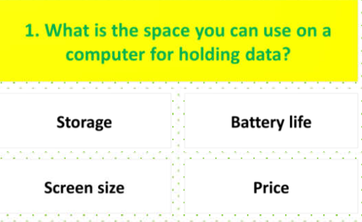  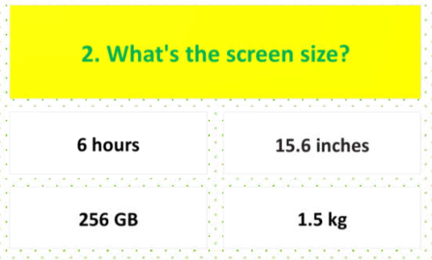  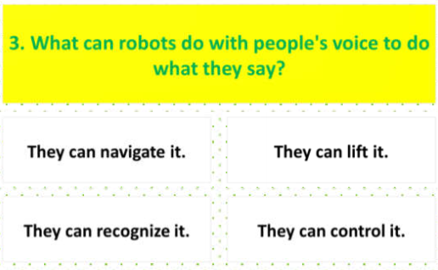  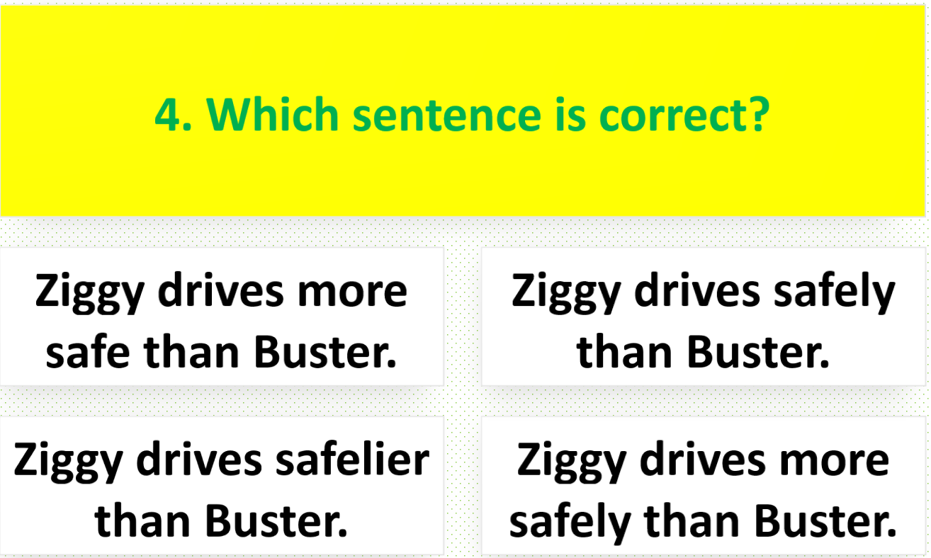  - Call Ss to give answers.  - Check Ss’ answers and give feedback.  - Lead to the new lesson. | - Read the statements and choose the correct answers.  - Give answers.  Answer keys  1. Storage 2. 15.6 inches  3. They can recognize it.  4. Ziggy drives more safely than Buster.

B. New lesson (35’)
- Activity 1: Vocabulary (7’)
a) Objective: Ss can review vocabulary about science and technology.
b) Content: Circle the correct words.
c) Expected outcomes: Ss produce the new language successfully, and they can use these words in speaking and writing.
d) Organization of the activity:
TEACHER’S ACTIVITIES | STUDENTS’ ACTIVITIES
Circle the correct words.  - Have Ss read the sentences.  - Ask Ss to work in pairs to circle the correct words.  - Have Ss give answers, tell the meaning of the words /phrases again.  - Check answers as a whole class. | - Read the sentences.  - Work in pairs.  - Give answers.  Answer keys  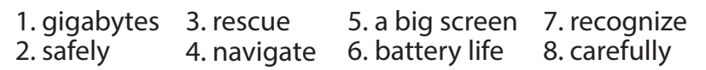

- Activity 2: Grammar (10’)
a) Objective: Ss can review Wh-questions and Yes/No questions and comparative adverbs.
b) Content: Underlining the mistakes and writing the correct answers on the lines.
c) Expected outcomes: Ss produce the language successfully, and they can use the grammar points in speaking and writing.
d) Organization of the activity:
TEACHER’S ACTIVITIES | STUDENTS’ ACTIVITIES
Underline the mistakes and write the correct words on the lines.  - Ask Ss to work individually to underline the mistakes and write the correct answers on the lines.  - Have Ss work in pairs to check each other’s work.  - Call Ss to give answers, explain for their choice.  - Check answers as a whole class using DCR. | - Work individually.  - Work in pairs.  - Give answers.  Answer keys  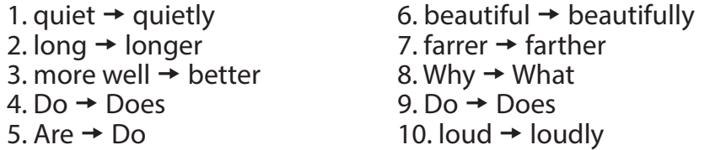

- Activity 3: Pronunciation (5’)
a) Objective: Ss can review the stress of nouns and adjectives with 2 and 3 syllables and 3 syllable adverbs ending with -ly.
b) Content: Circling the word that differs from the other three in the position of primary stress in each of the following questions.
c) Expected outcomes: Ss produce the new language successfully.
d) Organization of the activity:
TEACHER’S ACTIVITIES | STUDENTS’ ACTIVITIES
Circle the word that differs from the other three in the position of primary stress in each of the following questions.  - Remind Ss some word stress rules in English, including two or three syllables.  - Ask Ss to work individually.  - Have Ss work in pairs to check each other’s work.  - Call Ss to give answers, pronounce the words again.  - Give feedback, correct Ss’ pronunciation if necessary. | - Review.  - Work individually.  - Work in pairs.  - Give answers.  Answer keys

- Activity 4: Writing (13’)
a) Objective: Ss can review the structure and language used in a descriptive paragraph.
b) Content: Writing about where you think people will and won't live in 100 years, and why.
Write 80 to 100 words.
c) Expected outcomes: Ss produce the new language successfully.
d) Organization of the activity:
TEACHER’S ACTIVITIES | STUDENTS’ ACTIVITIES
Describe your phone, laptop, or tablet, and say what it can do. Write 80 to 100 words.  - Briefly remind Ss of the structures of a descriptive paragraph.  - Ask Ss some questions to remind them of the paragraph structure.  What do you write in the topic sentence?  How do you describe your device?  Do you give explanations and examples to describe it?  Do you only write about its good features?  - Have Ss write a paragraph.  - Have Ss look at each other’s work (peer correction).  - Call Ss to read their writing.  - Give feedback to one S’s writing. | - Review.  - Answer the questions.  Suggested Writing  My parents got a new laptop for me for my birthday. It has a big screen, so I can watch movies and TV shows on it. The screen is seventeen inches. My laptop has 256 GB of storage so I can download lots of music and  movies. I can also save lots of games and homework. One thing I don't like is the weight. It's a little bit heavy to carry in my backpack with my school books. I really like my laptop.

C. Consolidation and homework assignments (5’)
* Consolidation:
- Grammar of Unit 5: Wh-questions and Yes/No questions and comparative adverbs.
- Vocabulary of Unit 5: Words of the topic “science and technology” (tablet, screen, inch, weight, gigabyte, storage, rescue, lift, complete, navigate, recognize, carefully, quietly, safely).
- Make three sentences to describe your electronic device.
* Homework:
- Review vocabulary, grammar and language skills of unit 5.
- Do the exercises in WB: Unit 5 Review - Part 2 (page 54).
- Prepare: Unit 6 – Vocabulary and Reading (pages 54 & 55 – SB).

V. Reflection
a. What I liked most about this lesson today:
…………………………………………………………………………………………
b. What I learned from this lesson today:
…………………………………………………………………………………………
c. What I should improve for this lesson next time:
…………………………………………………………………………………………

