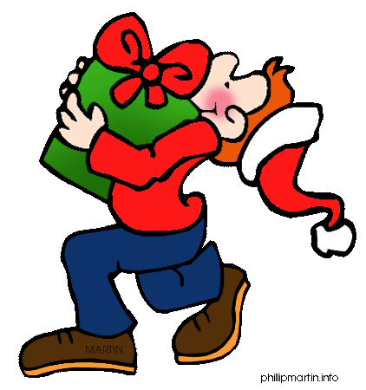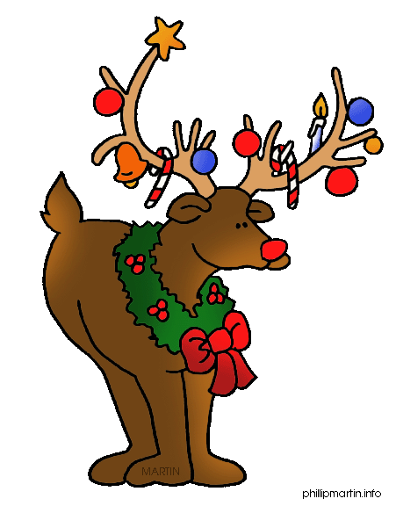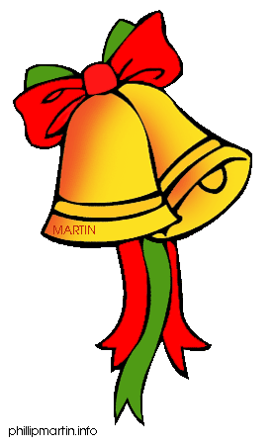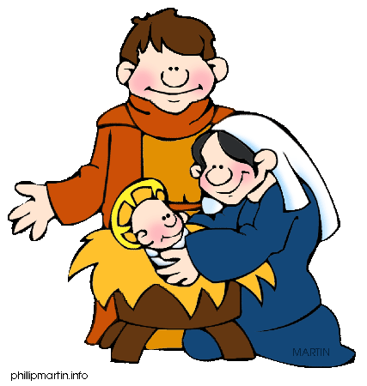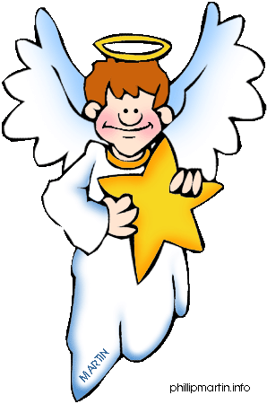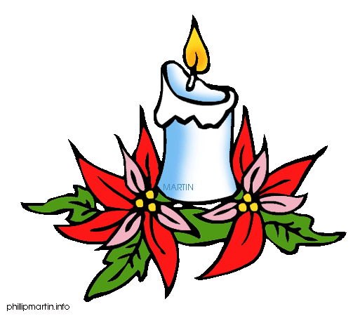

Name a Christmas movie!

How many days has December?

What is the name of Santa’a helpers?

What does Father Christmas say?

What are the names of Jesus’ parents?

How does Santa get into your house?

What is the name of the ”meat” eaten on Christmas Eve?

Sing a Christmas song!

How many reindeer are there?

Where does Santa live?

What do you call December 26?

How many reindeer does Santa have?

Miss a turn!

What does Frosty the Snowman have for a nose?

Christmas is about giving –so you get two free squares!

How many sides does a snowflake have?

Name two reindeer!

Which plant allows you to kiss a person who stands under it?

Name a Christmas flower!

What is Egg Nog?

Get an extra throw!



Name a Christmas song.

☺

How many wise men were there to see baby Jesus?

When is the birthday of Jesus Christ?

Move back one square!



Name the colours of Christmas

