Date of preparing: ………………………………….
Date of teaching: ………………………………….

Period……
UNIT 9: HOUSES IN THE FUTURE
Lesson 2 - Part 2 (Page 74) - Grammar

I. OBJECTIVES
By the end of the lesson, Ss will be able to…
1. Knowledge
- know how to use Modal verb Might to say that something is possible in the future
2. Ability
- improve the use of language
- develop the ability to communicate and cooperate with their partners, to self-study and other skills
3. Quality
- have a positive attitude in English language learning so that they actively participate in all classroom activities
II. TEACHING EQUIPMENT AND LEARNING MATERIALS.
Lesson plan, PPT slides, student’s book, workbook, notebook, personal computer (if any), projector/TV, speakers, DCR & DHA on EDUHOME, handouts…
III. PROCEDURES
A. Warm up: (5’)
a) Objective: To introduce new lesson and set the scene for students to acquire new language
b) Content: a game
c) Product: Ss can review the language learnt in the previous lesson
d) Competence: Collaboration, communication, analytical skills
e) Organization of the activity:
Teacher’s activities | Students’ activities
- Books closed, show the questions on the board  - Have Ss work in pairs, read and find the missing words  - Give time for Ss to find the answers  - Check the answers with the whole class | -Work in pairs, read the sentences and fill in the missing words  - A _______, like a TV or a mobile phone, is a machine with a computer in it.  - A _______ is a flying machine. It can carry things.  - I use my phones by touching the _______.  - A _______ can make all kinds of objects.  - An _______ will make anything you want to eat.  - Get a _______ to do your washing and cleaning at home.  - Check answer with the T  Answer keys  - smart device 2. drone 3. Screen  4. 3D printer 5. automatic food machine 6. robot helper

B. New lesson (35’)
- Activities 1: Introduce and practice new language (25’)
a) Objective: To have Ss learn the new grammar point – Might for future possibilities
b) Content: Grammar (page 74)
c) Products: Students can understand, practice and use the mentioned grammar point correctly in communication.
d) Competence: Communication, collaboration, critical thinking
e) Organization of the activity:
Teacher’s activities | Students’ activities
* GRAMMAR  a. Listen and repeat. (Presentation)  * Option 1:  - Have Ss look at the picture.  - Have Ss guess what they are talking about.  - Play audio and have Ss listen and read the speech bubbles.  - Play the audio again.  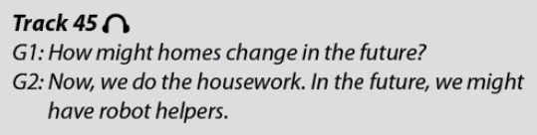  * Option 2:  - Ask students to look at the grammar explanation.  - Have Ss look at the table with the forms of Might.  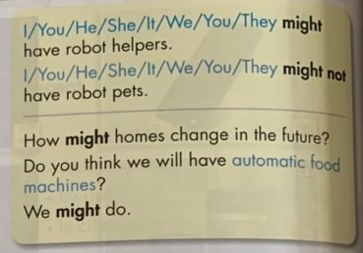  - Have some Ss read the sentences aloud.  - Have Ss give the rule of using Might.  -Ask Ss to write the new language in their notebooks. | - Look at the pictures  - Guess what the picture is about  - Listen and read the speech bubbles.  - Do the task in pairs.  - Work in pairs.  + Expected answer:  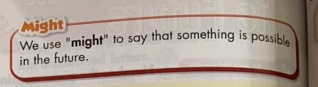  - Read the sentences aloud.  - Write in notebooks.
b. Fill in the blanks using “might” and a verb from the box.  - Have Ss study the task.  - Demonstrates the activity using the example.  1. Automatic food machine might make all our food.  - Have Ss fill in the blanks using “might” and a verb from the box.  - Have Ss check their works in pairs.  - Have some Ss share their answers with the class.  - Give feedback  c. Unscramble the sentences.  - Have Ss explore the task  - Demonstrate the activity using the example.  1. In the future, we might have robot helpers.  - Have Ss unscramble the sentences.  - Have Ss check their works in pairs.  - Have some Ss share their answers with the class.  - Give feedback (if any) | - Listen to T’s demonstration and take notes in notebooks.  - Do the task individually  - Work in pairs (check each other's work)  - Share the answers with the class.  - Check the answers and correct the mistakes (if any)  + Expected answers:  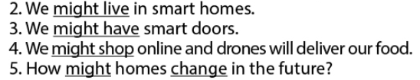  - Listen to T’s demonstration and write the sentence in notebooks.  - Write sentences using the prompts individually  - Work in pairs  - Share the answers with the class.  + Expected answers:  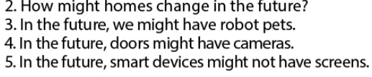

- Activity 2: Speaking Skill (10’)
a) Objective: to get Ss another step in grasping the grammar point
b) Content: Speaking
c) Products: Ss can be more proficient in the target language presented
d) Competence: Collaboration, communication, creativity
e) Organization of the activity:
Teacher’s activities | Students’ activities
d. Now, practice saying the sentences with your partner:  * Option 1:  - Divide the class into pairs.  - Have Ss practice saying the sentences.  - Call some Ss to demonstrate the activity in front of the class.  * Option 2: Game: Lucky numbers  - Ask Ss to play the game in teams.  - Divide the class into two team: Team A and B.  - Ask Ss to choose a number which is attached a word/ phrase and then say out loud a sentence with the structure they have learned. If any number showing the word Lucky, Ss can choose a word from the lesson and T has to make a sentence for it.  # 1: Smart phones  # 2: Cameras  # 3: Lucky number  # 4: Robot helpers  # 5: Lucky number  # 6: Lucky number  # 7: Smart homes  # 8: Drones  - Announce the winner of the game. | - Work in pairs and do as guided  - Play the game in teams; Team A and B.  Suggested answers  - In the future, smart phones might be very thin.  - In the future, cameras might make a phone calls.  - ………………………………………………

C. Consolidation (3’)
- Use Modal verb Might to say that something is possible in the future.
- How might homes change in the future?
- We might not have robot pets.
D. Homework (2’)
- Do exercise in the workbook: Lesson 2- Grammar and Writing (page 53)
- Prepare: Lesson 2 – Pronunciation & Speaking (Page 75 – SB).

