Date of preparing: ………………………………….
Date of teaching: ………………………………….

Period……
UNIT 3: FRIENDS
Lesson 1 - Part 3 (Page 24) – Pronunciation and Speaking

I. OBJECTIVES
By the end of the lesson, Ss will be able to…
1. Knowledge
- pronoun the sound /bl/.
- ask and answer about what people look like.
- describe friends in class.
2. Ability
- improve speaking skills.
3. Quality
- have positive attitude in English language learning so that they actively participate in all classroom activities.
- love their school and friends.

II. TEACHING AIDS AND LEARNING MATERIALS
Lesson plan, PPT slides, student’s book, workbook, notebook, personal computer (if any), projector/TV, speakers, DCR & DHA on Eduhome, handouts…

III. PROCEDURES
A. Warm up: (5’)
a) Objective: Introduce the new lesson and set the scene for Ss to acquire new language; get students' attention at the beginning of the class by means of enjoyable and short activities as well as to engage them in the steps that follow.
b) Content: Introduction of the cluster: /bl/.
c) Product: Ss know some words containing sound /bl/.
d) Competence: Collaboration, observation, memorizing, imagination
e) Organization of the activity:
Teacher’s Activities | Students’ Activities
- Give greetings  - Check attendance  - Option 1:  - Show a picture and ask Ss to describe the picture    - Show teacher’s sentence:  The black dog is blowing a blue whistle.  - Have Ss read this sentence  - Introduce the word black, blow, blue which contains the sound Ss are going to study today  → Lead to the new lesson.  - Option 2: SONG: The /bl/ sound  - Let Ss listen to the song “The /bl/ sound”. Ss can sing together while the song is being played. (T doesn’t need to play all song, 1m20s is ok)  - Have Ss listen to the song and try to remember the words with the sound /bl/ (same as “Kim’s Game)  - Have Ss give answers  - Link from youtube:  https://www.youtube.com/watch?v=gr5sorDoH2s  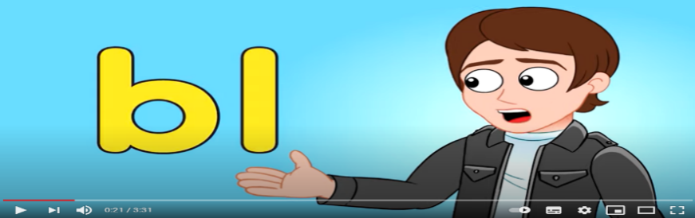  Or:  https://www.youtube.com/watch?v=li52N4KKzro  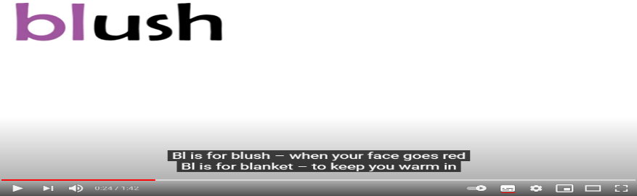  - Give feedback  → Lead to the new lesson | - Greet T  - Look and describe  Expected answers  1. The dog is black  2. The whistle is blue  …  - Look and read  - Listen  - Listen and remember  - Write answers on the board / or read answers  - Listen

B. New lesson (35’)
- Activities 1: Pronunciation (10’)
a) Objective: Ss know how to pronounce /bl/ sound.
b) Content:
- Listening, repeating, practicing the sound.
c) Products: Ss can pronounce the correct sound /bl/ when speaking.
d) Competence: Communication, collaboration, listening
e) Organization of the activity:
Teacher’s Activities | Students’ Activities
a, b, c, d: Listen to the words and focus on the underlined letters, then repeat  - Play the recording (CD1, track 33)  - Ask Ss to listen and pay attention to the /bl/ sound  - Play the audio again. Have Ss listen and repeat with a focus on the sound.  - Have Ss practice saying the examples using the sound correctly.  - Call some Ss to read in front of the class.  - Check Ss’ pronunciation if necessary | - Listen  - Work individually  - Read
- Activity 2: Practice (10’)
a) Objective: Ss can ask and answer about what people look like.
b) Content: Asking and answering by using the pictures
c) Products: Ss can apply the target language learnt naturally in communication.
d) Competence: Collaboration, communication, creativity, public speaking.
e) Organization of the activity:
Teacher’s Activities | Students’ Activities
Ask and answer  - Option 1:  - Emphasize the structure used to ask about personal appearance:  What does he / she look like?  - Demonstrate the activity by asking and answering with a student  - Have Ss work in pairs to ask and answer, using the pictures  - Have some pairs demonstrate the activity in front of the class  - Give feedback and evaluation  - Option 2: (for class with better students)  - Follow the same steps as option 1  - Provide more questions / structures for Ss to practice:  How old is he / she?  How tall is he / she?  - Have some pairs demonstrate the activity in front of the class  - Have another pair act out the conversation in front of the class without looking at the book  - Give feedback and evaluation | - Listen, take notes  - Listen  - Work in pairs  - Present  Suggested conversation  A: I’m looking for my friend.  B: Is your friend a boy or a girl?  A: A girl  B: What does she look like?  A: She’s tall and she has black hair.  B: Is she carrying a bag?  A: No, she isn’t  B: Is it Mai?  - Listen and take notes  - Present  - Present
- Activity 3: Speaking (15’)
a) Objective: Ss can describe people.
b) Content: Asking and answering questions about looking for friends at a party.
c) Products: Ss use the language provided confidently, fluently and naturally.
d) Competence: Collaboration, communication, creativity, public speaking.
e) Organization of the activity:
Teacher’s Activities | Students’ Activities
a. You are looking for friends at a party. Work in pairs. Student A use information in File 1 (p.120) and Student B use information in File 8 (p.123)  - Demonstrate the activity by practicing role-play with a student  - Have Ss work in pairs. Student A use information in File 1 (p.120) and Student B use information in File 8 (p.123)  - Have Ss role-play the conversation, swap roles and repeat  - Observe, give help if necessary  b. Take turns to describe friends in your class for your partner to guess.  - Have Ss take turns to describe and guessing their friends in class  - Have some Ss demonstrate the activity in front of the class  - Give feedback and evaluation | - Observe and listen  - Work in pairs  - Present  Suggested conversation  A: I’m looking for my friend Toby  B: What does he look like?  A: He’s wearing brown shorts and a green T-shirt.  B: Oh, he’s in the dining room.  - Work in pairs  - Present

C. Consolidation (3’)
* /bl/ sound: blue, black, blow, blind, blast
* Asking and answering about personal appearance
What does he / she look like?
→ He / She is … or: He / she has got …

D. Homework (2’)
- Practice the /bl/ sound.
- Review the structures used to ask and answer about personal appearance.
- Complete the survey for those who haven’t finished it in class.
- Do exercises in WB: Grammar (Part b, c), page 15.
- Prepare: Lesson 2 – New Words and Reading (page 25 – SB).

