

A. VOCABULARY
No. | Word/ Phrase | Type | IPA | Meaning
1. | life | (n) | /laɪf/ | cuộc sống
2. | countryside | (n) | /ˈkʌntrisaɪd/ | nông thôn, miền quê
3. | harvest | (n), (v) | /ˈhɑːrvɪst/ | vụ mùa, thu hoạch
4. | harvest time | (n) | /ˈhɑːrvɪst taɪm/ | thời gian thu hoạch
5. | harvester | (n) | /ˈhɑːrvɪstər/ | máy gặt, người gặt
6. | combine harvester | (n) | /ˈkɒmbaɪn ˈhɑːrvɪstər/ | máy gặt đập liên hợp
7. | load | (v), (n) | /ləʊd/ | chất hàng, tải trọng
8. | unload | (v) | /ʌnˈləʊd/ | dỡ hàng
9. | milk | (n), (v) | /mɪlk/ | sữa, vắt sữa
10. | milk cows | (v) | /mɪlk kaʊz/ | vắt sữa bò
11. | feed | (v) | /fiːd/ | cho ăn
12. | feed pigs | (v) | /fiːd pɪɡz/ | cho lợn ăn
13. | catch | (v) | /kætʃ/ | bắt
14. | catch fish | (v) | /kætʃ fɪʃ/ | bắt cá
15. | dry | (adj), (v) | /draɪ/ | khô, làm khô
16. | dry rice | (v) | /draɪ raɪs/ | phơi lúa, sấy lúa
17. | plough | (v), (n) | /plaʊ/ | cày, cái cày
18. | plough fields | (v) | /plaʊ fiːldz/ | cày ruộng
19. | village | (n) | /ˈvɪlɪdʒ/ | làng
20. | villager | (n) | /ˈvɪlɪdʒər/ | dân làng
21. | herd | (n), (v) | /hɜːrd/ | bầy đàn, chăn dắt
22. | buffalo | (n) | /ˈbʌfələʊ/ | con trâu
23. | herd the buffaloes and cows | (v) | /hɜːrd ðə ˈbʌfələʊz ənd kaʊz/ | chăn trâu bò
24. | paddy | (n) | /ˈpædi/ | lúa, gạo lứt
25. | paddy field | (n) | /ˈpædi fiːld/ | cánh đồng lúa
26. | bamboo dancing | (n) | /ˌbæmˈbuː ˈdænsɪŋ/ | múa sạp
27. | dragon-snake | (n) | /ˈdræɡən sneɪk/ | rồng rắn
28. | envy | (v), (n) | /ˈenvi/ | ghen tị, sự ghen tị
29. | crop | (n) | /krɒp/ | vụ mùa, cây trồng
30. | gather the crop | (v) | /ˈɡæðər ðə krɒp/ | thu hoạch mùa màng
31. | cattle | (n) | /ˈkætl/ | gia súc
32. | poultry | (n) | /ˈpəʊltri/ | gia cầm
33. | orchard | (n) | /ˈɔːrtʃərd/ | vườn cây ăn quả
34. | ancient | (adj) | /ˈeɪnʃənt/ | cổ xưa
35. | observe | (v) | /əbˈzɜːrv/ | quan sát
36. | lighthouse | (n) | /ˈlaɪthaʊs/ | hải đăng
37. | canal | (n) | /kəˈnæl/ | kênh, mương
38. | cultivate | (v) | /ˈkʌltɪveɪt/ | canh tác, trồng trọt
39. | stretch | (v), (n) | /stretʃ/ | kéo dài, sự kéo dài
40. | picturesque | (adj) | /ˌpɪktʃəˈresk/ | đẹp như tranh
41. | vast | (adj) | /vɑːst/ | rộng lớn, bao la

B. WORD FORM
- village (n): làng, xã  - villager (n): dân làng  - collect (v): thu thập, sưu tầm  - collection (n): bộ sưu tập, sự thu thập  - collector (n): người sưu tầm  - collective (adj): tập thể, chung  - collectively (adv): một cách tập thể, cùng nhau  - color (v): tô màu, nhuộm màu  - color (n): màu sắc  - colorful (adj): nhiều màu sắc, sặc sỡ  - colorfully (adv): một cách sặc sỡ  - peace (n): hòa bình, sự yên bình  - peaceful (adj): yên bình, hòa bình  - peacefully (adv): một cách yên bình, trong hòa bình  - ride (v): cưỡi (ngựa, xe đạp), đi (xe buýt, ô tô)  - ride (n): chuyến đi, cuộc đi chơi (bằng xe)  - rider (n): người cưỡi, người đi xe  - farm (v): trồng trọt, chăn nuôi  - farm (n): nông trại  - farmer (n): nông dân  - farming (n): nghề nông, sự canh tác  - farmhouse (n): nhà ở nông trại | - develop (v): phát triển  - development (n): sự phát triển  - developer (n): nhà phát triển  - developing (adj): đang phát triển  - developed (adj): đã phát triển  - care (v): quan tâm, chăm sóc  - care (n): sự quan tâm, sự chăm sóc  - careful (adj): cẩn thận  - carefully (adv): một cách cẩn thận  - careless (adj): bất cẩn  - carelessly (adv): một cách bất cẩn  - friend (n): bạn bè  - friendship (n): tình bạn  - friendly (adj): thân thiện  - friendliness (n): sự thân thiện  - tradition (n): truyền thống  - traditional (adj): thuộc về truyền thống  - traditionally (adv): theo truyền thống

C. GRAMMAR
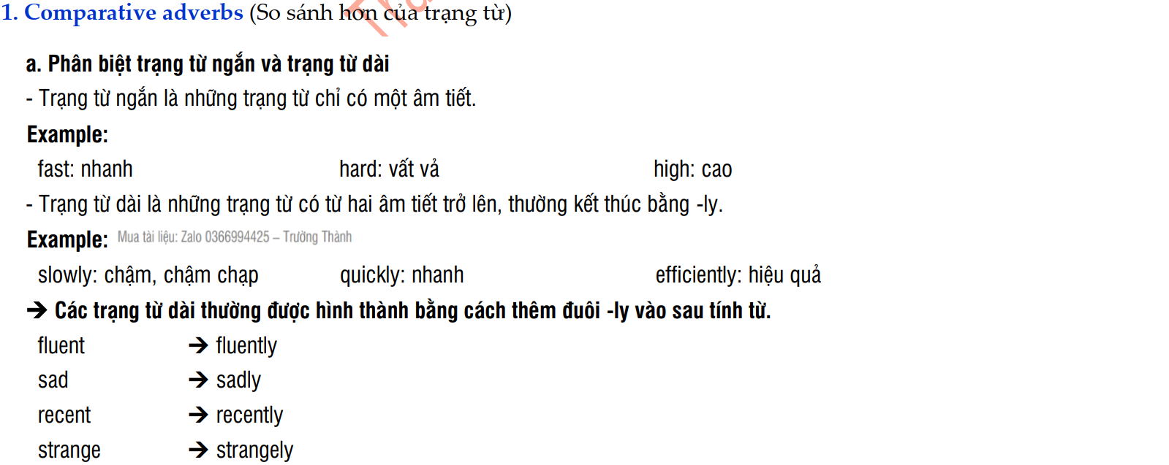

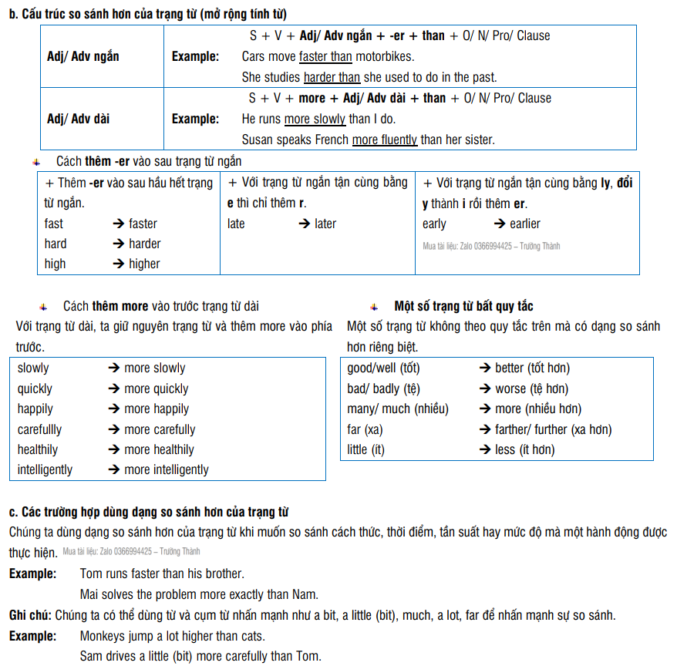
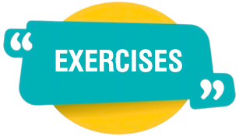

EXERCISES

- PHONETIC
Exercise 1: Choose the word (A, B, C, or D) whose underlined part is pronounced differently from the others.
1. A. normal B. visitors C. transport D. chore
2. A. basic B. major C. craft D. racing
3. A. ceremony B. cultural C. cattle D. costume
4. A. country B. cloud C. loudly D. mouse
5. A. camel B. cattle C. paddy D. buffalo
6. A. entertain B. rain C. air D. strain
7. A. traffic B. relative C. tragedy D. jam
8. A. apartment B. offer C. prefer D. another
9. A. create B. peaceful C. increase D. easily
10. A. accessible B. pressure C. illness D. success

Exercise 2: Choose the word (A, B, C, or D) whose main stress is different from the others in the group.
1. A. charade B. transport C. expect D. paddy
2. A. popular B. calculus C. beehive D. disturb
3. A. harvest B. collect C. peaceful D. whisper
4. A. opportunity B. inconvenient C. facility D. optimistic
5. A. activity B. traditional C. majority D. population
6. A. nomadic B. generous C. colourful D. countryside
7. A. leisure B. beehive C. unique D. behave
8. A. heritage B. pasture C. virtual D. detest
9. A. festival B. nomadic C. ornament D. turmeric
10. A. addicted B. socialise C. terraced D. custom

- VOCABULARY AND GRAMMAR
Exercise 3: Choose the word/ phrase/ sentence (A, B, C, or D) that best fits the space in each sentences or best answers the question.
1. How long will it take to ______ these bunches of rice onto the lorry?
A. cut B. fill C. load D. unload
2. The ______ is so peaceful with boys ______ the buffaloes on the slopes of the hill.
A. village / guiding B. countryside / herding C. paddy field / leading D. life / catching
3. My grandmother was a peasant; she used to ______ rice from the buffalo-drawn cart.
A. carry B. load C. unload D. collect
4. After ______ the field, farmers grow some kinds of important ______ suitable for each season.
A. combining / cattle B. collecting / poultry C. ploughing / crops D. cultivating / harvest
5. I heard the clank of buckets as they went to ______ the cows.
A. herd B. keep C. feed D. milk
6. Every afternoon they went to the park to ______ the ducks with their favorite food.
A. raise B. catch C. feed D. milk
7. It's ______ when fruits are all ripe and local people ______ them in the orchard.
A. harvest time / pick B. harvest / choose C. life / decide D. harvest time / gather
8. In those days when I was at high school, I often helped my parents to ______ crops at harvest time.
A. save B. gather C. collect D. all are correct
9. When a boy, my granddad used to ______ fish from the pond behind his house.
A. hold B. pick C. catch D. feed
10. After cutting rice from the field, farmers ______ it in the sun for 2 or 3 days.
A. drain B. bake C. dry D. plough
11. Russia is a _______ country with a lot of natural resources.
A. vast B. envious C. cultivable D. far
12. Farmers often leave the rice in the sun to _______.
A. damp B. wet C. warm D. dry
13. They _______ the buffalo-drawn cart with hay.
A. built B. hugged C. loaded D. milked
14. Farmers always need extra help with the _______.
A. accident B. harvest C. explosion D. cattle
15. My uncle raises a herd of _______ on his farm.
A. cattle B. fruit C. countryside D. village
16. Farmers in Ly Nhon are ________ in the yard after they have harvested all the fields.
A. drying rice B. washing clothes C. dragon-snake D. milk cows
17. Can Gio is a suitable place to plant ________ suitable for saline soils.
A. cattle B. villagers C. orchards D. cows
18. At the weekend, my family and I went to the countryside to visit our grandparents. On the way,
we encountered many houses with ________ architecture.
A. ancient B. disturbing C. vast D. envious
19. The experience of ________ cows at Long Thanh dairy farm is a very memorable memory from my travels.
A. herding B. envying C. catching D. milking
20. We really enjoyed flying kites over the green rice ________ during our picnic last year.
A. facilities B. hays C. fields D. collections
21. We are looking forward to a bumper _______.
A. lighthouse B. village C. countryside D. crop
22. I used to go _______ buffaloes when I was small.
A. herding B. swimming C. hiking D. cooking
23. They _______ the boxes into the trucks.
A. harvested B. loaded C. caught D. observed
24. _______ is often the hardest but the most important time to people living in the countryside.
A. Tet holiday B. Harvest time C. Daylight D. Travelling time
25. John invited Ann to join his family on _______ to his home village about 60 kilometers to the north of Ha Noi.
A. a two-day trip B. two- days trip C. a two- days trip D. a trip two days
26. After an hour walking between the green paddy _______, we finally reached the village entrance.
A. places B. fields C. yards D. courts
27. We can enjoy the fresh air and beauty in the_______.
A. city B. factory C. countryside D. gas station
28. The small bamboo forest _______ the entrance to the village makes it picturesque.
A. at B. in C. on D. to
29. Alice met Aly’s family at his house _______ the early morning.
A. on B. at C. in D. about
30. I am _______ on visiting my grandparents' on the weekend.
A. fond B. keen C. interested D. bored
31. It is _______ in the city than it is in the country.
A. noisily B. more noisier C. noisier D. noisy
32. The English test was _______ than I thought it would be.
A. the easier B. more easy C. easiest D. easier
33. English is thought to be _______ than Math.
A. harder B. the more hard C. hardest D. the hardest
34. Her office is _______ away than mine.
A. father B. more far C. farther D. farer
35. The streets in cities are _______ than those in the countryside.
A. crowded B. more crowded C. crowdeder D. less crowded
36. City drivers have to drive _______ than country ones.
A. more careful B. more careless C. more carefully D. more carelessly
37. My house is _______ hers.
A. cheap than B. cheaper C. more cheap than D. cheaper than
38. Tom is _______ than David.
A. handsome B. the more handsome C. more handsome D. the most handsome
39. He did the test _______ I did.
A. as bad as B. badder than C. more badly than D. worse than
40. My new sofa is _______ than the old one.
A. more comfortable B. comfortably C. more comfortabler D. comfortable
41. A boat is _______ than a plane.
A. slower B. slowest C. more slow D. more slower
42. My sister dances _______ than me.
A. gooder B. weller C. better D. more good
43. This road is _______ than that road.
A. narrower B. narrow C. the most narrow D. more narrower
44. He drives _______ his brother.
A. more careful than B. more carefully
C. more carefully than D. as careful as
45. Things in the city are _______ than in the country.
A. moderner B. more moderner C. modern D. more modern

Exercise 4: Choose the letter A, B, C, or D to indicate the word(s) CLOSEST in meaning to the underlined word(s) in each of the following sentences:
1. Nomadic people live in a ger. It keeps them cool in summer and warm in winter.
A. house B. circular tent C. cave D. yatch
2. The nomads move two or three times a year to look for new pastures
A. food B. places C. grasslands D. lifestyles
3. life in the city is more exciting than in the country.
A. boring B. interesting C. convenient D. beautiful
4. That village is very peaceful, so we like to live there.
A. noisy B. quiet C. boring D. skillful
5. I don’t like living in the country.
A. dislike B. hate C. enjoy D. A and B are correct

Exercise 5: Choose the letter A, B, C, or D to indicate the word(s) OPPOSITE in meaning to the underlined word(s) in each of the following sentences:
1. The life in the countryside is very quiet and relaxing
A. noisy B. exciting C. modern D. hard
2. City people seem to react more quickly to changes than country people.
A. noisy B. slow C. slowly D. fast
3. A buffalo ploughs better than a horse.
A. well B. bad C. badly D. worse
4. This exercise is more difficult than that one.
A. easy B. boring C. good D. easily
5. Life in the city is more convenient and exciting than life in the country.
A. inconvenient B. more inconvenient C. slow D. A and B are correct

Exercise 6: Circle the correct options to complete the sentences.
1. City people seem to react (quicklier / more quickly) to changes than countryside people.
2. She came to the party (later / more lately) than her friends.
3. Does a computer work at calculus (more fast / faster) than a human being?
4. Nga writes English essays (better / more well) than Mai.
5. Nick can jump (higher / more high) than Mike.
6. Today it’s raining (more heavily / heavilier) than it was yesterday.
7. Juice contains (more / many) vitamins than coke.
8. The farmers in my village work (hard / harder) than the ones here.
9. People in rural areas talk (optimistically / more optimistically) than city people.
10. Ms. Sarah dances (more beautifully / beautifully) than Ms. Susan.

Exercise 7: Complete the sentences, using the comparative form of the adverbs from the correspondent adjectives in the brackets.
1. It usually rains ____________________ in Central Viet Nam than in other region. (heavy)
2. I will have to try a bit ____________________ than this. (hard)
3. The hall was lighted ____________________ than the corridors. (bright)
4. Time goes by ____________________ when we are busy. (quick)
5. Our family has lived ____________________ in the country than in the town since last year. (happy)
6. The boys were playing the game ____________________ than the girls. (noisy)
7. This task can be completed ____________________ than that one. (easy)
8. A tractor can plough ____________________ than a buffalo or a horse. (good)

Exercise 8: Use the adjective in brackets in their correct forms of comparison to complete the sentences.
1. Tea is ____________________ coffee. (cheap)
2. The new harvest machine is ____________________ the old one. (effective)
3. The countryside is ____________________ the town. (beautiful)
4. A tractor is ____________________ a buffalo. (powerful)
5. My sister is ____________________ me. (tall)
6. Blue whales are ____________________ elephants. (heavy)
7. The Mekong River is ____________________ the Red River. (long)
8. Do you think English is ____________________ French in grammar? (easy)
9. My new bed is ____________________ my old bed. (comfortable)
10. The film about my village town is ____________________ the book. (interesting)

Exercise 9: Fill in each blank with the appropriate form of the word in brackets.
1. ____________________ are very friendly and hospitable. | (village)
2. My grandfather owns a valuable ____________________ of stamps. | (collect)
3. Spring coming, the hills are ____________________ with many species of wild flowers blooming. | (color)
4. Each nation tries to work hard to protect the world ____________________. | (peaceful)
5. ____________________ a camel is the most exciting activity I have ever experienced. | (ride)
6. Nomads usually move to get food and find lands to ____________________. | (farmer)
7. Country children often react less quickly to technical ____________________ than city children. | (develop)
8. You must drive ____________________ on the city roads or you will take high risk of getting accidents. | (care)
9. During my stay in the village, I was ____________________ with several local farmers. | (friend)
10. Local people in the village often wear their ____________________ costumer during the festivals. | (tradition)

- COMMUNICATION
Exercise 10: Choose the word or phrase (A, B, C, or D) that best completes each of the following exchanges.
1. Lan: “Have you ever ridden a cart?”
Nam: "_______"
A. Yes, we do. B. That’s a good idea. C. No, but I’d like to. D. Not at all.
2. Nick: You’ve made new friends?
Aly: "_______"
A. Yes, I did. B. Yeah- right on the first day.
C. Yes, please. D. You’re welcome.
3. Ba: "Why don’t we take a trip to my home town?"
Nam: "_______"
A. Yes, we do. B. That’s a good idea. C. Not at all. D. You’re welcome.
4. Nick: "How is your stay there?"
Nam: "_______"
A. Yes, please. B. So exciting. C. Never mind. D. Sure
5. Lan: "What are you doing there?"
Nam: "_______"
A. Lots of things. B. Good idea. C. Ok. D. Not at all.

Exercise 11: Choose the correct answer (A, B, C, or D) to arrange the following sentences into a meaningful conversation.
1. a. Brian: Me too, Ally. City life is too noisy for me.
b. Ally: And look at all the green fields! It's so peaceful.
c. Ally: It's so quiet here, Brian. I love the fresh air!
A. a-b-c B. c-a-b C. c-b-a D. a-c-b
2. a. Brian: That's true. And everyone is so friendly in the village.
b. Ally: Not really. We can get fresh food from the farm here.
c. Brian: Do you ever miss the shops in the city, Ally?
A. a-b-c B. c-a-b C. b-a-c D. c-b-a
3. a. Brian: Me too, Ally. It's much quieter than the city, isn't it?
b. Ally: It's so lovely here, Brian. I really enjoy the peaceful countryside.
c. Ally: It's a great place to live, especially with all the fresh food from the farms.
d. Brian: Yes, and the air feels so much cleaner here.
e. Ally: Definitely! And I love waking up to the sound of birds instead of traffic.
A. b-a-e-d-c B. a-b-c-d-e C. b-e-a-d-c D. c-a-b-e-d

- READING
Exercise 12: Look at the sign or the notice. Choose the best answer (A, B, C or D) for these questions.
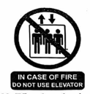 | 1. What does the notice say?  A. Three people can use the elevator at the same time during a fire.  B. For your safety, use the elevator with others during a fire.  C. If there is a fire, don't use the elevator.  D. You have to use the elevator when it is on fire.
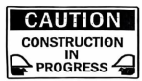 | 2. What does the sign say?  A. Be careful because building work is happening.  B. There is careful construction.  C. Construction must be carefully done in progress.  D. You have to construct buildings with caution.
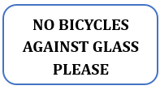 | 3. What does the notice say?  A. Your bicycle may not be safe here.  B. You mustn't touch the glass bicycle.  C. Broken glass may damage your bicycle tyles.  D. Do not leave your bicycle touching the window.
 | 4. What does the sign say?  A. You must get a license to fish here.  B. You don't need to pay attention to your fishing.  C. You are not allowed to fish here.  D. You can only catch certain types of fish.
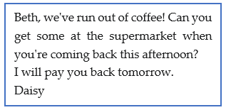 | 5. What does the message mean?  A. Daisy wants Kim to buy some coffee this afternoon.  B. Beth will buy coffee tomorrow when she returns home.  C. Beth will go to the supermarket tomorrow.  D. Daisy should give Beth some money to buy coffee.

Exercise 13: Read the following advertisement/ notice/ flyer/ announcement and mark the letter A, B, C or D to indicate the correct option that best fits each of the numbered blanks

Come Enjoy Life in the Countryside!
Do you want peace and fresh air? Come to (1) _______ countryside! Life here is quiet and beautiful. You can walk in green fields, (2) ______ clean air, and listen to birds sing. People are (3) ______ and always ready to help. There is no noise, no traffic — just nature and simple living. You can grow your own food and enjoy healthy meals every day. Life in the countryside is good (4) ______ your body and mind. Come and feel happy and free. The countryside is waiting for you!
1. A. no article B. the C. a D. an
2. A. cut B. harvest C. breathe D. unload
3. A. friendliness B. unfriendly C. friendship D. friendly
4. A. with B. to C. for D. at

📢 Notice to All Students: Bat Trang Pottery Trip
Dear students,
We are happy to announce our upcoming trip to Bat Trang Pottery Village! 🎨🏺
Please be ready at the school gate (1) ______ 7:30 AM this Saturday. Remember to bring a hat, water bottle, and snack. Wear comfortable clothes because you (2) ______your own pottery!
This is a fun way to learn about Vietnamese (3) ______ and practice English with friends. Don’t be late!
(4) ______ you have any questions, ask your teacher.
Thank you!
1. A. on B. at C. for D. in
2. A. will make B. made C. are making D. make
3. A. culturally B. culture C. cultural D. multicultural
4. A. If B. When C. For D. Unless

Exercise 14: Read the following passage and mark the letter A, B, C, or D to indicate the correct word that best fits each of the numbered blanks.
Last summer, Long went (1) __________ a holiday for two weeks to the island of Cat Ba. He (2) __________ a hotel which had a wonderful swimming pool and beautiful views of the sea. It was in a village where the local people went fishing in the winter, and foreign visitors came in the summer.
Long spent his first day on the beach, but on the second day he felt very ill. First, he was too hot, then he was too cold. He couldn't understand why he felt (3) __________ that. So he went to see the local doctor, who was a very nice man, and (4) __________ voice was so sweet.
"Summer is a time when people often feel ill," the doctor said. "It's too hot for most of us! (5) __________ this medicine, and stay out of the sun." Long took the doctor's (6) __________ and stayed in his room for the rest of his holiday. He soon felt better. "What a cheap holiday!" he thought happily.
1. A. to B. for C. on D. in
2. A. lived B. rented C. hired D. stayed
3. A. like B. as C. so D. Ø
4. A. spoke B. an C. who D. whose
5. A. Eat B. Drink C. Take D. Have
6. A. chance B. advice C. opportunity D. advise
Viet Nam is famous for its countryside and traditional village life. In a Vietnamese village, people live (1) ________ to nature and are more self-sufficient. They grow their own vegetables and raise their own animals. There are also (2) ________rice fields where farmers work hard to produce the staple food of the country.
In the village, people are more connected to their community. They often help each other (3) ________ tasks like farming, building homes, and cooking. There are also many festivals throughout the year where people come together to (4) ________ and share food.
Despite the many benefits of village life, there are also some (5) ________. Access to healthcare and education can be limited. Many young people also leave the village to find work in the city, which can lead to a decline in the population.
Overall, life in a Vietnamese village is simple and traditional, but also has its challenges. (6) ________, many people continue to cherish and preserve this way of life.
1. A. closer B. closest C. more close D. as close
2. A. much B. little C. many D. lots
3. A. on B. at C. by D. with
4. A. celebrate B. train C. surround D. combine
5. A. happiness B. advantages C. challenges D. benefits
6. A. Because B. Moreover C. Despite D. However

Exercise 15: Read the following passage and mark the letter A, B, C, or D to indicate the correct answer to each of the questions.
With the habit of working in teams and being helpful to one other, villagers usually earn their living from farming, raising livestock and making handicrafts. They live in a small community with a temple or a communal cultural house where great events, such as festivals worshipping the village god and traditional games are organized. Villagers in the Southern usually live in houses lined up along central road and built on stilts to keep above flood waters. Along the coastal lines, fishermen depend on the sea as a means of livelihood. In the Central of Vietnam, a place suffering lots of natural disasters all the year round, citizens tend to be more studious and hard-working than those in regions with favourable conditions. People in the central highlands and the northern mountains live by growing rice, rubber trees coffee and tea as well as hunting.
(Source: Adapted from Vietnam Travel Center)
1. What is the main idea of the passage?
A. The types of houses Vietnamese villagers live in.
B. The importance of communal houses in Vietnamese villages.
C. The diverse livelihoods and lifestyles of people in different regions of Vietnam.
D. The impact of natural disasters on the people of Central Vietnam.
2. What does the word "livelihood" in the passage mostly mean?
A. A way of living comfortably.
B. A means of securing necessities such as food and shelter.
C. The act of enjoying life to the fullest.
D. A group of people living in a particular area.
3. The word “They” in line 2 refers to _______.
A. handicrafts B. Southern Vietnamese C. great events D. villagers
4. According to the passage, which of the following sentences is TRUE?
A. People in the Southern region build houses on stilts to protect against earthquakes.
B. Villagers in Vietnam rarely work in teams.
C. People in the Central Highlands primarily earn their living through fishing.
D. People in Central Vietnam are generally more diligent due to difficult environmental conditions.
5. Which of the following can be inferred from the passage?
A. Vietnamese culture emphasizes individual achievement over community cooperation.
B. Geographical conditions significantly influence the economic activities and characteristics of people in Vietnam.
C. All Vietnamese people live in villages and engage in farming.
D. Festivals in Vietnam are only organized in temples.
Living in the country is something that people from the city often dream about. However, in reality, it has both advantages and disadvantages.
There are certainly many advantages to living in the country. First, you can enjoy peace and quietness. Moreover, people tend to be friendlier. A further advantage is that there is less traffic, so it is safer for young children.
However, there are certain disadvantages or drawbacks to life outside the city. First, because there are fewer people, you are likely to have few friends. In addition, entertainment is difficult to find, particularly in the evening. Furthermore, the fact that there are fewer shops and services means that it is hard to find jobs.
In short, it can be seen the country is more suitable for some people than others. On the whole, it is often the best for those who are retired or who have young children. In contrast, young people who have a career are better provided in the city.
1. What can be the best title for the passage?
A. The Joys of Retirement in the Countryside B. City Life vs. Country Life: A Comparison
C. Finding a Job in Rural Areas D. The Challenges of Raising Children in the Country
2. The word “drawbacks” in paragraph 3 is closest in meaning to __________
A. benefits B. solutions C. disadvantages D. opportunities
3. The word “it” in paragraph 4 refers to _______.
A. the city B. the country C. a career D. entertainment
4. Which of the following is NOT true according to the passage?
A. The countryside generally offers more peace and quiet than the city.
B. People in the country tend to be more unfriendly than those in the city.
C. It is typically safer for young children in the country due to less traffic.
D. Finding entertainment in the evening can be a challenge in the countryside.
5. Which of the following can be inferred from the passage?
A. The decision to live in the city or the country depends on an individual's life stage and priorities.
B. Young people should avoid living in the countryside at all costs.
C. All city dwellers dream of moving to the countryside.
D. There are more job opportunities in the countryside than in the city.

Exercise 16: Four phrases/sentences have been removed from the text below. Choose the correct answer to complete the text. Write only the letter A-D in each blank.
People in Viet Nam's countryside come from many different ethnic groups. (1) ____________________, remote areas in mountainous regions, and coastline areas. Depending on native natural conditions in each region, (2) ____________________. With the larger land area than urban regions, (3) ____________________.
Nowadays, locals in the countryside are mainly elders and children. Many young people and adults study, live, and work in big cities. The majority of them decide to settle down in urban areas instead of coming back to their hometown. (4) ____________________ to visit their families in the countryside; therefore, you can see big cities in Viet Nam with cleaner atmosphere than usual at these times.
(Adapted from https://www.insidevietnamtravel.com)
A. each group has its own language, culture and lifestyle
B. National holidays are the time for them
C. They mainly live in rural areas in the lowlands
D. people in the countryside live a quieter and more peaceful life
The country is more beautiful than a town and more pleasant to live in. Many people think so, (1) ____________________ though they cannot live there all the year round. Some have a cottage built in a village so that they can go there whenever they can find the time.
English villages are not all alike, but in some ways they are not very different from one another. (2) ____________________, the round or square tower of which can be seen from many miles around. Surrounding the church is the church yard, where people are buried.
The village green is a wide stretch of grass, and houses or cottages are built round it. (3) ____________________ have running water brought through pipes into each house. Most villages are so close to some small towns that people can go there to buy (4) ____________________.
A. Almost every village has a church
B. Country life is now fairly comfortable and many villages
C. and go to the country for the summer holidays
D. what they can't find in the village shops

- WRITING
Exercise 17: Rearrange the words to make complete sentences.
1. people / In the countryside, / are/ and / life / is / more / simpler/welcoming/.

2. In general, /is /much/ convenient/ because/ in the city / life / many living facilities / available / more/ are/

3. busier/Like/her parents/other farmers, /are/harvest time /at

4. said that /felt /more/ about the future / city dwellers / country folks/ The article / optimistic /than/

5. the summer/The sun / brightly /in / than / in/ the winter / more /shines/

Exercise 18: Complete the sentences with suitable forms of the adverbs given in the brackets.
1. Nick is a careful write than Phuc. (carefully)
Nick writes essays
2. A snail is slower than a crab. (slowly)
A snail moves
3. My father’s explanation about the subject was clearer than my brother’s. (clearly)
My father explained the subject
4. My cousin is a better singer than I am. (well)
My cousin sings
5. Phong is a faster swimmer than Phuc. (fast)
Phong swims

Exercise 19: Rewrite the following sentences without changing their original meanings.
1. Tim is older than Sarah.
Sarah
2. Our house is large than yours.
Your house
3. Bill is not as tall as David.
Bill
4. Jack’s marks are worse than mine.
My marks
5. This book is the same price as that one.
That book is
6. Your bike is slower than mine.
My bike is
7. My house is bigger than your house.
Your house
8. The black car is cheaper than the red car.
The red car
9. This film is more interesting than that one.
That film
10. My kitchen is smaller than yours.
Your kitchen
11. My mother cannot cook as well as me.
I can
12. She has a house which is not as modern as my house.
My house
13. The movie was boring. I had been thought it was interesting.
The movie
14. He cannot play tennis as well as Jack.
Jack can
15. I did not spend as much money as you.
You spent
16. I didn’t think this book is expensive as it is.
This book
17. A city has more interesting activities than the countryside.
The countryside
18. A motorbike goes faster than a bike.
A bike
19. Life in the city is busier than life in the countryside.
Life in the countryside is
20. His uncle works less responsibly than Mr. Nam.
Mr. Nam
21. We fancy doing the housework.
We
22. Jane makes crafts better than her sister.
Jane’s sister

Exercise 20: Choose (A, B, C, or D) to indicate the correct arrangement of the sentences to make a meaningful paragraph/letter in each of the following questions.
1.
Dear Sarah,
a. We can go to the beach, eat fresh seafood, and explore the mangrove forest.
b. Please let me know if you can come. I'm excited to show you around!
c. I'd love to invite you to visit my hometown, Can Gio, next month.
d. It's a great place to relax for a weekend. I think you'll really enjoy it!
e. It's a beautiful place by the sea, not far from the city.
Your friend,
Thanh
A. c-e-a-d-b B. e-c-a-b-d C. a-d-e-c-b D. d-e-a-c-b
2.
a. While there might be fewer entertainment options, the benefits of peace, fresh air, and community make country living very appealing.
b. The air is fresh, and you can enjoy the quietness of nature without the constant noise of traffic and large crowds.
c. Life in the countryside offers a truly peaceful and healthy way of living, which I believe is much better than city life.
d. People in the countryside often live closer to their neighbors, creating a strong sense of community and support.
e. Moreover, fresh food from local farms is readily available, contributing to a healthier lifestyle.
A. d-e-a-c-b B. b-d-e-a-c C. c-b-d-e-a D. e-a-c-b-d

Exercise 21: Choose (A, B, C, or D) to indicate the correct answer to each of the following questions.

Put the sentences (a-c) in the correct order to form a logical paragraph about the downsides of country living, then fill in the blank to make a logical text.
Living in the countryside offers many wonderful things like fresh air and quiet mornings. However, it also has some disadvantages that can make life a bit more challenging. __________.
a. Also, getting around can be difficult as public transport options are usually limited.
b. One major issue is the lack of convenience, with fewer shops and restaurants nearby.
c. Finding work can also be a problem due to fewer job opportunities compared to the city.
A. b - a – c B. c - b – a C. b - c – a D. a - c - b
Choose the sentence that can end the text most appropriately.
A. These challenges are often outweighed by the peaceful environment and natural beauty.
B. Despite these inconveniences, I still prefer the calm and natural beauty of the countryside.
C. The friendly people in the countryside often help mitigate these issues.
D. Therefore, many people choose to move to the city for better opportunities.

(1) ______, it is far more appealing than the hustle and bustle of a big city. (2) ______ The peacefulness and friendly community truly make it a wonderful place to live.
Choose the TOPIC SENTENCE that can BEGIN the text most appropriately.
A. Living in the countryside offers a remarkably calm and enjoyable experience.
B. There are some drawbacks to living in the countryside, such as fewer shops.
C. City life is often characterized by noise and a lack of fresh air.
D. The author enjoys spending time in nature and seeing green fields.
Put the sentences (a-c) in the correct order, then fill in the blank to make a logical text.
a. Additionally, the people are often friendly and willing to help.
b. Waking up to fresh air and quiet mornings, away from city noise, brings a sense of calm.
c. Being surrounded by nature, hearing birds, and seeing green landscapes daily contributes to this peaceful feeling.
A. c-b-a B. a-c-b C. b-c-a D. b-a-c

- LISTENING
Exercise 22: Listen to the short talk twice and circle the correct answer to each of the following questions:
1. Where is Nguyen now?
A. countryside B. large village C. Ha noi D. small village
2. When was he able to make new friends?
A. on his 4th day B. on his 3rd day C. on his 2nd day D. on his 1st day
3. What is Nguyen’s kite like?
A. small B. big C. large and colorful D. short
4. Does Nick want to be there with Nguyen?
A. Yes, he did B. Yes, he does C. No, he doesn’t D. No, he don’t

Exercise 23: Listen to the conversation twice and decide whether the following sentences are True or False.
Statements | True/ False
1. Nguyen think country life could be so interesting.
2. Nguyen never joins the boys in herding the buffaloes.
3. Nick would like to visit the countryside at harvest time.
4. Rice is transported home on trucks.
--- THE END ---

