Họ tên thí sinh: .................................................................
Số báo danh: ......................................................................
Mã Đề: 030.
Câu 1. What is the offer for the swim class?
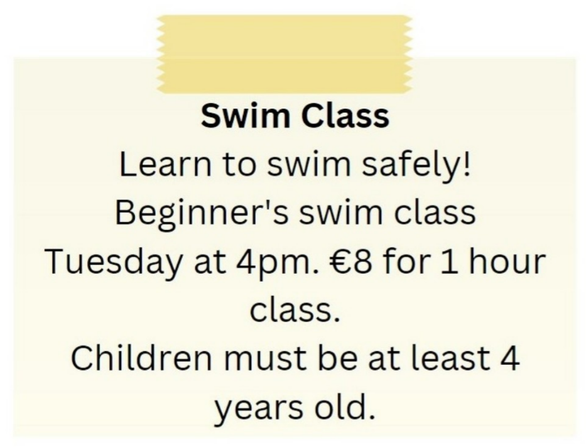
A. Beginner's swim class on Tuesday at 5pm for €10
B. Beginner's swim class on Tuesday at 4pm for €8
C. Advanced swim class on Tuesday at 4pm for €8
D. Beginner's swim class on Wednesday at 4pm for €8
Câu 2. Look at the signs. Choose the best answer for the question.

A. You must look after your cameras in this area. B. Cameras can be used in this area.
C. This area is supervised by camera. D. Cameras can only be used for security purposes.
Câu 3. What is true about the Tanzania advertisement?
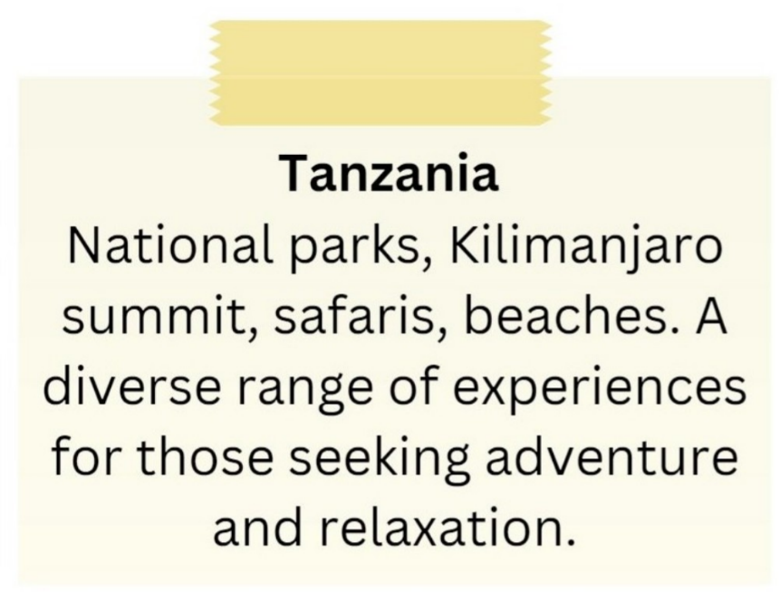
A. It features Kilimanjaro summit and safaris.
B. It promotes a single national park as the main attraction.
C. It excludes beach-related experiences.
D. It is focused solely on relaxation.
Câu 4. What does this sign mean?
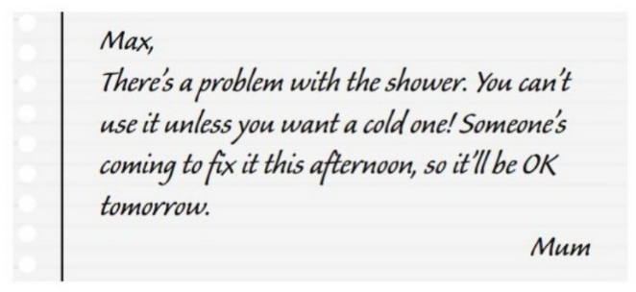
A. Max can take a hot shower now. B. Max can only have hot shower tomorrow.
C. Someone helped Max fix the shower. D. Mum needs Max to fix the shower.
Câu 5. What does this sign mean?
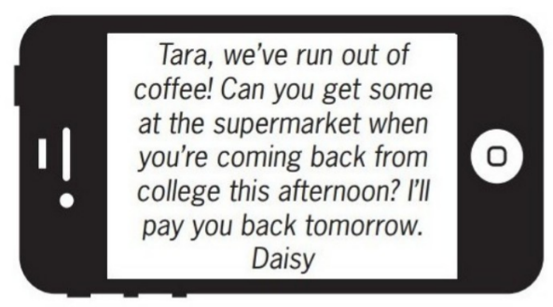
A. Daisy will buy coffee tomorrow when she returns home.
B. Daisy wants Tara to buy some coffee this afternoon.
C. Tara should give Daisy some money to buy coffee.
D. Tara will go to the supermarket tomorrow.
Câu 6. What caused damage to the library?
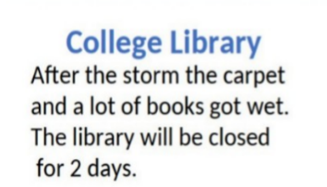
A. Renovation work B. Vandalism C. A storm D. A fire
Câu 7. What made Michael send this message to Arthur?
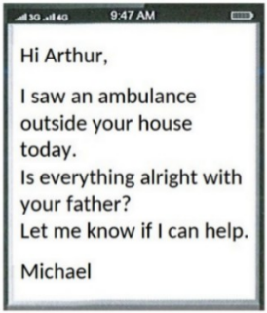
A. He heard about Arthur's father being ill B. He saw an ambulance outside Arthur's house
C. He received a message from Arthur's father D. Arthur called him about an emergency
Câu 8. Look at the signs. Choose the best answer for question.
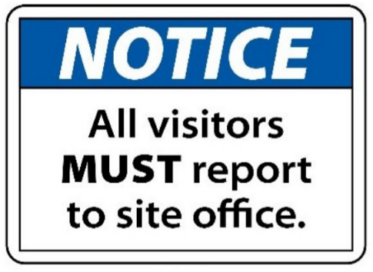
A. Guests are reported to visit the site office.
B. Anyone who visits must go to the site office and check in.
C. All visitors can enter the place through the site office.
D. The site office is for everyone to make a report.
Câu 9. Look at the signs. Choose the best answer for the question.
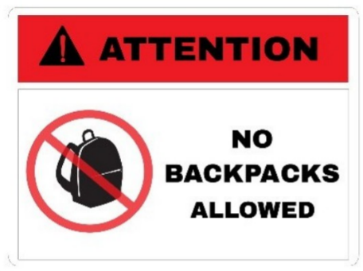
A. You shouldn’t carry a backpack when you’re in this area.
B. You must pay attention when you bring a backpack.
C. Backpacks are not allowed in this area without your attention.
D. You cannot bring your backpacks into this area.
Câu 10. Who is Andrew planning to go to the cinema with?
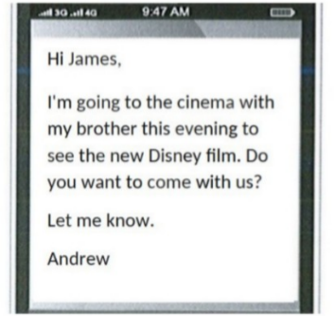
A. Alone B. His parents C. His brother D. James
----HẾT---

